Game content Doc
CONTENT DOCUMENT · FOR REVIEW
India Ke Top 1%
The 1% Club · every word players see and hear, plus all questions and answers

This document captures all of the on-screen text and spoken narration in the game, laid out the way a player moves through it, followed by every question in all three sets. It is meant for you to check and edit the wording. Developer and technical details have been deliberately left out.

How to read this
- Anything in {curly braces} is a value the game fills in automatically (a player's name, a live count, an amount of money). The wording around it is fixed copy you can change.
- Text in quotation marks is the exact wording that appears on screen or is spoken aloud.
- The questions in Part 4 show the actual images used in the game.

How the game flows
- Single player: a solo run that starts from the homepage.
- Multiplayer: a live room run by a host, with players competing and others watching.
- Host screen: the control screen the person running a live room uses (covered in Part 3).
- Every game is 10 questions, shown from 90% down to 1%. Each question has a 30 second timer.

Contents
Part 1: Single-player experience
Part 2: Live multiplayer experience
Part 3: Host screen
Part 4: Questions (Sets A, B and C)

Part 1: Single-player experience
Screen by screen, the way a solo player moves through the game.

1.1 Home and landing
- The home intro video plays (it has no text of its own).
- Enter button: "Enter" (a circular gold button that fades in near the end of the intro video)
- While the logo loads: "Loading the experience"

1.2 Welcome and teaser video
- The teaser video plays full screen.
- Skip control: "Skip"

1.3 Registration: Enter The Experience
- Kicker: "Registration"
- Heading: "Enter the experience"
- Name field: label "Your name", placeholder "Full name"
- Game mode toggle: "Game mode", with options "Single player" and "Multiplayer"
- Invite code (multiplayer only): label "Invite code", placeholder "ABCDEF"
- Invite code helper text: "Enter The Code Shared By The Host To Join The Lobby "
- Submit button: "Continue" (single player) or "Join lobby" (multiplayer)

1.4 Instructions (8 short scenes)
A skip control ("Skip") sits top-right on every scene except the last.
Scene | On-screen text
0. On the floor | "Welcome to the experience of India Ke Top 1% game show", then the player's first name, for example {first name}
1. The count | "10" · "Sawaal"
2. The rule | "%" · "Har sawaal ka apna percentage."
3. The warm-up | "90%" · "ka question har koi khel sakta hai"
4. The final filter | "1%" · "But only the Top 1% play the final question"
5. The clock | "Har question par milenge aapko sirf 30 seconds."
6. Your weapons | "Logic." · "Reasoning." · "Instinct."
7. Ready? | "Are you" · "Ready?"

- Final-scene button: "Start The Game"
- Scene names (also shown as taps along the bottom): On the floor, The count, The rule, The warm-up, The final filter, The clock, Your weapons, Ready?

1.5 Ready to play: Tonight's Stage
- Title: "Tonight's Stage"
- Three stat tiles (the big numbers are shown as styled graphics, the captions below them are text):
  - Tile 1: caption "Questions", number 10
  - Tile 2: caption "Contestants", number 100
  - Tile 3: caption "Cash prize", number 1 Cr
- Button: "Start the game"

1.6 Guided tour (before the first question)

Tour prompt card
- Kicker: "Guided instructions"
- Title: "Pehle, kuch quick instructions"
- Body: "Main aapko quickly dikha deta hoon ki yeh game kaise khela jata hai. Click below to begin, or skip straight to the first question."
- Buttons: "Read Instructions" (primary), "Skip instructions" (secondary)

Tour steps (pop-up tips)
- 1. The question: "Read the question carefully" : "At every round you will be shown a question. Read it slowly. The answer is usually hidden in the wordings."
- 2. Your answer: "Pick one of the four diamonds" : "The four options appear as diamonds. Tap the one you think is correct before time runs out."
- 3. The clock: "Watch the timer" : "Every question has a 30 second time limit. Hesitate too long, and the clock will decide for you."
- 4. The pot: "With every round, wrong answers are eliminated, and their value is added to the final prize pot.
- " : "Stakes from eliminated players stack up here. Progress to the Top 1% and this prize could be yours."

Ready gate card (after the tour)
- Kicker: "Instructions complete"
- Title: "Ready to play?"
- Body: "The clock starts the moment you click below. The first question is a 90% question. Most of India gets it right. Don't be an outlier.

- Buttons: "Start question 1" (primary), "Replay instructions" (secondary)

1.7 Question screen (the wording around the question)
The questions themselves are in Part 4. This covers the words on the screen surrounding them.
- Top-left chip: "Pot", with the live amount, for example ₹28L
- Top-right chip: "Players", with the live count, for example 45/100
- Timer controls (desktop): a countdown in seconds, plus "Pause timer" / "Resume timer", and "Paused" when paused
- Mobile percentage chip: caption "question" under the % number, timer label "Time left"
- Host status chip: "Host is speaking" (while narrating) / "Host muted" (when muted)
- Playing-along note: "Playing along, unscored"
- Heads-up hint chip (appears briefly, about 5 seconds, depending on the question type):
  - Multi-image question: "Swipe or use the arrows to compare each photo, then tap your choice to lock it in.

  - Typed-answer question: "Type your answer in the answer box, then hit Submit."
  - Other questions: "Choose carefully, once you select and submit, there's no changing your answer."
- Typed-answer placeholder: "Type your answer here..."
- Submit button: "Submit" (while checking: "Checking...")
- Image arrows: "Previous photo" / "Next photo"

Lifeline (one per game, from the 50% question onward, never on the 1% question)
- Button: "Lifeline · Skip this question (1 left)"
- After first tap (confirm): "Tap again to skip this question"

Answer-locked chip
- Normal: "Answer locked, waiting for the timer..."
- After a lifeline: "Lifeline used, question skipped. Waiting for the timer..."

Result banners (when the answer is revealed)
- Correct: "Correct!" (or, for observation questions, "Well observed.")
- Wrong: "Wrong answer. It was {correct answer}"
- Time up: "Time's up." (followed by the correct answer)
- Lifeline skipped: "Lifeline used, you're safe this round. The correct answer was {correct answer}"

Locked overlay (multiplayer, waiting for the shared reveal)
- Normal: "Your answer is now locked. Sit tight for the answer reveal after the timer ends."
- Skipped: "Question skipped, lifeline used. You're safe this round. Sit tight for the answer reveal after the timer ends."

1.8 After-round reveal
- Header: "After round", {percentage}% question
- Status chip: "Success" (green) / "Eliminated" (red)
- Count headline: "Eliminated this round" (with an animated number)
- Pot added block: "Added this round", amount +₹{added}, breakdown "{n} eliminated × ₹1L"
- Pot total chip: "Pot total" {amount}
- This-round block: "This round" +₹{added}
- Stats: "Still standing" {n} · "In the pot" {amount}
- Continue button: "Next question" (or "See end screen" on the last question)

1.9 Final result screen
- Left stat: "Questions correct", value {correct}/{total}
- Right stat: "In the pot", value {amount}

Closing gold tagline (two lines)
"Make your brand a part of the 1% Club." (Will change this to India ke top 1% tagline now)
"Coming Soon · August 2026"

1.10 Other on-screen text (appears across the game)
- Mute button: "Voice on" / "Muted"
- In-video skip: "Skip"
- "Coming soon" set gate:
  - Kicker / Heading: "Set B" / "Coming soon"
  - Body: "This set isn't available yet. Try Set A to play the current experience, or return to the registration page to choose again."
  - Button: "Back to registration"
- Tilt-your-phone notice (when a video is widescreen and the phone is upright):
  - Text: "Tilt your phone sideways. The video plays widescreen, turn your phone to watch it in full size."

Part 2: Live multiplayer experience
The screens players and watchers see in a live, host-run room.

2.1 Join screen

Host
- Kicker / Title: "Host" / "Host a 1% Club Quiz"
- Subtitle: "Spin up a new room and share the code with your players."
- Button: "Create new room"

Participant
- Kicker / Title: "Participant" / "Join the Quiz"
- Subtitle: "Enter the host's room code and your name to join."
- Fields: "Room code" (placeholder ABCDEF), "Your name" (placeholder Required)
- Button: "Join quiz"

Viewer
- Kicker / Title: "Viewer" / "Watch a Live Quiz"
- Subtitle: "Enter a room code to spectate in real time."
- Fields: "Room code" (placeholder ABCDEF), "Display name (optional)" (placeholder Anonymous)
- Button: "Watch quiz"

2.2 Live player intro
- Teaser stage: unmute button "Tap for sound" (when muted), skip "Skip intro"
Instruction cards (each shows the kicker "The 1% Club" above it):
- 1. How it works: "One question at a time" : "The host creates and manages the lobby. In each round, a single question appears on everyone's screen at the same time.

- 2. Beat the clock: "Lock your answer before the time runs out" : "A timer counts down on every question. Type or tap your answer and submit before the timer hits zero. Once you submit, it's locked in."
- 3. Survive: "A wrong answer eliminates you from the game" : "Get it wrong or run out of time and you're eliminated, then watch the rest play out. Stay sharp and you could be amongst the Top 1%."
- Buttons: "Next" (cards 1 and 2), "I'm ready" (card 3), "Skip"

2.3 Sound prompt
- Kicker: "The 1% Club"
- Heading: "Join with your name and sound" (when collecting a name) / "Tap to join with sound" (when not)
- Body: "One tap turns on the host voice and music. Your browser needs this each time you open the link before sound can play."
- Name placeholder: "Your name"
- Button: "Enter with sound" (busy: "Starting...")

2.4 Connecting and waiting lobby
- Connecting: "Connecting to room {code}..."
- Kicker: "Waiting for host"
- Heading: "You're in, {name}. Sit tight." (the name part is dropped if there is no name)
- Sub-line: "Room {code} · {n} player(s) joined"
- If the host is connected elsewhere: "Host is connected from another tab."

2.5 Late arrival or removed

Late arrival
- Kicker: "The game experience is in progress" (or "Quiz finished" if it has ended)
- Heading: "This lobby has already started" (or "This lobby has already finished")
- Body (in progress): "You can still join as a viewer, you'll see every question live and play along for fun, but you won't be scored or eliminated."
- Body (finished): "You can still hop in to see the final standings."
- Button: "Play as a viewer" (or "See the results" if finished)

Removed
- Kicker / Heading: "Removed" / "You were removed from this room"
- Body: "The host removed you from this lobby."

2.6 In game (player)
- Loading states: "Joining...", "Loading question..."
- The question screen uses the same wording as Part 1.7.

Eliminated screen
- Kicker / Heading: "Eliminated" / "You're out of the game"
- Body: "That answer knocked you out, but the game isn't over for you. Keep playing along as a viewer (your answers won't count), or sit back and watch the survivors."
- Buttons: "Continue playing as viewer", "Just watch"

2.7 Watching (spectator)
- Connecting: "Connecting to room {code}..."
- Spectator lobby: kicker "Spectating", heading "Room {code}"
- Lobby body: "Lobby, waiting for the host to start. You can jump in to play along once it begins."
- Lobby section: "In the lobby", line "{n} player(s) · {m} watching", empty state "No players yet."
- Between questions: "Waiting for the next question..."
- Top banners: "You're out, spectating" · "Host is reading the question, timer starts soon" · button "Play as viewer"
- Sidebar toggle: "Hide players" / "Players"
- Participants sidebar: kicker "Participants", heading "{survivors}/{total} still in", "Round {n} of {total}"
- Participant counts: "{n} passed" / "{n} eliminated" (on reveal), or "{n} answered so far..."
- Status tags: "spectating" · "out · Q{n}" · "score {n}"
- Footer: "{n} watching" (plus "{n} playing along")

Part 3: Host screen
The control screen the person running a live room uses. Included for completeness.

Note
Purely technical and error messages (sign-in, network and server-configuration warnings) are not listed here, since they are not editable content.

3.1 Host dashboard
- Page label / Heading: "Host dashboard" / "The 1% Club, your lobbies"
- Subtitle: "Rooms you created, plus ones you co-host. Start or end them individually."
- Set selector: label "Question set"
- Create button: "Create room · {Set label}" (busy: "Creating...")
- Filter tabs: "All", "Open", "Running", "Finished"
- Empty state: "No rooms yet. Click Create new room to spin up your first."
- Footnote: "Each room can hold about 100 players."
- Per-filter empty: "No {filter} rooms right now."
- Section headings: "My rooms", "Co-hosting" (with "owned by {email}")

3.2 Room controls
- Breadcrumb / Heading: "Back to dashboard" / "Room {code}" (plus a set badge)
- Copy buttons: "Play link", "Watch link"
- Phase badges: "Lobby" / "Live" / "Ended"
- Question counter: "Q{n}/{total}"
- Player summary: "{n} player(s) · {n} still in · {n} viewer(s)" (plus "· {n} playing along")
- Buttons by phase: "Start quiz" (lobby); "Start Q{n}", "End question", "End quiz" (running); "Reset to lobby" (ended)
- End-quiz confirm: title "End the quiz now?", message "The current standings are frozen.", confirm "End quiz"

Host controls ("Live controls you can change at any point during the game.")
- Manual questions: "You press Start to open each question's timer and End question to reveal early. Off means the server runs rounds automatically."
- Mute everyone: "Silences the host voice-over and the game-show audio for all players and viewers. Unmute individuals in the participants table below."
- Instructions screen: "Whether joining players see the 3-page rules screen before the lobby. Affects players who join from now on."

Narration ("Choose how questions are narrated. Locked once the quiz starts.")
- Read out: "You read each question aloud, every round holds with the timer frozen until you press Start question timer. No recorded voice-over plays."
- Mute VO: "Rounds follow normal server timing, but recorded voice-overs stay silent for the whole game." (plus "No effect while Read out is on.")
- In-game read-out helper: "Read the question aloud, then press Start Q{n} above.", "Clock running...", "Revealing answer..."

Co-hosts
- Section text: "Add another host by email, they'll see this lobby on their own dashboard. They must have a host account first."
- Field / Button: placeholder "cohost@email.com", button "Add co-host" (busy "Adding...")
- Success: "Added {email} as a co-host."

Participants table
- Empty: "No one yet. Share the play link."
- Columns: "Name", "Status", "Score", "Time", "Action"
- Status values: "Playing along", "Spectator", "Out · Q{n}", "In", "Survived", "Ready"
- Actions: "Mute" / "Unmute", "Kick" (confirm title "Remove {name}?", confirm "Remove")

3.3 Room card (on the dashboard)
- Stats: "{n} joined", "{n} still in" / "{n} ready", "{n} viewer(s)", "{n} playing along"
- Buttons: "Start quiz", "Start Q{n}", "End question", "Mute everyone" / "Unmute everyone", "End quiz", "Reset to lobby", "Open lobby", "Remove from dashboard", "Play link" / "Watch link"
- End-quiz confirm: title "End room {code}?", message "All players freeze on their current question.", confirm "End quiz"
- Remove confirm: title "Remove {code}?", message "Removes this lobby from your dashboard. The live room stays alive until everyone disconnects.", confirm "Remove"

3.4 Live stats panel
- Title / Tabs: "Live stats"; "Overview", "Per-question", "Eliminations", "Play-along"
- Overview labels: "still in", "players", "answered this Q", "current question", "playing along", "watching"
- Per-question columns: "Q", "Answered", "Correct", "Eliminated"
- Eliminations: empty "No eliminations yet.", row "Q{n} · {n} out"
- Play-along columns: "Name", "Origin", "Reached", "Correct" (origin values "out Q{n}, continued" / "viewer"); empty "Nobody is playing along unscored."

3.5 Shared confirm and cancel buttons
- Buttons: "Confirm", "Cancel", and "Working..." while in progress

Part 4: Questions
Each room plays one set, chosen by the host when the room is created. Every set has 10 questions, shown from 90% down to 1%. Each question has a 30 second timer. The answers below are the in-app answer keys, and the images are the ones used in the game.
Open item
In Set C, the 70% question (Nelson Mandela) does not yet have a recorded voice-over. Every other question across all three sets has one.

Set A
90% Typed answer
Which word becomes "shorter" when you add two letters to it?
Answer: SHORT (short + ER becomes "shorter")
Logic: The word short becomes ‘Shorter’ when you add the letters ‘ER’ to it.e
80% Image, 2 options
What are there more of in this picture: cards or glasses?

Options: Cards / Glasses
Answer: Glasses
Logic : There are more glasses (Eye glasses, water glasses) compared to cards.
70% Pick the photo
Which of these photographs of Pandit Nehru cannot be real?
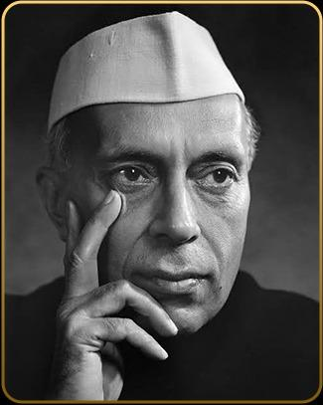  Photo 1 | 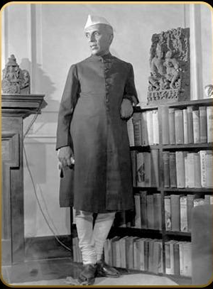  Photo 2 | 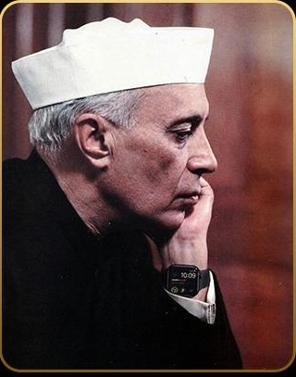  Photo 3
Options: Photo 1 / Photo 2 / Photo 3
Answer: Photo 3
Logic : The photo showcases Jawaharlal Nehru wearing a smartwatch, which did not exist in that era.
60% Sequence
Which figure and letter combination correctly completes the sequence?
Sequence: ▲ A, ● C, ■ E, ▲ G, ● I, ?
Options: B ● / K ■ / L ▲ / Z ■
Answer: K ■
Logic: The pattern alternates between shapes (▲, ●, ■) and increases letters by two (A, C, E, G, I). The next is K ■.
50% Typed answer
A is the father of B. C is the sister of B. What is A's relationship to C?
Answer: Father (A is C's father)
Logic: A is the father of B and C is the sister of B, so A is the father of both.
40% Typed answer
If the first six months of the year are arranged alphabetically, which month comes third in the new order?
Answer: January (April, February, January, ...)
Logic: Arranging April, February, January, June, March, May alphabetically puts January in the third position.
30% Typed answer
If January 1 is Day 1 and December 31 is Day 365, which month contains Day 155?
Answer: June (Day 155 falls on June 4)
Logic: January (31days) + February (28 days) + March (31days) + April (30days) + May (31days) = 151 days. Day 155 falls in June.
20% Image options
One clock is 15 minutes fast, one is 5 minutes slow, one has stopped, and one shows the correct time. Which clock is correct?
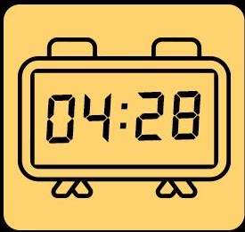  Clock 1 | 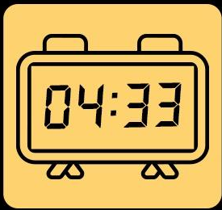  Clock 2 | 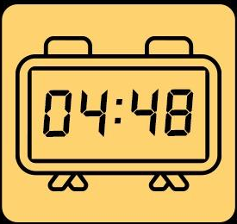  Clock 3 | 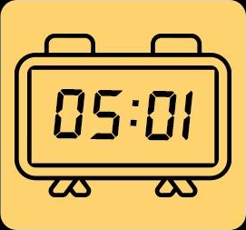  Clock 4
Options: Clock 1 / Clock 2 / Clock 3 / Clock 4
Answer: Clock 2
Logic: As per the conditions given only clock 2 fits the criteria i.e. at 4:33 , 15 minutes ahead is 4:48, five minutes behind is 4:28
10% Word puzzle
A five-letter word is missing from this alphabetical sequence (A to Z). What is it?
Sequence: ABCDEFGIJKLMNPQRSVWXZ
Answer: YOUTH (missing letters: H, O, T, U, Y)
Logic: The missing letters (H, O, T, U, Y) spell "YOUTH".
1% Image + typed
What five-letter common English word comes next in this sequence?

Answer: SCOLD (hot becomes cold; S + COLD)
Logic: Remove the first letter to reveal an opposite (e.g., Yearly becomes Early, Slate becomes Late). The opposite of Hot is Cold; add an 'S' to get the 5 letter word Scold.

Set B
90% Typed answer
The opposite of long is short. What is the opposite of tall?
Answer: Short
Logic : : "Short" is the direct antonym of "Tall" in this context.
80% Image + typed
What is the answer to this question?
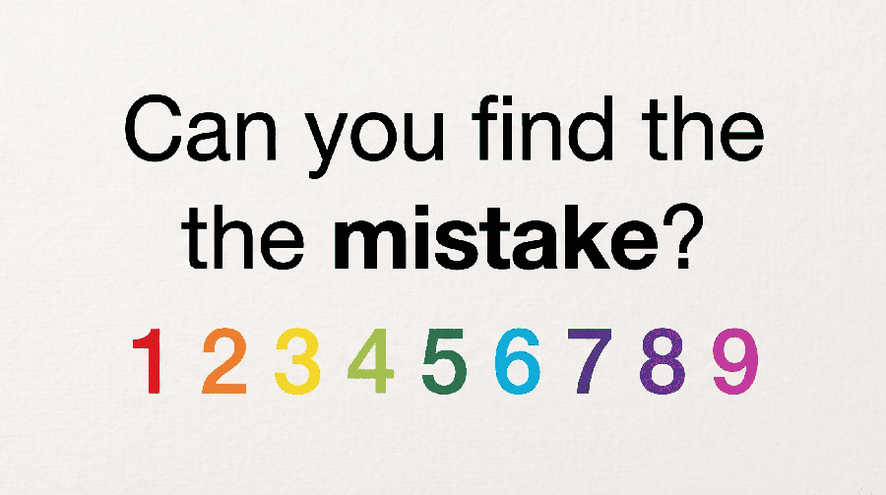
Answer: The word "the" appears twice (the article is doubled)
Logic: The word "the" is written twice in the sentence.
70% Pick the photo
Which photograph of Gandhiji cannot be real?
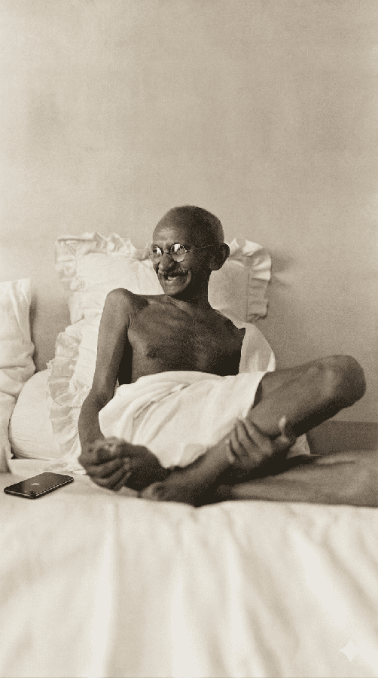  Photo 1 | 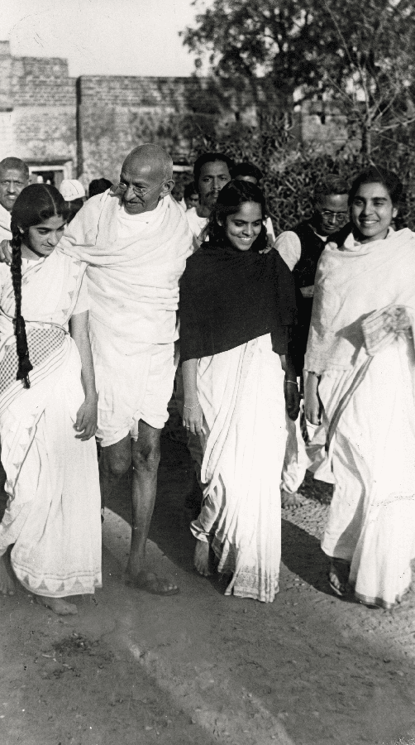  Photo 2 | 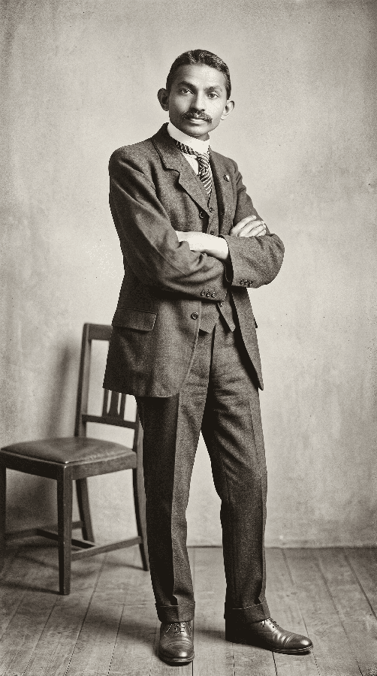  Photo 3
Options: Photo 1 / Photo 2 / Photo 3
Answer: Photo 1
Logic: This photo shows a historical inaccuracy of mobile phones being present at a time during which it didnt ,that identifies it as a fake.
60% Typed answer
What occurs once in a minute, twice in a moment, but never in a thousand years?
Answer: The letter M
Logic: The letter "M" appears once in "minute", twice in "moment", and zero times in "thousand years".
50% Typed answer
A is the father of B. B is the father of C. C is the brother of D. What is D to A?
Answer: Grandchild
Logic: A is the father of B and grandfather of C and D. Therefore, D is the grandchild of A.
40% Typed answer
If the flags of these 5 countries were arranged alphabetically, which country would come last: Australia, England, Ireland, Japan, India?
Answer: Japan
Logic: Alphabetically: Australia, England, India, Ireland, Japan. Japan comes last.
30% Typed answer
If January 1 is Day 1 and December 31 is Day 365, which month contains Day 215?
Answer: August (Day 215 falls on August 3)
Logic: January (31days) + February (28 days) + March (31days) + April (30days) + May (31days) + June (30days) + July(31days) = 212 days. Day 215 falls in August.
20% Image + options
Rohan names his pets with the first letter of the animal, his dog is named Duncan. Which of these is NOT one of his pets' names?
 | 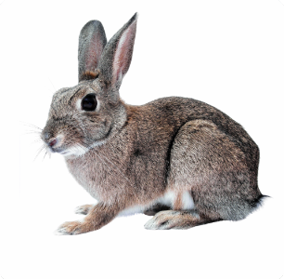 | 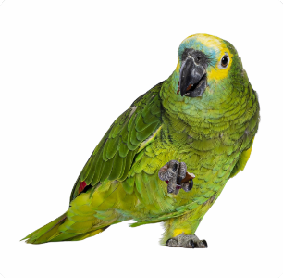 | 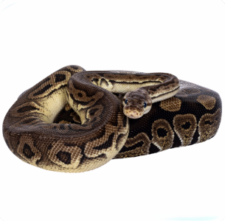 | 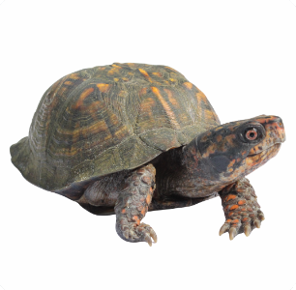
Options: Caesar / Ronit / Pravin / Tina / Navin
Answer: Navin (no pet's animal starts with N: Cat, Rabbit, Parrot, Snake, Tortoise)
Logic: The animals are Cat, Rabbit, Parrot, Snake, Tortoise. None start with N.
10% Word puzzle
A four-letter word is missing from this alphabetical sequence (A to Z). What is it?
Sequence: ABCDEGHIJKLMNPQSTVWXYZ
Answer: FOUR (missing letters: F, O, R, U)
Logic: The missing letters (F, O, R, U) spell "FOUR".
1% Image + typed
Which three letters replace the question marks so that both the blue and the pink underlined parts spell a word?

Answer: UNT (DISCOUNT, UNTANGLED)
Logic: "UNT" completes "DISCOUNT" and "UNTANGLED".

Set C
90% Typed answer
If you are running in a race and you pass the person in second place, what position are you in?
Answer: Second
Logic : If you pass the person in second place, you take their position (second).
80% Flag options
Spot what is wrong, one of these flags doesn't match its country. Which one?
 |  |  |  | 
Options: Ireland / South Africa / India / Australia / Italy
Answer: Australia (its tile shows the wrong flag)
Logic: The flag tile showcases a New Zealand flag that does not match the country name labeled.
70% Pick the photo (no voice-over yet)
Which of these photographs of Nelson Mandela cannot be real?
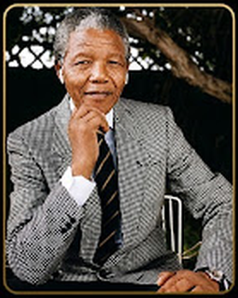  Photo 1 | 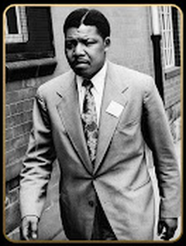  Photo 2 | 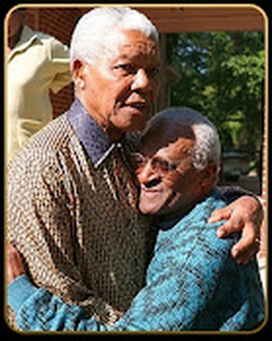  Photo 3
Options: Photo 1 / Photo 2 / Photo 3
Answer: Photo 1
Logic: This image features Nelson Mandela wearing earpods that were not available at that timel.
60% Typed answer
What starts with T, ends with T, and has T in it?
Answer: Teapot (it has "tea" in it)
Logic: The word "Teapot" starts with T, ends with T, and has "tea" (T) inside it.
50% Typed answer
A doctor and a boy were fishing. The boy was the doctor's son, but the doctor was not the boy's father. Who was the doctor?
Answer: His mother
Logic: The doctor is the boy's mother.
40% Sequence
What comes next in this sequence?
Sequence: J F M A M J J ?
Answer: A (the months January to July, so the next is August)
Logic: he sequence lists the first letter of each month (Jan, Feb, Mar, Apr, May, Jun, Jul). The next is August (A).
30% Typed answer
If December 31 is Day 1 and January 1 is Day 365, which month contains Day 215?
Answer: May (Day 215 falls on May 31)
Logic: Counting backward from December 31 (Day 1) to January 1 (Day 365), Day 215 falls in May.

20% Image + typed
Who is holding the left hand of the child who is holding the left hand of the child who is next to a child whose right hand is not held by anyone?
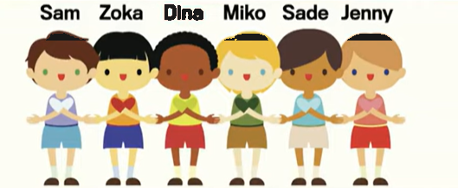
Answer: Dina
Logic: Jenny's right hand is not held by anyone. Her left hand is held by Sade, whose left hand is held by Miko, whose left hand is held by Dina.
10% Word puzzle
A five-letter word is missing from this alphabetical sequence (A to Z). What is it?
Sequence: CDFGHIJKLMNOPQSTUVWXY
Answer: ZEBRA (missing letters: A, B, E, R, Z)
Logic: The missing letters (A, B, E, R, Z) spell "ZEBRA".
1% Image + typed
Surprisingly, there is only one English word that can be made by filling in these blanks so that the finished word has no repeated letters. What is that word?
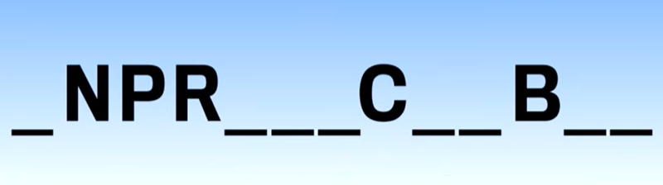
Answer: UNPREDICTABLY (a 13-letter word with no repeated letters)
Logic: Unpredictably" is the word where every letter is unique.

Game audio
Game show audio -
https://drive.google.com/drive/folders/1oGPkVDNpbTN1eB4xF6jzSUefN78qhcKc?usp=sharing

