CS 148 Database Design for the Web

Elizabeth Vine

Assignment Four

Animal Story Blog

Version <1.0>

|  |  |  |  |
| --- | --- | --- | --- |
| Time Log | | | |
| Date | Time Spent (in hours) | Description | Author |
| 10/11/13 | 1.5 | First Version of Software Requirements | Elizabeth Vine |
|  |  | I believe this project will take 25 hours |  |
| 10/13/13 | 2 | Re-designed project. Changed the specs of the project |  |
| 10/15/13 | 1.5 | Creating basic layout. |  |
| 10/17/13 | 1.5 | Playing around with CSS |  |
| 10/20/13 | 5 | Getting the tables to work and such |  |
| 10/23/13 | 5 | Attempting to get php to work |  |
| 10/24/13 | 3.5 | CSS work |  |
| 10/25/13 | 2 | Getting the kinks out in the php |  |
| 10/26/13 | 4.5 | Small but important details  Updated tables  Re-did project specs |  |
| 10/27/13 | 3 | CSS! |  |
|  |  |  |  |
|  |  |  |  |
|  |  |  |  |
|  |  |  |  |
|  |  |  |  |
|  |  |  |  |
|  |  |  |  |
|  |  |  |  |
|  |  |  |  |
|  |  |  |  |
|  |  |  |  |
| Total | 29.5 |  |  |

# Table Of Contents

Software Requirements Specifications 4

Introduction 4

Purpose 4

Definitions, acronyms, and abbreviations 4

Overall Description 5

Data Dictionary 6

E-R Diagram 6

Schema 8

Story Board 9

# Software Requirements Specifications

## Introduction

### Purpose

The purpose of this document is to describe the requirement specification for the web site for the “Animal Story Blog”. This document is to help explain what the website will look like and how the information will be displayed.

### 

### Definitions, acronyms, and abbreviations

HTML – Hypertext markup language – used to define the content.

PHP – Personal Home Page – language that helps to customize html.

CSS – Cascading Style Sheets – used to define the look of a web site.

W3 Validation – refers to both Html and CSS validation tool provided by the W3c.org.

## Overall Description

The blog is going to have a place where users can sign in. Users will receive an email confirmation once they sign in to verify that it was actually them who signed up. Once they have created an account they can then start blogging. The point is to share stories of animals. I am hoping the stories will be cute and fuzzy, just like the animals. The posts will be divided into categories by animals.

### Data Dictionary

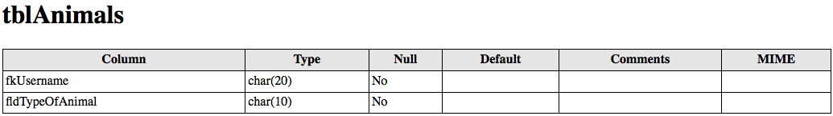

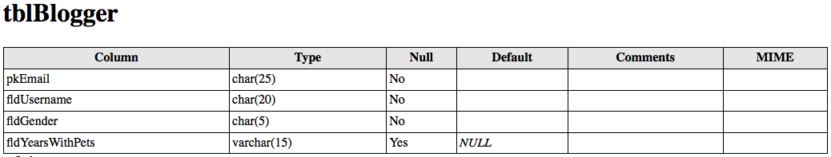

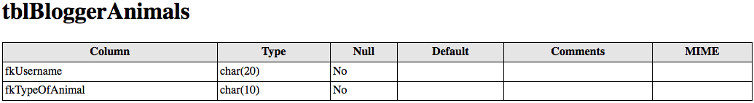

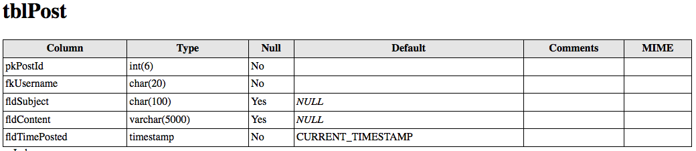

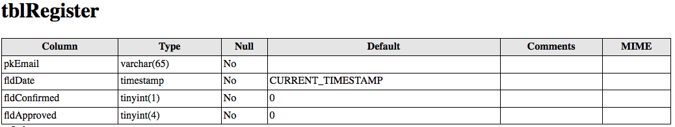

### E-R Diagram

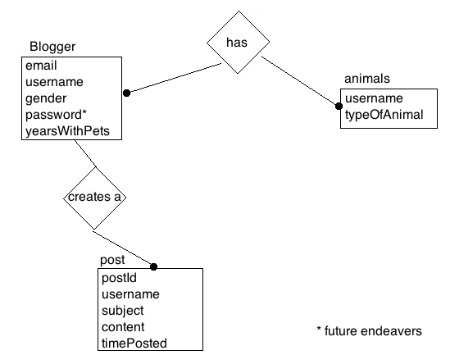

### Schema

CREATE TABLE tblBlogger(

pkEmail CHAR(25) Primary KEY NOT NULL,

fldUsername CHAR(20) NOT NULL,

fldGender CHAR(5) NOT NULL,

fldYearsWithPets VARCHAR(15)

);

CREATE TABLE tblPost(

pkPostId INT(6) PRIMARY KEY NOT NULL AUTO_INCREMENT,

fkUsername CHAR(20) NOT NULL REFERENCES tblBlogger(fldUsername),

fldSubject CHAR(100),

fldContent VARCHAR(5000),

fldTimePosted TIMESTAMP NOT NULL

);

CREATE TABLE tblAnimals(

fkUsername CHAR(20) NOT NULL REFERENCES tblBlogger(fldUsername),

fldTypeOfAnimal CHAR(10) NOT NULL

);

CREATE TABLE tblBloggerAnimals (

fkUsername CHAR(20) NOT NULL REFERENCES tblBlogger(fldUsername),

fkTypeOfAnimal CHAR(10) NOT NULL REFERENCES tblAnimals(fldTypeOfAnimal),

PRIMARY KEY(fkUsername, fkTypeOfAnimal)

);

CREATE TABLE tblRegister (

pkEmail VARCHAR(65) PRIMARY KEY NOT NULL,

fldDateJoined timestamp NOT NULL DEFAULT CURRENT_TIMESTAMP,

fldConfirmed tinyint(1) NOT NULL DEFAULT '0',

fldApproved tinyint(4) NOT NULL DEFAULT '0'

);

### Story Board

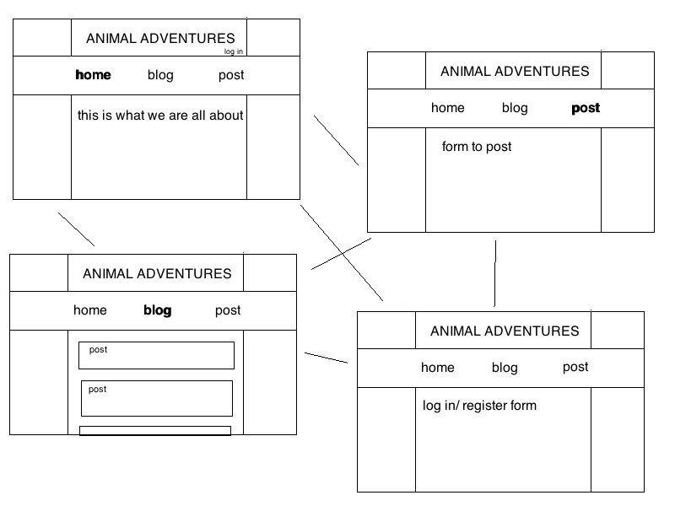

### Specific Requirements

Below is a list of requirements for the project:

1. Location- all of the files will be in the public folder.
2. HTML Validation- all pages will pass W3C HTML 5 validation.
3. CSS Validation- all pages will pass W3C 3.0 CSS validation.
4. Meta Information- all pages will have the proper meta tags.
5. CSS- all pages will have linked style sheets.
6. Navigation- all pages will contain navigation using an ordered list.
7. Content- each page will contain a minimum of 150 words, not counting title, lists, or links.
8. Browser compatibility- the site will be checked on Firefox, Safari, Chrome, and Internet Explorer
9. File names- the home page will be called home.php with the rest of the file names up to you.
10. Registration- saves log-in information and tells you if you left anything blank. Sent an email confirmation.
11. Blog posts- Use a form to post information