Motion Controller and Odometry Interface for the RCV

Develop a useful and easy to use interface that will allow the RCV to be used reliably and easily through ROS. A simple diagram of the expected outcome is as follows:
RCV
Onboard System

Odometry
Vehicle Info
Path Requests
ROS Messages

Trajectory Tracking Controller

Trajectory Tracking Controller

The Trajectory Tracking Controller will be able to receive trajectory requests and will be responsible for following them. In order to make the system reusable and useful for different purposes, the trajectory requests can come in the following ways:
- An trajectory, i.e., a set of states with an associated time;
- An path with a fixed velocity;
- A GPS trajectory, with an associated time;
- A GPS path with a fixed velocity;

Benefits:
Providing a controller that will follow given paths. Emphasys will be put in simplifying as much as possible its use. For that purpose there will be well defined interfaces, allowing the users to send commands in the way they are more comfortable with, either GPS coordinates or Cartesian coordinates. Cartesian coordinates are often a cause of trouble due to ambiguous definitions of its referentials. The system will also provide simple ways to use and define different referentials (as examples see figures 1 and 2).
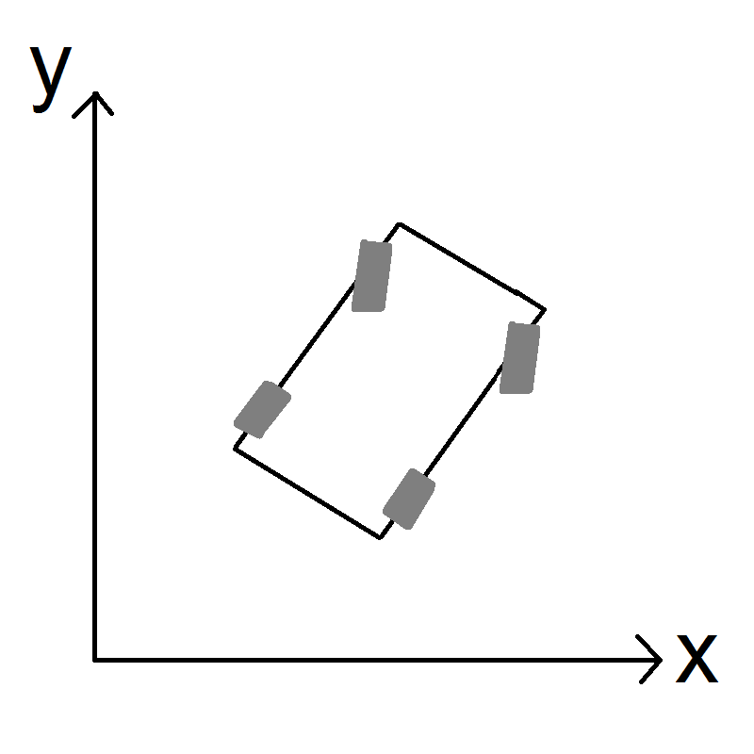
Figure 1 Fixed Referential
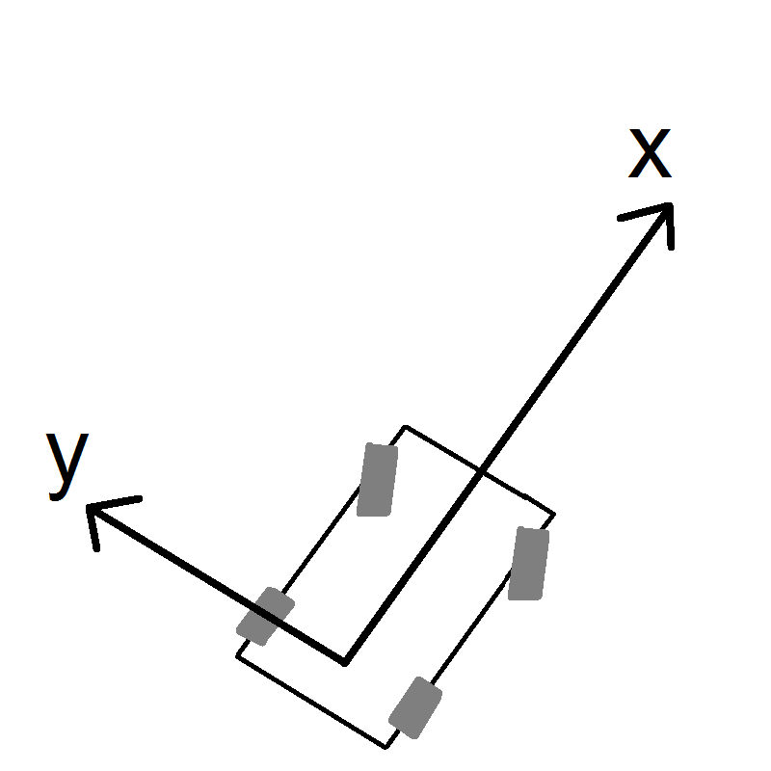
Figure 2 Local (moving) Referential

Risks:
Ideally the Controller will be implemented by a Master Thesis Student, if that fails, an alternative controller will have to be developed from scratch.

Assumptions:
The given path is feasible, otherwise the controller will safely handle it (warning and/or stopping).

Lane Keeping
If possible (or required), a lane keeping command can also be implemented. This will make use of the Lane Tracking camera that will be implemented in the RCV. Very high level commands can then be sent to the controller:
- Keep on lane with a fixed velocity or fixed acceleration
- Change to a different lane
- More complicated commands, such as those happening in intersections

Benefits:
Providing a simple and robust controller to drive in well behaved (nice lane markings) roads.

Risks:
The camera system still has to be tested, and its performance evaluated.

Error Handling
If possible a Radar will be integrated and will serve as a safety check, overriding desired path in case they conflict with the radar readings.

Odometry
A simple odometry/Information system will also be implemented, it will be responsible from broadcasting general information about the car such as its position and velocities.
Not much state estimation effort will be put into it, it will simply make use of the existing GPS/IMU to generate odometry information.
The generated odometry will be processed and displayed in a simple way to the user, and be consistent with the desired coordinate system.
Typical sources of errors will be shown to the user (battery check, etc…)

