SDW1 2017 Spring Semester Project

**Web Game - Whac A Mole**

**System Design Specification (SDS)**

**Version 6.0**

**2017.05.04**

Zhenghao Wu (l630003054)

Guozhen Wang (l630003048)

Xianggao Gu (l630003015)

**Computer Science and Technology Program**

**United International College**

1. Document Change Log

|  |  |  |  |
| --- | --- | --- | --- |
| ***Change Date*** | ***Changed By*** | ***Version*** | ***Change Description*** |
| *02/24/2017* | *Zhenghao Wu* | *Beta 1.0* | *Prepared Document* |
| *03/11/2017* | *Zhenghao Wu* | *Beta 2.0* | *Add Basic Frame* |
| *03/17/2017* | *Xianggao Gu* | *Beta 2.5* | *Content modification* |
| *03/18/2017* | *Zhenghao Wu* | *3.0* | *Finish content* |
| *03/18/2017* | *Xianggao Gu* | *4.0* | *Finish all information* |
| *04/20/2017* | *Zhenghao Wu* | *5.0* | *Change Standard and Tools* |
| *05/04/2017* | *Zhenghao Wu* | *6.0* | *Change Game Description / Change Test Procedure* |
|  |  |  |  |
|  |  |  |  |
|  |  |  |  |

1. Table of Contents

1. Document Change Log 2

2. Table of Contents 3

3. Overview 4

3.1. Purpose 4

3.2. Software Target Customer 4

3.3. Aim 4

4. Tools and Standards 5

4.1. Tools 5

4.2. Standards 5

5. System Design 6

5.1. Game Description 6

5.2. Interface Design 6

5.3. Event Diagram 8

6. Test Procedure 9

6.1. Special Requirements 9

6.2. Steps 9

1. Overview

## Purpose

This is a web game called ‘Whac A Mole’ written by HTML/CSS/JavaScript. In this game, players should hit as many moles as they can to get scores. We will record and show players’ scores at the end of game.

## Software Target Customer

This is a casual game for gamers of all ages.

## Aim

* Train player's response speed
* Relaxing and entreating

1. Tools and Standards

## Tools

* *HTML & HTML5*
* *CSS & CSS 3*
* *JavaScript*
* *Bootstrap (V4.0.0 Alpha 6)*
* *jQuery*
* *PHP*

## Standards

* Testing on latest stable version of Google Chrome browser (56.0.2924.87 (64-bit) or later).
* Using *HTML & HTML5* Standard.
* Using UTF-8 encoding Standard.

1. System Design

## Game Description

* After All elements loaded in this page, a login page will pop up and request player to input their name. Player can also play anonymously.
* ‘Game icon’ is on the upper left corner of the game interface. The icon will link to this page.
  + There are three buttons on the right of the icon. They are ‘PLAY’, ‘HELP’, ‘EXIT’.
  + After clicking ‘PLAY’ button, the moles will show and countdown begins. At the same time, the ’PLAY’ button will be changed into ‘RESET’.
  + After clicking ‘HELP’ button, there will be a floating window which can be closed. The introduction about the game will be there.
  + After clicking ‘EXIT’ button, a window will prompt and ask player whether to leave. If player confirms to leave, the web page will jump into UIC official website.
* There are nine holes under the icon. No use in clicking before the game start.
* ‘TIMER’, ‘SCORE’, ‘NUMBER OF STRIKES’ are under the buttons.
  + ‘TIMER’ records the remaining time of the game, and when the remaining time is 0, game over.
  + ‘SCORE’ displays player’s current score. The initial score is 0. Every successfully hit at mole will lead score plus 1. A bad mole will Random pop-up. If you click on it, score will minus 1.
  + ‘NUMBER OF STRIKES’ will plus 1 if you click the mole hole during the game time.
  + If your score reaches zero because clicked the bad mole, game will over.
* Copyright information and group information are on the bottom right corner of the page.
* At the end of the game, there will be a window showing the final score and the occurrence number of mole. And allow player upload their score to a global database.

## Interface Design

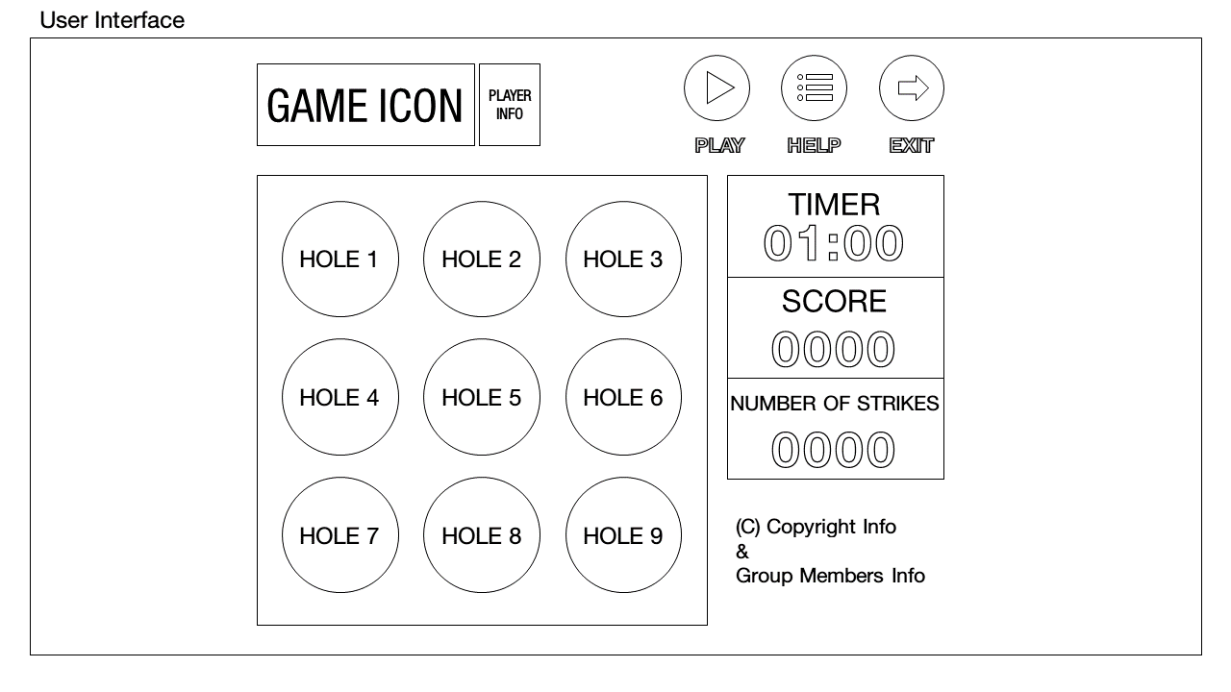

|  |  |  |  |  |
| --- | --- | --- | --- | --- |
| Class | Element Name | Element ID/Class | Attributes | Value |
| body | body | body | Font-family | "Segoe UI", Roboto, "Helvetica Neue", Arial, sans-serif; |
| Heading Area | Heading container | title | Margin/padding | 0 20% |
| Button Group | Play & Reset Button | startBtn | Width/Height | 50px/50px |
| Help Button | helpModal | Width/Height | 50px/50px |
| Exit Button | exitModal | Width/Height | 50px/50px |
| Hole Area | container | holerow | margin | 15px auto |
|  |  | margin | 15px auto |
| Mole Hole | holei | Shape/width | Square/ 33.3% of the holerow |
|  |  | margin | 10px |
| Info Area | Timer | displayTimer | width | 20% of the container |
| timertitle |  | Align/Font-size | center/25px |
| time | InfoTimerTime | Font-size | 45px |
|  |  | padding | 10px 30px 10px 30px |
| Scores | displayScore | Align/Font-size | center/25px |
| scoretitle |  | Font-size | 45px |
| Score |  | padding | 10px 30px 10px 30px |
| Number of strikes | displayStrikes | Align/Font-size | center/25px |
|  |  | Font-size | 45px |
| Copyright Area | Copyright info | card-blockquote | Align | left |

Resources

|  |  |
| --- | --- |
| Name | about |
| 0.png | A normal mole hole |
| 1.png | mole hole with a hittable mole |
| 2.png | a distortion mole |
| 3.png | mole hole with a “bad mole” |

## Event Diagram

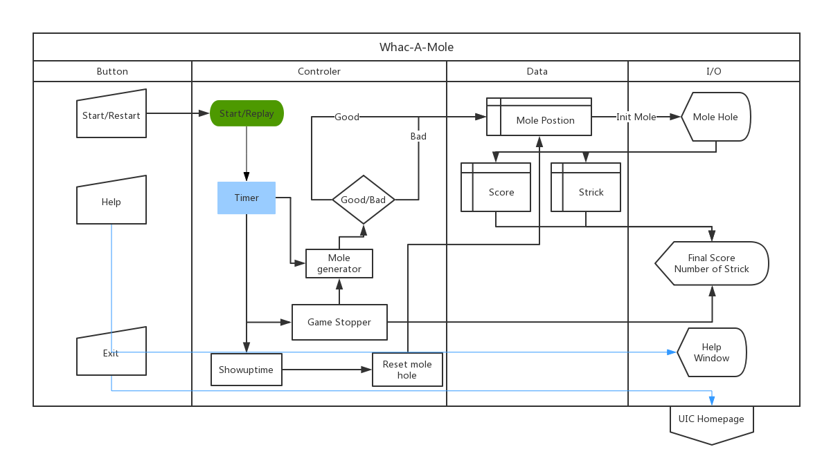

1. Test Procedure

## Special Requirements

* *Manual*
* *Test environment:*
  + *Google Chrome browser (56.0.2924.87 (64-bit) or later).*
  + *UTF-8 Encoding Browser*

## Steps

* Syntax test
  + There is no error alert in the Chrome Developer Tools console.
* Browser test
  + Make sure all elements can be shown regularly.
  + All hyperlinks can link to scheduled website.
  + “Start Reset” “Help” and “Exit” buttons can work.
    - ‘Help’ window can be closed
    - Exit button will be linked to UIC Homepage
  + Timer can work
  + Each time there are three moles appear.
  + Number of Strikes counter will plus one if you click once.
  + When you hit the mole, the Score counter will increase 1.
  + Non-hit mole will disappear after “show-up-time” occurs.
  + When bad mole was hit by the user, scores will decrease 1.
    - When scores reach to 0. Game Over.
  + When countdown ends. Game Over
    - Score and Number of Strike window will pop up.
  + Score and Number of Strike window and user’s info can be normally upload.
  + When you click ‘Reset’. The game will be initialized.