**Gym Management System**

**System Design Specification (SDS)**

**Version 1.0**

**2018/4/22**

Zhenghao Wu (1630003054)

Qizhou Xie (1630003056)

**Computer Science and Technology Program**

**United International College**

1. Document Change Log

|  |  |  |  |
| --- | --- | --- | --- |
| ***Change Date*** | ***Changed By*** | ***Version*** | ***Change Description*** |
| 2018/4/22 | Zhenghao Wu | 1.0 | Prepared Document |
| 2018/4/23 | Qizhou Xie | 2.0 | Write Design Overview |
| 2018/4/25 | Zhenghao Wu | 3.0 | Defined Tools and Standards |
| 2018/4/26 | Zhenghao Wu | 4.0 | Update User Interface Design and Descriptions |
| 2018/4/26 | Qizhou Xie | 5.0 | Add Entities Relationship Diagram |
| 2018/4/27 | Zhenghao Wu | 6.0 | Add Control Flow Diagrams |
|  |  |  |  |
|  |  |  |  |
|  |  |  |  |
|  |  |  |  |

1. Table of Contents

1. Document Change Log 2

2. Table of Contents 3

3. Design Overview 7

4. Tools and Standards 8

4.1. Tools 8

4.2. Standards 8

5. User Interface Design 9

5.1. Login Page 9

5.2. Dashboard 9

5.3. Navigation Bar & Footer 10

5.4. Check-in 11

5.5. Recharge 11

5.6. Record 12

5.7. Make New Appointment 13

5.8. Balance Report 13

5.9. Create Member 14

5.10. Create Coach 14

5.11. User Info 15

6. Database Design 16

7. Diagrams 17

1. Design Overview
2. Purpose:

* The purpose of this system is to provide an online platform for customers to make appointment with the coach and at the time they want. First customers need to ask staffs to create accounts for them, after requiring their account, they can make recharges through the Internet via WeChat Pay or Alipay, or they can recharge on the counter. Once it’s confirmed, staffs will help in modifying the quota. Customers are able to make appointments online and search for coaches’ information.

1. Target customers:

* Our system is made to help in reducing customers’ time waste and make staffs manage the gymnasium in an efficient way. Also it provide a platform for coaches to show their strengths.

1. Aim:

* To help in reducing customers’ time waste while making appointments and to provide a platform for them to gain coaches’ information.
* To manage the gymnasiums in an efficient way.

1. Tools and Standards

## Tools

* HTML 5
* CSS 3
* JavaScript
* jQuery
* Bootstrap 4.1
* Tabler 0.0.32
* Python 3.6
* Django 2.0
* MySQL/Maria DB

## Standards

* Testing on latest stable version of Google Chrome browser (66.0.3359.117 (64-bit) or later) and Mozilla Firefox browser (59.0.2 (64-bit) or later), no longer support IE 8 / IE 9.
* Using HTML5 Standard.
* Using UTF-8 encoding Standard.

1. User Interface Design

## Login Page

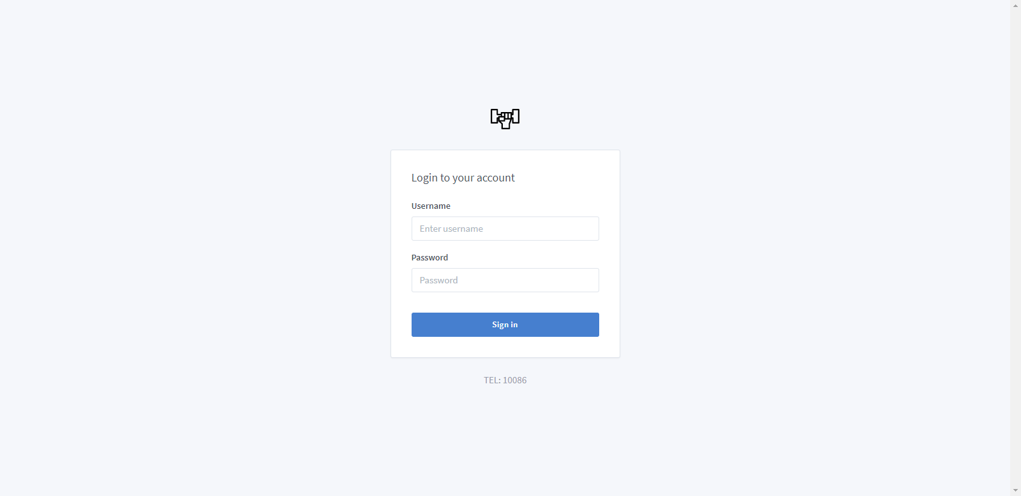

Figure 1Login page

此页面为登陆页面，页面上会显示一个有用户名，密码填写区域的表单和一个提交表单的按钮，密码填写区域会用“*”号代替输入内容。

## Dashboard

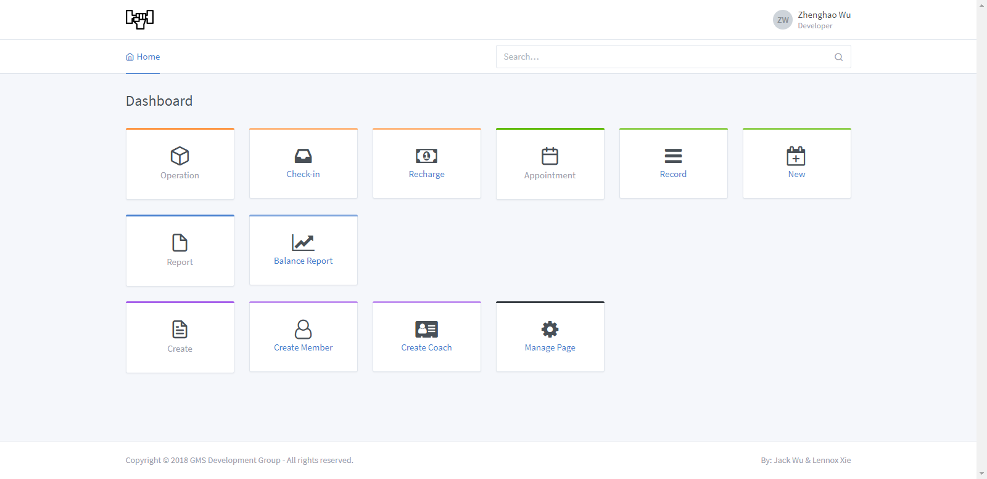

Figure Dashboard Page

用户登陆Dashboard后，页面上会展示当前用户所有能使用的功能（开发者，员工能访问所有功能；会员能访问Operation的Recharge和Appointment下的所有功能；教练只能使用Appointment 功能），点击这些功能链接即可访问对应功能。

## Navigation Bar & Footer

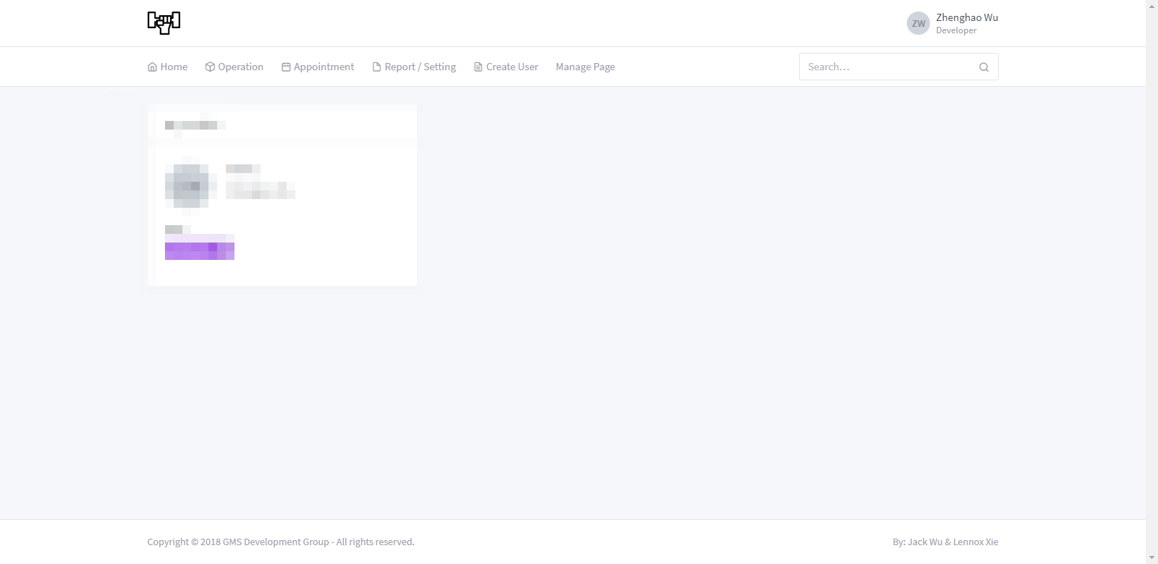

Figure Navigation Bar & Footer Design

Navigation Bar 与 Footer 在每一页中的样式都基本相同。最左上角显示系统Logo，右侧显示目前登陆用户的相关信息，单击用户头像，即可看到个人资料按钮和退出登陆按钮，点击退出登陆按钮，即可结束当前用户的登陆状态。Navigation Bar还提供了分类过的功能菜单和搜索栏，点击即可进入对应功能页。

Footer显示版权信息和作者。

## Check-in

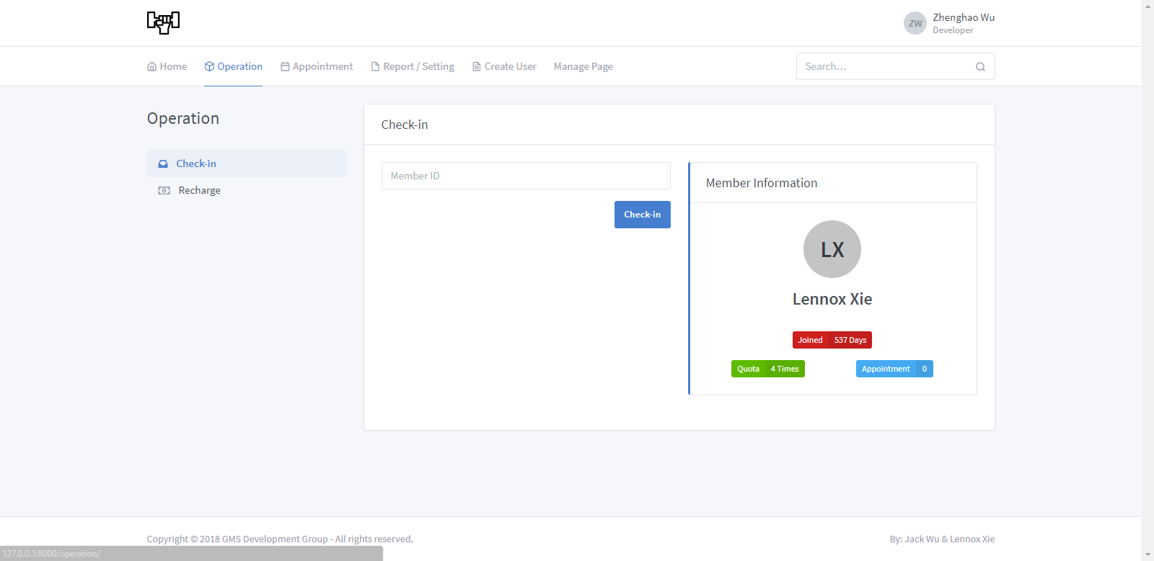

Figure Check-in page

本页面只允许登录后的员工访问，用于Check-in会员并减少会员账户中的Quota数量，页面上有一个输入框，输入用户ID后，右侧Member Information栏会在输入用户存在的前提下，显示用户相应的信息。点击Check-in后，会弹出成功Check-in的提示框，然后刷新并重新加载Check-in页面

## Recharge

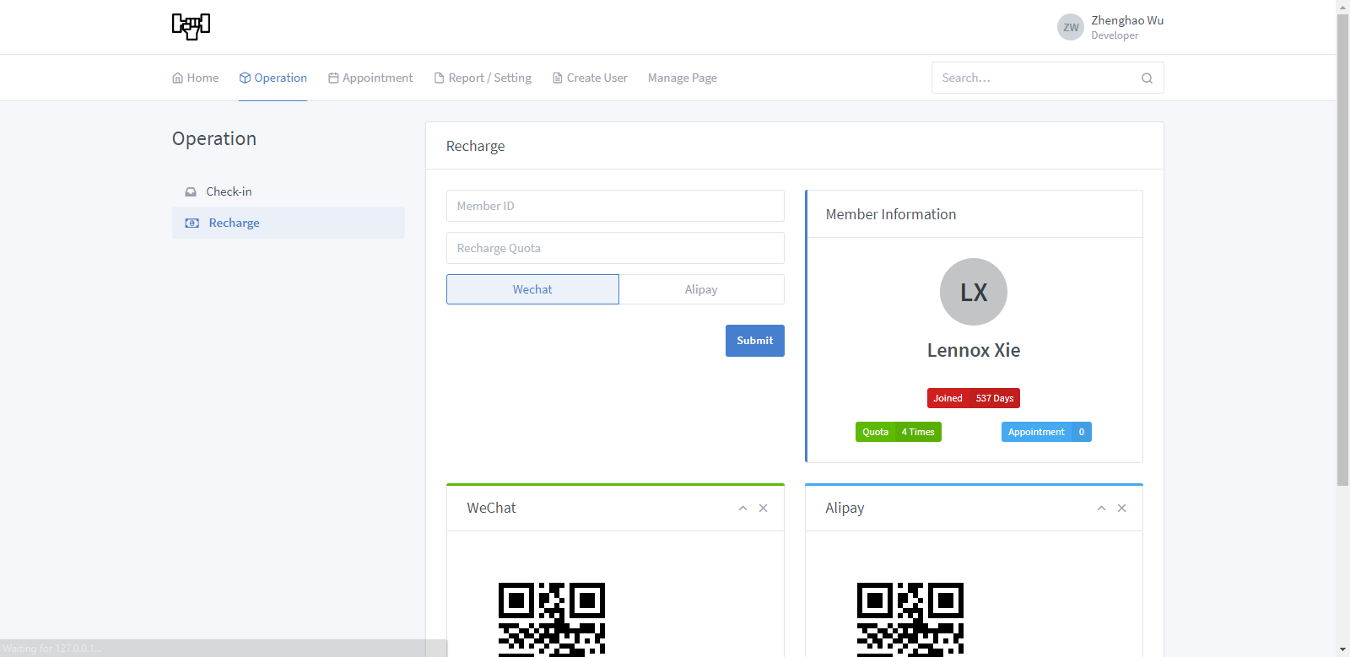

Figure Recharge Page

登陆后的会员和员工可以登陆Recharge页面，页面中会显示充值信息的表单，上面有Member ID, Recharge Quota, Payment Method 的选择区域。右侧Member Information栏会在输入用户存在的前提下，显示用户相应的信息。当信息填写完整且正确后，页面会弹出一个Pop Window，并显示需要转账的金额，转账二维码（根据用户选择的支付方式显示），和剩余转账时间，和一个已转账的按钮。

当转账结束（成功或失败），页面会自动刷新并重新加载Recharge页面。

## Record

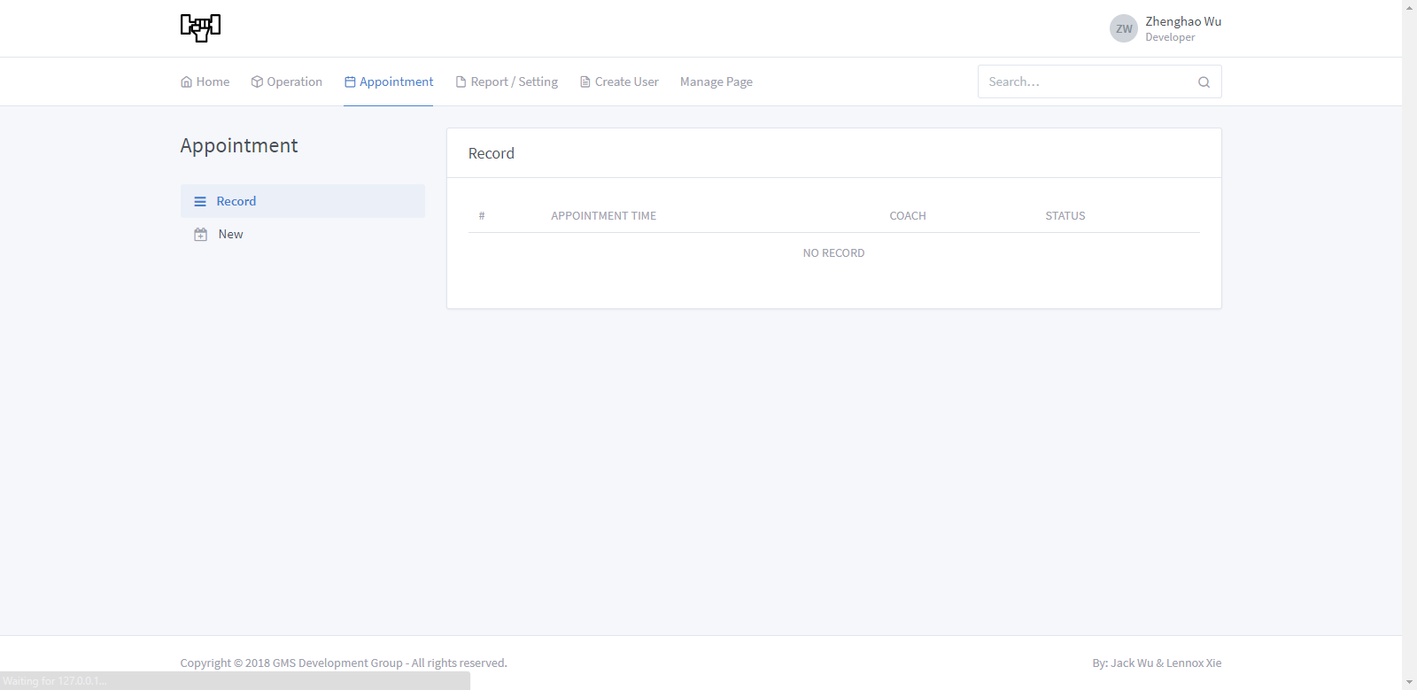

Figure Appointment Records Page

此页面可以被所有登陆后的用户浏览；会员能查询自己与教练的预约；教练能查询与自己有关的预约；员工能看到所有的预约记录。

## Make New Appointment

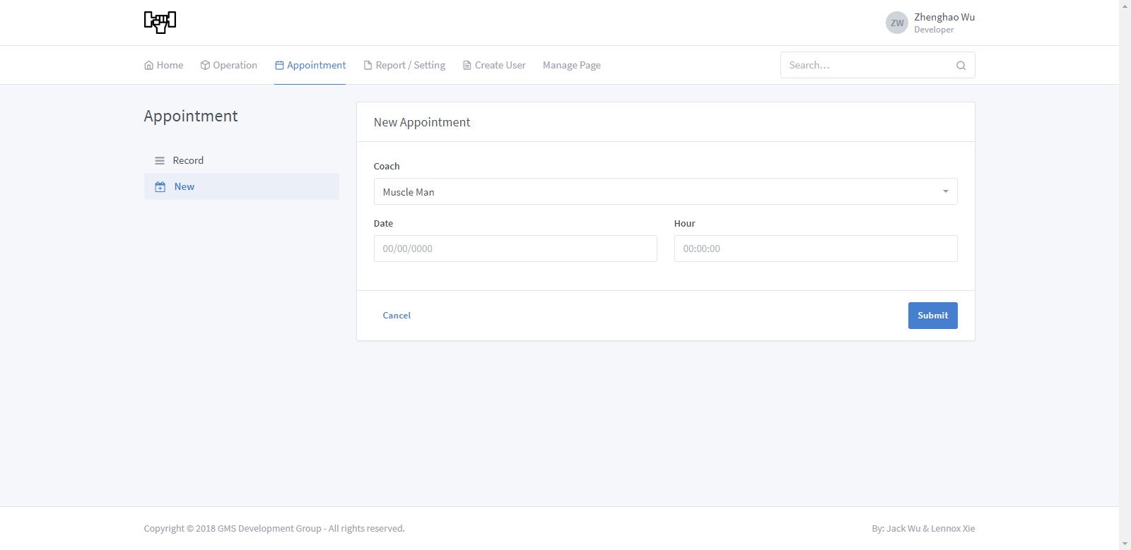

Figure Make New Appointment Page

当前页面可以由登陆后的会员和员工浏览，页面上会显示一个表单，表单上有教练的下拉菜单和填写日期时间的表单框格，用户点击submit后即可提交申请。

## Balance Report

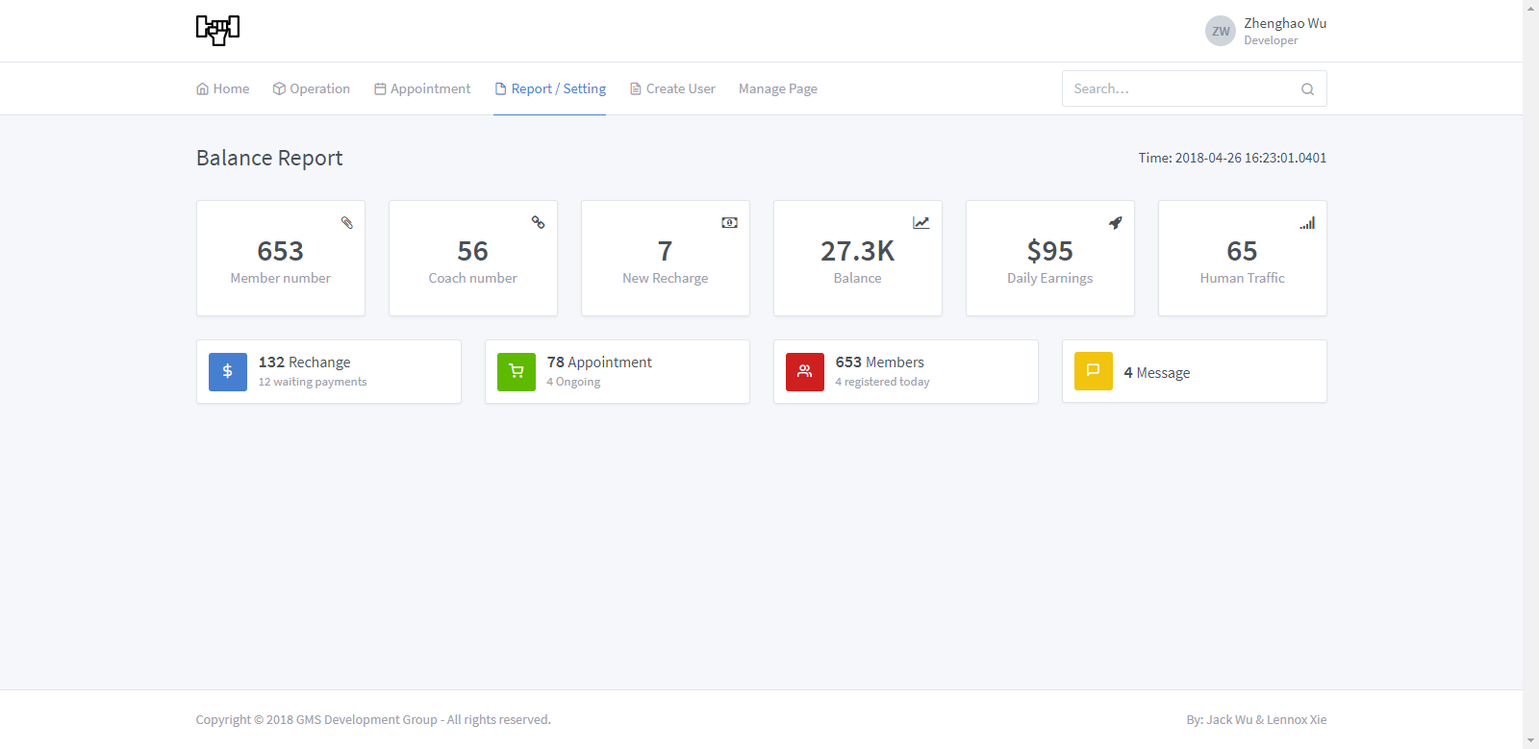

Figure 8 Balance Report

此页面只允许登陆后的员工浏览，页面上会用数字的形式展示一些事项的变化或状态，右上角会显示页面创建的时间，方便员工打印时留下时间戳。

## Create Member

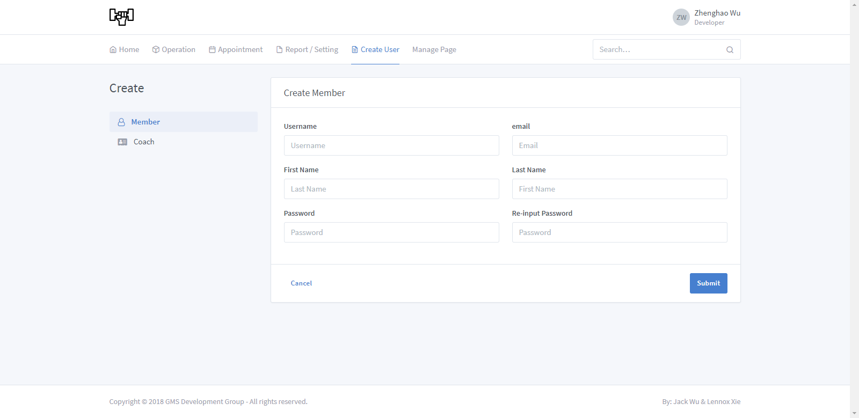

Figure Create Member Page

此页面只允许登录后的员工访问，里面会显示一个创建会员的表单，表单需要填入的字段有：用户名，邮箱，姓氏，名字，密码，第二次要求输入密码。本表单所有字段都必须正确填写，并会在点击Submit时验证内容有效性。如果认证不通过，则不允许提交表单。

## Create Coach

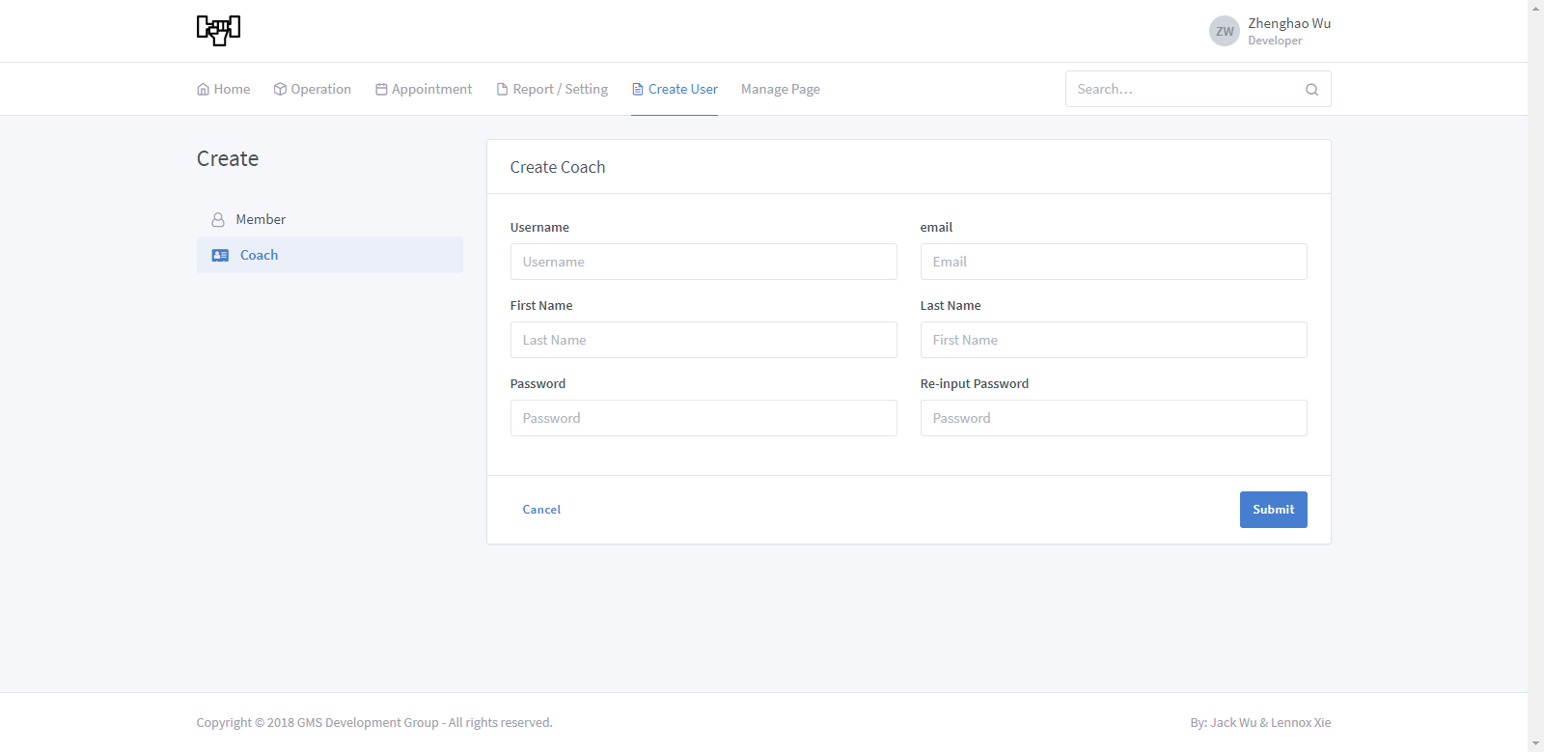

Figure Create Coach Page

此页面只允许登录后的员工访问，里面会显示一个创建教练的表单，表单需要填入的字段有：用户名，邮箱，姓氏，名字，密码，第二次要求输入密码。本表单所有字段都必须正确填写，并会在点击Submit时验证内容有效性。如果认证不通过，则不允许提交表单。

## User Info

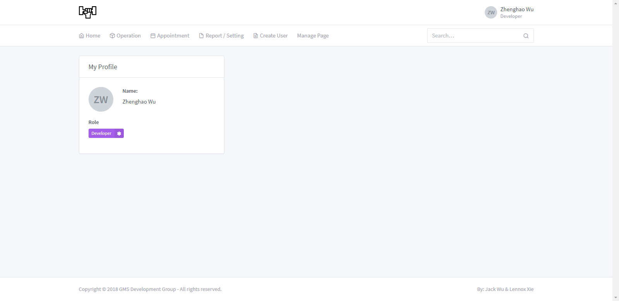

Figure User Info Page

本页面会显示当前用户的个人信息，包括姓名，角色。如果当前用户是一个会员，则还会显示会员的会员卡信息（Quota，Appointment）。

1. Database Design

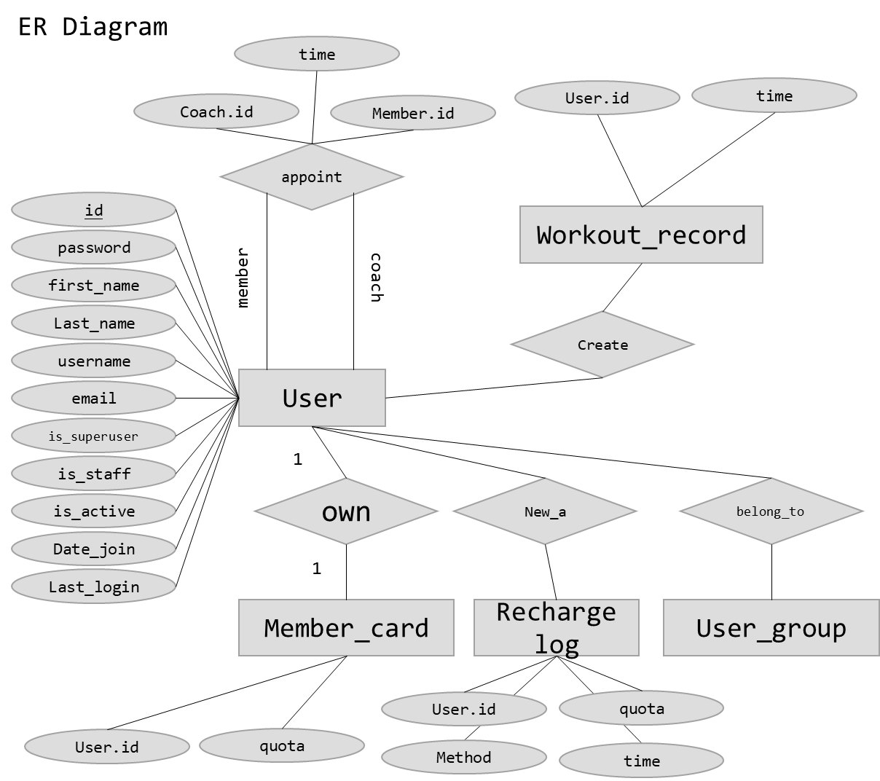

Figure ER diagram for Gym Management System

1. Diagrams

## 

Figure User Authentication Control Flow diagram

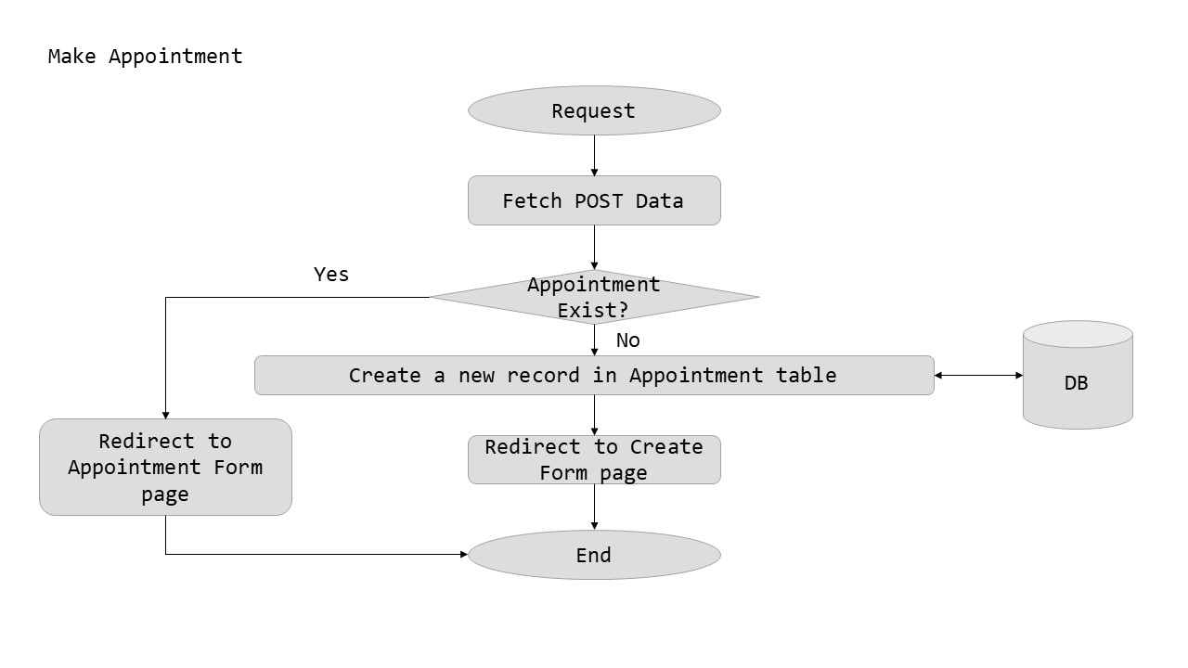

Figure Appointment Control Flow diagram

## 

Figure Recharge Control Flow diagram

## 

Figure Recharge Verify Control Flow diagram

## 

Figure Check - in Control Flow diagram

## 

Figure Control Flow diagram for Page render / Search / records display / Information display

## 

Figure Create Member / Coach Control Flow diagram