The GMS System Database Documentation

Group 5 | Zhenghao Wu (1630003054) & Qizhou Xie (1630003056)

# Project description

## Purpose

The purpose of this system is to provide an online platform for customers to make appointment with the coach and at the time they want. We think it will be a good way in saving customers’ time, and it can also help in manage the gymnasium in a more efficient way.

## Functionalities

At the very beginning, customers need to ask staffs to help them to create an account for them. Once the account is created, a member card is created automatically, it will store the customer’s ID and remaining quotas. With the account created for them, customers are able to login to make use of the functionalities of the system. First they will need to login, it’s impossible for them to use the system before login. Second they will need to recharge quotas via AliPay or WeChat Pay, after their recharge, they can now make an appointment with the coach they want. Before they enter the gymnasium, staffs will help them check-in and quota of that account will deduct by one. Also, when the appointment is done, customer and the appointed coach can browse their appointment history in the website. Besides creating customers account, staffs can also create account for coaches. Coach are users who can only view their appointment history, they cannot make new appointments. What’s more, staffs can confirm customers’ recharge, once the payment is confirmed quotas will be added to the account.

## User Interface

### Login Page

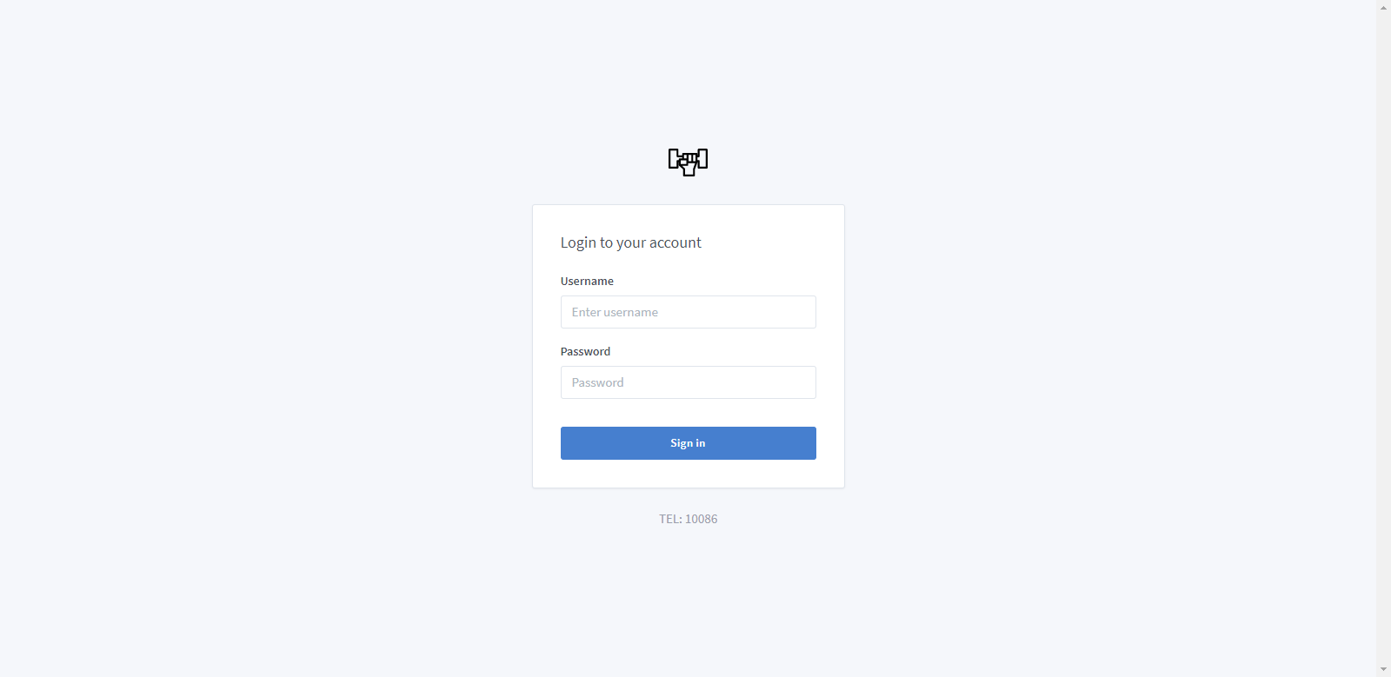

### Dashboard

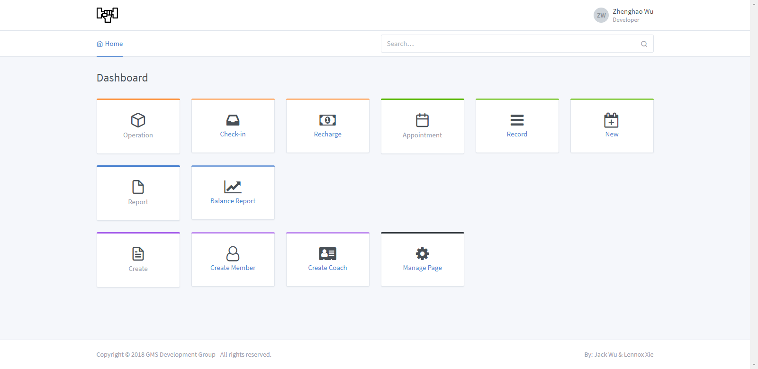

### Navigation Bar & Footer

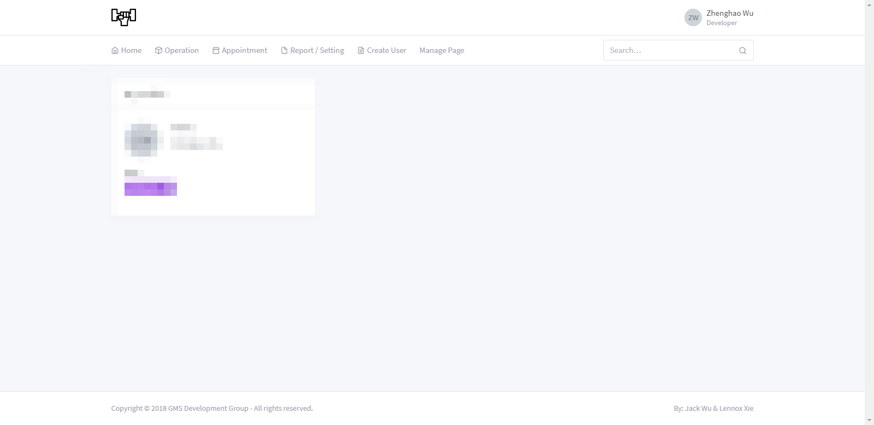

### Check-in

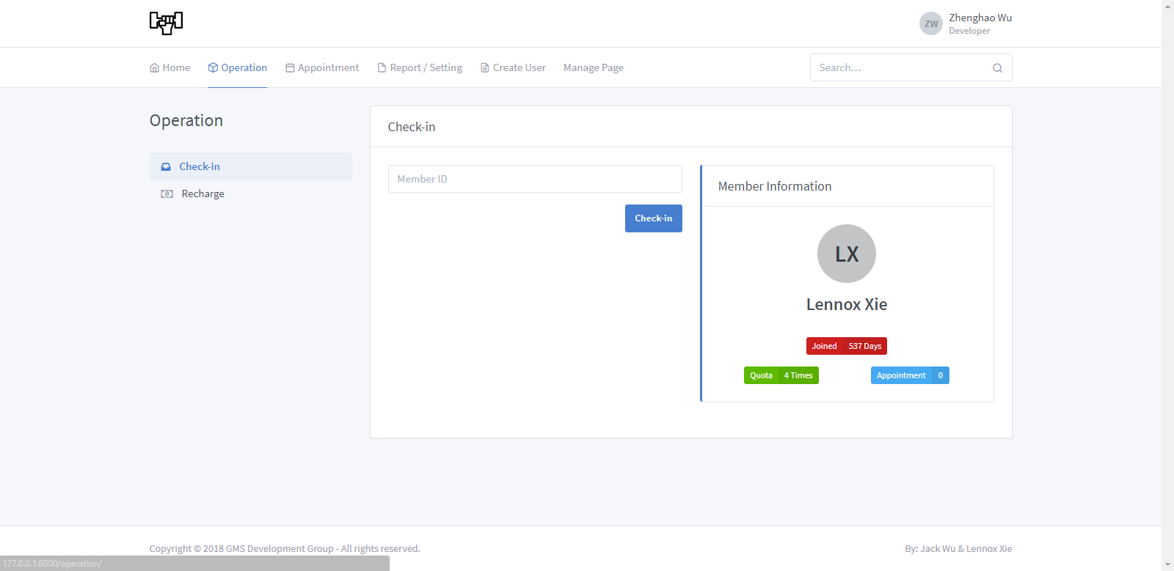

### Recharge

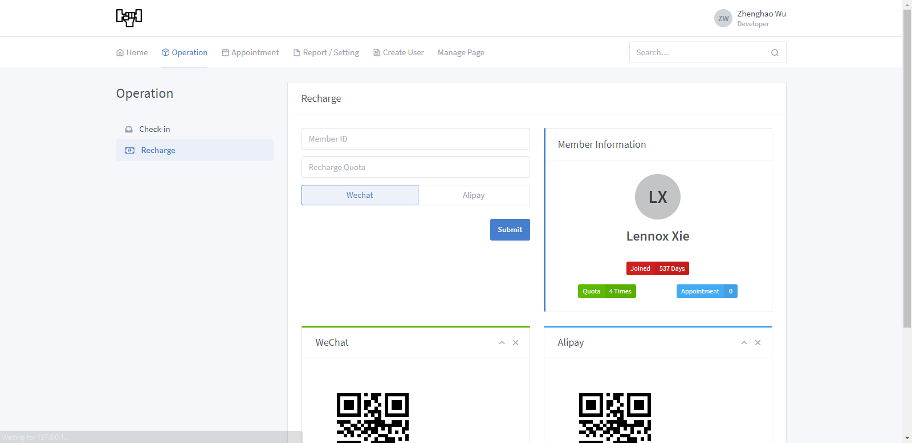

### Record

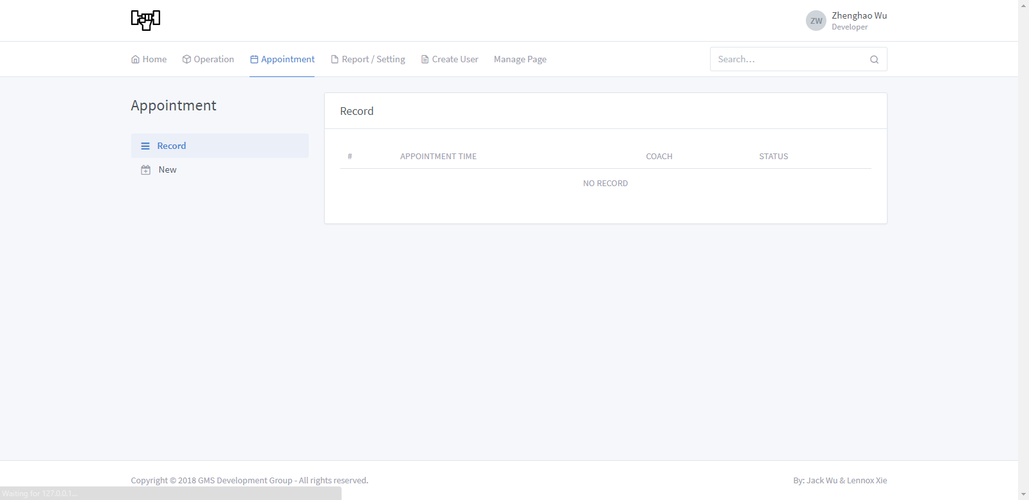

### Make New Appointment

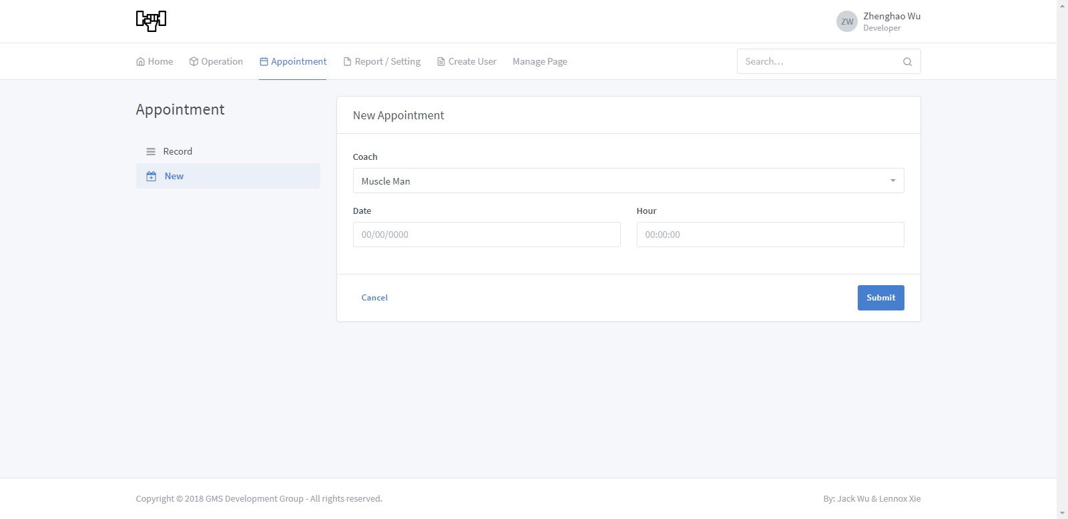

### Balance Report

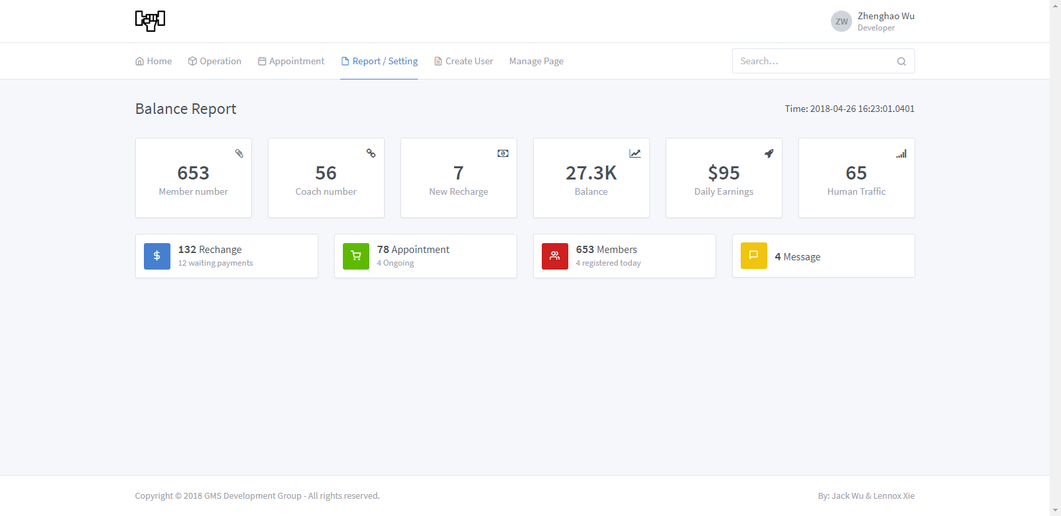

### Create Member

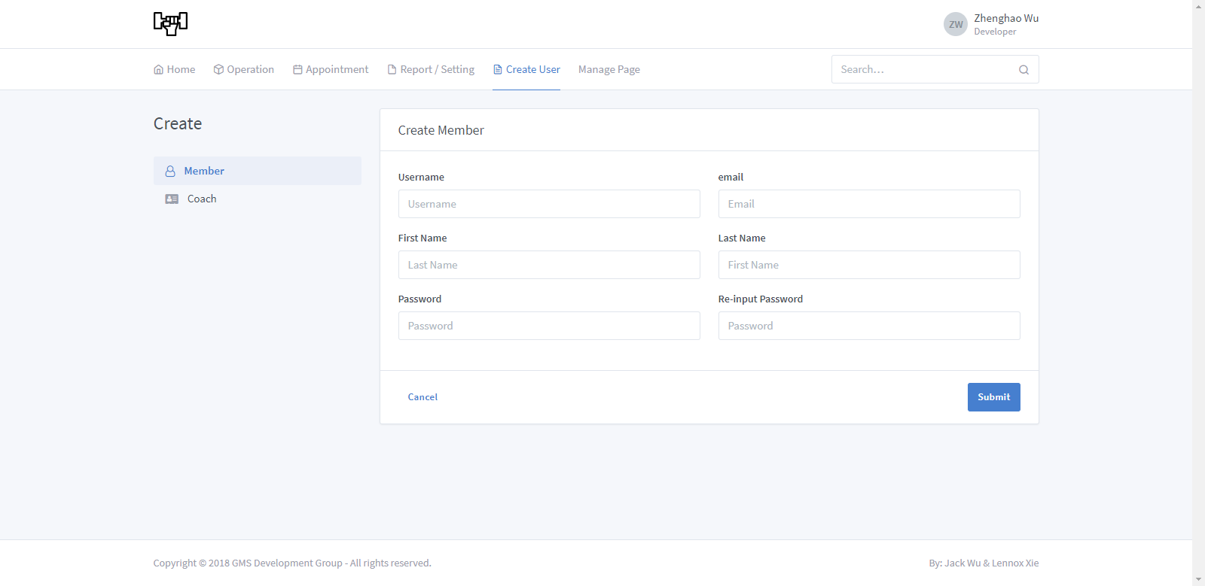

### Create Coach

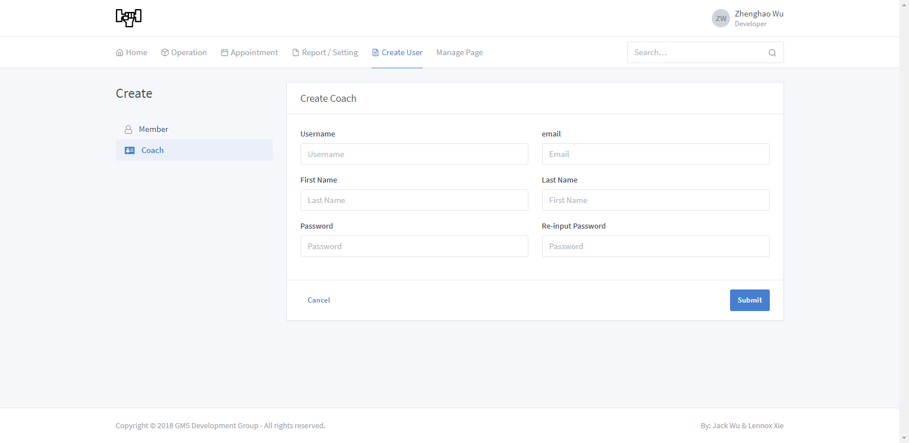

### User Info

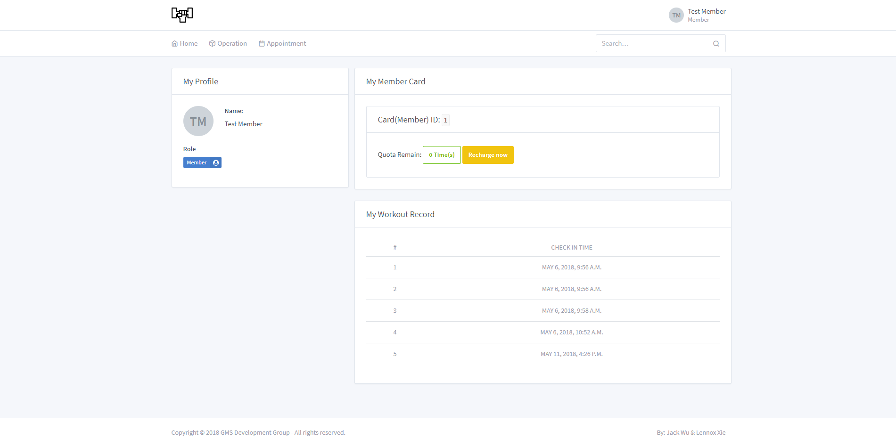

# ER Diagram

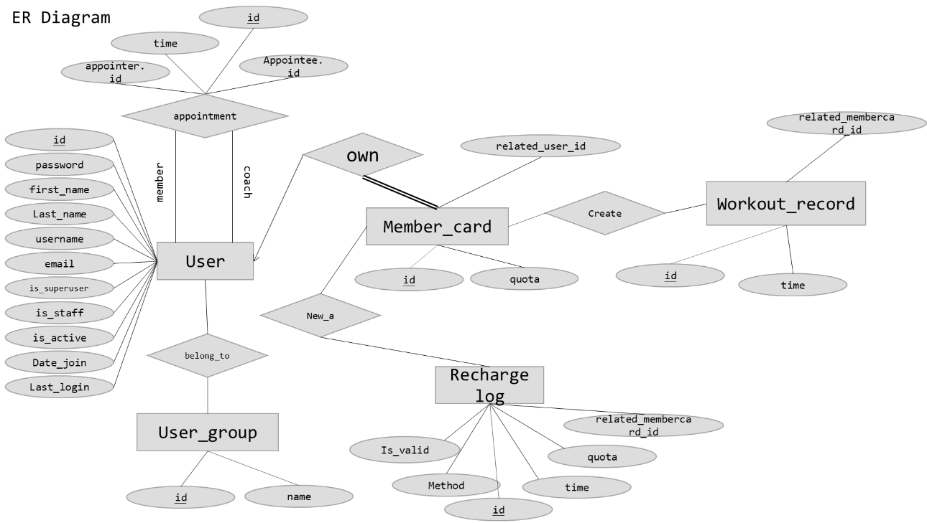

# Assumption of our system

* We allow multiple users join in the system, each of them is identified by user_id.
* Each member of the system is only allowed to have one member-card, it’s also identified by user_id, accounts without member-card are not allowed to recharge, for example, coaches are not allowed to recharge, each recharge is identified by recharge_id.
* Customers are only allowed to make appointments at the time between 9:00 to 12:00 and 14:00 to 21:00, each appointment is identified by appointment_id.
* Customers and the coach they appoint can only browse the history related to themselves, staffs can browse all appointment history.
* All user can search for other users’ information.
* Customers’ must have remaining quotas in their account before making appointment.

# Workload of each member

Zhenghao Wu (50%)

* Database Design
* Create Test Data
* Database deploy & backup

Qizhou Xie (50%)

* Database Design
* Draw the ER diagram
* Database Connection

# Functional dependencies

## auth_user

id -> password, last_login, is_superuser, username, first_name, last_name, email, is_staff, is_active, date_joined

## auth_group

id -> name

## auth_user_groups

id -> user_id, group_id

## dashboard_membercard

id -> quota, related_user_id

## operation_workoutrecord

id -> check_in_time, related_member_card_id

## operation_rechargelog

id -> quota, recharge_time, recharge_method, related_member_card_id, is_valid

## appointment_appointment

id -> appoint_time_date, appoint_time_hour, create_time, appointee_id, appointer_id

# Metadata

## appointment_appointment

* Order the data descending according to appoint_time_date, then order the data increasing according to appoint_time_hour.

## operation_rechargelog

* Order the data descending according to recharge_time