Software Requirements Specification

for

Gym Management System

Version 1.0

Prepared by Zhenghao Wu & Qizhou Xie

GMS Studio (Team 5)

April 2, 2018

1. Table of Contents

1. Table of Contents 2

2. Introduction 3

2.1. Purpose 3

2.2. Document Conventions 3

3. System Features 4

3.1. Login 4

3.2. Recharge Quota 4

4. External Interface Requirements 5

4.1. User Interfaces 5

4.2. Hardware Interfaces 6

4.3. Communications Interfaces 6

5. Other Nonfunctional Requirements 7

5.1. Performance Requirements 7

5.2. Security Requirements 7

5.3. Software Quality Attributes 7

1. Introduction

## Purpose

The purpose of this document is to show the detail description of the Gym Management System. It will talk about the feature of the system (what the system can do for customers), the interface of the system, the constraints under which it must operate and how the system will react to external stimuli. This document is intended for both the stakeholders and the developers of the system and will be proposed to the Supervisor of Software Development Workshop II’s Group Project for approval.

## Document Conventions

This document will be written using only one font, Arial for main content and titles. Main content’s font size should be in 12pt.

1. System Features

## Login

### Description and Priority

Because the system does not allow registration, and all functions need to be logged in before allowing use.

The three roles in the system (Member, Worker, Coach) have login privileges.

### Stimulus/Response Sequences

* When a not login user accesses the system, a login window is displayed on the page
* The user enters the account password and clicks the login button
* Server verified the account and the password
* If correct: open login session, return to the menu page

### Functional Requirements

* Require database Inquiry
* If the username & the password don’t match or don’t exist: return error message, stay on the current page.

## Recharge Quota

### Description and Priority

Members can recharge quota through the online payment platform (WeChat Pay and Alipay), After the user recharges, the quota is added to the user account after being manually confirmed by the staff. The staff can also manually modify the quota for the member.

### Stimulus/Response Sequences

* The user enters the recharge page via the button
* The button selection will be displayed on the page (select the recharge platform used)
* The system will display a recharge QR code and confirm button according to the selection. The user transfers the amount by himself and recharges according to the need.
* After the user confirms, the system will record the relevant information of this recharge behavior and wait for the staff to confirm manually.
* Quota added to user account after manual confirmation

### Functional Requirements

* Require database Inquiry
* After display of the QR code, User have to complete the transfer and confirm within 180 seconds.

## Make Appointment

### Description and Priority

Members can make an appointment with the coach. The staff can also make appointment for the member.

### Stimulus/Response Sequences

* The user enters the appointment page via the button
* The page will show the coach information who is available in the last three days. The user can also use the full list to find a familiar coach to make an appointment.
* Clicking into the coach's page will show the coach's relevant information and available time.
* The user can select the time period by the pull-down menu. After the confirmation bottom is pressed, the pop-up window will ask the user to confirm the time again.
* After confirmation, data entry database.

### Functional Requirements

* Require database Inquiry
* Each user can only make two appointments at the same time

## Operations

### Description and Priority

This function is used for the daily operation of gyms, members come to exercise, and staff help member to check-in. System will automatically record the information and deduce Quota.

### Stimulus/Response Sequences

* The user enters the Operations page via the button
* An input box and Check-in button appear on the page.
* Enter the member's account and click the Check-in button.
* Member's information will be displayed, A double check window will pop up.
* After confirmation, Quota reduced, data entry database.

### Functional Requirements

* Require database Inquiry

## Create New User

### Description and Priority

Employees can add accounts for new coaches and members.

### Stimulus/Response Sequences

* The user enters the Create page via the button
* A form will be displayed, including new user types, user names, user IDs, user passwords, and other related information.
* Each time the information is completed and the input box loses focus, JS verifies the input information (Involves communicating with the server through AJAX).
* After all the required information is correct, the submit button will be displayed.
* After submission, the user is created and stored in the database.

### Functional Requirements

* Require database Inquiry
* jQuery for AJAX

1. External Interface Requirements

## User Interfaces

All the User interfaces are done with CSS framework Bootstrap v4.0.0, and Dashboard UI kit Tabler (Bootstrap based).

If you need to access any function in the system, you must log in, and the login page does not provide a registration window.

After login, the user will automatically jump to the main page. The page will display related content and functions according to the user's identity.

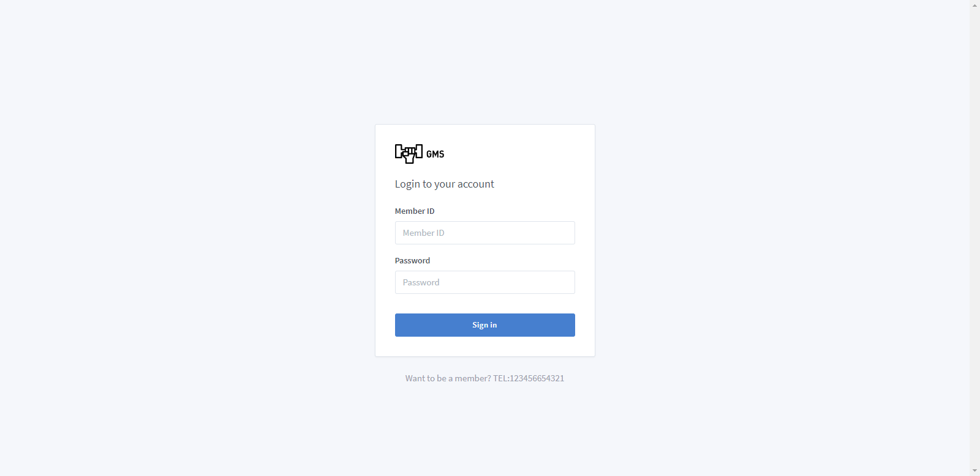

Figure 1GMS Login Page

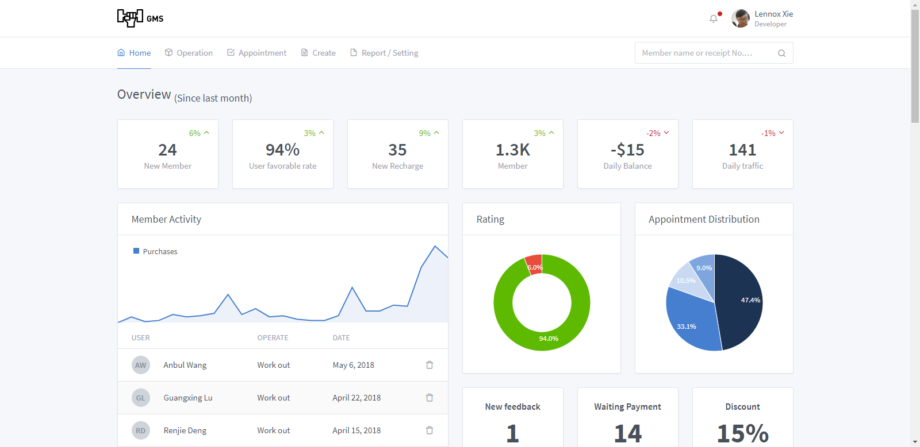

Figure 2 GMS Dashboard Page (Homepage)

## Hardware Interfaces

Because the development of the backend relies on the framework Django (2.0+), all of the following conditions must be met to run this program:

Local Environmental dependence:

* Python 3.6.4 running under 32-bit or 64-bit

If you want to deploy it to VPS, extra dependences are required:

* uWSGI 2.0 (PyPy need extra plugins)
* XAMPP for Database (MariaDB or MySQL) environment
* Nginx or Apache for Forward traffic

## Communications Interfaces

During the testing phase, all features will be tested in Google Chrome (65.0.3325.181(64-bit) or later) and Firefox (58.0.2 (64-bit) or later).

After the program is deployed, all traffic should be encrypted by HTTPS. When running locally, do not enable port mapping to ensure data security.

1. Other Nonfunctional Requirements

## Performance Requirements

Within the scope of server processing capabilities, all requests should react accurately and the order of execution should be scheduled in the order in which the requests are delivered.

## Security Requirements

* All user passwords need SHA256 encryption
* Forms and AJAX Asynchronous Requests Pass POST
* Save User Information Change Log

## Software Quality Attributes

Front-end:

* All content and information are correctly displayed and encoded properly. All links need to be properly connected to the specified location.

Back-end:

* All front-end requests need to be properly received, responded, and processed. The data changes should be accurate.