1. Introduction

Issue tracker is a web application that can handle and track issues.

1.1 Purpose

You can manage issue activities from start to end. Users with specific permissions can manage these issues.

1.2 Intended Audience

Managers.

1.3 Intended Use

Users and managers.

1.4 Scope

-better, more organized issue management  
-ability to get up to date information

1.5 Definitions and Acronyms

Once this system is used, it will be difficult afterwards to handle issues if the system is down.

2. Overall Description

This will be a new system implementation.

2.1 User Needs

agent: who works on the issue  
manager: who monitors the issues

2.2 Assumptions and Dependencies

3. System Features and Requirements

3.1 Functional Requirements

-Security: login and authentication

-Database:   
 repository method: Hibernate  
 DB name: issue_tracker_db  
 User DB

-CRUD functions

-Nice UI

-GIT

3.2 External Interface Requirements

3.3 System Features

Server side code: Spring Boot  
Back end server: capable of running JavaSE-1.8  
Client side resources: JavaScript, Bootstrap 4

3.4 Nonfunctional Requirements

TDT (Test Driven Development)

Roadmap

1. Login page, authentication on auth0, store token

2. Test environment

3. Database

4. Tickets page

The following improvements were made using this issue tracker by creating tickets and resolving them:

* add status field to ticket
* ticket update function
* insert logged in user name automatically
* delete ticket function
* select status from radio buttons
* ticket activities
* sign-in sign-out button
* user not displayed
* fix navbar
* dashboard
* admin page
* rearrange ticket fields
* show signed in user in navbar
* ticket search
* in ticket view change delete ticket to close ticket
* delete ticket page redirect
* inactivate fields in closed ticket
* correct admin sort
* ticket head fixed
* are you sure to delete? function
* admin modify ticket
* dark mode
* close ticket confirmation
* save dark mode to user profile
* correct tables in dark mode
* add dark mode to ticket open view
* go back to the same window scroll position
* format ticket number
* bottom screen notification adjust
* title accepts minimum characters
* make sort ascending, descending; show status
* move notifications from bottom screen
* add created, updated fields
* add filters by last week, last 30 days etc, by status
* correct search with INC - show only ID results
* split screen for more than 50 results
* keep query parameters after ticket view
* correct admin page
* add/remove table columns
* user selection from list
* correct responsive navbar
* dashboard ticket links
* add updated column
* make title removable
* resizable table columns

Screen shots

Home screen

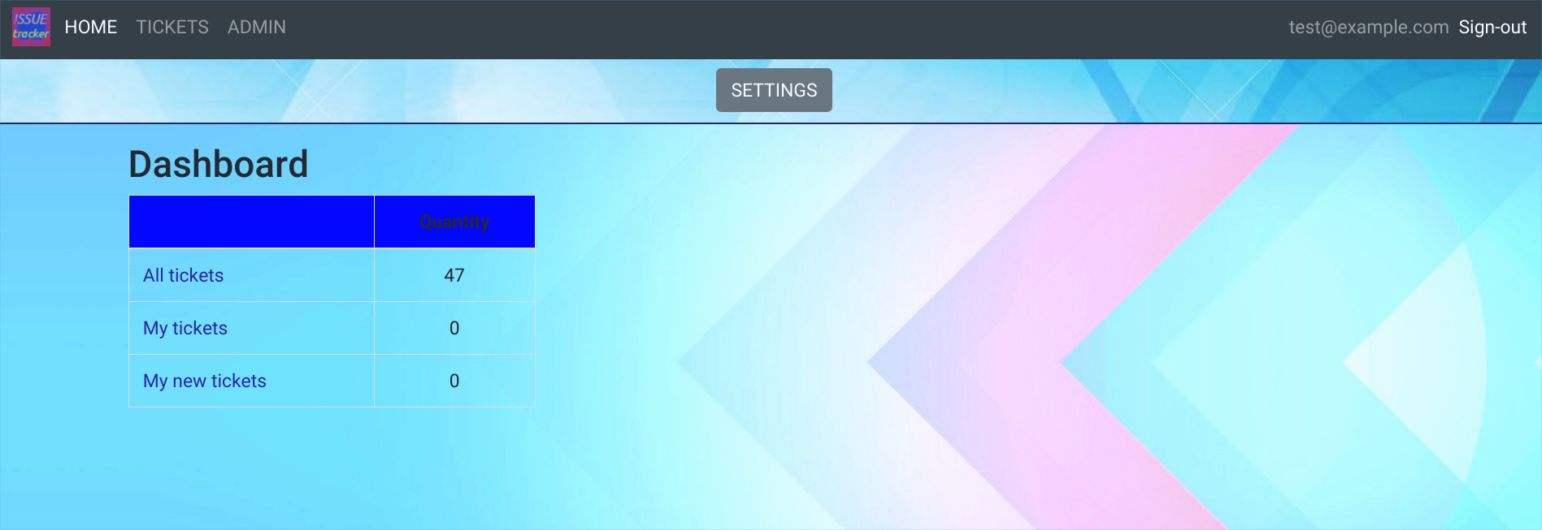

Tickets list

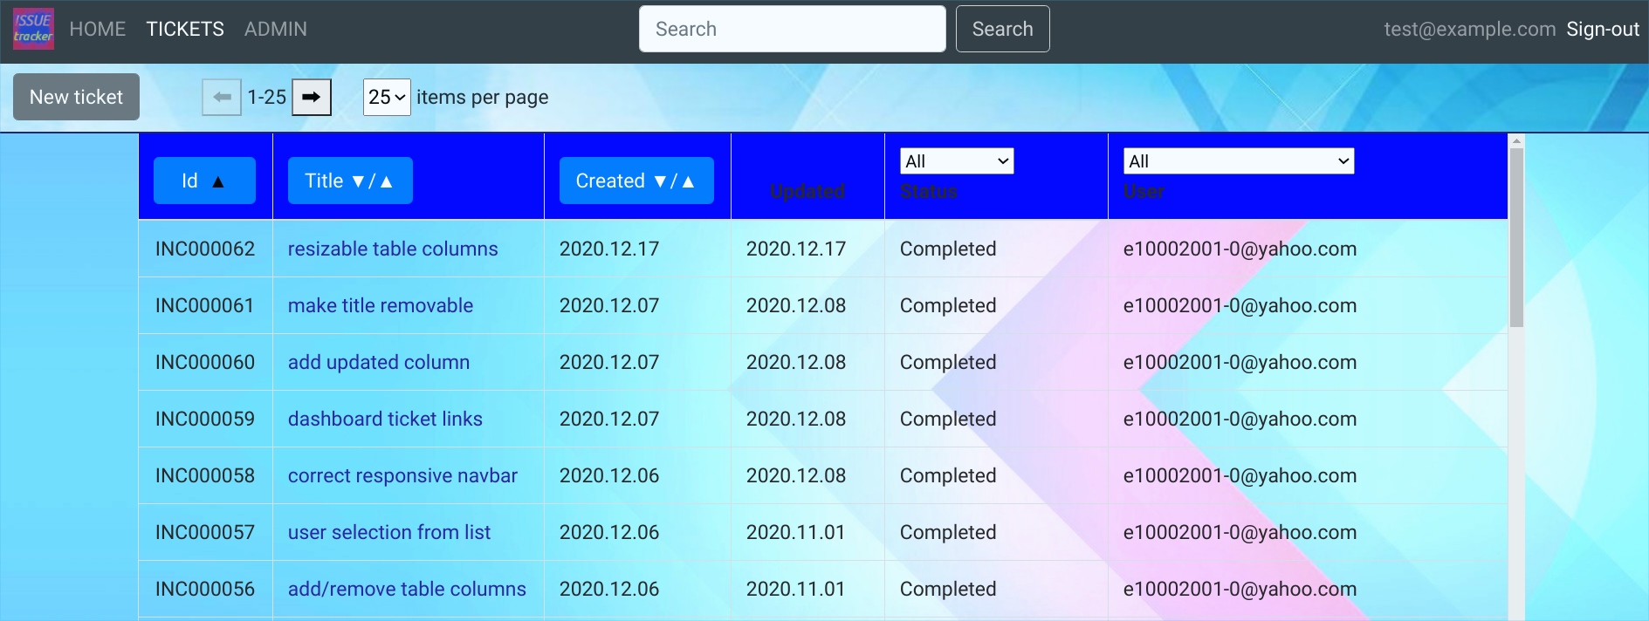

Update ticket

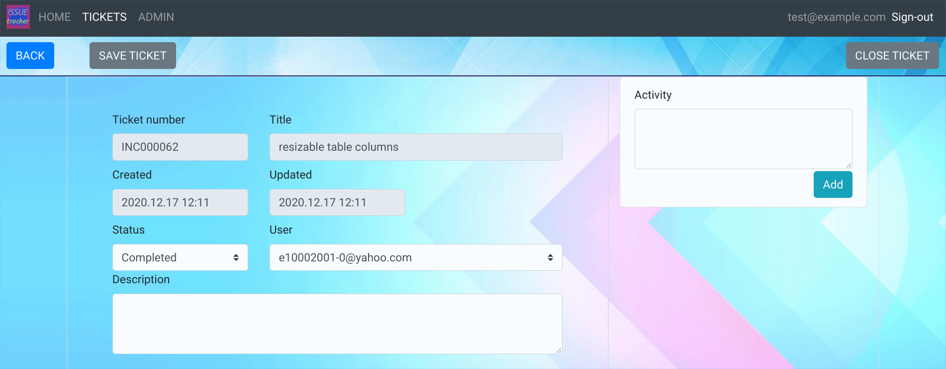

Admin page

