Standardisation of Sporadic Temperature Data from the late 18th and early 19th Century

C. S. Morrell

Armagh Observatory, College Hill, Armagh BT61 9DG, Northern Ireland, U.K.

Abstract

Standardising the Armagh temperature records and filling in the gap in this temperature series gives Armagh a continuous temperature series from 1795 to the present day. This is one of the longest running temperature series from a single site in the UK and Ireland and is valuable in modelling climate change and predicting the climate changes in the future. Some of the possible explanations for climate change are solar activity, enhanced green house effect, volcanic eruption and the chaos theory.
Contents

- Introduction

- Theory

  - Maximum, Minimum and Mean Temperature at Armagh Observatory
  - The Sun-Climate Link
  - Other Effects on Climate

- Air Temperature Records at Armagh Observatory

  - External ‘Spot’ Temperature Records at Armagh Observatory
  - Hourly Temperatures from the Automatic Weather Station at Armagh Observatory
  - Sporadic Temperature at Dunsink Observatory

- Analysis of Data and Programming

- Discussion

  - Mean Temperatures at Armagh Observatory
  - Comparison of the Armagh Temperature Series with the Central England and Eastern United State Series
  - The Variation in the Mean Temperature at Armagh and the Possible Link to Solar Activity

- Conclusion

Acknowledgements

References

1. Introduction

Armagh Observatory (longitude 6˚38.9’W and latitude 54˚21.2’N) is situated in the south of Northern Ireland. The observatory is on a 14-acre site at an altitude of 64 m above the mean sea level and 20m above the surrounding valleys. The Atlantic Ocean lies approximately 100 Km West and the Irish Sea 50-km East. Valleys and drumlins surround the site and it is only 700 m away from the centre of the historic City of Armagh.

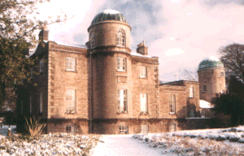
The Armagh Observatory is a modern astronomical research institute with a rich heritage. Founded in 1790 by Archbishop Richard Robinson, the Observatory is one of the UK and Irelands leading astronomical research establishments. Around 25 astronomers, post-doctorate and PhD students are studying stellar astrophysics, Solar Physics, Solar System Astronomy and the Earth’s climate.

Figure 1. Armagh Observatory in the Winter

Ireland functions as a meteorological watch dog for most of north western Europe’s weather and it is within this area that the air masses clash which determine the climates characteristics for much of Europe. It is here that indications of weather further east may be first assessed and early warning for future weather events can be seen. In Ireland any significant changes in oceanic circulation linked with global warming in Europe may be first detected.

Ireland has a rich and varied climate of its own within its 84,000km². About 5 per cent of its area lies over 300m above sea level. Ireland has a mountainous perimeter of hard ancient rocks and a relatively flat interior of softer, younger rocks. The mountains along the west coast give western Ireland a complex climatic character as some parts are sheltered and other parts are exposed to the full brunt of the Atlantic.

The equability of the Irish climate is the characteristic that sets it apart from Britain with the main cause being the moderating influence being the North Atlantic Drift. The North Atlantic Drift which flows at about 16-32km/day with the surface water taking about eight months to reach Ireland from Florida, has a temperature of 10˚C in January which is 3 to 4 degrees C warmer than the air over Ireland.

With the global warming becoming a pressing issue over the past couple of decades the study of what is causing the Earth’s climate to change is becoming more urgent. We wish to know how much anthropogenic influence, such as the concentration of greenhouse gases in the atmosphere are effecting the change in the climate or whether it is more the natural causes, such as solar variability or volcanic dust. How the solar activity influences the Earth’s climate is not fully known as there are many different theories with not much evidence to support any of the mechanisms.

This difficulty can be approached by comparing the historic temperature series from instrumental measurements made over recent centuries and measurements of some related factor, such as tree rings widths, which cover much longer time intervals. With these series it is important to find out whether the effects are local or global. When a global temperature series has been established, the influences of the changes in the supposed contributing factors can be correlated with temperature to deduce their importance for past climatic change. This way even without the physical mechanism being fully understood, predictions can be made as to how these factors can affect the climate in the future.

The difficulty in obtaining a global mean is that before the 20th century there was very few meteorological stations operating and most of these were in Europe and North America. Therefore the variation of the Northern Hemisphere is better known than the Southern Hemisphere but neither is accurately known before the middle of the 19th century.

The main difficulties in deriving a temperature series earlier than the mid-19th century are the following: Significant errors in the thermometers which may be greater in magnitude than the actual temperature variation, changes in the placement of the instruments, urban encroachment in the surrounding area of the station and the gaps in coverage leading to a lack in continuity. The series made at Armagh Observatory is one of the longest in the British Isles and is thought to be especially important record for the following reasons.

There is a small diurnal and annual range in temperature in Northern Ireland. Therefore there is a smaller statistical uncertainty in the mean temperature than for a more continental site. Northern Ireland has a maritime climate. The Atlantic Ocean influences temperatures. For this reason Armagh is more representative of a large region and is less affected by the global influences than a continental site. There have been very few changes in the location of the instruments. The instruments have been located at the Observatory’s 20-acre site on top of a drumlin in Armagh City. There is only a small effect on urban encroachment of the site. The population has been roughly between 8000-14,000 people since the early 19th century. Also any additional urban microclimate effect is minimised by the windy maritime conditions. The third director, T.R. Robinson, who invented the Cup Anemometer, had a great interest in meteorology and was director for 59 years. This ensured a careful and conscientious approach to recording meteorological data when this was more uncommon than today (Butler and Johnston, 1996).

The purpose of this project is to transform temperature measurements made sporadically, but usually twice or more often per day, to the equivalent of the mean of maximum and minimum temperature.

2. Theory

2.1 Maximum, Minimum and Mean Temperature at Armagh Observatory

While a true mean would be defined as a time average of temperature, it has been found that this ‘ideal’ mean is related to the mean of the maximum and minimum temperature for any given day. Therefore it has become standard practice to refer to the mean of the maximum and minimum as the mean temperature and since maximum and minimum thermometers were invented it has been possible to determine the standard mean temperature by simply taking the mean of the two measurements.

Previous to the widespread use of maximum and minimum thermometers the practice was to take temperature readings twice per day, 12 hours apart. The mean of these will also give a mean temperature but the transformation of the mean determined in this way to the mean of the maximum and minimum depends on the time of the measurement. In order to calibrate this transformation and make it possible to convert the mean ‘spot’ temperature to the equivalent of the mean of maximum and minimum, a series of hourly measurements made by an Automatic Weather Station has been employed. This Automatic Weather Station was in operation at Armagh Observatory between 1868 and 1882.
Midnight
Midnight
Midday
6AM
6PM
Minimum temperature
Maximum temperature
Mean temperature
Figure 2. A temperature Curve for an Average Day in the Year.

There are two methods for finding the mean of the maximum and minimum temperature. The first method involves comparing the mean of the maximum and minimum temperature against the mean of two spot temperatures 12 hours apart. This gives the relationship shown in equation 1 that can be applied to find the mean of the maximum and minimum from the mean of the spot temperatures.

T(Max+Min)/2 = α T(AM+PM)/2 + ß (Equation 1)

Method 2 is finding the maximum and minimum analytically by fitting a least squares curve to the spot temperatures and determining the maximum and minimum from that. Fitting a series of sine and cosine waves to the hourly temperature series for an average day and then fitting them to the spot temperatures can do this.

A_{i} sin(Φ /n) + B_{i} sin(Φ/n) + C_{i} (Equation 2)

Where n = 1, 2, 3… and Φ is the phase during the cycle. The least squares program determined the coefficients, Ai, Bi and Ci.

2.2 The Sun-Climate Link

The Sun is the source of energy that causes the motion of the atmosphere and so controls weather and climate. Any change in the energy from the Sun received at the Earth’s surface will affect climate. Therefore a possible cause in global temperature change is solar activity.

It is unclear how small changes in solar radiation whose direct effects are in the upper atmosphere, could have a significant impact on Earth’s surface. Possible physical mechanisms linking solar activity to climate could be a direct change in solar irradiance, indirect effect of solar activity on cosmic ray flux or convective motion of the atmosphere.

An decrease in solar activity causes an increase in cosmic rays which, promote the formation of terrestrial clouds through ionisation of particles in the troposphere, increasing cloud cover which effects the albedo of the Earth and has an effect on climate. Clouds could then affect temperature by trapping radiation in, increasing the temperature, or by reflecting radiation from the Sun, decreasing the temperature. Solar cycle variation is much larger in the ultraviolet part of the spectrum of solar radiation. Ultra violet radiation effects the ozone in the upper atmosphere, which effects the convective motion of the Hadley cells.

It is suggested that solar irradiance has varied in phase with the 11-year sunspot cycle and that this variation is causing a significant part of the changes in the global temperature. However, there are satellite observations that indicate significant changes in the solar irradiance. The variation of the solar cycle length supports the suggestion of a direct influence of solar cycle length.

The absorbed flux of light is reradiated in the infrared range and gives a black body frequency distribution, mostly at the surface. In this approximation and calculating without any green house effect, the reradiated energy flux is

F = ¼ a c T⁴ (Equation 3)

T is the black body temperature in degrees absolute, c is the speed of light, and a is the radiation density constant 7.565 x 10⁵. The value for T is usually 239K or 34°C.

This is Stefan’s Law, which can be used to predict the change in Earth’s mean temperature expected from the observed solar activity level since 1800. This is too small by a factor of about 5 compared to the observations.

2.3 Other Effects on Climate

Other possible effects on global temperature change are carbon dioxide and other greenhouse gases in the atmosphere, urban encroachment, volcanic activity, internal climate oscillations and exposure of instruments. Radiation from the Sun is reradiated from of the Earth’s surface as infrared radiation. Greenhouse gases trap the infrared radiation, warming the Earth. Naturally occurring greenhouse gases are water vapour, carbon dioxide, ozone, methane and nitrous oxide which create a natural greenhouse effect.

Urban encroachment would have an effect on temperature over a long period, as this would effect the microclimate in several ways. It will be warmer in towns than in the surrounding countryside because there is less vegetation and more buildings, changing the albedo of the area and so more radiation is absorbed and heating of the houses will also have some effect.

Volcanic activity can also have an effect on temperature change. It could cause a positive effect as volcanic eruptions increase the amount of green house gases in the atmosphere raising temperature. They could also have a negative effect as these gases could act as hygroscopic nuclei, which increase cloud cover which blocks out radiation from the sun causing a fall in temperature.

Internal climate oscillations also have an effect on weather, such as the El Nino. In this project the North Atlantic Oscillation will be looked at as this is the oscillation that is the most likely to affect the temperature in Armagh as it is close to the North Atlantic Ocean.

3. Air Temperature Records at Armagh Observatory

Daily air temperature measurements have been made at Armagh Observatory from 1795 to the present day, excluding a period of nine years, from 1825 to 1833, for which no data has been found. As part of the project an attempt to fill in this gap in the data is made using the ‘spot’ temperature readings from Dunsink Observatory near Dublin from May 1818 until August 1850.

At Armagh Observatory five main temperature series exist. Series I is the ‘spot’ external air temperature measurement made twice daily, from 1795 to 1825 and from 1833 to 1882. Series II is the daily maximum and minimum external temperatures from 1843 to 2002. Series III is the wet and dry thermometer readings, once per day, sporadically, from 1836 to 1843, twice daily, regularly, from 1844 to 1963, once daily from 1964 to 2002. Series IV is the twice-daily temperature inside an unheated room from a thermometer attached to the barometer, from 1795 to 1883. Series V is the hourly wet and dry temperature from the Automatic Weather Station operated at Armagh Observatory by the Board of Trade, from 1868 to 1882.

In this project series I, series V and the sporadic external dry temperature measurements made at Dunsink Observatory are used.

3.1 External ‘Spot’ Temperature Records at Armagh Observatory

The external temperature records which began in 1795 were originally made three times a day at 8am, noon and 8pm local time. From 1833 measurements were made twice a day at 10am and 10pm local time. Later in the 19th century observation times changed to Irish Civil Time (Dublin Local Time) and then later to Greenwich Mean Time (GMT). In Table 1, the GMT times are given when the ‘spot’ temperature measurements were taken up until the date they finished in 31st December 1882.

Period | Morning | Evening
1 Jul 1795 – 31 May 1825 | 8:27 | 20:27
1 Jan 1833 – 30 Jun 1850 | 10:27 | 22:27
1 Jul 1850 – 31 Mar 1852 | 9:27 | 21:27
1 Apr 1852 – 18 Jan 1882 | 9:25 | 21:25
19 Jan 1859 – 3 Jan 1882* | 10:25 | 22:25
4 Jan 1882 – 31 Dec 1882 | 10:00 | 22:00
* For the month of December 1861, readings were taken at 9:25 am/PM GMT.

Table 1. Greenwich Mean Time of ‘Spot’ Temperature Measurements (Butler and Johnston, 1996)

The identity of the thermometer used for the measurements made between 1795 and 1825 is not certain. It is believed highly likely that the thermometer was by Troughton this was recorded in an early Observatory inventory and was found to be still in use at the Observatory in 1823 when Robinson arrived and became director of the Observatory. The Troughton thermometer was unfortunately broken in 1859 and was replaced with a Kew standard that was used until the series ended in December 1882. They were both believed to have an error of no more than 0.2˚F. Because of the reported accuracy of these two thermometers and as there is no detailed calibration data it is assumed the thermometers have an error of zero.

The place where the thermometers were kept and measurements taken had changed during this temperature series. When Robinson arrived at the Observatory he reported the thermometers were placed outside the tower. Following the construction of the East Dome in 1827 it was placed outside the north window of the east tower of the Observatory. The thermometers were placed in a double casing of light metal that gives free access to air but screens it from radiation. These sites are within a few meters of each other. These buildings were not heated at the time so it is unlikely that there would have been much difference between sites.

3.2 Hourly Temperatures from the Automatic Weather Station at Armagh Observatory

The Automatic Weather Station consisted of three self-recording instruments. The Thermograph which recorded continuously the temperature of the air with wet and dry thermometers, the Barograph which recorded continuously the pressure of the air and the Anemograph which recorded continuously the direction of the wind, and the space that it passes over in a given time.
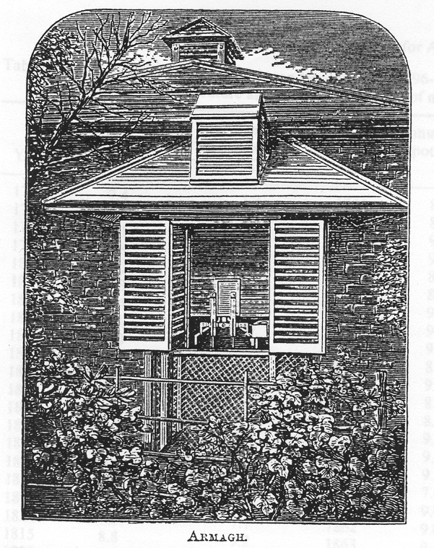
Figure 3. The Continuously Recording Thermograph Screen on the North Wall of the Meteorological House, Created at Armagh Observatory by the Board of Trade in 1869 (From the Quarterly Weather Report of the Meteorological Office for 1870, HMSO, London (Butler and Johnston, 1996)

The thermograph is an instrument that is designed to record continuously the temperature of the air using the dry bulb thermometer and that of evaporation using the wet bulb thermometer. These two simultaneous readings are compared and photographed together. They have the same time scale and are photographed together. It serves a double purpose, to give a temperature time profile and a humidity time profile. There is a cylinder covered in sensitive paper and a spot of light is shone on the paper to mark it. There are two spots of light for each thermometer which are focused on to the paper using a system of mirrors, condensers and lenses.

The thermometer readings are measurements of the photographic curves made at points two minutes before each other. All the readings were corrected for instrumental errors at the time. The height of the bulb was 4 feet above the ground. The times throughout were in Greenwich Mean Time and not local time.

3.3 Sporadic Temperature at Dunsink Observatory

Dunsink Observatory in the Republic of Ireland is the oldest observatory in Ireland. It is situated on a hill 8km Northwest of Dublin’s city centre. Data from the external temperature series from Dunsink Observatory in Dublin are to be used to fill the nine-year gap in the temperature series at Armagh Observatory between 1825 and 1833.

These data are ‘spot’ temperature readings taken at different times of the day from May 1818 until August 1850. Throughout these years there are many days when data were not taken. It is believed that the time given in the tables of meteorological data is local Dunsink Astronomical time. That is 00:00 hours are at midday Dublin time. This is confirmed by the observation of sunshine at 0h on various days throughout the years. At the latitude of Dunsink the sun never shines at midnight.

4. Analysis of Data and Programming

All the temperature series were checked against the original data written in the meteorological books since 1795 and corrected in the plain text files on the computer. All analysis of the data and programming was done in FORTRAN 95.

A program was written to read in the hourly dry temperature for each day with day numbers 1 to 365. By averaging all the years for which data are available, mean temperature curves were formed for each day of the year. The curves did not appear smooth, especially for the days during the winter as the range is less, so for each day the curves were averaged over a several day period and compared. It was found that averaging the data with 7 days either side of the day gave a smoother curve.

For each day of the year the maximum, minimum, range, mean of the maximum and minimum, mean over the 24 hours and the difference from the means of ‘spot’ temperatures at 08:00 and 20:00, 09:00 and 21:00, 10:00 and 22:00, were computed. The difference between the ‘spot’ temperature means and the mean of the maximum and minimum temperature for each month throughout the year are plotted to see if this shows a straight line. Then a regression line is determined to relate the mean of the maximum and minimum and the ‘spot’ temperature mean (see equation 1).

A program was also written to read in the observed ‘spot’ temperatures to determine the mean of the ‘spot’ temperatures and convert them to the mean of the maximum and minimum using the relationship found using the hourly data.

Another method employed a least squares method to fit the periodic curves to the temperature curves for an average day taken from the hourly temperature series and fitted to the spot temperatures taken in Armagh and Dunsink and from these curves the maximum and minimum can be determined analytically. This is done by using a least square method to fit a cyclic curve by a series of sine and cosine terms (see equation 2).

Another program was written to read in the data from Dunsink Observatory. The mean of the maximum and minimum temperature for a day in Dunsink is found by fitting the Armagh temperature curves for an average day in a year to the sporadic spot temperatures at Dunsink for that day. Then the difference is found between the mean of the maximum and minimum temperature for the days when there are both Dunsink and Armagh data. The difference for an average day in a year is found and applied to the Dunsink data to get the mean of the maximum and minimum temperature for Armagh to fill in the gap.

By filling in the gap the monthly, seasonal and yearly mean temperatures can be found from the equivalent of the mean of maximum and minimum temperatures in a day. These means can then be compared to the data for solar activity and other factors that could affect the weather.

5. Discussion

5.1 Mean Temperatures at Armagh Observatory

Mean temperature curves were formed for each day in an average year and it was found that when they were all put on the same temperature scale that they appeared smooth. To ensure that the curves were even smoother it was decided to use a 9-day interval. It is found that the maximum was around 1PM GMT in winter and between 2PM and 3PM GMT in the summer. The minimum occurs just before sunrise, which is earlier in the summer than the winter. The range in temperature is less in winter and higher in spring but as summer progresses, the range in temperature will fall again, though the temperature remains high and in the autumn and winter again the temperature becomes colder and the range gets less.

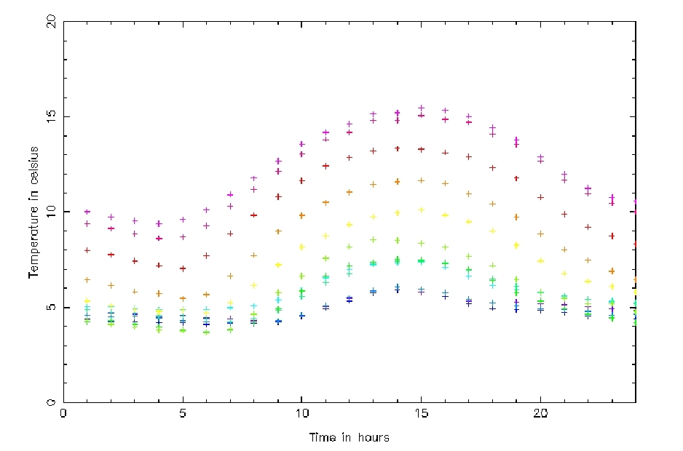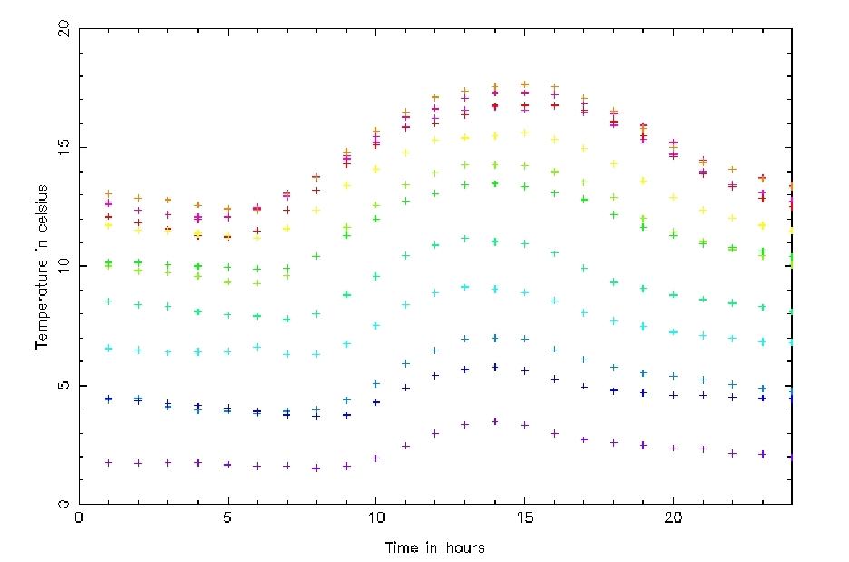
Figure 4. Mean Temperature Curves (˚C) for Every 9 Days in an Average Year from January to June (Left) and from July to December (Right)

Figure 4 shows that December has the coldest temperatures for an average year over the period considered. It is usually found that January is the coldest month of the year but during the years when the hourly data is available, between 1874 and 1883, the most common coldest month of the year was December. This is found by using a program to find the monthly means. This should not affect the mean curves too much as the curve for an average day of the year is positioned to fit the spot temperatures later.

From the monthly mean temperatures it is also found that during the period when the hourly temperature series were taken there were some of the coldest Decembers and Januarys on record. Especially in December 1878 and January 1881 when the mean monthly temperature was below zero degrees Celsius. This cold period can also be seen in figure 9 where the mean temperatures for each day are also some of the coldest from 1795 to 1883.

Using a Fourier series subroutine a system of sine and cosine waves is fitted to the curves to give estimated temperature data for every ten minutes. These curves are of order 6 so that they fit the data better. If the order is any higher or lower the curve doesn’t fit the data properly. The curves look different in the winter than in the summer.

A graph is plotted in figure 5 to show the mean ‘spot’ temperature against the mean of the maximum and minimum. It is shown that the points for times of observation of spot temperatures AM and PM GMT follow a straight line. This shows there is a relationship between the mean of the ‘spot’ temperatures and the mean of the maximum and minimum temperature (see equation 1).
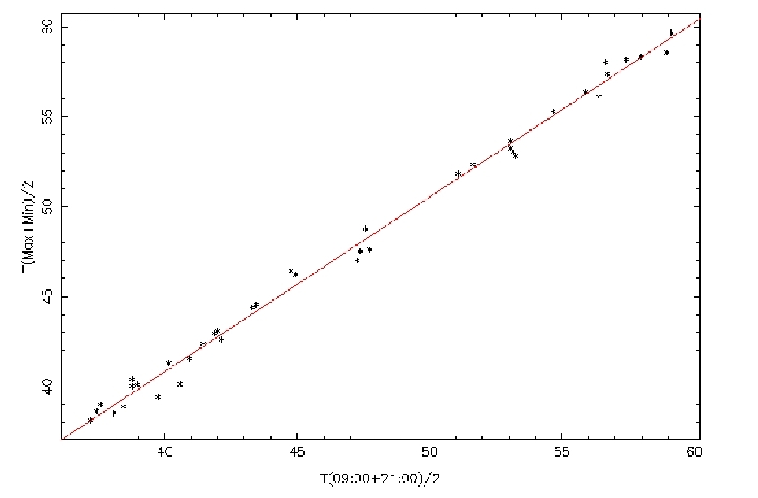
Figure 5. The Mean of ‘Spot’ Temperatures (˚F) Observed at 09:00 and 21:00 GMT Against the Mean of the Maximum and Minimum Temperatures (˚F) for Different Days in an Average Year as Determined from the Hourly Temperature Series (Points Are Determined from the Mean of Every 10 Days)

Graphs of the mean of the ‘spot’ temperatures against the mean of the maximum and minimum temperatures are plotted for different times of the day. It is found that these plots are all straight lines but the intercepts are not zero and the gradients are not unity as was previously believed. The intercept is still very close to zero and the gradient is very close to one but there are changes depending on the time of the ‘spot’ temperatures used which can be seen in figure 6.

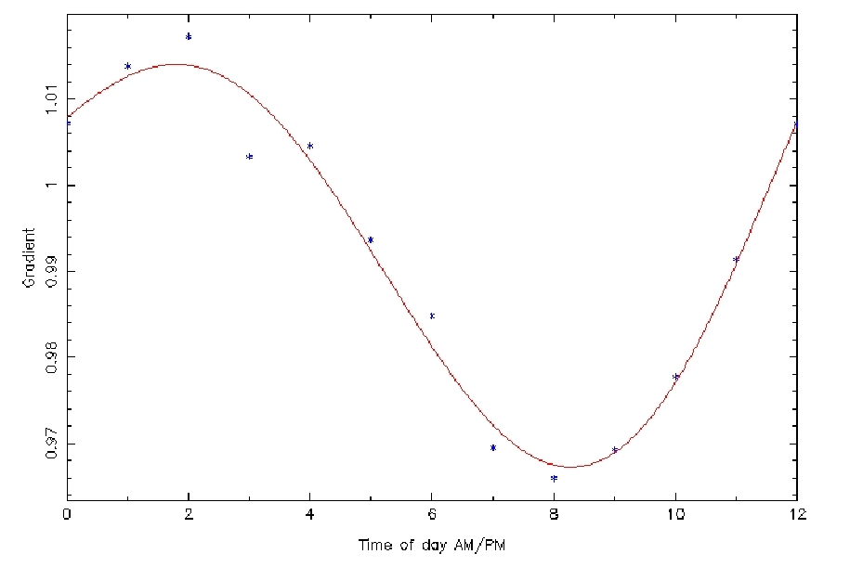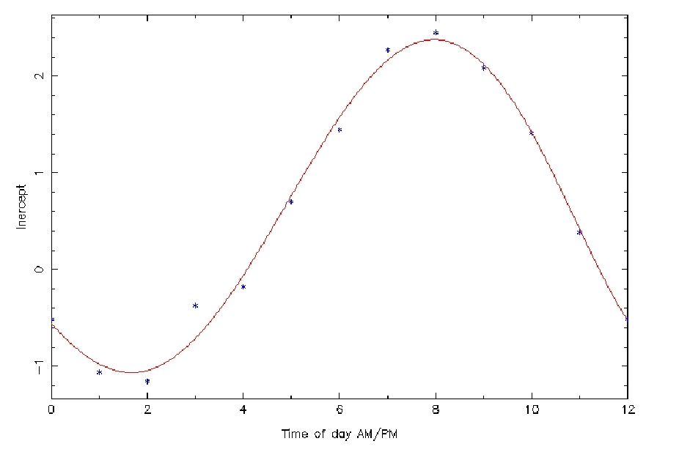
Figure 6. The Gradient (Left) and Intercept (Right) Against AM and PM Time of Day in GMT Taken from Graphs Similar to That of Figure 5 for Armagh

The gradient and intercept depend on the time of the ‘spot’ temperatures. The gradient and intercept appear to have a sine or cosine relationship with the time of the ‘spot’ temperatures. There appears to be a discrepancy at 3AM and 3PM but the data has been checked and found not to be in error so it is thought that this inconsistency may occur at these times when the temperatures are at a minimum and maximum. From these curves the equivalent of the mean of the maximum and minimum can be found from the ‘spot’ temperature data by using equation 1 depending on the time of day.

Another method to find the mean of the maximum and minimum of the ‘spot’ temperatures is to find the maximum and minimum analytically by fitting a curve for the average day of that time of year to the spot temperatures. This method has been used to find the mean of the maximum and minimum for the Armagh ‘spot’ temperature series and the Dunsink temperature series using equation 2.

For the days when there are both Armagh and Dunsink temperature data the difference between the mean of maximum and minimum temperature for the two stations is found. As there is a large amount of scatter in this difference, we smoothed the data with a 100-day filter, which can be seen in figure 7. It is found that it is colder at Dunsink during the winter than Armagh and warmer in the summer. This is thought to be due to be due to the latitude difference in the summer as isotherms in the summer are east-west and in the winter the isotherms are approximately north-south with temperature dependant on the proximity to the Atlantic.

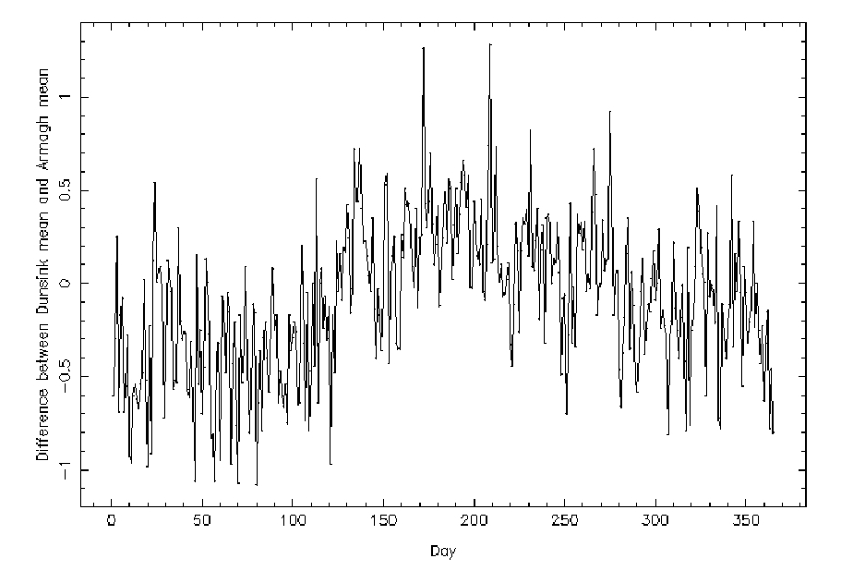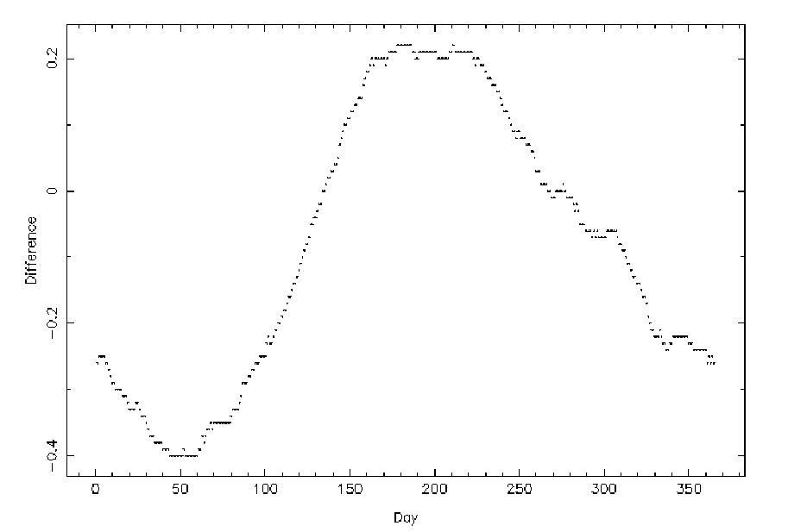
Figure 7. The Average Difference (˚C) Between the Computed Mean of the Maximum and Minimum Temperature at Dunsink Observatory and the Mean of the Maximum and Minimum Temperature at Armagh Observatory Throughout the Year (Left) and Averaged Over a 100 Day Period (Right)

The average difference for each day is applied to the Dunsink data to predict the mean temperature to fill in the gap in the Armagh temperature series. The equivalent mean of the maximum and minimum for Armagh is found by applying the difference between Armagh and Dunsink for each day in an average year to the Dunsink mean data to fill in the gap.

This fills in the gap in the Armagh temperature series, which can be seen in figure 8. Figure 8 is a graph of the days when Dunsink data is available to predict the mean temperature at Armagh. Within the gap in Armagh data (1825 to 1833) there is a further gap in the Dunsink data of about a year between summer 1829 and summer 1830. We can not estimate the temperature in Armagh at this time and this gap can be seen in figure 8. There are slight differences between the real mean temperatures, represented by pink in figure 8, and predicted mean temperatures, represented by blue in figure 8, at Armagh Observatory. Weather has a random component so it is impossible to fill in this gap accurately.

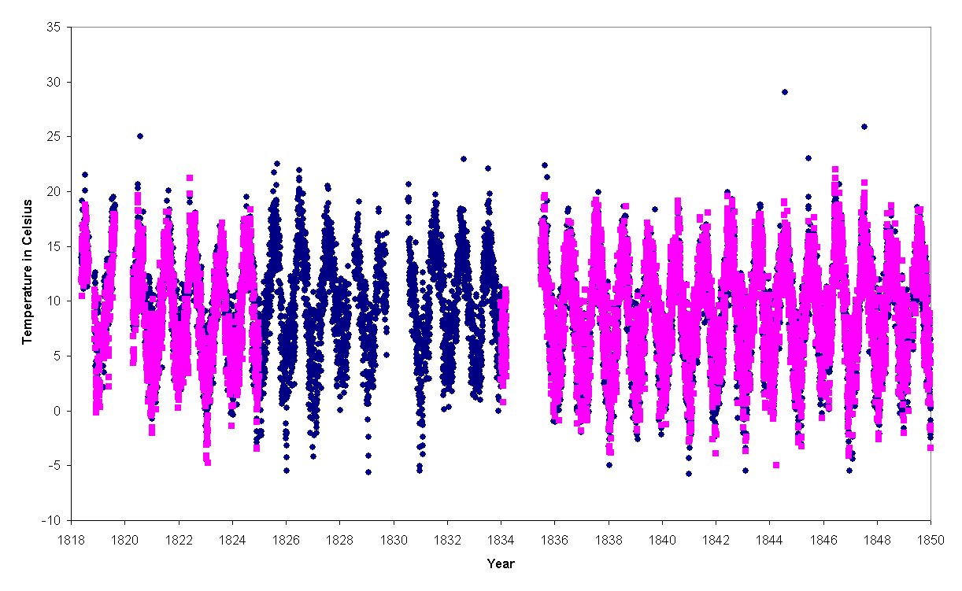
Figure 8. Filling in the Gap in the Armagh Temperature Series (˚C) Using the Dunsink Observatory Temperature Series Data and Applying the Difference

Expanding figure 8 and including the original Armagh daily mean temperatures shows the daily mean temperatures from 1795 to 1883 which can be seen in figure 9. This shows that there were some very warm days in 1821, 1844 and 1847 and some very cold days in 1798, 1814, 1867 and 1871.

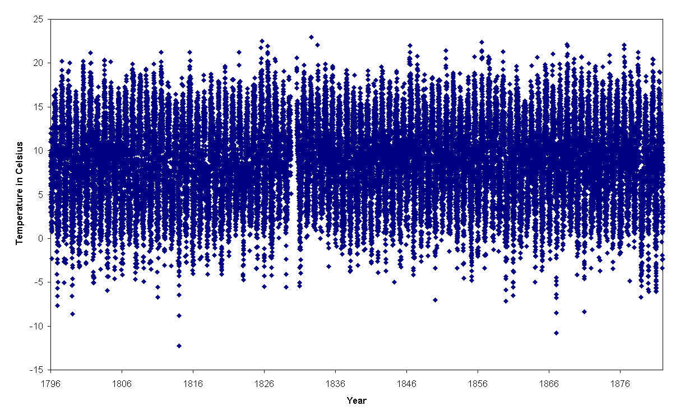
Figure 9. The Armagh Temperature Series from 1795 to 1883 After Filling in the Gap

Monthly means can be found from the daily means. The seasonal means can be found from the monthly means that can be seen in figure 10. This shows some very warm summers in 1807, 1826 and 1846. The year 1846 is the year when the potato famine started. There were some cold summers in 1796, 1802, 1813 and 1823. There were some cold winters in 1813-1814, 1822-1823 and 1878-1879. There was a very cold winter in 1878-1879, which can also be seen in the daily and yearly mean temperatures as being a very cold period in the late 1870’s.

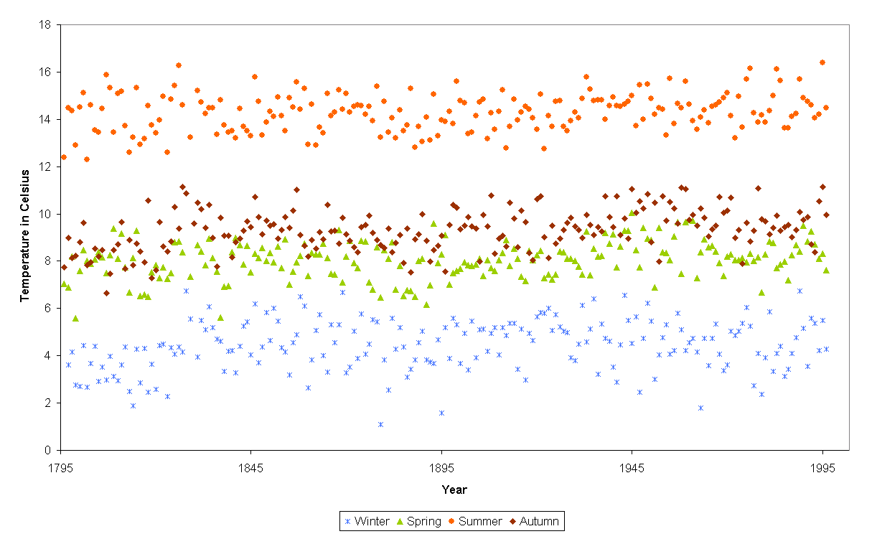
Figure 10. Seasonal Means at Armagh Observatory

Also from the daily means the yearly means for Armagh Observatory can be found. The yearly means are used for comparison with the Central England and Eastern USA series and for comparing with solar activity.

5.2 Comparison of the Armagh Temperature Series with the Central England and Eastern United State Series

The Armagh temperature is compared to the Central England and Eastern USA series to see if there is a correlation between them.
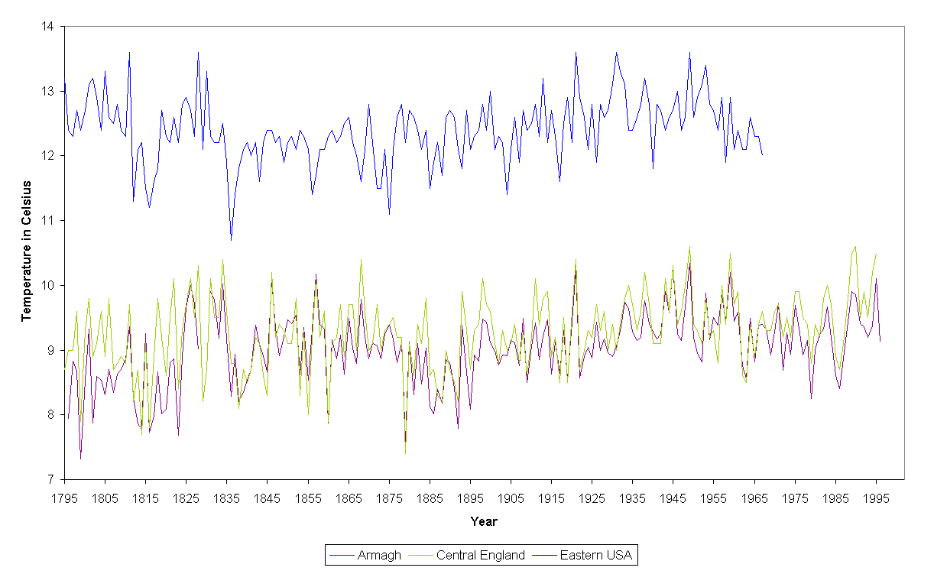
Figure 11. Yearly Mean Temperatures at Armagh Observatory, Central England and Eastern USA

There were some very warm years at Armagh in 1827, 1831, 1834, 1846, 1857 1921, 1949, 1960, 1990 and 1995. There were some cold years in 1799, 1813, 1816, 1823, 1860 and 1879. Central England has the same warmer years as Armagh but the warm years that Armagh didn’t experience are 1822 and 1828. Central England also had the same cold years as Armagh. There weren’t any colder years after 1880.

Looking at this graph there almost appears to be a 100-year cycle with the warmest years occurring between the 1820’s to 1850’s and in the 1920’s to 1950’s and the coldest years towards the end of the 18th century and towards the end of the 19th century. Although there was a fall in temperature towards the end of the 20th century this doesn’t appear to show so much.

It is shown that global warming is evident in the records of Armagh Observatory. This can not be due to urban encroachment, as Armagh has not grown too much in the last 200 years. The yearly mean temperatures from 1795 to the present day at Armagh Observatory seem to have increased in temperature since 1795 by about 1°C.

Central England appears to be about 0.1°C warmer than Armagh. Eastern USA is about 3.4°C warmer than Armagh. All of these series appear to have a range in yearly means of 2.9°C. Central England appears to have the same warm and cold years as Armagh but Eastern USA appears to be ahead. The year 1879 is a very cold year for Armagh and Central England. Eastern USA had a very cold year in 1875, which is 4 years before. When the warmer years occurred in Eastern USA in 1811 and 1828 the warmer years in Armagh and Central England did not occur until 3 or 4 years after in 1815 and 1831.

The temperature data shows that there were some very warm summers in the late 1840’s especially in 1846 in Armagh, which would have aided the potato blight in Ireland. The Irish Potato Famine Fungus Phytophthora infestans devastated the potato crop in Western Europe in 1845. Its greatest impact was the potato blight epidemic in Ireland. In 1845 and in 1848 a third of the potato crop was destroyed by disease. Three-quarters of the crop failed in 1846. One million people died of famine-related diseases and one and half million people emigrated. The spores are formed in humid conditions mainly during the night and are dispersed under dry conditions during the day by wind.

The year of 1816 is commonly known as ‘The year without a summer’ a dramatic cooling that resulted from the Tambora Plinian eruption in April 1815. Mount Tambora is located in Sumbawa in Indonesia. It was a violent eruption that produced more than 10km³ of magma and emitted about 200 million tons of sulphuric acid aerosols into the atmosphere. This eruption plunged a region of up to 60km west of the volcano into darkness for about three days. The ash and other volcanic fallout landed as far as 1300km from the volcano. Lighter ash, dust particles and gas molecules drifted around the world for several years. The average decrease in temperature estimated in the Northern Hemisphere is estimated at 0.4-0.7°C.

A decrease in temperature can be seen in the Armagh and Central England series but the year 1814 was a colder year so 1816 does not stand out. This can also be seen in the monthly and seasonally means in Armagh that also shows 1814 to be a colder year. In the Eastern USA series 1816 does appear to be a much colder year but so was 1812 in that decade. The temperatures didn’t really start to rise until the early 1820’s which might be the result of lighter ash, dust particles and gas molecules from the volcanic eruption that drifted around the world for several years.

5.3 The Variation in the Mean Temperature at Armagh and the Possible Link to Solar Activity

The sunspot cycle varies in length between 10 and 13 years. It has been suggested that the temperature at Armagh (Butler and Johnston, 1996), as with that of the Northern Hemisphere in general (Friis-Christensen and Lassen, 1991), shows an inverse behaviour to that of the sunspot cycle length, i.e. that short cycles are accompanied by higher temperatures.

The variation in the sunspot cycle length is known to vary with solar activity. High activity implies short solar cycles whereas long solar cycles are characteristic for low activity levels of the Sun. Gleissberg demonstrated that the variability occurred in a systematic manner with a long term periodicity of 80 to 90 years, now known as the Gleissberg period (Friis-Christensen and Lassen, 1991).

The yearly means are averaged over 11 years, as the average sunspot cycle length is about 11 years, to see if there is a pattern in Armagh temperatures which correspond to changes in the sunspot cycle length.
7
7.5
8
8.5
9
9.5
10
1795
1845
1895
1945
1995
Year
Temperature in Celsius
9
10
11
12
Sunspot cycle length
11 year mean temperature
Sunspot cycle length
Figure 12. Mean Temperature at Armagh Observatory over an 11 Year Period Compared to the Length of the Sunspot Cycle

Comparing the sunspot cycle length with the 11-year mean temperature at Armagh shows a relationship between the Armagh temperature series with solar activity in figure 12. The sunspot cycle length is believed to be a physical important index of solar activity. Figure 12 shows that there is an 80 to 90 year cycle in the Armagh temperature series confirming the Gleissberg period.

The level of activity observed on the sun is believed to have an effect on the climate, as a larger number of sunspots are a sign of increased solar activity.
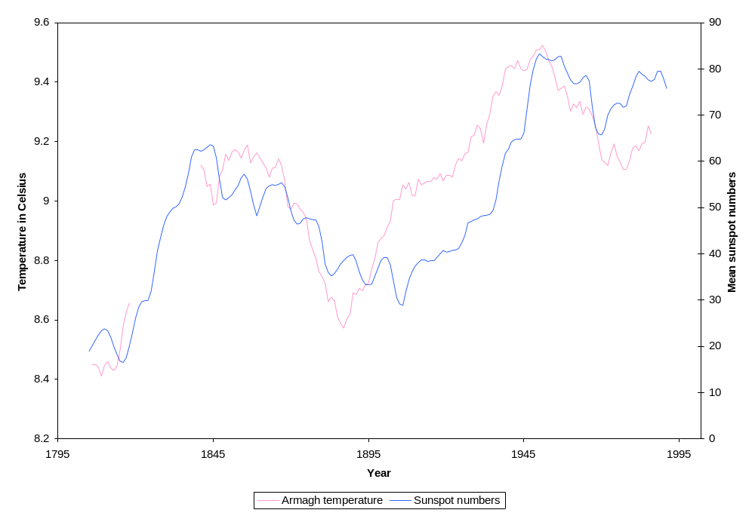
Figure 13. Yearly Mean Sunspot Numbers from 1795 to 1882 Compared to the Yearly Mean Temperatures at Armagh Observatory smoothed out over 20 years

The yearly mean sun spot number curve shows a very similar curve to the Armagh yearly means with a time difference of about 10 years. Yearly mean sun spot numbers lag 10 years behind the Armagh yearly means. This is not seen in the Central England series or the Eastern USA series. This could be due to that the Central England and Eastern USA series are a collection of different data from several stations. This could have lost the extremes of the data. The data from Armagh is from a single site.

The North Atlantic Oscillation (NAO) index is related to one of the principal climatic oscillations of the Earth, similar to the better known El Nino. The NAO index is the difference in air pressure between the Azores and Iceland. When the NAO index is high there are mild winters and when it is low there are cold winters. The yearly NAO index is compared to winter means to show this in figure 14.
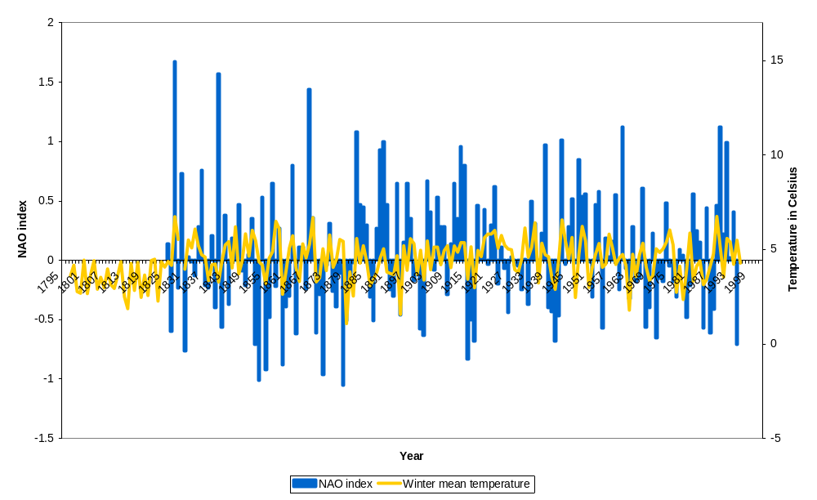
Figure 14. North Atlantic Oscillation Index Compared to the Winter Mean Temperature at Armagh Observatory

When the NAO index is high there are some mild winters in 1829, 1882, 1890 and 1992. When the NAO index is low there are some cold winters in 1915, 1917, 1941 and 1963.

6. Conclusion

Standardising the Armagh temperature records and filling in the gap in this temperature series gives Armagh a continuous temperature series from 1795 to the present day. This is one of the longest running temperature series from a single site in the UK and Ireland and is valuable in modelling climate change and predicting the climate changes in the future. Some of the possible explanations for climate change are solar activity, enhanced green house effect, volcanic eruption and the chaos theory. These theories for climate change could be comparison with the temperature series to discover what the real causes are tested by.

There are still many gaps in the Dunsink data where sometimes there are weeks and even months of missing data. Given more time at Armagh Observatory other temperature records could have been obtained and used in this project such as Botanic Gardens in Dublin where it is believed they could date back to early in the 19th century. There are other methods of filling in the nine-year gap in the Armagh temperature series. This could be to use proxy methods such as the width of tree rings which may be employed to confirm the temperature series for Armagh using trees in the surrounding area which is another project ongoing at the Armagh Observatory.

Comparing the Armagh temperature series to the sunspot cycle length and yearly number of sunspots shows that there is a relationship between climate and solar activity over a long period. The degree of solar activity appears to have a significant effect on climate and a model for solar variability is still needed to predict climate change. There is still no adequate model to predict climatic change. Volcanic activity does appear to have a small effect on the temperatures following a volcanic eruption. This suggests that the emissions of green house gases in the atmosphere, although small, are having some effect on climate. The North Atlantic Oscillation Index is also having an effect on climate and this may help to predict temperature changes in winter and this may be also be related to solar activity.

Acknowledgements

The author would like to thank all members of staff who have made meteorological observations since 1795. The author would also like to thank the Heritage Lottery Fund and the Irish Soldiers and Sailors land trust for their financial support for this project. Research at Armagh Observatory is grant aided by the Department for Culture Arts and Leisure for Northern Ireland. The author also wishes to thank Dr. John Butler and Miss Ana Maria Garcia Saurez for their supervision and guidance in this project.

References

Bennett, J.A.: 1990 Church, State and Astronomy in Ireland – 200 years of Armagh Observatory.
Burroughs, W.J.: 1992 Weather Cycles – Real or Imaginary, Cambridge
Butler, C.J.: 1994 Maximum and Minimum Temperatures at Armagh Observatory, 1844-1992, and the Length of the Sunspot Cycle, Solar Physics 152, 35
Butler, C.J. and Johnston, D.J.: 1996 A Provisional Long Mean Air Temperature Series for Armagh Observatory, J. Atmosph. And Terrestrial Phys. 58, 1657
Friis-Christensen, E. and Svensmak, H.: 1997 What Do We Really Know About the Sun – Climate Connection, Adv. Space Res. Vol. 20, No 4/5
Friis-Christensen, E. and Lassen, K.: 1991 Length of the Solar Cycle: An Indicator of Solar Activity Closely Associated with Climate, Science, Vol. 254
Foukal, P. and Lean, J.: 1990 An Empirical Model of Total Solar Irradiance Variation between 1874 and 1988, Science, Vol. 247
Green, J.S.A.: 2002 Reflections on the Earth’s Albedo: A Collection of Scattered Thoughts, Weather, Vol. 57
Hoyle, F.: The Green House Controversy, The Global Warming Debate
Lean, J., Beer, J. and Bradley, R.: 1995 Reconstruction of Solar Irradiance Since 1610: Implications for Climate Change, Geophysical Research Letters, Vol. 22, No. 23
Peixoto, J.P. and Oort, A.H.: 1993 Physics of Climate
Wheeler, D. and Mayes, J.: 1997 Regional Climates of the British Isles
Shindell, D., Rind, D., Balachandran, N., Lean, J. and Lonergan, P.: 1999 Solar Cycle Variability, Ozone, and Climate, Science, Vol. 284
Shine, K.: 2000 Radiative Forcing of Climate Change, Space Science Reviews 94, 363-373
Solanki, S.K. and Fligge, M.: 2000 Reconstruction of Past Solar Irradiance, Space Science Reviews 94, 127-138
Soon, W.H., Posmentier, E.S. and Bulianas, S.L.: 1996 Inference of Solar Irradiance Variability from Terrestrial Temperature Changes, 1880-1993: An Astrophysical Application of the Sun-Climate Connection
Svensmark, H.: 2000 Cosmic Rays and Earth’s Climate, Space Science Reviews 93, 155-166

Report of the Meteorological Committee of the Royal Society for 1867: A Description of the Self-recording Instruments recently erected by the Meteorological Committee of the Royal Society in various Parts of the United Kingdom.

