Unique Academy Student Attendance System
This document presents the Unique Academy Student Attendance System, a Laravel-based application adapted for student attendance tracking, scheduling, late-time monitoring, and reporting.

Project Overview
The system was customized for Unique Academy and NACTVET NTA Level 5 ICT. It replaces generic clone branding with a student-focused attendance workflow and a simplified dashboard for academic administration.

Core Features
- Student attendance recording with on-time and late tracking.
- Schedule management with subject and teacher details.
- Attendance review with search and date-based filtering.
- Late-time monitoring and attendance summary cards.
- Role-based access for admin and staff users.
- Clean branding for the Unique Academy portal.

Raspberry Pi Database Hosting Plan
The database can be hosted on a Raspberry Pi, Server or Personal Computer using MariaDB, which is lightweight and suitable for a small academic project deployment.
- Install MariaDB on a Computer, Raspberry Pi or Server and create a database named unique_academy.
- Create a dedicated database user and grant access to the attendance schema.
- Update the Laravel .env file with the ip address of the database host, database name, username, and password.
- Ensure the database host is reachable on the local network and port 3306 is open for the application server.
- Run php artisan migrate and test the login and attendance workflow against the remote database.
Example .env values: (Note These database credentials should match the ones created on the database host)
DB_CONNECTION=mysql
DB_HOST=192.168.1.50
DB_PORT=3306
DB_DATABASE=unique_school_attendance
DB_USERNAME=unique_app
DB_PASSWORD=UniqueAcademy@2026

Implementation Highlights
- Added student_class and contact_phone fields for student records.
- Extended schedule management with subject_name and teacher_name fields.
- Updated the dashboard layout to focus on attendance metrics.
- Refined the UI title and branding for a more professional presentation.
- Prepared documentation assets for reports, presentations, and project delivery.

Setup Instructions
1. Copy .env.example to .env and configure the database.
2. Run composer install.
3. Run php artisan key:generate.
4. Run php artisan migrate.
5. Start the Laravel server and verify the system ( The command is “php artisan serve” )

Screenshots
The following screenshots capture the login page and the attendance dashboard used for the project documentation.

Features
- Attendance Sheet
- Sheet Report
- Attendance Logs
- Late Time Students
- Over Time Students
- Students that took a leave
- Biometrice Attendance

Biometric Attendance
With this feature the students can be identified via a biometric device reducing the complexity of assigning each students attendance in the system manually.
A Fingerprint reader or Face id Scanner can be used to identify each student whenever they scan… Confirming their attendance.

Attendance Login
The login credentials (that are also migrated when “php artisan seed” is issued) are:
Email: admin@uniqueacademy.local
Password: password123
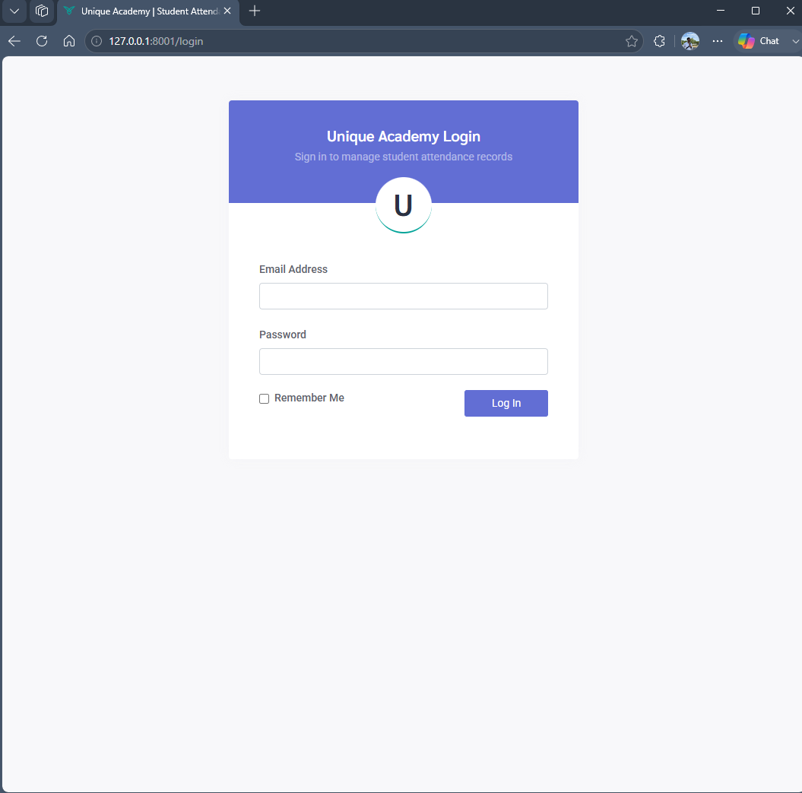
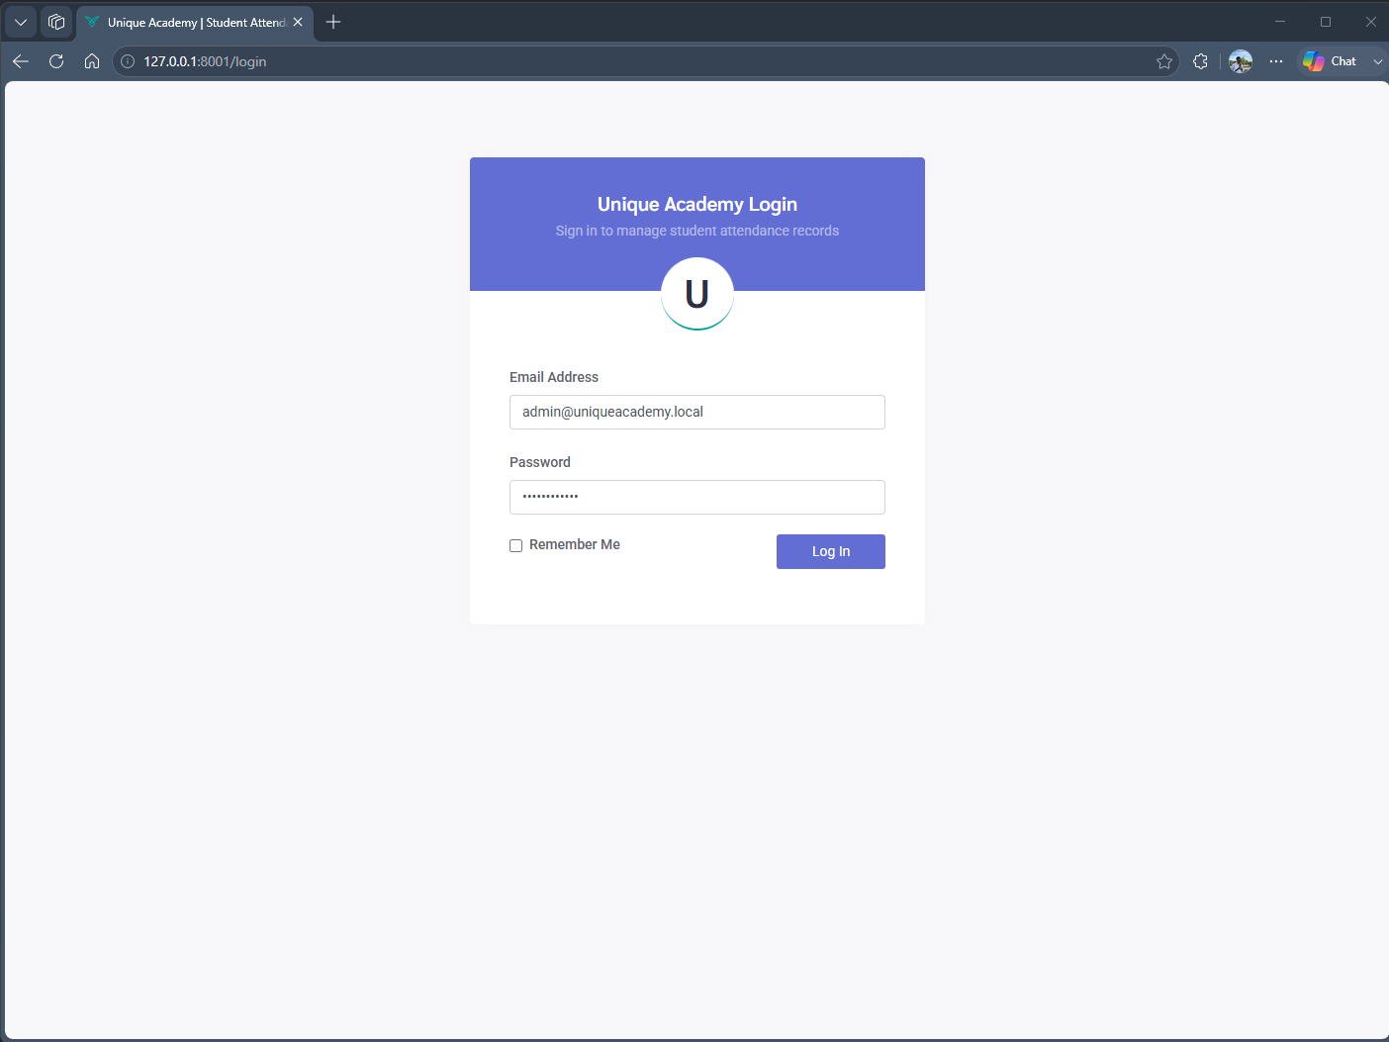

Dashboard
The unique academy dashboard consists of various widgets with different metrics
Including: Total Students, On Time Percentace, On Time Today, Late Today
A well put together navbar on the left allows for easy access to different sections.

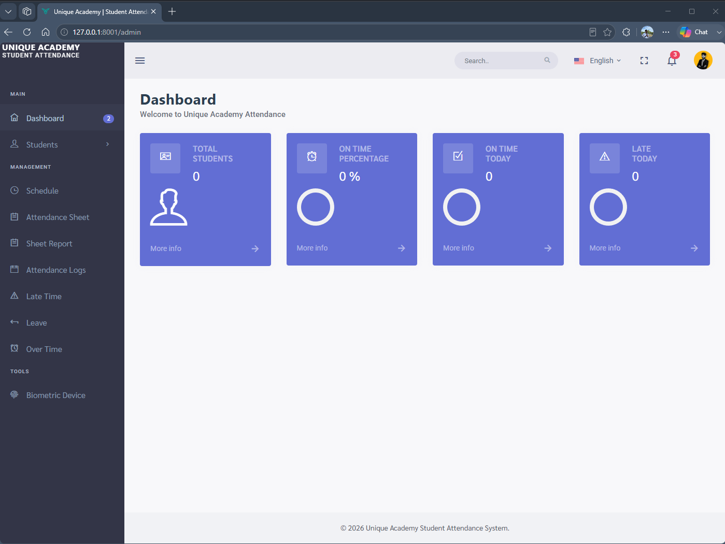

Student Section
The student page can be used to add new students per specified class
The student list can be exported in Excel and Pdf format.

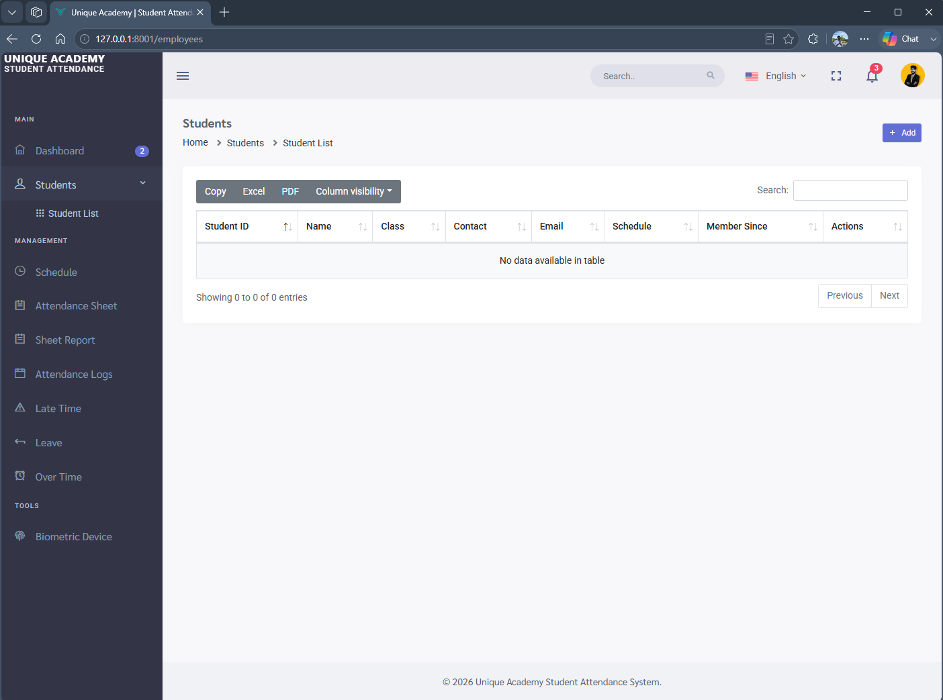

Screenshot (php artisan serve)
This command starts the webapp 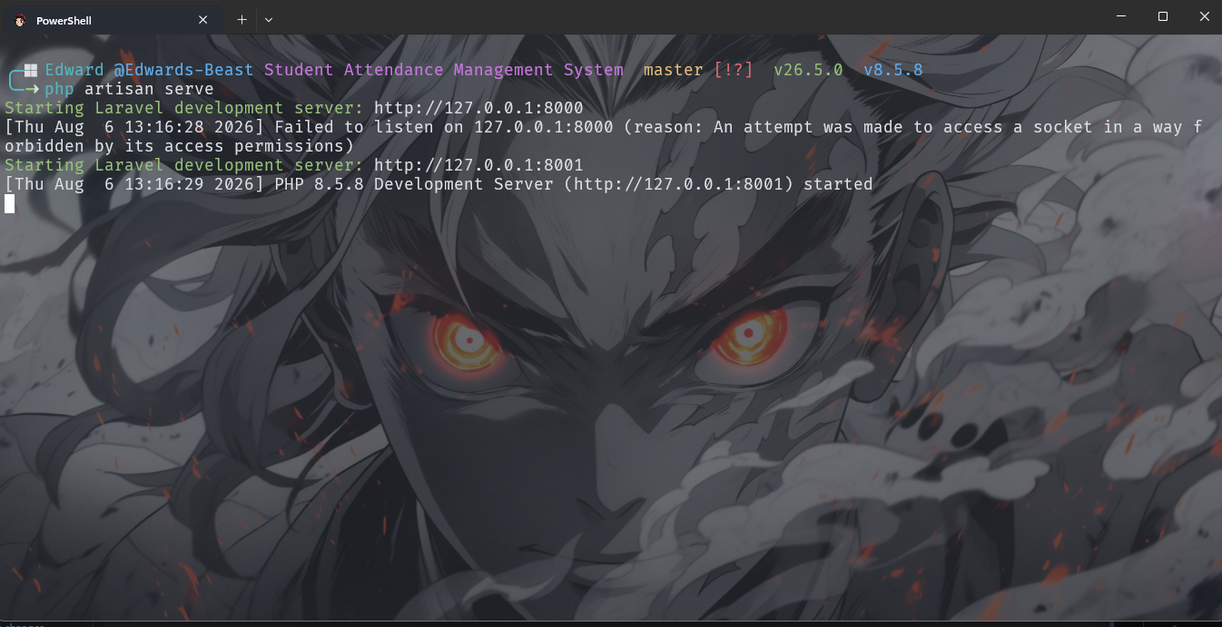

Student Details
Name: Edward Terry
Id: DS2526062/NS1267/0021/2019

