Embedding Diagra

Supplement to manual. ReportLab Europe Ltd. Last updated: 5 May 2007

This technical note describes the C API for our Diagra product, the general techniques for runtime chart construction, and the chart types available with the Quickchart object. It supplements our standard Diagra manual which should be read alongside it.

Table of Contents

Embedding Diagra 1
1 Purpose of Document 3
2 About Diagra 3
2.1 Key technical features 3
2.2 Commercial Implications 4
3 Deployment options for customers 5
4 Evaluation and development versions 6
4.1 Where to get it 6
4.2 What to do next 6
4.3 About the manual (shortcomings) 7
4.4 Acceptance tests 7
5 Installing the embedded distribution 9
5.1 What's in the distro 9
5.2 Diagnostics and test utilities 10
5.3 C API 14
5.4 The Interface Routines & Structure 15
5.5 A trivial exercise 16
5.6 Creating a simple chart 16
5.7 Creating a more complex chart or graphic 16
5.8 Creating a barcode 17
5.9 Note on Font Registration 17
6 Direct script-based chart creation 18
6.1 Calling python scripts directly 18
6.2 Modifying the code to save the chart 18
6.3 Using the Postscript renderer 19
6.4 Postscript rendering options 19
6.5 Font directories 20
6.6 Tips on wrapping the executable 20
6.7 Performance Considerations 20
7 Chart types and properties 21
7.1 QuickChart: the new compatibility layer 21
7.2 Direct use of chart classes 45
7.3 Font support 48

Recent changes:

5 May 2007: update with information on fontfinder

Introduction

Purpose of Document
This is additional documentation for the Diagra chart library. It covers how to embed the library inside other languages through a C interface; and the code snippets needed to create charts and barcodes in various formats.

This is a highly specialised use of our libraries. It is generally only done by developers of products, who need to ship the product out to their own customers within their own software distributions. In this context, it's important to have a completely self-contained distribution which is as close to one file as possible.

In other contexts (for example deployment onto internal servers, where it is reasonable to run an installation program), we have much simpler distributions available

About Diagra

Diagra is ReportLab's library for automatic chart creation. This document will not repeat the marketing material. We presume that readers have first scanned the product web page (available by clicking two-page product datasheet:
http://www.reportlab.com/docs/diagra-ds.pdf

We also assume that any developer using Diagra in an embedded context has (or will) spend a few hours getting familiar with the Python language using a 'normal' distribution of the language, before they worry about passing through correct strings of Python in a call to a C API.

Key technical features
Here are some of the really important points about the library which we think developers will understand, and which are not stressed in the marketing literature:

Diagra is a library for generating charts and data graphics. Depending on how we agree to deploy it, there may or may not be an actual server process involved. Our view is that sophisticated programmers generally want a library they can integrate any way they choose.

Diagra is part of the ReportLab Enterprise Publishing and Reporting Server (EPRS) suite. The latter is written primarily in Python, with parts in C for speed (we also have Java equivalents). Since Python is itself written in C, we can deploy it anywhere with a C compiler, and can hide the language itself within the distribution.

Diagra creates VECTOR charts and graphics. A drawing is basically a ‘shapes collection’; shapes consist of primitives (text, rectangle, circle) and ‘smart shapes’ like barcodes, charts, axes and so on. At the right time, renderers convert this into different formats – EPS and PDF, as well as bitmaps in most common formats.

Diagra can be used in several modes. In general, if you are working through an API, you create a Drawing object in memory; set various properties (e.g. numeric data or title); then ask it to save itself as a GIF, EPS, PDF or whatever.

It can also create executable charts with data sources. You can create and save a recipe for a chart which, when run, will connect to a database and spit out a batch of 100 charts for use at month end. This is often a very useful mode in publishing; chart generation is separate, and the main documents just need to have the filenames.

Diagra is not just for charts. One can create any kind of data graphic fairly easily, as well as multiple charts. You have a high-level language embedded inside the DLL which is an ideal choice for data acquisition and transformation.

We support high quality Postscript charts, with full control over spot and process colors and knockout and the precise fonts used. You can thus generate EPS charts which go with the enclosing document they are intended to be used in. Very few chart packages do this, and this is the main reason why we fill a need in variable data printing.
The graphics model is Postscript based and “high end”: it supports the key elements of paths, coordinate transforms and clipping which form the basis of Postscript, PDF, SVG, and modern Windows and Java graphics.

The renderers are as accurate and high quality as we can make them. If you render a chart to EPS or PDF then you will have ‘infinite zoom’, because it’s pure vectors all the way down, and you can use the fonts of your choice. If you render the same chart to a bitmap, you will still find the text wrap points and sizing decisions are identical (i.e. accurate to pixel level).

Diagra does NOT do certain things which trendier bitmap libraries are good at: rounded 3d shapes, lighting effects, and stacks of technicolor pineapples for use as bars. This is partly because some of these effects are very hard in a vector model, and partly because we work for discerning financial and scientific customers who regard such things as ‘chart junk’.

Commercial Implications
If you have a product in the variable-data publishing business and are licensing Diagra for its charting capabilities, be aware that there are quite a few doors we can help open:
- It should be easy to give your customers access to a range of basic charts using the Quickchart function, and to create some dialogs and menus to drive it
- Extra ranges of charts and drawings can be created and shipped out in future versions, or as optional ‘download packs’ – from you, from us or from third parties. We can help add metering and ‘try before you buy’ features and are willing to consider this on a joint venture basis. So, Diagra could give you an easy route to sell packs of ‘extras’ if you wish.
- Power users at customer sites could use our development tools to create their own custom chart types using our Drawing Editor, and then ‘drop them in’ to be used in your runtime environment.
- You may well have a dealer or integrator network. These firms look for opportunities to do specialized consulting. We have found there is considerable repeat business in helping companies automate chart production. Very often firms want to create the same range of charts each month for their web site, for high quality publication and for other documents. Diagra can provide a simple and complete solution for graphical assets; integrators can be trained to do the ‘advanced’ work in a few days.
- If you embed Diagra, you will also be adding a very powerful scripting language to your product; people can write pre- and post-processing scripts to fetch data, rearrange directories, deliver output and lots of other things and you can allow them to trigger this as part of your main process, just as you would request a chart. This may provide additional opportunities to deliver ‘whole solutions’ to key customers and/or more work for integrators. Or, you may want to keep quiet about it ☺

Other deployment options for customers

We have prior experience of packaging in numerous ways
- Ordinary python libraries (for customers or environments where Python is part of the system already)
- The above packaged in a single-file runtime library
- A single-directory free-standing distribution which includes all dependencies.

It is possible to put everything in a single giant DLL or EXE, but this generally reduces flexibility; it’s nice to have several entry points.

There are also numerous interfacing techniques available including
- Command line
- C API
- Python API
- Java API via native code bridge
- Java running as a pure JAR file using Jython
- Various techniques for exposing charts as C++ objects
- COM Server
- .NET via various runtime interface techniques
- .NET native code (Microsoft has now released IronPython, a 100% native .NET implementation of Python, which we could port to if needed)

This document only covers the C API, used from a "one directory" distribution.
Evaluation and development versions

There are two separate issues for evaluators: first, finding out if the library will do what you want; and secondly, finding out it can be packaged and integrated correctly.

You should be able to satisfy yourself as to the first part in a few hours and this section gives some pointers.

We have a standard package to install ReportLab's software for evaluation, development and server-side use. This covers RML, Diagra, PageCatcher and other components in our suite. It assumes that you install the Python language, and use this as your primary means of evaluation. It is much quicker and easier to try out the software from short Python scripts and interactive prompts; and if we are working together, we can quickly iterate with changes to the Python chart code.

Where to get it
You can download a copy of the software from a password-protected directory on our web site. This will be a ‘developer copy’ containing documentation and examples.
The installation instructions are available here:
http://developer.reportlab.com/install.html

The download area is here, but you will need to get a password from us via email:
http://developer.reportlab.com/devnet/

Most of the literature refers to Report Markup Language, our product for PDF generation, but all the Diagra code is included.

We recommend finding a Windows machine for initial evaluation; this is the only platform for which we always have up-to-date, one-step installers available, and it has various menu items and dependencies available. Even if your target is Linux or Mac OS, you should spend an hour trying the steps below. If something then goes wrong on another platform, at least you’ll know it’s a build issue and know what behaviour to expect.

What to do next
Once this is installed, we can look at some of the Diagra components. These have not been clearly signposted in earlier releases.

Try the Drawing Editor: The start menu should contain a ‘ReportLab’ submenu with a ‘Drawing Editor’ item. This is the Diagra chart configuration tool. You probably won’t be shipping this to your customers, but it’s the easiest way to play around with charts and discover what Diagra can and cannot do. The first time you start it up, it may take a long time.

Skim the manual: The manual for Diagra is available in the source form in RML within the distro. However, it has not been automatically built on installation (up to 31/12/2005; this will be rectified in future distros). You can build the manual yourself by going to a DOS prompt. If you installed n default locations with Python 2.3 then the command would look like this:
C:\Python23>cd rlextra\graphics\doc

C:\Python23\rlextra\graphics\doc>..\..\rml2pdf\rml2pdf.pyc diagradoc.rml
diagradoc.pdf

(We’re pretty good at making PDF – it’s our core business).

Be warned: the manual has some shortcomings which are covered below.

Try some data-aware charts:
The distro includes some examples of charts which know how to connect to a data source and create chart batches. This is the main thrust of the manual to date. Go to the directory rlextra/examples/graphics.

Some of these work from CSV files present in the directory:
C:\Python23\rlextra\examples\graphics>legendedpie.py
generating PDF file C:\Python23\rlextra\examples\graphics\output\piechart001.pdf
generating EPS file C:\Python23\rlextra\examples\graphics\output\piechart001.eps
generating PDF file C:\Python23\rlextra\examples\graphics\output\piechart002.pdf
generating EPS file C:\Python23\rlextra\examples\graphics\output\piechart002.eps

Others pull data directly from a database. Unzip the file sampledata.zip in place to get sampledata.mdb; it is not necessary to register an ODBC data source. You can then try out some of the others:
C:\Python23\rlextra\examples\graphics>gridlineplot.py
generating PDF file C:\Python23\rlextra\examples\graphics\output\linechart119.pdf
generating EPS file C:\Python23\rlextra\examples\graphics\output\linechart119.eps
generating PDF file C:\Python23\rlextra\examples\graphics\output\linechart120.pdf
generating EPS file C:\Python23\rlextra\examples\graphics\output\linechart120.eps
generating PDF file C:\Python23\rlextra\examples\graphics\output\linechart666.pdf
generating EPS file C:\Python23\rlextra\examples\graphics\output\linechart666.eps

About the manual (shortcomings)
The current manual, Diagradoc.rml / pdf, was written for our first customers in the investment management business. It focuses almost exclusively on data-aware charts: ones which can connect to a database, run in a loop and produce (say) the sector breakdowns for 80 funds in a range in a few seconds, then put them in the right place with the right names.

It is good for telling you how to create and save a custom chart at design time. This may or may not be relevant, depending on whether end users should have this option.

The early chapters contain obsolete installation info. The later ones talk about the data associations, which may not be relevant if embedding it.

It has very little detail on the available chart classes and common properties. In general the customers we worked with would show us a gallery of charts they wanted; we would realize them; and they then needed to know enough to change sizes and colours but not to create new charts.

We are working to fold in the information herein about other ‘runtime contexts’, to properly explain the common properties and chart types, and to generate a complete and always-up-to-date visual reference to all the graphical classes. We hope to complete this in Q1 2005.

Acceptance tests
Finally we’ll mention a couple of graphics test cases. Each renderer can generally be run as a script to create some output samples. The renderPM one (PM= pixmap, i.e. it does bitmaps) is useful as it makes a directory of bitmaps and an index.html page linking them. A quick glance at this is a great way to check everything has built on your platform, and gives some insights into our shape hierarchy.
C:\Python23\reportlab\graphics>renderPM.py
wrote pmout\renderPM0.gif
wrote pmout\renderPM0.tif
wrote pmout\renderPM0.png
wrote pmout\renderPM0.jpg
wrote pmout\renderPM0.pct
wrote pmout\renderPM1.gif
..
wrote pmout\index.html

renderPS and renderPDF do the same sort of thing.

(In general, when we create a compact DLL distribution or server, we will package it with a test suite which can be run from a very short script).

Installing the embedded distribution

This section describes how to download, install and run some basic tests. It doesn't cover programming the API, which is in the next chapter.

We prepare these distros for each customer and will notify you of the correct password-protected download directory. There may be scripts with the customer name, which have been omitted below.

Download and run the installer. This is a Windows executable, usually about 10Mb in size. Run this. It suggests a directory c:\program files\reportlab\APPNAME. You may change this to a temporary directory if you wish.

Once completed, a directory like the one below will be created…

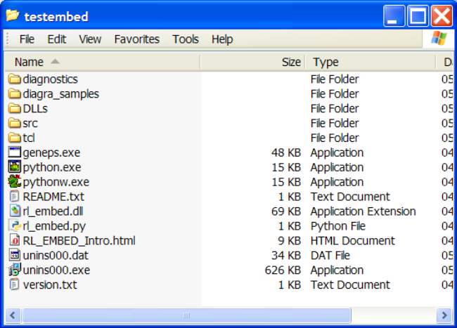

What's in the distro
The DLLs directory is the important part. It contains most of the "one directory distribution". In particular it includes two files,
- python25.dll which is the embedded version of the language, and
- python25.zip, which includes all needed Python code. This contains compiled versions of our own library, and of the Python standard library modules it depends on. It also contains other compiled C libraries needed by the app. (This could be slimmed down further if needed; it contains enough code to run our visual drawing editor, and some "embedded fonts" which we use in testing).

python.exe is an interpreter which uses these libraries. It can be used to execute scripts or to run interactive prompts.

pythonw.exe is a Python interpreter which does not create any standard output. It can be used to start a GUI without leaving a nasty DOS box hanging around.

geneps.exe is a small compiled program designed to call a Python program and save the output in a file. The source code for this, in src/, shows you how to call the C API and pass commands through to Python.

diagnostics/ contains Python scripts you can run using the provided python.exe.

diagra_samples/ contains some Python chart modules in a package format, so that our diagnostic tests can import them and generate charts. You don't need to do anything with these.

tcl/ includes some libraries from the TCL language and Tkinter GUI framework, which are needed for the embedded drawing editor to work. You don't need to do anything with these – and don't need to redeploy to your clients unless there is a reason to ship Tkinter GUIs to your clients.

Diagnostics and test utilities

Assuming you have installed in c:\temp\testembed, the following command runs a comprehensive suite of tests:

C:\temp\testembed>cd diagnostics

Main test script…

C:\temp\testembed\diagnostics>..\python.exe diagra_test.py

This produces LOTS of output on the console. It also creates a directory pmout which contains many rendered charts in many formats. Among these, the following files are interesting and worth a look:
- DiagnosticDrawing.pdf - this displays internal variables in a 'text drawing'
- QCTests.html - an HTML page which "ties together" a large number of test drawings from the QuickChart API, allowing you to browse them. Open this in the browser, and you should see a lot of charts each of which hopefully "does what it says".

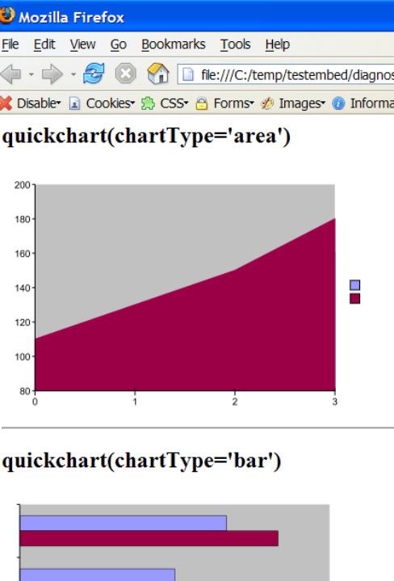
index page showing charts

Starting the drawing editor
The distro includes our "Drawing Editor" which can be used to explore chart properties and create reusable chart scripts. Usage of the editor is covered in the main Diagra manual (available from the product page on our site). Running that script will cause a window like this to open (on all platforms…).

C:\temp\testembed\diagnostics>..\python.exe guieditstub.py

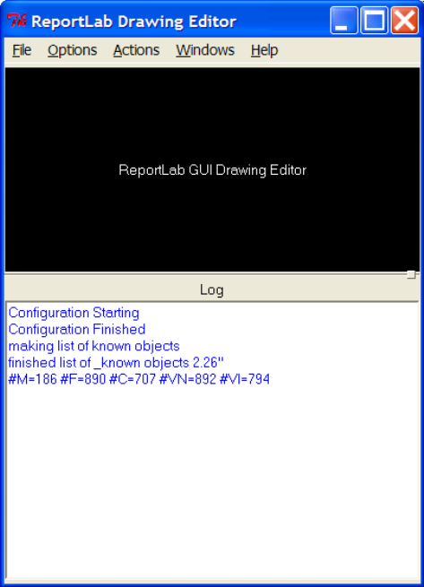

The drawing editor is not intended for untrained customers, but it will be very helpful to view chart scripts, see what properties have which effect, and to create new ones in development.

Create an EPS chart with sample_eps.py
This is the "realistic test" – it does exactly what your C code will do.

On Windows we supply an executable, geneps.exe, which calls the C API the same way your code will. (This is simply a compiled version of the short C program in src/; you can compile the latter on Mac OS X or Windows).

This accepts a file containing Python source as first argument. It prints the value returned by Python to standard output, and you can redirect this into a file.

We also provide a number of short Python scripts such as sample_eps.py. The command line below will pass this Python script to the program, and write a valid EPS file to the disk.

C:\temp\testembed\diagnostics>..\geneps.exe sample_eps.py > sample.eps

C:\temp\testembed\diagnostics>dir *.eps

Directory of C:\temp\testembed\diagnostics

05/05/2007 23:34 8,802 sample.eps

Other chart creation examples
The other short Python scripts in diagnostics/ are example strings which may be passed to geneps or your own C code. You may wish to look at these.

TODO: run all of them and say what they do.

The Diagra C interface
This section details how C can be used to call the library to create charts in various formats.

The library has 2 entry points which are conceptually similar. In both cases you pass a chunk of executable code (a script) to the library, and it returns a binary ‘object’. The script will hopefully be a short string specifying which chart and which properties to create, and the return value is likely to be an EPS or GIF or PDF file.

The C interface is actually a generic technique for embedding Python in another program. You send a string of Python code to it, it gets executed, and various things can be returned. There is nothing about charts in it whatsoever; instead, the string you pass through starts with a line to invoke the relevant chart class. This means that you would use the same API to access our PDF-making capabilities as for charts.

C API

You call one of two functions in the Shared Library: rl_run_file or rl_run_string. You either pass a chart format string to rl_run_string, or you pass a filename containing such text to rl_run_file. You get back a struct with an error-or-success flag, the length of the result, and a pointer to the location of the result. The result object can be ANYTHING but in the case of the above program (and most of ours) it is an EPS file (i.e the same block of bytes that you would find in an EPS file on the disk).

The program below is an example program which demonstrates correct use of both APIs. It can be given a number of “input files” on the command line. Each of these contains a chart configuration string as documented elsewhere in this manual. It them calls a simple ‘hello world’ chunk of code through the API.

#include <stdio.h>
#include <io.h>
#include <stdlib.h>
#define WIN32_LEAN_AND_MEAN
#include <windows.h>

typedef struct {
char* errorString;
int resultStringLength;
char* resultString;
} rl_embed_rt;
__declspec(dllimport) rl_embed_rt rl_run_file(char*);
__declspec(dllimport) rl_embed_rt rl_run_string(char*);
void main(int argc, char** argv)
{
rl_embed_rt r;
if(argc<2){
fprintf(stderr,"Use %s script script.....\n", argv[0]);
exit(1);
}
else{
int i;
for(i=1;i<argc;i++){
printf("=============================\nStart rl_run_file(%s)\n", argv[i]);
r = rl_run_file(argv[i]);
printf(" finish r.errorString = %s\n", r.errorString==NULL ? "(NULL)" : r.errorString);
printf(" r.resultString %d bytes = %s\n", r.resultStringLength, r.resultString==NULL ? "(NULL)" : r.resultString);
}
}
printf("=============================\n");
printf("Doing string run Hello World\n");
r = rl_run_string("print 'Hello World from trl_embed.c'\n");
printf(" finish r.errorString = %s\n", r.errorString==NULL ? "(NULL)" : r.errorString);
printf(" r.resultString = %s\n", r.resultString==NULL ? "(NULL)" : r.resultString);

The Interface Routines & Structure

The Interface Routines & Return Structure:
rl_embed_rt rl_run_file(char*);
rl_embed_rt rl_run_string(char*);
rl_embed_rt rl_register_ttfont(char *name, char *data, int len))

typedef struct {
char* errorString;
int resultStringLength;
char* resultString;
int uncaughtError;
} rl_embed_rt;

‘errorString’ above holds the result of any and all writes to Python’s sys.stderr stream. This will be used to indicate both warnings and serious error conditions. If an unrecoverable or uncaught error occurs then uncaughtError will be non-zero. It is assumed that we only write normal null terminated strings to stderr so we don’t need a separate length variable for errorString. The normal output of the script is returned in the pair of fields resultStringLength & resultString. Because we may choose to return non-Ascii values in the result (eg a GIF file) the result may contain null characters. We therefore provide a length as well as a pointer to the value. Note that either or both of the string pointers in the rl_embed_rt structure may be NULL indicating that the corresponding value was empty. If non-empty these strings should both be assumed to be inviolate (ie don’t try to free them).

rl_run_file
This routine has a single string argument, the name of a script file that contains the code that is to be run. The return value is of type rl_embed_rt (see above).

rl_run_string
This routine takes a single string argument that should contain a fragment of Python code that is to be run. . The return value is of type rl_embed_rt (see above).

rl_register_ttfont
The function described herein is unnecessary if using the automated fontfinder, documented below.

If compiled with freetype support the compact distribution will support True Type fonts. These fonts can be pre-registered by supplying them in memory using rl_register_ttfonts. This makes sense if the embedding application has already loaded the font files into memory. The name argument is a null terminated string that scripts will use to reference the font eg "Garamond", argument data should point to the TTF file in memory; the length of the memory should be passed in the third argument, len.

An alternative interface is available in Python code using code such as

from reportlab.pdfbase import pdfmetrics, ttfonts
pdfmetrics.registerFont(ttfonts.TTFont("Garamond",
"c:\\winnt\\fonts\\gara.ttf"))

A trivial exercise
You can try passing this ‘code chunk’ to the API:

mystring = ‘hello’
import __main__
__main__._rl_embed_result = mystring.reverse()

This should assign the string ‘elloh’ to the variable _rl_embed_result.

Creating a simple chart
The following code snippet would create a simple column chart with a title and a legend:

from rlextra.graphics.quickchart import quickChart
drawing = quickChart(chartType='column',
width = 400,
height = 250,
data = [[20,25,30],[22,27,32]],
seriesNames = ["widgets", "sprockets"],
titleText = "Profit Growth",
legendPos = "top_right")

import __main__
__main__._rl_embed_result = drawing.asString('eps')

The chart this creates is shown here:
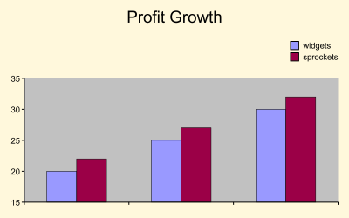

The EPS file we create containing this chart may contain a bitmapped preview image. By default this preview is OFF (so since we haven’t specified it, this chart will not have one). To switch the preview on, replace the last line with the following:
__main__._rl_embed_result = drawing.asString('eps', preview=1)

To make sure the preview is suppressed, use the following:
__main__._rl_embed_result = drawing.asString('eps', preview=0)

Creating a more complex chart or graphic
In general one would use the draweing editor to create a ‘master drawing’ looking the way you want. The code passed through at run time would have a line to construct the chart, and then further lines to set the data properties, title or whatever changed from one chart to the next. In general, the property settings can all be discovered from the drawing editor.

Creating a barcode
Barcodes can’t be created using the quickChart compatibility layer – the method we have for quickly creating charts. If you need to create barcodes, you’ll need to do with from the basic classes in the reportlab graphics package – see section 5.2.4 (Barcodes) for a snippet on how to do this.

Note on Font Registration
The examples given so far, and used for diagnostics, use a minimal set of fonts which are embedded inside our library for testing only. We have built in support for the following fonts:

Helvetica, Times and Courier (in regular, bold, italic, and bold-italic variants); Symbol and
ZapfDingbats.

LettError-RobotChrome: a highly stylised Type 1 font provide by the author, Just van Rossum. JvR is the brother of Python's author, and a typographer. LettError is very useful for testing, because it looks different to anything else.

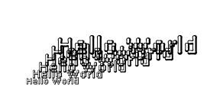

Rina: a stylised TrueType font which is easy to recognise, included in a Regular face only. Here's some Rina:

Bitstream Vera Sans: a TrueType "family of four" fonts which is redistributable. This has been included so that we have one "family of four" fonts in bold/italic combinations. Unfortunately Vera is not particularly distinctive.

Direct script-based chart creation
In general, Diagra will be called from a C API. However, this may need to be built to order, and some discussion is needed on getting the right compact distribution. This section shows a very simple way to 'cheat' and start prototyping from the command line. This can be done with our standard ReportLabJumboInstaller on Windows, and a standard copy of Python.

This will be slow, but will let you make code

Calling python scripts directly
If you've followed our standard installation instructions (on http://developer.reportlab.com/intall.html), then you will have the Python interpreter on your system – e.g. in C:\python23.

Thus, any simple script can be executed in the current directory by typing its name at a DOS prompt, or by passing it as first argument to the python executable. All 3 of these are equivalent:

C:\temp\charts>hello.py
hello, world

C:\temp\charts>python hello.py
hello, world

C:\temp\charts>c:\Python23\python.exe hello.py
hello, world

So, what you will do is generate your python snippet, save it to disk as a script, and execute it using an API call such as ShellExecute.

Modifying the code to save the chart
Recall section 5.4 above. The following code snippet would create a simple column chart with a title and a legend, and pass it back to the calling C program. The 'passing back' happens in the last two lines, which are in bold

from rlextra.graphics.quickchart import quickChart
drawing = quickChart(chartType='column',
width = 400,
height = 250,
data = [[20,25,30],[22,27,32]],
seriesNames = ["widgets", "sprockets"],
titleText = "Profit Growth",
legendPos = "top_right")

import __main__
__main__._rl_embed_result = drawing.asString('eps')

The alternative approach is just to call the Python interpreter directly. Your application will construct a script where the last lines actually save the chart, and then execute it. Here's a generic way to do this for all output formats:

from rlextra.graphics.quickchart import quickChart
drawing = quickChart(chartType='column',
width = 400,
height = 250,
data = [[20,25,30],[22,27,32]],
seriesNames = ["widgets", "sprockets"],
titleText = "Profit Growth",
legendPos = "top_right")

drawing.save(format=['eps','pdf','gif'], fnRoot='mychart', verbose=1)

The last line here is longer than we actually need: it tells Diagra to create three files called 'mychart.eps','mychart.pdf' and 'mychart.gif' in the current directory, and to print a line saying it has done so. If I saved this to disk in a file called 'example1.py', and executed it from a DOS prompt, I'd see this:

C:\temp\charts>example1.py
generating PDF file C:\temp\charts\mychart.pdf
generating gif file C:\temp\charts\mychart.gif
generating EPS file C:\temp\charts\mychart.eps

This takes advantage of the fact that the .py extension is registered with the Python executable when Python gets installed; it will work for a developer with a stock copy of Python. However, if we've bundled Python with another app and don't want to rely on this, the correct approach is
c:\path\to\python.exe scriptname.py

In addition, once we know it works and want to do it under program control, we can slim down the last name of our script. We don't need the verbose standard output, and we don't need the PDF and GIF versions, so can do
drawing.save(format=['eps'], fnRoot='mychart')

Using the Postscript renderer
If we know we are only making EPS, we can achieve more fine-grained control by using a different function to save the EPS file. The EPS rendering module, rlextra.graphics.renderPS_SEP, exports a function drawToFile which has some useful options.

Here is the example script to save an EPS quickchart to disk. Note the extra import line at the top:

from rlextra.graphics.quickchart import quickChart
from rlextra.graphics.renderPS_SEP import drawToFile

drawing = quickChart(chartType='column',
width = 400,
height = 250,
data = [[20,25,30],[22,27,32]],
seriesNames = ["widgets", "sprockets"],
titleText = "Profit Growth",
legendPos = "top_right")

drawToFile(drawing, 'output.eps', title='',company='',dept='')

Postscript rendering options
The function drawToFile supports some useful options, summarized here:
def drawToFile(d,fn,
showBoundary=rl_config.showBoundary,
dviPreview=None,
title=None,
company=None,
dept=None,
preview=0):
The drawing and filename parameters are compulsory.

A small bug was found and fixed on 23/2/2005: Prior to this you need to set the title, company and department to a string (which can be empty), or it will cause an error. With newer versions you can omit these three arguments.

The preview parameter states whether a bitmap preview should go into the EPS file. Turning this off makes generation faster, and cuts out the need for a lot of rendering libraries. The example above produces a 360kb file with preview, and 19kb (in under half the time) without it.

The title, company and dept parameters are embedded in EPS files for information and have no appearance on rendering. They can be seen in the source and in properties dialogs in various graphical applications. You can set it to your company name, or ours if you feel grateful!

showBoundary can be set to 0 or 1; 1 will create a very thin black line around the drawing to give it a visible boundary.

Font directories

import reportlab.lib.fontfinder
ff = reportlab.lib.fontfinder.FontFinder()
ff.addDirectory("c:\\windows\\fonts")
ff.search()
found 274 fonts; skipped 11; bad 8. Took 15.26 seconds
xml = ff.getFamilyXmlReport()
import __main__
__main__._rl_embed_result = xml

Tips on wrapping the executable
When you do this from a DOS prompt and just supply a file name, the chart will be saved in the current directory. When you run within another program, the current directory is not always obvious. Therefore, you either need to know where the current directory is, or the command to be executed should ideally include the full path to the Python executable, and the full output path should be specified in the filename parameter.

Performance Considerations
The technique of executing a script directly carries some overhead, as one starts up Python and our entire library just to make one chart. On Windows this can be a second or more, although it is much faster on Unix. CGI charts basically use this technique.

It can be very efficient and simple in two cases: one, where you want to generate a batch of charts in a loop (or kick off a data-aware chart to make hundreds of charts);

Chart types and properties
Our chart library was originally designed for a philosophy of ‘exact positioning’. Users create a master chart in a GUI from one of a number of chart types, set the properties and preview it. This works very well for publishing and allows very precise control over all aspects of a chart. However, each chart class was written differently and may have different properties. They are added to all the time and the best way to find out about one of them is to create one and play with it in the Drawing Editor.

However, some licensees need to create dialogs of their own to offer a simple, Excel-like interface to their customers. This requires a different kind of interface. We added a ‘consistency layer’ over the top of all the chart modules, called quickChart. This is a function which accepts optional arguments and returns a drawing.

QuickChart: the new compatibility layer

QuickChart adds a single additional layer over our framework with a finite and consistent set of properties. It can quickly create a drawing to order, with title, legend, chart, various labels and so on - and will make sensible decisions about the space taken up by each.

The philosophy behind quickChart is that sensible, visually pleasing defaults are picked for anything which is not specified. This is most obvious for font sizes – the largest font size is picked for the title, a medium-sized font is used for the X and Y axis titles, and a smaller one is used for the various axis, bar and column labels. These work to give the chart a unified appearance (since they are all in proportion to the chart size and related items are the same size). It is possible to over-ride these automatic options but there is very little sanity checking if you do this – we assume that if you specifically give a size or dimension then this is exactly what you intend and you know what you are doing.

You should have a method for passing in an “undefined” or “automatic” value for most options. This should translate to a “None” which is passed to quickChart. In most cases this can be the string “None” which is automatically converted by quickChart to the Python None value. If you do not do this and force the user to make their own selections, you miss out the most powerful features of the quickChart API.

The currently allowed chart types are:
'area', 'stacked_area', 'percent_area', 'doughnut',
'bar', 'clustered_bar', 'percent_bar', 'stacked_bar', ‘bubble’,
'column', 'clustered_column', 'percent_column', 'stacked_column’,
'linechart', 'linechart_markers', 'lineplot', 'lineplot_markers',
'pie', 'exploded_pie', 'scatter', 'scatter_lines', 'scatter_lines_markers',
'radar', 'filled_radar', 'radar_markers',
'bar3d', 'column3d', 'pie3d', 'exploded_pie3d', 'linechart3d', 'lineplot3d'

(Area and bubble are now complete).

NB the previously valid ‘line', and 'line_markers' charts have been replaced by ‘lineplot', and 'lineplot_markers'. See the section on line charts vs line plots (in section 5.1.5).

A great way to play with this is using a web based demo here:
http://server.reportlab.com/cgi-bin/webcharts.cgi

QuickChart interface specification.
Here is the Python API for construction of a QuickChart:

quickChart(
chartType='column',

width=400,
height=270,

#array of data for the chart.
data="100 120 140 160\n110 130 150 180",
textData=None,
categoryNames=None,
seriesNames=None,

#series arrangement
seriesRelation=None, #or 'stacked' or 'percent'

#colors for chart
chartColors = None,

#chart title
titleText = '',
titleFontName = 'Helvetica',
titleFontSize = None,
titleFontColor = black,

#big labels saying what each axis is
xTitleText = '',
xTitleFontName = 'Helvetica',
xTitleFontSize = None,
xTitleFontColor = black,

yTitleText = '',
yTitleFontName = 'Helvetica',
yTitleFontSize = None,
yTitleFontColor = black,

#visibility and text properties for each axis
xAxisVisible = 1,
xAxisGridLines = 0, #0 or 1
xAxisFontName = 'Helvetica',
xAxisFontSize = None,
xAxisFontColor = black,
xAxisLabelAngle = None,
xAxisLabelTextFormat = None,
xAxisLabelTextScale = None,

yAxisVisible = 1,
yAxisGridLines = 0, # 0 or 1
yAxisFontName = 'Helvetica',
yAxisFontSize = None,
yAxisFontColor = black,
yAxisLabelAngle = None,
yAxisLabelTextFormat = None,
yAxisLabelTextScale = None,

#data labels.
dataLabelsType=None, #None, values,
#percentage, labels/fields(?)
dataLabelsFontName = 'Helvetica',
dataLabelsFontSize = None,
dataLabelsFontColor = black,
dataLabelsAlignment = None, #top, bottom, center
#or None (for default)

#markers for lines eg, in scatter_lines_markers
markerType = None,
markerSize = 6,

# legend properties.
legendPos = 'right',
legendText = None,
legendFontName = 'Helvetica',
legendFontSize = None,
legendFontColor = None,

# background of entire drawing
bgColor = None,
plotColor = backgroundGrey,
bgStrokeColor = None,

chartFillColors=None,
chartStrokeColors=None,
chartStrokeWidth=None,
chartSeparation=0,

#'advanced' arguments which may be needed by
#a power user
showBoundaries = 0, #show how space is divided up,

drawingClass = Drawing,
pad = None,
padMax=None,
padMin=None,
padFrac=0.05,

checkLabelOverlap=0,
orderMode='fixed',
pointerLabelMode=None,
legendVariColumn=1,
legendXPad=None,
legendYPad=None,
legendMaxHFrac=None,
legendMaxWFrac=None,
)

QuickChart Defaults

These are the default values for a call to quickChart. Where a default is not specified, it is either None or 0 (ie that property will not be displayed unless you supply a value).

chartType: 'column',
width: 400,
height: 270,
titleFontName: 'Helvetica' (but no titleText),
titleFontColor: black,
xTitleFontName: 'Helvetica' (but no xTitleText),
xTitleFontColor: black,
yTitleFontName: 'Helvetica' (but no yTitleText),
yTitleFontColor: black,
xAxisVisible: 1,
xAxisFontName: 'Helvetica',
xAxisFontColor: black,
yAxisVisible: 1,
yAxisFontName: 'Helvetica',
yAxisFontColor: black,
dataLabelsFontName: 'Helvetica',
dataLabelsFontColor: black,
legendPos: 'right',
plotColor: backgroundGrey,
markerSize: 6,

QuickChart Chart Gallery
The following section shows illustrations of each of the quickChart chart types for quick reference.

area  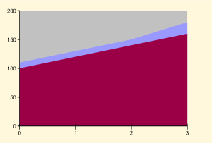 | bar  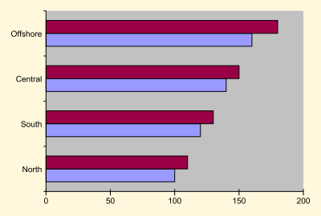
bar3d  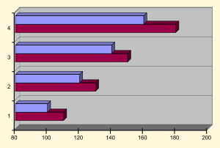 | bubble  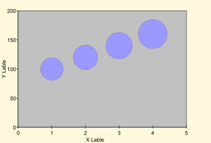
clustered_bar | clustered_column  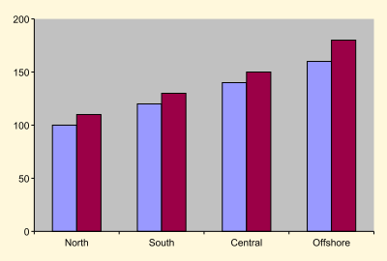
column | column3d  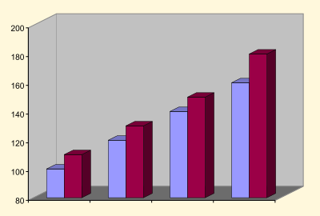

doughnut  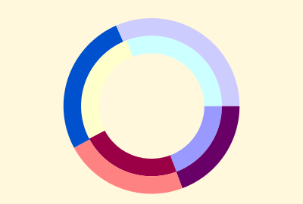 | exploded_pie  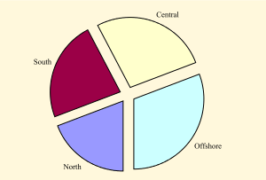
exploded_pie3d  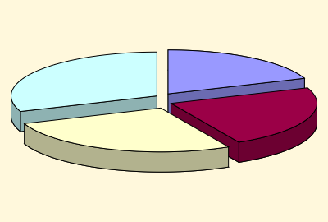 | filled_radar  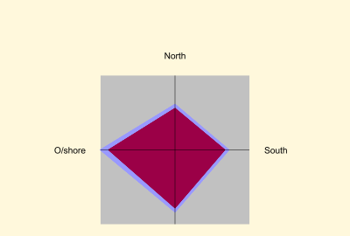
linechart_markers  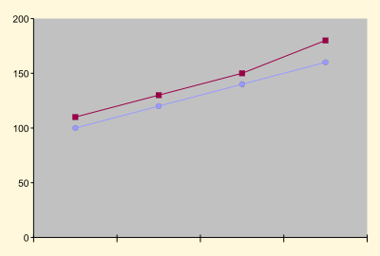 | linechart  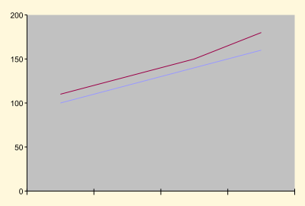
lineplot_markers  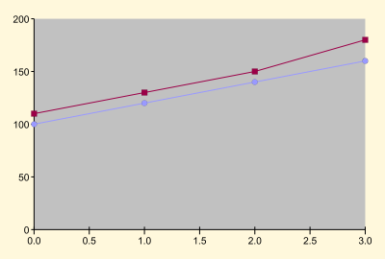 | lineplot  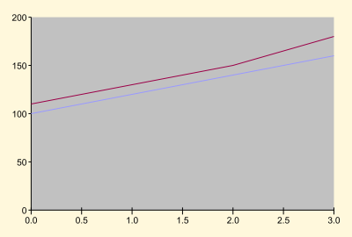
lineplot3d  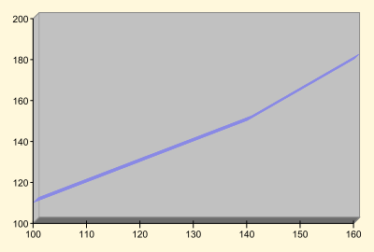 | linechart3d  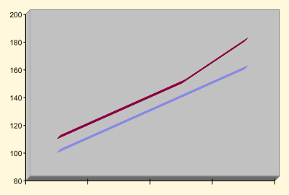
percent_bar  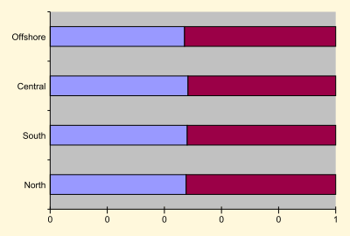 | percent_area  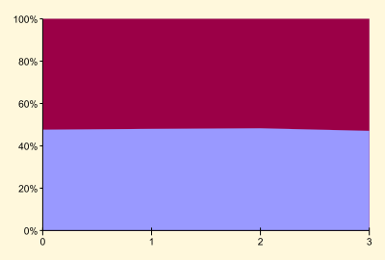
pie  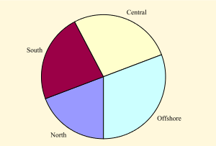 | percent_column  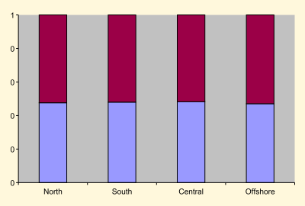
radar  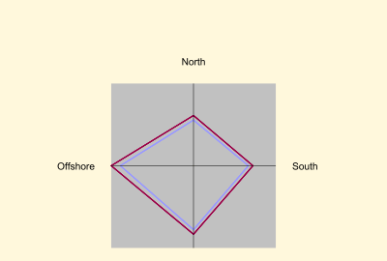 | pie3d  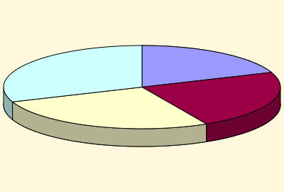
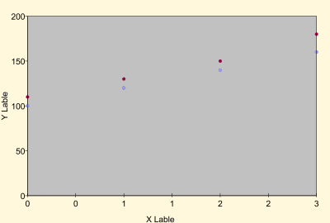  scatter | radar_markers  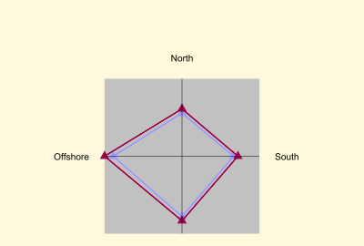
scatter_lines_markers  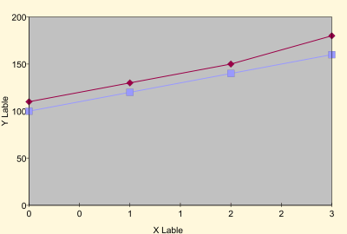 | scatter_lines  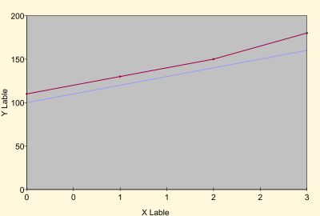
stacked_area  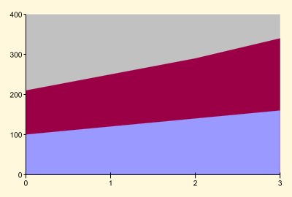 | stacked_bar  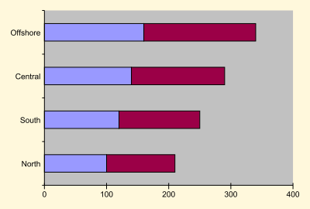
stacked_column

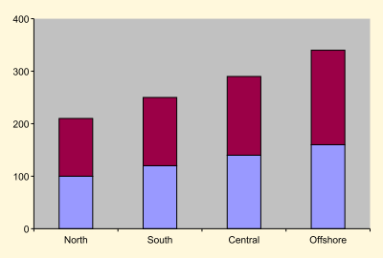

Notes:

- ‘clustered_bar’ is identical to the basic ‘bar’ type,
‘clustered_column’ is identical to the basic ‘column’ type
- doughnut should now work correctly.
- 'line' and 'line_markers' have been replaced by ‘lineplot', and 'lineplot_markers'. See the section on line charts vs line plots (in section 5.1.5).

QuickChart examples
Here are a few examples of how to use quickChart. They show the code snippets you would pass through the API:

Column chart with a height of 100, and a width of 200.

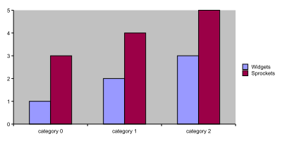

quickChart(data=[[1,2,3], [3,4,5]], height=100, width=200)

from rlextra.graphics.quickchart import quickChart
drawing = quickChart(width = 100,
height = 200,
data = [[1,2,3], [3,4,5]],
)
import __main__
__main__._rl_embed_result = drawing.asString('eps')

Notice how you only need to specify the properties you need to change from the defaults. Since ‘column’ is the default chart type, you do not even need to specify this. You do need to specify the data for your chart, however.

Pie chart with title

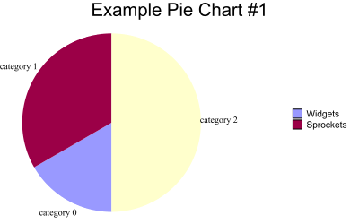

from rlextra.graphics.quickchart import quickChart
drawing = quickChart((data=[[1,2,3]],
chartType= 'pie',
titleText='Example Pie Chart #1'
)
import __main__
__main__._rl_embed_result = drawing.asString('eps', preview=0))

Notice how this chart uses the ‘preview’ argument in the asString function call. This suppresses the bitmap preview embedded in the EPS output (use preview=1 to switch it on).

More complex column example

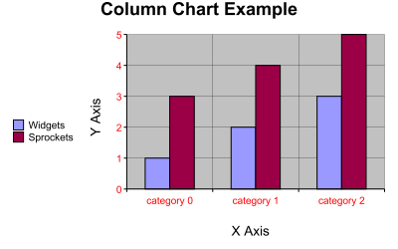

from rlextra.graphics.quickchart import quickChart
drawing = quickChart(data=[[1,2,3], [3,4,5]],
chartType='column',
titleText = 'Column Chart Example',
titleFontName = 'Helvetica-Bold',
titleFontSize = 18,
xTitleText = 'X Axis',
xTitleFontName = 'Helvetica',
xTitleFontColor = red,
yTitleText = 'Y Axis',
yTitleFontName = 'Helvetica',
yTitleFontColor = red,
xAxisVisible = 1,
xAxisGridLines = 1,
xAxisFontName = 'Helvetica',
xAxisFontSize = 10,
xAxisFontColor = red,
yAxisVisible = 1,
yAxisGridLines = 1,
yAxisFontName = 'Helvetica',
yAxisFontSize = 10,
yAxisFontColor = red,
legendPos = 'left',
chartStrokeColors=black,
chartStrokeWidth=1)
import __main__
__main__._rl_embed_result = drawing.asString('eps')

QuickChart Properties
This section contains a list of all the properties that quickChart uses with appropriate descriptions and code snippets. Note that all the charts have a cornsilk coloured background in these illustrations – this shows up the edge of the chart area. By default there is no background, this coloured one is just used for illustration.

chartType
This specified which type of chart you wish to create. Allowed values are
'area', 'stacked_area', 'percent_area', 'doughnut',
'bar', 'clustered_bar', 'percent_bar', 'stacked_bar', ‘bubble’,
'column', 'clustered_column', 'percent_column', 'stacked_column’,
'linechart', 'linechart_markers', 'lineplot', 'lineplot_markers',
'pie', 'exploded_pie', 'scatter', 'scatter_lines', 'scatter_lines_markers',
'radar', 'filled_radar', 'radar_markers',
'bar3d', 'column3d', 'pie3d', 'exploded_pie3d', 'linechart3d', 'lineplot3d'

Used by: All charts

Many of the types are ‘sub-types’ of other types. lineplot_markers is a subtype of the lineplot chart with markers placed on the lines. In many cases, these can be simulated by a mix of other properties. For example, the charts produced by these two snippets would be identical:

quickChart(chartType='lineplot_markers',
width=400,
height=270)

quickChart(chartType='lineplot',
width=400,
height=270,
markerType = 'FilledCircle',
markerSize = 6)

Also, the main type chart is usually duplicated by one of the subtypes. The basic version of a bar chart is a clustered_bar, so the ‘bar’ and ‘clustered_bar’ charts produce identical output.
- line charts vs line plots
The chart type ‘line’ has been split into lineplot and linechart. Linechart is intended for discrete data, which is why it has a category axis for the x axis. Lineplot is intended for continuous (or fractional) data, and it has two value axes.
The format in which data is passed to them also differs. Linechart expects data as multiple series, in the same way as bar or column charts. These become the y values plotted on the chart. Lineplot expects two or more lists of numbers – the first becomes the common x values, and the second and subsequent lists of numbers are used for the y values used to plot the lines.

width, height
The width and height for the chart (in pixels or points depending on the output format). Each of these must be a number, but quickChart can handle floating point numbers as well as integers.
Used by: All charts

data
This is the array of data for the chart.

There are two forms it can take, either as a string or as a list (or lists of lists) .

- providing data as strings
For a single series (as used in for example pie charts), the data can be supplied in a string enclosed by quotes (either single or double) and separated by spaces:
quickChart(data="1 2 3")

For multiple series (eg bar charts with more than one set of bars), the series can either be separated by a newline inside a string enclosed by treble quotes, or the literal \n inside a string enclosed by normal quotes.

quickChart(data="""1 2 3
1 2 3""")

quickChart(data="1 2 3\n1 2 3")

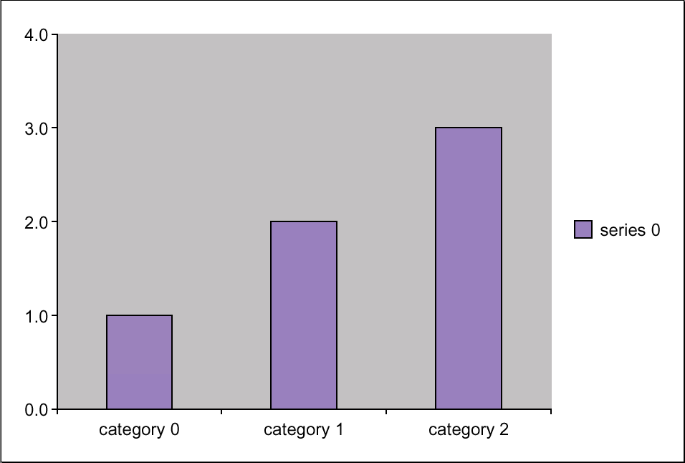 | 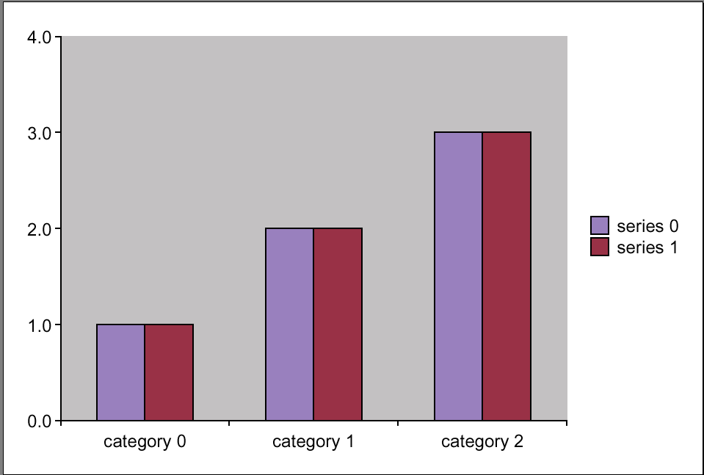
quickChart(data="1 2 3") | quickChart(data="""1 2 3  1 2 3""")  or  quickChart(data="1 2 3\n1 2 3")
- Providing data as lists

This is slightly more complex, since it changes depending on the chartType being used. For a chart type which expects a single series (such as ‘pie’ and ‘exploded_pie’), you can supply a single series in a simple list

quickChart(data=[1,2,3])

Notice how the data items are separated by commas and enclosed by a single set of square brackets.

For a chart expecting multiple series (ie columns, bars, lines), a single series can be supplied in the data as a single list contained in an outer list:
quickChart(data=[[1,2,3]])

For multiple series (eg bar charts with more than one set of bars), the series are supplied as multiple lists inside an outer container list.

quickChart(data=[[1,2,3],[1,2,3]])

Notice how there are two individual lists separated by a comma in between them.

How charts handle data

- Singles series charts
The following are ‘single series’ chart – if multiple series are submitted, only the first is used and any subsequent series are ignored.
The charts which use a single series are:
- pie
- exploded_pie
An example of how these look is
data=[1,2,3]

- Multiple series charts
The following are ‘multiple series’ chart – if multiple series are submitted, then additional chart elements are created, such as an additional set of bars in a bar chart. A single series has one set of bars of the same colour, adding another series adds another set of bars of a second colour and so on.
The charts which use a multiple series are:
  - area
  - stacked_area
  - percent_area
  - bar
  - clustered_bar
  - percent_bar
  - stacked_bar
  - column
  - clustered_column
  - percent_column
  - stacked_column
  - doughnut
  - linechart
  - linechart_markers
  - linechart3d
  - radar
  - filled_radar
  - radar_markers
An example of how these look is
data=[[1,2,3], [5,6,7], [10,20,30]]

- X-Y charts
Another type of multi-series chart handles the series in a different manner to the type above. With these, the first series provides one property, and the subsequent series provide multiples of a second property. For example, with scatter plots, the first series provides the data for co-ordinates on the X axis, the second and later series provide further instances of data for co-ordinates on the Y axis. This means that you can have multiples lines (in a 'scatter_lines', or 'scatter_lines_markers' version) where the points all line up against the same ticks on the X axis but have independent vertical positions against the Y axis. (Excel also does this for certain types of chart). If you only provide one series, the missing one is synthesized for you – the chart library will take its ‘best guess’ for the missing data.

The charts which use this kind of data are:
- bubble
- scatter
- scatter_lines
- scatter_lines_markers
- lineplot
- lineplot_markers
- lineplot3d

An example of how these look is
data=[[1,2,3], [5,6,7], [10,20,30]]
(This looks exactly the same as the multi-series charts above, but is handled differently by the chart library)
NB With the bubble charts, the repeated elements are Y and Z, rather than just Y. So, if you use this data:
data=[[15,25,35], [21,32,43], [10,20,30], [10,20,30], [1,2,3]]
It breaks down as:
X: [15,25,35]
Y1: [21,32,43]
Z1: [10,20,30]
Y2: [10,20,30]
Z2: [1,2,3]

And you create a chart which looks like this:
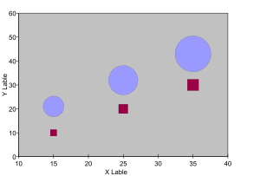

categoryNames
With bar charts the categories appear at the base of the bars on the X axis (and can refer to bar from multiple series). With column charts, they appear on the Y axis. With pie charts, they are used to make up the legend, and may appear as data labels.

The category names should be specified as a string containing the names separated by spaces:
quickChart(categoryNames="spam ham dongles")

When none are specified, the defaults of “category 1… category N” are used.

seriesNames
With some charts you can supply multiple series: for example in a column chart, multiple series give you two different sets of coloured columns. The seriesNames property allows you to name these series. When a legend is supplied (see the section on legend properties below), the name associated with the colour swatches in the legend come from the seriesNames. (NB, the seriesNames are not used for the legends for pies – those come from the categoryNames).

The series names should be specified as a string containing the series names separated by spaces:
quickChart(seriesNames="spam ham dongles")

chartColors
These are the colours to be used for the main items of the chart (ie the wedges in a pie chart, the bars in a bar chart, the columns in a column chart). They can be specified in a number of ways:

- A string which contains a list of colours which Diagra knows about.
These can be named colours, RGB colours, CMYK colors, PCMYK colors. For a discussion of these, see the section on titleFontColor below.
quickChart(chartColors="[Color(1,0,0), Color(0,1,0), Color(0,0,1)]")
This would give you a chart whose colours are red, green and blue.

- A string of named colours separated by spaces.
quickChart(chartColors="red green blue")
- A string of named colours separated by commas.
quickChart(chartColors="red, green, blue")

Note that if more slices/columns/bars are supplied than the colours in chartColors, they will ‘wrap-around’. If you supply 3 colours and 6 series in the data, then bars 1 and 4 will have the same colour, as will bars 2 and 5, and bars 3 and 6. Please also note, excess colors are ignored.

seriesRelation
In bar and column charts, this property decides how the bars/columns appear in relationship to each other. (It is also used by area charts, but ignored by all the others including pie, radar, and line charts).

This value should be one of the following:
None, ‘sidebyside’, 'stacked' or 'percent'

- None and ‘sidebyside’ do the same thing, and produce identical charts – in the case of column charts, the clustered column version.

- ‘stacked’ produces a chart where the bars in the second and subsequent series appear over the bars in the first (looking like single bars with multiple different coloured regions).

- ‘percent’ produces a stacked chart whose values have been normalized so that they sum to 100.

clustered_column  quickChart(chartType='column',  seriesRelation=‘sidebyside’  ) | stacked_column  quickChart(chartType='column',  seriesRelation=‘stacked’  )
percent_column
quickChart(chartType='column',
seriesRelation=‘percent’
)

titleText
titleFontName
titleFontSize
titleFontColor

These relate to the main title of the chart. They are used by all charts.

If the titleText = “”, then no title actually appears on the chart, otherwise this is the text used for it. The titleFontSize should be a number (not a string).

TitleFontName should be the name for a font known to the system (ie one of the standard 14 Adobe fonts or a font in a known location - make sure you have the correct AFM and PFB files for the font you required in a directory on the path).

The colour in titleFontColor (and the similar properties such as xTitleFontColor and yTitleFontColor) can be one of a number of formats:
- Named colours:
eg, ‘red’, ‘blue’, ‘lightgoldenrodyellow’.
These are mainly the named colours defined in the HTML 3.2 specification, plus one or two synonyms (such as ‘grey’ and ‘gray’).
- RGB colours:
eg Color(0,0,0), Color(1,1,1), Color(0.5,0.5,0.5)
These represent colors as their red, green and blue components, with the numbers being in the range 0 (dark) to 1 (full intensity).The above examples represent pure black, pure white and a shade of dark grey.

- CMYK colors:
eg CMYKColor((1,1,1,1), CMYKColor((0.5,0.5,0.5,0.5)
These represent colors using their CMYK (cyan, magenta, yellow, black)
components. Each number should be in the range 0 to 1.

- PCMYK colors:
eg PCMYKColor(100,0,0,0), PCMYKColor(100,25,25,25)
These are like CMYK colours in that they use the Cyan-Magenta-Yellow-
Black(Key) model from professional publishing, but differ in that each number
specifying a colour varies from 0-100 rather than 0-1.

This code snippet will produce the chart that follows it.

quickChart(chartType='column',
titleText=”THIS IS THE titleText”,
titleFontName=”Helvetica-Bold”,
titleFontSize=24,
titleFontColor=Color(0,0,1))
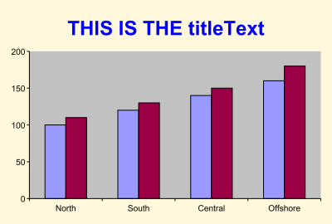
xTitleText
xTitleFontName
xTitleFontSize
xTitleFontColor

yTitleText
yTitleFontName
yTitleFontSize
yTitleFontColor

These work the same way for the xTitle (the label for the X axis of the chart) and yTitle (the label for the Y axis of the chart) as the title properties above do for the main chart title. For both of these, if the text is “” they do not appear or if it is a string then that is the text that is used for the relevant title, the FontName should be a recognised font, the size should be a number and the FontColor should be a colour specified in one of the ways above (Named colour, RGB colour, CMYK colour, PCMYK colour.

The following example should show how it works:

quickChart(chartType=’bar',
xTitleText=’This is the xTitle’,
xTitleFontName=’Helvetica-Bold’,
xTitleFontColor=PCMYKColor(100,25,25,25),
yTitleText=’This is the yTitle’,
yTitleFontName=’Courier’,
yTitleFontSize=12,
yTitleFontColor=Color(1,0.25,0.25))

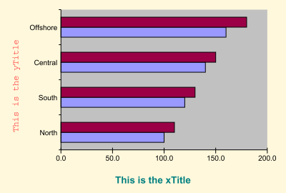
The ytitle has been specified as Courier with an RGB colour which is mainly red, and xTitle has been specified as Helvetica-Bold with a CMYK color which has a large amount of cyan in it.

xAxisVisible
xAxisGridLines
xAxisFontName
xAxisFontSize
xAxisFontColor
xAxisLabelAngle

yAxisVisible
yAxisGridLines
yAxisFontName
yAxisFontSize
yAxisFontColor
yAxisLabelAngle

The x and y axis properties apply to charts with x and y axes, specifically:
- 'bar',
- 'clustered_bar',
- 'clustered_column',
- 'column',
- 'line',
- 'line_markers',
- 'percent_bar',
- 'percent_column',
- 'scatter',
- 'scatter_lines',
- 'scatter_lines_markers',
- 'stacked_bar',
- 'stacked_column',

They also work (though slightly differently in the case of GridLines) for the following 3D charts:
- 'column3d',
- 'linechart3d',
- 'lineplot3d',

The xAxisVisible and yAxisVisible properties control whether the axis (and ticks and labels associated with it) are displayed at all. These properties override any other properties associated with that axis (with the exception of the axis titles described above). Accepted values are 0 or 1 for both of these.

For example, this following code

quickChart(chartType='column',
xTitleText='This is the X Axis',
yTitleText='This is the Y Axis',
xAxisVisible=0,
xAxisFontName='Courier',
xAxisFontSize=12,
xAxisFontColor=Color(1,0,0),
yAxisVisible=0,
yAxisFontName='Courier',
yAxisFontSize=12,
yAxisFontColor=Color(1,0,0)
)

produces the following chart:

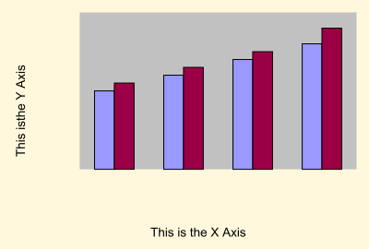
Notice that we have specified a number of properties for the x and y axis which don’t get used – they are overridden by xAxisVisible=0 and yAxisVisible=0. This will happen regardless of whether the x and y axis properties are specified before or after xAxisVisible=0 and/or yAxisVisible=0.

This following code is identical except for the fact that the AxisVisible properties are set to 1:

quickChart(chartType='column',
xTitleText='This is the X Axis',
yTitleText='This is the Y Axis',
xAxisVisible=1,
xAxisFontName='Courier',
xAxisFontSize=12,
xAxisFontColor=Color(1,0,0),
yAxisVisible=1,
yAxisFontName='Courier',
yAxisFontSize=12,
yAxisFontColor=Color(1,0,0)
)

Which produces this chart:

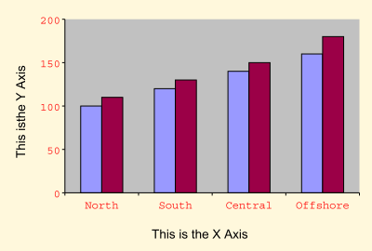
Now that the x and y axes aren’t overridden by the xAxisVisible and yAxisVisible properties we can see the red axis labels in red Courier text. The xAxisFontName, yAxisFontName, xAxisFontSize, yAxisFontSize, xAxisFontColor, and
YAxisFontColor properties all work in the same way as the similar properties for titles.

xAxisGridLines and yAxisGridLines
Gridlines produce a grid on the chart area (behind the bars, columns or lines making up the plot itself). As an example, this code:

quickChart(chartType='column',
xAxisGridLines=1,
yAxisGridLines=1)

produces this chart:
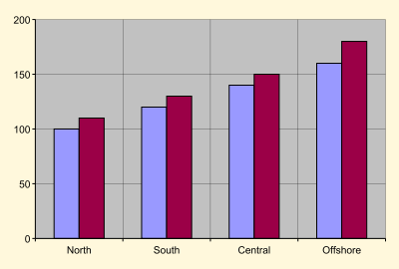
Notice the grey gridlines (both horizontal and vertical) appearing in line with the tick marks and behind the bars.

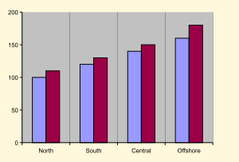  xAxisGridLines | 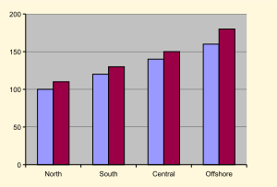  yAxisGridLines

NB The X axis is the axis in the X direction, ie horizontally. X-Axis Gridlines are gridlines which are connected to the X-Axis ie those which are vertical. They are NOT horizontal gridlines (in the X-direction). Similarly, Y-Axis Gridlines are those which are attached to the Y-Axis and are horizontal.

xAxisLabelAngle and yAxisLabelAngle

These control the angles which the labels on the X and Y axis are rotated from the axis itself. These numbers can be any angle, positive or negative. The examples below show some of the common angles used. These examples show both the xAxisLabelAngle and the yAxisLabelAngle being set to the same number for the sake of illustration – they can of course both be set independently of each other or left unset (in which case they default to 0).

angle: 45  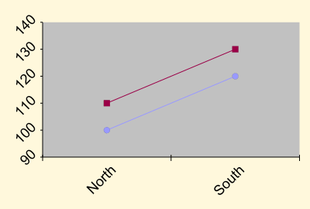 | angle: 90  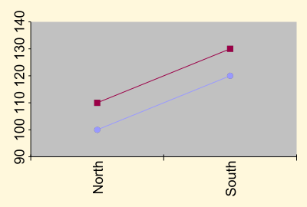
angle: -45  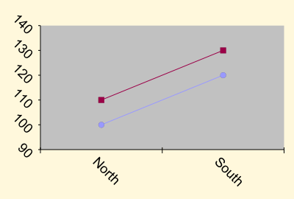 | angle: -90  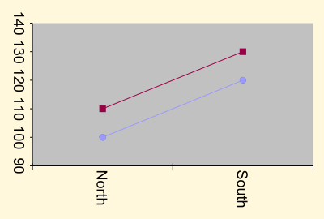

dataLabelsType

This controls the label which appears at the top of an individual bar in a bar chart (or a column in a column chart or a wedge in a pie chart). It allows four possible values:
None, “values”, “percent”, or a C style formatting string (eg “%0.2f”), or a dictionary substitution (eg "%(category)s"). There is a special case for percent eg “percent,2” gives percentage with 2 decimal places and a percent sign. This is equivalent to the dictionary format “%(percent).2f%%”. Note that if you use either the C formatting style or one of the standard dictionary substitutions you can add arbitrary strings before and after the substitution eg we could use “%(percent).2f%% per Year” as an acceptable format string. The allowed dictionary substitutions are “%(value)”, “%(percent)”, “%(category)” & “%(series)”. The trailing parenthesis must be followed by a C style format suffix eg .2f, there is no point in attempting anything other than an s format for the latter two as these are by definition strings.

For these examples, imagine you are using a data set that looks like this:
100.5 120.2 140.8 160.8

This is how the data labels would look with the various types:

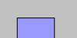  None  No data label is used. | 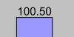  values  If this is used, the data must be supplied as a string. The EXACT text supplied is used as the data label. | 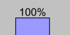  percent  Shows the value as a percentage.

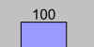  C-style format string: %d  %d shows the data labels as a ‘decimal’ ie no decimal places. | 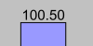  C-style format string: %0.2f  '%0.2f' for a ‘float’ with 2 decimal places

In addition to C style format strings, you can also do dictionary substitutions. For example, if you wish to have the category names being used, you can use the following:
dataLabelsType="%(category)s"

Similarly, for series names, you would use:
dataLabelsType="%(series)s"

textData
If this is supplied, the text supplied is used for the dataLabels. This is only enabled if the dataLabelsType is set to “values”. Elements in are separated by spaces, and data series should be separated by new lines (‘\n’characters).

No textData specified  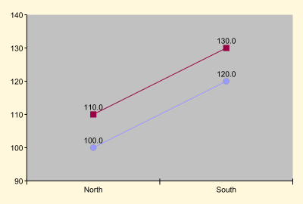 | textData='red_one red_two\nblue_one blue_two'  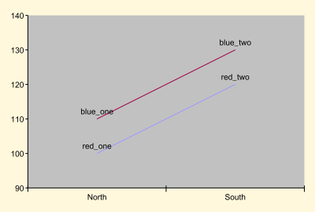

dataLabelsAlignment

As well as specifying what the dataLabels display, you can also specify where they appear relative to the bar they refer to:

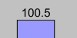  top  data labels appear above the bar border in a column chart or to the right in a bar chart (ie outside the bar) | 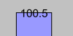  center  data labels appear on the border itself (straddles it) | 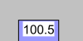  bottom  data labels appear below the bar border or to the left in a bar chart (ie inside the bar)

The alternative to any of these is using None, which allows quickChart to use its own defaults (which have been chosen so that they usually do something sensible). The default dataLabelsAlignment is None. DataLabels work for bar and column charts, but also for the 3d version (column3d).

How piecharts use datalabels

As we have seen, dataLabels can be None, “values”, “percent”, a C style formatting string (“%0.2f”), or a dictionary substitution ("%(categoryNames)s").

In all the following examples, we have set the dataLabels font size to be 24 to make the changes more obvious).

None, values, and percentage all work as you would expect:

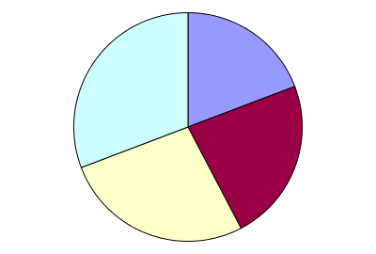  dataLabelsType = None  No datalabels are used for the pie sectors. | 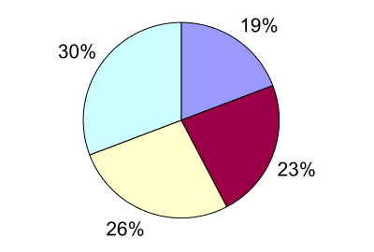  dataLabelsType='percent'  Percentages (with percent signs) are used to label the pie sectors. | 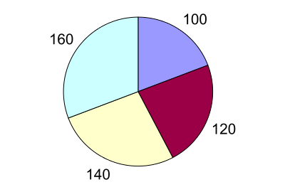  dataLabelsType='values'  The actual values (exactly as they are in the data attribute) are used as labels.

The various C-style formatting strings also work as you would expect:

dataLabelsType = '%d'  Each datalabel is the value formatted with no decimal places (ie as a ‘decimal’). | 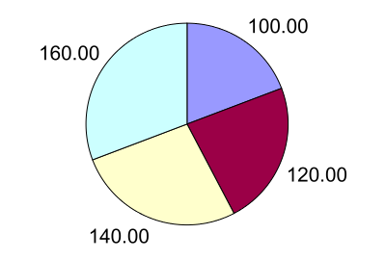  dataLabelsType = '%0.2f'  Each datalabel is the value formatted to 2 decimal places (ie as a float).

Dictionary substitutions need more care: '%(series)s' won’t be much use…

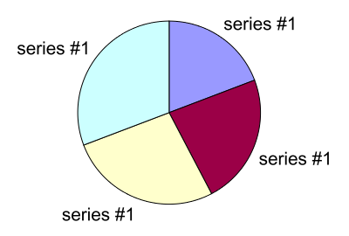 | Pies only have one series. Therefore attempting this:  seriesNames = ['series #1', 'series #2', 'series #3', 'series #4']  dataLabelsType = '%(series)s'  works, but produces useless results – all the sectors are labelled the same!

… but '%(category)s' works fine.

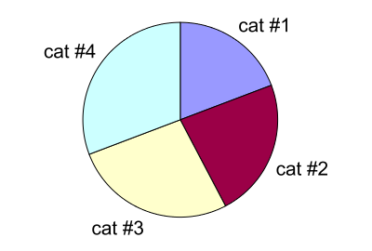 | There are multiple categories in the single series which a pie chart uses, so this is much more sensible:  categoryNames = ('cat #1', 'cat #2', 'cat #3', 'cat #4')  dataLabelsType = '%(category)s'

It is also possible to combine more than one of these, to produce mixed labels such as the following:

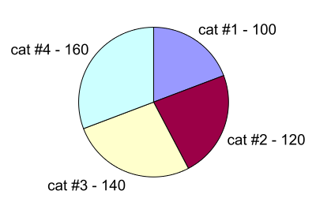 | You can combine one or more dictionary substitutions with plain text – such as the spaces and the dash being used as a separator here:  DataLabelsType = '%(category)s - %(value)s'

dataLabelsFontName
dataLabelsFontSize
dataLabelsFontColor
The font name, font size and font colour for the data labels. These work in the same way as those for titleText – look in the section on titleText for a description of how to use colours.

markerType
markerSize
Some types of chart allow you to use a marker at each data point. These are the allowed values for markerType:

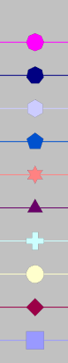
'FilledHeptagon'
'FilledHexagon'
'FilledOctagon'
'FilledPentagon'
'FilledStarSix'
'FilledTriangle'
'FilledCross'
'FilledCircle'
'FilledDiamond'
'FilledSquare'

In addition to those above, you can do None to use no markers at all, or 'Sequence' to run through them (ie series one uses a marker of FilledSquare, series two uses a FilledDiamond and so on).

The markerSize has a default of 6 and is used to set the size of the marker used.

legendPos
legendText
legendFontName
legendFontSize
legendFontColors

These are the properties related to legends. LegendPos is the position for the legend and should be one of the following:
- 'left',
- 'right',
- 'top',
- 'bottom',
- 'top_left',
- 'top_right',
- 'bottom_right',
- 'bottom_left',
- 'middle'

If legendPos is set to either ‘top’ or ‘bottom’, the legend will be one line high, and horizontally arranged. For the other versions it will be vertically arranged and take as many lines as are required.

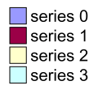 | Used for legendPos of left, right, top-left, top-right etc.
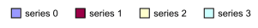 | Used for legendPos of top or bottom.

To suppress the legend altogether, use a legendPos of None.

Legendtext is the text to be used for the legends. This should be a list of strings
eg
LegendText = [“widgets”, “sprockets”, “doobries”]

LegendFontSize is the size of the font to be used and should be a number.
LegendFontName is the name of the font to be used for the legend.
LegendFontColors should be a list of colours in any of the formats discussed in the section on titleText

bgColor
plotColor
bgColor is the color to be used for the background for the whole drawing.
plotColor is the colour used for the background of the chart’s plotting area.

In the following example, the bgColor is green while the plotColor is yellow.

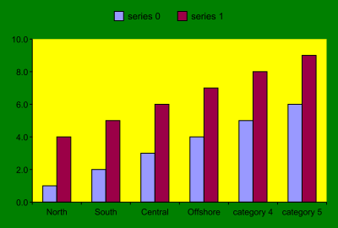

showBoundaries
This shows how space is divided up. It uses a red line to show borders. This is an advanced property useful when checking to see if chart layout routines are working correctly. Most users don’t need to set this.

drawingClass
An advanced property, used to specify which base class is used for the chart (either Drawing or DataAwareDrawing). Most users don’t need to change this.

pad padFrac padMax padMin
Used to specify a padding value; if not None, pad is used otherwise padFrac*width is computed. The value is limited so that padMin<=pad<=padMax.
checkLabelOverlap orderMode pointerLabelMode
Advanced properties used to control pie chart drawing. If checkLabelOverlap is true then pie charts will attempt to ensure their labels do not overlap. The value of orderMode is used to control the order in which slices are drawn so as to aid readability of slice labels. The default is ‘fixed’ which means use the existing order; the other value ‘alternate’ attempts to place the slices so that labels are more easily read. The default for pointerLabelMode is None which means use traditional slice labels; the value could be ‘LeftRight’ or ‘LeftAndRight’ which makes the pie chart use labels with pointers to the slices; the ‘LeftRight’ mode tries to put all labels on one side.

legendVariColumn legendXPad legendYPad legendMaxHFrac legendMaxWFrac
These advanced properties control various aspects of the legend layout. The legendVariColumn controls whether the legend should allow variable width columns. The default is True. The pad used by the legend may be overridden with the legendXPad & legendYPad which both default to None ie use the standard pad value.

The legendMaxHFrac & legendMaxWFrac values control the allocated space for a legend. Both default to None which implies a fairly robust attempt at getting space for the legend. If specified the absolute values are used as fractions of the width ie legendMaxWFrac = 0.5 means 50% of the width. If positive values are used then the computed restriction will be used in all cases; if a negative value is used then the computed value is used when appropriate ie legendMaxHFrac=-0.125 means 12.5% of the height is the allowed height when a horizontal style legend is required (that is when legendPos in (‘top’,’bottom’)).

Direct use of chart classes

It is possible to customize almost anything about one of our graphics, or even create a new one on the fly, with the correct chart format string.

To generate a chart of one of these types, you send through a ‘format string’. This string is actually executable Python code and will consist of multiple lines. It finishes by assigning a value to a special variable which can be retrieved by the C API. Here’s a very simple example just 5 lines long. All it does is set the numeric data of a chart (keeping all other defaults) and retrieve it in EPS format:

from reportlab.graphics.samples import clustered_bar
drawing = clustered_bar.ClusteredBar()

drawing.chart.data = [[20,25,30],[22,27,32]]

import __main__
__main__._rl_embed_result = drawing.asString('eps')

We will step through the various parts of this and explain their meaning.

Importing a base class
The first stage is to construct a Drawing object. Drawings are not necessarily charts. A single Drawing is a rectangle which can contain multiple charts, legends and anything else. It is possible to make a naked, blank drawing and explicitly add things to it. However, we will start the easy way by taking a “ready made” one from our 8 samples, which has a legend, a title and a bar chart.

from reportlab.graphics.samples import clustered_bar
drawing = clustered_bar.ClusteredBar()

The first two lines import the relevant code module defining the “Base Class” we are going to use. The “import” statement can find code modules anywhere on the python path, which is a lot like a Java classpath. This includes the current directory; various places under the Python distribution; and user-defined directories or ones which can be specified by the app. The second line just creates a drawing object. The variable name ‘drawing’ is arbitrary, but we recommend using it throughout.

If you are using the samples which are now “built in” to the Diagra.slb file, you can use the format above. If you are using an external directory of samples, you will need two additional lines at the beginning of the file:

import sys
sys.path.insert(0,"path to folder with the application and samples")

You may also need to add the path to your fonts directory. If it is in the standard location, it should look something like this:

from reportlab import rl_config
rl_config.T1SearchPath.append("Macintosh HD:System Folder:Extensions:fonts")

When you first start up the library, you should initialize it with something like the following. or the equivalent from whatever interface you now have at a higher
level. Duplicating this code won't hurt, but will be wasteful.

rl_run_string("import sys\
sys.path.insert(0,'path to folder with the application and samples')\
from reportlab import rl_config\
rl_config.T1SearchPath.append('Macintosh HD:System Folder:Extensions:fonts)");

If you are also using Truetype fonts, you may also need to set their location using the
TTFSearchPath - if these are in the fonts folder, you would add this line to the above:

rl_config.TTFSearchPath.append("Macintosh HD:System Folder:Extensions:fonts")

Setting drawing attributes
The next stage will be to set attributes of the drawing. Each drawing has many attributes, which are covered in our computer generated “graphics reference”. However the best place to get a QUICK idea of the important ones is to look at the source code of the Python modules listed above; apart from a bit at the beginning and the end, they are basically long lists of property assignments.

Even if you like the size and style of the sample drawing, you will almost certainly want to set its numeric data. For a bar chart this is a two-dimensional array formatted as follows.

drawing.chart.data = [[20,25,30],[22,27,32]]

If you use a line like this, it will override the “canned data” present in the sample drawing. You will probably also want to set up the ‘categories’. Specifically, the chart’s category axis has a list of categoryNames you can set:

drawing.chart.categoryAxis.categoryNames = ['North', 'South', 'Central']

There is nothing special about the data and categories. There are hundreds of properties. The best way to get a quick feel is to look in the source of the module clustered_bar.py. It was actually created with our “Drawing Editor”, and shows the properties that were set visually.

We will run through some of the more common things which need setting. The first one is likely to be the size.
Warning: when dealing with charts directly like this, there is no ‘auto sizing’. If you asked for a big drawing e.g. 400x300 instead of 200x150, the chart within it would be sitting lost in the bottom left corner.

You can set the size of the overall drawing. This is in points for vector formats (EPS, PDF) or pixels for bitmaps (PNG, GIF, JPG).

drawing.width = 400
drawing.height = 300

You can also set the position of any object within it, such as the chart itself. Charts have x,y,width and height, which defines the inner ‘plot area’; it is your responsibility to allow enough space for the axis labels.
drawing.chart.x = 50
drawing.chart.y = 50
drawing.chart.width = 200
drawing.chart.height = 140

For most charts there is a title, a chart and a legend, and you can set the positions of each. There is no automatic layout logic to size them. For the moment the quickest way to hide the legend is to move it off the page with a large negative x or y coordinate! We will make sure that there is some automatic logic to hide or remove legends shortly.

Each chart has a title label. This one is called, not surprisingly, ‘Title’. To change its text, position and font you might do this:

drawing.Title.fontName = 'Times-Roman'
drawing.Title.fontSize = 6
drawing.Title.x = 100
drawing.Title.y = 135
drawing.Title._text = 'Chart Title'
drawing.Title.maxWidth = 180
drawing.Title.height = 20
drawing.Title.textAnchor ='middle'

The Title is an instance of a Label object, which can be found in the graphics reference. Labels are quite smart; you can define if they are anchored by their start, middle or end, a bounding box to enclose them and force wrapping onto multiple lines, as well as font name and size.

Charts are object-oriented and most properties are found in sub-objects. For example you can set all the properties of the axis label text . All the available properties can be found by looking in the”graphics reference”
drawing.chart.valueAxis.labels.fontSize = 6

Finishing off
The final thing your script must do is to return something to the calling C program. Two things are going on here.

First of all, each drawing object knows how to convert itself into an array of bytes in several formats. The line drawing.asString(‘eps’) returns an EPS file in memory. Similarly, drawing.asString(‘gif’) would return a GIF.

Secondly, we needed a way for a calling C program to retrieve an arbitrary binary object. The convention is that a variable _rl_embed_result , in a special global namespace, holds the generated object.

import __main__
__main__._rl_embed_result = drawing.asString('eps')

Known formats include ‘eps’, ‘pict’, ‘gif’
If possible we will add support for PICT files in this manner, so you can ask for ‘pict’ as a file format. If this is troublesome we might provide some QuickDraw hooks and a different manner to get back a PICT file.

Barcodes
This is a short snippet showing you how to use barcodes from reportlab graphics:

#first make your Drawing
from reportlab.graphics.shapes import Drawing
d= Drawing(100,50)

#create and set up the widget
from rlextra.graphics.barcode.widgets import BarcodeStandard93
bc = BarcodeStandard93()
bc.value = 'RGB-123456'

#add to the drawing and save
d.add(bc)
# d.save(formats=['gif','pict'],fnRoot='bc_sample')

That code produces this barcode:
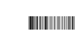

Possible barcode types to use in the ‘create the widget’ section include:
- BarcodeI2of5
- BarcodeCode128
- BarcodeStandard93
- BarcodeExtended93
- BarcodeStandard39
- BarcodeExtended39
- BarcodeMSI
- BarcodeCodabar
- BarcodeCode11
- BarcodeFIM
- BarcodePOSTNET

Font support

Using TrueType fonts
For using fonts which are not one of the “standard 14” (those which come bundled with Adobe Acrobat) you need to register the font before you actually use it.

To do this you do the following:
pdfmetrics.registerFont(ttfonts.TTFont(fontName, ttf_filename))

You can then use it as you would another font name – for example:
self.chart.valueAxis.labels.fontName = 'fontName'

Your fonts should live in a known location – look at section 5.2.1 for details on how to set the TTFSearchPath.

For the font ‘Rina’ - the example TrueType font we bundle with our open source software (which should be in your distribution) – you would need to initially import the functions you need at the top of the file:

from reportlab.pdfbase import pdfmetrics
from reportlab.pdfbase.ttfonts import TTFont

then register your font:
pdfmetrics.registerFont(TTFont('Rina', 'rina.ttf'))

and call it using something like this (if you wanted to set the font for your barLabels to Rina)
self.chart.barLabels.fontName = 'Rina'

So, a whole, but basic, example of a chart using a TrueType font would look like this (bold lines are the font-related ones):

from reportlab.graphics.charts.barcharts import HorizontalBarChart
from reportlab.graphics.shapes import Drawing, _DrawingEditorMixin, from reportlab.pdfbase import pdfmetrics
from reportlab.pdfbase.ttfonts import TTFont

class ClusteredBar(_DrawingEditorMixin,Drawing):
def __init__(self,width=200,height=150,*args,**kw):
apply(Drawing.__init__,(self,width,height)+args,kw)
pdfmetrics.registerFont(TTFont('Rina', 'rina.ttf'))
self._add(self, HorizontalBarChart(), name='chart',
validate=None, desc="The main chart")
self.chart.valueAxis.labels.fontName = 'Rina'
self.chart.categoryAxis.labels.fontName = 'Rina'
self.chart.width = 200
self.chart.height = 100
self.chart.x = 25
self.chart.y = 25
self._add(self,0,name='preview',validate=None,desc=None)

if __name__=="__main__": #NORUNTESTS
ClusteredBar().save(formats=['pdf','eps'],outDir=None,
fnRoot='clustered_bar_with_ttf')

The same principle applies when using TTF fonts with a quickChart -

from reportlab.pdfbase import pdfmetrics
from reportlab.pdfbase.ttfonts import TTFont
from rlextra.graphics.quickchart import quickChart

pdfmetrics.registerFont(TTFont('Rina', 'rina.ttf'))

drawing = quickChart(data=[[1,2,3], [3,4,5]],
chartType='column',
titleText = 'Column Chart Example',
titleFontName = 'Rina',
titleFontSize = 18)
import __main__
__main__._rl_embed_result = drawing.asString('eps')

This phrase was coined by Edward Tufte, a world authority on presentation graphics
Font gurus will be aware that Courier and Helvetica use oblique, not italic. Let's not nitpick here.

