A Comparison of ReportLab and Excel chart types

What is the reportlab graphics library?
The Reportlab graphics library is part of the ‘graphics engine’ for our Diagra chart server.
Some of its most important features are:
- It allows you to use elements from simple shapes, up to high-level charts.
- Simple charts are simple to implement, complex charts are still possible.
Simple charts have sensible defaults, but you can do cylindrical shading, dash arrays, shaded backgrounds or asymmetrical scales if you want.
- Charts can be saved in multiple formats (EPS, PDF, bitmaps), allowing you to have identical charts on the web, in PDFs and in print media.
- Charts can be made ‘data-aware’ (actually in data-aware drawings’), allowing them to pull data from CSV files, databases or most other data sources.
- You can control chart elements as a group (all bars are red, all labels on an axis are in 10 point Helvetica), or singly (bar number 3 should be green, bar label number 4 should be rotated at 30º).
- You can use either standard chart classes - horizontal or vertical barcharts, line plots, pie charts and so on – or add new elements to make your own custom charts .You can add grids, backgrounds and markers.
- The reportlab GUI editor allows you to develop charts visually and interactively.

What this document is
The Reportlab graphics library is generalised charting library which allows you great flexibility. Users of some other charting systems (eg, that used in Excel) expect a limited amount of chart types and subtypes. This document shows which of the Reportlab chart classes are closest to the various Excel chart subtypes.

Some of the Excel chart types seem obscure and of limited use.
We have taken screen shots of all the chart types and subtypes available in excel 2000 and stated for each one whether
- it works now
- we plan to add it in Q2 2003
- we have no plans to add it at all

Some other notes

Legends
Excel charts have legends build in. The Reportlab Graphics library has a Legend as an entirely separate class. This is often added to the basic chart in a custom chart class.

3D charts
Reportlab will be adding 3D versions of a number of our charts to the chart library in the near future. Unlike those in Excel, ours will be from a single viewpoint – you will not be able to rotate the chart in three dimensions or do the other things you may have become accustomed to being able to do to 3D charts in Excel.

Chart Types

Type: Column
Subtype: Clustered column

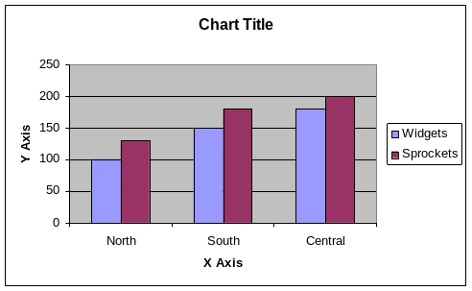
Status: Supported
This chart type is in the ReportLab Graphics library as the class VerticalBarChart.

Type: Column
Subtype: Stacked column
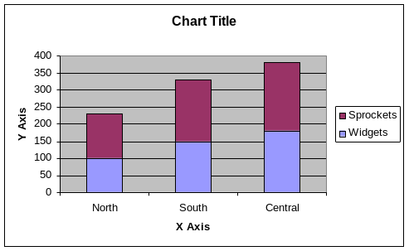
Status: Supported
This chart type is in the ReportLab Graphics library as the class VerticalBarChart, if it is used with the categoryAxis.style property ‘stacked' (rather than the default of ‘parallel’).

Type: Column
Subtype: 100% stacked column
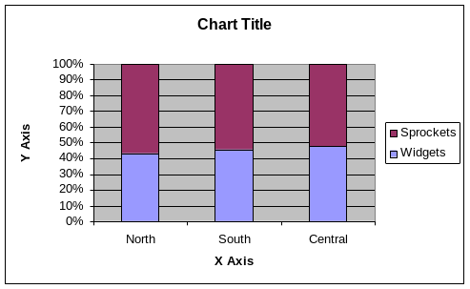
Status: Expected Q2 2003
This type of chart isn’t currently supported, but could be developed by using a version of VerticalBarChart which scales the data to fit.

Type: Column
Subtype: 3D clustered column
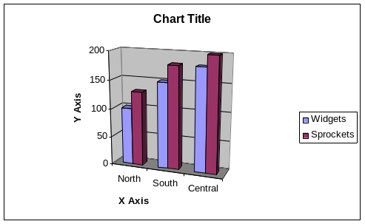
Status: Expected Q2 2003
This class of chart is not currently supported, but ReportLab plan to develop it in the near future (see note on page 1 re: 3D charts)

Type: Column
Subtype: 3D stacked column
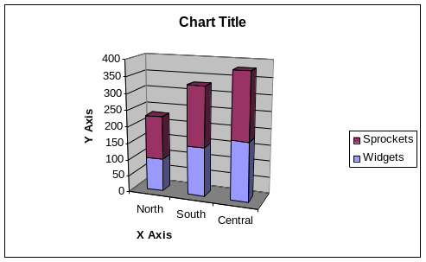
Status: Expected Q2 2003
This class of chart is not currently supported, but ReportLab plan to develop it in the near future (see note on page 1 re: 3D charts)

Type: Column
Subtype: 3D 100% stacked column
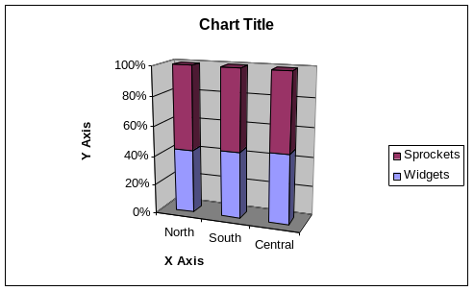
Status: Expected Q2 2003
This class of chart is not currently supported, but ReportLab plan to develop it in the near future (see note on page 1 re: 3D charts)
Type: Column
Subtype: 3D column
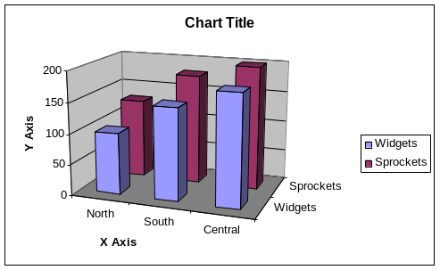
Status: Expected Q2 2003
This class of chart is not currently supported, but ReportLab plan to develop it in the near future (see note on page 1 re: 3D charts)

Type: Bar
Subtype: Clustered bar

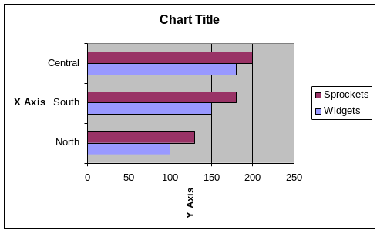
Status: Supported
This chart type is in the ReportLab Graphics library as the class ‘HorizontalBarChart’

Type: Bar
Subtype: Stacked bar
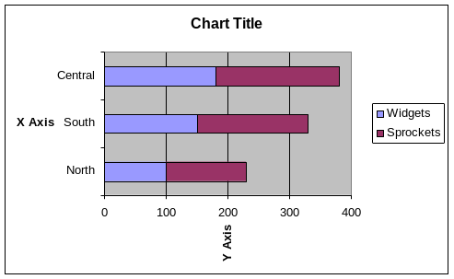
Status: Supported
This chart type is in the ReportLab Graphics library as the class ‘HorizontalBarChart’, if it is used with the categoryAxis.style property ‘stacked' (rather than the default of ‘parallel’).

Type: Bar
Subtype: 100% stacked bar
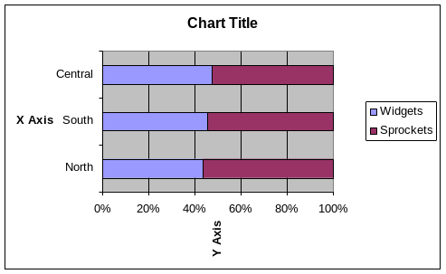
Status: Expected Q2 2003
This type of chart isn’t currently supported, but could be developed by using a version of HorizontalBarChart.

Type: Bar
Subtype: 3D clustered bar
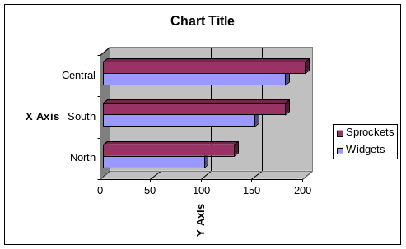
Status: Expected Q2 2003
This class of chart is not currently supported, but ReportLab plan to develop it in the near future (see note on page 1 re: 3D charts)

Type: Bar
Subtype: 3D stacked bar
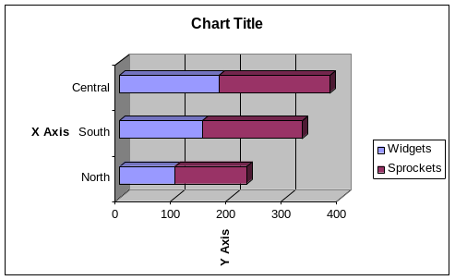
Status: Expected Q2 2003
This class of chart is not currently supported, but ReportLab plan to develop it in the near future (see note on page 1 re: 3D charts)

Type: Bar
Subtype: 3D 100% stacked bar
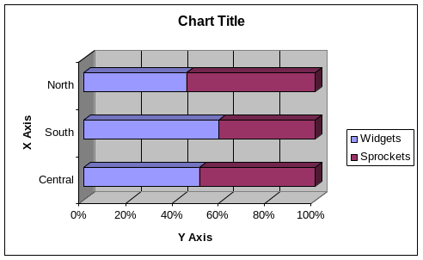
Status: Expected Q2 2003
This class of chart is not currently supported, but ReportLab plan to develop it in the near future (see note on page 1 re: 3D charts)

Type: Line
Subtype: Line chart
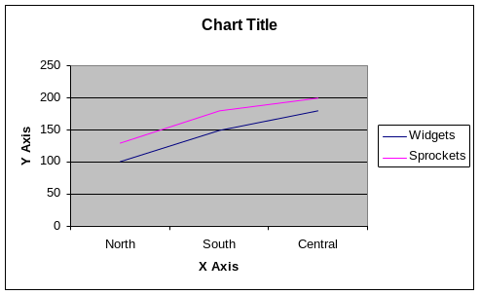
Status: Supported
This chart type is in the ReportLab Graphics library as the class ‘LinePlot’

Type: Line
Subtype: Stacked line
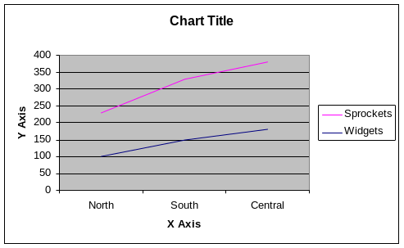
Status: Not planned
This chart type is not currently in the ReportLab Graphics library, but could be developed from the class ‘LinePlot’. We think stacked lines are accidental features of Excel and highly likely to mislead in the real world.

Type: Line
Subtype: 100% stacked line
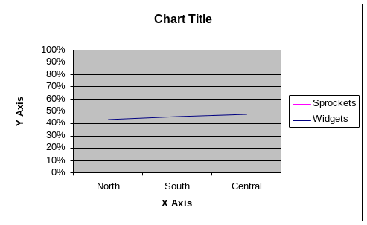
Status: Not planned
This chart type is not currently in the ReportLab Graphics library, but could be developed from the class ‘LinePlot’. We think stacked lines are accidental features of Excel and highly likely to mislead in the real world.

Type: Line
Subtype: Line with markers
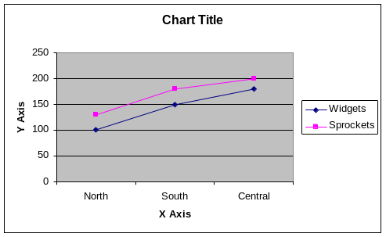
Status: Supported
This chart type is in the ReportLab Graphics library as the class ‘LinePlot’. You need to set the.symbol property for lines to be makeMarker('FilledSquare'). You can also have FilledCircle, Cross, Pentagon etc for these markers.

Type: Line
Subtype: Stacked line with markers
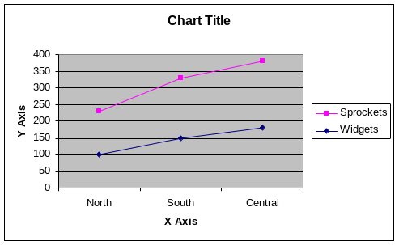
Status: Not currently supported
This chart type is not currently in the ReportLab Graphics library, but could be developed from the class ‘LinePlot’. We think stacked lines are accidental features of Excel and highly likely to mislead in the real world.

Type: Line
Subtype: 100% stacked line with markers
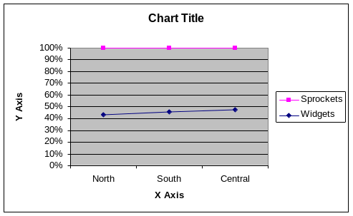
Status: Not planned
This chart type is not currently in the ReportLab Graphics library, but could be developed from the class ‘LinePlot’. See note on other stacked line charts

Type: Line
Subtype: 3D line
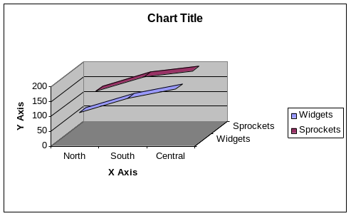
Status: Expected Q2 2003

Type: Pie
Subtype: Pie
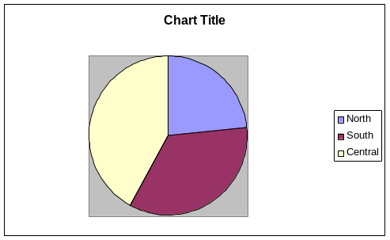
Status: Supported
This chart type is in the ReportLab Graphics library as the class ‘Pie’.

Type: Pie
Subtype: 3D pie
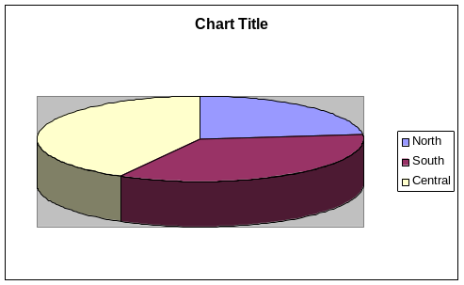
Status: Expected Q2 2003

We can already do the elliptic effect

Type: Pie
Subtype: Pie of pie
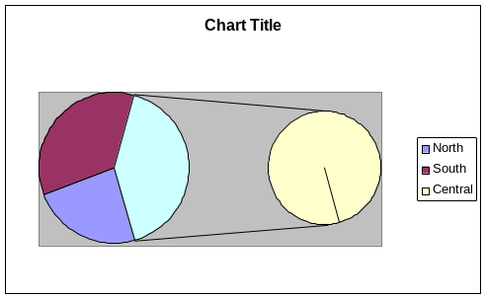
Status: Not planned as a distinct type
This chart is not currently supported by the reportlab graphics library, but could be constructed out of existing charts (eg, a drawing containing two pie charts and some lines, using some Python to connect the data properties of the two charts as required)

Type: Pie
Subtype: Exploded pie
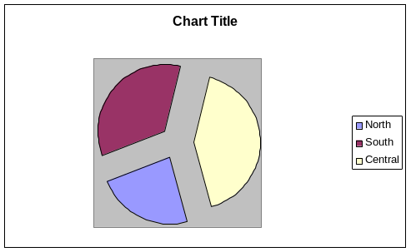
Status: Supported
This chart type is in the ReportLab Graphics library as the class ‘Pie’, if it is used with the ‘slices.popout’ property set to be greater than 0. We can also adjust the popout amount of each individual slice

Type: Pie
Subtype: 3D exploded pie
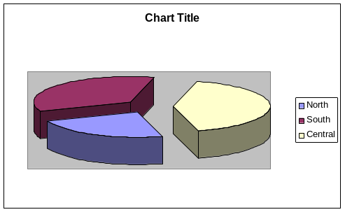
Status: Due Q2 2003

Type: Pie
Subtype: Bar of pie
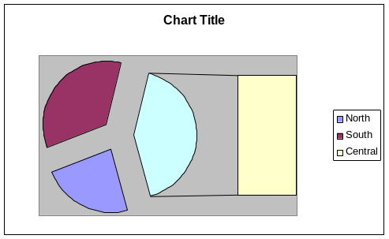
Status: Not currently supported
Not currently supported, but could be constructed from existing charts.

Type: XY(Scatter)
Subtype: Scatter
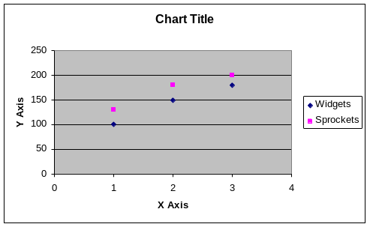
Status: Supported
This chart type is in the ReportLab Graphics library as the class ‘ScatterPlot’

Type: XY(Scatter)
Subtype: Scatter with points connected by smooth lines
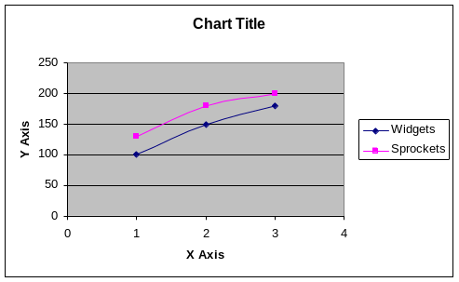
Status: Not supported. However, line plots with markers are equivalent to this. We regard a ‘scatter’ plot as one without an ordering to the points

Type: XY(Scatter)
Subtype: Scatter with points connected by smooth lines without markers
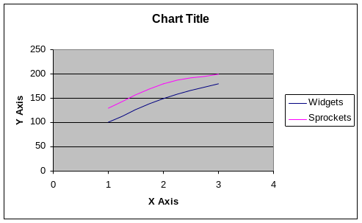
Status: Not planned. However, line plots without markers are equivalent to this. We regard a ‘scatter’ plot as one without an ordering to the points

Type: XY(Scatter)
Subtype: Scatter with points connected by lines
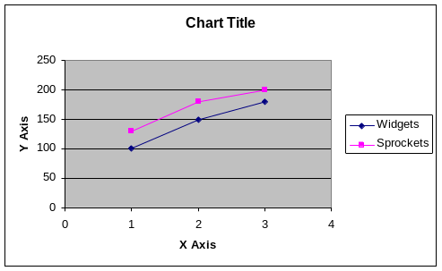
Status: Not planned. However, line plots with markers are equivalent to this. We regard a ‘scatter’ plot as one without an ordering to the points
Type: XY(Scatter)
Subtype: Scatter with points connected by lines without markers
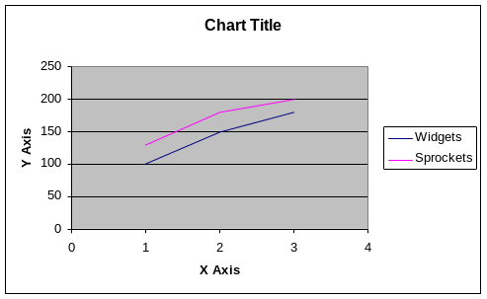
Status: Not planned. See notes on other scatter plots.

Type: Area
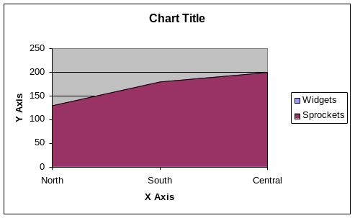

Subtype: area
Subtype: stacked area
Subtype: 100% stacked area
Subtype: 3D area
Subtype: 3D stacked area
Subtype: 3D 100% stacked area

Status: No area charts are currently supported by the Reportlab graphics library. We plan to add them in Q2 2003.

Type: Doughnut

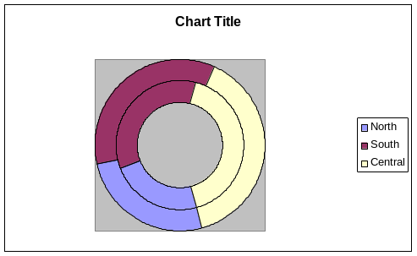

Subtype: Doughnut
Subtype: Exploded doughnut

Status: No Doughnut charts are currently supported by the Reportlab graphics library. We can add them in Q2 2003 if there is customer demand.

Type: Radar
Subtype: Radar

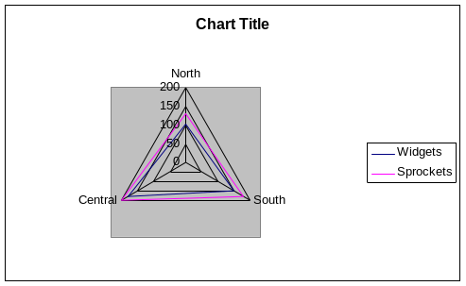
Status: Supported
This chart type is in the ReportLab Graphics library as the class ‘SpiderChart’. This chart has the fill on by default, so the strands.fillColor property must be set to None, the strands.strokeColour property must be set, and the strands.strokeWidth must be greater than the default of 0.

Type: Radar
Subtype: Radar with markers
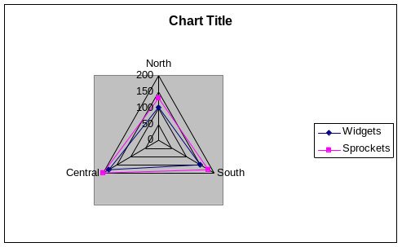
Status: Planned Q2 2003
This chart type not currently supported, but we should be able to develop it from the class ‘SpiderChart’.

Type: Radar
Subtype: Filled radar.
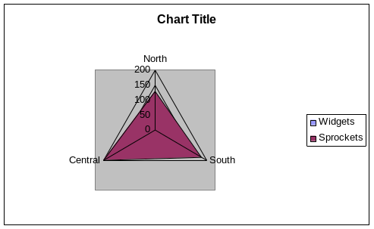
Status: Supported
This chart type is in the ReportLab Graphics library as the class ‘SpiderChart’. Filled charts are the default for the ‘SpiderChart’ class.

Type: Surface
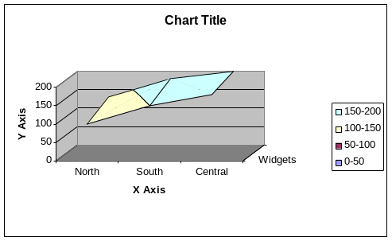
Subtype: 3D surface
Subtype: Wireframe 3D surface
Subtype: Contour
Subtype: Wireframe contour

Status: No surface charts are currently supported by the Reportlab graphics library.

Type: Bubble
Subtype: Bubble
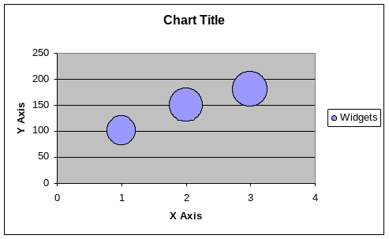
Status: Not currently supported by the Reportlab graphics library. Woiuld be easy to implement as a variant of

Type: Bubble
Subtype: 3D bubble
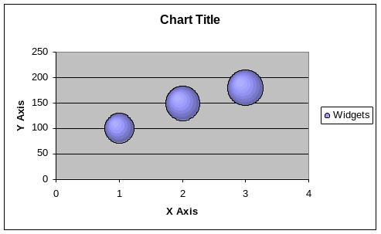
Status: Not currently supported by the Reportlab graphics library.

Type: Stock
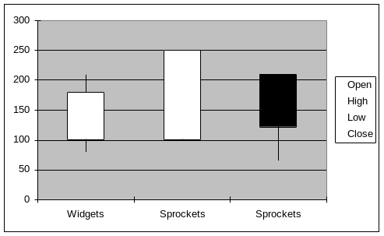
Subtype: High-Low-Close
Subtype: Open-High-Low-Close
Subtype: Volume-High-Low-Close
Subtype: Volume-Open-High-Low-Close

Status: Not Planned
No stock charts are currently supported by the Reportlab Graphics library.

Type: Cylinder
Subtype: Column with a cylindrical shape
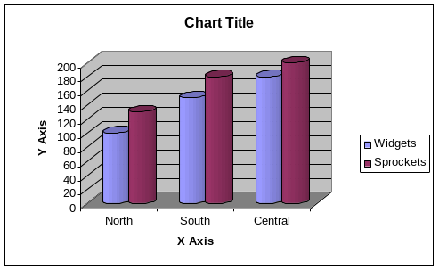
Status: Partially supported
The Reportlab graphics library supports cylindrical shading of bars in 2d bar charts. It does not currently support 3D cylinders. The closest approximation to this chart would be a VerticalBarChart with the bars.symbol set to a ShadedRect, cylinderMode set to1, and the bars.symbol.orientation set to 'vertical'.

Type: Cylinder
Subtype: Stacked Column with a cylindrical shape
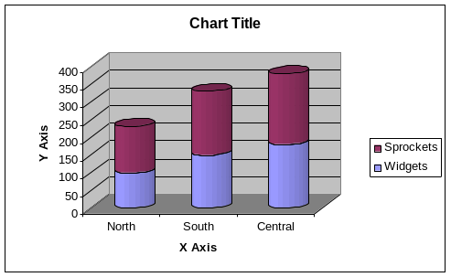
Status: Partially supported
The Reportlab graphics library supports cylindrical shading of bars. It does not currently support 3D cylinders. The closest approximation to this chart would be a VerticalBarChart with the bars.symbol set to a ShadedRect, cylinderMode set to1, bars.symbol.orientation set to 'vertical', and the categoryAxis.style set to 'stacked'

Type: Cylinder
Subtype: 100% stacked column with a cylindrical shape
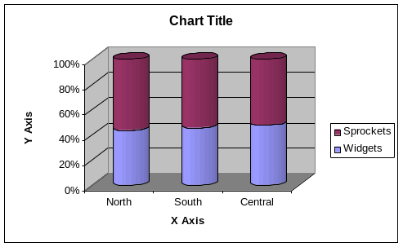
Status: Partially supported
The Reportlab graphics library supports cylindrical shading of bars. It does not currently support 3D cylinders.

Type: Cylinder
Subtype: Bar with a cylindrical shape
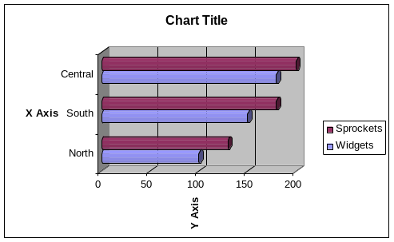
Status: Partially supported
The Reportlab graphics library supports cylindrical shading of bars. It does not currently support 3D cylinders. The closest approximation to this chart would be a HorizontalBarChart with the bars.symbol set to a ShadedRect, cylinderMode set to 1, and the bars.symbol.orientation set to 'horizontal.

Type: Cylinder
Subtype: Stacked bar with a cylindrical shape
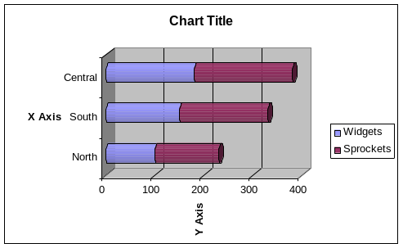
Status: Partially supported
The Reportlab graphics library supports cylindrical shading of bars. It does not currently support 3D cylinders. The closest approximation to this chart would be a HorizontalBarChart with the bars.symbol set to a ShadedRect, cylinderMode set to 1, and the bars.symbol.orientation set to 'horizontal.

Type: Cylinder
Subtype: 100% stacked bar with a cylindrical shape
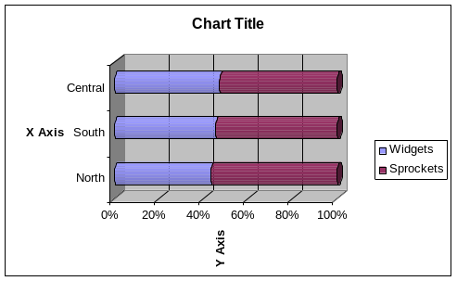
Status: Partially supported
The Reportlab graphics library supports cylindrical shading of bars. It does not currently support 3D cylinders. The closest approximation to this chart would be a HorizontalBarChart with the bars.symbol set to a ShadedRect, cylinderMode set to 1, bars.symbol.orientation set to 'horizontal', and the categoryAxis.style set to 'stacked'

Type: Cylinder
Subtype: 3D column with a cylindrical shape
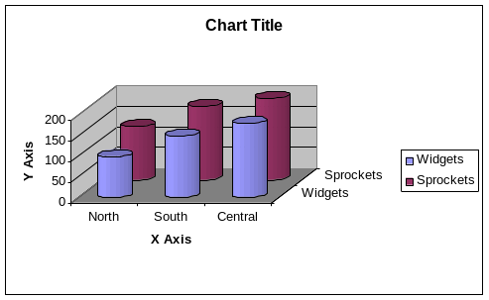
Status: Not currently supported

Type: Cone
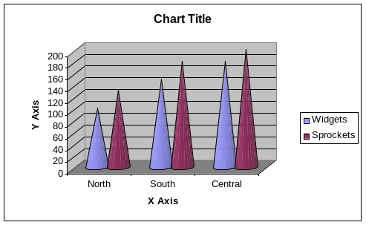

Subtype: Column with a conical shape
Subtype: Stacked Column with a conical shape
Subtype: 100% stacked column with a conical shape
Subtype: Bar with a conical shape
Subtype: Stacked bar with a conical shape
Subtype: 100% stacked bar with a conical shape
Subtype: 3D column with a conical shape

Status: No cone charts are currently supported by the Reportlab graphics library, nor do we plan to.

Type: Pyramid
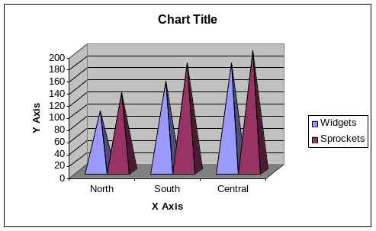

Subtype: Column with a pyramid shape
Subtype: Stacked Column with a pyramid shape
Subtype: 100% stacked column with a pyramid shape
Subtype: Bar with a pyramid shape
Subtype: Stacked bar with a pyramid shape
Subtype: 100% stacked bar with a pyramid shape
Subtype: 3D column with a pyramid shape

Status: No pyramid charts are currently supported by the Reportlab graphics library.

