8 Running & Managing Charts

8.1 Running within the Drawing Editor
The biggest visible change is that one can run jobs within the Drawing Editor, without the need for a DOS prompt. This is very useful in development and testing. This is accessed from "File | GO".

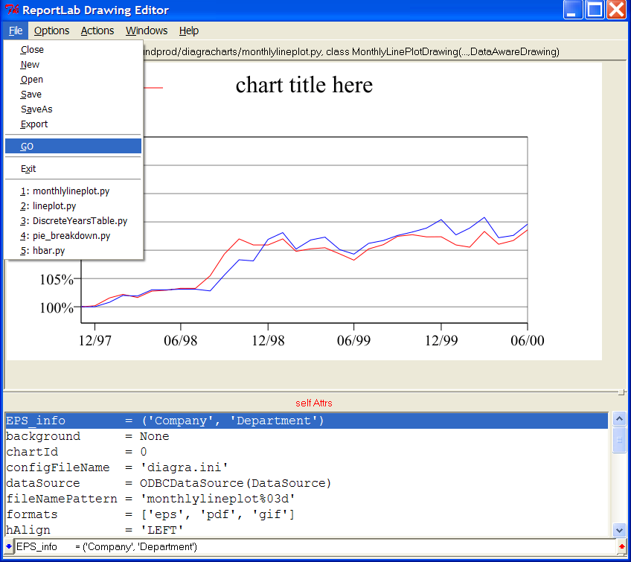

This leads to a screen with many 'run parameters' you can override….clicking OK will start the job and provide visible indications of progress.
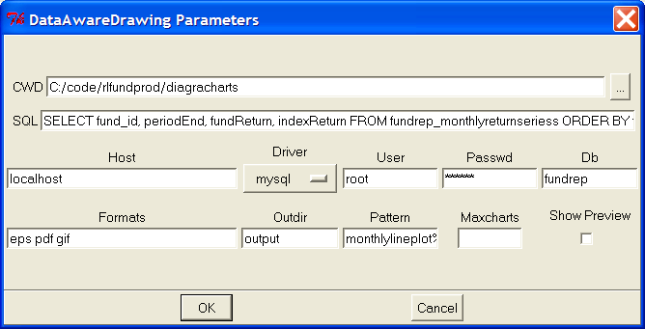

We do NOT recommend using this as a substitute for large-scale production tasks; graphical applications are inherently less stable and vulnerable to user clicks and other things which do not occur with scheduled jobs. However, it has turned out to be very useful, combined with the ability to override various properties.
- Test against different database: you can copy a production chart file, temporarily test it against a different database or query/proc and see if it works, without saving any changes to the file
- Limit the size – you can limit the run to, say, 3 or 10 charts rather than doing a huge run
- Show Preview – if you check this, it will draw every chart on screen as it runs. You can sit back and watch. This is a great way to see what is happening with extreme data conditions or to proof a whole run for ay 'visual nasties'.
- Extra formats – you can take a production process designed to make EPS and quickly run off some sets of GIFs for another purpose

8.2 Data Tester

The dataTester is a “special drawing” which allows you to verify that the connection between the Diagra editor and database server has been established, and to see what data is coming back. You create a drawing based on DataTester rather than DataAwareDrawing, and use it to try out your connection parameters.

You need to provide your connection details in addition to a SQL query in order to view your data.

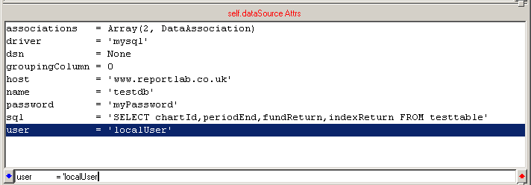

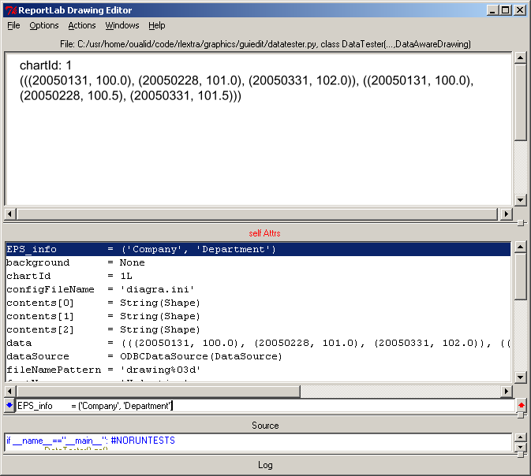
Once you entered your connection details and have a valid SQL query statement, you should now be able to retrieve your data by running a test. The test is run by setting the ‘test’ property to one, like this:

test = 1

If everything is OK and runs seamlessly then you should end up with a window like the one opposite that shows a series of retrieved data.

You can also set
test = 2
test = 3
and so on to see the data for the second and third data sets.

8.3 Command Line Arguments
Once you have produced your charts using the editor, it is possible to generate those charts using the command line.

The most basic use of Diagra to generate charts is with no arguments. At the command prompt simply type the name of your program without any arguments, and it will produce your charts. (see example below)

C:\code\rlfundprod\diagracharts>hbar_breakdown.py
generating PDF file C:\code\rlfundprod\diagracharts\output\hbar_breakdown_001.pdf
generating gif file C:\code\rlfundprod\diagracharts\output\hbar_breakdown_001.gif
generating png file C:\code\rlfundprod\diagracharts\output\hbar_breakdown_001.png
generating jpg file C:\code\rlfundprod\diagracharts\output\hbar_breakdown_001.jpg
..etc..

First of all the –help option will give an up-to-date listing of all available options e.g.

<chartName>.py --help

usage: chartName.py [options]

options:
-h, --help show this help message and exit
-d, --debug show tracebacks if errors occur
-v, --verbose show each chart as created
-s, --save save fetched data in file for later use
-r, --replay do not fetch data, instead replay last saved data set
-m MAXCHARTS, --max=MAXCHARTS create at most this number of charts

When run on the command line, the charts scripts can accept a number of arguments such as save, replay, max and any other available in the list above.

The ‘save’ option:

cmd>chartName.py --save

Running the above chart with the ‘save’ option will, as it name indicates, save all the data that have been pulled out from a database to a dat file with the same name as the chart script. This has the benefit to reduce time and resources when trying to acquire the data from the database, and also allow you or other users to work on generating charts locally without the need for a database.

Notice below the output once the fetched data is saved.

--save called, will create <chartName>.dat

The ‘replay’ option:
The replay argument allows you to replay the data that have been fetched from the database without the need to connect to it. Most of the retrieved data is saved onto a pickle file that when the replay option is requested, the program then fetches data from that file instead of connecting to the database.

<chartName>.py --replay

The ‘max’ option:
The max argument allow you to run the script and generate several charts for a maximum number of funds specified by the ‘n’.

<chartName>.py –-max n

look in datacharts.py a

The ‘verbose’ option:
In the beginning, you may find it useful to use ‘–-verbose’ at all times; if you want to see what the program is currently doing when it is running. Once you are more accustomed to the charts generation process, you will likely want to use it at certain times but not at others.

<chartName>.py –-verbose

With the verbose option on as above, the program shows a progressive listing of the actions performed. The result output should look like the following

C:\code\rlfundprod\diagracharts>lineplot.py –verbose

found config C:\code\rlfundprod\diagracharts\diagra.ini
Applying config options:
Using namespace from __main__
connecting... maxCharts= None
connected to fundrep, driver=mysql
fetched 1118 rows
OK
checking license
license ok
generating gif file C:\code\rlfundprod\diagracharts\drawing001.gif
generating EPS file C:\code\rlfundprod\diagracharts\drawing001.eps
generating gif file C:\code\rlfundprod\diagracharts\drawing002.gif
generating EPS file C:\code\rlfundprod\diagracharts\drawing002.eps

The ‘debug’ option:

When the program starts, it initiates several processes such as reading the config file, connecting to the database, retrieving data from the tables, etc.. .

By including the ‘—debug’ option on the command line, the program is placed in a debugging mode.
This implies that when an error occurs, the program stops and prints out an error message telling you what happened. As you can notice below (a MySQL error connection)

C:\code\rlfundprod\diagracharts>lineplot.py --debug
A DebugMemo has been written to "C:\code\rlfundprod\diagracharts\RL_LegendDrawing_pickle.dbg"
Traceback (most recent call last):
File "C:\Python24\Lib\site-packages\MySQLdb\__init__.py", line 66, in Connect
return Connection(*args, **kwargs)
File "C:\Python24\Lib\site-packages\MySQLdb\connections.py", line 134, in __init__
super(Connection, self).__init__(*args, **kwargs2)
_mysql_exceptions.OperationalError: (2003, "Can't connect to MySQL server on 'localhost' (10061)")

In addition, a DebugMemo is created with settings information that helps you when debugging your program.

8.4 Changing Environments and the Config file

The Config file is a small ‘ini’ file that holds configuration information and is read whenever the chart program starts, as we saw earlier when we pointed out the ‘verbose’ option command line argument.

found config C:\code\rlfundprod\diagracharts\diagra.ini
Applying config options:
etc ...

The intention behind the configuration file is that it allows you to specify many aspects of the program’s behaviour and settings from a single location.

Changing the environments is a straightforward practice because the ‘diagra.ini’ is an text file that is broken into named sections, each containing variables related to that section. Each section looks something like this:

[MySection]
variable="value"
anotherVariable="anotherValue"

The key benefits when modifying the configuration text file can be summarize in the following points:

- You don’t need a new chart to switch from DEV to UAT to LIVE databases. When used in a production setting, you will typically be pointing the charts in your live environment at your company’s live database, but pointing your test charts at test databases with new tables that haven’t gone live yet. And the passwords might differ. It is risky to go into a fully-tested chart and change the connection properties, and time consuming. So we provide a way to override this from outside of the graphically-edited chart module. You can then copy a directory of charts up onto a live server, and they will pick up the database name and password from the live config file.

- overriding the chart properties such as sizes, formats, colours. Sometimes you have a range of charts for on purpose, and you only need a slight change of two or three properties to repurpose them for something else. For example you might want exactly the same ten charts you use in your printing for use on the web site, except that (a) you want to hide all the titles, (b) you want thm 25% bigger, and (c) your web site uses different colours. By using a config file you avoid having to create ten new chart modules.
e.g.
[lineplot]
title.fillColor = white #hide it
formats = [‘gif’] #for web
scale = 1.25 #make it a little bigger

Even if you have set the title to be another colour in your chart, the program reads the config file and then applies the new value for that specific property.

Finally, it is important that you know what your are editing, because otherwise the program might behave not as you wished it to.

