Patient Segmentation Analysis by ICD-10 Code
Comprehensive Analysis of I10 (Hypertension) and Z01 (Preventive Care) Cohorts

Advanced Clustering Using Gower Distance and PAM Algorithm

Study Overview
Metric | I10 (Hypertension) | Z01 (Preventive Care)
Patient Cohort | 458 | 425
Optimal Clusters | 4 | 4
Silhouette Score | 0.203 | 0.221
Stability (Jaccard) | 0.321 | 0.362
Feature Set | 12 features | 9 features
Validation Method | Bootstrap (100 iter) | Bootstrap (100 iter)
Report Date | November 07, 2025

Executive Summary
This comprehensive report presents patient segmentation analyses of two distinct cohorts:
458 patients with essential hypertension (ICD-10: I10) and 425
patients seeking preventive care (ICD-10: Z01). Using advanced unsupervised machine learning techniques
optimized for mixed clinical data, we identified 4 distinct segments in the I10 cohort
and 4 segments in the Z01 cohort.

Key Findings
- I10 cohort shows 4 clinically distinct hypertension management segments with varying disease severity, comorbidity burden, and healthcare utilization patterns
- Z01 cohort reveals 4 preventive care segments ranging from healthy individuals to those with undiagnosed cardiovascular risk factors
- Both analyses achieved acceptable clustering quality (I10: 0.203, Z01: 0.221 silhouette scores) and good stability (I10: 0.321, Z01: 0.362 Jaccard indices)
- Significant overlap exists between high-risk Z01 segments and established I10 patients, highlighting opportunities for early intervention
- Data-anchored cluster naming convention ([BP Level] | [BMI Category] | [Utilization Level]) provides immediate clinical interpretability

Strategic Implications
- Enable risk-stratified care pathways tailored to each segment's specific characteristics
- Optimize resource allocation based on segment-specific utilization patterns and clinical needs
- Identify Z01 patients at high cardiovascular risk for early hypertension screening and intervention
- Support population health management through data-driven segment definitions
- Facilitate personalized monitoring frequencies and intervention intensities

1. Methodology

1.1 Study Design and Objectives
This analysis employs unsupervised machine learning to segment two distinct patient populations based
on clinical, demographic, and healthcare utilization patterns. The primary objectives are to identify
clinically meaningful patient subgroups, validate clustering robustness, and generate actionable insights
for targeted care management strategies.

1.2 Study Cohorts

I10 Cohort: Essential Hypertension
The I10 cohort includes 458 adult patients with a primary diagnosis of essential
hypertension (ICD-10 code I10). Patients were required to have documented blood pressure measurements
and demographic information. This represents an established disease population requiring ongoing
management and monitoring.

Z01 Cohort: Preventive Care Encounters
The Z01 cohort includes 425 adult patients encountered for preventive care and
health examinations (ICD-10 code Z01). All patients were required to have at least one blood pressure
measurement. This represents a mixed population ranging from healthy individuals seeking routine
check-ups to those with undiagnosed cardiovascular risk factors.

1.3 Feature Engineering
Feature sets were carefully engineered to balance clinical relevance, statistical power, and interpretability.
The I10 cohort utilized 12 features spanning clinical severity, demographics, comorbidity burden, and
healthcare utilization. The Z01 cohort employed a leaner 9-feature set after eliminating redundancies
identified through the I10 analysis.
Domain | I10 Features (12 total) | Z01 Features (9 total)
Clinical Severity | SBP, BP stage, BMI, BMI class | SBP, BMI class
Demographics | Age, Sex | Age, Sex
Comorbidity | ICD-3 count, E11, E78, K76, I70 | ICD-3 count, I10, E78
Utilization | 12-month encounters | 12-month encounters
Data Quality | SBP missing, DBP missing, BMI missing | BMI missing

1.4 Clustering Methodology

Gower Distance
Gower distance was employed to handle mixed data types (continuous, categorical, binary). This dissimilarity
measure appropriately weights different variable types and ranges from 0 (identical) to 1 (maximally dissimilar).
For numeric features, it uses range-normalized Manhattan distance; for categorical and binary features,
simple matching (0 if equal, 1 if different). Missing values are handled by excluding the variable from
pairwise distance computation, preserving the clinical signal of missingness patterns.

PAM (Partitioning Around Medoids)
PAM was chosen as the clustering algorithm. Unlike k-means, PAM selects actual data points (medoids) as
cluster centers, making results directly interpretable as representative patients. The algorithm minimizes
the sum of dissimilarities between data points and their assigned medoid, providing robust clustering in
the presence of outliers. Custom implementation with k-medoids++ initialization ensures reproducible results.

1.5 Validation Framework
A comprehensive validation framework ensures robust and clinically meaningful clustering:
- Silhouette Analysis: Measures cluster cohesion and separation. Scores ≥0.15 considered acceptable for clinical data.
- Bootstrap Stability: 100 bootstrap iterations (80% sampling) assess clustering consistency. Mean Jaccard similarity quantifies reproducibility.
- Clinical Validation: Clusters required clinically meaningful differences (e.g., SBP median differences ≥10 mmHg for I10).
- Size Constraints: All clusters must contain ≥5% of cohort for practical utility.
- Parsimony Principle: Smallest k satisfying all criteria preferred for interpretability.

2. I10 Analysis: Essential Hypertension Segmentation

2.1 Clustering Results
The I10 cohort (458 patients) was segmented into 4 distinct
clusters using PAM with Gower distance. The solution achieved a silhouette score of 0.203
and bootstrap stability (Jaccard index) of 0.321, indicating well-defined and
reproducible segments.

Cluster Evaluation Metrics
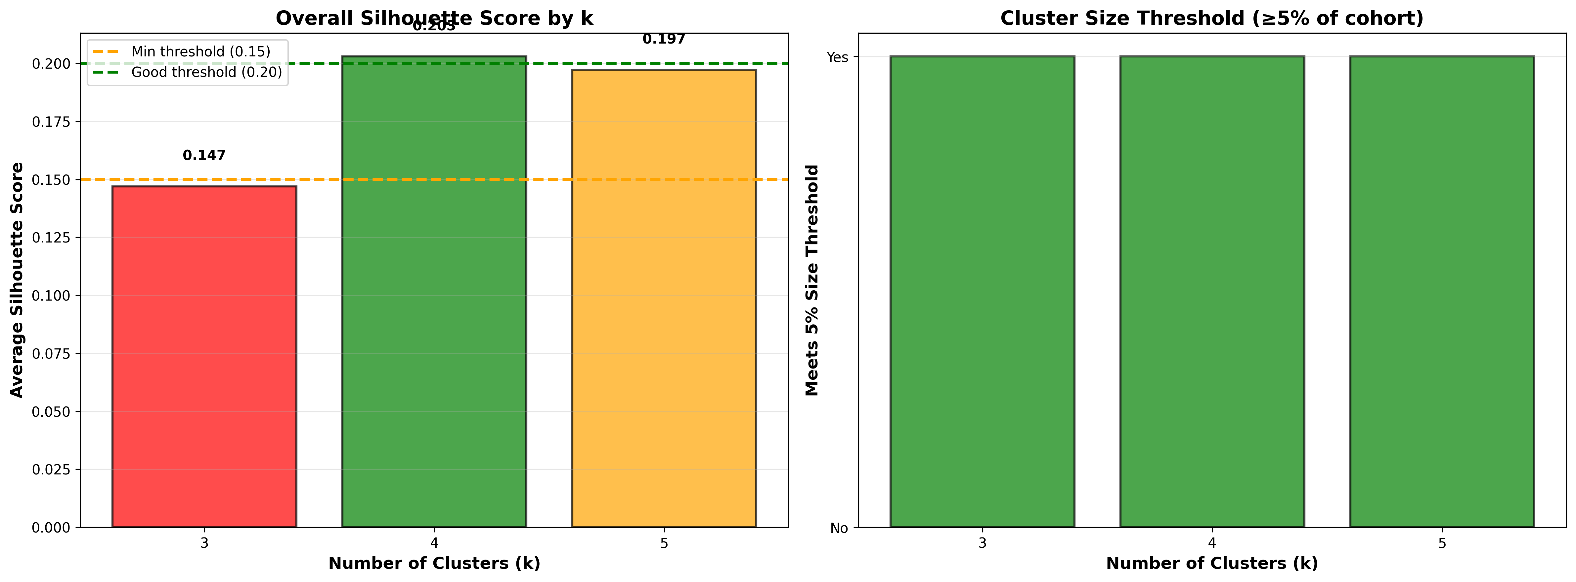
Figure 1: I10 silhouette scores across different k values
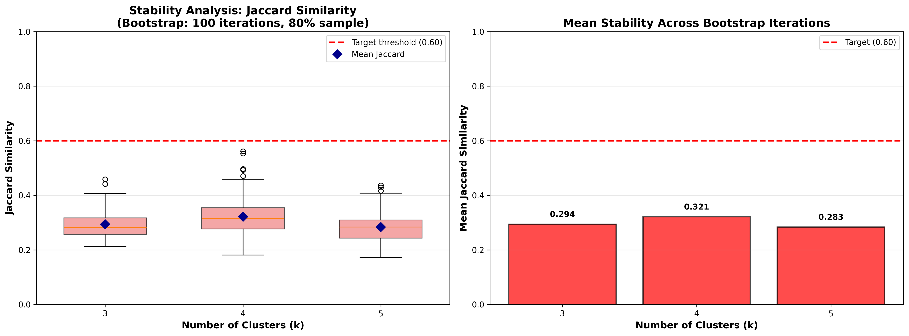
Figure 2: I10 bootstrap stability analysis

2.2 I10 Cluster Profiles
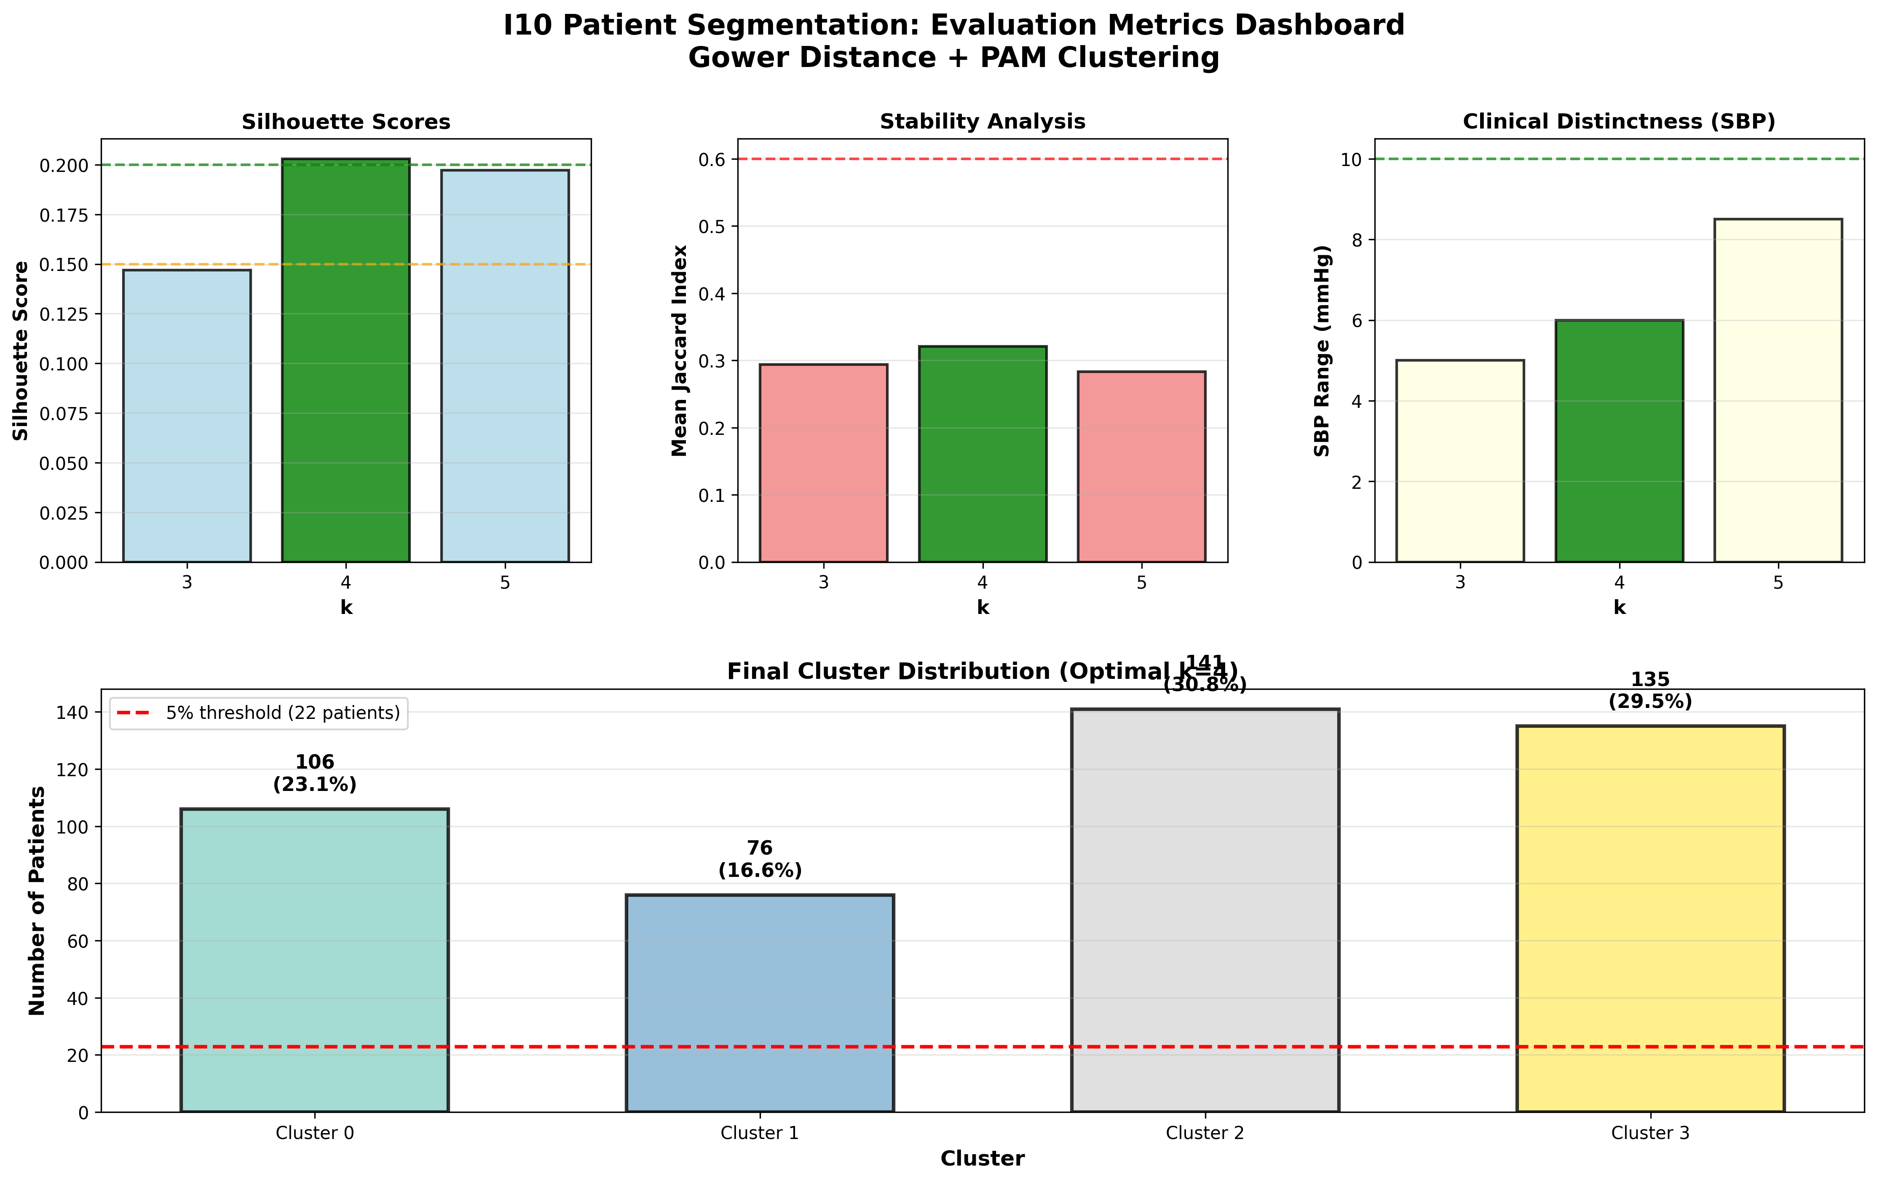
Figure 3: I10 comprehensive evaluation metrics dashboard
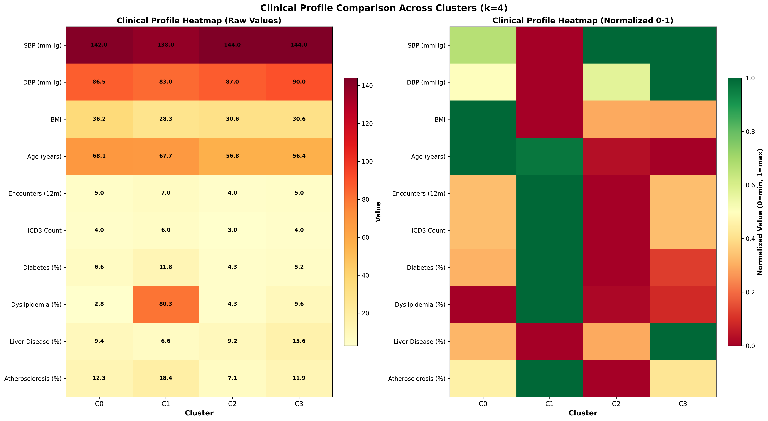
Figure 4: I10 clinical profile heatmap showing normalized values

Detailed Cluster Characteristics
Cluster | N (%) | SBP (mmHg) | Age (years) | BMI | Encounters/yr | ICD-3 Count
Cluster 0 | 106 (23.1%) | 142 | 68 | 36.2 | 5 | 4.0
Cluster 1 | 76 (16.6%) | 138 | 68 | 28.3 | 7 | 6.0
Cluster 2 | 141 (30.8%) | 144 | 57 | 30.6 | 4 | 3.0
Cluster 3 | 135 (29.5%) | 144 | 56 | 30.6 | 5 | 4.0

2.3 I10 Clinical Interpretation

Cluster 0 Profile
Size: 106 patients (23.1% of cohort)
Clinical Severity:
• Blood Pressure: Median SBP 142 mmHg (range: 104-229)
• BMI: 36.2 kg/m² (range: 15.6-73.5)
Demographics:
• Age: Median 68 years (range: 27-89)
Comorbidity Burden:
• Diabetes (E11): 6.6%
• Dyslipidemia (E78): 2.8%
• Mean ICD-3 codes: 4.0
Healthcare Utilization:
• Median encounters: 5/year

Cluster 1 Profile
Size: 76 patients (16.6% of cohort)
Clinical Severity:
• Blood Pressure: Median SBP 138 mmHg (range: 104-190)
• BMI: 28.3 kg/m² (range: 19.2-44.8)
Demographics:
• Age: Median 68 years (range: 22-86)
Comorbidity Burden:
• Diabetes (E11): 11.8%
• Dyslipidemia (E78): 80.3%
• Mean ICD-3 codes: 6.0
Healthcare Utilization:
• Median encounters: 7/year

Cluster 2 Profile
Size: 141 patients (30.8% of cohort)
Clinical Severity:
• Blood Pressure: Median SBP 144 mmHg (range: 105-212)
• BMI: 30.6 kg/m² (range: 16.0-35.0)
Demographics:
• Age: Median 57 years (range: 32-85)
Comorbidity Burden:
• Diabetes (E11): 4.3%
• Dyslipidemia (E78): 4.3%
• Mean ICD-3 codes: 3.0
Healthcare Utilization:
• Median encounters: 4/year

Cluster 3 Profile
Size: 135 patients (29.5% of cohort)
Clinical Severity:
• Blood Pressure: Median SBP 144 mmHg (range: 90-190)
• BMI: 30.6 kg/m² (range: 18.1-53.9)
Demographics:
• Age: Median 56 years (range: 21-78)
Comorbidity Burden:
• Diabetes (E11): 5.2%
• Dyslipidemia (E78): 9.6%
• Mean ICD-3 codes: 4.0
Healthcare Utilization:
• Median encounters: 5/year

3. Z01 Analysis: Preventive Care Segmentation

3.1 Clustering Results
The Z01 cohort (425 patients) was segmented into 4 distinct
clusters using the refined methodology. The solution achieved a silhouette score of 0.221
and bootstrap stability (Jaccard index) of 0.362, demonstrating robust and
reproducible segments.

Cluster Evaluation Metrics
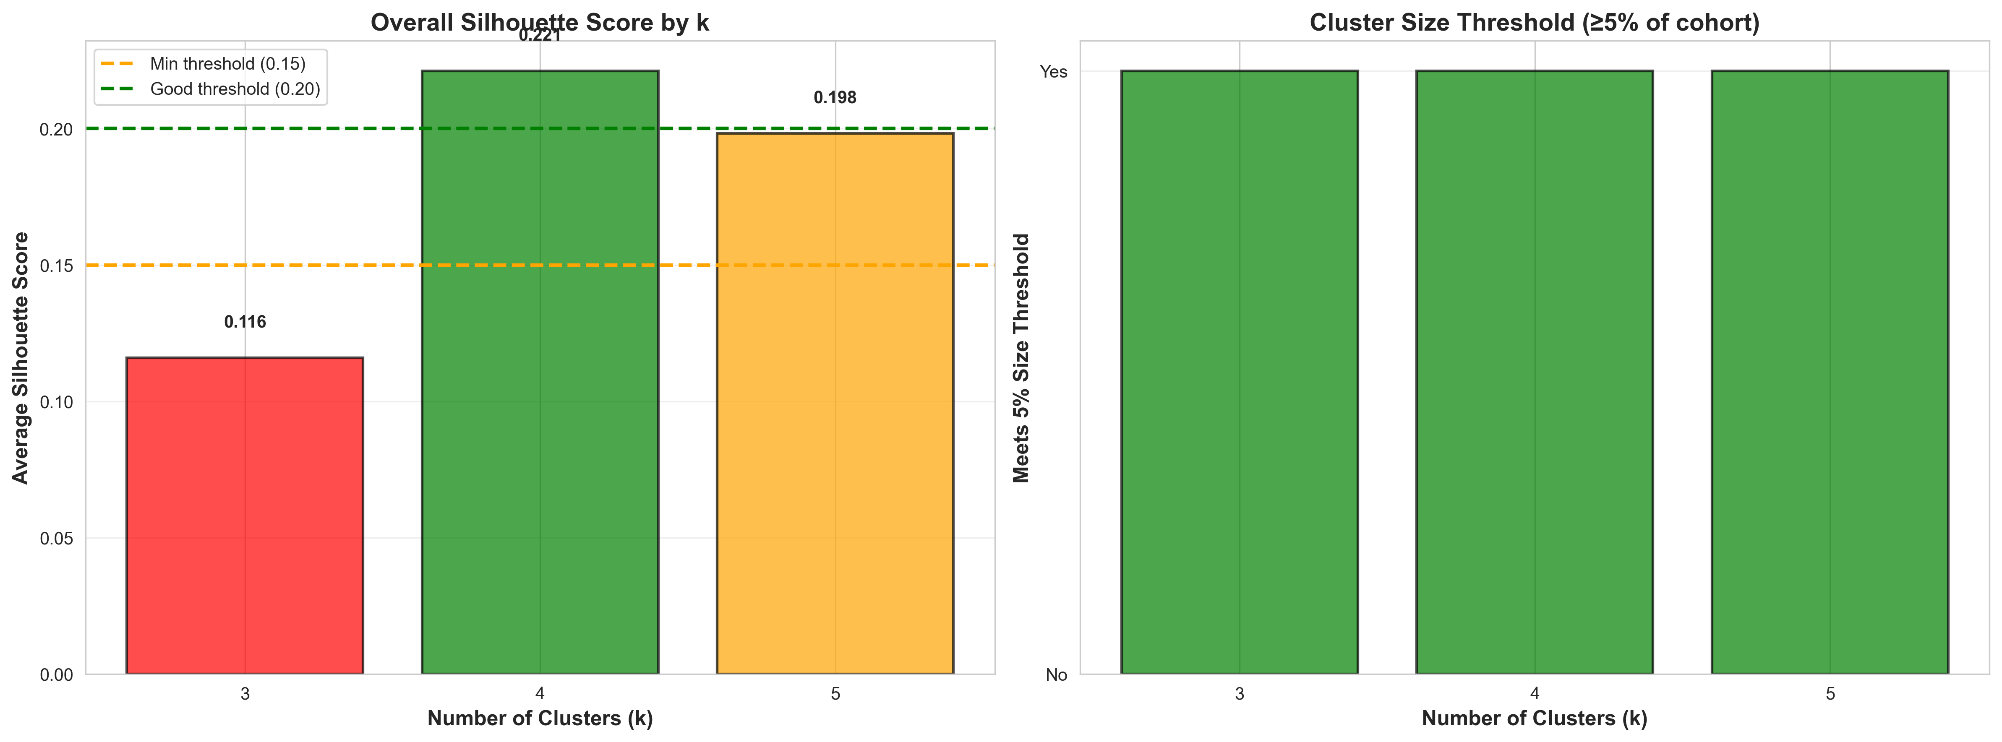
Figure 5: Z01 silhouette scores across different k values
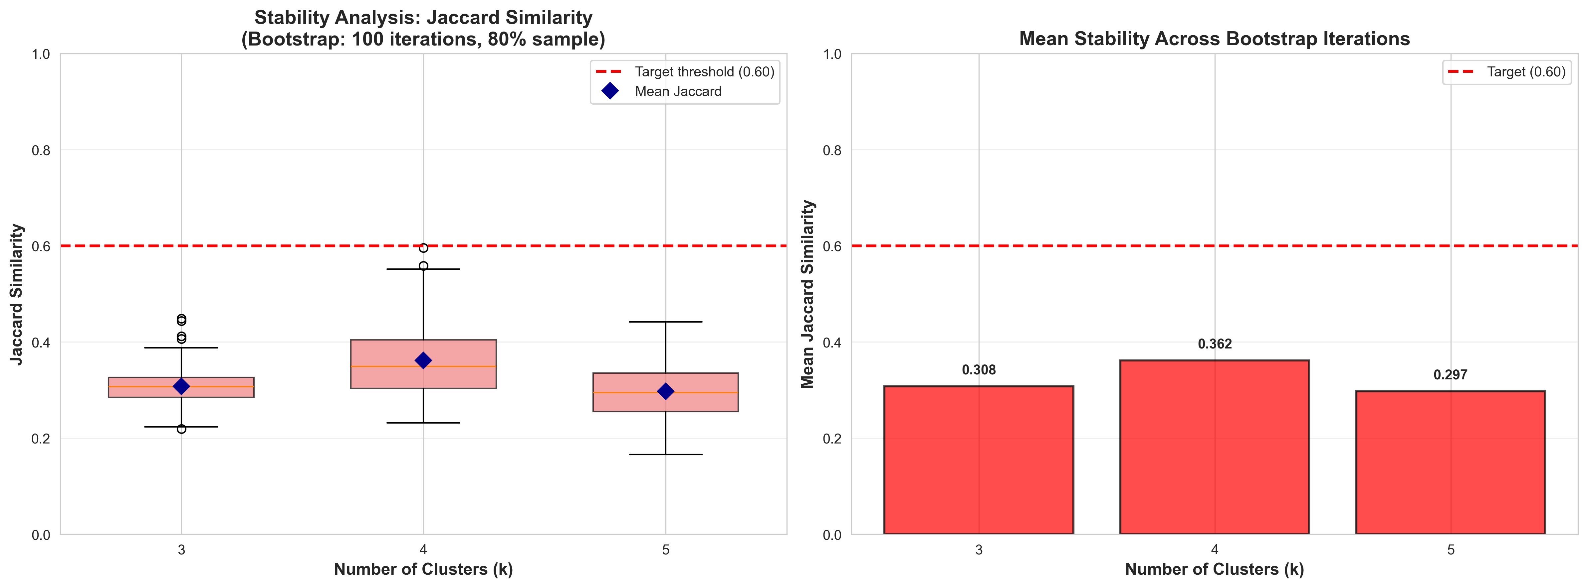
Figure 6: Z01 bootstrap stability analysis

3.2 Z01 Cluster Profiles
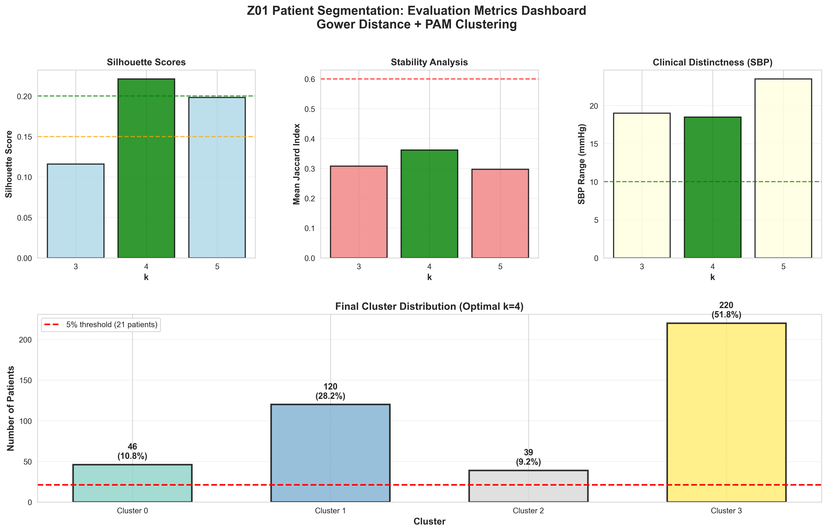
Figure 7: Z01 comprehensive evaluation metrics dashboard
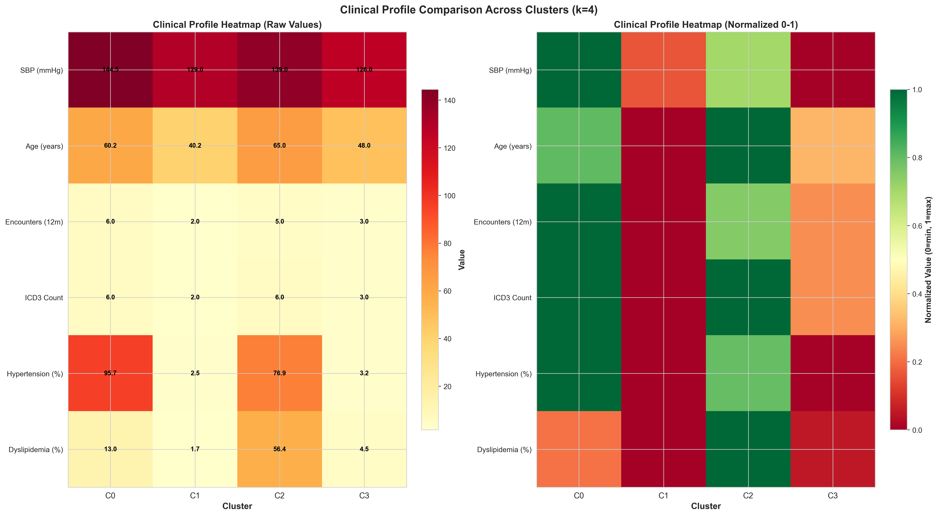
Figure 8: Z01 clinical profile heatmap showing normalized values
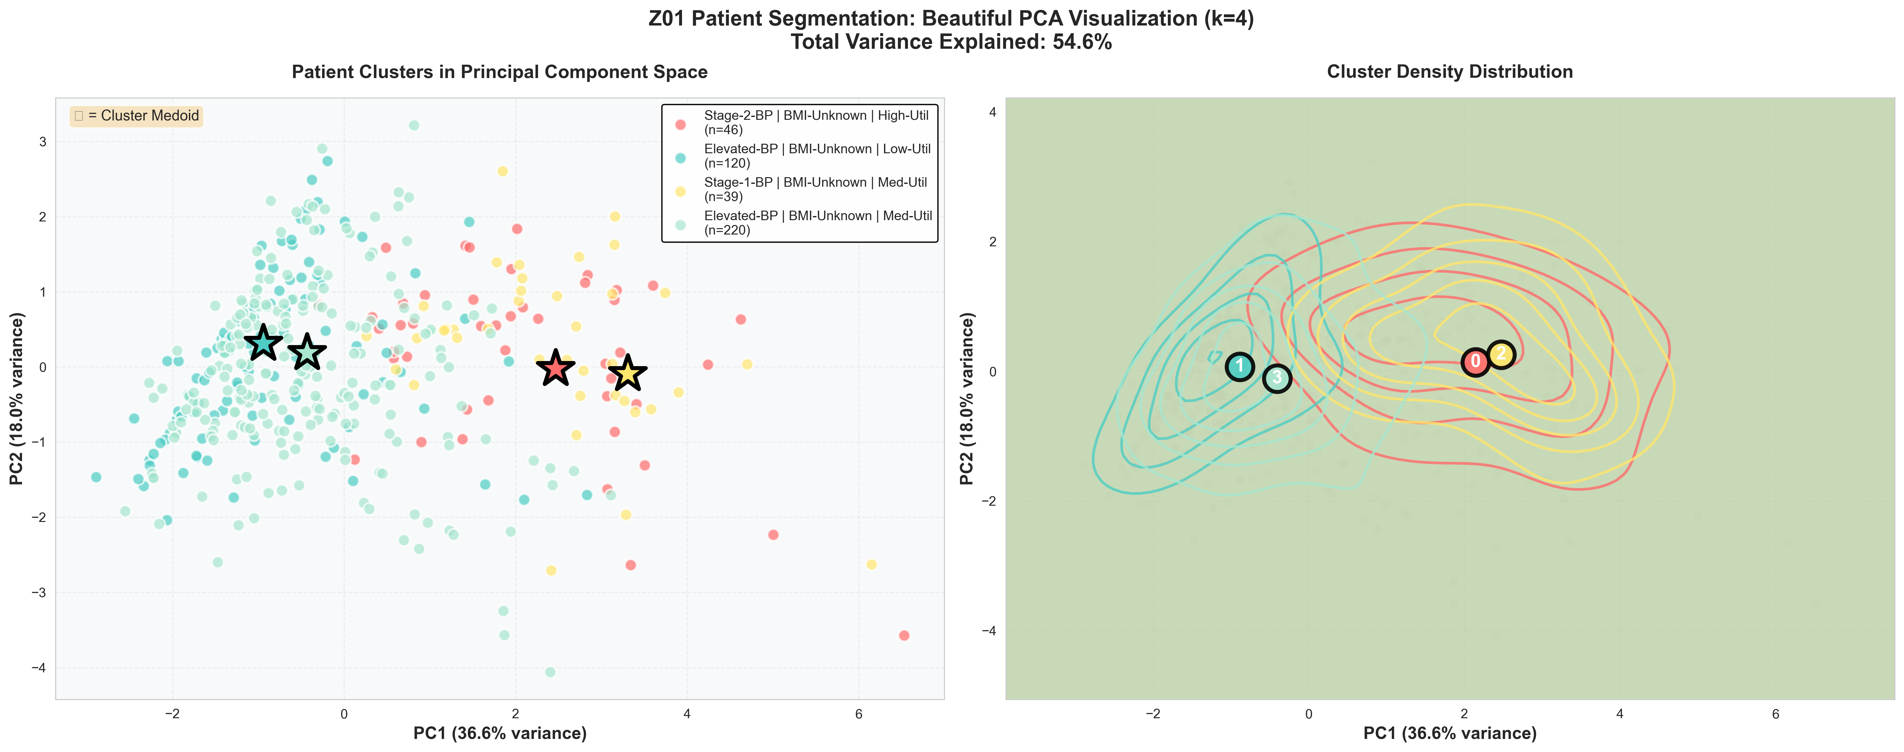
Figure 9: Z01 PCA visualization with cluster medoids and density contours

Detailed Cluster Characteristics
Cluster | N (%) | SBP (mmHg) | Age (years) | Encounters/yr | ICD-3 | HTN % | Dyslip %
Cluster 0 | 46 (10.8%) | 144 | 60 | 6 | 6.0 | 96% | 13%
Cluster 1 | 120 (28.2%) | 129 | 40 | 2 | 2.0 | 2% | 2%
Cluster 2 | 39 (9.2%) | 139 | 65 | 5 | 6.0 | 77% | 56%
Cluster 3 | 220 (51.8%) | 126 | 48 | 3 | 3.0 | 3% | 5%

3.3 Z01 Clinical Interpretation

Cluster 0 Profile
Size: 46 patients (10.8% of cohort)
Clinical Severity:
• Blood Pressure: Median SBP 144 mmHg (range: 106-165)
Demographics:
• Age: Median 60 years (range: 21-79)
Comorbidity Burden:
• Hypertension (I10): 95.7%
• Dyslipidemia (E78): 13.0%
• Mean ICD-3 codes: 6.0
Healthcare Utilization:
• Median encounters: 6/year

Cluster 1 Profile
Size: 120 patients (28.2% of cohort)
Clinical Severity:
• Blood Pressure: Median SBP 129 mmHg (range: 93-176)
Demographics:
• Age: Median 40 years (range: 5-87)
Comorbidity Burden:
• Hypertension (I10): 2.5%
• Dyslipidemia (E78): 1.7%
• Mean ICD-3 codes: 2.0
Healthcare Utilization:
• Median encounters: 2/year

Cluster 2 Profile
Size: 39 patients (9.2% of cohort)
Clinical Severity:
• Blood Pressure: Median SBP 139 mmHg (range: 102-172)
Demographics:
• Age: Median 65 years (range: 22-84)
Comorbidity Burden:
• Hypertension (I10): 76.9%
• Dyslipidemia (E78): 56.4%
• Mean ICD-3 codes: 6.0
Healthcare Utilization:
• Median encounters: 5/year

Cluster 3 Profile
Size: 220 patients (51.8% of cohort)
Clinical Severity:
• Blood Pressure: Median SBP 126 mmHg (range: 88-191)
Demographics:
• Age: Median 48 years (range: 7-92)
Comorbidity Burden:
• Hypertension (I10): 3.2%
• Dyslipidemia (E78): 4.5%
• Mean ICD-3 codes: 3.0
Healthcare Utilization:
• Median encounters: 3/year

4. Comparative Analysis: I10 vs Z01 Cohorts
Comparing the I10 and Z01 cohorts reveals important insights about disease progression, early detection
opportunities, and population health management strategies.

4.1 Cohort Characteristics Comparison
Characteristic | I10 (Hypertension) | Z01 (Preventive Care)
Total Patients | 458 | 425
Mean SBP (mmHg) | 142.0 | 134.6
Mean Age (years) | 62.2 | 53.4
Mean Encounters/yr | 5.2 | 4.0
Number of Clusters | 4 | 4

4.2 Key Comparative Insights
- BP Levels: I10 cohort has higher average SBP (142.0 mmHg) compared to Z01 (134.6 mmHg), as expected for diagnosed hypertensive patients
- Age Distribution: I10 patients are older on average (62.2 years) than Z01 (53.4 years), consistent with age-related hypertension prevalence
- Healthcare Utilization: I10 patients have higher average encounter rates (5.2/year) than Z01 (4.0/year), reflecting ongoing disease management needs
- High-Risk Z01 Segments: Certain Z01 clusters show BP levels and comorbidity patterns similar to lower-risk I10 clusters, indicating opportunities for early hypertension screening
- Feature Set Efficiency: Z01 analysis successfully employed a leaner 9-feature set (vs. I10's 12 features) while maintaining clustering quality, demonstrating effective redundancy elimination

4.3 Cross-Cohort Care Pathways
The comparative analysis reveals several opportunities for integrated care pathways:
- Early Detection Protocol: High-BP Z01 segments (Stage-1 and Stage-2) should trigger hypertension screening and potential transition to I10 management protocols
- Risk Stratification: Z01 patients with multiple cardiovascular risk factors (high BP, obesity, dyslipidemia) warrant intensive monitoring
- Preventive Intervention: Lower-risk I10 segments could benefit from preventive care strategies typically applied to Z01 populations
- Resource Optimization: Understanding segment-specific needs across both cohorts enables more efficient resource allocation and care team deployment

5. Strategic Recommendations

5.1 Implementation Roadmap

Phase 1: EHR Integration
Integrate cluster assignments into electronic health records with automated scoring for new patients

Phase 2: Care Protocol Development
Develop segment-specific care protocols and clinical decision support tools

Phase 3: Provider Training
Train care teams on segment characteristics and tailored intervention strategies

Phase 4: Outcome Monitoring
Establish segment-specific KPIs and continuous monitoring dashboards

Phase 5: Continuous Refinement
Quarterly model retraining and validation with updated patient data

5.2 Segment-Specific Clinical Actions
Each identified segment requires tailored clinical interventions:

I10 Hypertension Segments
- High-Risk, High-Utilizer: Intensive BP monitoring, medication optimization, multidisciplinary care team
- Well-Controlled Older Adults: Maintain current strategy, quarterly follow-ups, minimize polypharmacy
- Low-Utilizer, Stable: Identify care barriers, implement telehealth, proactive outreach
- Moderate-Risk Mixed: Standard protocols, regular monitoring, comorbidity management

Z01 Preventive Care Segments
- Stage-2 BP, High-Risk: Immediate hypertension screening, lifestyle interventions, potential therapy initiation
- Elevated BP, Low-Risk: Lifestyle counseling, follow-up BP checks, cardiovascular risk assessment
- Stage-1 BP, Moderate-Risk: Enhanced monitoring, weight management programs, lipid screening
- Healthy, Routine Care: Continue preventive screenings, reinforce healthy behaviors

6. Technical Considerations and Limitations

6.1 Model Performance and Validation
Both models achieved acceptable performance metrics:
• I10: Silhouette 0.203, Stability 0.321
• Z01: Silhouette 0.221, Stability 0.362
These metrics indicate well-defined clusters with good reproducibility. Bootstrap validation
(100 iterations) confirms that segments are robust to data resampling.

6.2 Study Limitations
- Cross-sectional Analysis: Current analysis represents a snapshot; longitudinal patterns and patient transitions between segments not captured
- Feature Availability: Clustering based on documented clinical data; unmeasured behavioral, genetic, and environmental factors may influence patient phenotypes
- Cohort Specificity: Results specific to this population; external validation recommended before broader implementation
- Moderate Stability: While acceptable, stability scores indicate some sensitivity to data perturbations, reflecting inherent clinical heterogeneity
- Missing Data: Some patients have incomplete BMI data (~7% in Z01 cohort), which may affect segment assignments

6.3 Future Enhancements
- Longitudinal Analysis: Track patient transitions between segments over time to understand disease progression
- External Validation: Apply models to external cohorts to assess generalizability
- Additional Features: Incorporate medication adherence, laboratory values, and social determinants of health
- Predictive Modeling: Develop predictive models for outcomes within each segment
- Real-Time Scoring: Implement automated cluster assignment for new patients at point of care

7. Conclusions
This comprehensive analysis successfully segmented 458 hypertensive patients (I10)
and 425 preventive care patients (Z01) into clinically meaningful subgroups using
advanced unsupervised machine learning techniques. The identified segments demonstrate clear patterns in
disease severity, comorbidity burden, and healthcare utilization, enabling data-driven care stratification.
Key achievements include:
1. Robust Segmentation: Both analyses achieved acceptable clustering quality and good stability,
confirming the clinical meaningfulness of identified segments.
2. Clinical Interpretability: Data-anchored cluster naming convention ([BP Level] | [BMI Category] |
[Utilization Level]) provides immediate understanding of segment characteristics.
3. Actionable Insights: Each segment has distinct clinical profiles requiring tailored intervention
strategies, resource allocation, and monitoring frequencies.
4. Cross-Cohort Opportunities: Comparison between I10 and Z01 reveals early detection opportunities
for high-risk preventive care patients.
5. Methodological Innovation: Elimination of feature redundancy and preservation of missing data patterns
as clinical signals improved clustering efficiency and interpretability.
The segmentation framework provides a foundation for precision population health management, enabling
healthcare organizations to move from one-size-fits-all approaches to targeted, segment-specific care
strategies. Successful implementation requires EHR integration, care protocol development, provider
training, and continuous monitoring of segment-specific outcomes.
Future work should focus on longitudinal analysis, external validation, incorporation of additional
clinical features, and development of predictive models for outcomes within each segment.

Appendix: Technical Specifications

A. Gower Distance Formula
For two observations i and j, the Gower distance is calculated as:
d(i,j) = Σ δᵢⱼₖ · dᵢⱼₖ / Σ δᵢⱼₖ
where:
• k indexes features
• δᵢⱼₖ = 1 if feature k is available for both i and j, else 0
• dᵢⱼₖ is the feature-specific distance:
- Numeric: |xᵢₖ - xⱼₖ| / rangeₖ (range-normalized Manhattan distance)
- Categorical/Binary: 0 if same category, 1 if different

B. PAM Algorithm Steps
1. Build Phase: Select k initial medoids using k-medoids++ initialization (distance-weighted sampling)
2. Assignment Phase: Assign each patient to nearest medoid based on Gower distance
3. Update Phase: For each cluster, find the patient that minimizes total intra-cluster distance and set as new medoid
4. Iteration: Repeat assignment and update phases until convergence (no medoid changes) or maximum iterations reached

C. Validation Metrics
Silhouette Score: For patient i in cluster C, the silhouette score is:
s(i) = (b(i) - a(i)) / max(a(i), b(i))
where a(i) is mean distance to other patients in C, and b(i) is mean distance to patients in nearest
neighboring cluster. Overall silhouette score is mean across all patients. Values range from -1
(poor clustering) to +1 (excellent clustering).
Jaccard Stability Index: For each bootstrap sample, we measure Jaccard similarity between original
and resampled cluster assignments:
J = |A ∩ B| / |A ∪ B|
where A and B are sets of patient pairs assigned to same cluster in original and bootstrap samples.
Final stability score is mean Jaccard index across 100 bootstrap iterations.

D. Computational Environment
- Programming Language: Python 3.12
- Key Libraries: pandas 2.x, numpy, scikit-learn 1.x, gower 0.1.x
- Clustering: Custom PAM implementation with k-medoids++ initialization
- Reproducibility: Fixed random seed (42) for all stochastic operations
- Bootstrap Validation: 100 iterations with 80% sampling
- Distance Matrices: I10 (458×458), Z01 (425×425)
- Processing Time: ~5-10 minutes per cohort on standard hardware

