Target Source Source reconstructed

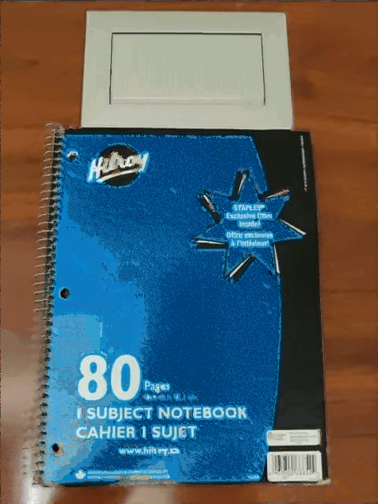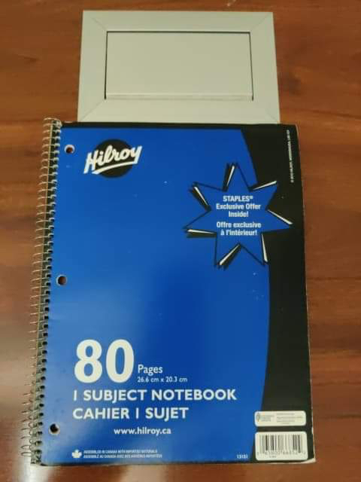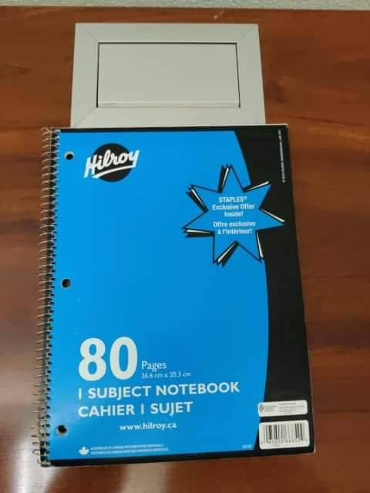

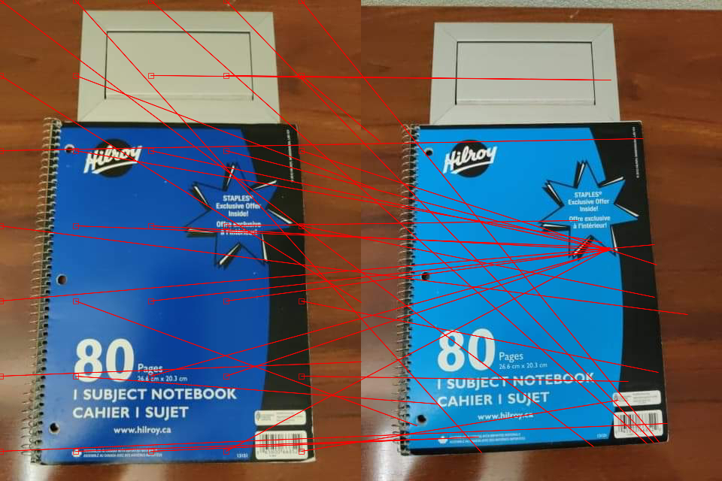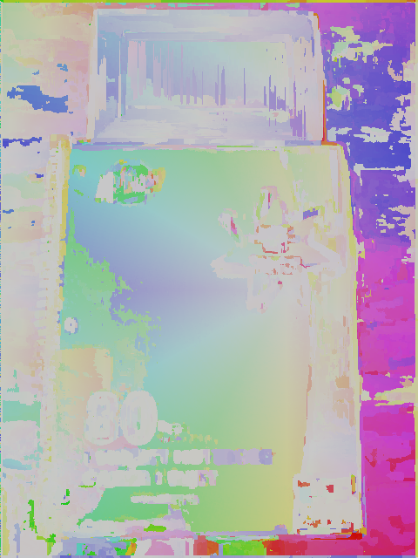NNF-col NNF-vec

This experiment contains two notebooks of similar shape and with similar patterns. The background is the same with slightly different angle, but the notebooks have two different yet close colours. This testcase showcases the some of the strength of the PatchMatch algorithm; being able to find the darkest blue patches (for example the bottom of the star) on the lighter notebook and use them to reconstruct the darker notebook and being able to reconstruct shapes and details that are of the same colour. Only the bottom left side is matched with lighter blue due to the higher light intensity in the source image making the dark blue look lighter. However, it also showcases a very big limitation of the algorithm; that the source images’ coloured patches must match patches in the target image in order for the reconstruction to actually look like the source image. The background is almost perfectly reconstructed despite the angle difference because it would be an example of what PatchMatch is best at reconstructing, the same object at a different angle. As a result, the background is almost perfect while the foreground is visibly different.

Source Reconstructed source

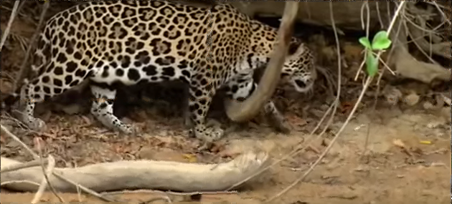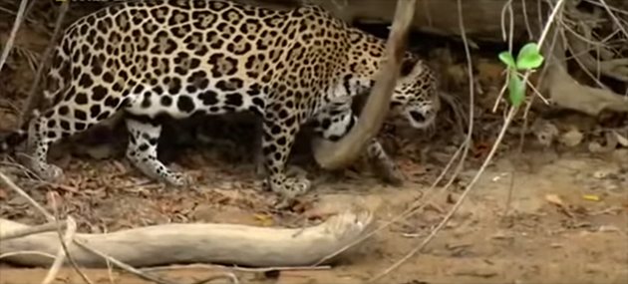

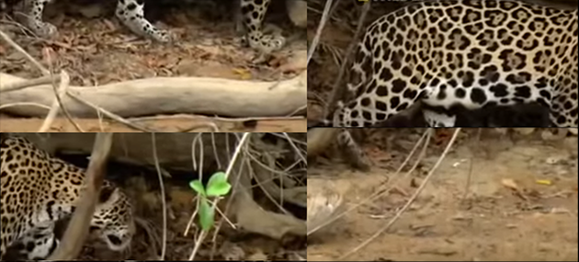Target NNF-col

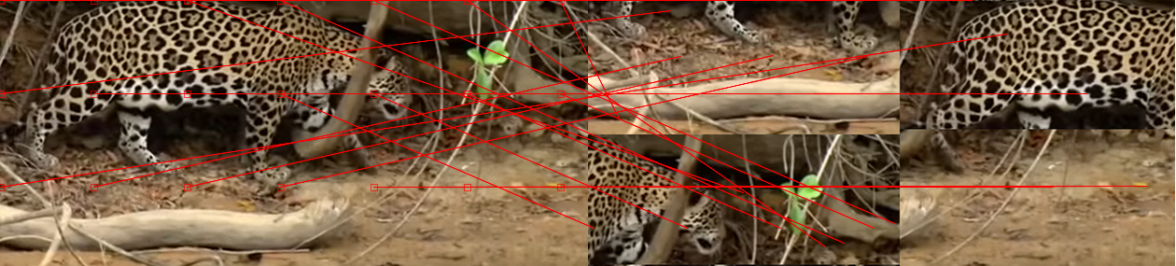NNF-vec



This test case contains a scrambled version of the source image as the target image. This test tests the PatchMatch algorithm’s ability to match patches that have linear position change. This test case is very easy for the algorithm as it tests one of its fundamental functions. The NNF-col is divided into 4 main colours, clearly identifying the 4 scrambled parts of the source image. There are, however, some artifacts on the border of each of the scrambled parts. An example is shown on the left, where the bottom left part and the top right part of the target image meets. The result overall, is quite good. Without magnifying the reconstructed image, it would be hard for a human to notice the difference between the source and the reconstructed image.