ADL Task – 2
Rohan Leo C / 1024121
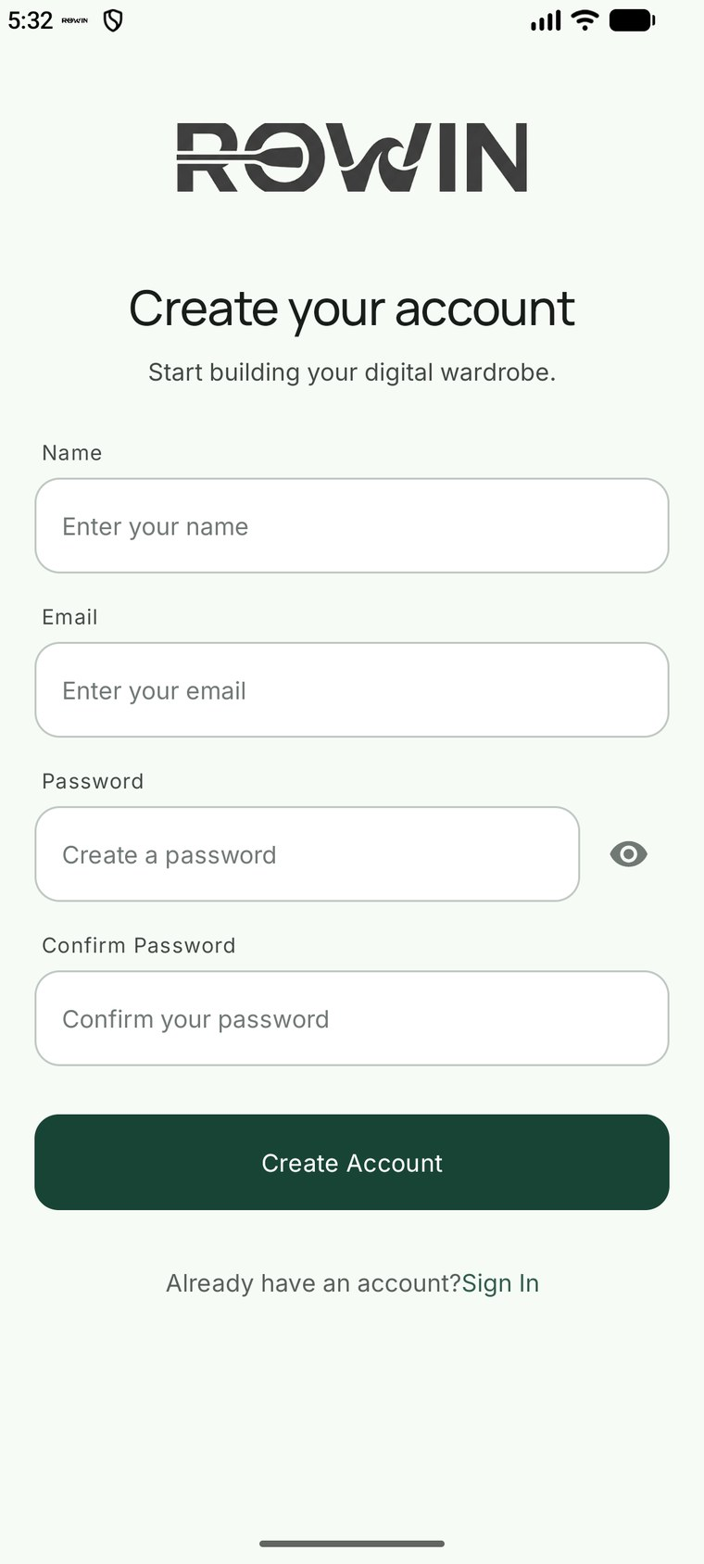
1. ui/auth/RegisterFragment.kt
b.registerButton.setOnClickListener { attemptRegister() }

private fun validate(): String? = when {
b.registerName.text.isNullOrBlank() -> getString(R.string.error_enter_name)

!Patterns.EMAIL_ADDRESS
.matcher(b.registerEmail.text?.toString()?.trim().orEmpty())
.matches() ->
getString(R.string.error_valid_email)

(b.registerPassword.text?.length ?: 0) < 6 ->
getString(R.string.error_password_length)

b.registerPassword.text?.toString() != b.registerConfirm.text?.toString() ->
getString(R.string.error_password_match)
else -> null // all checks passed -> write to the database
}
private fun attemptRegister() {
if (loading) return
validate()?.let { message ->
b.registerError.text = message
Views.show(b.registerError)
return
}
loading = true
AuthUi.setLoading(b.registerButton, true)
host.rowin.register(
b.registerName.text?.toString()?.trim().orEmpty(),
b.registerEmail.text?.toString()?.trim().orEmpty(),
b.registerPassword.text?.toString().orEmpty(),
) { result ->
loading = false
AuthUi.setLoading(b.registerButton, false)
result.exceptionOrNull()?.message?.let { message ->
b.registerError.text = message
Views.show(b.registerError)
}
}
}
2. ui/RowinViewModels.kt
fun register(name: String, email: String, password: String, onDone: (Result<Long>) -> Unit) {
viewModelScope.launch {
val result = repository.register(name, email, password)
result.onSuccess { id -> container.sessionManager.startSession(id) }
onDone(result)
}
}
3. data/WardrobeRepository.kt hashing and entering the credentials
suspend fun register(name: String, email: String, password: String): Result<Long> {
val normalizedEmail = email.trim()
if (userDao.emailExists(normalizedEmail)) {
return Result.failure(
IllegalArgumentException("An account with this email already exists.")
)
}
val salt = PasswordHasher.newSalt()
val user = UserEntity(
name = name.trim(),
email = normalizedEmail,
age = 0,
passwordHash = PasswordHasher.hash(password, salt), // salted SHA-256
passwordSalt = salt, // never store raw password
)
return runCatching { userDao.insert(user) }
}
4. data/UserEntity.kt the row that stores them
@Entity(tableName = "users", indices = [Index("email", unique = true)])
data class UserEntity(
@PrimaryKey(autoGenerate = true) val id: Long = 0,
val name: String,
val email: String,
val age: Int,
val phone: String? = null,
val location: String? = null,
val avatarFileName: String? = null,
val passwordHash: String,
val passwordSalt: String,
val createdAt: Long = System.currentTimeMillis(),
)
5. data/daos.kt inserting the data
@Dao
interface UserDao {
@Insert
suspend fun insert(user: UserEntity): Long
@Query("SELECT * FROM users WHERE email = :email COLLATE NOCASE LIMIT 1")
suspend fun findByEmail(email: String): UserEntity?
@Query("SELECT EXISTS(SELECT 1 FROM users WHERE email = :email COLLATE NOCASE)")
suspend fun emailExists(email: String): Boolean
}

SQLite Room Database showing the local tables used in ROWIN
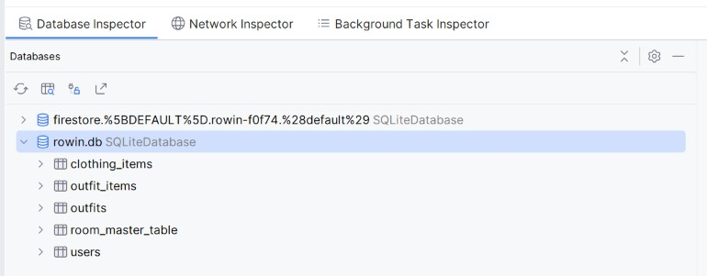

Firebase Firestore showing synchronized user profile data
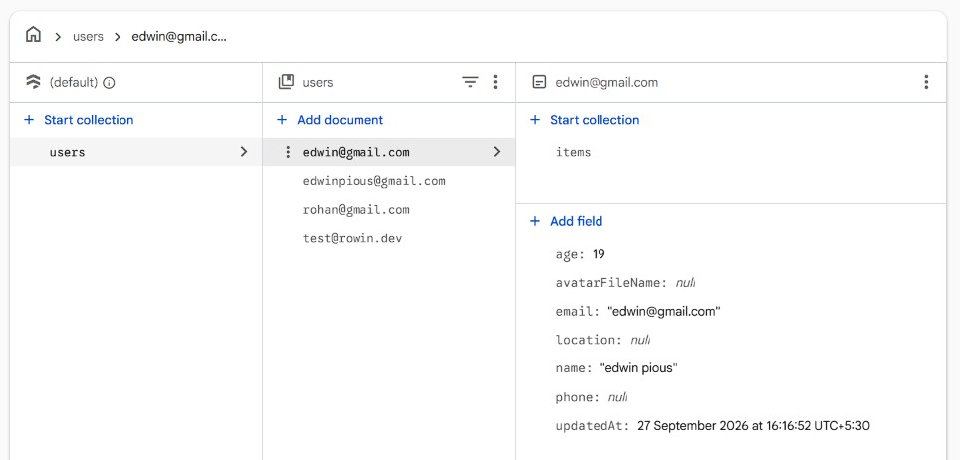

Firebase Firestore showing synchronized wardrobe/clothing item data
