**COMPUTER ENGINEERING DEPARTMENT**

ISIK UNIVERSITY



**COMP2222.1 Database Systems (SPRING22) Project Report**

**Derya CEZIK 19SOFT1035**

**Eda BELGE 19SOFT1022**

1. **How is the GUI used?**

GUI is a graphics-based operating system interface that uses icons, menus and a Mouse (to click on the icon or pull down the menus) to manage interaction with the system.

In the first part of our project, we have implemented a login page that user can login the system with writing their uniquely identified ssn and password[1] and clicking the button “Login”.

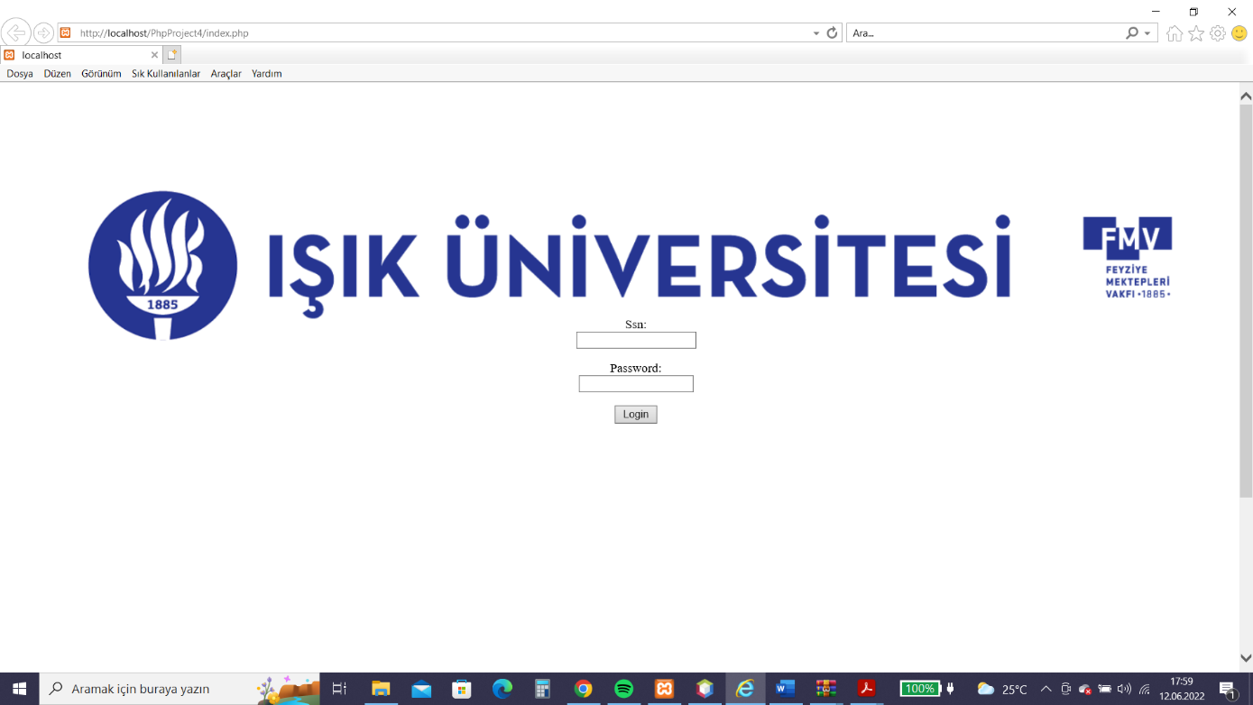

When the user click the “Login” button, based on the database connections, is detected if the user is instructor or student. And the new window for the specific user page opens.

If the user is student, the page is:

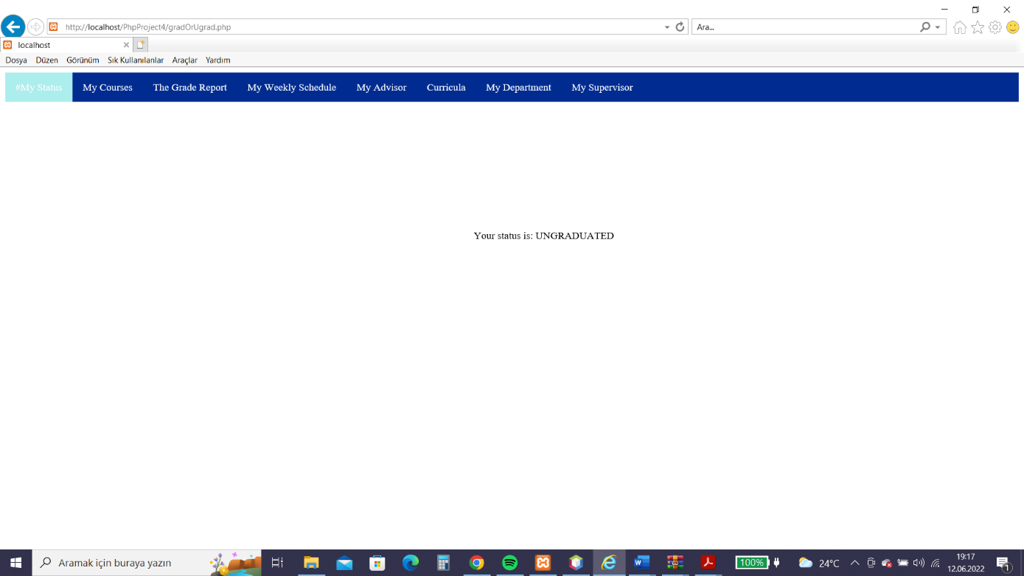

There is a menu top of the page, that student can see their status, courses,advisor etc. with clicking on them.

If the user is instructor, the page is:

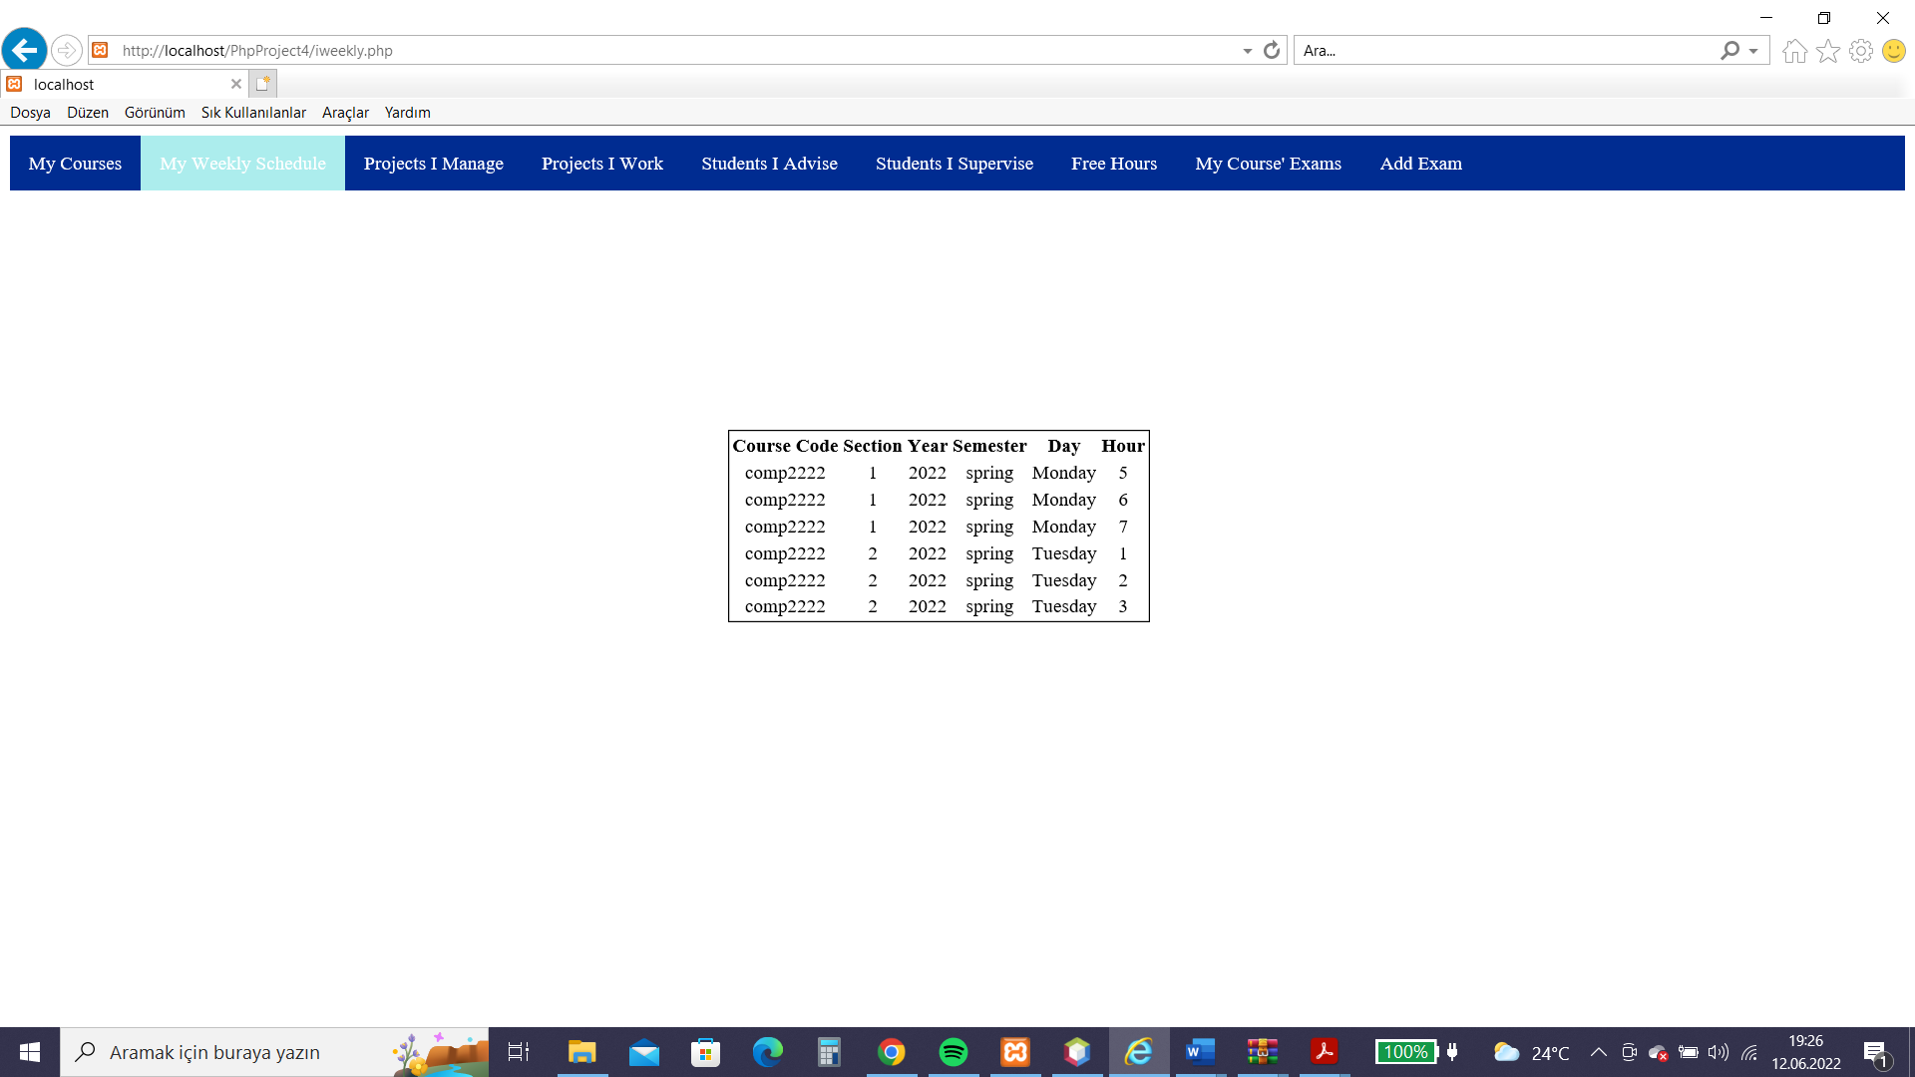

There is a menu top of the page as in the student page, instructors can choose which option they want to access. The outputs from database is in the table, so user can see the information clearly.

**b) Lets test our relations one by one**

1) Attends(sssn , eName , issn , courseCode , yearr , semester , sectionId , score) : (S,N,I,C,Y,E,D,O)

FD1 = SI -> C

FD2 = SINCYED -> O

|  |  |  |  |
| --- | --- | --- | --- |
|  | 2NF | 3NF | BCNF |
| FD1 | + | + | + |
| FD2 | + | + | + |

2) Course(courseCode, courseName, ects, numHours, preReqCourseCode) : (C,N,E,H,P)

FD1 = C –> NEHP

FD2 = P -> C

|  |  |  |  |
| --- | --- | --- | --- |
|  | 2NF | 3NF | BCNF |
| FD1 | + | + | + |
| FD2 | - | - | - |

3)Curricula(currCode,gradOrUgrad,dName) : (C,G,D)

FD1 = CD -> G

|  |  |  |  |
| --- | --- | --- | --- |
|  | 2NF | 3NF | BCNF |
| FD1 | + | + | + |

4) curriculaCourses(currCode , dName , courseCode) : (C,D,A)

FD1 = C -> DA

|  |  |  |  |
| --- | --- | --- | --- |
|  | 2NF | 3NF | BCNF |
| FD1 | + | - | - |

5) Department(dName , budget , headSsn , buildingName) : (D,B,H,N)

FD1 = D -> BHN

FD2 = H -> D

|  |  |  |  |
| --- | --- | --- | --- |
|  | 2NF | 3NF | BCNF |
| FD1 | + | + | + |
| FD2 | + | + | - |

6) emails(email , sssn) : (E,S)

FD1 = ES -> ES

|  |  |  |  |
| --- | --- | --- | --- |
|  | 2NF | 3NF | BCNF |
| FD1 | + | + | + |

7) Enrolled(sssn , issn , courseCode , sectionId , yearr , semester , lettergrade) : (S,I,C,D,Y,E,G)

FD1 = SI -> C

FD2 = SICDYE -> G

|  |  |  |  |
| --- | --- | --- | --- |
|  | 2NF | 3NF | BCNF |
| FD1 | + | + | + |
| FD2 | + | + | + |

8) Exam(eName , edate , issn , courseCode , yearr , semester , sectionId) : (E,D,I,C,Y,S,T)

FD1 = ICD -> EDYS

|  |  |  |  |
| --- | --- | --- | --- |
|  | 2NF | 3NF | BCNF |
| FD1 | + | + | + |

9) gradstudent(ssn , supervisorSsn) : (S,U)

FD1 = S -> A

|  |  |  |  |
| --- | --- | --- | --- |
|  | 2NF | 3NF | BCNF |
| FD1 | + | + | + |

10) Instructor(ssn , iname , rankk , baseSal , dName , extraSalary) : (S,I,R,B,D,E)

FD1 = S -> IRBDE

FD2 = R -> B

FD3 = I -> R

|  |  |  |  |
| --- | --- | --- | --- |
|  | 2NF | 3NF | BCNF |
| FD1 | + | + | + |
| FD2 | - | - | - |
| FD3 | + | - | - |

11) prevDegrees(college , degree , yearr , Gradssn) : (C,D,Y,G)

FD1 = CDYG -> CDYG

|  |  |  |  |
| --- | --- | --- | --- |
|  | 2NF | 3NF | BCNF |
| FD1 | + | + | + |

12) Project(leadSsn , pName , subject , budget , startDate , enddate , controllingDName ) : (L,P,S,B,A,E,C)

FD1 = LP -> SBAEC

|  |  |  |  |
| --- | --- | --- | --- |
|  | 2NF | 3NF | BCNF |
| FD1 | + | - | - |

13) GradsInProjects(leadSsn , pName , Gradssn , workingHour) : (L,P,G,W)

FD1 = LPG -> W

|  |  |  |  |
| --- | --- | --- | --- |
|  | 2NF | 3NF | BCNF |
| FD1 | + | + | + |

14) InstrInProjects(leadSsn , pName , issn , workinghour) : (L,P,I,W)

FD1 = LPI -> W

|  |  |  |  |
| --- | --- | --- | --- |
|  | 2NF | 3NF | BCNF |
| FD1 | + | + | + |

15) sectionn(issn , courseCode , yearr , semester , sectionId , quota) : (I,C,Y,S,E,Q)

FD1 = ICYSE -> Q

|  |  |  |  |
| --- | --- | --- | --- |
|  | 2NF | 3NF | BCNF |
| FD1 | + | + | + |

16) student(ssn , gradorUgrad , advisorSsn , studentid , studentname , currCode) : (S,G,A,T,N,C)

FD1 = S -> GATNC

FD2 = C -> G

|  |  |  |  |
| --- | --- | --- | --- |
|  | 2NF | 3NF | BCNF |
| FD1 | + | + | + |
| FD2 | + | - | - |

17) TimeSlot(dayy ,hourr) : (D,H)

FD1 = DH -> DH

|  |  |  |  |
| --- | --- | --- | --- |
|  | 2NF | 3NF | BCNF |
| FD1 | + | + | + |

**c) Lets try to improve our database**

1) For Course Table :

We need to do preReqCourseCode primary key.

We can create another table called : “requestCode”

requestCode(preReqCourseCode , courseName) : (P,N)

FD2 = P -> C is updated to FD2 = P -> N

Now , for FD2 , 2NF , 3NF and BNCF are passed.

2) For Department Table :

headSsn should be unique key for FD2 = H -> D because every department has only 1 head instructor. When we did headSsn (H) unique , now , for FD2 , 2NF , 3NF and **BCNF are passed**.

3) For Project Table :

4) For student Table :

1. For the login informations, the updated userr.sql file is in the zip file we have uploaded.