Assignment 6
Daniel Achig-Aranha
OCAD University
Direct Studio 2 - 501
Michelle Gay
April 8, 2026

TOPIC AND JUSTIFICATIONS

Throughout the semester, I developed a deeper understanding of my research project, Typographic Archives of Latino Life: New Media Alphabets in Southwestern Ontario. While the central claim has remained consistent, my meetings with the professors in Directed Studio 2 clarified the direction, scope, and purpose of the work. These conversations helped me define a more focused research question: How can co-designed alphabets developed with Latino residents along the London-Sarnia corridor document everyday life, challenge dominant assumptions about typographic quality and multilingual readability, and support ethical forms of visibility and representation?

To support this question, I organized the project into five interconnected areas of inquiry. Together, they give the thesis a clearer research-creation structure and help me move between conceptual framing, typographic form, ethics, and place.

1. Typography as evidence and co-created archive
This inquiry asks whether typography can do more than communicate words. Waller argues that typography participates in discourse and meaning making rather than acting as a neutral container for language. Beier similarly positions letterform research as a legitimate, though historically underrecognized, field of design inquiry, while Spencer shows how experimental approaches can reshape how letterforms are understood and produced. Together, these sources support the idea that type design can function as a research method rather than only as a formal practice (Beier, 2016; Waller, 1991).
In this project, that means the alphabet becomes more than an output. When letterforms are co-developed from participants’ everyday visual worlds, such as storefronts, handwritten notes, vehicles, workplaces, religious spaces, domestic objects, and digital communication, they can register traces of migration, labour, memory, language, and belonging that are often absent from official records. Nat Pyper’s recent work is especially relevant because it treats type as a vehicle for memory, archival transmission, and speculative cultural continuity (Nat Pyper, n.d.).
This framing also strengthens the ethics of the project by positioning participants as co-authors rather than subjects to be observed. That shift moves the work away from extraction and toward shared authorship, situated knowledge, and collaborative meaning-making. Diasporic Constructions of Home and Belonging is useful here because it centers homemaking and belonging in diasporic contexts, while Merleau-Ponty offers a philosophical foundation for understanding perception as embodied and lived (Merleau-Ponty, 2013).
I can explore this idea through interviews, visual mapping, collection of vernacular references, and participatory workshops that lead to collaborative alphabet development. The outcome is therefore not only the final typeface, but also the stories, references, and shared decisions that shape it (Moore, 2025; Nat Pyper, n.d.).
Hypothesis: Co-designed alphabets built from participants’ everyday visual environments will function as documentary evidence by recording social, cultural, and spatial experiences that are often excluded from official archives.
Claim: Typography can operate as testimony and archive, not only as aesthetic communication.
Why it matters: This question gives the project a strong research-creation foundation because it connects typography to memory, representation, embodiment, and community authorship. It also helps position type design as a critical and socially situated practice through which underrepresented histories can be made visible and legible on their own terms.

2. Who decides what counts as “good typography”
This question examines typographic quality as a cultural and political issue rather than a neutral technical standard. It asks who has the authority to define what counts as clear, correct, readable, or professional typography, and how those judgments are shaped by institutions, dominant languages, and design traditions. Typographic standards often appear universal, but they are historically constructed through specific forms of knowledge and professional practice (Lund, 1999; Macdonald‐Ross & Waller, 1975).
It also challenges the assumption that readability is stable across readers and contexts. Beier’s work is especially useful here because it suggests that legibility is closely tied to familiarity, meaning that what readers perceive as readable is influenced by repeated exposure and learned recognition. This becomes especially important in multilingual settings, where extended Latin characters, accents, and hybrid language forms may not align with dominant English-centered expectations of typographic clarity (Beier, 2009; Lund, 1999).
From a decolonial perspective, this question asks how typographic standards have been shaped by Western design traditions that present themselves as neutral and universal. A decolonial approach instead treats design knowledge as situated within particular histories, languages, and systems of power. In my project, participants are not simply adapting to dominant typographic norms, but contributing alternative understandings of quality, readability, and correctness through their own linguistic practices and everyday experience. (Escobar, 2018; Schultz et al., 2018).
Macdonald-Ross and Waller help strengthen this discussion by showing that typography should be understood through criticism, alternatives, and testing rather than through unquestioned professional assumptions. Their framework makes it possible to treat participants not only as users of typography, but also as contributors to the criteria by which typographic quality is judged (Beier, 2009; Macdonald‐Ross & Waller, 1975).
For my project, this matters because Latino communities along the London-Sarnia corridor may define good typography through recognition, cultural familiarity, emotional resonance, and linguistic fit, not only through professional norms inherited from Euro-American publishing traditions. The goal is not to reject typographic standards altogether, but to examine where they come from, whom they serve, and how more inclusive evaluative frameworks might emerge through co-design and community participation.
Hypothesis: Participatory typographic workshops will show that typographic quality is culturally situated, and that participants may value recognition, belonging, and linguistic fit as much as, or more than, dominant professional standards.
Claim: What counts as “good typography” is not universal. It is shaped by cultural norms, institutional histories, and relations of power.
Why it matters: This question gives my project a critical and decolonial framework for examining typographic standards. It helps reveal how established standards may exclude multilingual communities while also creating space for new, community-informed definitions of quality, readability, and correctness. In this way, my project not only critiques typographic exclusion, but also proposes participatory ways of understanding design knowledge and practice.

3. Typographic mechanics, readability, and multilingual conditions
This guiding inquiry focuses on typography at the level of formal construction. It examines how spacing, hierarchy, alignment, paragraph structure, contrast, scale, and rhythm shape reading experience and organize access to language and meaning. Hochuli explains that typographic detail is fundamental to how text performs in practice, while Ambrose, Harris, and Theodosiou show how hierarchy and structure guide readers through content (Ambrose et al., 2020; Hochuli, 2015).
This inquiry becomes especially important in multilingual contexts, where reading conventions cannot be assumed to be universal. What appears clear or balanced in one linguistic setting may not function the same way in another. Beier’s work is especially relevant here because legibility depends on how readers recognize letterforms and process visual distinctions within text. In bilingual or mixed-language conditions, accented characters, punctuation, translation, and shifts in word or line length may affect recognition, pace, and comprehension. Standard typographic conventions often reflect dominant reading habits and may not fully accommodate multilingual readers (Beier, 2016; Hochuli, 2015).
This also supports a methods-based approach to the project. By testing variables such as letter spacing, word spacing, line spacing, paragraph width, contrast, and hierarchy, I can observe how multilingual readers respond to different typographic conditions. These experiments allow typographic mechanics to function not only as matters of craft, but also as tools for revealing who typography is designed for and whose reading habits are treated as standard.
Hypothesis: Systematic testing of multilingual text through typographic variation will demonstrate that readability is context-dependent and that conventional typographic settings often privilege dominant language norms rather than diverse reading conditions.
Claim: Microtypographic decisions such as spacing, hierarchy, and paragraph settings are not only technical adjustments but also cultural choices that reveal assumptions about who the “normal” reader is and how text is expected to be read.
Why It Matters: This inquiry grounds the project in the formal practice of typography while showing that typographic decisions also carry social and political implications. It connects craft-based design knowledge with critical inquiry and positions readability as a site of investigation rather than a neutral standard.

4. Ethical visibility, representation, and risk
This question addresses the ethical responsibilities of representing Latino life through research-creation. In community-based work, visibility cannot be assumed to be inherently positive. Although making underrepresented communities more visible may support recognition and public presence, it can also expose participants to misrepresentation, monitoring, or reductive cultural framing. A transformative research approach is useful here because it treats research not as neutral observation, but as a process shaped by justice, power, and accountability to the people involved (Tashakkori & Teddlie, 2010).
This question is also important because typographic work circulates. Once a font, poster, animation, or other visual system is published, it may move far beyond the context in which it was created. For that reason, the project must think carefully about consent, naming, authorship, anonymity, and circulation. It must ask who decides what becomes public, who benefits from that visibility, and how participants remain protected when their words, forms, or experiences are translated into design. Tierney and Clemens are especially helpful here because they frame qualitative research as socially consequential, with implications that extend beyond the research setting into public life (Tierney & Clemens, 2011).
The question also requires careful attention to interviews as a method. Participant voices do not simply appear unchanged in research. They are shaped by the way interviews are framed, classified, edited, and interpreted. Walford is useful because he reminds us that ethnographic interviewing is not a transparent extraction of truth, but a structured interaction in which meaning is produced through relationships, context, and framing. In this project, interviews should not be treated as raw material to mine for visual content, but as collaborative encounters that require care in how testimony is gathered, translated, and represented (Walford, 2007).
Seen this way, the issue is not only whether participants are included, but whether they can shape the terms of their own representation. A non-extractive and decolonial approach would give participants meaningful control over selection, interpretation, and circulation. It would allow them to decide what remains private, what becomes public, and how their presence is carried into typographic form. Ethical visibility, then, is about designing processes that respect complexity, agency, and refusal where needed (Tashakkori & Teddlie, 2010; Tierney & Clemens, 2011; Walford, 2007).
Hypothesis: When participants retain control over selection, naming, interpretation, and circulation, typographic representation can support visibility in ways that are more ethical, collaborative, and resistant to extraction.
Claim: Visibility is not automatically empowering. In research-creation, ethical representation requires attention to power, consent, framing, and the public consequences of how participants are made visible.
Why it matters: This question strengthens the project by ensuring that representation is approached as an ethical and methodological issue rather than only a visual one. It helps protect participant agency, improves the integrity of the interviews and design process, and supports a form of visibility grounded in justice rather than appropriation or exposure.

5. Corridor Life, Labour, Movement, and Visual Ecology
This question grounds the project in the lived realities of a specific region and approaches typography as part of everyday social experience rather than as an isolated formal system. Along the London-Sarnia corridor, commuting routes, industrial landscapes, agricultural zones, stores, churches, homes, and roadside signage all become places where letterforms are repeatedly encountered, interpreted, and remembered. A qualitative interview approach is useful here because it allows participants to describe how these environments structure what they notice, what they trust, and what they carry into the design process (Kvale, 2004).
This question also supports a spatial and relational understanding of visual culture. By mapping routes, sites, and recurring references, the project can examine how visual memories are organized through movement and how signage, packaging, informal graphics, and service lettering become meaningful through repetition. Mind mapping is especially relevant because it offers a participant-centered way to connect place, memory, and visual reference, making it possible to trace how typographic choices emerge from lived experience rather than from abstract preference alone (Wheeldon & Ahlberg, 2019).
Framing the study in this way strengthens the project as research-creation. Rather than treating the corridor as a neutral backdrop, the project understands it as a material and cultural environment that shapes typographic form. This makes it possible to examine how labour, transit, commerce, and community life inform the creation of letterforms and visual systems. In this sense, the resulting typefaces are not only design outcomes but also situated responses to social geography, observation, and creative inquiry (Collins & Collins, 2019).
This focus gives the project regional specificity. Instead of speaking about Latino typography in generalized terms, it locates typographic making within the patterns of life that structure Southwestern Ontario. The project can therefore ask how a typeface emerges from repeated encounters with local materials, infrastructures, and forms of movement, and how design can register a corridor shaped by labour, migration, and everyday circulation (Collins & Collins, 2019; Kvale, 2004; Wheeldon & Ahlberg, 2019).
Hypothesis: The visual environments of the London–Sarnia corridor will reveal recurring typographic patterns connected to labour, transit, commerce, and community life, and those patterns will shape the visual references and design decisions participants make.
Claim: Typography is shaped by place, it emerge not only from formal design history but also from the everyday environments through which people move, work, and build meaning.
Why It Matters: This question gives the project geographic and cultural specificity. It strengthens the connection between typography, lived experience, and regional identity, while also showing how research-creation can document the visual conditions of everyday life along the corridor.

Work in Progress
These five interconnected questions have helped me understand that my thesis is not only about designing letterforms, but about examining how typography can participate in the production of knowledge. They have also helped me recognize my own role in shaping what becomes visible, legible, and valued through the work.
I chose these five ideas because each one responds to a tension I kept encountering as the project developed: archive versus output, standards versus cultural specificity, mechanics versus assumed neutrality, visibility versus extraction, and place versus abstraction. Together, they give the thesis both conceptual range and methodological direction.
My work in Directed Studio 2 has shaped this thesis in a reflexive way because it has changed how I understand my role in the project while the project is still unfolding. At the beginning, I was thinking more broadly about typography, Latino representation, and making. Through critiques, conversations, and feedback, I began to see that the project needed a stronger methodological and ethical structure. More importantly, I began to recognize that I am implicated in every stage of the process, from framing participation to interpreting visual material and formalizing it through design.
At the moment, I am focusing on two main areas. The first is the detailed study of typographic mechanics through Petr van Blokland’s course at Cooper Union. This includes spacing, rhythm, interpolation, structure, and the internal logic of the type system. This work matters because it helps me question what counts as formal quality in type design and where those standards come from. I am also trying to understand the software environments that best support the project, especially Glyphs and RoboFont.
The second area I am focusing on is developing a deeper understanding of decolonizing design process. This is becoming central to the thesis because it asks me to reflect on how the work is made, not only on what it looks like in the end. I am trying to understand how a decolonizing process can shape collaboration, representation, authorship, and accountability throughout the project, and whether the final typographic outcomes avoid turning community experience into aesthetic material detached from context.
At this stage, my thesis is being shaped by the relationship between formal typographic study and critical reflexive inquiry. On one side, I am working to strengthen the technical precision of the type through mechanics, systems, and software. On the other, I am examining how these formal processes are entangled with ethics, visibility, and power. What is becoming clearer to me is that these dimensions cannot be separated.

WAYS OF MAKING AND METHODS
Throughout the semester, and particularly through Exhibition: Labyrinth, I was able to explore two distinct ways of making in relation to my ongoing research project: printmaking and type design with typographic mechanics testing. These approaches, together with their associated methodologies, helped me engage relevant literature, examine materiality, and connect making to my broader research questions. At the centre of this process was Otavalo, a typeface exploration through which I was able to reflect on how Andean textile references, monolinear construction, and typographic rhythm could be translated into letterforms, while also testing how typography can carry memory, identity, labour, and place as part of the visual and conceptual direction of a future thesis exhibition.

Printmaking:
In exploring printmaking as one of my methods, I came to understand Otavalo not only as a digital typeface but as a material and embodied typographic form. My hypothesis is that, if Otavalo is explored through printmaking, the typeface will reveal qualities of texture, repetition, rhythm, and physical presence that are not fully visible on screen. This became clearer through my participation in [LAB]YRINTH, where the work moved from screen preparation and mirrored stencil-making to proofing, framing, and exhibition display. Rather than treating the typeface as a finished digital product, printmaking allowed me to test how Otavalo behaves through ink, paper, scale, pressure, registration, and layering. In this sense, the method helped me understand typography as process, translation, and embodiment (Print Club London, 2017, see Figures 1-4).
Reflexively, this method also changed how I think about my own design decisions. Seeing Otavalo first on the screen, then reversed on the mesh, then pulled as specimen proofs, and finally installed in the exhibition made me more aware of how typographic form is shaped by material resistance and display conditions. The prepared screen, early printed tests, the framed print, and the installation context all show that the typeface gains meaning through making and public encounter. Because Otavalo draws from handcrafted and textile-based references, printmaking became more than a way to present the work. It became a way to think through the work (Print Club London, 2017).

Type design and typographic mechanics testing
In this part of my research, and in preparing the pieces for [LAB]YRINTH, I approach Otavalo as a functional typeface shaped by spacing, rhythm, hierarchy, legibility, and multilingual character support. My working hypothesis is that, if I test Otavalo through typographic mechanics such as spacing, contrast, hierarchy, and paragraph settings, I will better understand how formal decisions shape readability and reveal whose reading norms are being prioritized. This method is important because it connects the conceptual questions of my thesis with the technical work of type design. In this sense, Otavalo is not only a visual concept, but a system that must be tested, adjusted, and made accountable through design practice (Google Fonts, n.d.; Microsoft, 2024).
This method has also become one of the clearest ways for me to understand how research and making are inseparable in my process. As I work more deeply with Glyphs, RoboFont, Fontra Pak, and variable-font workflows, I am learning that designing a typeface also means learning how interpolation, axes, masters, and export systems structure the form of the letters themselves. Technical documentation becomes especially important here because variable-font testing depends on current standards and tool behavior. Microsoft defines variable fonts through OpenType variation axes and variation data, while Glyphs organizes the process around defining axes, setting masters, and exporting and testing the variable font. Fontra Pak is useful because it opens .ufo and .designspace files natively, allowing me to treat the design space itself as a place of experimentation rather than only as back-end production data (Fontra, 2026; Glyphs, 2026; Microsoft, 2024).
My way of making in this method includes drawing letterforms, building glyph sets, testing accented and extended Latin characters, producing digital proofs, and comparing different typographic settings in editorial and poster formats. I also see type specimen making as part of the research, not simply as a final presentation format. Griffin helps me think about the specimen as a historical and visual form that records how type is shown, circulated, and understood, while Drucker allows me to position the specimen closer to the logic of the artist’s book, where form, sequencing, and material presentation produce meaning. Through this lens, the Otavalo specimen becomes a reflective tool for studying the typeface across scales, layouts, and reading conditions (Drucker, 1995; Griffin, 2022).
I am also expanding this method through motion graphics with type. In the Otavalo motion experiments, the variable font moves with music and responds to song lyrics, allowing me to test typography not only as static form but as temporal form. This shifts my attention from fixed pages to rhythm, pacing, transition, and emphasis over time. Brownie and Wang are useful here because they frame kinetic typography as a practice in which movement changes how type is read, felt, and interpreted on screen. In my project, this motion work helps me test whether Otavalo can carry affect, voice, and atmosphere in addition to readability (Brownie, 2020; Wang, 2019, See Figure 5).
Another important part of this process is learning the relationship between XML, HTML, UFO, and designspace files. I understand HTML as the structure used to organize content for the screen, while XML is a markup language for storing and describing structured data with custom tags. UFO is relevant because it is a human-readable, cross-application source format for font development, and Glyphs notes that each .ufo stores only a single master. This means that when I export Otavalo to UFO, each master becomes its own editable source, and the designspace file defines how those masters relate to one another across an axis such as weight. For me, this relationship matters because it shows that the font is not only a set of drawings, but also a structured system of files, metadata, and interpolation logic that can move across tools and outputs (Fontra, 2026; Glyphs, 2026).
The influence of Petr van Blokland is also important in how I am thinking about this stage of the project. What I find especially relevant is his emphasis on systematic design, tool-making, programming, and the relation between drawing and structure. That perspective supports my own interest in sketching design spaces, using TypeCooker parameters to generate formal directions, and understanding type design as both aesthetic and procedural work. In my case, TypeCooker helps me externalize variables such as weight, contrast, construction, and application so that design decisions can be tested more deliberately (TypeCooker, 2026).
Based on my current Otavalo workflow, I understand the variable font as developing from a set of UFO original masters connected through one design space. In practical terms, I use UFO exports for the individual masters, build or refine the design space in Fontra Pak, and then use Glyphs, including Python-assisted preparation in my workflow, to make the font variable-ready for testing and export. This lets me move between drawing, proofing, interpolation, and motion testing as part of one continuous research process. The design space I am currently imagining for Otavalo is structured around a Weight axis with three original masters: OtavaloV3-Light.ufo at 32, OtavaloV3-Regular.ufo at 60, and OtavaloV3-Bold.ufo at 108, with Regular as the default position (see Appendix 1).

Conclusion
Taken together, the sections on Topic and Justifications and Ways of Making and Methods have helped me understand that my thesis, Typographic Archives of Latino Life: New Media Alphabets in Southwestern Ontario, is not only about producing a typeface, but about building a research-creation practice that is formally rigorous, materially grounded, and ethically accountable. The project asks how co-designed alphabets can document Latino life along the London-Sarnia corridor while also questioning dominant assumptions about typographic quality, multilingual readability, visibility, and representation. Through printmaking, type design, typographic mechanics testing, and motion experiments, I have been able to move from abstract questions into processes of making that test how typography can function as archive, testimony, embodied form, and social practice.
This understanding was shaped in an important way through Directed Studio 2. The guidance I received in meetings with Michelle Gay and Diane Mikhael helped me refine the scope of the thesis and pushed me to think more carefully about methodology, positionality, and the ethical implications of representation. Their feedback encouraged me to see that the work is not only about what I make, but about how I make it, with whom, and under what conditions. In parallel, my conversations with Gordon Boyd, a glass artists, opened another valuable space of exchange, where I could think across disciplines about process, craft, materiality, and how decolonizing design might be understood differently in each practice.
Ultimately, the relationship between my topic and my methods has shown me that Typographic Archives of Latino Life: New Media Alphabets in Southwestern Ontario is being formed through both critical inquiry and acts of making. I am working to strengthen typographic form through detail, rhythm, structure, and testing, while also remaining attentive to lived experience, community participation, and non-extractive representation. For that reason, I now understand my thesis as an evolving practice of designing typography through reflexive, collaborative, and decolonizing processes that remain accountable to the people, places, and visual cultures that shape it.

References
Ambrose, G., Harris, P., & Theodosiou, S. (2020). The fundamentals of typography (Third edition). Bloomsbury Visual Arts.
Beier, S. (2009). Typeface legibility: Towards defining familiarity [PhD thesis, Royal College of Art]. RCA Research Repository record
Beier, S. (2016). Letterform research: An academic orphan. Visible Language, 50(2), 64–79.
Brownie, B. (2020). Transforming type: New directions in kinetic typography. Bloomsbury. https://doi.org/10.5040/9781474246187
Collins, H., & Collins, H. J. (2019). Creative research: The theory and practice of research for the creative industries (Second edition). Bloomsbury Visual Arts.
Drucker, J. (with Granary Books (Firm) & Press Collection (Library of Congress)). (1995). The century of artists’ books. Granary Books.
Escobar, A. (2018). Designs for the pluriverse: Radical interdependence, autonomy, and the making of worlds. Duke University press.
Fontra. (2026, April 8). Fontra. Opening a UFO or Designspace File in Fontra. Fontra Docs. https://docs.fontra.xyz/how-tos/opening-ufo-designspace/
Glyphs. (2026, April 9). Exporting font files. Glyphs Handbook. https://handbook.glyphsapp.com/
Google Fonts. (n.d.). Introducing variable fonts. Retrieved https://fonts.google.com/knowledge/introducing_type/introducing_variable_fonts
Griffin, D. (2022). Type specimens: A visual history of typesetting and printing. Bloomsbury Visual Arts.
Hochuli, J. (2015). Detail in typography: Letters, letterspacing, words, wordspacing, lines, linespacing, columns. Éditions B42.
Kvale, S. (2004). InterViews: An introduction to qualitative research interviewing (12. [print.]). Sage.
Lund, O. (1999). Knowledge construction in typography: The case of legibility research and the legibility of sans serif typefaces [PhD thesis]. University of Reading.
Macdonald‐Ross, M., & Waller, R. (1975). Criticism, Alternatives and Tests: A Conceptual Framework for Improving Typography. Programmed Learning and Educational Technology, 12(2), 75–83. https://doi.org/10.1080/1355800750120202
Merleau-Ponty, M. (2013). Phenomenology of Perception. Routledge. https://doi.org/10.4324/9780203720714
Microsoft. (2024, May 30). OpenType font variations overview. https://learn.microsoft.com/en-us/typography/opentype/spec/otvaroverview
Moore, P. (2025, September 10). A Queer Year of Love Letters is a collection of “time machine” fonts that take us to our countercultural past and futures [Graphic Design Blog]. It’s Nice That. https://www.itsnicethat.com/articles/nat-pyper-publication-graphic-design-project-100925
Nat Pyper. (n.d.). Retrieved December 8, 2025, from https://www.natpyper.com/
Print Club London. (2017). Screenprinting: The Ultimate Studio Guide from Sketchbook to Squeegee. Thames & Hudson.
Schultz, T., Abdulla, D., Ansari, A., Canlı, E., Keshavarz, M., Kiem, M., Martins, L. P. D. O., & J.S. Vieira De Oliveira, P. (2018). What Is at Stake with Decolonizing Design? A Roundtable. Design and Culture, 10(1), 81–101. https://doi.org/10.1080/17547075.2018.1434368
Tashakkori, A., & Teddlie, C. (2010). Sage handbook of mixed methods in social and behavioral research. Sage.
Tierney, W. G., & Clemens, R. F. (2011). Qualitative Research and Public Policy: The Challenges of Relevance and Trustworthiness. In J. C. Smart & M. B. Paulsen (Eds.), Higher Education: Handbook of Theory and Research (Vol. 26, pp. 57–83). Springer Netherlands. https://doi.org/10.1007/978-94-007-0702-3_2
TypeCooker. (2026, April 9). TypeCooker. https://typecooker.com
Walford, G. (2007). Classification and framing of interviews in ethnographic interviewing. Ethnography and Education, 2(2), 145–157. https://doi.org/10.1080/17457820701350491
Waller, R. (1991). Typography and discourse. In Handbook of Reading Research: II (pp. 341–380). Longman.
Wang, S. (Ed.). (2019). Typography for screen: Type in motion (1. Auflage). HOAKI BOOKS.
Wheeldon, J., & Ahlberg, M. (2019). Mind Maps in Qualitative Research. In P. Liamputtong (Ed.), Handbook of Research Methods in Health Social Sciences (pp. 1113–1129). Springer Singapore. https://doi.org/10.1007/978-981-10-5251-4_7

Figures

Figure 1
Otavalo specimen screen prepared for screenprinting, showing the uppercase and lowercase character set with selected symbols before ink transfer.
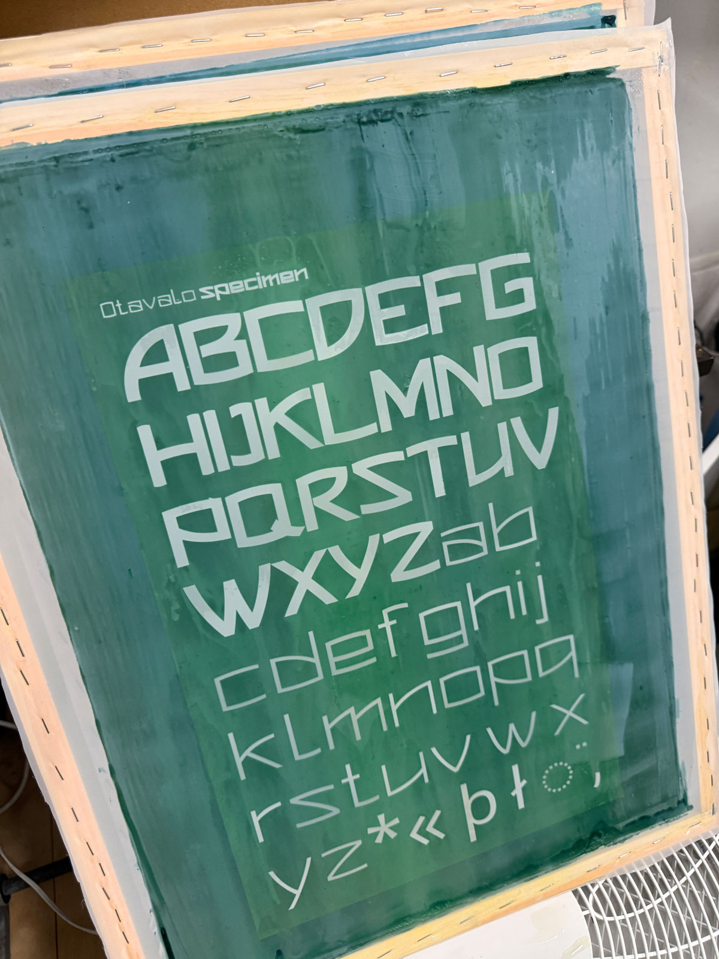

Figure 2
Printed Otavalo specimen proofs on coloured paper, documenting the transition from screen preparation to physical print output and material testing.
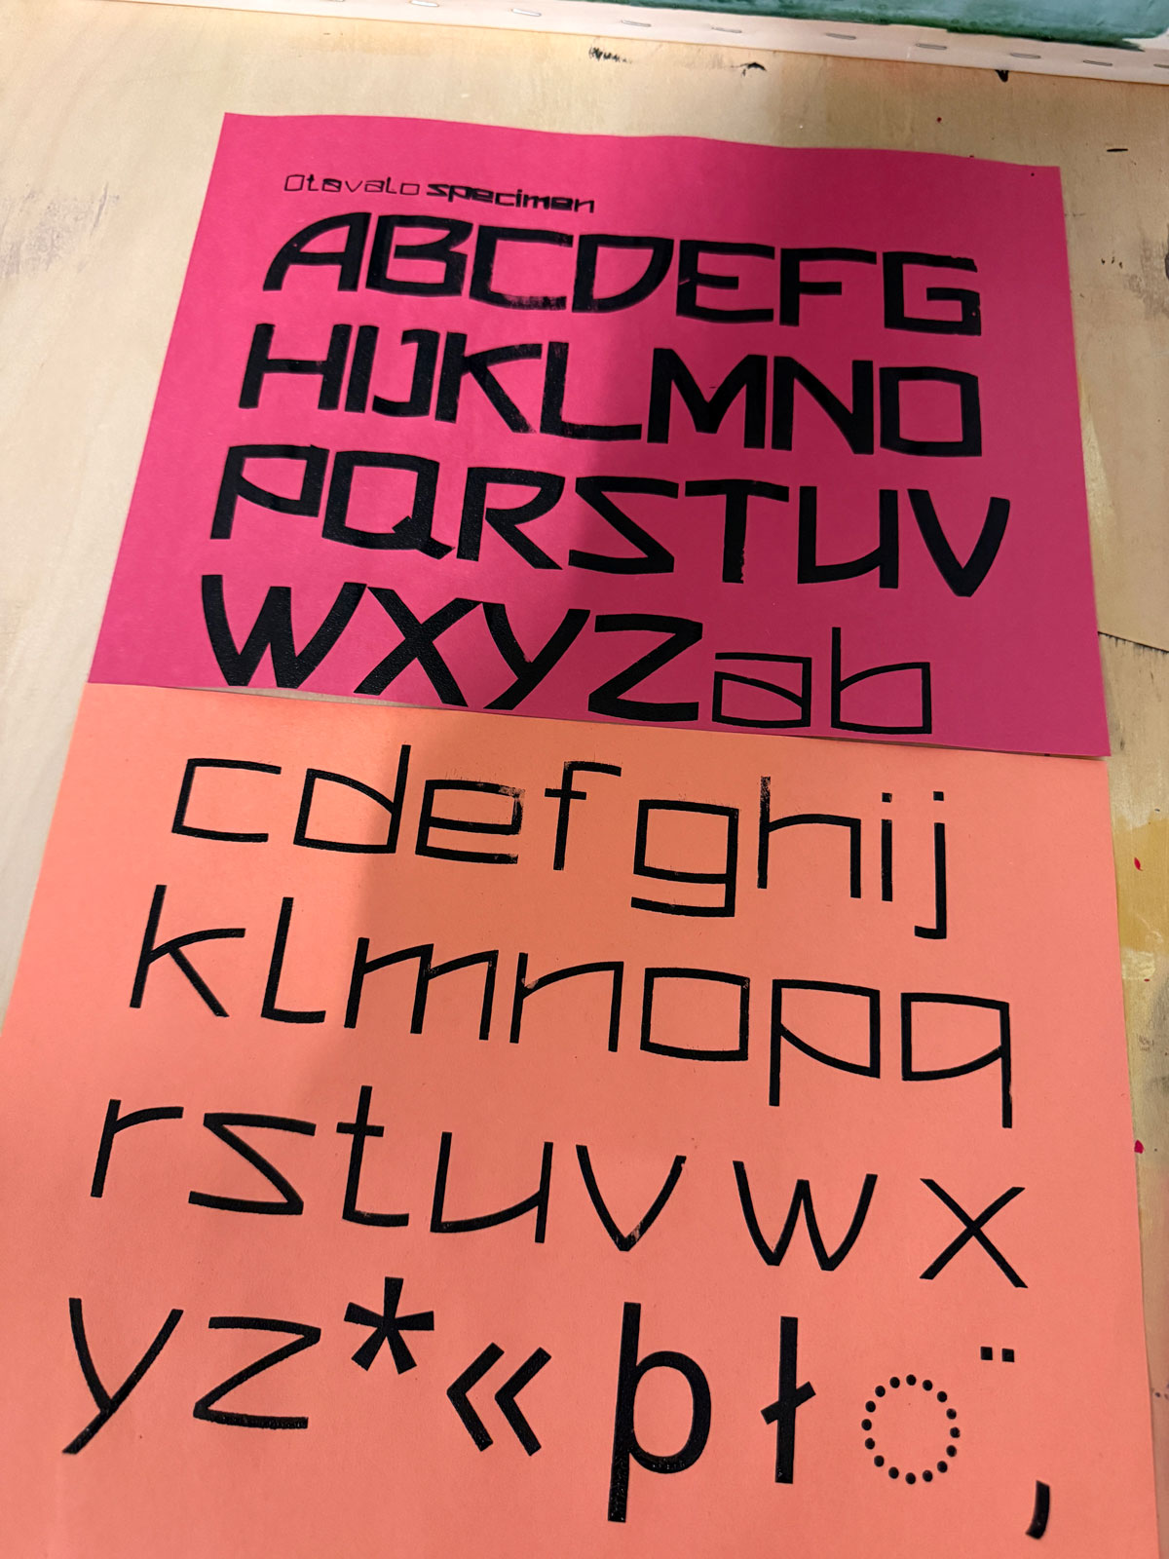

Figure 3
Framed Otavalo print displayed as part of the project’s material exploration, combining typographic form with visual references drawn from Otavalo textile culture and portraiture.
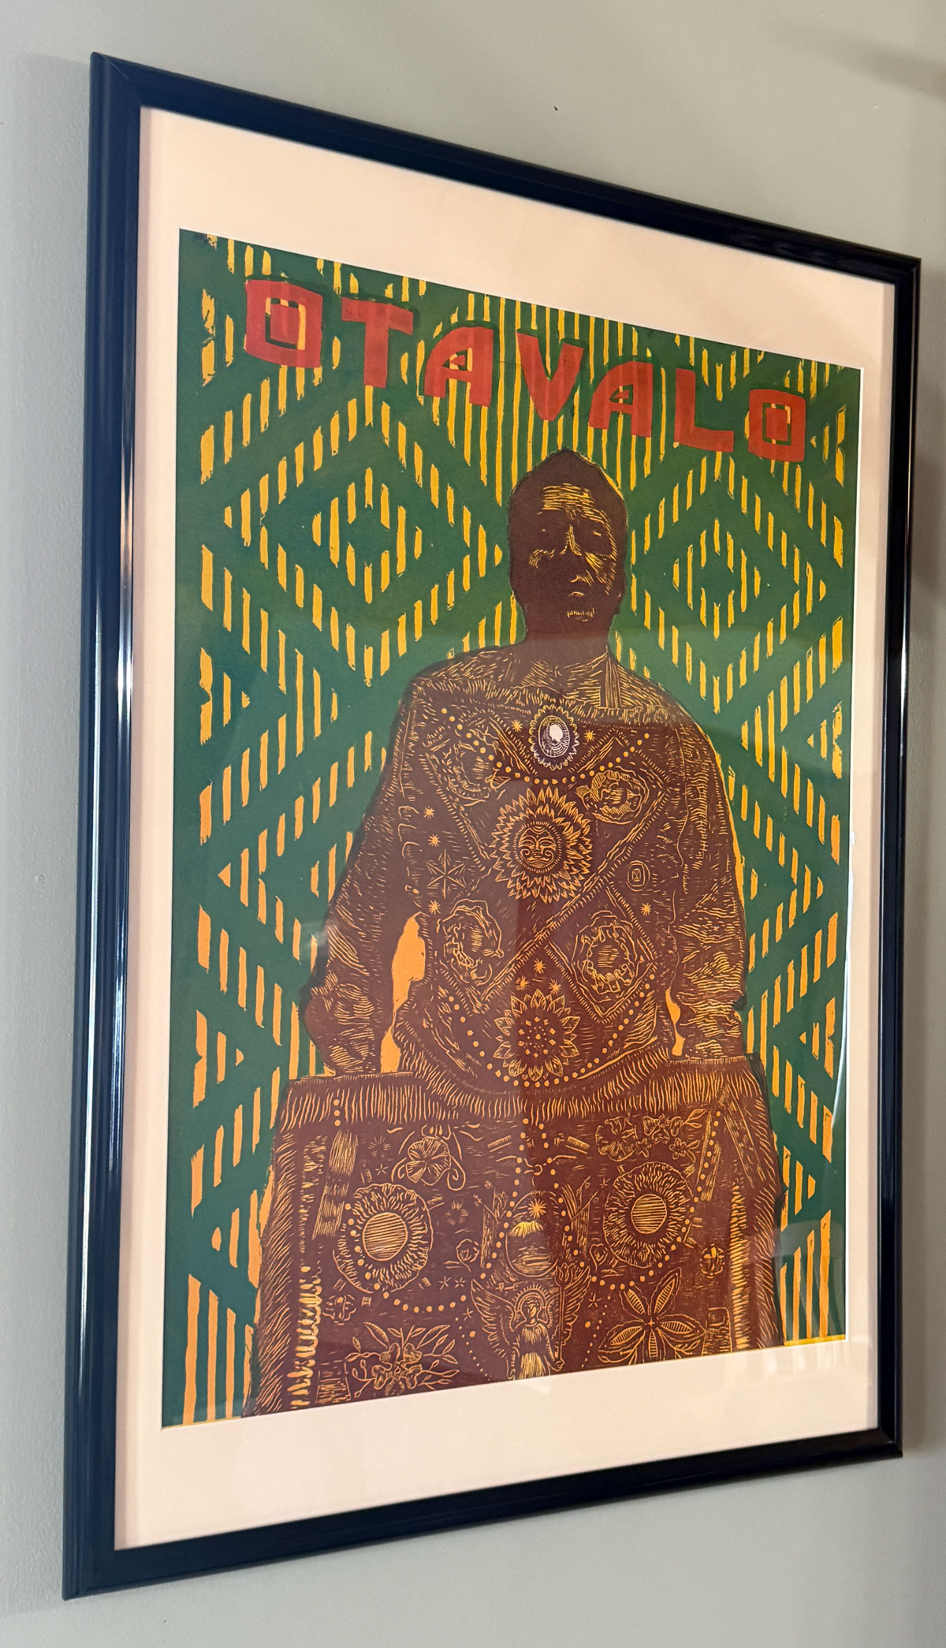

Figure 4
Installation view of the Otavalo project in the [LAB]YRINTH exhibition, presenting process materials, specimens, research references, and typographic experiments together in a public display.
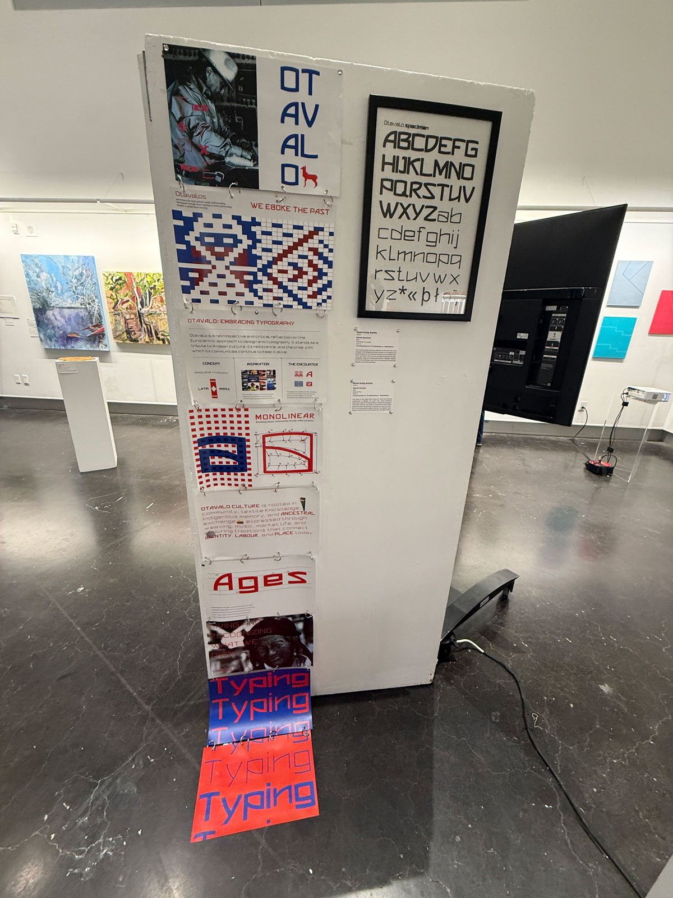

Figure 5
Still from the Otavalo motion experiment, showing the variable typeface animated on screen in response to rhythm, timing, and audiovisual testing.
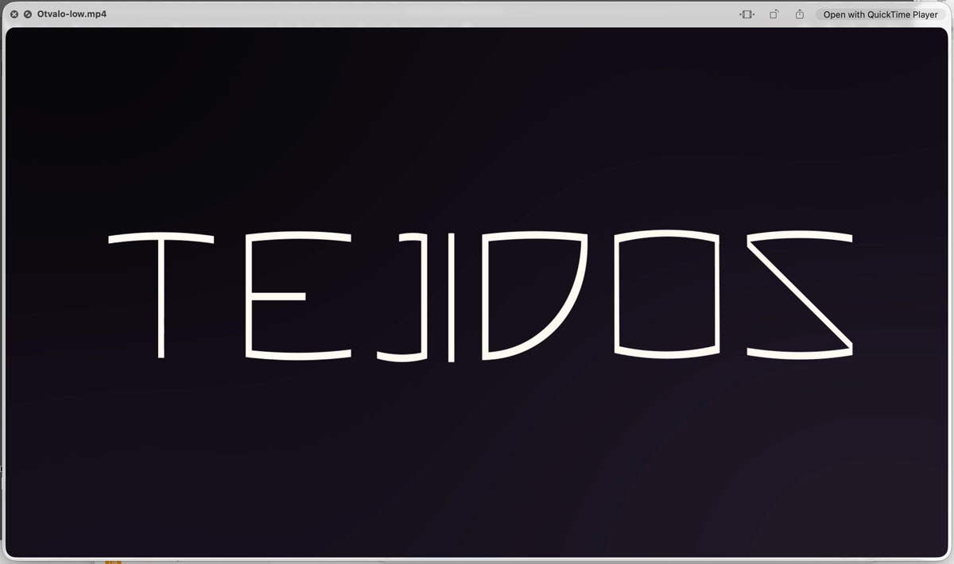

Appendix

Appendix 1: Example designspace for the Otavalo UFO masters
Based on the current variable font setup, a matching. designspace structure could be organized like this:
#Designspace
<?xml version="1.0" encoding="UTF-8"?>
<designspace format="5.0">
<axes>
<axis tag="wght" name="Weight" minimum="300" default="400" maximum="900"/>
</axes>

<sources>
<source filename="OtavaloV3-Light.ufo" name="Otavalo Light">
<location>
<dimension name="Weight" xvalue="300"/>
</location>
</source>

<source filename="OtavaloV3-Regular.ufo" name="Otavalo Regular">
<location>
<dimension name="Weight" xvalue="400"/>
</location>
</source>

<source filename="OtavaloV3-Bold.ufo" name="Otavalo Bold">
<location>
<dimension name="Weight" xvalue="700"/>
</location>
</source>

<source filename="OtavaloV3-Black.ufo" name="Otavalo Black">
<location>
<dimension name="Weight" xvalue="900"/>
</location>
</source>
</sources>

<instances>
<instance familyname="Otavalo V3" stylename="Light">
<location>
<dimension name="Weight" xvalue="300"/>
</location>
</instance>
<instance familyname="Otavalo V3" stylename="Regular">
<location>
<dimension name="Weight" xvalue="400"/>
</location>
</instance>
<instance familyname="Otavalo V3" stylename="Bold">
<location>
<dimension name="Weight" xvalue="700"/>
</location>
</instance>
<instance familyname="Otavalo V3" stylename="Black">
<location>
<dimension name="Weight" xvalue="900"/>
</location>
</instance>
</instances>
</designspace>

