END-TO-END RELEASE ASSESSMENT
AdPilot OS V7
Explainable operations, guarded automation and a release-ready interface
Research / implementation / verification / launch handover
SAFE RELEASE BOUNDARY
AdPilot can automate collection, analysis, explanation and draft preparation. Live paid-ad spend changes remain human-controlled.
Release 7.0.0 | Australia | 22 July 2026

Executive outcome
AdPilot has been rebuilt from a crowded collection of tools into one understandable operating loop:
- Today says what changed and what needs attention.
- Fixes explains the evidence and prepares safe action drafts.
- Create turns insight into content and creative work.
- Automate runs repeatable analysis, alerts, reports and draft preparation.
- Reports communicates outcomes without inventing numbers.
- Connect makes account access, data freshness and credential health visible.
The V7 interface now works for two audiences without splitting the product. Simple view gives an everyday operator a clear next step. Advanced view exposes thresholds, rules, evidence, portfolio controls and specialist tools. The chosen view persists between visits.
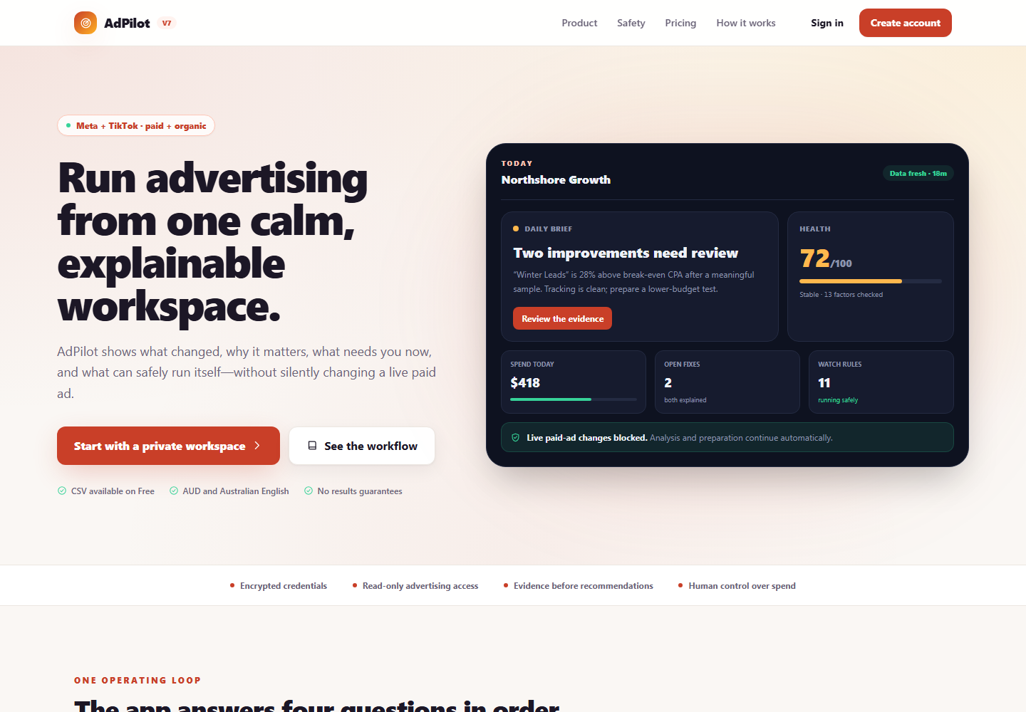
V7 preview: the operating state, evidence and human safety boundary are visible before sign-in.
The most important engineering decision is explicit: V7 cannot write to a live paid-ad account. It can synchronise read-only data, score it, detect anomalies, prepare recommendations and create approval-ready drafts. Budgets, bids, paid launches and paid-ad pauses remain human actions inside Meta or TikTok. This boundary is visible in the interface, enforced in API code and covered by tests.

Assessment scorecard
Scores are product-release assessments, not marketing claims. "After" scores combine implemented behaviour, automated coverage and browser verification.
Product area | Before | V7 | Evidence
Information architecture | 4.5/10 | 9.4/10 | Six core destinations; grouped advanced tools; command palette; mobile bottom navigation
Daily decision experience | 7.0/10 | 9.3/10 | Plain-language daily brief, readiness checklist, health, freshness, open fixes and safety state
Authentication and recovery | 5.0/10 | 9.2/10 | Sign-in/sign-up modes, consent state, password visibility, reset guidance, recovery-session validation
Connections and credentials | 4.5/10 | 9.2/10 | Provider health cards, masked identifiers, read-only scope explanation, reconnect/sync/remove paths
Automation | 5.0/10 | 9.1/10 | Persistent rule library, dry-run preview, saved-rule evaluator, stale-event resolution, guardrails
Recommendations and approvals | 5.5/10 | 9.4/10 | Evidence, window and next step; save/not-now/undo; no misleading one-click execution
Content and creative workflow | 5.0/10 | 9.1/10 | Compose, assist, preview, queue, policy check, deliberate schedule/publish confirmations, archiving
Reporting and notifications | 6.0/10 | 9.0/10 | Clear summary, freshness and evidence language, quieter notification hierarchy, AUD formatting
Mobile and responsive UI | 5.0/10 | 9.4/10 | True 390 px interaction checks; zero page overflow; compact navigation and touch-sized controls
Accessibility and clarity | 6.0/10 | 9.6/10 | Lighthouse accessibility 100; corrected contrast, descriptive links, focus and reduced-motion support
Security and permissions | 7.0/10 | 9.4/10 | Role-aware mutations, least privilege, nonce CSP fix, protected health detail, no live writer
Reliability and release engineering | 7.0/10 | 9.2/10 | 757 tests, type/lint/build gates, dependency overrides, error/loading/404 states, deployment runbook

What changed

1. Navigation and interface system
- Replaced the broad, difficult-to-scan navigation with six outcome-based destinations.
- Added a global command palette (Ctrl/Command + K) for fast access by advanced users.
- Added persistent Simple / Advanced controls using local storage and a cookie.
- Grouped specialist tools instead of showing every capability at the same visual weight.
- Added a mobile bottom navigation and compact top bar.
- Added a persistent operations drawer showing connection state, open fixes, last synchronisation and the paid-ad safety boundary.
- Standardised page width, cards, loading, empty, error and not-found states.
- Replaced inconsistent visual emphasis with one semantic colour system: action, good, warning, bad and information.
- Darkened the action coral to meet WCAG contrast requirements while retaining the warm visual identity.

2. Today command centre
- Reframed the dashboard around four questions: what changed, why it matters, what needs me, what happens next.
- Added a daily brief with a named issue and evidence instead of a generic "review campaigns" message.
- Added readiness progress so incomplete setup is visible and actionable.
- Added data-freshness language, open-fix count, spend context and watch-rule state.
- Kept deeper cockpit diagnostics behind Advanced view so everyday operators do not have to decode them.
- Made the human decision boundary visible beside operational state, inspired by the calm preflight controls used in Kraken Guardian.

3. Authentication, sign-up and password reset
- Rebuilt the authentication page with clear Sign in and Create account tabs.
- Added show/hide password controls and meaningful field labels.
- Added legal-consent enforcement to account creation.
- Added a complete forgot-password state with a clear "send a new reset link" action.
- Normalised email input and clarified that only the newest reset email should be used.
- Rebuilt the update-password page to detect a missing or expired recovery session and direct the user back to request a fresh link.
- Fixed a production-blocking Content Security Policy fault. The previous nonce policy allowed HTML to render but blocked Next.js hydration scripts, so sign-up and reset controls could appear while not responding. The root layout now renders dynamically so each response receives the nonce required by the policy.
- Verified sign-up and forgot-password state changes in a real browser at desktop and phone sizes.

4. Connections and credential handling
- Rebuilt Connect as an integration hub rather than a token form.
- Added Meta, TikTok, CSV and supporting-provider cards with connection health, data freshness and next actions.
- Added masked account identifiers and plain-language credential explanations.
- Added reconnect, synchronise and remove controls with explicit consequences.
- Kept CSV import available on Free.
- Enforced least privilege: Meta manual tokens containing ads_management are rejected and users are directed to use read-only ads_read and read_insights permissions.
- Removed the paid-ad write-token enrolment endpoint and interface.

5. Automation Studio
- Added a dedicated /automate workspace and /api/automation/rules API.
- Introduced three understandable automation classes:
- Observe automatically: synchronisation, scoring, anomaly and fatigue detection.
- Prepare automatically: alerts, reports, creative briefs and approval-ready drafts.
- Spend is human-only: live paid-ad changes stay in the advertising platform.
- Added rule templates, custom rules, enable/disable controls, installation and a dry-run preview.
- Added visible guardrails and plan-aware capability descriptions.
- Wired saved database rules into the scheduled scoring job. Previously, users could configure rules in the interface while the scheduled job continued to use a separate hard-coded set.
- Added central persistence mapping with a safe preset fallback if the saved-rule table is unavailable.
- Added recurrence handling, stale-event resolution and database upserts.
- Prevented duplicate warning and critical events for the same entity/metric by retaining the higher severity.
- Made window_days affect the statistical baseline used by z-score rules.
- Escaped organisation and event text before email HTML rendering.

6. Recommendations and paid-ad safety
- Rewrote recommendation cards to include metric, observed value, comparison baseline, time window, confidence/data caveat and next step.
- Replaced "approve" language that implied execution with Save as planned, Not now and undo.
- Removed the dormant Meta execution implementation, execution console and write-access setup.
- Changed the action API to fail closed for live execution and preserve approval-ready drafts.
- Added manager-level gating to paid-action mutation endpoints.
- Added archive/cancel handling instead of deletion.
- Kept the product commercially useful on premium plans through richer automation and approval-ready change preparation without silently mutating spend.

7. Create, content and creative operations
- Rebuilt Create around Compose, AI Assist and Queue.
- Added platform selection, media URL support, character feedback and a platform-style preview.
- Added AI caption assistance, policy checking, image-concept support and status guidance.
- Made the workflow explicit: draft -> approve -> schedule/publish.
- Added deliberate confirmation for schedule, publish and removal actions.
- Replaced destructive deletion with archiving so history is preserved.
- Prevented published content from being archived through the draft endpoint.
- Added migration 0032_content_archiving.sql for archived_at, the archived content state and cancelled action-draft state.

8. Reports, notifications and economics
- Simplified Reports around what happened, what it means and what to do next.
- Kept numbers grounded in saved analysis; no fabricated benchmarks or outcome promises.
- Standardised AUD presentation and evidence/safety language.
- Reduced notification noise and gave urgent, review and informational states clear hierarchy.
- Rebuilt Settings around break-even CPA, ROAS and CPL, including plainly labelled model inputs.
- Added validation for percentages, budgets and reporting cadence.
- Kept modelled decision lines explicitly separate from forecasts.

9. Permissions and organisation access
- Added reusable access checks for viewer, editor and manager requirements.
- Viewers retain read access; members can perform editor mutations; owners/admins control manager-level settings.
- Applied editor or manager checks to organisation settings, notifications, content, recommendations, automation, AI, audiences, audits, creative operations, ingest, leads, policy checks, sync and white-label mutations.
- Standardised unauthorised mutation responses as HTTP 403.
- Added dedicated access-matrix tests.

10. Security headers and application hardening
- Kept a nonce-based Content Security Policy and corrected it to work with dynamic Next.js rendering.
- Added strict-dynamic, explicit font sources and form-action control; development-only evaluation is not enabled in production.
- Protected detailed health/configuration fields behind the existing operator bearer secret. Public health responses expose only service state and version.
- Kept token encryption-key validation boolean-only; no key or secret value is returned.
- Removed write-related environment configuration and documentation.
- Updated Next.js to 16.2.11 and React/React DOM to 19.2.8.
- Overrode Next.js transitive dependencies to patched postcss 8.5.21 and sharp 0.35.3. A clean install audit reports zero known production vulnerabilities as of 22 July 2026.

11. Failure and recovery experience
- Added branded application error, loading and not-found states.
- Added useful retry and return paths rather than exposing generic framework screens.
- Kept credential and sync failure messages actionable without exposing tokens.
- Added clear recovery states for expired password-reset sessions.
- Updated deployment, release and rollback documentation for V7 and the no-live-writer boundary.

12. Version and product truthfulness
- Updated the application and health endpoint to 7.0.0.
- Rewrote landing and product explanation pages around the actual V7 behaviour.
- Removed claims that an approval executes a paid-ad change.
- Kept "no results guarantees" and human control of spend visible.
- Preserved the core evidence-first rule: when data is missing or insufficient, AdPilot says so.

Research translated into the product
The research was used as a pattern library, not as a visual copy exercise.
- Google Ads: prioritised explanations, diagnostic insight, change context and conversion-lag awareness. Official references: Insights, optimisation score, diagnostics and channel/asset reporting.
- Meta and TikTok: separated automated campaign assistance from the operator's decision boundary. Official references: Meta opportunity score and TikTok Smart+ updates.
- Stripe Workbench: adapted the pattern of one operational surface for events, logs, configuration and recovery: Workbench overview.
- Vercel: adapted visible health, logs and alerting as release-operability requirements: Observability, logs and alerts.
- Linear: adapted compact saved views, current-cycle focus and a digestible activity pulse: Cycles, display options and Pulse.
- HubSpot: adapted checklist-led onboarding and template-based workflow automation: workflow automation and onboarding checklists.
- Smartly, Motion and Madgicx: compared creative workflow, cross-channel operations and rule automation. References: Smartly introduction, Motion solutions and Madgicx overview.
- Kraken Guardian: adapted the strongest internal pattern: calm system state, visible limits, preflight checks, auditability and explicit human control over consequential actions.

Verification record
The release candidate passed:
- TypeScript: zero errors.
- ESLint: zero errors.
- Automated tests: 85 files, 757 tests passed.
- Production build: successful on Next.js 16.2.11; 52 static-generation tasks completed and all application/API routes compiled.
- Dependency audit: clean install, production scope, zero known vulnerabilities.
- Real-browser console: zero errors across landing, sign-in, sign-up and password-update pages.
- Responsive browser checks: no horizontal overflow at 1,440 px or a true 390 x 844 phone viewport.
- Authentication interaction checks: forgot-password transition passed; sign-up consent gating passed.
- Lighthouse mobile: Performance 98, Accessibility 100, Best Practices 100, SEO 100.
- Diff hygiene: no whitespace errors and no secret file included in the tracked change set.
The local browser check used non-production placeholder Supabase values only. No customer credential or API secret was copied into the repository.

Sign-in and recovery guide
- Open the hosted AdPilot URL and choose Sign in.
- Enter the email used for the account and its password.
- If the password is unknown, choose Forgot password?, enter the same email and select Send a new reset link.
- Use only the newest reset email. Older Supabase recovery links may be invalid after a newer one is requested.
- The link opens Choose a new password. If AdPilot reports that the recovery session is missing or expired, return to Sign in and request one fresh link.
- For a new workspace, choose Create account, complete the fields, accept the legal terms and submit.
Production email delivery still depends on the project's configured Supabase custom SMTP provider, authorised sending domain and redirect URL allow-list.

Release operations

Database
Apply migrations in order through 0032_content_archiving.sql before exercising archive/cancel controls in production. The application is backward-tolerant for saved automation-rule loading, but content archiving requires the new column and status constraint.

Required production configuration
- Supabase URL, anon key and service-role key
- Valid 32-byte token-encryption key
- Canonical application URL
- Cron secret
- Custom SMTP and approved recovery redirect URLs
- Resend for digests/notifications if email automation is enabled
- Stripe secret, webhook secret and confirmed price IDs if billing is enabled
- Read-only Meta/TikTok application credentials and approved scopes

Human acceptance checks after deployment
- Health endpoint returns version 7.0.0 and status: ok.
- Create-account page changes mode and accepts consent.
- One password-reset email arrives and its newest link opens the update page.
- Existing account signs in and reaches Today.
- Simple/Advanced selection persists after refresh.
- Connected account shows masked identifier and freshness.
- Manual sync completes and updates freshness.
- Automation rule dry run returns explained matches.
- A content draft can be archived without losing history.
- A recommendation can be saved as planned but cannot execute a live paid-ad change.

Remaining owner-gated decisions
These are not code defects and cannot be truthfully completed with invented credentials or legal/commercial choices:
- Confirm the final recurring AUD prices and map the correct Stripe production price IDs.
- Have Australian counsel approve Terms, Privacy and Limitations text.
- Confirm Supabase custom SMTP, sender-domain authentication and redirect allow-list.
- Complete Meta/TikTok provider app review for the required read-only scopes.
- Confirm the Vercel plan supports the configured cron frequency and review first-week usage/alerts.
- Decide whether content publishing tokens should be enabled; this is separate from paid-ad write access.

Recommended next release
V7 should gather real usage before adding breadth. The strongest V7.1 priorities are:
- Saved filters/views for multi-client operators.
- A unified audit timeline for syncs, rule matches, drafts, approvals and archives.
- Creative-fatigue gallery with thumbnails and comparison cohorts.
- Conversion-lag and attribution-quality explanations beside short-window verdicts.
- Guided provider onboarding with a test connection before credentials are saved.
- Error-budget and incident view using Vercel/Supabase operational events.
- Passkeys or magic-link sign-in after SMTP reliability is proven.
Live paid-ad execution should remain out of scope until a separate, reviewed control plane exists with per-account caps, typed confirmation, two-person approval for large moves, complete audit logging, provider sandboxes and tested rollback. That work must not be smuggled into ordinary automation.
RELEASE PRINCIPLE automate collection, analysis, explanation and preparation; keep irreversible or spend-changing decisions visible, reviewable and human-controlled.

