🡺 Open <https://www.python.org/>

* Click on Downloads

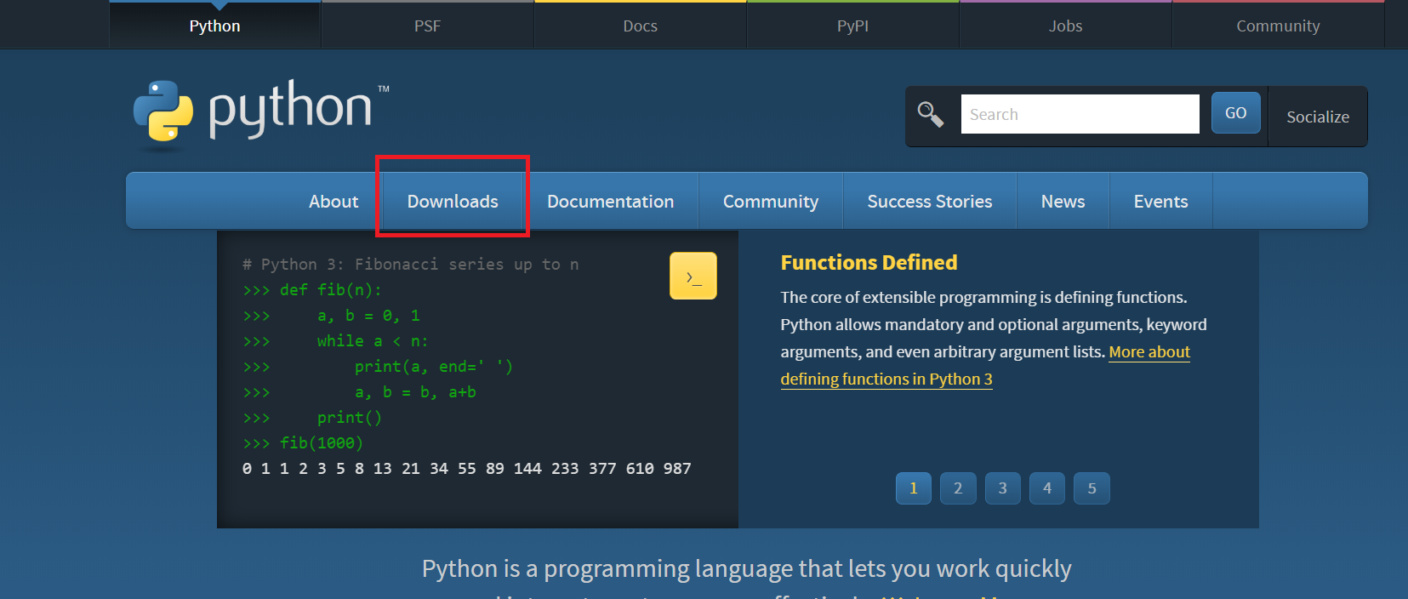

* Click on Download python 3.7.2

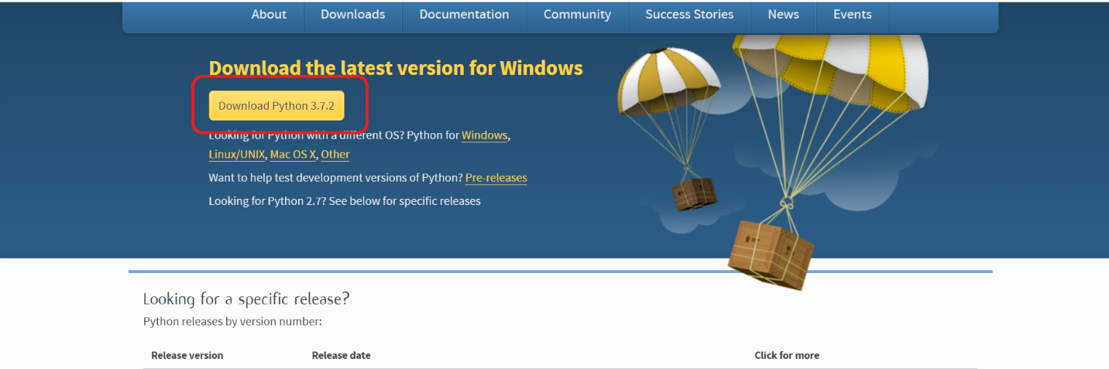

* It will download python-3.7.2.exe file

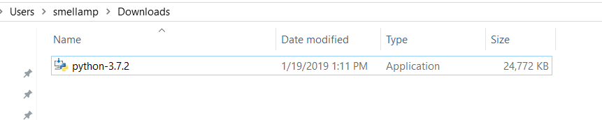

* Double click on python-3.7.2.exe file

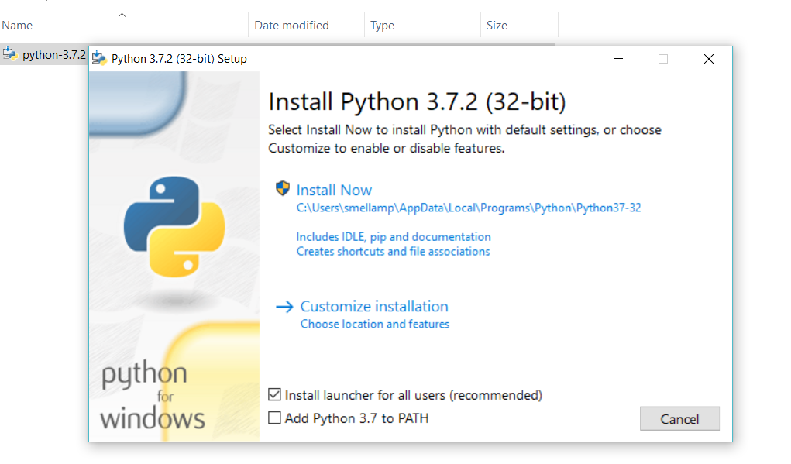

* Select Add python 3.7 to PATH check box
* Then Click on Install Now

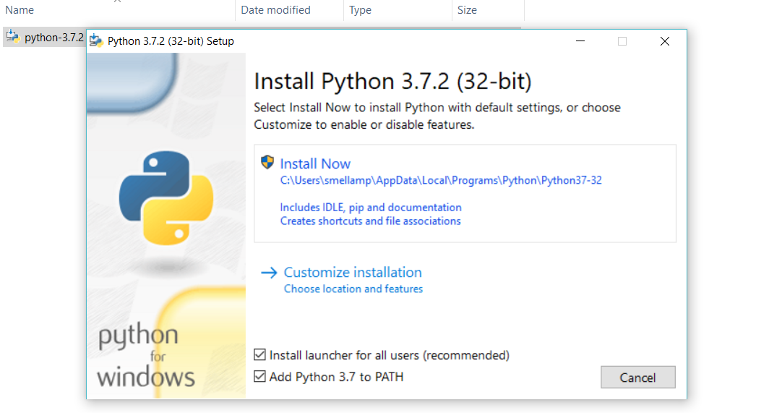

* Then Click on YES

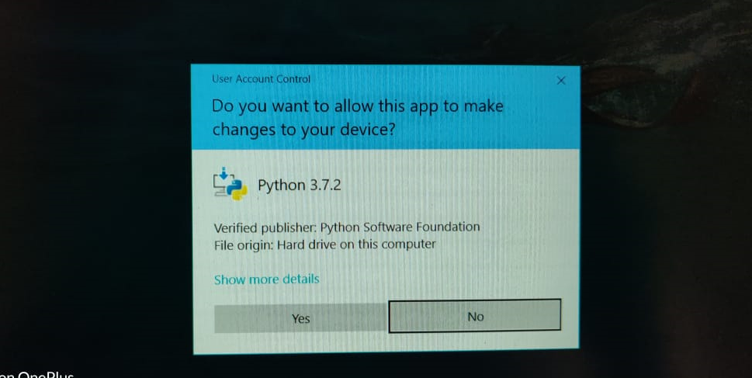

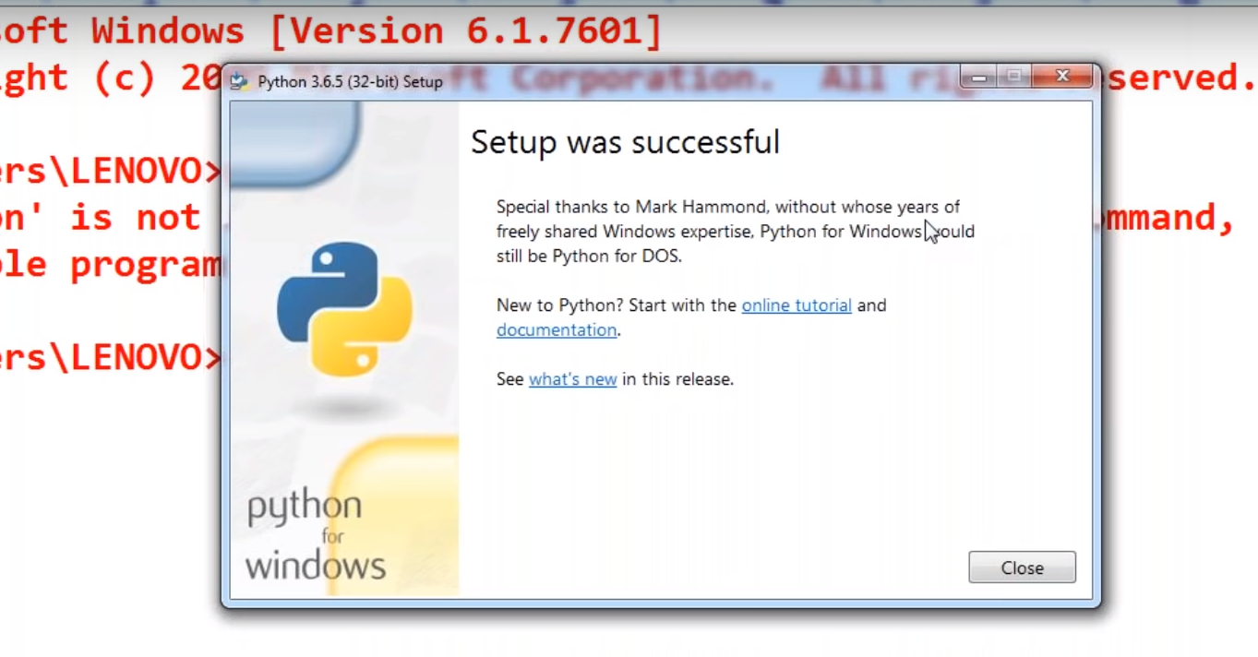

* Click on close button
* Run below command to know python installed or not

**python –V OR python --version**

