* **INSTALL ROBOT FRAMEWORK**

**pip install robotframework**

**OR**

Download tar.gz file form below path

<https://github.com/robotframework/robotframework/releases>

* Click on Source code.(zip) to download

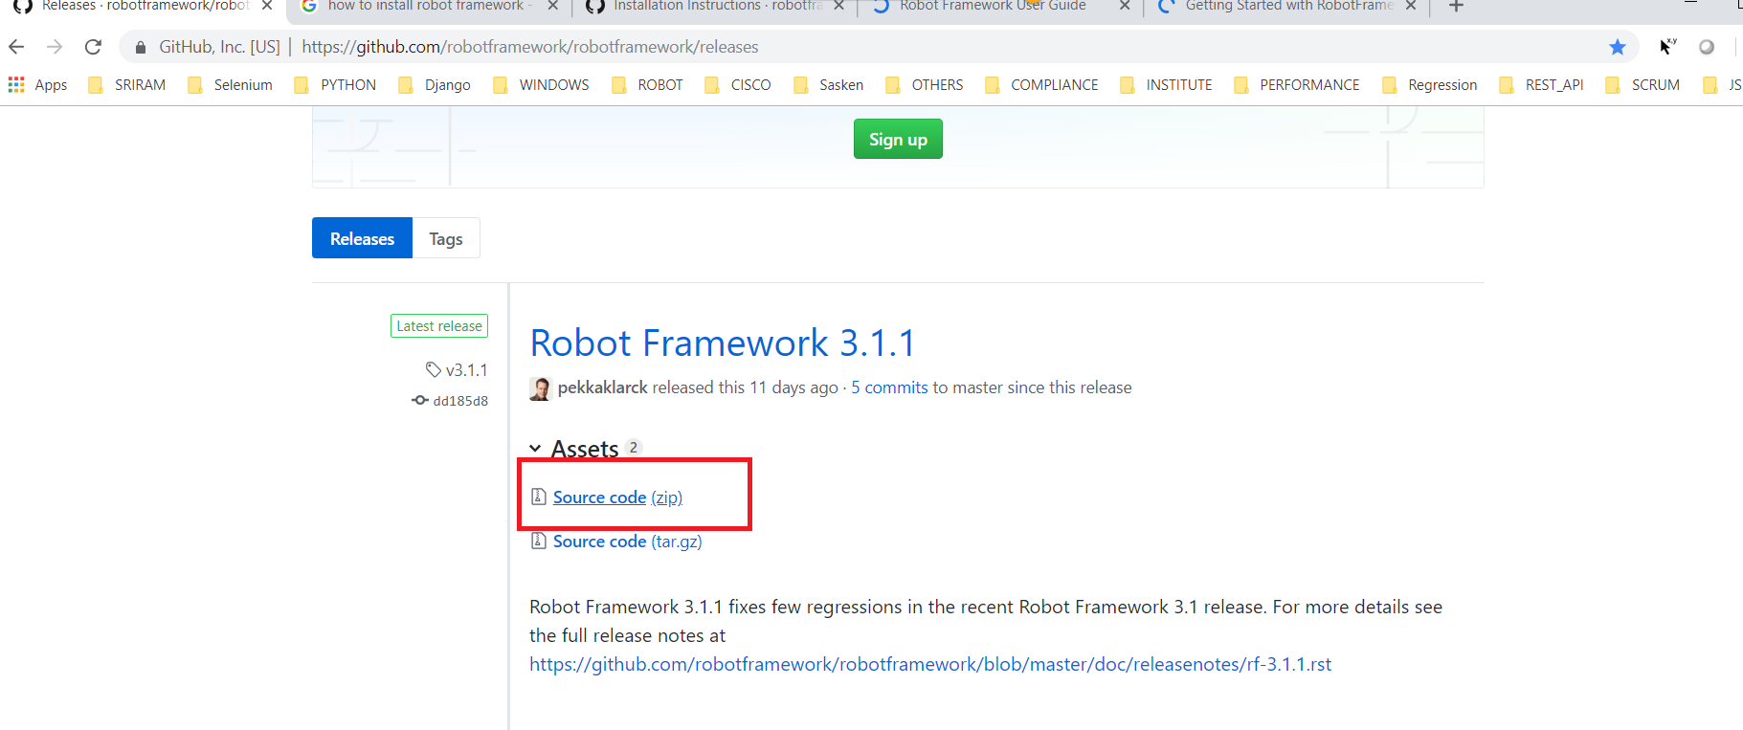

* UNZIP Sourcecode.zip file after unzipping you will see below files

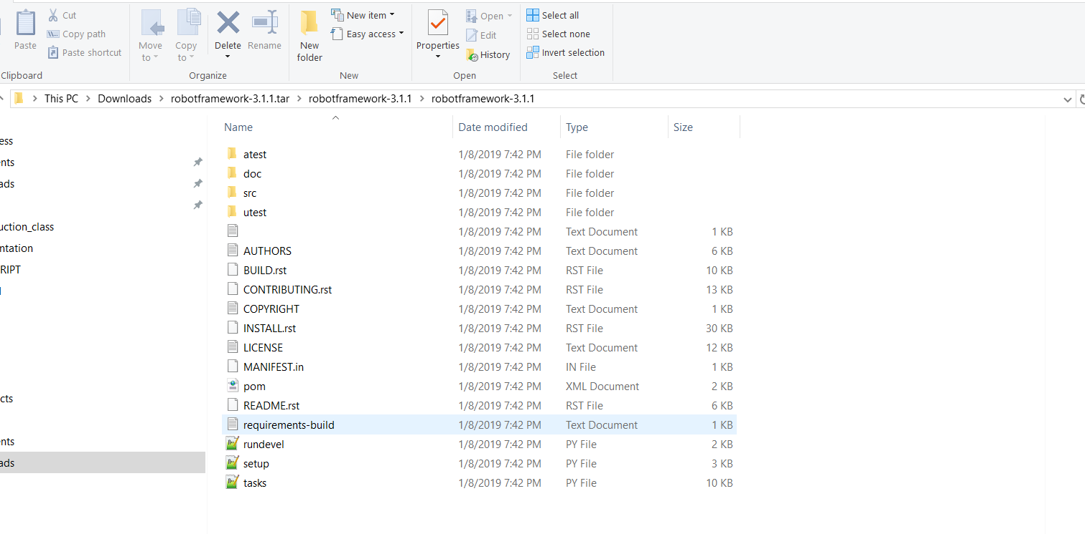

* Then run this command :- **python setup.py install**
* Run below command to know installed or not

**robot --version**