Animators Hub: Project Demonstration Report
Level 5 Diploma in Computing: Computing Project demonstration
Edem Angel Edem Hogan (P00193366)
AfriHUB
Supervisor: Mrs. Nkechi Ajaegbo
November 2026

1 Purpose
This report is the plan and the evidence for the demonstration of Animators Hub, the web application on which animators share short animations and viewers find, watch, upvote and discuss them. The project guidelines give 10 minutes for the demonstration and 5 minutes for questions about it. The demonstration is 10% of the project mark.
The demonstration is marked on five points, each worth 20 marks: the system operates correctly, it has appropriate help for users, its interface exposes its functionality, it meets or exceeds the functional requirements, and it reflects academic and industrial best practice. This report shows how each point will be demonstrated. Requirement numbers (FR, NFR) and objective numbers (O1 to O5) are those of the final report.

2 Demonstration set-up
The demonstration uses the live system, not a recording, so that the examiners see the real behaviour.
Table 1: Set-up for the demonstration
Item | Detail
System | The deployed application at https://animatorshub.apexlinks.org, running on Cloudflare Workers with a D1 database and R2 storage
Browser | A current desktop browser (Chrome or Edge) on the presentation PC, with a second private window for a second member
Accounts | A new account is created during the demonstration. A second account, created before the session, is signed in to the private window
Test files | One short video under 50 MB (mp4) and one thumbnail image under 5 MB, saved on the desktop
Network | An internet connection is needed. The fallback is the local development server (pnpm dev, port 8080), which runs the same code with a local database and storage
Last check | On 13 November 2026 the live site answered correctly, and Unit Test 9 (community messaging) passed 4 of 4 cases on it

3 Demonstration script
Table 2 is the script for the 10 minutes. Each step follows the order in which a real member uses the system, and each names the requirement that it proves. The steps use the labels of the interface, which are lowercase by design.
Table 2: Demonstration script (10 minutes)
Time | Step | What the examiners see | Proves
0:00 to 0:45 | Open the site as a visitor. Open about and help from the link at the foot of the page | The landing page, then the help page with getting started and communities guidance | Help
0:45 to 1:45 | Select sign up. First enter a five-character password, then a valid one | The message for the invalid password, then the member signed in on the discover feed | FR1; NFR4
1:45 to 3:30 | Select upload. Choose the video and thumbnail, enter a title and description, pick a community, and publish | The upload dialog, the “uploading video...” status, and the new animation at the top of the discover feed | FR4; O1
3:30 to 4:30 | On discover, switch between new and top, search for a word from the title, and select load more | The feed in pages of 20, re-sorted, and the search result | FR5; O2
4:30 to 5:45 | Open the animation. Play it, select the upvote button twice, post a comment, then delete it | The player; the count changes only after the server answers; the comment appears and is removed | FR6, FR8, FR9; O3
5:45 to 6:45 | Select add to playlist, create a playlist, add the animation, and open the playlist from the profile | The playlist dialog and the playlist page with the animation in it | FR10; O4
6:45 to 8:00 | Open communities, join one, and send a message. In the private window, the second member opens the same community | The joined state, the message with the sender’s name, and the same message seen by the second member | FR11, FR14; O5
8:00 to 8:45 | Open edit profile and change the bio. Switch the theme. Narrow the window to phone width | The saved profile, the light and dark themes, and the layout at 375 pixels with no sideways scrolling | FR12; NFR6
8:45 to 9:30 | In the private window, open the first member’s animation. Then sign out in the main window | The second member has no edit or delete control; after sign-out the upload and comment actions ask for sign-in | FR7, FR2; NFR4
9:30 to 10:00 | Close: name the features shown and the known limits in Section 6 | A short spoken summary | All

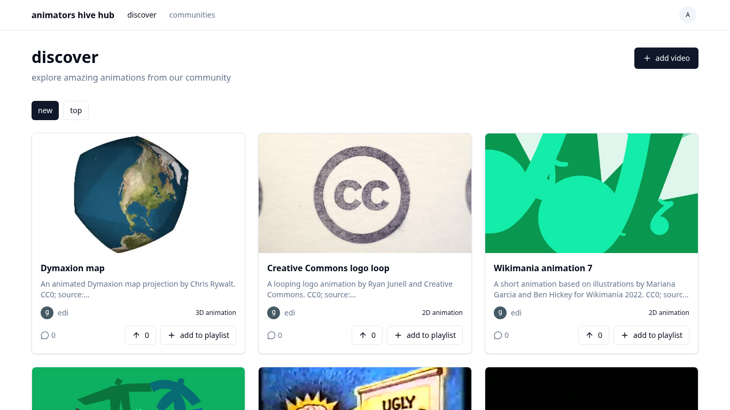
Figure 1: The discover feed, the starting point of the demonstration after sign-up

4 How the demonstration meets the marking criteria
Table 3 sets each demonstration criterion from the project assessment form against what will be shown.
Table 3: Evidence for each demonstration criterion
Criterion (20 marks each) | How it is shown
System operates correctly in the demonstration context | Every step in Table 2 runs on the live system. Testing passed 84 of 87 cases: the end-to-end browser suite passed 4 of 4, the smoke script of more than sixty API checks passed, and the type check, lint and build were clean
System has appropriate help for users | The about and help page is linked from the foot of every page (Figure 2). Forms give a clear message for each error, such as “invalid email or password”. Visitors are told to sign in when an action needs an account. The user guide in Appendix D of the report covers every screen with numbered steps
System has an appropriate interface that exposes its functionality | One header on every screen gives discover, communities, the theme switch and the account menu. Upload, sign in, sign up and add to playlist open as dialogs from the page the member is on. The same layout works on a phone
System meets or exceeds functional requirements | All 14 functional requirements in the report are built, and Section 5 maps each one to a step. Community messaging (FR14, objective O5) is included. The proposal’s reporting and administrator removal are not built, and this is stated openly
System is reflective of academic and industrial best practice | Passwords are stored as salted PBKDF2 hashes; sessions are held on the server and end on sign-out; every owner-only action is checked on the server and returns 403 to other users; inputs are validated on the server; requests are rate-limited. The code is in strict TypeScript under Git, and a push to the main branch builds and deploys it

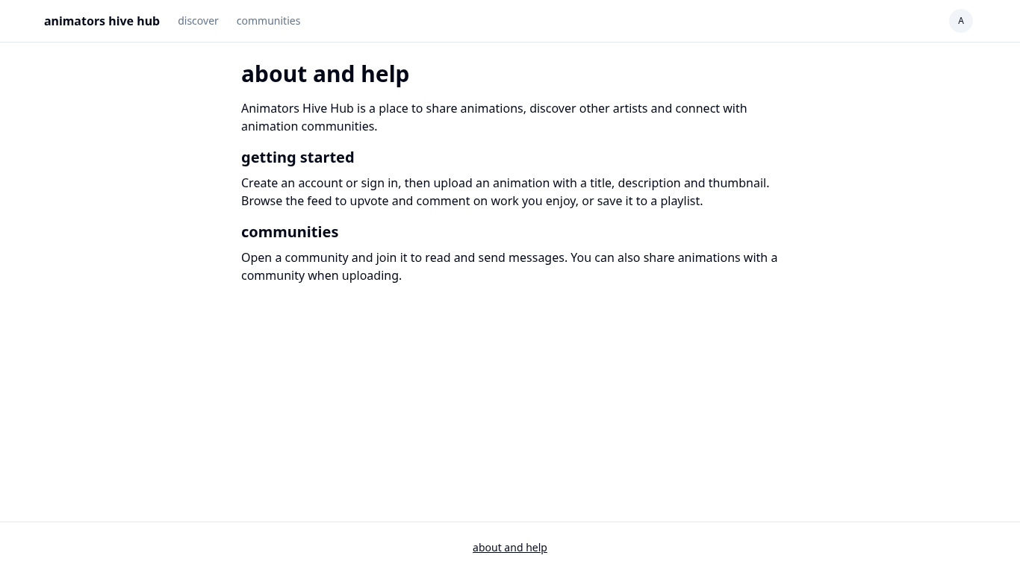
Figure 2: The about and help page, the help subsystem of the site

5 Functional requirements shown
Table 4 maps each functional requirement of the report to the step of the script that shows it.
Table 4: Functional requirements and where each is shown
ID | Functional requirement | Priority | Shown at
FR1 | Register with email, username and password | Must | 0:45
FR2 | Sign in and sign out with email and password | Must | 8:45
FR3 | Sign in with a Google account | Should | On request, in questions
FR4 | Upload an animation with video, thumbnail, title, description and community | Must | 1:45
FR5 | Browse the discover feed with new and top sorts, search and load more | Must | 3:30
FR6 | View an animation page with player, description and comments | Must | 4:30
FR7 | Edit or delete an animation the member owns | Should | 8:45
FR8 | Upvote an animation and remove the upvote | Must | 4:30
FR9 | Comment on an animation and delete one’s own comment | Must | 4:30
FR10 | Create, rename and delete playlists; add and remove animations | Should | 5:45
FR11 | Browse, search, create, join and leave communities | Should | 6:45
FR12 | View public profiles; edit one’s own profile and avatar | Should | 8:00
FR13 | Change password and delete account | Should | On request, in questions
FR14 | Send a message to a community | Should | 6:45

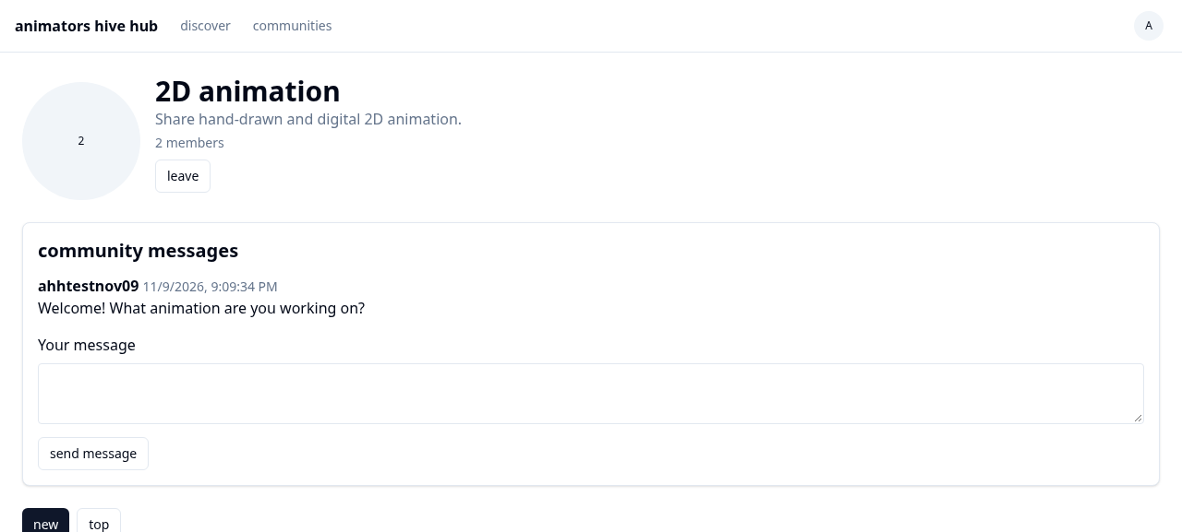
Figure 3: A community page with its messages (FR14)

6 Known limits to state in the demonstration
The limits below are in the final report. Stating them in the demonstration is better than leaving the examiners to find them.
- The sign-in rate limit is approximate. In test case 1.2.1, a first burst of 31 sign-in requests was not refused, so the limit slows an attacker but does not always stop the 31st request.
- Reporting of content and removal by an administrator, promised in the proposal, are not built. They are the first item of further work.
- There is no password reset and no email verification, because the system sends no email.
- The two Google sign-in test cases (2.4 and 2.5) need a real Google account and were not run in the test session.
- Counts of members and votes are not recounted when a user account is deleted, so a count can stay too high until the next join or vote.
- No animators were interviewed, so the requirements rest on the author’s own judgement.

7 Likely questions and short answers
Table 5: Questions the examiners may ask about the demonstration
Question | Answer
Where is the data stored? | Records such as accounts, animations, comments and messages are in the Cloudflare D1 database. Video and image files are in R2 storage, and the database holds only the address of each file
How are passwords protected? | Only a PBKDF2-SHA256 hash with a random salt is stored, never the password. The session cookie cannot be read by scripts, and only its hash is stored
What stops one member from deleting another member’s work? | The server checks the owner before every change and returns 403 to anyone else. The edit and delete controls are also hidden from other members
Why SvelteKit and Cloudflare, and not React and Supabase? | Pages are built on the server, so they load fast and a shared link shows a preview. The application, database and storage are on one platform, which reduces latency and leaves no server to maintain
What happens with a very large video? | The server refuses a video over 50 MB and an image over 5 MB, and the form shows the reason
How was the system tested? | By black-box testing at three levels: nine unit test scripts, three integration suites, and system tests with an end-to-end browser suite and a smoke script. 84 of 87 cases passed, 1 failed and 2 were not run
What is missing, and what would be added next? | Reporting and administrator removal first; then direct messages between users and a checker for AI-generated animation at upload
Is there help for a new user? | Yes: the about and help page on the site, clear error messages on each form, and the user guide in Appendix D of the report

8 Risks on the day and the fallback for each
Table 6: Risks during the demonstration
Risk | Fallback
No internet connection in the room | Run the local development server on the laptop (pnpm dev, port 8080) and open http://localhost:8080. It runs the same code
The upload is slow | Use a video of a few megabytes. If it still waits, continue with an animation uploaded before the session
Sign-up fails because the username is taken | Use a username with the date in it, or sign in with the account prepared before the session
The projector shows the dark theme poorly | Switch to the light theme with the theme switch in the header
Time runs short | Skip the 8:00 step (profile and theme). The Must requirements are all shown before 5:45

9 Checklist before the demonstration
- Open https://animatorshub.apexlinks.org and confirm that the landing page loads.
- Sign in to the second account in a private window and join the community that will be used.
- Put the test video and thumbnail on the desktop.
- Start the local development server as the fallback and confirm that it opens.
- Set the browser zoom so that the header and one row of cards are readable from the back of the room.
- Rehearse the script once against a timer, and keep it within 10 minutes.

