Animators Hub: Design and Development of a Web-Based Platform for Sharing and Discovering Animated Contents
Level 5 Diploma in Computing: Computing Project final report
Edem Angel Edem Hogan (P00193366)
AfriHUB
Supervisor: Mrs. Nkechi Ajaegbo

Abstract
This report describes Animators Hub, a web application on which animators share short animations and viewers find, watch, upvote and comment on them. The project aims to give animators a dedicated space where their work can be discovered, instead of being lost on general-purpose platforms. The scope covers accounts with email or Google sign-in, video upload with a title, a description and a custom thumbnail, a discover feed with sorting and search, animation pages, profiles, playlists, and communities with messaging. The work followed an iterative approach with MoSCoW prioritisation. The system was built as a SvelteKit application running on Cloudflare Workers, with records held in a D1 database and media in R2 storage. The report documents the analysis, design, implementation and testing of the system, together with its project and risk management. The outcome is a working, deployed platform whose core features were confirmed through black-box unit, integration and system testing. The report closes with a critical evaluation, a reflection on the learning, and directions for further work.
Contents
1 Introduction 1
1.1 Chapter Overview 1
1.2 Background 1
1.3 Aims and objectives 1
1.3.1 Aim 1
1.3.2 Objectives 1
1.4 Method of solution and justification 1
1.5 Overall architecture 1
1.6 Overview of the solution 1
1.7 Overview of the remaining chapters 1
2 Analysis 1
2.1 Chapter Overview 1
2.2 Requirements 1
2.2.1 Functional requirements 1
2.2.2 System-wide non-functional requirements 1
2.3 Use cases 1
2.4 Architecture 1
2.4.1 Interfaces with other systems 1
2.4.2 Technical architectures for development and implementation 1
2.4.3 Initial class diagram 1
2.5 Conclusion 1
3 Design 1
3.1 Chapter Overview 1
3.2 Structural model 1
3.3 Behavioural model 1
3.3.1 Animation upload 1
3.3.2 Google sign-in with PKCE 1
3.3.3 Upvote toggle 1
3.4 User interface design 1
3.5 Frameworks used 1
3.6 Tools used for design and implementation 1
3.7 Justification of design approach 1
3.8 Conclusion 1
4 Implementation 1
4.1 Chapter Overview 1
4.2 Choice of programming language 1
4.3 System cutover from development to implementation architecture 1
4.4 Data migration 1
4.5 Training 1
4.6 Conclusion 1
5 Other Project Issues 1
5.1 Chapter Overview 1
5.2 Project management 1
5.3 Risk management 1
5.4 Configuration management 1
5.5 Testing 1
5.5.1 Testing strategy 1
5.5.2 Developing the first unit test 1
5.5.3 Integration and system testing 1
5.5.4 Summary of results 1
5.6 Conclusion 1
6 Conclusion 1
6.1 Chapter Overview 1
6.2 Summary of aims and achievement 1
6.3 Further work 1
6.4 Critical evaluation 1
6.4.1 Requirements 1
6.4.2 Design 1
6.4.3 Implementation and testing 1
6.4.4 Review of the plan 1
6.5 Reflective practice 1
References 1
Appendices 1
Appendix A: Requirements catalogue 1
Appendix B: Use case descriptions 1
Appendix C: Test plan and test scripts 1
Appendix D: User guide 1
Appendix E: Risk management 1

List of Figures
Figure 1: Use case diagram for Animators Hub 1
Figure 2: Interfaces with other systems 1
Figure 3: Technical architecture for development and implementation 1
Figure 4: Initial class diagram 1
Figure 5: Class diagram 1
Figure 6: Animation upload sequence 1
Figure 7: Google sign-in sequence 1
Figure 8: Upvote toggle sequence 1
Figure 9: System cutover from development to implementation 1
Figure 10: Data migration 1
Figure 11: Planned schedule from the proposal, 10 May to 7 September 2026 1
Figure 12: Gantt chart of the build, 26 September to 21 October 2026 1
Figure 13: Unit Test 1, case 1.1: sign-up form with test data 1
Figure 14: Unit Test 1, case 1.1: result after sign-up 1
Figure 15: Unit Test 1, case 1.7: wrong password message 1
Figure 16: Sign-up 1
Figure 17: Discover feed 1
Figure 18: Upload an animation 1
Figure 19: Animation page: upvote and comment 1
Figure 20: Playlists 1
Figure 21: Communities 1
Figure 22: Your profile 1
Figure 23: Mobile view 1

List of Tables
Table 1: Key technical terms 1
Table 2: Functional requirements 1
Table 3: System-wide non-functional requirements 1
Table 4: Programming language and platform options 1
Table 5: Unit Test 1, header and first test cases (Account) 1
Table 6: Test evidence summary 1
Table 7: Evaluation of objectives and proposal commitments 1
Table 8: Requirements catalogue 1
Table 9: Test plan 1
Table 10: Unit Test 1 test cases (Account) 1
Table 11: Unit Test 2 test cases (Session and Google sign-in) 1
Table 12: Unit Test 3 test cases (Animation upload) 1
Table 13: Unit Test 4 test cases (Upvote) 1
Table 14: Unit Test 5 test cases (Comment) 1
Table 15: Unit Test 6 test cases (Playlist) 1
Table 16: Unit Test 7 test cases (Community) 1
Table 17: Unit Test 8 test cases (Profile) 1
Table 18: Unit Test 9 test cases (Community message) 1
Table 19: Integration Test Suite 1.1 test cases (functional flow) 1
Table 20: Integration Test Suite 1.2 test cases (security and robustness) 1
Table 21: Integration Test Suite 1.3 test cases (usability and accessibility) 1
Table 22: Risks from the proposal and what happened 1

List of Appendices
- Appendix A: Requirements catalogue
- Appendix B: Use case descriptions
- Appendix C: Test plan and test scripts
- Appendix D: User guide
- Appendix E: Risk management

Acknowledgements
I thank my supervisor, Mrs. Nkechi Ajaegbo, for guidance on the proposal and on the build, and all the staff at AfriHUB, the study centre, for their support during the course.

1 Introduction

1.1 Chapter Overview
This chapter gives the background to the project, its aim and objectives, the method used, the overall architecture, an overview of the solution and the structure of the report. Technical terms are explained in Table 1.

1.2 Background
Animators publish their work on general platforms such as YouTube, Instagram, and X, where animation competes with every other kind of video. YouTube’s recommendation system ranks content partly by how well it already holds viewers (YouTube, 2026), which works against an animator with no following. Newgrounds has hosted independent animation since 1995 but is small beside the mainstream platforms (Newgrounds, 2026), and ArtStation presents animation as part of a portfolio, with no discussion around a piece (ArtStation, 2026). Gillespie (2014) argues that a platform’s ranking decides what an audience ever sees. A platform built only for animation can rank animation by its own criteria, so that less popular animators are found sooner. Another motivation is to give animators a place where their work is not overshadowed by AI-generated animation. This is the rationale for Animators Hub.
The scope follows the proposal. A visitor can open the landing page, animation pages, public profiles, and the communities list. A signed-in member can upload a video with a title, description, and custom thumbnail, browse and search a feed, upvote and comment, keep playlists, join communities and post messages to them; and edit their profile. Owners can edit and delete their animations. Reporting, administrator removal of content, password reset, and email verification are not included; the last two because the system sends no email.

1.3 Aims and objectives

1.3.1 Aim
- To design and develop Animators Hub, a web-based platform that allows animators to share their work and allows viewers to easily discover it.

1.3.2 Objectives
By 7 September 2026, the end date of the proposal’s schedule:
- O1: enable a registered user to upload a video of up to 50 MB with a title, a description and a custom thumbnail, and see it on the feed.
- O2: enable viewers to browse videos, sorted by newest or most upvoted in pages of 20, and search them by title and description.
- O3: enable users to comment on videos and upvote them, and delete their own comments.
- O4: enable a user to create playlists and add videos to them.
- O5: enable users to join a community and post messages to it.

1.4 Method of solution and justification
The project used an agile, iterative approach, with requirements prioritised by MoSCoW as used in the DSDM method (Agile Business Consortium, 2014; Clegg and Barker, 1994). I chose it over waterfall, which fixes requirements before design and suits stable requirements (Sommerville, 2016). This project’s platform was not stable. A first build in June 2025 used React and Supabase and was left for fifteen months. When work resumed in September 2026, the platform moved to Cloudflare and the code to SvelteKit. The agile value of responding to change (Beck et al., 2001) describes that situation. The method was applied loosely. The work was broken into small steps, and each step had to pass a check, such as a successful build or a passing test, before it was marked done. Scope decisions, such as leaving out email, were written down as they were made, making it possible to resume after a long pause and trace the reasons for each decision in this report.

1.5 Overall architecture
The system has three parts (Figures 2 and 3). The user’s browser shows the pages. A Cloudflare Worker, a program running on Cloudflare’s servers, builds each page, checks each request and applies the rules. A D1 database holds the records, and an R2 storage bucket holds the videos and images. Google is used only for sign-in with a Google account. Only the Worker reads or writes the data, so every request passes the same checks.
Table 1: Key technical terms
Term | Meaning in this report
Cloudflare Worker | A program that runs on Cloudflare’s servers and answers requests from browsers; here it is the whole server.
D1 and R2 | Cloudflare’s database service, which stores the records, and its file storage service, which stores media.
SvelteKit | The framework used to build the pages and the server code.
Server-side rendering | The server builds the full page before sending it, instead of the browser building it.
Session and cookie | A session records that a user is signed in; the browser holds a cookie that identifies the session.
OAuth 2.0 and PKCE | The standard way of signing in with another provider, here Google; PKCE adds a secret check to it.
Hash | A one-way scrambling of data, so that a password or token is never stored as plain text.
Rate limit | A cap on requests per minute; extra requests receive HTTP 429.
HTTP status codes | Server replies: 200 success, 400 bad input, 401 not signed in, 403 forbidden, 404 not found.
MoSCoW | A way of ranking requirements as Must, Should, Could or Won’t have.
Black-box testing | Testing what the system does against its requirements, without looking at the code.

1.6 Overview of the solution
The final system is a server-rendered application built with SvelteKit 2, Svelte 5, and TypeScript, styled with Tailwind CSS 4, and running as a Cloudflare worker with D1 and R2. Google sign-in uses the arctic library with PKCE. A push to the main branch on GitHub builds and deploys the application, and development runs on a local server with the same database and storage. Owners can edit and delete their animations, and authors can delete their comments; a member can change their password or delete their account from the edit profile page. Appendix D shows each screen; the live site shows the name in lowercase, as animators hive hub.

1.7 Overview of the remaining chapters
Chapter 2 gives the analysis, Chapter 3 the design and Chapter 4 the implementation. Chapter 5 covers the other project issues: project management, risk management, configuration management and testing. Chapter 6 evaluates the project, reviews the plan and reflects on the learning. The appendices hold the requirements catalogue, use case descriptions, test plan and scripts, user guide, and the record of project risks.

2 Analysis

2.1 Chapter Overview
This chapter sets out what the system must do and how it is arranged. The requirements come from the proposal, the problem in Chapter 1 and my own use and testing of the system. No animators were interviewed and no survey was run, so the requirements reflect my judgement rather than measured user needs. Appendices A and B give the full catalogue and use case descriptions.

2.2 Requirements

2.2.1 Functional requirements
Table 2 gives each functional requirement with its MoSCoW priority. Must covers accounts, upload, the feed, the animation page, upvotes and comments. Should adds playlists, communities, messaging, profiles and owner control. Won’t covers reporting, moderation, administration, follows, notifications, password reset and email verification. Reporting and administrator removal were promised in the proposal but were left out of the requirements by mistake (Section 6.4.1).
Table 2: Functional requirements
ID | Functional requirement | Priority | Supporting non-functional requirement
FR1 | Register with email, username and password | Must | NFR1, NFR4
FR2 | Sign in and sign out with email and password | Must | NFR2, NFR3
FR3 | Sign in with a Google account | Should | NFR2
FR4 | Upload an animation: video, optional thumbnail, title, description, optional community | Must | NFR3, NFR5
FR5 | Browse the discover feed with new and top sorts, search and load more | Must | NFR5
FR6 | View an animation page with player, description and comments | Must | NFR6, NFR7
FR7 | Edit or delete an animation the member owns | Should | NFR4
FR8 | Upvote an animation and remove the upvote | Must | NFR3, NFR4
FR9 | Comment on an animation and delete one’s own comment | Must | NFR4
FR10 | Create, rename and delete playlists; add and remove animations | Should | NFR4
FR11 | Browse, search, create, join and leave communities | Should | NFR4
FR12 | View public profiles; edit one’s own profile and avatar | Should | NFR4, NFR8
FR13 | Change password and delete account | Should | NFR2
FR14 | Send a message to a community | Should | NFR3

2.2.2 System-wide non-functional requirements
Each target in Table 3 is measurable. The security requirements follow the OWASP Top 10 (OWASP Foundation, 2021): NFR4 addresses broken access control, and NFR1 to NFR3 address authentication failures. NFR2 and NFR3 shape the design most, because they need a session store on the server and a single place where every request is rate-limited. Where a figure is a design limit rather than a measured result, such as the 20-item feed page in NFR5, the table says so. NFR7 is a target, not a finished claim.
Table 3: System-wide non-functional requirements
ID | Category | Requirement and measurable target
NFR1 | Security | Passwords are stored as PBKDF2-SHA256 hashes, 80,000 iterations, 256-bit output, random salt.
NFR2 | Security | The session token is 32 random bytes in an httpOnly, SameSite Lax cookie for 30 days. Only its SHA-256 hash is stored. Sessions end on sign-out, password change and deletion.
NFR3 | Security | Rate limits per 60 seconds: 30 authentication requests per IP, 120 writes per user, 30 uploads per user. Excess requests receive HTTP 429.
NFR4 | Integrity | Inputs are checked on the server against shared limits, such as a title of at most 100 characters. Owner-only actions return 403 to other users.
NFR5 | Performance | Feed pages hold at most 20 items; the offset is capped at 2,000; uploads are capped at 50 MB video and 5 MB image. These are design bounds; no timing benchmark was run.
NFR6 | Usability | The layout works at 375 by 667 pixels without horizontal scrolling. Light and dark themes are available.
NFR7 | Accessibility | Dialogs trap focus and close on Escape; icon-only buttons are named. The target is WCAG 2.1 (W3C, 2018).
NFR8 | Privacy | Public pages never show an email address.
NFR9 | Maintainability | Strict TypeScript, lint and check scripts, all SQL in one module, numbered migrations.
NFR10 | Deployability | A push to main produces a Cloudflare Workers build and deployment.

2.3 Use cases
Figure 1 is the use case diagram. Guest is a visitor who is not signed in, Member is a signed-in animator who inherits the guest use cases, and Google is an external actor used only in sign-in. Discovery is open to visitors, so that work can be found before sign-up, and changes to data are reserved for members. Each oval carries an identifier that matches Appendix B, and each Must requirement maps to a use case: FR1 to UC1, FR2 to UC2 and UC15, FR4 to UC5, FR5 to UC4, FR6 to UC6, FR8 to UC8 and FR9 to UC9. FR14, community messaging, is UC16. The notation follows Fowler (2004).
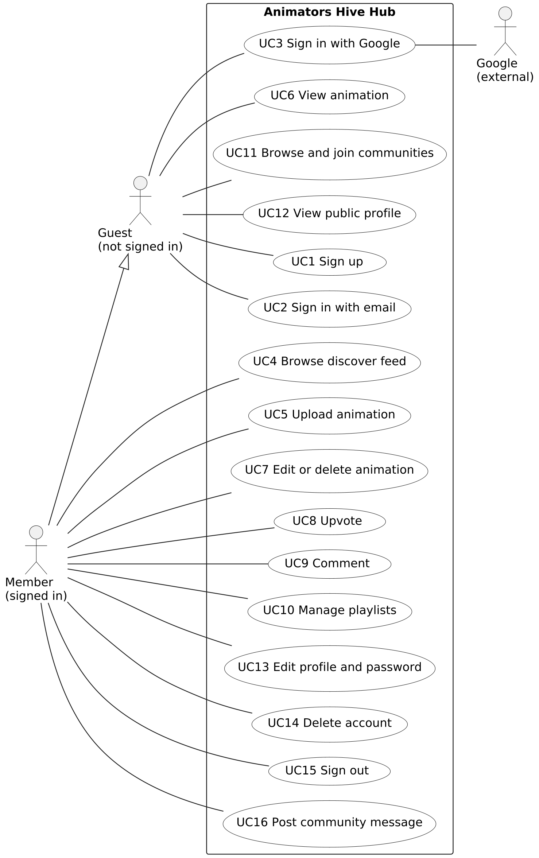
Figure 1: Use case diagram for Animators Hub

2.4 Architecture

2.4.1 Interfaces with other systems
Figure 2 shows the data flows. The browser sends forms, JSON, and files to the Worker, which returns HTML, JSON, and media. Google sign-in follows OAuth 2.0 (Hardt, 2012) with PKCE (Sakimura, Bradley and Agarwal, 2015). The Worker redirects the browser to Google with a state value and a PKCE challenge, then exchanges the returned code and reads the email address, name, and picture. Only the Worker talks to D1 and R2. Clients see media addresses whose keys are random identifiers, never the storage bucket itself. No email, payment, or analytics service receives data, which keeps personal data within the system

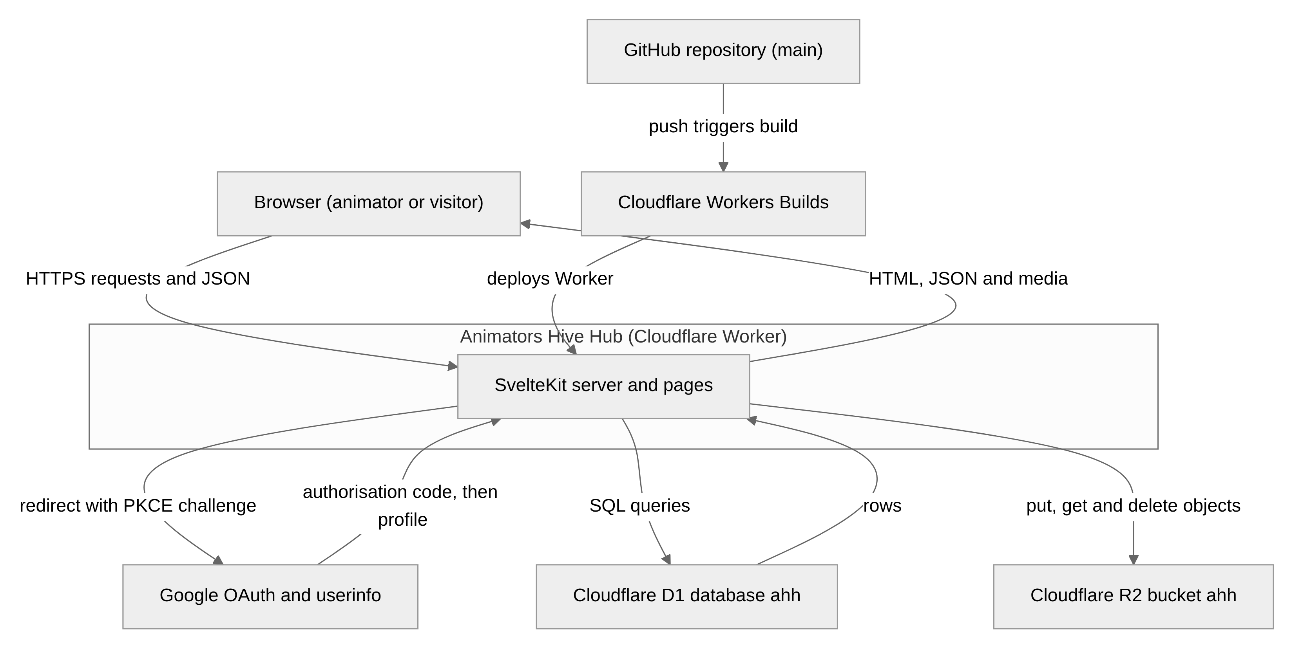
Figure 2: Interfaces with other systems

2.4.2 Technical architectures for development and implementation
Figure 3 separates the development computer, a Linux machine running Node 22, from the implementation, where Cloudflare runs the Worker, D1 and R2 (Cloudflare, 2026a, 2026b, 2026c). The implementation has no hardware for me to manage. The main software is SvelteKit 2, Svelte 5, Vite 7, TypeScript 5.9, Tailwind CSS 4 and Wrangler 4. Local emulation of D1 and R2 does not reproduce the live network, so behaviour that depends on the network, such as rate limiting, can differ between the two.
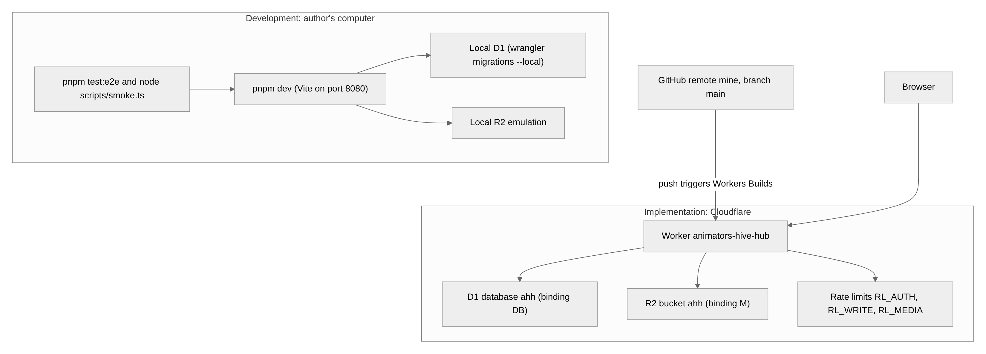
Figure 3: Technical architecture for development and implementation

2.4.3 Initial class diagram
Figure 4 is the initial class diagram, derived from the use cases. It left three questions open: whether a community’s creator is also a member, the multiplicities of the optional link between an animation and a community, and where sessions belong. It was also unclear whether upvotes and comments needed their own identity. Some classes were missing: there was no session class, because the first build relied on a hosted sign-in service, and counts of votes, comments, and members were added later for sorting. Media is held as addresses on the Animation and User classes, so it needs no class of its own. Chapter 3 settles these questions.

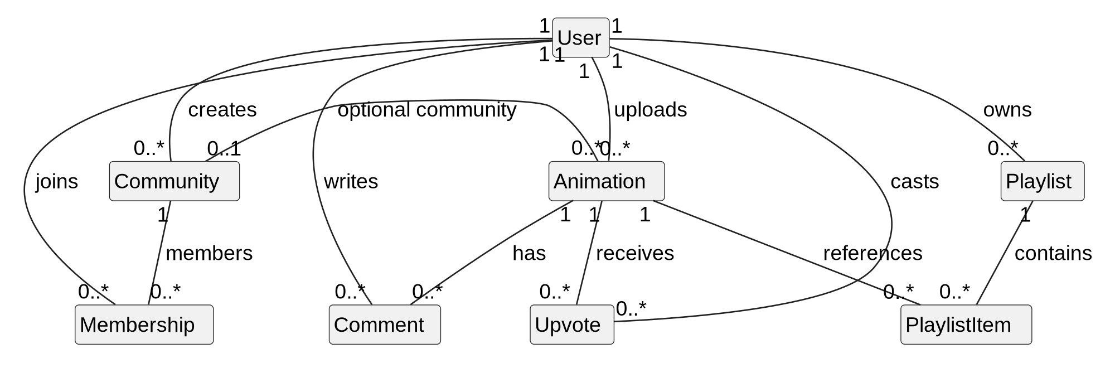
Figure 4: Initial class diagram

2.5 Conclusion
The analysis produced 14 prioritised functional requirements, ten measurable non-functional requirements, a use case diagram and an initial class diagram.

3 Design

3.1 Chapter Overview
This chapter gives the design. The class diagram in Section 3.2 fixes the data the system keeps, and the sequence diagrams in Section 3.3 show the three flows that cross the most components. Sections 3.4 to 3.6 cover the user interface, the frameworks and the tools, and Section 3.7 justifies the approach.

3.2 Structural model
Figure 5 is the completed class diagram. I built it by mapping each database table to a class and checking each association against its foreign key. The schema made four changes: a Message class, added with community messaging, which belongs to one community and one author; a session class, keyed by the hash of a random cookie value; counters for upvotes, comments, and members, recomputed with each write; and explicit membership, so a community’s creator is also a member. Deleting a user removes everything they own or joined, while deleting a community only clears the community from its animations. The community avatar and banner attributes exist but are never written, a gap recorded in Section 6.4.2.

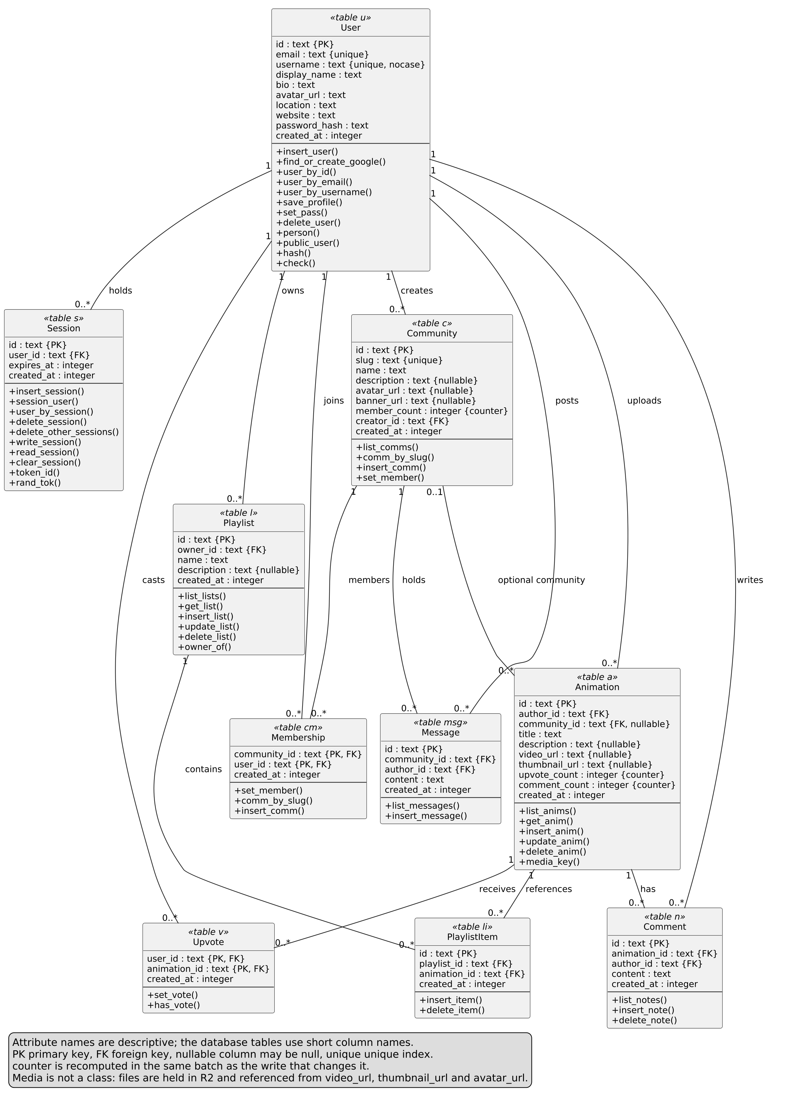
Figure 5: Class diagram

3.3 Behavioural model

3.3.1 Animation upload
In Figure 6, the video goes first to /api/media, which checks its type and size, stores it under a random identifier, and returns its address. The title and description then go to /api/animations, which checks them and confirms that the media address is one the system issued. This check stops a client pointing an animation at a file it does not own. If no thumbnail is chosen, the browser captures a still frame from the video and uploads it the same way; if that fails, the animation is saved without one. If the member creates a new community during upload, it is made first, and its identifier is passed with the metadata.

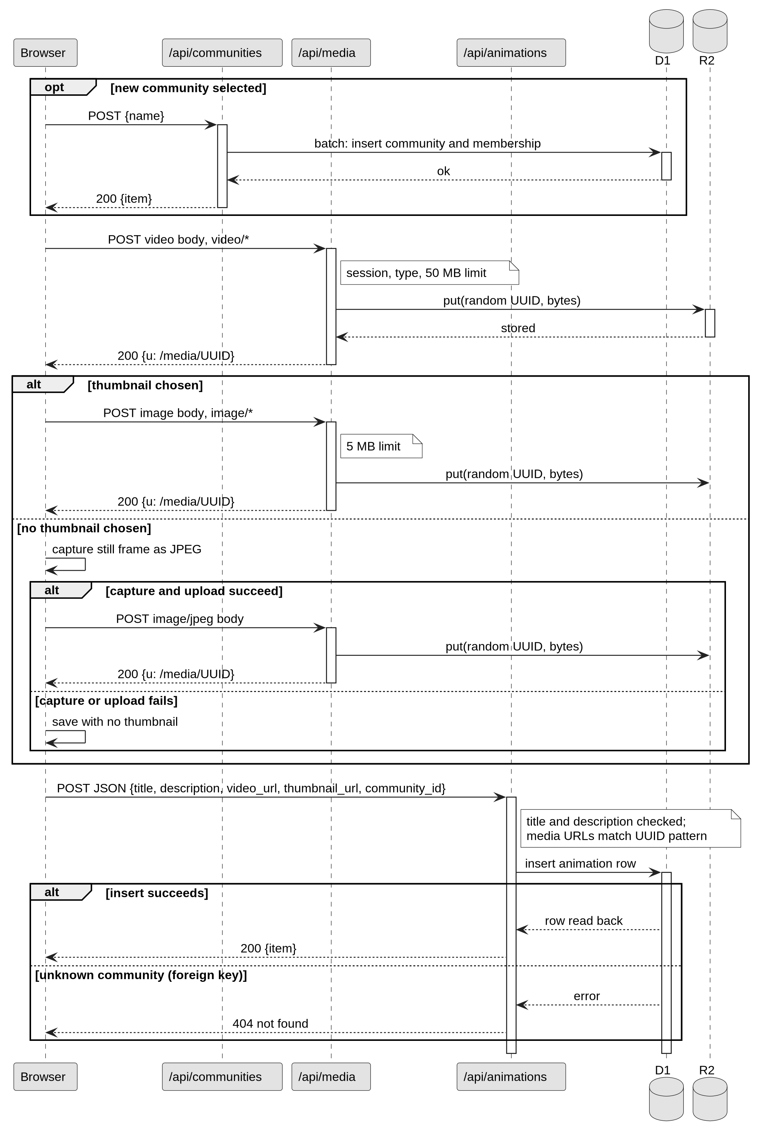
Figure 6: Animation upload sequence

3.3.2 Google sign-in with PKCE
Figure 7 follows the OAuth 2.0 code grant with PKCE. The state value stops forged replies, and unverified Google email addresses are rejected. The PKCE verifier is kept in a cookie that the page’s scripts cannot read and that lasts ten minutes. Accounts are matched by email address, so an existing password account with the same address is signed in without its password. I accepted this because Google reports the address as verified, but it is a weakness discussed in Section 6.4.2.
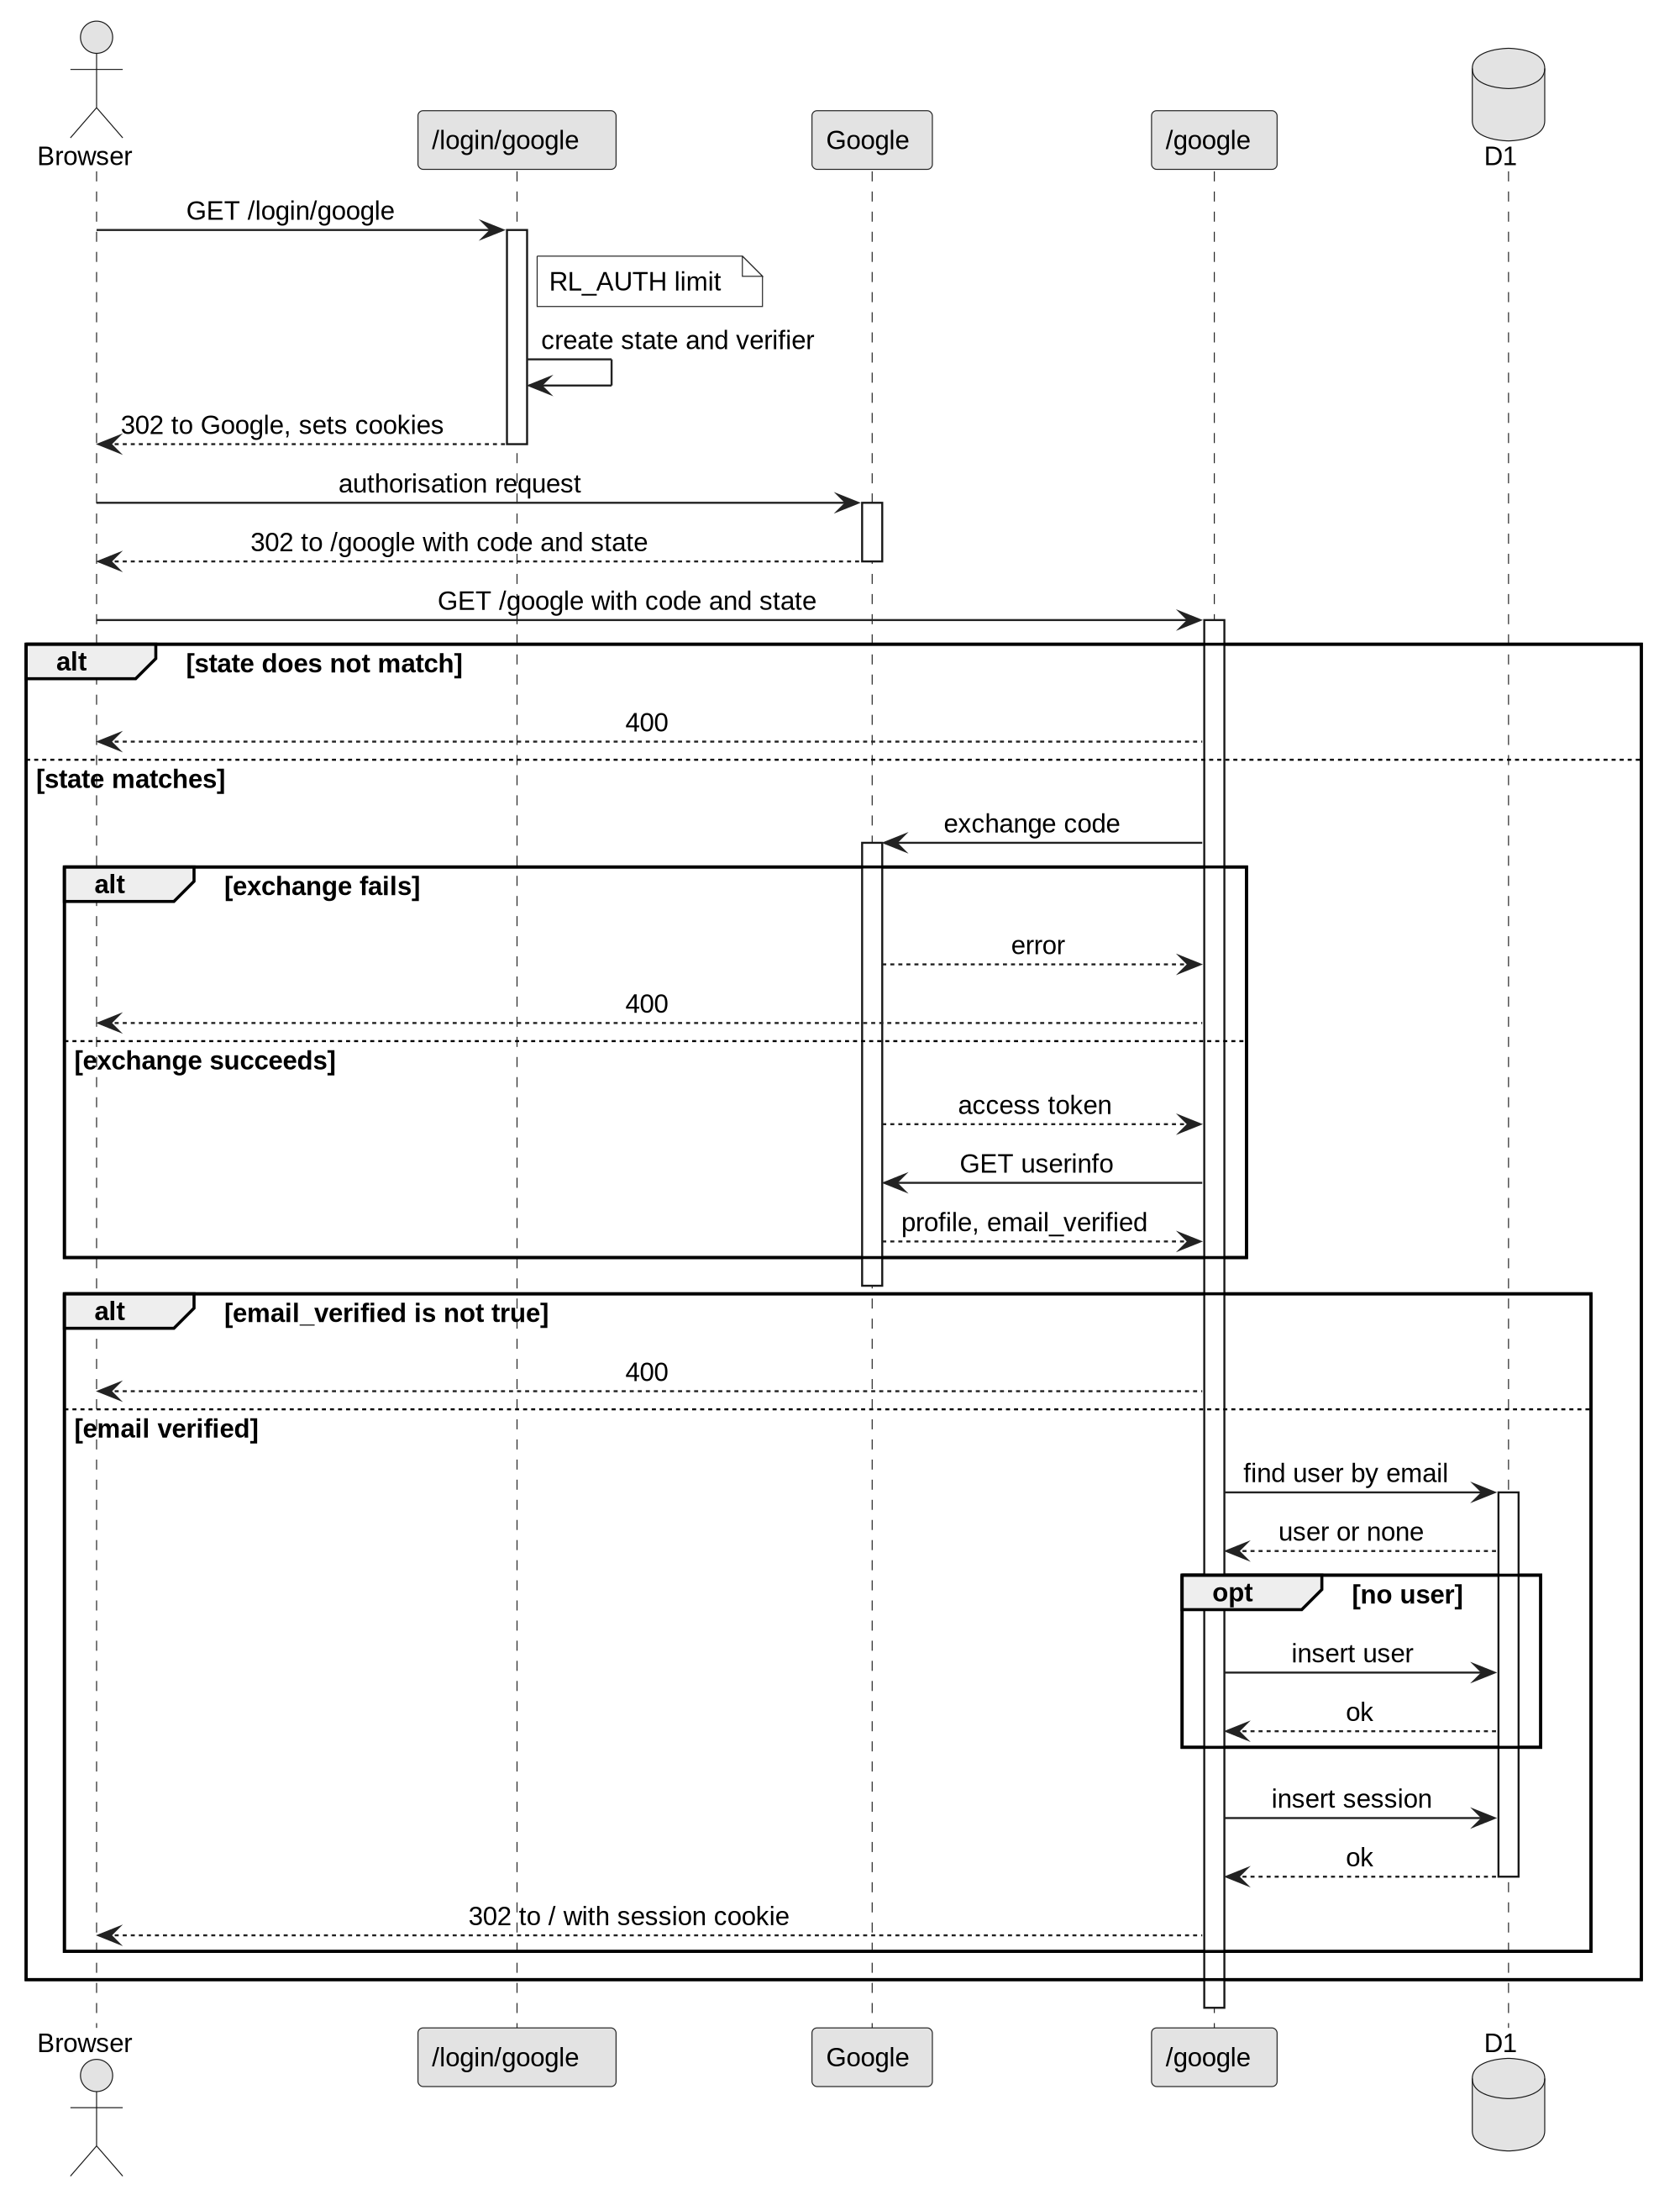
Figure 7: Google sign-in sequence

3.3.3 Upvote toggle
In Figure 8, every write passes one hook that checks the session and the rate limit. Because the hook runs before every route, the checks are applied in one place and cannot be forgotten on a new route. The button changes only after the server answers, and a visitor who is not signed in sees a message and no request is sent. The vote change and the recount are sent together, and a repeated upvote is ignored rather than rejected, so the toggle is safe to repeat.
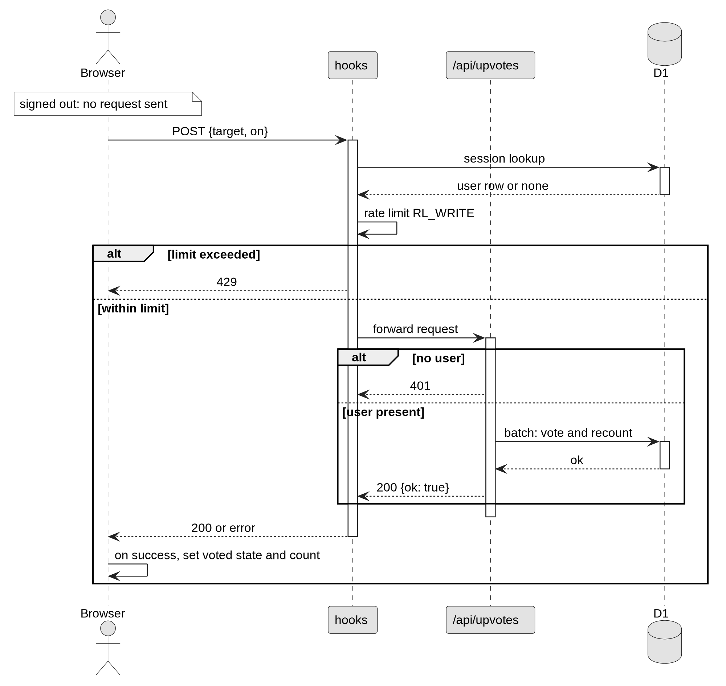
Figure 8: Upvote toggle sequence

3.4 User interface design
Every screen shares one header, with the logo, the discover and communities links, a dark or light theme switch, and either a sign in button or the member’s account menu. Animations appear as cards in a grid, with a thumbnail, title, creator and counts of upvotes and comments, so a viewer can judge a piece before opening it. The account menu holds view profile, edit profile and sign out. The main screens are the landing page, the discover feed, the animation page, the communities list, community pages with their messages, profiles and playlists (Appendix D). Sign in, sign up, upload and add to playlist open as dialogs that keep keyboard focus and close on Escape (NFR7).
The default theme is dark so that animations stand out, with one blue accent for actions and red for deleting. Headings use the Fraunces typeface and interface text uses Space Grotesk, and every icon-only button has a text name for screen readers. The layout works at 375 by 667 pixels without sideways scrolling (NFR6). The design follows Nielsen’s (1994) usability heuristics, named in the proposal. For example, the upvote button changes only when the server confirms the vote (visibility of system status), and the same labelled navigation is on every page (recognition rather than recall).

3.5 Frameworks used
SvelteKit 2 provides the pages, the JSON endpoints and server rendering, and builds the Worker through its Cloudflare adapter. Svelte 5 provides the interface components, such as the header, an animation card or a dialog. Tailwind CSS 4 provides the styling, with the colours and typefaces defined once as theme values. The arctic library handles the OAuth exchange with Google, Lucide provides the icons, and Fontsource serves the two typefaces from the application itself rather than from a third party.

3.6 Tools used for design and implementation
The UML diagrams were written in PlantUML, and the architecture diagrams and Gantt charts in Mermaid. Both are free, follow standard notation, and keep each diagram as text beside the code, so a diagram can be corrected and regenerated quickly when the design changes. The implementation was planned with Node 22, pnpm, Vite, TypeScript in strict mode, Wrangler for the database, storage and secrets, and Git with GitHub. These tools were chosen because they are free and work together without extra set-up. Wrangler runs D1 and R2 on the development computer, so the same code runs locally and live.

3.7 Justification of design approach
Pages are rendered on the server, so a shared animation link shows a preview without script. All records sit in one D1 database that enforces foreign keys, and all SQL is in one module, which keeps the route handlers thin. Sessions are stored in the database rather than in a signed cookie, so sign-out and password change end them at once, at the cost of one lookup per request. Each owner-only action returns 200, 404 or 403, in line with OWASP (2021). Media stays in R2, separate from the records, so the database stays small. The stored counters are the weakest part, because each write must recount them, and deleting a user does not recount the animations that user voted on. Vector search with an external embedding service was tried and removed, because a title and description search met the requirement with one fewer external service.

3.8 Conclusion
The design gives one structural model, three behavioural models, an interface design, and the frameworks and tools used to build them.

4 Implementation

4.1 Chapter Overview
This chapter covers the choice of language, the cutover to the live platform, data migration and training.

4.2 Choice of programming language
The application is written in TypeScript with SvelteKit 2 and Svelte 5 (Svelte, 2026). Strict TypeScript (Microsoft, 2026) checks the data passed between server and browser, and the validation rules are kept in one file shared by the server and the forms, so each limit is written once. SvelteKit keeps pages and JSON endpoints in one project, which suits server rendering, and its Cloudflare adapter targets the Workers runtime directly (Cloudflare, 2026c). Table 4 compares the options.
Table 4: Programming language and platform options
Option | Strengths for this project | Reason not chosen
React and Vite single-page application (2025 prototype) | Familiar; already built | Pages render and fetch data in the browser, which made server-rendered pages harder
PHP and MySQL on a conventional web server | Common hosting; well documented | No edge runtime; the server must be maintained; storage built separately
TypeScript with SvelteKit on Cloudflare Workers (chosen) | Shared types and rules; server-rendered pages; D1 and R2 bindings | Fewer examples than React; the project follows the Svelte 5 runes API

4.3 System cutover from development to implementation architecture
Figure 9 shows the code, schema and secrets moving from the development computer to Cloudflare. A new database migration is applied to the live database before the code that depends on it is pushed, so deployed code never meets a schema it does not expect. The code then moves by a push to the main branch, and Cloudflare builds and deploys it. Each push is followed by a build check, so a failed build can be traced to the change that caused it. Secrets, such as the Google client secret, are set with Wrangler and never stored in the repository. This keeps one repository as the source of truth and makes a rollback a revert and a push.
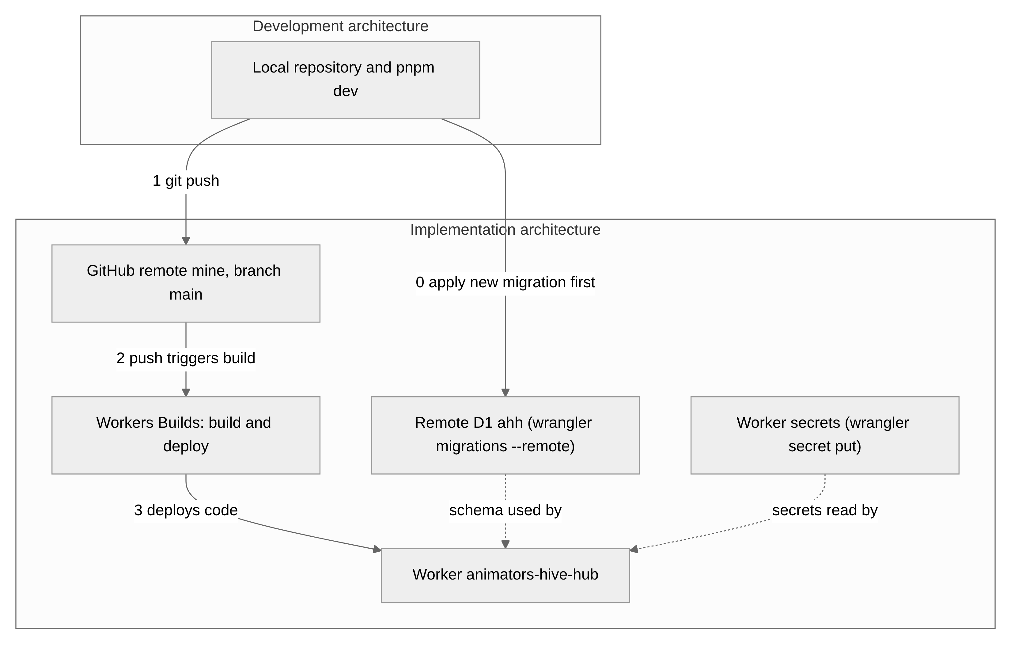
Figure 9: System cutover from development to implementation

4.4 Data migration
Figure 10 shows the data migration. No data from the 2025 prototype was migrated, because its Supabase project no longer exists and its rows cannot be exported. The schema is three numbered migrations, applied locally and then live; the third fills in memberships for existing communities. The R2 bucket was created new, and no media was copied into it.
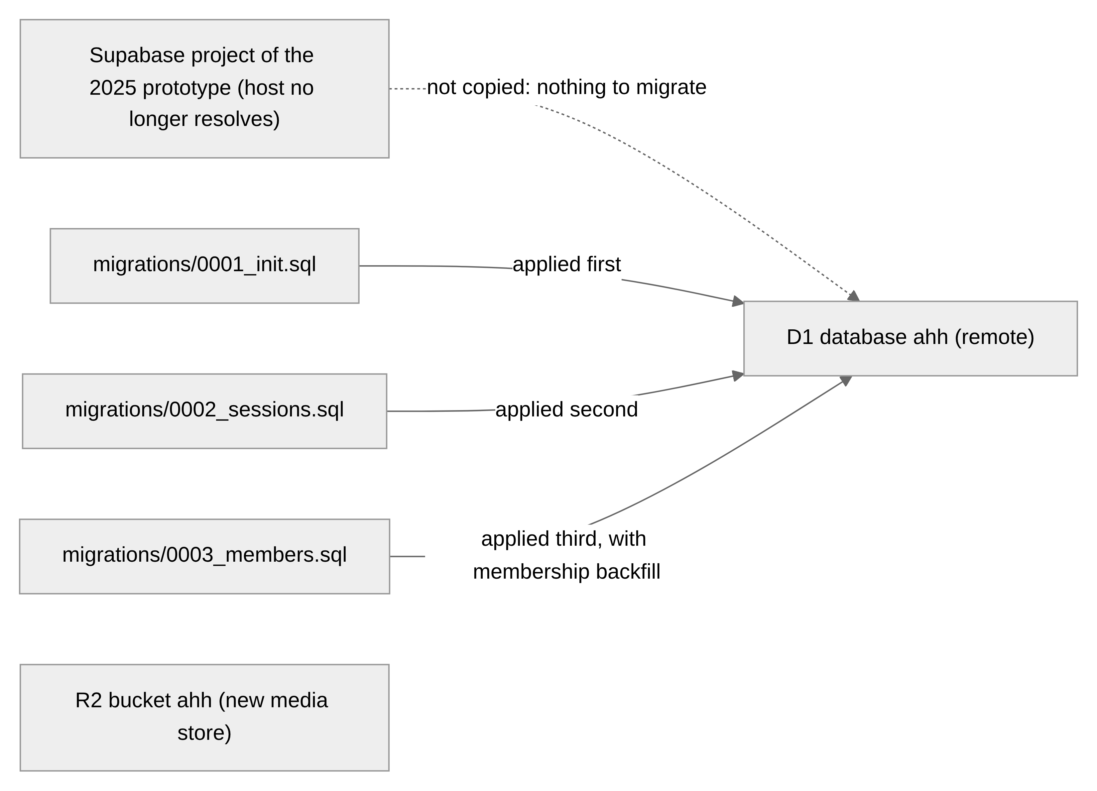
Figure 10: Data migration

4.5 Training
The users are members and visitors. No live training was given and no external users were recruited. The user guide in Appendix D gives each screen with a screenshot and numbered steps that use the interface’s own labels, so a member can read it before first use. The site also has an about and help page, reached from the landing page, which explains the site to new visitors. There is no evidence of training outcomes, because no users were trained.

4.6 Conclusion
The system was built in TypeScript with SvelteKit, deployed by a push to the main branch, and documented for users in Appendix D. The full source code is available at https://github.com/144126/animators-hive-hub.

5 Other Project Issues

5.1 Chapter Overview
This chapter covers the other project issues: how the project was managed (Section 5.2), how risks were handled (Section 5.3), how the code and documents were kept under configuration management (Section 5.4) and how the system was tested (Section 5.5). The full test plan and scripts are in Appendix C, and the risk record is in Appendix E.

5.2 Project management
The project was managed with a work breakdown structure and a Gantt chart, because one person can keep both up to date without special tools. The proposal planned 18 weeks, from 10 May to 7 September 2026 (Figure 11): three weeks of analysis, four of design, ten of build in two iterations from 7 June, seven of testing overlapping the build from 19 July, and four for the report. Figure 12 shows the build that produced the final system. I checked my progress against the plan and the project guide as I worked. Section 6.4.4 reviews the differences between the plan and what happened.
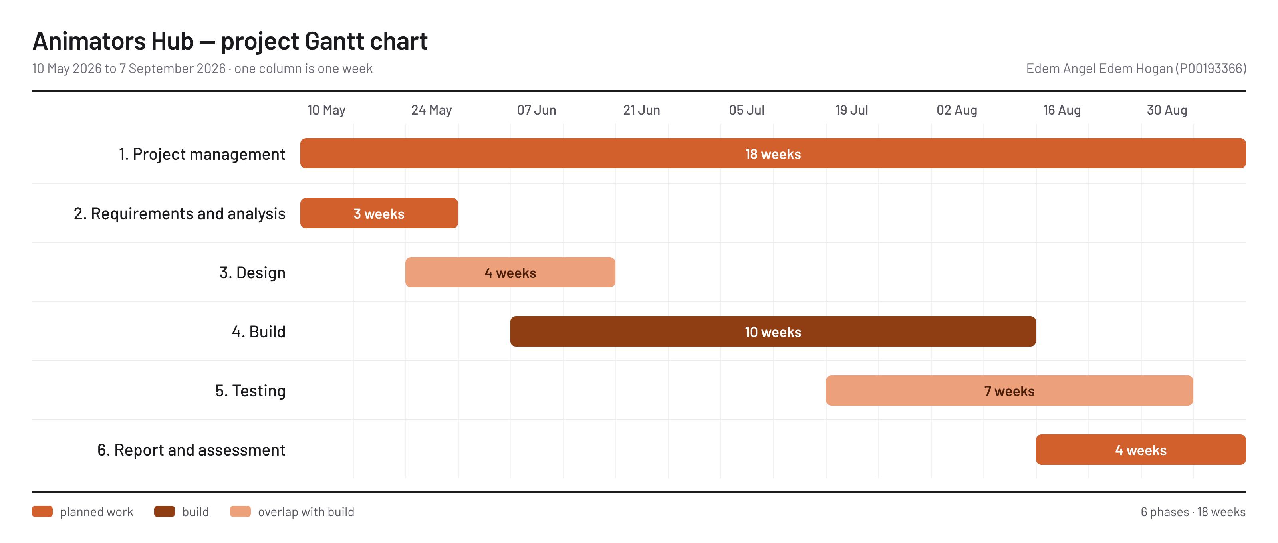
Figure 11: Planned schedule from the proposal, 10 May to 7 September 2026
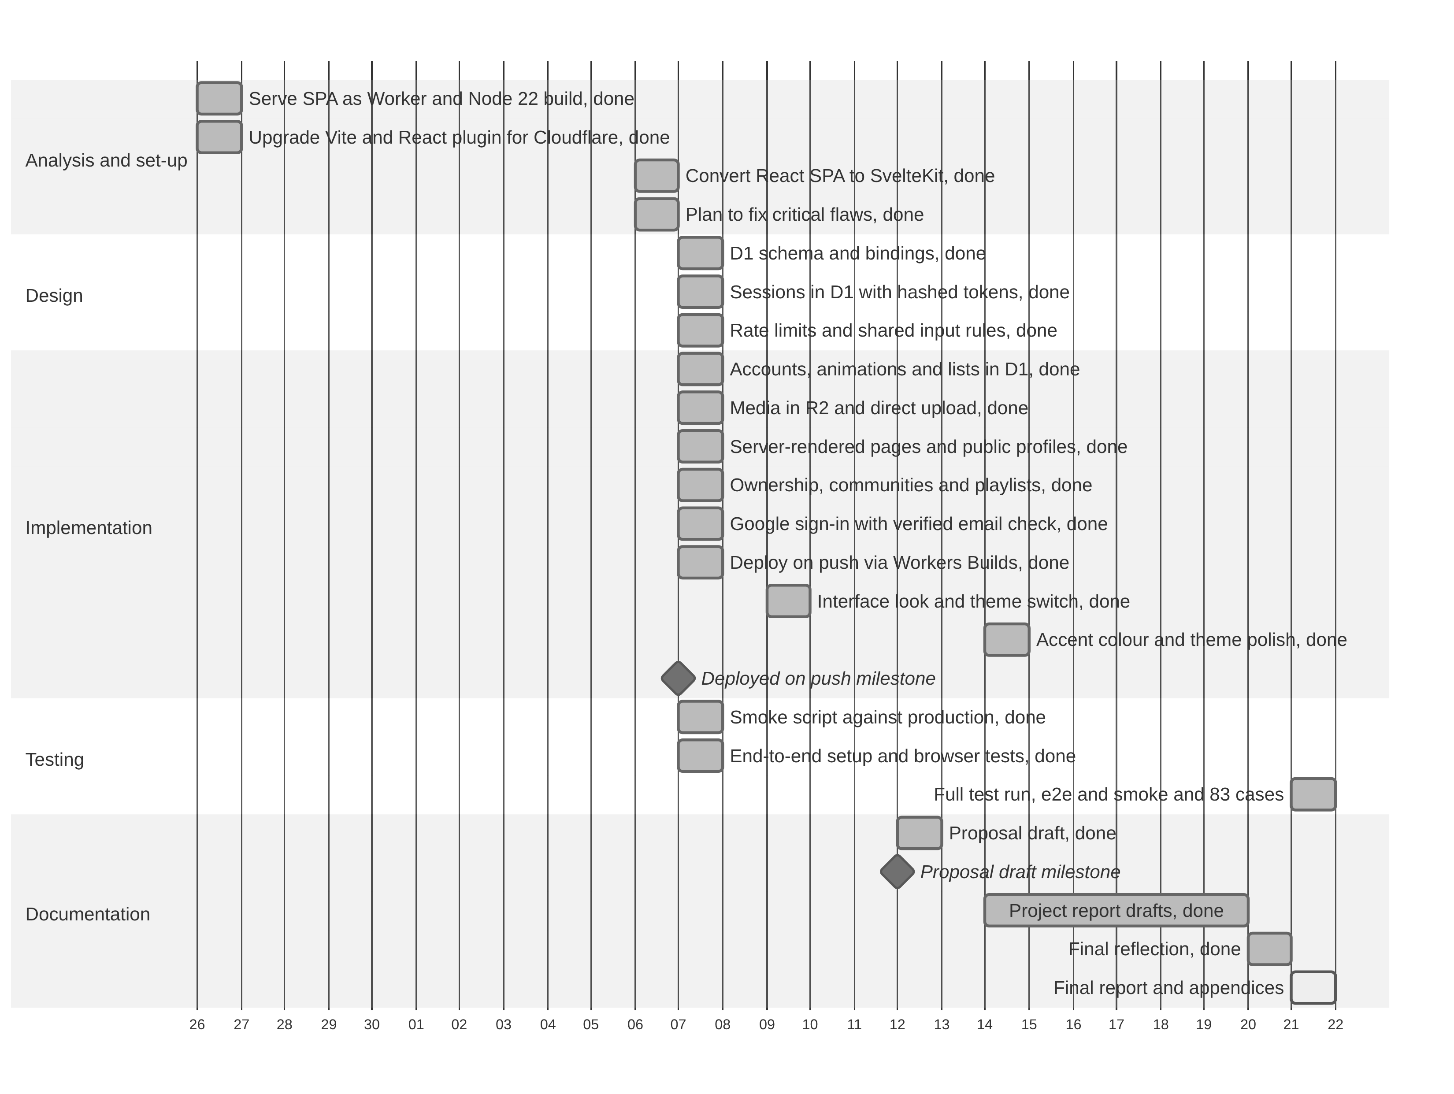
Figure 12: Gantt chart of the build, 26 September to 21 October 2026

5.3 Risk management
Risks were managed with a simple risk list. In the proposal I identified seven risks and wrote a planned response for each, to contain the risk or to recover from it. I chose a list over a scored risk matrix because a one-person project has few risks. Appendix E (Table 22) records what happened to each risk. Two risks happened: the time overrun, and the loss of work when the first build’s data was lost. One risk remains open: unsafe or infringing uploads, because the report control and administrator removal were not built.

5.4 Configuration management
All the code, database migrations, tests and diagram sources are kept in one Git repository that is pushed to GitHub. I chose Git because it is free, records every change with a message, and lets any earlier version be restored. The directory structure is simple: src holds the application, migrations the numbered database changes, tests and scripts the automated checks, and docs the report and its diagrams. The main branch is always the deployed version, because a push to it starts the Cloudflare build, and secrets are kept out of the repository. The first build’s data sat in a hosted service outside this control, which is why it could not be recovered.

5.5 Testing

5.5.1 Testing strategy
Testing is black-box, as the module requires. Each case checks what the system does against a requirement in Table 2 or Table 3, so every case can be traced to a requirement. Testing was done at three levels. Unit testing used nine scripts, one for each main class. Integration testing used three suites: the full member flow (1.1), security (1.2), and usability and accessibility (1.3). System testing used an end-to-end browser suite of four tests, a smoke script of more than sixty API checks, and the lint, type check and build scripts. The project has no unit test runner, so the unit scripts were run by hand and with curl. All tests ran on 21 October 2026 against the local development server, except Unit Test 9, which ran on 13 November 2026 against the live site. I chose this mix because scripted manual tests document each requirement in the NCC format, while the automated checks can be repeated after every change.

5.5.2 Developing the first unit test
The first script was Unit Test 1, for the Account class, because every other test needs a signed-in member. I took FR1 and FR2 and their rules from Appendix A, and the main and alternative flows of UC1 and UC2 from Appendix B. Each main flow became a case that succeeds (1.1 sign-up, 1.6 sign-in), and each alternative flow a case that fails with a known message (1.2, 1.3, 1.7, 1.8 and 1.9). I added invalid input at the boundaries, such as a five-character password, one under the minimum (1.5). Table 5 shows the header and three of the nine cases; the full script is Table 10.
Table 5: Unit Test 1, header and first test cases (Account)
Unit Test 1 | Tests Class: Account; Designed By: Edem Angel Edem Hogan
Data Source | User Entry
Objective | Test Functional Requirement (FR1, FR2)
Tester | Edem Angel Edem Hogan
Test Case 1.1 | Description: Sign up with valid details. Tasks: send the sign-up form with a new email, username and the password smoke-pass-1. Expected Result: status 200; user id returned; session cookie set. Actual Result: Pass.
Test Case 1.5 | Description: Password under six characters. Tasks: send the sign-up form with the password “abcde”. Expected Result: status 400 with error “password invalid”. Actual Result: Pass.
Test Case 1.7 | Description: Sign in with wrong password. Tasks: sign in with the correct email and a wrong password. Expected Result: status 400 with error “invalid email or password”. Actual Result: Pass.
The header identifies the script. Unit Test is its number; Tests Class is the class from Figure 5; Designed By and Tester name who wrote it and who ran it; Data Source says where the data comes from, here typed in by the tester; and Objective gives the requirements tested, so that each can be traced. Each row is one test case: its number, a one-line Description, the exact Tasks so that anyone can repeat it, the Expected Result written before the test, and the Actual Result observed, with pass or fail. Figures 13 to 15 show the first unit test being carried out.
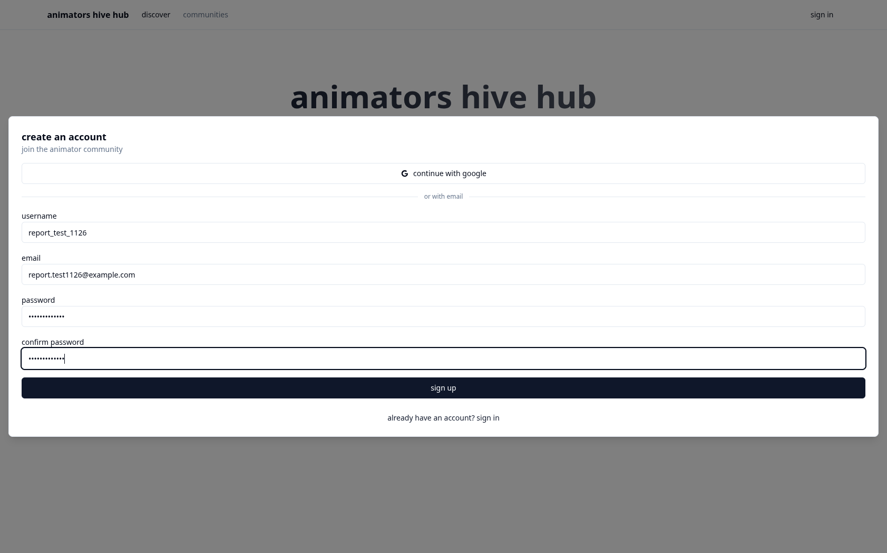
Figure 13: Unit Test 1, case 1.1: sign-up form with test data
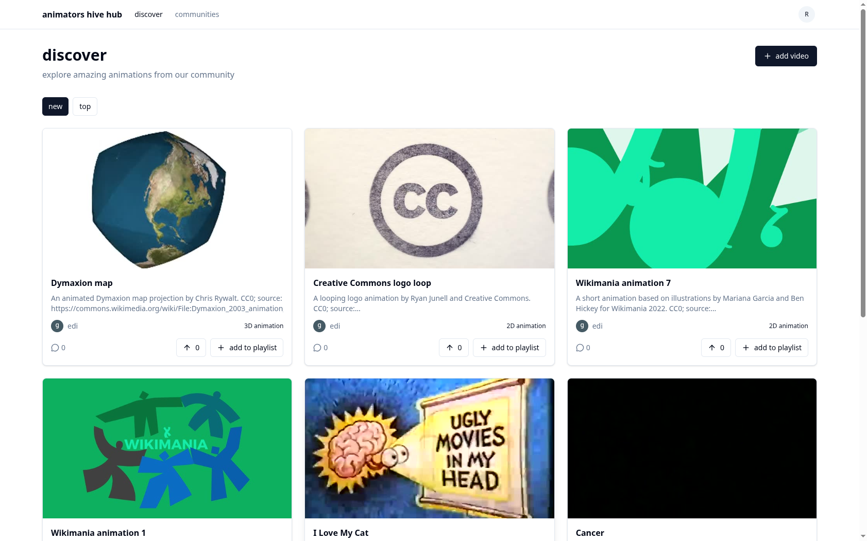
Figure 14: Unit Test 1, case 1.1: result after sign-up
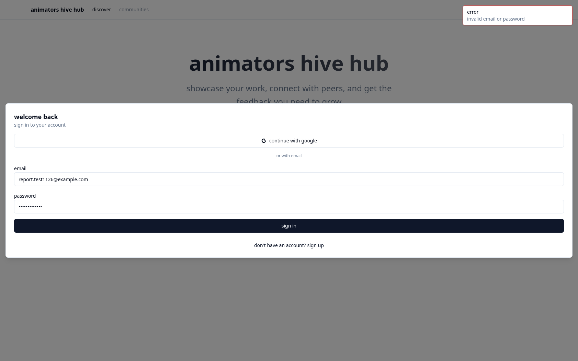
Figure 15: Unit Test 1, case 1.7: wrong password message

5.5.3 Integration and system testing
Suite 1.1 follows one member from sign-up through upload, viewing, upvote and comment, in the order a real user would. Suite 1.2 tests the rate limits, ownership checks, input limits, password storage and cookie flags (NFR1 to NFR4). Suite 1.3 tests the phone layout, dialog focus, the saved theme and button names (NFR6 and NFR7). The end-to-end suite drives a real browser through the landing page, sign-in, sign-up with upload, upvote and comment, and the phone layout. The smoke script checks paging, search, votes, comments, playlists, communities, ownership and deletion through the API, and stops at the first failure. Because all tests ran locally, they show that the code is correct but do not measure live speed.

5.5.4 Summary of results
Table 6 summarises the results.
Table 6: Test evidence summary
Evidence | Scope | Status and result
End-to-end suite (4 tests) | Landing, sign-in focus, sign-up with upload, upvote and comment, phone layout | Passed, 4 of 4, on 21 October 2026
Smoke script | API paging, search, votes, comments, playlists, communities, ownership, deletion | Passed: exit code 0, “smoke ok”, on 21 October 2026
Static checks | Formatting, types, build | Passed on 21 October 2026: svelte-check 0 errors and 0 warnings over 596 files; ESLint clean; production build succeeded
Unit test scripts 1 to 9 | Account through community message | 68 passed, 2 not run (Google sign-in cases 2.4 and 2.5); Unit Test 9 was run on 13 November 2026 on the live site
Integration suites 1.1 to 1.3 | Functional flow, security, usability | 16 passed, 1 failed (case 1.2.1)
Case 1.2.1 failed. In a first burst of 31 sign-in requests none was refused, although after a pause the 31st request of a second burst received HTTP 429. Cloudflare’s rate limiting counts approximately, so the limit slows an attacker but cannot be relied on to stop the 31st request. The write and upload limits (cases 1.2.2 and 1.2.3) passed. Cases 2.4 and 2.5 need a real Google account and could not be run against the local server; the Google flow was checked by reading the code and by case 1.9, which uses an account row of the same shape.

5.6 Conclusion
Testing passed 84 of 87 cases, and every Must requirement works as specified. Community messaging was added after the main run, so its script, Unit Test 9, was run on the live site on 13 November 2026 and passed 4 of 4. The one failure is the approximate authentication rate limit (case 1.2.1). The unit tests are manual scripts, and no real users took part.

6 Conclusion

6.1 Chapter Overview
This chapter evaluates the objectives, sets out further work, critically evaluates each stage of the project including the plan, and reflects on the learning using the model of Rolfe, Freshwater and Jasper (2001).

6.2 Summary of aims and achievement
Animators Hub is a deployed web application on which members upload animations, upvote and comment, keep playlists, join communities and post messages to them. Table 7 evaluates the objectives.
Table 7: Evaluation of objectives and proposal commitments
Objective or proposal commitment | Assessment | Evidence
O1 Upload a video with a title, description and custom thumbnail; see it on the feed | Met late | Unit Test 3 passed 9 of 9; integration suite 1.1 passed 6 of 6
O2 Browse, sort and search by title and description | Met late | Smoke script paging and search checks passed; integration case 1.1.2 passed
O3 Comment on and upvote videos | Met late | Unit Tests 4 and 5 passed 15 of 15
O4 Create playlists and add videos to them | Met late | Unit Test 6 passed 9 of 9
O5 Join a community and post messages to it | Met late | Joining passed in Unit Test 7 (8 of 8); messaging added in November 2026; Unit Test 9 passed 4 of 4 on 13 November 2026
Security controls (NFR1 to NFR4) | Partly met | Suite 1.2 passed 6 of 7; the authentication rate limit is approximate (case 1.2.1)
Proposal: reporting, administrator removal, terms of use, copyright confirmation, animator feedback | Not met | Left out of the requirements by mistake (Section 6.4.1)
Because the work had to be redone, no objective was met by the planned end date of 7 September 2026. O1 to O4 were met by 21 October 2026 and O5 in November 2026. The main lessons learnt are these:
- Settle the platform and the storage before building the first screen. The change from Supabase to Cloudflare meant rebuilding the data layer, and the first build’s data was lost.
- Back up the work often. The first version’s data was lost because it existed only in a hosted service.
- Write and run each test script as soon as its feature is built. The rate limit problem was found only in the final test run.
- Record decisions when they are made. Notes on scope, such as leaving out email, made the report easier to write.

6.3 Further work
The first priority is the proposal’s unmet commitments: a report control, an administrator who can remove content, terms of use, and a copyright confirmation on upload. Next, I would add private chat between users, a checker for AI-generated animation during the upload process, and beginner video tutorials on animating. The remaining steps are to add a unit test runner, add password reset and email verification once an email provider is chosen, delete unused files from R2, recount counters when a user is deleted, and add captions for videos.

6.4 Critical evaluation

6.4.1 Requirements
Looking back, I believe the website includes everything users really need, although there are features that would be good to add. I did not ask animators what they wanted. I do not think this changed what I built, but it means the requirements rest on my own judgement. Content reporting and removal by an administrator, promised in the proposal, were not built because I forgot to add them to the requirements, so they never reached the design. Looking at the requirements critically, some non-functional requirements are also tied too closely to the code: NFR1 names 80,000 hashing iterations because it was written after the code, whereas stating the security goal would have been better.

6.4.2 Design
I switched from React and Supabase to SvelteKit and Cloudflare, and I am glad I did. I found SvelteKit faster than React, and on Cloudflare the application and the database run in the same place, which reduces latency. Another reason was that I did not find the semantic search I wanted in Supabase, although that search was later removed (Section 3.7). Table 4 compares the options. The proposal planned to send videos straight to R2, but a 50 MB cap let them pass safely through the Worker, which gives one place to check each file. The part of the design I am least happy with is the upload, because it has no checker to see whether a video was made with AI. If I started again, I would design the upload with that checker, so that AI-generated animation is found before it is published. Evaluating the design critically, the stored counters can drift, and signing in a Google user to an existing account with the same email address is a weakness.

6.4.3 Implementation and testing
The feature that gave me the most trouble was video upload, because I was no longer dealing only with a relational database; I also had to handle binary data, the video files, which are stored separately in R2. The core flows work end to end, with hashed passwords, sessions that can be ended on the server and an ownership check before every change, and members can delete their account and uploads, which meets the proposal’s commitment under the Nigeria Data Protection Act (Federal Republic of Nigeria, 2023). The failed test 1.2.1 matters because, if a user is not blocked after many sign-in attempts, that level of security is not in place to prevent brute-force attacks on passwords. I do not feel I have tested the website enough. I need to run the 30 sign-in attempts test again so that I can fix the bug, and the tests were scripts that I ran myself, mostly on my local server, so they do not show how the site behaves under load.

6.4.4 Review of the plan
The plan and the Gantt chart of the build are in Section 5.2 (Figures 11 and 12). The work started months before late September 2026, with the first version, but I had to go through it again because I had not written my proposal and report to the correct guidelines. I checked how I was doing against my plan and the project guide, because I could not be sure of completing the goals of the project without doing so. Compared with the plan, the deviations were these:
- The rebuild began on 26 September 2026, after the planned end date, so the build, testing and report were done in about four weeks instead of eighteen.
- The two iterations were not kept apart, and testing ran once, on 21 October 2026, instead of alongside the build.
- Community messaging was finished in November 2026, after the main test run, and reporting, administrator removal and the weekly D1 export were not done.
Starting the rebuild late affected the web development most. With a short time frame, I did not properly implement or test the account lock-out, which is the sign-in rate limit that failed in case 1.2.1.

6.5 Reflective practice
What? I set out to create a website to promote animators, so that AI-generated animations do not overshadow their work. I ended up with a website that meets that objective, where animators can share their work and viewers can find, upvote and discuss it, but it is missing direct messaging between users and an AI checker for videos. The hardest moment of the project for me was keeping to the key objective of the website while I was building it.
So what? Losing my first version and its data taught me to back up my work more often and to be more responsible for it. I learned that proper time management needs realistic planning and early buffer periods, especially for testing and debugging. Rushing the early phases, or having to redo code, eats up valuable time, and that directly affects the quality and thoroughness of the final product. The skill I improved most was my report writing, especially my choice of words.
Now what? In my next project I will:
- conduct user research into what people want from the website, so that I add more useful features, such as the AI checker for videos;
- improve my time management, so that I do not rush through important parts of the project and leave them incomplete;
- make the project more interactive for my target audience, for example with a direct messaging interface.

References
Agile Business Consortium (2014) The DSDM Agile Project Framework Handbook. Ashford: Agile Business Consortium.
ArtStation (2026) ArtStation: portfolio platform for artists. Available at: https://www.artstation.com (Accessed: 6 November 2026).
Beck, K. et al. (2001) Manifesto for Agile Software Development. Available at: https://agilemanifesto.org/ (Accessed: 21 October 2026).
Clegg, D. and Barker, R. (1994) Case Method Fast-Track: A RAD Approach. Wokingham: Addison-Wesley.
Cloudflare (2026a) Cloudflare D1 documentation. Available at: https://developers.cloudflare.com/d1/ (Accessed: 21 October 2026).
Cloudflare (2026b) Cloudflare R2 documentation. Available at: https://developers.cloudflare.com/r2/ (Accessed: 21 October 2026).
Cloudflare (2026c) Cloudflare Workers documentation. Available at: https://developers.cloudflare.com/workers/ (Accessed: 21 October 2026).
Federal Republic of Nigeria (2023) Nigeria Data Protection Act 2023. Abuja: Federal Government of Nigeria.
Fowler, M. (2004) UML Distilled. 3rd edn. Boston: Addison-Wesley.
Gillespie, T. (2014) ‘The relevance of algorithms’, in Gillespie, T., Boczkowski, P.J. and Foot, K.A. (eds) Media Technologies: Essays on Communication, Materiality, and Society. Cambridge, MA: MIT Press, pp. 167-194.
Hardt, D. (2012) The OAuth 2.0 Authorization Framework. RFC 6749. IETF.
Microsoft (2026) TypeScript documentation. Available at: https://www.typescriptlang.org/docs/ (Accessed: 21 October 2026).
Newgrounds (2026) Newgrounds: Everything, By Everyone. Available at: https://www.newgrounds.com (Accessed: 6 November 2026).
Nielsen, J. (1994) ‘10 usability heuristics for user interface design’. Available at: https://www.nngroup.com/articles/ten-usability-heuristics/ (Accessed: 6 November 2026).
OWASP Foundation (2021) OWASP Top 10:2021. Available at: https://owasp.org/Top10/ (Accessed: 21 October 2026).
Rolfe, G., Freshwater, D. and Jasper, M. (2001) Critical Reflection for Nursing and the Helping Professions: A User’s Guide. Basingstoke: Palgrave.
Sakimura, N., Bradley, J. and Agarwal, N. (2015) Proof Key for Code Exchange by OAuth Public Clients. RFC 7636. IETF.
Sommerville, I. (2016) Software Engineering. 10th edn. Harlow: Pearson.
Svelte (2026) SvelteKit documentation. Available at: https://svelte.dev/docs/kit (Accessed: 21 October 2026).
W3C (2018) Web Content Accessibility Guidelines (WCAG) 2.1. Available at: https://www.w3.org/TR/WCAG21/ (Accessed: 21 October 2026).
YouTube (2026) ‘How YouTube’s recommendation system works’. Available at: https://support.google.com/youtube/answer/9315727 (Accessed: 6 November 2026).

Appendices

Appendix A: Requirements catalogue
The catalogue gives one entry for each functional requirement (FR) and each system-wide non-functional requirement (NFR). The source column names the origin of the requirement: the proposal’s function list, or the analysis in Section 2.2 and the code it is based on. The acceptance criterion names the test that shows the requirement is met.
Table 8: Requirements catalogue
ID | Name | Description | Priority | Source | Acceptance criterion
FR1 | Register | A visitor creates an account with email, username and password. The email is lower-cased; the username matches a-z, 0-9 and underscore, 3 to 30 characters; the password has 6 to 200 characters. | Must | Proposal function list; Section 2.2.1 | Unit test 1, cases 1.1 to 1.5
FR2 | Sign in and out with email | A member signs in with email and password, and signs out to end the session. A wrong password gives the same message as an unknown email. | Must | Proposal function list; Section 2.2.1 | Unit test 1, cases 1.6 to 1.8; unit test 2, case 2.7
FR3 | Sign in with Google | A member signs in with a verified Google account. Sign-in starts with a PKCE challenge and ends with a session. | Should | Analysis of the first build | Unit test 2, cases 2.1 to 2.5
FR4 | Upload animation | A member uploads a video of up to 50 MB and an optional image of up to 5 MB, then saves a title, description and optional community. | Must | Proposal function list | Unit test 3, cases 3.1 to 3.9; integration case 1.1.2
FR5 | Discover feed | Members browse animations by newest or most upvoted, search by title and description, and load more in pages of 20. | Must | Analysis | Smoke script paging and search checks; integration case 1.1.2
FR6 | Animation page | A visitor opens an animation to watch its video, read its description and comments, and see its counts. | Must | Analysis | Integration case 1.1.3
FR7 | Edit or delete animation | The owner changes the title and description, or deletes the animation and its media. Other users receive 403. | Should | Analysis | Integration suite 1.2, case 1.2.4
FR8 | Upvote | A member toggles one upvote per animation. The count is recomputed in the same write. A signed-out user receives 401. | Must | Proposal function list | Unit test 4, cases 4.1 to 4.7
FR9 | Comment | A member posts a comment of 1 to 1,000 characters and deletes their own. Other users receive 403. | Must | Proposal function list | Unit test 5, cases 5.1 to 5.8
FR10 | Playlists | A member creates, renames and deletes playlists, and adds and removes animations. Adding a duplicate is refused. | Should | Proposal function list | Unit test 6, cases 6.1 to 6.9
FR11 | Communities | A member browses, searches, creates, joins and leaves communities. Joining and leaving updates the member count. | Should | Proposal function list | Unit test 7, cases 7.1 to 7.8
FR12 | Profiles | Public profiles show a member’s details and animations without an email address. A member edits their own profile and avatar. | Should | Proposal function list; analysis | Unit test 8, cases 8.1 to 8.8
FR13 | Password and account | A member changes the password, which ends other sessions, and deletes the account after typing the username. | Should | Analysis | Unit test 2, case 2.8; integration case 1.2.6
FR14 | Community messaging | Members send a message to a community. | Should | Proposal function list | Unit Test 9
NFR1 | Password storage | Passwords are stored as PBKDF2-SHA256 hashes with 80,000 iterations and a random salt. | Must | OWASP (2021); src/lib/server/session.ts | Integration case 1.2.6
NFR2 | Session handling | Session tokens are random, stored as SHA-256 hashes, and valid for 30 days. Sign-out, password change and deletion end sessions. | Must | OWASP (2021); src/lib/server/session.ts | Unit test 2, cases 2.6 to 2.8; integration case 1.2.7
NFR3 | Rate limits | Limits of 30 authentication requests, 120 writes and 30 uploads per minute, with HTTP 429 when exceeded. | Must | src/hooks.server.ts; wrangler.jsonc | Integration case 1.2.1 to 1.2.3
NFR4 | Validation and ownership | Inputs are checked against shared limits; owner-only actions return 403 for other users. | Must | OWASP (2021); src/lib/rules.ts | Unit tests 3 to 8; integration cases 1.2.4 and 1.2.5
NFR5 | Bounded responses | Feed pages hold 20 items; uploads are capped at 50 MB and 5 MB; media supports range requests. | Should | src/routes/api; src/routes/media | Unit test 3, cases 3.2 to 3.4; smoke script range check
NFR6 | Phone layout | The layout works at 375 by 667 pixels without horizontal scrolling. | Should | Analysis | Integration case 1.3.1
NFR7 | Accessibility | Dialogs trap focus and close on Escape; icon-only buttons have names. | Should | WCAG 2.1 (W3C, 2018) | Integration cases 1.3.2 and 1.3.4
NFR8 | Privacy | Public pages never show an email address. | Must | Analysis; src/routes/u | Unit test 8, case 8.7
NFR9 | Maintainability | Strict TypeScript; lint, format and check scripts; SQL in one module; numbered migrations. | Should | Analysis; package.json | Static checks in Table 6
NFR10 | Deployability | A push to main results in a build and deployment. | Should | Analysis; wrangler.jsonc | Deployment check

Appendix B: Use case descriptions
Each description follows the same pattern: actors, pre-conditions, post-conditions, main flow and alternative flows. The identifiers match Figure 1.
UC1 Sign up
- Actors: Guest.
- Pre-conditions: the visitor is not signed in, and the email and username are not already used.
- Post-conditions: a user row and a session exist, and the visitor is signed in.
- Main flow: the visitor selects sign up now, enters username, email, password and the same password again, and selects sign up. The system validates the fields, creates the account and sets the session cookie. The discover heading is shown.
- Alternative flows: if the passwords differ or the password is under six characters, the form shows a message and sends nothing. If the username is taken in any case, the system returns “username is already taken”. If the email is already used, it returns “email already used”.
UC2 Sign in with email
- Actors: Guest.
- Pre-conditions: an account exists with a password.
- Post-conditions: a session exists for the account.
- Main flow: the visitor selects sign in, enters email and password, and selects sign in. The system checks the password hash and creates a session.
- Alternative flows: a wrong password or unknown email returns “invalid email or password”. An account created with Google only returns “try signing in with google”.
UC3 Sign in with Google
- Actors: Guest, Google.
- Pre-conditions: the visitor has a Google account with a verified email address.
- Post-conditions: a session exists, and an account exists for the email address.
- Main flow: the visitor selects continue with google. The system redirects to Google with a state value and a PKCE challenge. The visitor approves. Google returns a code, and the system checks the state, exchanges the code, reads the profile, creates or finds the account and starts a session.
- Alternative flows: a mismatched state, a missing code or a failed exchange returns 400. An unverified Google email returns “google email not verified”.
UC4 Browse discover feed
- Actors: Member.
- Pre-conditions: the member is signed in.
- Post-conditions: none; the feed is read only.
- Main flow: the member sees the discover heading and the newest animations. The member selects new or top, or types in the search box. The member selects load more to see the next 20 items.
- Alternative flows: if no animation matches, the page says “nothing matches”. If there are no animations, it says “nothing here yet”.
UC5 Upload animation
- Actors: Member, Community (optional).
- Pre-conditions: the member is signed in, and has a video of up to 50 MB.
- Post-conditions: the video, its thumbnail and an animation row exist.
- Main flow: the member selects add video, enters a title, chooses a video file and optionally a thumbnail and a community, and selects upload animation. The system uploads the media, then saves the animation.
- Alternative flows: an empty title or no video is refused in the browser. A file over the size limit or of the wrong type is refused. A new community is created when create new community is chosen.
UC6 View animation
- Actors: Guest, Member.
- Pre-conditions: the animation exists.
- Post-conditions: none.
- Main flow: the visitor opens an animation, watches the video, and reads the description, counts and comments.
- Alternative flows: a missing animation returns not found. A video without a file shows its thumbnail.
UC7 Edit or delete animation
- Actors: Member (owner).
- Pre-conditions: the member is signed in and owns the animation.
- Post-conditions: the title and description are changed, or the animation and its media are deleted.
- Main flow: the owner selects edit, changes the title or description, and selects save. To delete, the owner selects delete and confirms.
- Alternative flows: another user receives 403. An empty title is refused.
UC8 Upvote
- Actors: Member.
- Pre-conditions: the member is signed in.
- Post-conditions: a vote row exists or has been removed, and the count is recomputed.
- Main flow: the member selects the count button. The system records the vote and the button changes state.
- Alternative flows: a signed-out visitor sees “sign in to upvote” and no request is sent. A repeated upvote is ignored.
UC9 Comment
- Actors: Member.
- Pre-conditions: the member is signed in.
- Post-conditions: a comment exists, and the comment count is recomputed.
- Main flow: the member types into the comment box and selects post comment. The comment appears at the top of the list.
- Alternative flows: an empty comment is not posted. A comment over 1,000 characters is refused. The member may delete their own comment with the delete control, and another member receives 403.
UC10 Manage playlists
- Actors: Member.
- Pre-conditions: the member is signed in.
- Post-conditions: a playlist or item exists, or has been changed or removed.
- Main flow: the member selects create playlist, enters a name and selects create. From any card, the member selects save and chooses a playlist. The owner can rename, delete and remove items.
- Alternative flows: a duplicate item is refused. Another member cannot change a playlist, and receives 403.
UC11 Browse and join communities
- Actors: Guest, Member.
- Pre-conditions: none for browsing; the member is signed in to join.
- Post-conditions: membership exists or has been removed, and the member count is recomputed.
- Main flow: the visitor opens communities and searches by name. A member opens a community and selects join or leave.
- Alternative flows: a community with symbols only in its name is refused on creation. A duplicate name returns “community exists”.
UC12 View public profile
- Actors: Guest, Member.
- Pre-conditions: the username exists.
- Post-conditions: none.
- Main flow: the visitor opens a profile by username and sees the display name, bio, location, website and the member’s animations.
- Alternative flows: an unknown username returns not found. The email address is never shown.
UC13 Edit profile and password
- Actors: Member.
- Pre-conditions: the member is signed in.
- Post-conditions: the profile or password is changed.
- Main flow: the member selects edit profile, changes the fields or picture, and selects save changes. To change the password, the member enters the old and new passwords and selects change password.
- Alternative flows: a website without http or https is refused. A wrong old password returns “wrong password”. A password change ends the member’s other sessions. An account without a password sets one with set password.
UC14 Delete account
- Actors: Member.
- Pre-conditions: the member is signed in.
- Post-conditions: the account, its records and its media are deleted, and the session ends.
- Main flow: the member types their username in the delete account section, confirms, and selects delete account.
- Alternative flows: a username that does not match returns “username mismatch” and nothing is deleted. Cancelling the confirmation keeps the account.
UC15 Sign out
- Actors: Member.
- Pre-conditions: the member is signed in.
- Post-conditions: the session is deleted and the cookie is cleared.
- Main flow: the member opens the account menu from the header and selects sign out.
- Alternative flows: none.
UC16 Post a message to a community
- Actors: Member.
- Pre-conditions: the member is signed in and has joined the community.
- Post-conditions: the message is stored and shown on the community page.
- Main flow: the member opens the community page, types a message and sends it. The message appears on the community page with the member’s name, where other members can read it.
- Alternative flows: a visitor who is not signed in is asked to sign in. An empty message is not sent.

Appendix C: Test plan and test scripts
The test plan lists every test script with its level, the requirements it covers, the number of cases and the result. All scripts were run on 21 October 2026 against the local development server, except Unit Test 9, which was run on 13 November 2026 against the live site.
Table 9: Test plan
Script | Level | Requirements covered | Cases | Result
Unit Test 1: Account | Unit | FR1, FR2 | 9 | 9 passed
Unit Test 2: Session and Google sign-in | Unit | FR3, NFR2 | 8 | 6 passed, 2 not run
Unit Test 3: Animation upload | Unit | FR4, NFR5 | 9 | 9 passed
Unit Test 4: Upvote | Unit | FR8 | 7 | 7 passed
Unit Test 5: Comment | Unit | FR9 | 8 | 8 passed
Unit Test 6: Playlist | Unit | FR10 | 9 | 9 passed
Unit Test 7: Community | Unit | FR11 | 8 | 8 passed
Unit Test 8: Profile | Unit | FR12, NFR8 | 8 | 8 passed
Unit Test 9: Message | Unit | FR14 | 4 | 4 passed (13 November 2026, live site)
Integration Suite 1.1: functional flow | Integration | FR1, FR4, FR5, FR6, FR8, FR9 | 6 | 6 passed
Integration Suite 1.2: security | Integration | NFR1 to NFR4, FR7, FR13 | 7 | 6 passed, 1 failed
Integration Suite 1.3: usability and accessibility | Integration | NFR6, NFR7 | 4 | 4 passed
End-to-end browser suite | System | FR1, FR4, FR8, FR9, NFR6 | 4 | 4 passed
Smoke script | System | FR5 to FR12 | 60+ | Passed (“smoke ok”)
Static checks (lint, type check, build) | System | NFR9 | 3 | Passed
The test scripts follow.
The scripts follow the NCC template. Each script has a header with the test class and designer, and a data source, objective and tester. The table gives the test cases, with description, tasks, expected result and actual result. All cases were run on 21 October 2026 against the local development server, using curl, a web browser and the automated suites. Each actual result records what was observed. The expected results are taken from the route handlers, the data functions and the existing scripts scripts/smoke.ts and tests/*.e2e.ts. Requirement references are to Table 2.
Unit Test 1 | Tests Class: Account | Designed By: Edem Angel Edem Hogan
Data Source: User Entry | Objective: Test Functional Requirement (FR1, FR2) | Tester: Edem Angel Edem Hogan
Table 10: Unit Test 1 test cases (Account)
Test Case | Description | Tasks | Expected Result | Actual Result
1.1 | Sign up with valid details | POST /api/auth/signup with email smkNNNNNNNN@example.com, username smkNNNNNNNN and password smoke-pass-1 | Status 200; user id returned; cookie ahh set; GET /api/me returns the same id | Pass. 200; user id returned; ahh cookie set (HttpOnly, SameSite=Lax); /api/me returned the same id (curl)
1.2 | Username already taken in another case | Sign up with the username of case 1.1 in upper case and a new email | Status 400 with error “username is already taken” | Pass. 400, error “username is already taken” (curl)
1.3 | Email already used | Sign up with the email of case 1.1 and a new username | Status 400 with error “email already used” | Pass. 400, error “email already used” (curl)
1.4 | Username with a space | POST signup with username “has space” | Status 400 with error “username invalid” | Pass. 400, error “username invalid” (curl)
1.5 | Password under six characters | POST signup with password “abcde” | Status 400 with error “password invalid” | Pass. 400, error “password invalid” (curl)
1.6 | Sign in with correct password | POST /api/auth/signin with the email and password from case 1.1 | Status 200; new cookie ahh set; user returned | Pass. 200; new ahh cookie set (HttpOnly, SameSite=Lax); user returned (curl)
1.7 | Sign in with wrong password | POST /api/auth/signin with the correct email and a wrong password | Status 400 with error “invalid email or password” | Pass. 400, error “invalid email or password” (curl)
1.8 | Sign in with unknown email | POST /api/auth/signin with nobody@example.com | Status 400 with error “invalid email or password”, the same as case 1.7 | Pass. 400, error “invalid email or password”, same body as 1.7 (curl)
1.9 | Sign in to a Google-only account | Create the account with Google first, then POST signin with any password | Status 400 with error “try signing in with google” | Pass. 400, error “try signing in with google” (curl). Stand-in: row written to local D1 with empty password, the shape find_or_create_google writes; real Google account not created
Unit Test 2 | Tests Class: Session | Designed By: Edem Angel Edem Hogan
Data Source: User Entry | Objective: Test Functional Requirement (FR3) and Non-functional Requirement (NFR2) | Tester: Edem Angel Edem Hogan
Table 11: Unit Test 2 test cases (Session and Google sign-in)
Test Case | Description | Tasks | Expected Result | Actual Result
2.1 | Start Google sign-in | GET /login/google | Status 302 to accounts.google.com with redirect_uri, openid, profile and email scopes; cookies oauth_state and oauth_verifier set, httpOnly, 600 seconds | Pass. 302 to accounts.google.com with redirect_uri and scope openid+profile+email; oauth_state and oauth_verifier set HttpOnly, Max-Age=600 (curl)
2.2 | Callback without parameters | GET /google with no code or state | Status 400 | Pass. 400 (curl)
2.3 | Callback with mismatched state | GET /google with code and a state that differs from the oauth_state cookie | Status 400 | Pass. 400 (curl)
2.4 | Google account with unverified email | Complete Google sign-in with an account whose email is not verified, or with a stub userinfo response that sets email_verified to false | Status 400 with body “google email not verified”; no session cookie | Not run. Needs a Google authorization code and userinfo response; no Google access from this run
2.5 | Successful Google sign-in | Complete Google sign-in with a verified account | Status 302 to /; cookie ahh set; oauth cookies removed; GET /api/me returns the user, with a username taken from the email | Not run. Needs a real verified Google account sign-in; no Google access from this run
2.6 | Forged session cookie | GET /api/me with cookie ahh set to a made-up value | Status 200 with user null | Pass. 200, {“user”:null} (curl)
2.7 | Sign out ends the session | POST /api/auth/signout with a valid cookie, then GET /api/me with the same cookie | Signout status 200; second request returns user null | Pass. Signout 200 {“ok”:true}; then /api/me {“user”:null} (curl)
2.8 | Password change ends other sessions | Sign in on two sessions A and B; POST /api/auth/password on A with the old and new passwords | Status 200; GET /api/me on B returns user null; on A it still returns the user | Pass. Smoke run: password change 200; session B user null; session A user kept
Unit Test 3 | Tests Class: Animation | Designed By: Edem Angel Edem Hogan
Data Source: User Entry | Objective: Test Functional Requirement (FR4) and Non-functional Requirement (NFR5) | Tester: Edem Angel Edem Hogan
Table 12: Unit Test 3 test cases (Animation upload)
Test Case | Description | Tasks | Expected Result | Actual Result
3.1 | Upload a video | POST /api/media with content type video/mp4 and a 1 KB body, signed in | Status 200 with u set to /media/ and a UUID | Pass. 200, {“u”:“/media/”} (curl)
3.2 | Unsupported content type | POST /api/media with content type text/plain | Status 415 with error “unsupported file type” | Pass. 415, error “unsupported file type” (curl)
3.3 | Video over 50 MB | POST /api/media with video/mp4 and a body of 50 MB plus one byte | Status 413 with error “file too large” | Pass. 413, error “file too large” (curl)
3.4 | Image over 5 MB | POST /api/media with image/jpeg and a body of 5 MB plus one byte | Status 413 with error “file too large” | Pass. 413, error “file too large” (curl)
3.5 | Create animation | POST /api/animations with a title, a description and the video URL from case 3.1 | Status 200; item with an id, upvote_count 0 and comment_count 0 | Pass. 200; item with id, upvote_count 0, comment_count 0 (curl)
3.6 | Empty title | POST /api/animations with a title of three spaces | Status 400 with error “title invalid” | Pass. 400, error “title invalid” (curl)
3.7 | Video not uploaded | POST /api/animations with video_url “/media/not-a-uuid” | Status 400 with error “upload the video first” | Pass. 400, error “upload the video first” (curl)
3.8 | Unknown community | POST /api/animations with a random UUID as community_id | Status 404 with error “not found” | Pass. 404, error “not found” (curl)
3.9 | Upload without signing in | POST /api/animations with no cookie | Status 401 with error “sign in required” | Pass. 401, error “sign in required” (curl)
Unit Test 4 | Tests Class: Upvote | Designed By: Edem Angel Edem Hogan
Data Source: User Entry | Objective: Test Functional Requirement (FR8) | Tester: Edem Angel Edem Hogan
Table 13: Unit Test 4 test cases (Upvote)
Test Case | Description | Tasks | Expected Result | Actual Result
4.1 | Upvote an animation | POST /api/upvotes with target and on true, signed in | Status 200 with ok true; animation upvote_count 1; GET /api/upvotes returns voted true | Pass. 200 {“ok”:true}; upvote_count 1; voted true (curl)
4.2 | Upvote twice | Repeat case 4.1 | Status 200; upvote_count still 1 | Pass. 200; upvote_count still 1 (curl)
4.3 | Remove upvote | POST /api/upvotes with on false | Status 200; upvote_count 0; voted false | Pass. 200 {“ok”:true}; upvote_count 0; voted false (curl)
4.4 | Upvote while signed out | POST /api/upvotes with no cookie | Status 401 with error “sign in required” | Pass. 401, error “sign in required” (curl)
4.5 | Upvote a missing animation | POST /api/upvotes with a random UUID as target | Status 404 with error “not found” | Pass. 404, error “not found” (curl)
4.6 | Missing target | POST /api/upvotes with only on true | Status 400 with error “missing” | Pass. 400, error “missing” (curl)
4.7 | Owner upvotes own animation | POST /api/upvotes by the author | Status 200; the vote is recorded, because the system has no owner check for votes | Pass. 200 {“ok”:true}; author’s vote recorded, upvote_count 1 (curl)
Unit Test 5 | Tests Class: Comment | Designed By: Edem Angel Edem Hogan
Data Source: User Entry | Objective: Test Functional Requirement (FR9) | Tester: Edem Angel Edem Hogan
Table 14: Unit Test 5 test cases (Comment)
Test Case | Description | Tasks | Expected Result | Actual Result
5.1 | Post a comment | POST /api/comments with post_id of an animation and content “hi” | Status 200; item with author and created_at; animation comment_count 1 | Pass. 200; item has author and created_at; comment_count 1 (curl)
5.2 | Empty comment | POST /api/comments with content of three spaces | Status 400 with error “comment invalid” | Pass. 400, error “comment invalid” (curl)
5.3 | Comment over 1,000 characters | POST /api/comments with 1,001 characters | Status 400 with error “comment invalid” | Pass. 400, error “comment invalid” (curl)
5.4 | Comment on a missing animation | POST /api/comments with a random UUID as post_id | Status 404 with error “not found” | Pass. 404, error “not found” (curl)
5.5 | List comments | GET /api/comments?post_id for the animation in case 5.1 | Status 200; items newest first, including case 5.1 | Pass. 200; list included the 5.1 comment; with two more comments the newer one came first (curl)
5.6 | Author deletes own comment | DELETE /api/comments?id for the comment in case 5.1 | Status 200; comment_count returns to 0 | Pass. 200 {“ok”:true}; comment_count 0 (curl)
5.7 | Another user deletes a comment | DELETE /api/comments?id with a second user’s cookie | Status 403 with error “forbidden” | Pass. 403, error “forbidden” (curl)
5.8 | Comment while signed out | POST /api/comments with no cookie | Status 401 with error “sign in required” | Pass. 401, error “sign in required” (curl)
Unit Test 6 | Tests Class: Playlist | Designed By: Edem Angel Edem Hogan
Data Source: User Entry | Objective: Test Functional Requirement (FR10) | Tester: Edem Angel Edem Hogan
Table 15: Unit Test 6 test cases (Playlist)
Test Case | Description | Tasks | Expected Result | Actual Result
6.1 | Create a playlist | POST /api/playlists with name “smoke” | Status 200; item with an id | Pass. 200; item with id (curl, named “rpt smoke”)
6.2 | Empty name | POST /api/playlists with name of three spaces | Status 400 with error “name invalid” | Pass. 400, error “name invalid” (curl)
6.3 | Add an animation to own playlist | POST /api/playlist-items with the playlist id and an animation id | Status 200 with ok true | Pass. 200 {“ok”:true} (curl)
6.4 | Add the same animation again | Repeat case 6.3 | Status 400 with error “duplicate key value” | Pass. 400, error “duplicate key value” (curl)
6.5 | Add to another user’s playlist | POST /api/playlist-items with a second user’s cookie | Status 403 with error “not your playlist” | Pass. 403, error “not your playlist” (curl)
6.6 | Owner renames playlist | PATCH /api/playlists/id with name “renamed”, then GET the playlist | Status 200; GET shows the name “renamed” | Pass. PATCH 200 {“ok”:true}; GET shows name “renamed” (curl)
6.7 | Another user renames playlist | PATCH /api/playlists/id with a second user’s cookie | Status 403 with error “forbidden” | Pass. 403, error “forbidden” (curl)
6.8 | Owner removes an item | DELETE /api/playlist-items?id for the item from case 6.3 | Status 200; GET shows no items | Pass. 200 {“ok”:true}; GET shows items [] (curl)
6.9 | Owner deletes playlist | DELETE /api/playlists/id, then GET the same id | Status 200, then GET returns 404 | Pass. DELETE 200 {“ok”:true}; GET 404 {“error”:“not found”} (curl)
Unit Test 7 | Tests Class: Community | Designed By: Edem Angel Edem Hogan
Data Source: User Entry | Objective: Test Functional Requirement (FR11) | Tester: Edem Angel Edem Hogan
Table 16: Unit Test 7 test cases (Community)
Test Case | Description | Tasks | Expected Result | Actual Result
7.1 | Create a community | POST /api/communities with name “Test Club” | Status 200; slug test-club; member_count 1; joined true for the creator | Pass. 200; slug test-club; member_count 1; creator flag is true, returned under the key j, not joined (curl)
7.2 | Duplicate name in another case | POST /api/communities with name “test club” | Status 400 with error “community exists” | Pass. 400, error “community exists” (curl)
7.3 | Symbols only | POST /api/communities with name “!!!” | Status 400 with error “name needs letters or digits” | Pass. 400, error “name needs letters or digits” (curl)
7.4 | Name too long | POST /api/communities with 51 characters | Status 400 with error “name invalid” | Pass. 400, error “name invalid” (curl)
7.5 | Join a community | POST /api/communities/test-club/join with o true, by a second user | Status 200; member_count 2 | Pass. 200; member_count 2 (curl)
7.6 | Leave a community | Repeat case 7.5 with o false | Status 200; member_count 1 | Pass. 200; member_count 1 (curl)
7.7 | Join a missing community | POST /api/communities/nope/join | Status 404 with error “not found” | Pass. 404, error “not found” (curl)
7.8 | Join while signed out | POST /api/communities/test-club/join with no cookie | Status 401 with error “sign in required” | Pass. 401, error “sign in required” (curl)
Unit Test 8 | Tests Class: Profile | Designed By: Edem Angel Edem Hogan
Data Source: User Entry | Objective: Test Functional Requirement (FR12) and Non-functional Requirement (NFR8) | Tester: Edem Angel Edem Hogan
Table 17: Unit Test 8 test cases (Profile)
Test Case | Description | Tasks | Expected Result | Actual Result
8.1 | Update profile | POST /api/profile with display_name “Test Name”, bio, location and website https://example.com | Status 200; user metadata shows the new values | Pass. 200; user_metadata shows display_name, bio, location and website_url (curl)
8.2 | Website without a scheme | POST /api/profile with website_url “example.com” | Status 400 with error “website invalid” | Pass. 400, error “website invalid” (curl)
8.3 | Website with javascript scheme | POST /api/profile with website_url “javascript:alert(1)” | Status 400 with error “website invalid” | Pass. 400, error “website invalid” (curl)
8.4 | Avatar not an upload | POST /api/profile with avatar_url “javascript:x” | Status 400 with error “avatar must be an uploaded image” | Pass. 400, error “avatar must be an uploaded image” (curl)
8.5 | Avatar from an upload | POST /api/profile with avatar_url set to the URL from case 3.1 | Status 200; avatar_url matches | Pass. 200; avatar_url matches the 3.1 upload URL (curl)
8.6 | Empty display name | POST /api/profile with display_name of three spaces | Status 400 with error “display name invalid” | Pass. 400, error “display name invalid” (curl)
8.7 | Public profile without email | GET /u/ followed by a username from case 1.1 | Status 200; page shows the username; no email address appears on the page | Pass. 200; username present in HTML; no @example.com address in HTML (curl)
8.8 | Unknown username | GET /u/nobody_here_9 | Status 404 | Pass. 404 (curl)
Unit Test 9 | Tests Class: Message | Designed By: Edem Angel Edem Hogan
Data Source: User Entry | Objective: Test Functional Requirement (FR14) | Tester: Edem Angel Edem Hogan
Community messaging was added in November 2026, after the main test run. The cases below were designed from FR14 and UC16. Each actual result is to be recorded when the script is run.
Table 18: Unit Test 9 test cases (Community message)
Test Case | Description | Tasks | Expected Result | Actual Result
9.1 | Post a message as a member | Sign in, join a community, type a message on the community page and send it | The message appears on the community page with the member’s name | Pass. Status 200; the message was stored and shown on the community page with the member’s username (live site, curl)
9.2 | Read messages as another member | Sign in as a second member of the same community and open the community page | The message from case 9.1 is shown | Pass. The community page of the second member showed the message from case 9.1 with its author’s username
9.3 | Post while signed out | Sign out, open the community page and try to post | No message is sent; the visitor is asked to sign in | Pass. The request was refused with 401 “sign in and join to send a message”; no message was stored
9.4 | Post an empty message | As a member, try to send an empty message | Nothing is sent | Pass. The request was refused with 400 “enter a message of up to 2000 characters”; nothing was stored
Integration Test Suite 1.1 | Tests Classes: Account, Animation, Upvote, Comment | Designed By: Edem Angel Edem Hogan
Data Source: User Entry | Objective: Test Functional Requirement (FR1, FR4, FR6, FR8, FR9) | Tester: Edem Angel Edem Hogan
Table 19: Integration Test Suite 1.1 test cases (functional flow)
Test Case | Description | Tasks | Expected Result | Actual Result
1.1.1 | Sign up through the form | Open the landing page, select sign up now, enter username, email, password and confirm password, select sign up | Discover heading is visible; the account is created | Pass. Discover heading visible after sign up (browser); same credentials then signed in via /api/auth/signin (curl)
1.1.2 | Upload through the form | Select add video, enter the title “tiny” with the account name, select tests/fixtures/tiny.mp4, select upload animation | The dialog closes and a card with the title appears on the feed | Pass. Dialog closed; card “tiny” on the feed (browser)
1.1.3 | Open the animation page | Select the card title | The URL starts with /animation/; the video source starts with /media/ | Pass. URL /animation/; video src /media/ (browser)
1.1.4 | Upvote | Select the count button, which shows 0 | The button shows 1 and changes state | Pass. Count button went from 0 to 1 (browser); no separate pressed-state check
1.1.5 | Comment | Type “nice work” in the comment box and select post comment | The comment appears in the list and the count shows 1 comment | Pass. “nice work” listed; label shows “1 comments” and “COMMENTS (1)” (browser)
1.1.6 | Smoke script | Run node scripts/smoke.ts against the running development server | The script exits with code 0 and its last line starts with “smoke ok” | Pass. Exit 0; last line “smoke ok …” (run today)
Integration Test Suite 1.2 | Tests Classes: Account, Animation, Upvote, Comment, Playlist | Designed By: Edem Angel Edem Hogan
Data Source: User Entry | Objective: Test Non-functional Requirement (NFR2, NFR3, NFR4) | Tester: Edem Angel Edem Hogan
Table 20: Integration Test Suite 1.2 test cases (security and robustness)
Test Case | Description | Tasks | Expected Result | Actual Result
1.2.1 | Authentication rate limit | Send 31 sign-in requests from one IP address within one minute | The 31st request returns 429 with “too many requests, try again in a minute” | Fail. Burst 1 (after 70 s idle): requests 1-31 all 400 “invalid email or password”, no 429. Burst 2 (after 70 s): 1-30 400, 31st 429 “too many requests, try again in a minute”. Local limiter inconsistent
1.2.2 | Write rate limit | Send 121 write requests from one user within one minute | The 121st request returns 429 | Pass. Requests 1-120 200; 121st 429 “too many requests, try again in a minute” (curl)
1.2.3 | Upload rate limit | Send 31 uploads from one user within one minute | The 31st request returns 429 | Pass. Requests 1-30 200; 31st 429 “too many requests, try again in a minute” (curl)
1.2.4 | Ownership checks | As a second user, PATCH and DELETE an animation, delete a comment, and rename a playlist | Each request returns 403 | Pass. Smoke run asserts 403 for animation PATCH, animation DELETE, comment DELETE and playlist PATCH; curl also gave 403 for comment DELETE and playlist PATCH
1.2.5 | Input limit | POST /api/animations with a title of 101 characters | Status 400 with error “title invalid” | Pass. 400, error “title invalid” (curl)
1.2.6 | Password storage | Create an account, then inspect the p value of its row with wrangler d1 execute ahh –local | The value has the form salt colon base64 hash, and the password is not present | Pass. p is “:” (salt:hash); smoke-pass-1 not present (wrangler d1 execute –local)
1.2.7 | Cookie flags | Sign in and inspect the Set-Cookie header for ahh | The cookie has HttpOnly and SameSite=Lax; Secure is set only on https | Pass. Over http: HttpOnly; SameSite=Lax; no Secure. Secure on https not checked (local is http only)
Run the rate-limit cases (1.2.1 to 1.2.3) after waiting one minute, so that earlier requests do not count against them.
Integration Test Suite 1.3 | Tests Classes: Layout, Sign-in dialog, Theme | Designed By: Edem Angel Edem Hogan
Data Source: User Entry | Objective: Test Non-functional Requirement (NFR6, NFR7) | Tester: Edem Angel Edem Hogan
Table 21: Integration Test Suite 1.3 test cases (usability and accessibility)
Test Case | Description | Tasks | Expected Result | Actual Result
1.3.1 | Phone width | Set the viewport to 375 by 667, open the landing page, then select communities | No horizontal scroll; the communities heading is visible (tests/mobile.e2e.ts) | Pass. tests/mobile.e2e.ts passed in pnpm test:e2e (2026-10-21 02:35Z)
1.3.2 | Sign-in dialog focus | Open sign in, press Escape, reopen, press Tab 12 times | Escape closes the dialog; focus stays inside the dialog (tests/core.e2e.ts) | Pass. tests/core.e2e.ts “escape closes sign-in and tab stays inside” passed in pnpm test:e2e (2026-10-21 02:35Z)
1.3.3 | Theme persists | Select the theme switch, then reload the page (manual) | The theme is stored under the key theme and is kept after reload | Pass. localStorage theme “dark” after toggle and after reload; switch label kept “switch to light theme” (browser)
1.3.4 | Icon-only controls are named | Inspect the accessibility tree for account, clear video, delete comment and the theme switch (manual) | Each control has an accessible name | Pass. Named in snapshot: “account”, “clear video”, “delete comment”, “switch to light/dark theme” (browser)

Appendix D: User guide
This guide describes each screen of the system. The interface text is lowercase by design, so the labels below are written as they appear. Each section begins with the screenshot of its screen, followed by the steps. A visitor who is not signed in can read the public pages. The steps for members assume that the member has signed in.
D.1 Landing page
The landing page is the first screen a visitor sees. It shows the heading animators hive hub, the line “showcase your work, connect with peers, and get the feedback you need to grow”, and a link to the about and help page. The live site is at https://animatorshub.apexlinks.org.
- Open the site at its web address.
- To create an account, select sign up now. A dialog opens titled create an account.
- To sign in instead, select sign in in the header. A dialog opens titled welcome back.
D.2 Sign-up
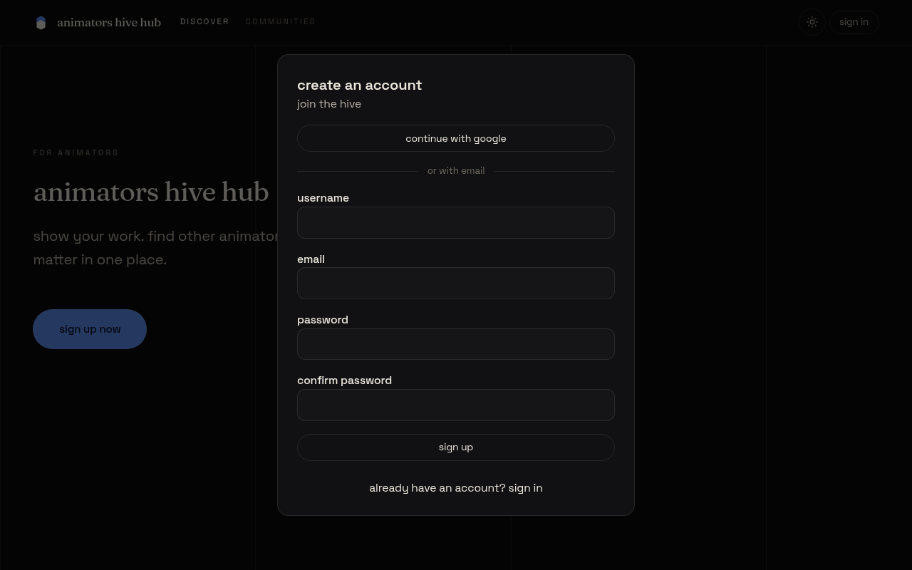
Figure 16: Sign-up
The sign-up dialog creates an account with an email address and a password, or with a Google account.
- Select continue with google to create or sign in to an account with Google, or fill in the fields below it.
- In username, enter three to 30 letters, numbers or underscores.
- In email, enter your email address.
- In password, enter at least six characters.
- In confirm password, enter the same password again. If the two passwords differ, a message says so and nothing is sent.
- Select sign up. A message says account created, and the discover heading appears.
- To use an existing account, select already have an account? sign in, then enter email and password and select sign in.
D.3 Discover feed
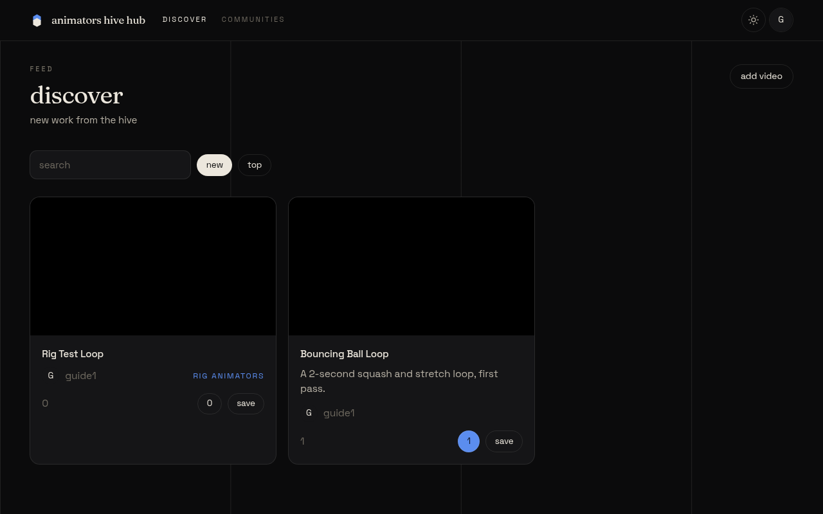
Figure 17: Discover feed
The discover feed is the home screen for a signed-in member. It shows new work from the community, newest first.
- To find an animation, type a word into the search box labelled search. The list narrows to matching titles and descriptions.
- Select new to list the newest animations, or top to list the most upvoted ones.
- Select a card’s title or picture to open its animation page.
- Select load more at the foot of the list to see the next 20 animations.
- On a card, the count button shows the number of upvotes, and the comment count is shown beside it.
- Select save on a card to add the animation to one of your playlists (see D.6).
- Select add video to upload a new animation (see D.4).
D.4 Upload an animation
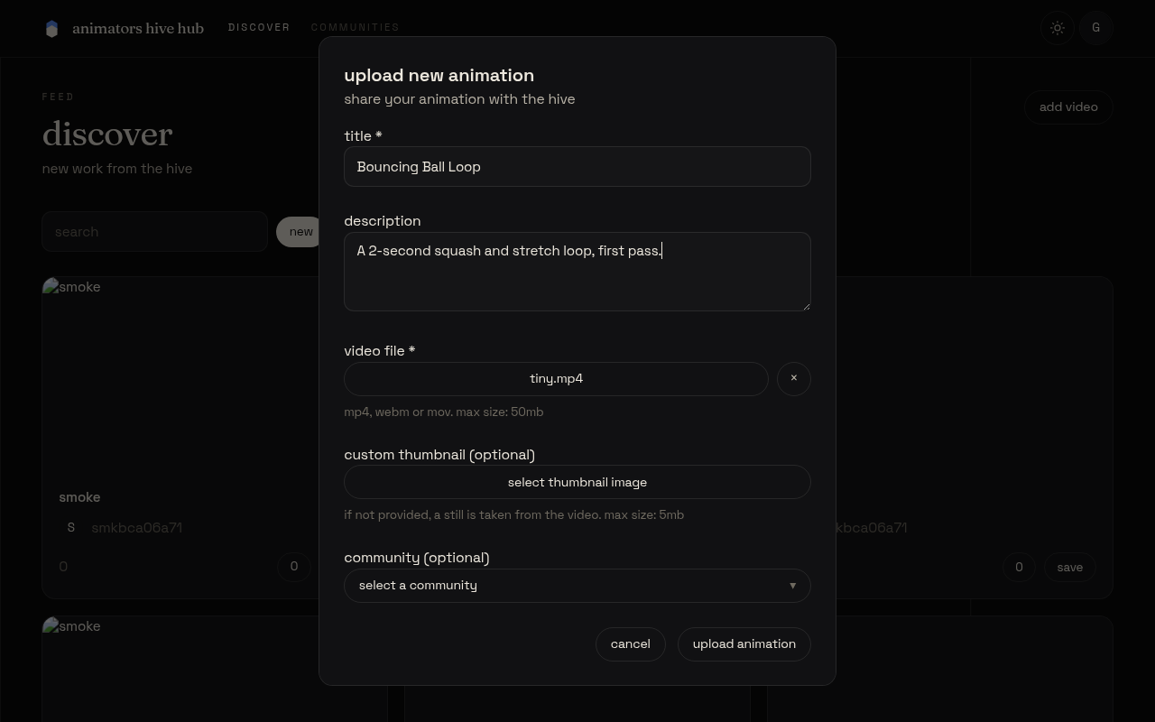
Figure 18: Upload an animation
Use this screen to share an animation. It opens from add video on the discover feed or the profile page.
- In title, enter a title for the animation. The title is required.
- In description, enter an optional description of up to 2,000 characters.
- Select select video file, and choose an mp4, webm or mov file of up to 50 MB.
- Optionally, select select thumbnail image and choose an image of up to 5 MB. If you do not choose one, a still is taken from the video.
- Optionally, open community (optional) and choose a community. Choose no community to leave it out, or create new community to make one. For a new community, enter its name in new community name.
- Select upload animation. The button shows the current step, such as uploading video, and the dialog closes when the animation is saved.
- To leave without uploading, select cancel.
D.5 Animation page: upvote and comment
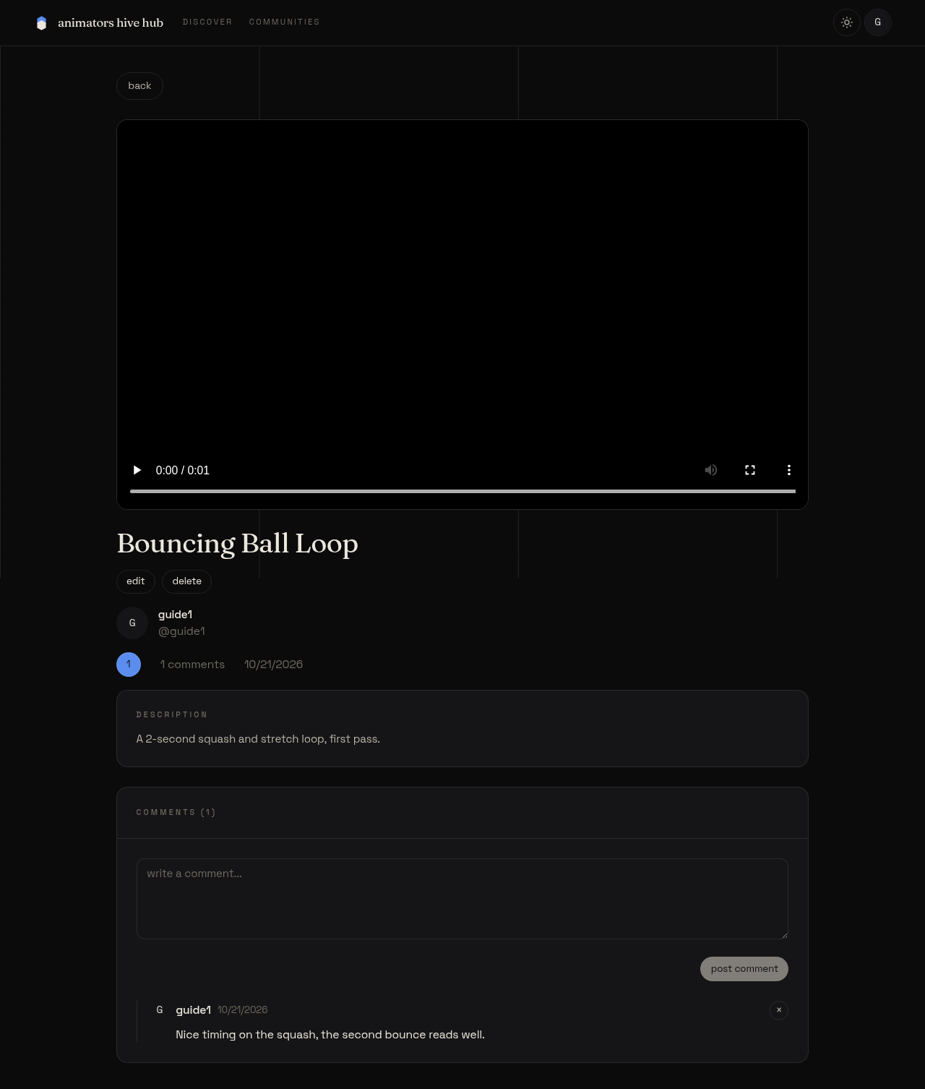
Figure 19: Animation page: upvote and comment
The animation page shows the video, its details and its comments.
- Watch the video with the controls under the player.
- To upvote, select the count button. It changes state and the count goes up by one. Select it again to remove your upvote. If you are not signed in, the message sign in to upvote appears instead.
- To comment, type into the box labelled write a comment, then select post comment. Your comment appears at the top of the list.
- To delete your own comment, select the × button beside it.
- If you own the animation, select edit to change its title and description, then save. Select delete and confirm to remove it for good.
- Select back to return to the previous screen.
D.6 Playlists
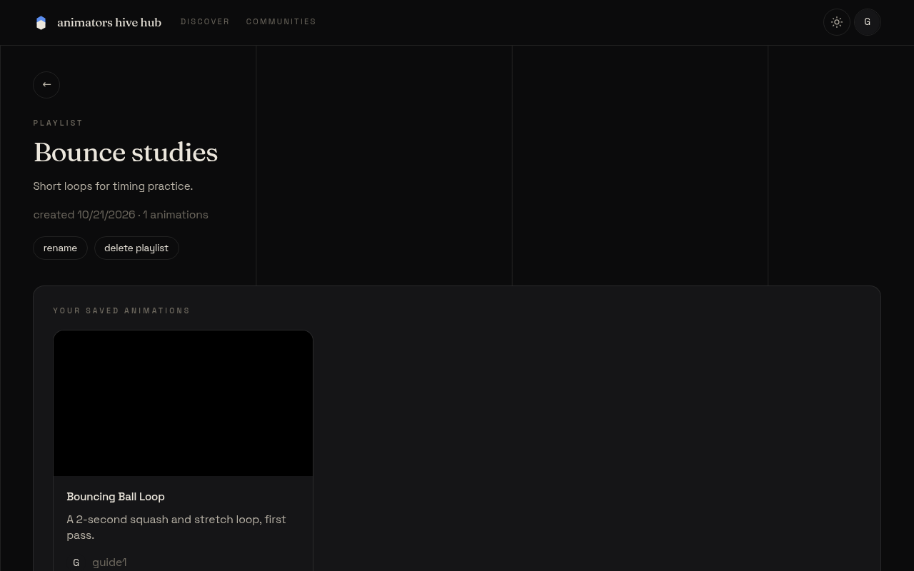
Figure 20: Playlists
Playlists group animations that you want to keep together. They are kept on your profile, under the playlists tab.
- Open your profile and select the playlists tab.
- Select create playlist. In the dialog, enter a name in name, and optionally a description in description (optional). Select create.
- Select view playlist on a card to open the playlist.
- To add an animation, select save on the animation’s card. Choose a playlist in the list. If you have no playlists, the dialog says so.
- On a playlist you own, select rename to change its name and description, and save. Select remove under an animation to take it out, and delete playlist to remove the playlist.
D.7 Communities
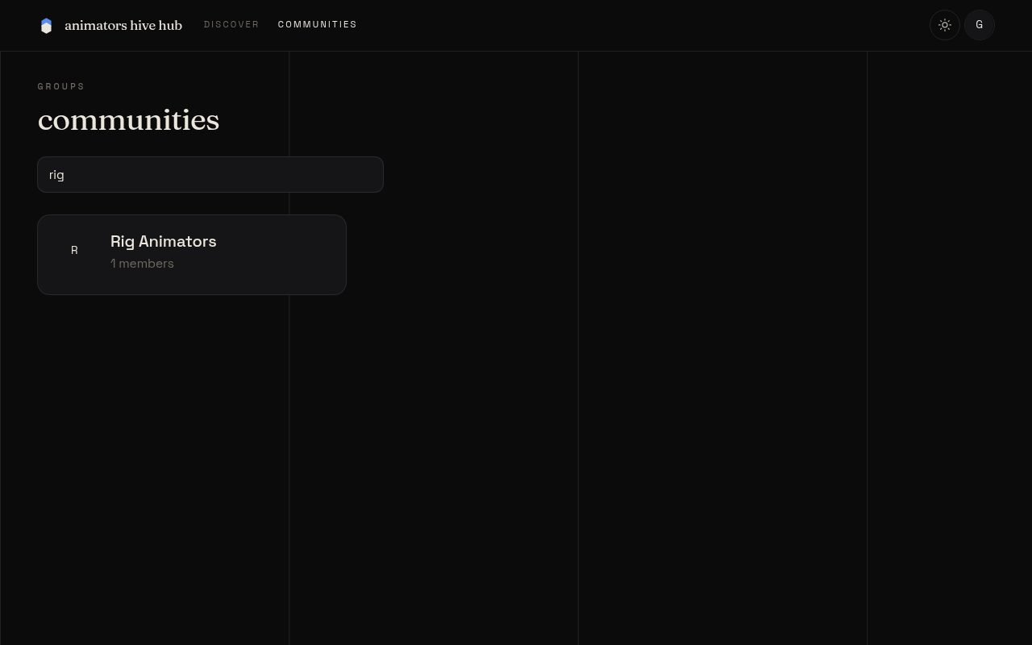
Figure 21: Communities
Communities gather animations on one theme. Anyone can browse them, and members can join.
- Select communities in the header.
- In the box labelled search communities, type part of a name to narrow the list.
- Select a community to open its page. The member count is shown under its name.
- If you are signed in, select join to become a member, or leave to stop being one. The count changes at once.
- The community page shows its animations, with the same search and sort options as the discover feed.
D.8 Your profile
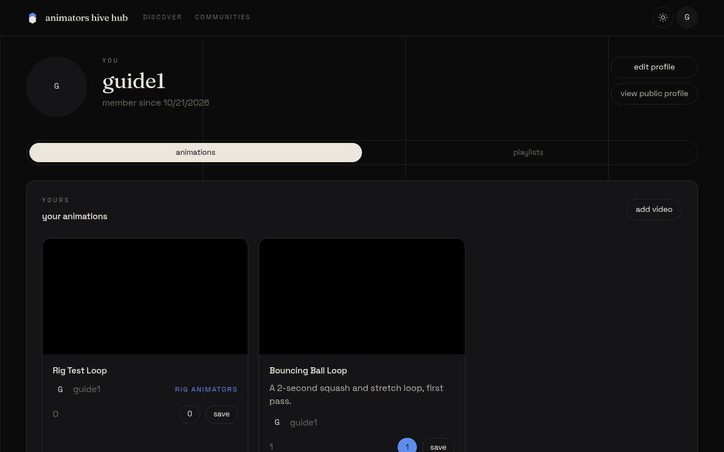
Figure 22: Your profile
Your profile shows your picture, display name, bio, location and website, and your work.
- Open the account menu from your picture in the header, then select view profile.
- Select edit profile to change your display name, bio, location, website and picture, then select save changes.
- To change your password, open edit profile, enter your old password and a new one in the password section, and select change password. Other signed-in sessions will end. An account created with Google can set a password instead, with set password.
- To delete your account, open edit profile, type your username in the delete account section, and select delete account. Confirm the message. This removes your animations, comments and playlists.
- Select view public profile to see the page other people see.
- Select the animations tab for your uploads, or the playlists tab for your playlists.
D.9 Mobile view
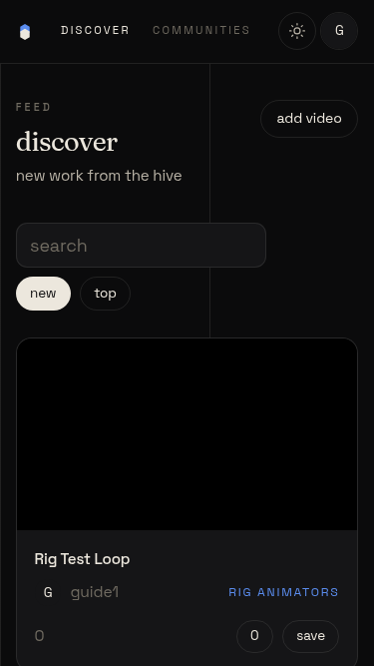
Figure 23: Mobile view
On a phone, the page fits the screen width and the header stays at the top.
- The header shows discover and communities as links, and your picture as the account button. There is no hamburger menu.
- Select the account button to see view profile, edit profile and sign out.
- Scroll the page up and down. It does not scroll sideways.
- If you are not signed in, the sign in button appears in the header.

Appendix E: Risk management
This appendix records what happened to each risk identified in the proposal.
The proposal identified seven risks, each with a planned response. Table 22 records what happened to each.
Table 22: Risks from the proposal and what happened
Risk in the proposal | Planned response | What happened
Upload size limits | Upload videos straight from the browser to R2; test early | Uploads pass through the Worker instead, with a 50 MB video cap that keeps each request within Cloudflare’s limit; tested in Unit Test 3
Time overrun | MoSCoW priorities in two iterations; buffer weeks | Happened: the work had to be redone and the rebuild began in late September 2026; some features were finished late (Section 6.4.4)
Free-tier limits | Watch D1, R2 and Workers usage during testing | No quota problem was recorded
Security weaknesses | Validate uploads; parameterised queries; owner-only delete (OWASP, 2021) | Done: uploads checked by type and size; every query is prepared with bound values; other users receive 403 (suite 1.2)
Unsafe or infringing uploads | Report control; administrator removal; terms of use | Not done: the risk remains open and is the first item of further work
Loss of work | Push a commit every session; export D1 weekly | Commits pushed to GitHub; no weekly D1 export is recorded
Illness or absence | Weekly supervision and progress statements | A long break happened before the planned start; the work was later redone

