**Unidad Educativa PCEI Primero de Mayo**“Prepárate para alcanzar tus sueños”



**GUIA DE ESTUDIOS**

**DE**

**INGLÉS**

**EDUCACIÓN GENERAL BÁSICA**

Contenido

Objetivo general 3

Lineamientos de la materia. 3

UNIT 3 4

Definite pronouns. 4

First Week 5

Overview 5

Subject and object pronoun 7

Exercise No.3.1 8

Second Week 9

Possessive adjective and possessive pronouns 9

Exercise No.3.2 12

Third Week 13

Reflexive pronouns 13

Exercise No.3.3 15

Fourth Week 16

Exercise No.3.4 16

# Objetivo general

Durante el transcurso de este periodo deberemos aprender algunas pautas sobre los pronombres definidos en Inglés.

# Lineamientos de la materia.

Al igual que con el resto de materias de preparación que usted recibe, necesitaremos que se organice de la mejor manera para cumplir con la revisión periódica de las asignaturas y no perder la secuencia.

Estos son los lineamientos y responsabilidades que el estudiante asume en la asignatura de Inglés, una vez matriculado en la Institución.

* Las unidades duran un mes aproximadamente, es decir 4 semanas.
* Cada semana tiene una tarea a ser cumplida, es decir, en total 4 tareas al mes.
* Al final de cada unidad existe una Evaluación de la unidad. Esta es una prueba que demuestra si los objetivos de la unidad fueron alcanzados por su parte.
* Las tareas de Inglés puede realizarla hasta el último domingo de la semana en cuestión, es decir, tiene alrededor de 8 días para realizarla dentro de la plataforma de la Institución que está activa 24/7. Por lo cual no existe ninguna justificación para trabajos atrasados.
* Las tareas las debe realizar dentro de la plataforma a manera de cuestionarios automáticos los cuales se cierran al cumplir la fecha especificada.
* Es responsabilidad del estudiante estar pendiente de los horarios de las tutorías y de asistir a ellas.
* Es responsabilidad del estudiante mantener sus medios comunicación disponibles para recibir las tutorías de forma correcta es decir, cámara, micrófono y conexión de internet funcionando de forma apropiada.
* Para las notas de Conducta y Aprovechamiento se tomará en cuenta su asistencia y participación en las tutorías.

# UNIT 3

## Definite pronouns.

* Overview
* Subject pronouns and Object pronouns
* Possessive adjectives and Possessive pronouns
* Reflexive or intensive pronouns

## First Week

### Overview

A pronoun is a word that is used instead of a noun. Pronouns refer to either a noun that has already been mentioned to or a noun that does not need to be named specifically.

The distinguishing characteristic of pronouns is that they can be substituted for other nouns. For instance, if you’re telling a story about Antonio, the story will begin to sound repetitive if you keep repeating “Antonio” over and over again.

Something important to remember is that pronouns could be the subject of a sentence, as well.

Subject +Verb + Complement

S + V+ C

**The pronoun in English**

We have to big groups definitive and indefinite pronouns; we will begin our study with the definite pronouns.

Alicia and I play tennis on Saturdays.

Or

Alicia and me play tennis on Saturdays.

**Definite pronouns summary**

**Summary:**



### Subject and object pronoun



Remember always use and object pronoun after a preposition like:

* To
* With
* Around
* Without
* From
* Between
* Inside
* For

### Exercise No.3.1

**Choose the correct subject or object pronoun.**

1. (They, them) are both Ecuadorians.
2. I know her sister and (she, her).
3. (He, him) is a very studious person.
4. He sends (she, her) a lot of presents.
5. She seldom speaks to (we, us) in Spanish.
6. He looks at (she, her) all during the lesson.
7. She always helps (I, me) with my homework.
8. He always sits between Amy and (I, me).
9. He wants to talk with (they, them).
10. They speak English. (They, them) are Canadians.
11. I know (he, him) very well.
12. Antonio is very intelligent. (He, him) is a very studious person.
13. Miguel writes (I, me) during the test.
14. Clara speaks to (me, I) during the exam.
15. Eduardo looks at (he, him) during the exam.
16. Amy and (I, me) always sit together.
17. He always sits between Amy and (I, me).
18. He wants to talk with (they, them).
19. Oscar goes to school with (she, her)
20. Matias works in the factory with (we, us)

## Second Week

### Possessive adjective and possessive pronouns

When you’re starting to learn the details of English grammar, learning about possessives can be especially tricky.

And it’s definitely the case when you need to learn how to tell possessive adjectives and pronouns apart – because they can seem so similar!

So what is the difference between them? And how can you tell them apart? Let’s take a closer look.



Your book

or

yours book



**Possessive adjective**

The possessive adjectives in English (also called 'possessive determiners') are: my, your, his, her, its, our and their. They say who something belongs to.

* I have a bag this is my bag.
* You have a cat that is your cat.
* He has a car it is his car.
* She has a book it is her book.
* The dog has a bed it is its bed.
* We have a flat it is our flat.
* They have a daughter she is their daughter.

**Possessive pronoun**



**This book is mine book**

**or**

**This is mine book.**



Possessive pronouns also say who something belongs to, but they replace the noun. So we use them alone. In this case, we don't use 'its'. In English, the possessive pronouns are: mine, yours, his, hers, ours and theirs.

* I have a bag this is **mine**.
* You have a cat that cat is **yours**.
* He has a car it is **his**.
* She has a book it is **hers**.
* We have a flat it is **ours**.
* They have a daughter she is **theirs**.

### Exercise No.3.2

Write the correct possessive adjective.

1. She knows ________ lesson well.
2. I also know _________ lesson well.
3. Pepe likes _______ English class very much.
4. I do ________ homework on the bus every day.
5. You always get good marks on _________ examinations.
6. Both girls prepare ________ lessons well.
7. Mr. Bach drives to work in ________ car.
8. Mary and I do ______ homework together.
9. Grace writes a letter to _____ aunt every week.
10. She takes _______ sister to the party.

Write the correct possessive pronoun.

1. This pen is my pen.
2. These seats are our seats.
3. This umbrella is her umbrella.
4. These pencils are your pencils.
5. That computer is my father's computer.
6. That overcoat is his overcoat.
7. These cigarettes seem to be your cigarettes; they are not my cigarettes.
8. I believe this pen is her pen; it is not my pen.
9. Is this notebook your notebook or Sarah's?
10. These shoes are my shoes.

## Third Week

### Reflexive pronouns

Reflexive pronouns are words ending in -self or -selves that are used when the subject and the object of a sentence are the same (e.g., I believe in myself). They can act as either objects or indirect objects. The nine English reflexive pronouns are myself, yourself, himself, herself, oneself, itself, ourselves, yourselves, and themselves.

A reflexive pronoun can be a direct object in a sentence when the subject and the direct object are one and the same.

* Jack decided to reward Mary with a dinner out.
* Jack decided to reward himself with a dinner out.

In the first sentence, Mary is the object of reward. Jack, the subject, is the object of reward in the second sentence, so we use the pronoun himself.

Reflexive pronouns can also play the indirect object role in a sentence.

* Cynthia pours a cup of tea for me every morning.
* Cynthia pours a cup of tea for herself every morning.

It is worth noting that referring twice to the same noun as subject and object (rather than using a reflexive pronoun for the object) sounds just a bit creepy. “Jack decided to cook Jack a special supper,” for example, sounds unnerving to a native English speaker.

We also often use them when we talk about actions where the subject and the object are the same person or people.

* He blames himself.
* She talks to herself.

|  |  |
| --- | --- |
|  | Cartoon Businessman Loves To Look At His Reflection In Mirror... Royalty  Free Cliparts, Vectors, And Stock Illustration. Image 98619999. |

Students’ new vocabulary.

1. little
2. girl
3. hurt
4. when
5. fell
6. from
7. rain
8. taught
9. sew.
10. Both
11. Taught
12. swim.
13. enjoyed.
14. amusing
15. kitten.
16. shot
17. last
18. cut
19. knife
20. careful.
21. jumped
22. blame
23. mistake

### Exercise No.3.3

Write the correct reflexive pronoun.

1. The little girl hurt _____ when she fell.
2. We protect ________ from the rain with an umbrella.
3. The boy taught _______ to sew.
4. Both boys taught _______ to swim.
5. We all enjoyed__________ at the concert last night.
6. The children are amusing ________ with the kitten.
7. The policewoman shot __________ by accident.
8. Did you enjoy ________ at the party last night?
9. You will cut ________ with that knife if you are not careful.
10. Annie usually talks to ______ .

## Fourth Week

### Exercise No.3.4

**Jack from the forest**

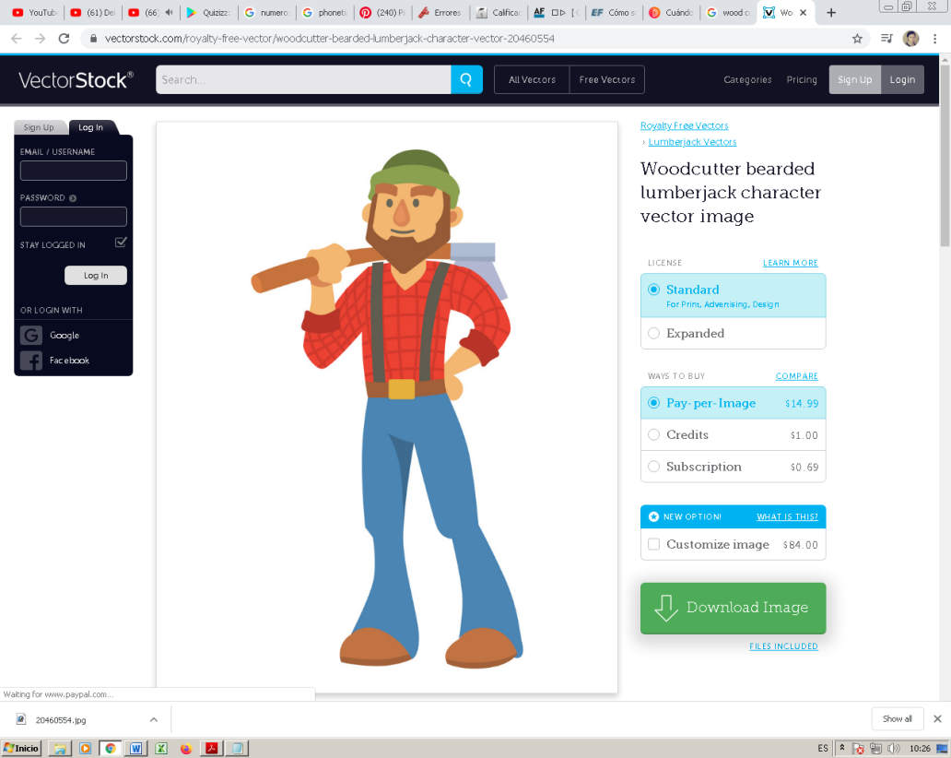Jack lives alone in a small house in the forest. He lives more than 20 miles from the road. He rarely leaves home, but when he does, he drives a big car. In the winter, he drives a especial car that can move over snow.

Jack grows his own food in a large garden. He plants carrots, potatoes, tomatoes, and corn. His apple tree provides him with plenty of apples.

Jack also hunts deer, rabbits, and turkeys for food. He lives near a small river, which provides him with plenty of clean water. It also provides him with plenty of fish! Jack loves to fish, and he is pretty good at it.

Jack uses an axe and chops down trees for wood. He then cuts the wood into small pieces, which he burns in his stove. He keeps warm in the winter!

Jack also has fun. He reads a lot. He has a lot of books, and reads most of them more than once. He also writes his own stories with an old typewriter.

Every night, Jack plays his guitar. He knows many different songs and plays several every night before he goes to bed.

Jack does not spend all of his time inside, though he loves to spend time outside. During the day, he looks at plants and animals. Sometimes he even talks to the animals. During the night, he looks up at the night sky. He knows many stars by name.

He also plays a lot of solitaire. He is pretty good at it! He does not always win, but no one ever beasts him!

**Using the story of “Jack from the forest”, fill the box below.**

|  |  |  |  |  |
| --- | --- | --- | --- | --- |
| **Subject pronouns** | **Object pronouns** | **Possessive adjective** | **Possessive pronoun** | **Reflexive or intensive** |
|  |  |  |  |  |