Wordpress:

World most popular CMS.

Most than 60 million use world press.

wordpress website

blog website

shopping website

theme development

plugins development

https://youtu.be/WmYlFUhZiR8?list=PLlUrVpujUh3_PnBb1B-YOSP_oUqBL4gsh&t=98

1. Download xampp
2. downoload wordpress.
3. Install xampp
4. Extract the wordpress and paste inside xampp > htdocs.
5. change the wordpress folder name eg. microsoftwp
6. Open browser and type localhost/phpmyadmin, click database, type database name eg. mei and click at create.
7. Again type localhost/microsoftwp and press enter.
8. Choose English and click at continue.
9. 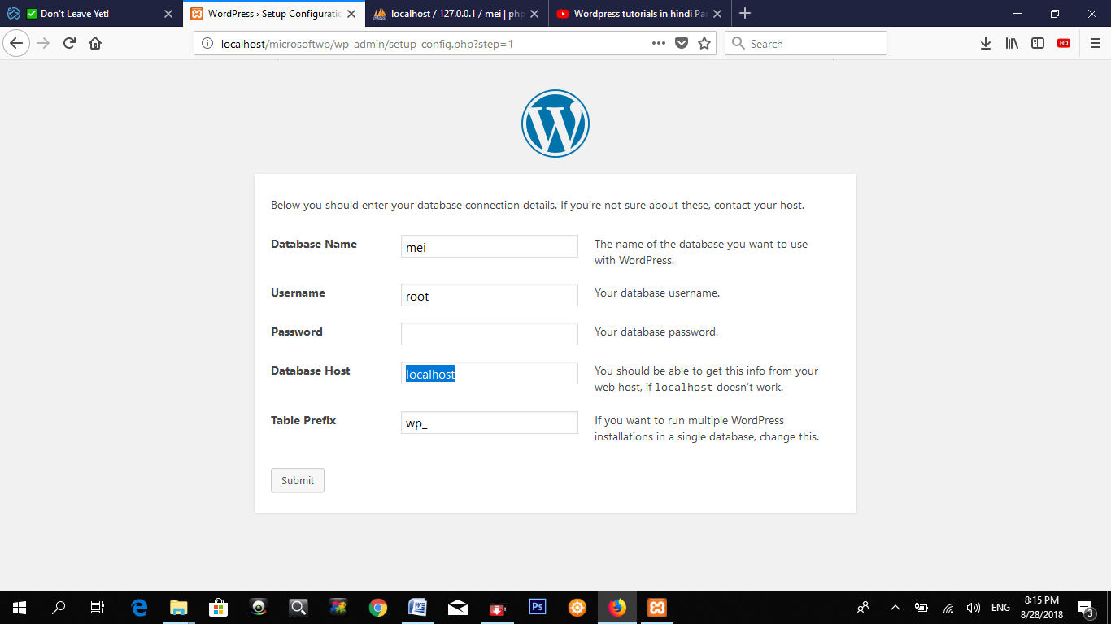
10. database name mei
11. username=root
12. password=blank
13. database host localhost
14. click at submit and click at run the installation.

# Edit Profile

1. Click at right corner of the dashboard.
2. Click at edit my profile.
3. Type first, last, display name.
4. Click at update

# screen option

1. Click at dashboard.
2. Click at screen option.
3. Tick mark the following boxes to display and remove tickmark if you do not want to display on dashboard.

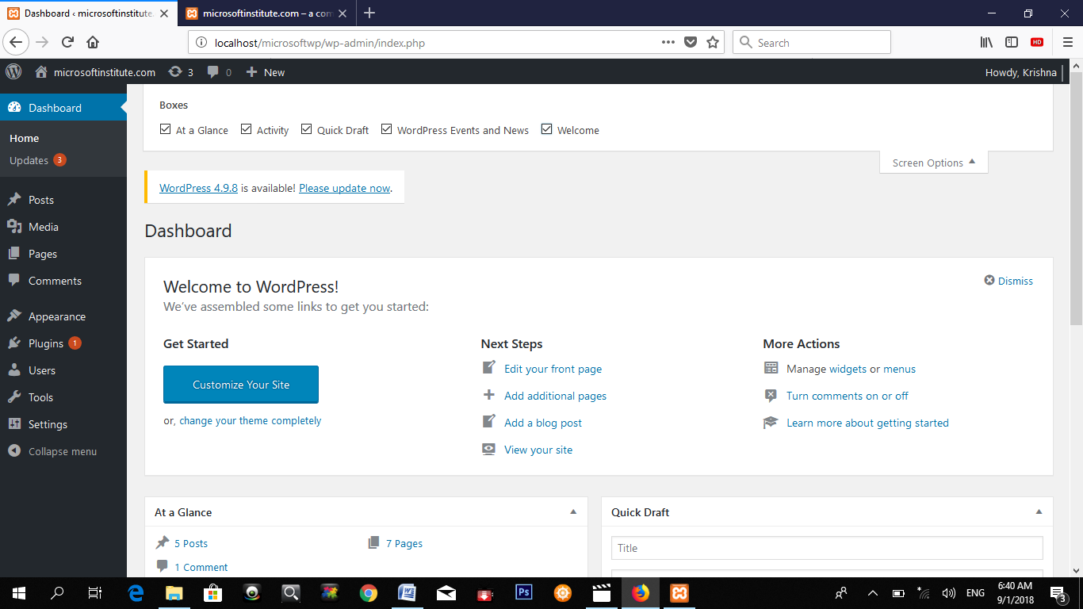

# Post:

It is use in blog site to post any kind of news like sports, poltics, entertainment etc.

1. Click at post.
2. Click at Add New
3. Type post title
4. Type paragraph.
5. For image click at set featured image from right bottom of the dashboard.
6. Click at upload files, and click at select files.
7. Click at set featured image.
8. Click at publish.
9. Preview in front end.

# General Setting:

From this we can change site name and others.

1. Click at Setting from dash board.
2. Click at setting
3. Click at general
4. Change title, date, time format etc.
5. Click at save changes.
6. Update it.

# Media Setting

1. Click at setting.
2. Click at media

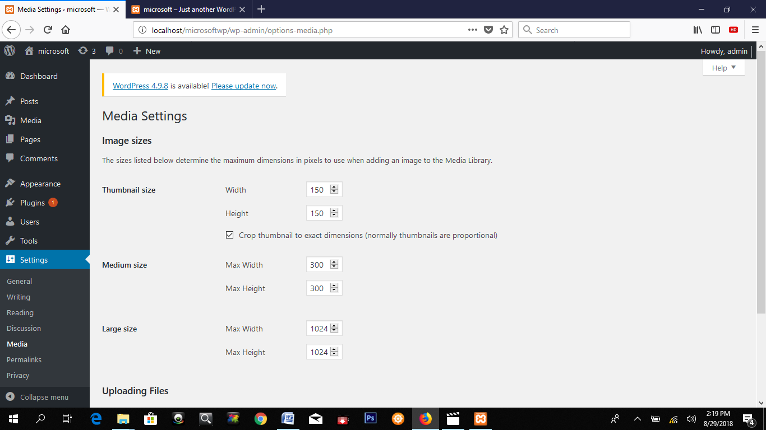

# Category title

1. Click at appearance.
2. Click at widget
3. Type category title.
4. Click at save.

# Category

1. Click at posts
2. Click at category
3. Type category name.
4. Click at add new category

Note: when you post choose category otherwise category does not display.

# Post with category and Tag:

Tag is use for search engine.

1. Click at post.
2. Click at Add New
3. Type post title
4. Type paragraph.
5. Add new category
6. Type tag word.
7. Choose category and click at post.

**Delete and Restore Post**

1. Click at post.
2. To delete all post, click at title.
3. Click at trash
4. to delete permanently, click at trash.
5. Click at delete permanently to delete post permanently.
6. Click at restore.

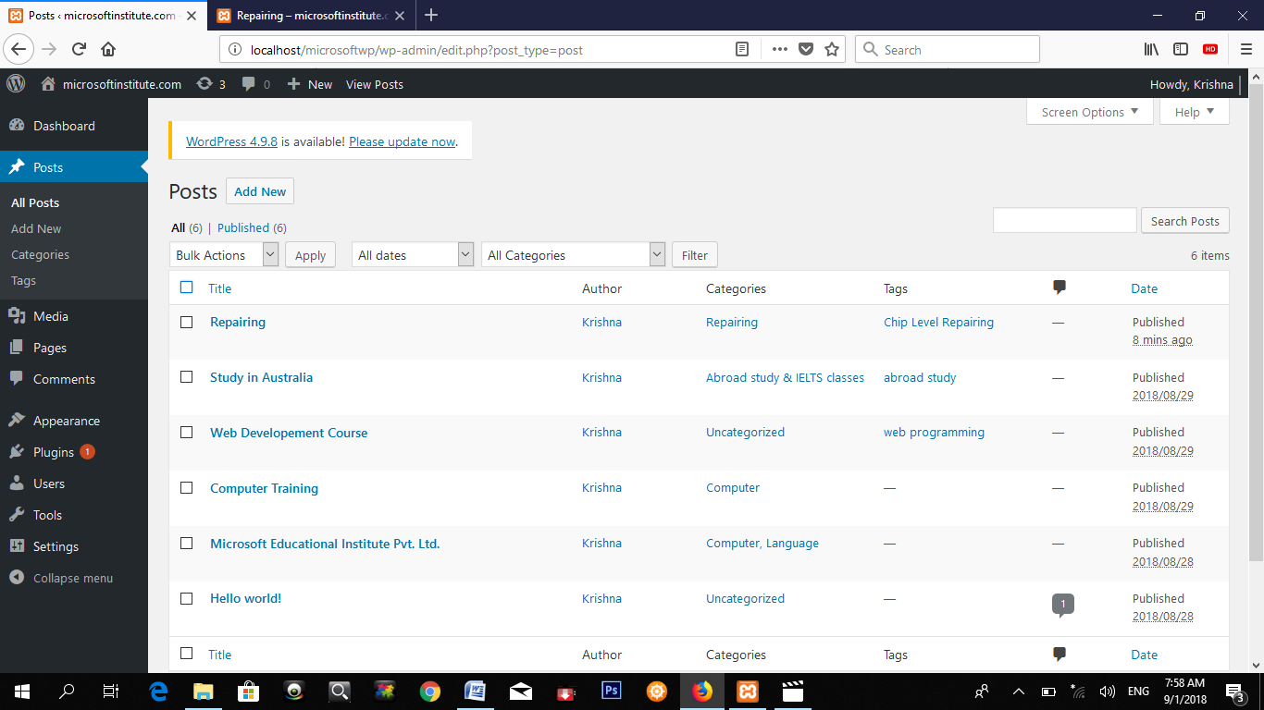

# Add Media in post

1. Click at post, click at add new. or click at page.
2. Click at add media.
3. Click at upload files and click select files or choose any image from meida library.
4. Click at insert into post.
5. Select image and click at edit.
6. Choose image size, alignment etc.

Note : Set featured image is use to show just thumbnail.

Youtube video link

First open youtube website.

Search any video.

Right click on video and click at copy video url.

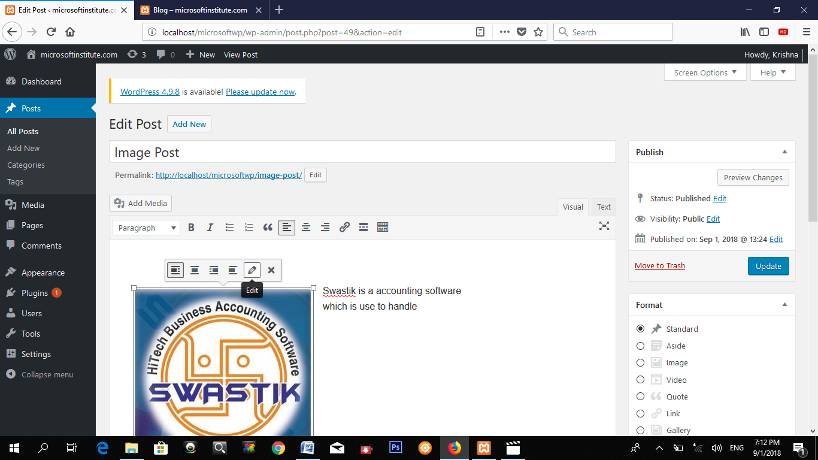

Menus: We can create menu by creating page, category, post and link.

# Pages & Menus.

1. Click at page.
2. Click at add new.
3. Type page name eg. about us., Home, Computer Course, Language Courses, Contact us
4. Type paragraph or information of the page.
5. Click at update.
6. Now create a menu.
7. Click at appearance
8. Click at menu.
9. Click at create a new menu.
10. Type name eg. main menu and click at create.
11. Now tick mark the page and click at add to menu.
12. Click at primary menu.
13. You can arrange menu by drag up and down.
14. For sub menu, drag right side.
15. Click at save

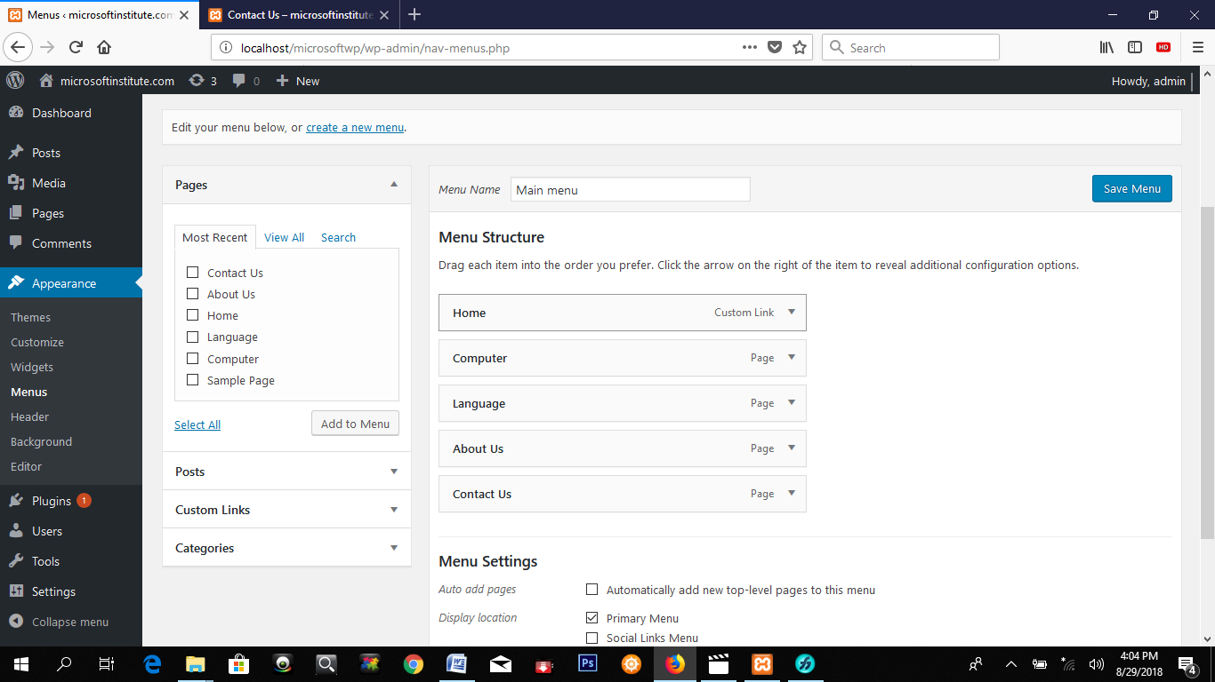

# Menu by Category

1. First make a category eg. Sports, Football, Cricket.
2. Make a post sports and choose sports category.
3. Make a post of football and choose football category.
4. Make a post of cricket and choose cricket category.
5. Click at appearance and click at menus.
6. Click at category drop down list.
7. Click at sports, Football and Cricket.
8. Click at add to menu.
9. Drag football and cricket right side for sub menu.
10. Click at save.

# Comment:

1. If you want to display comment after approve then Click at setting, click at discussion
2. Tick mark comment must be manually approved.
3. 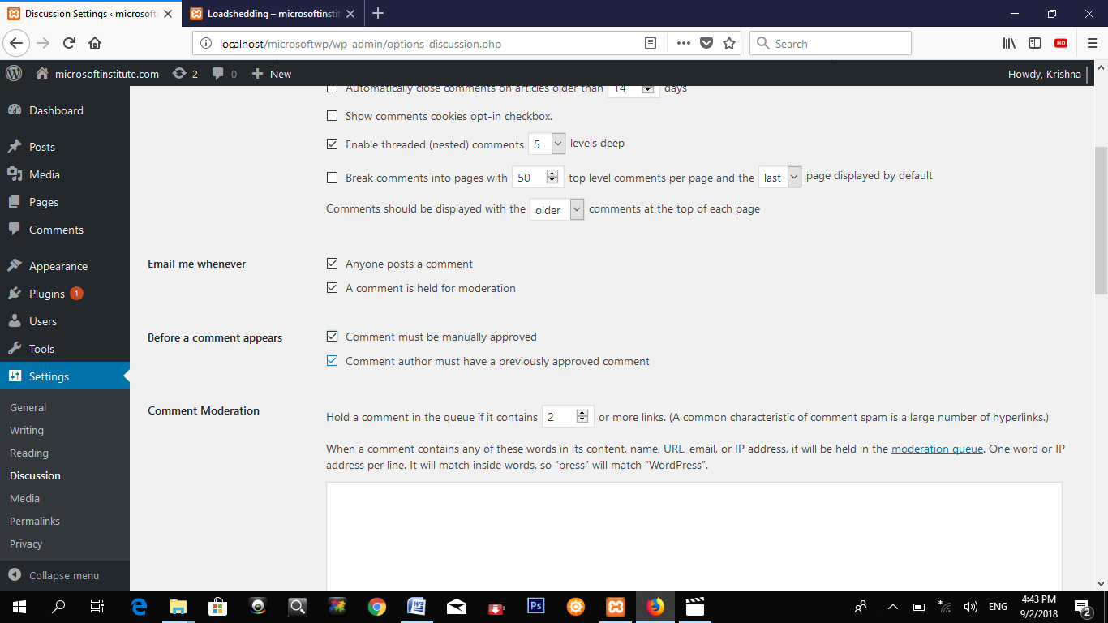
4. Now comment on any post, and click at post comment.
5. Now you can see "**Your comment is awaiting moderation".**
6. To approve, click at comment, Click at approve/unapproved.

# Reading setting:

It is use to display at first when you open web site for the first time

1. Click at setting.
2. Click at reading.
3. Click at a static page.
4. choose home from home page.
5. choose post pages eg. blog. (page)

# Theme

1. Click at appearance
2. Click at theme.
3. Click at activate from any theme.
4. For more theme, click at add new theme.

Some important theme:

astra, oceanwp, generate press, sydney

# wordpress plugins

A **plugin** is a piece of software containing a group of functions that can be added to a **WordPress** website. it add new features in wordpress. Different developer make plugins for wordpress. They can extend functionality or add new features to your **WordPress** websites. **WordPress plugins** are written in the PHP programming language and integrate seamlessly with **WordPress**. unnecessary makes slow the website. we can get the free plugins and paid plugins also. more than 1000 free plugins are available. to find best plugin we have to check the rating.

some important and useful plugins:

|  |  |
| --- | --- |
| **Plug-ins Name** | For |
| **Akismet Anti-Spam** | Used by millions, Akismet is quite possibly the best way in the world to **protect your blog from spam**. |
| **yoast seo** |  |
| **wpquad** |  |
| **social counter** | facebook like, tweeter follower |
| **meta slider** | for slider |
| **ready backup** |  |
| **title remover** | it remove the title |
| **buddy press** | for social networking site. |
| **bbpress** | for ecommerce site |
| **smart slider 3** |  |

popular paid plugins: visual composer

install by 3 method

download plugin from wordpress.org website, extract and paste in xamp > htdocs > website folder

2nd

**Contact plugins install:**

1. First make a contact page
2. Click at plugins
3. Click at add new
4. Type contact in search box.
5. 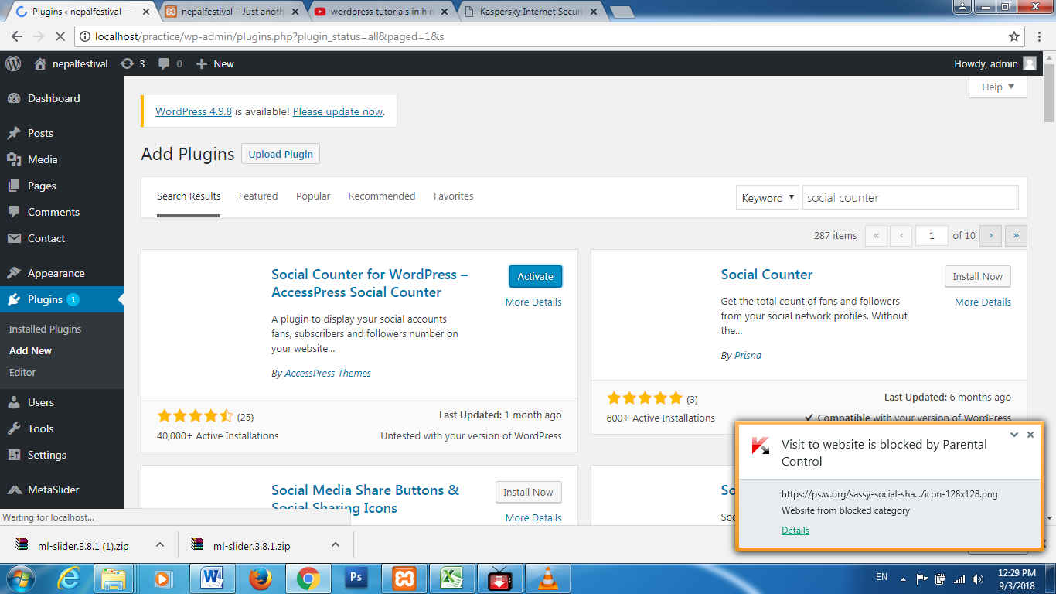to know the information of plugin click at more details.
6. Click at install now and then activate it.
7. after activate it appears in menu, now click at contact

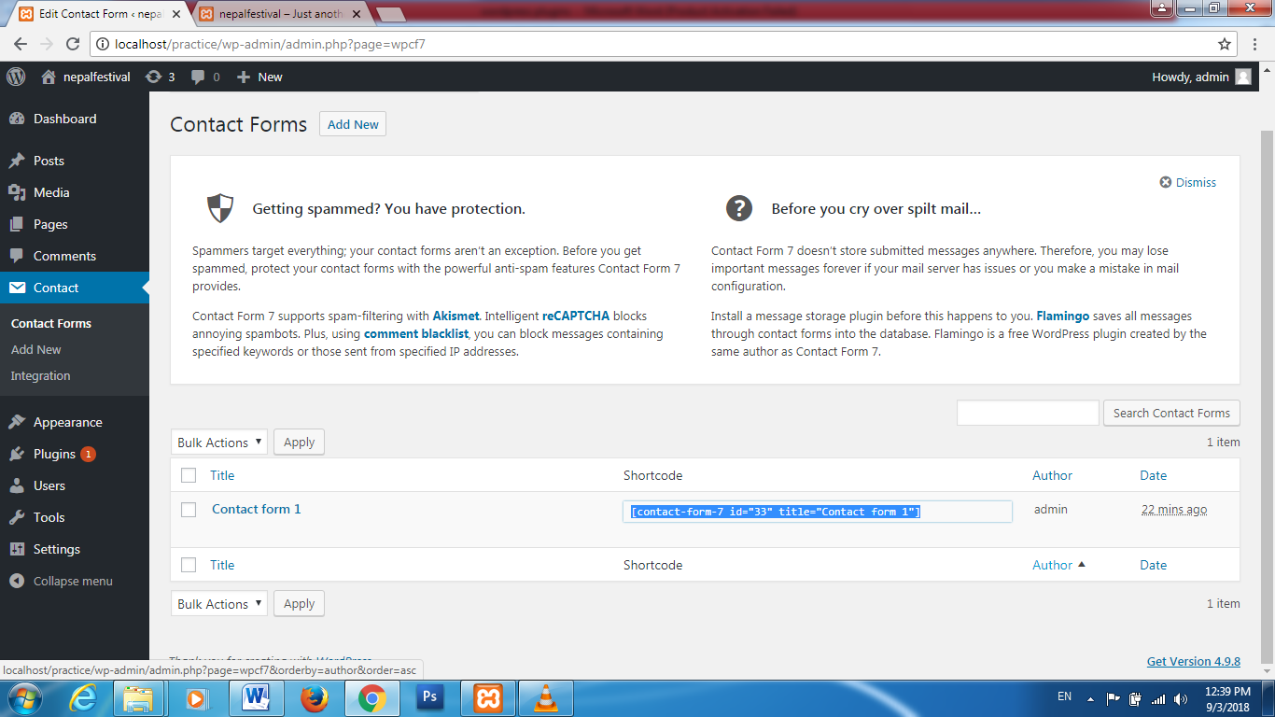

1. Copy shortcode.
2. Go to pages and click at edit from contact page and paste there.
3. Now preview in website.
4. To edit click at contact, click at edit.

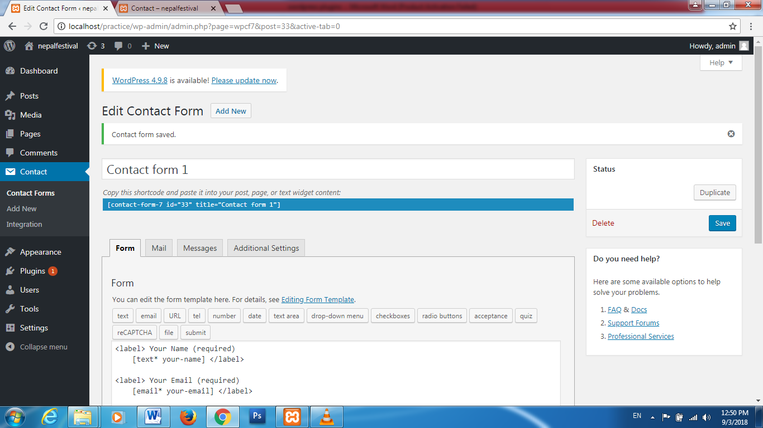

1. You can add drop down menu, radiobutton etc.
2. Click at save.

# Widget

Questions:

what is category

Image size change

menu bar position