Assignment - 2

Eda Nur COSKUN

14 01 2021

### PART - 1

Take a sample of 100 observations from this data(“assignment2_data.csv”), and save this sample as a new data. Answer the following questions according to this new data…

1. **Calculate the mean sales’ values for each color.**

|  |  |
| --- | --- |
| Color | Mean_Sales |
| Blue | 54.67857 |
| Green | 53.61905 |
| Red | 51.76923 |
| Silver | 78.60000 |

1. **Calculate the mean sales’ values for each region.**

|  |  |
| --- | --- |
| Region | Mean_Sales |
| East | 57.00000 |
| North | 65.39394 |
| South | 60.52632 |
| West | 54.76471 |

1. **Identify the five highest sales’ value according to date, color and region separately.**

|  |  |  |  |
| --- | --- | --- | --- |
| Date | Color | Region | Sales |
| 17-Sep-2018 | Silver | South | 120 |
| 29-May-2019 | Silver | North | 120 |
| 7-Nov-2018 | Silver | North | 120 |
| 21-Jun-2018 | Silver | East | 112 |
| 30-Apr-2018 | Silver | West | 112 |

1. **Identify the month in which the mean sales’ value is the highest.**
   * The month that has the highest mean sales value is **" Sep "** with **" 78.6 "** value.
2. **Plot the sales according to years.**

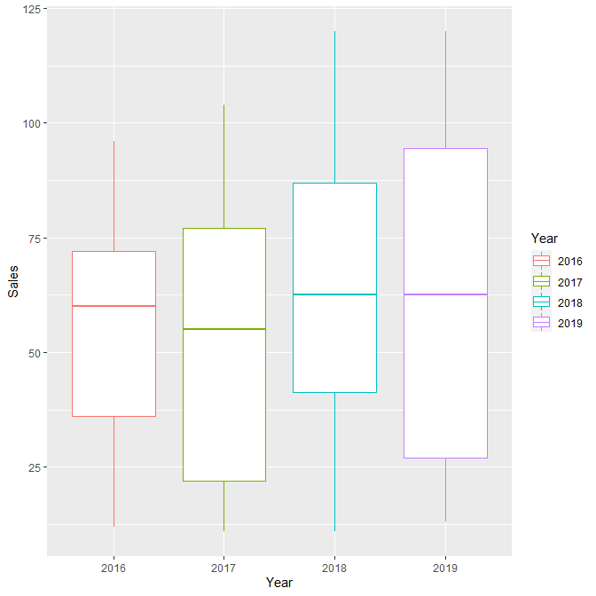

### PART - 2

Answer the following questions with using the words, which are provided in stringr::words…

1. **Take a sample of 100 words from this data, and save this sample as a new data.**

|  |
| --- |
| words |
| never |
| would |
| pardon |
| lead |
| market |
| authority |
| expect |
| debate |
| this |
| old |

…

1. **Find words which are starting with “a” and ending with “e”.**
   * The word(s) that is starting with “a” and ending with “e” is **" appropriate "**.
2. **Calculate the number of words which have more than 3 vowels.**
   * There are **" 4 "** words(*appropriate, authority, encourage, situate*) that have more than 3 vowels.
3. **List the five longest word in your data.**

|  |  |
| --- | --- |
| words | lengths |
| appropriate | 11 |
| authority | 9 |
| character | 9 |
| paragraph | 9 |
| encourage | 9 |

1. **Try to find word(s) which contain any of these words: age, any, day, exp, her, pro, the.**

|  |
| --- |
| contains |
| expect |
| together |
| clothe |
| appropriate |
| tuesday |
| they |
| any |
| father |
| page |
| encourage |