**The 2011 Tohoku Tsunami in Tauranga Harbour, New Zealand**

Jose Borrero, Dougal Greer, Derek Goring

# Introduction

Tauranga Harbour in the Bay of Plenty, home to the Port of Tauranga., Several sources of water level and current speed data recorded during the 2011 Tohoku Tsunami. In total there were 5 water level gauges (TAUT, Moturiki, A Beacon, Tug Berth and Sulphur Point) and an ADCP measuring current speed in the entrance to the harbor likely making it a location with the most comprehensive recordings of a tsunami ever.

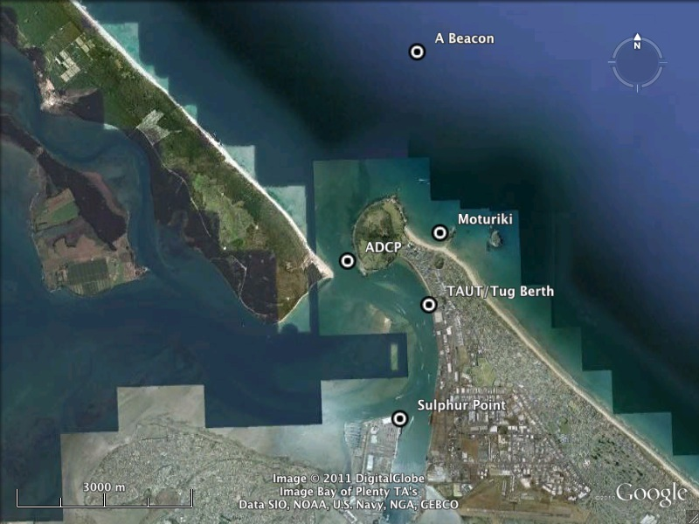

Figure 1 Tauranga harbor.

# Water Level Data

Water level data was recorded on two tide gauges that are part of New Zealand’s national tide gauge network. The TAUT station located inside the harbor and the Moturiki station located outside the harbor. In addition, The Port of Tauranga had three water level recorders in operation at A Beacon outside the harbor at the beginning of the entrance channel, Tug Berth at roughly the same location as TAUT and Sulphur Point.

The tide signal was removed from the water level record through a harmonic analysis using T_tide followed by Wavelet de-noising and a final high pass filter to remove residual long period component.

Comparisons between the raw signal and the de-tided signal at A-Beacon are shown in Figure 2. A comparison between the TAUT and Tug berth data is shown in Figure 3. This is important since these gauges are located very close to each other, however are recorded by different instruments. The similarity in the raw water level and the de-tided signal is apparent.

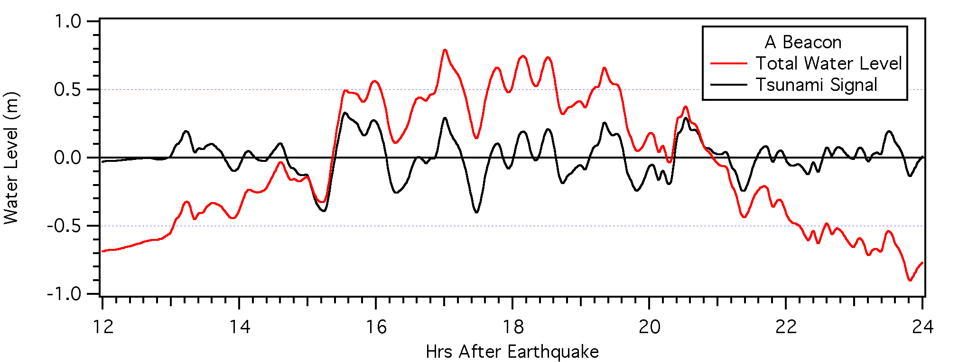

Figure 2 The total measured water level (tide included) and de-tided tsunami signal at A Beacon.

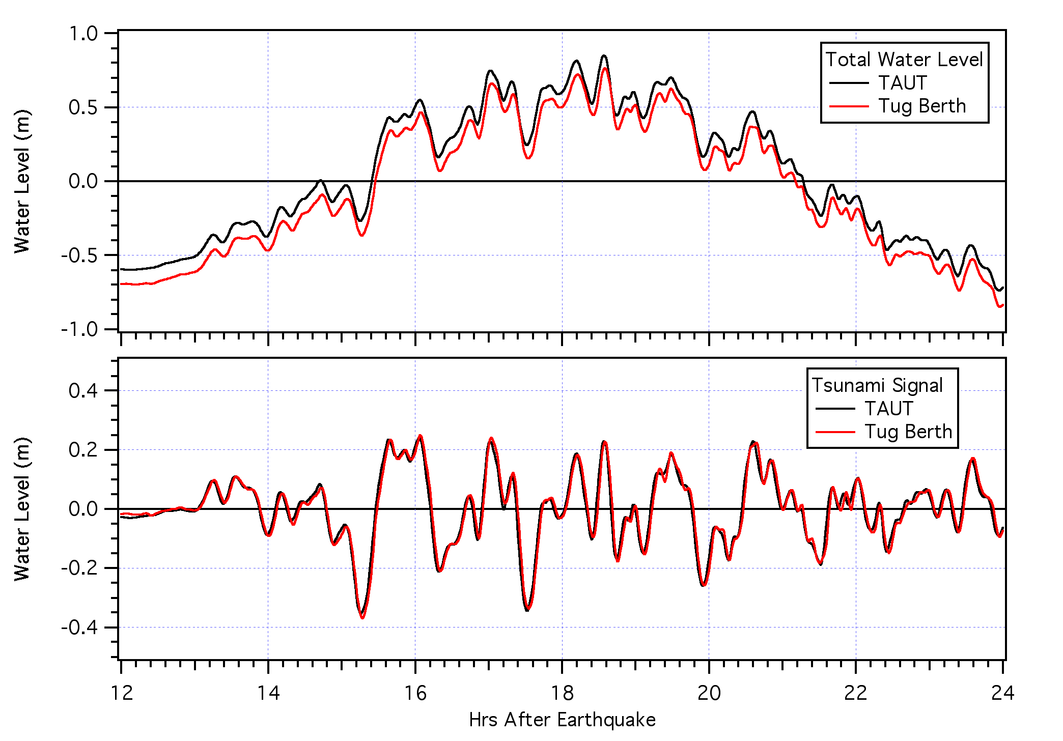

Figure 3 Comparison between TAUT and Tug Berth, two gauges located adjacent to one another.

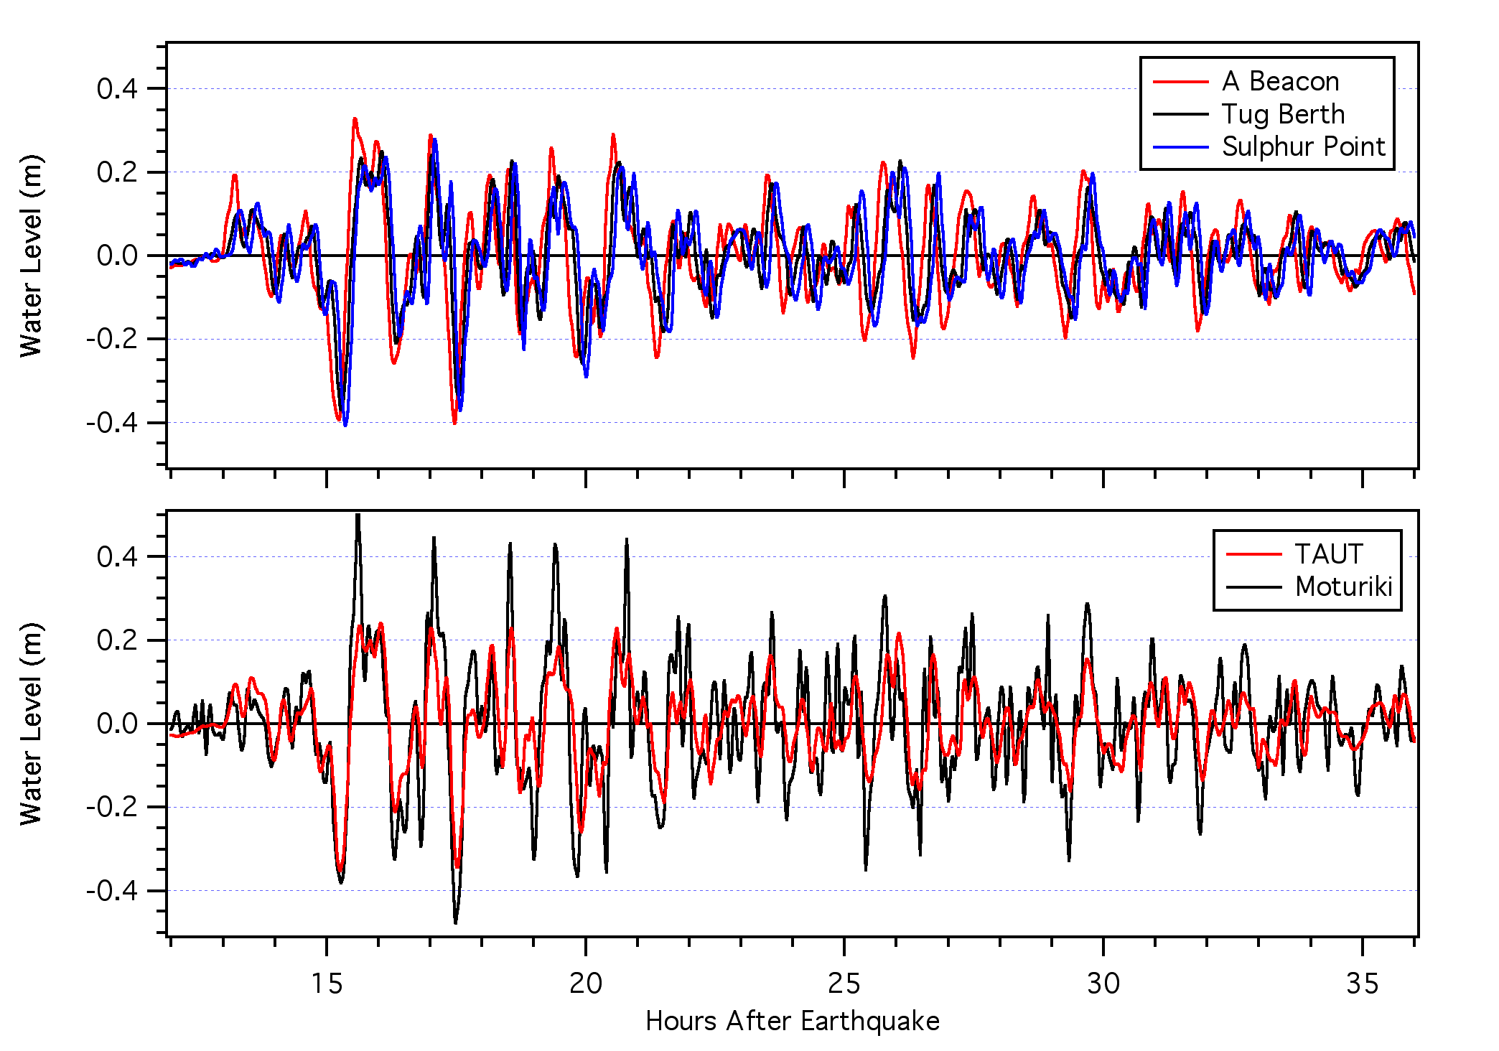

Figure 4 All of the water level recordings from Tauranga, with tide signal removed, during the 2011 Tohoku tsunami.

# Current Data

Currents were recorded in the entrance to Tauranga Harbor by a downward looking ADCP floating on the water surface. The total measured current speeds are shown in Figure 5. The effect of the tide is obvious as is the onset of the tsunami signal.

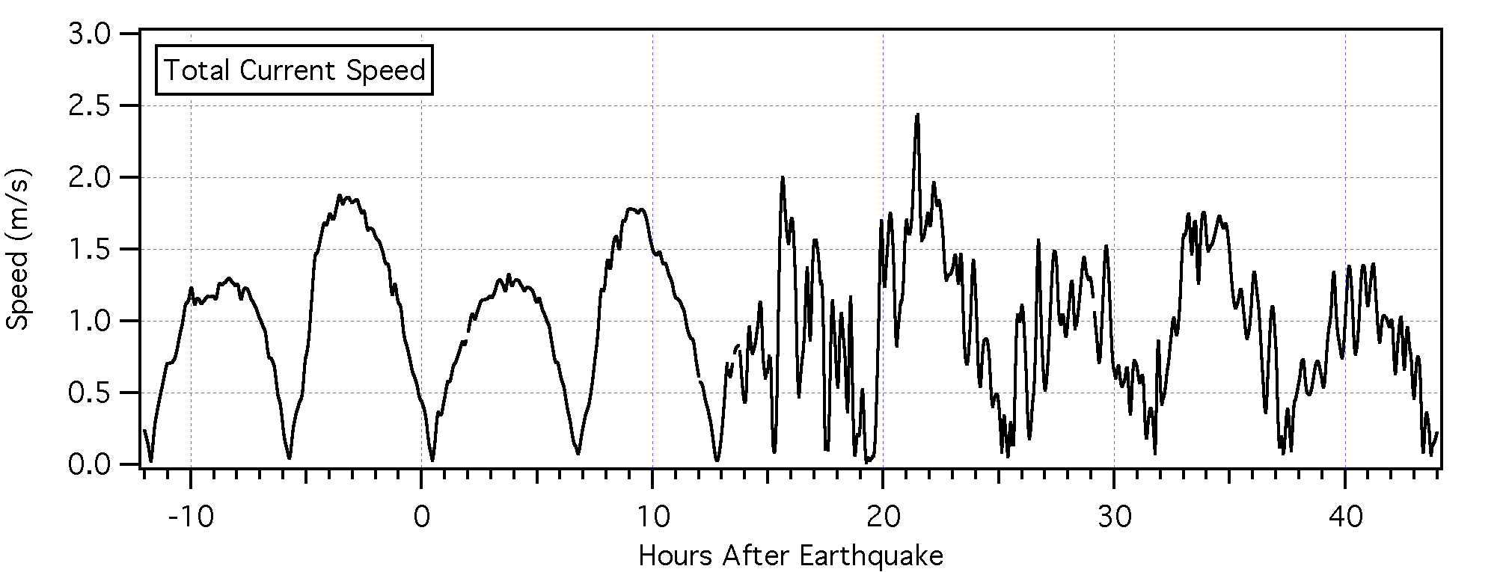

Figure 5 Total current speed measured by the ADCP at the entrance to Tauranga Harbour.

The tidal contribution to the velocity signal was removed through a harmonic analysis applied to each layer of measured data on for the separate U (north-south) and V (east west) components of the measured data. The resultant current speed is shown in Figure 6 along with the de-tided water level signal.

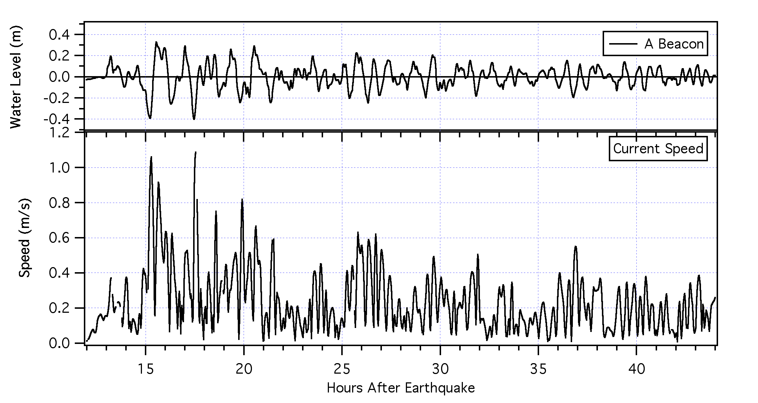

Figure 6 the de-tided tsunami current speed (bottom) and the de-tided tsunami water level signal (top).

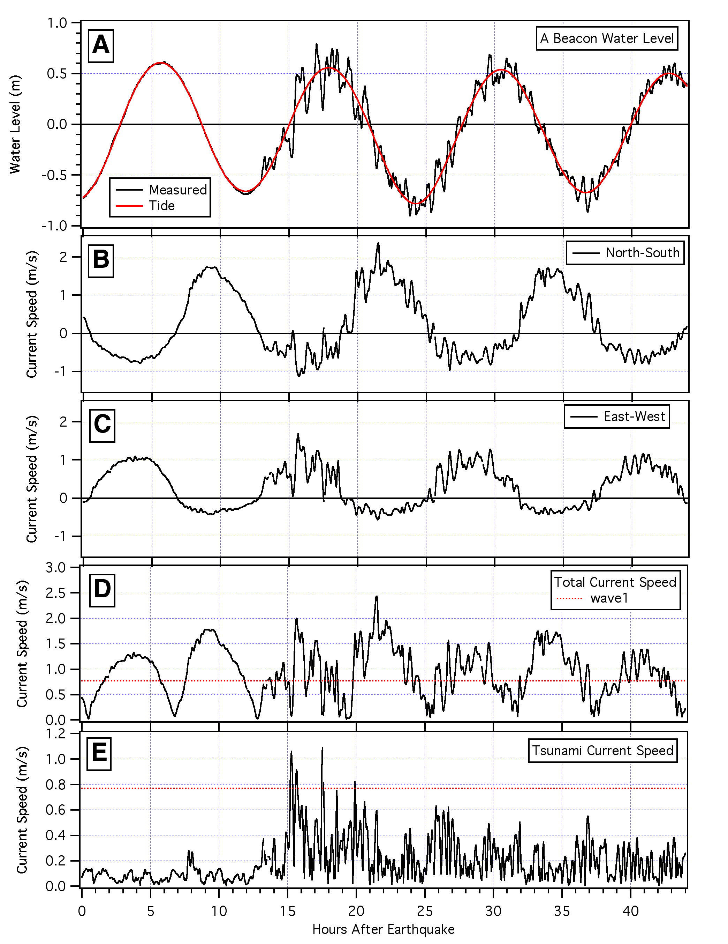

Figure 7 Summary of Water level and current speeds: A) Measured water levels at A beacon and tide signal; B) North-south current speed C) East-west current speed, D) Total current Speed E) Tsunami current speed (tide removed). Horizontal dashed line I panels D and E represent the 1.5-knot (0.77 m/s) threshold for safe movement of large vessels in and out of Tauranga Harbor.