**Benchmark #4**

This experiment has a single long-period wave (NOT a solitary wave) propagating up a piecewise linear slope and onto a small-scale model of the town of Seaside, Oregon. Free surface information was recorded via resistance-type wave gauges and sonic wave gages. Velocity information was recorded via ADV’s.

For this benchmark, we will compare free surface, velocity, and momentum flux information recorded throughout the tank.

***SETUP:***

**Water depth @ Wavemaker**: 0.97m

**Incident Wave (in directory “incident wave”)**

The generated wave for this problem is not a solitary wave. It is custom wave meant to maximize the stroke of the wavemaker, while generating a long period wave. Note that due to this generation approach, the wave is not permanent, like a solitary wave. Numerically, the wave can be generated using two different methods:

1. The wavemaker displacement time series can be used if a moving wall boundary condition is available in the numerical model
2. The time series of incident wave elevation at X=5m can be used to force the numerical model at X=5 m. Note that this is a synthetic time series, based on simulation of with a moving wall boundary condition, however it should re-produce the wave very well

Both of these time series can be seen and plotted using the “load\_wavemaker\_motion.m” script in the “incident\_wave” directory (see image below).

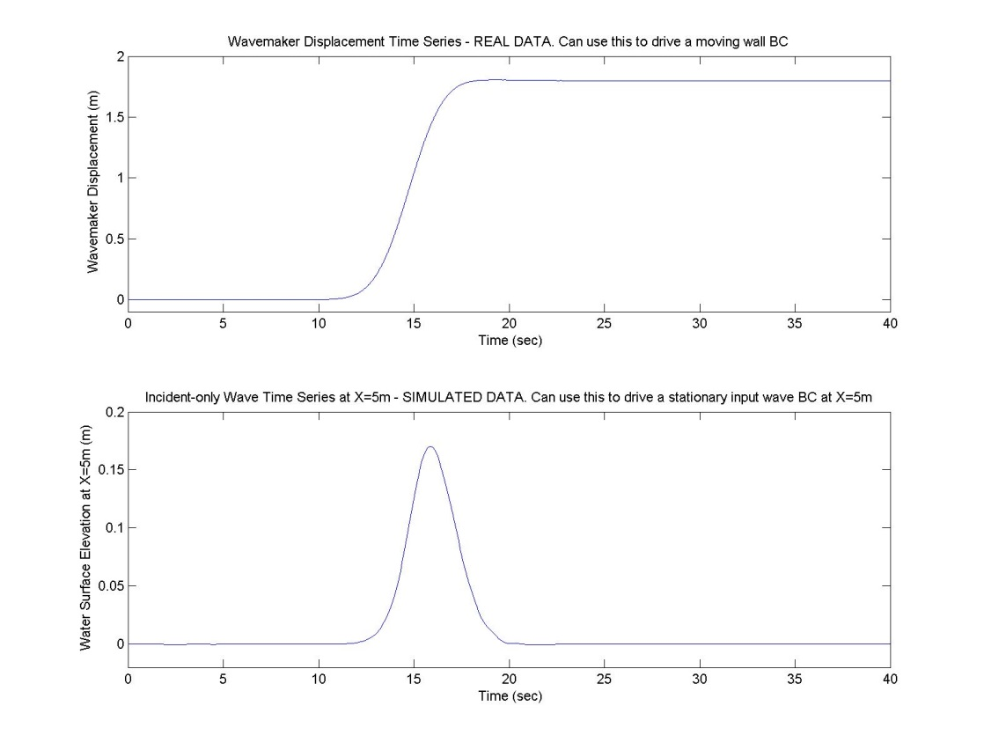

**Bathymetry (in directory “bathy”):**

Figure below (the bathymetry data) can be plotted in Matlab with the “plot\_bathy.m” script.

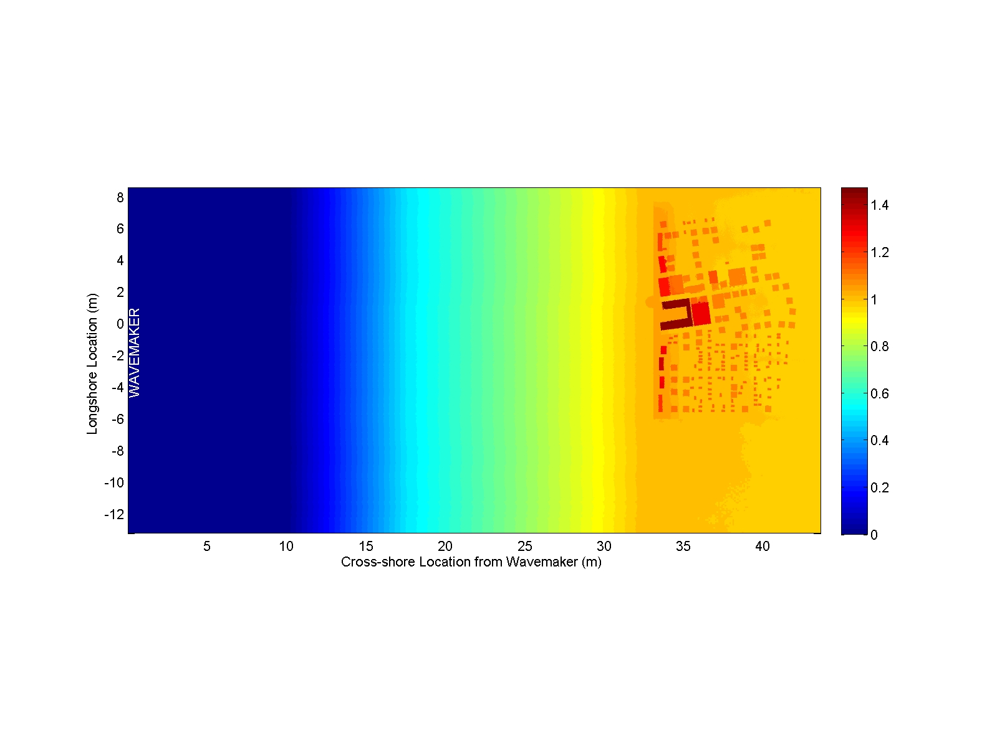

***Benchmark Data(in directory “comparison data”)***

***Free surface elevation data at WG3***This data is contained in the file: “**Wavegage.txt**”, and can be plotted with the script load\_WG3.m. The location of the wave gage is shown below (see also included journal paper). Note that there is other data included in these files as well. Modelers may compare with any data they wish, but please be sure to show comparisons at WG3. Comparisons at this particular location will be used to ensure that the generated waves in the model are correct, in terms of amplitude, period, and arrival time.

D:\work\01Tsunamicomparison\04 Coastal engineering Journal\Seaside_subscript\Color_figures\Fig2.tif

|  |  |
| --- | --- |
|  | X(m), Y(m) |
| Wmdisp  Wmwg (At the wave maker) | 0, 0 |
| Wg1 | 2.068, -0.515 |
| Wg2 | 2.068, 4.065 |
| **Wg3** | **18.618, 0** |
| Wg4 | 18.618, 2.86 |

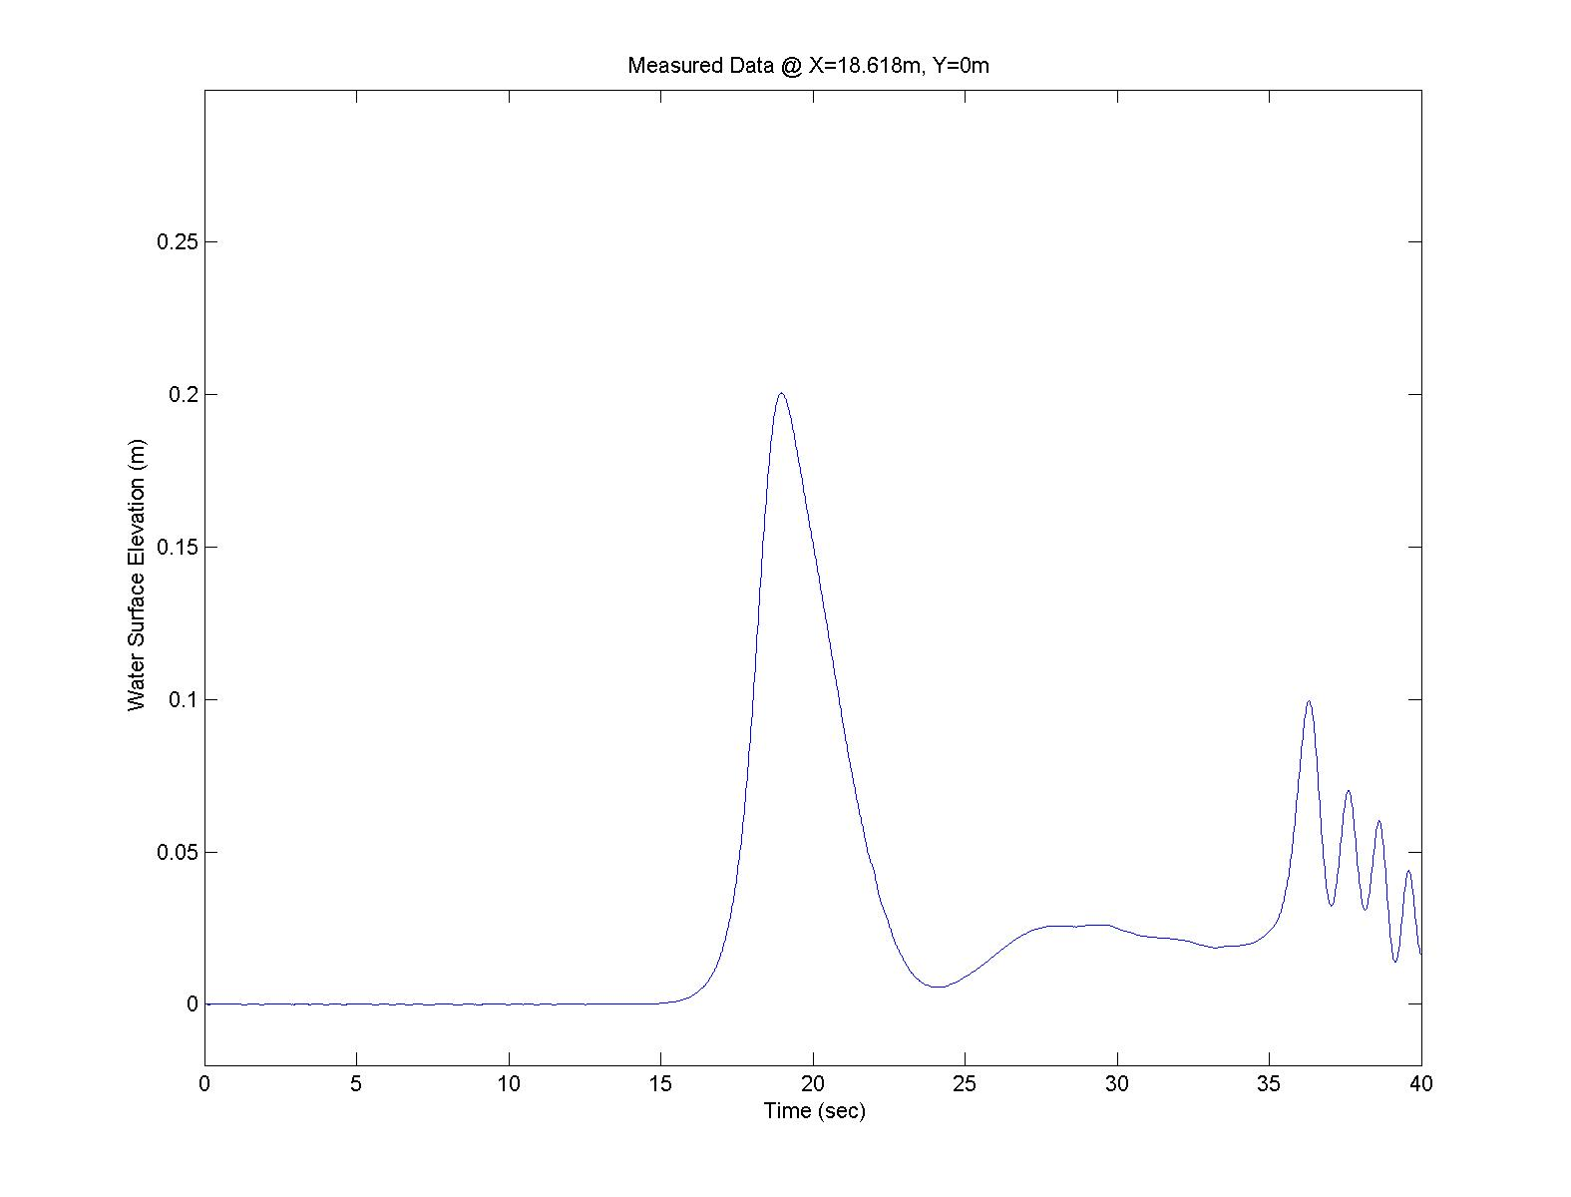

***Overland Flow Depth, Cross-shore (x-direction) Velocity, and cross-shore Specific Momentum Flux***This data comparison is the primary comparison of the benchmark exercise. Here, we compare flow depth (H), velocity (u), and specific momentum flux (Hu2) at four locations: B1, B4, B6, B9 (see image and table below). These four locations are discussed in depth in the attached journal article. Data for these locations can be plotted with the script “load\_B1\_4\_6\_9.m.” The data is shown below. Note that there is data for other overland flow locations included as well (in “comparison\_data/other”). Modelers may compare with any data they wish, but please be sure to show comparisons at B1, B4, B6, and B9.

D:\work\01Tsunamicomparison\04 Coastal engineering Journal\Seaside_subscript\Color_figures\Fig3.tif

