Benchmark #5
This experiment has a single solitary wave propagating up a triangular shaped shelf with an island feature located at the offshore point of the shelf. Free surface information was recorded via resistance-type wave gauges and sonic wave gages. Velocity information was recorded via ADV’s.

For this benchmark, we will compare free surface, velocity, and turbulence information recorded throughout the tank.

SETUP:

Water depth @ Wavemaker: 0.78m
Solitary wave height @ wavemaker: 0.39m

Bathymetry (in directory “bathy”):
Figure below (the bathymetry data) can be plotted in Matlab with the “plot_bathy.m” script.

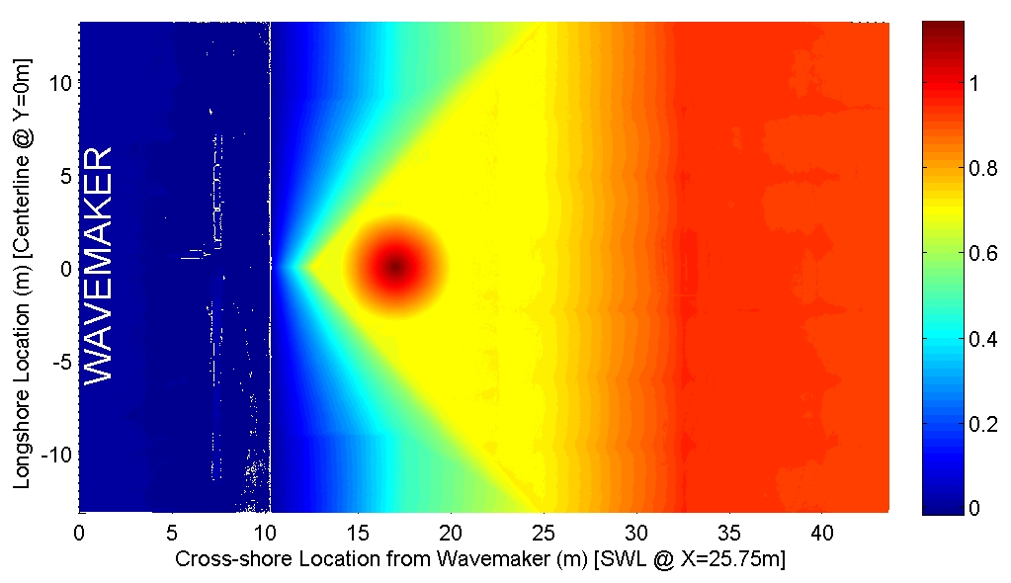

Benchmark Data (in directory “comparison data”)
Free Surface Elevation Measurements (can be plotted with plot_WG.m script)
Recorded @ y=0 (centerline of basis) at following x-locations:
X=7.5m, 13.0m, 21.0 m

Recorded @ y=5.0 at following x-locations:
X=7.5m, 13.0m, 21.0 m

Recorded @ x=25 at following y-locations:
Y=0.0 m, 5.0m, 10.0 m
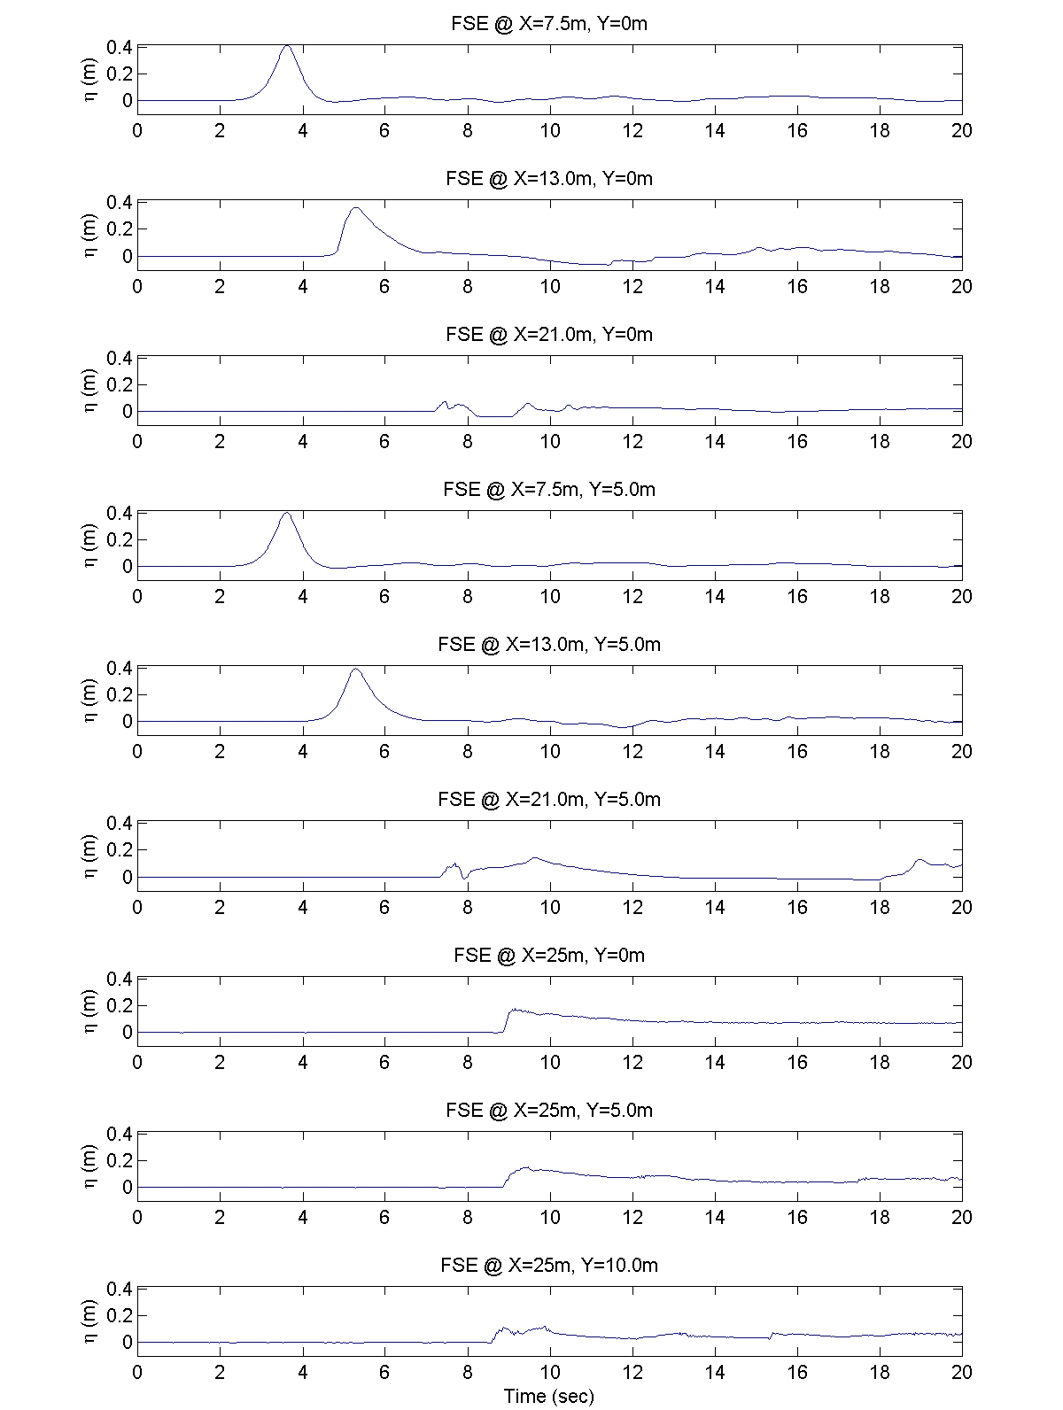
Benchmark Data
Velocity and Turbulence Measurements (can be plotted with plot_ADV.m script)
Recorded @ x=13m, y=0m, z=0.75 m (3 cm below still water level)
Mean and RMS turbulence fluctuations for the three velocity components are provided.

Recorded @ x=21m, y=0m, z=0.77 m (1 cm below still water level)
Mean and RMS turbulence fluctuations for the three velocity components are provided.

Recorded @ x=21m, y=-5m, z=0.77 m (1 cm below still water level)
Mean and RMS turbulence fluctuations for the three velocity components are provided.
