24.02.2020

Ben-Gurion University of the Negev

Faculty of Natural Sciences

C.S Department

**Privacy Preserving Frequent Itemset Generation for Vertically Partitioned Data Using Dot Product**

Edan Yaar

Advisor: Prof. Ehud Gudes

Table of Contents

Preface 2

The Problem Context 3

The Mining Algorithms 4

Software Implementation 9

Data Set Description 11

Test results 12

Evaluation and Analysis of the Implemented Algorithms 15

Appendix – Full Test Results 16

References 33

# Preface

Recent Technological advances, such as smart speakers, IP cameras and other network-connected smart home devices, have significantly increased the capability of commercial companies to store the personal data of consumers. This has raised concerns that this personal data will be viewed by unauthorized people, or even sold to other companies for a profit [1],[2],[3] . In order to deal with these concerns, several privacies preserving data mining methods have been proposed in recent years.

In this paper, two privacy preserving algorithms for finding the frequent Itemsets in a vertically partitioned database will be compared, both of which are based on dot product computation. These algorithms are:

1. The Vaidya-Clifton Private Scalar Product Protocol [1]
2. The Homomorphic encryption based scalar product protocol proposed by Goethals et al. [2] [3]

Due to the nature of the scalar dot product, both algorithms are generally limited to two-party interaction, and therefore both will be examined in a two-party setting, using 2 different databases and 3 values of support.

In Addition, code implementing of both algorithms is provided. The code is written in Java using the following dependencies:

1. The Two-party communication is facilitated by Akka[4].
2. The homomorphic encryption is based on the Paillier Cryptosystem[5] [4] per the layout in [2] [3].
3. The correctness of the Frequent Itemsets found was compared against the results from the uregina Apriori Java applet[6].
4. The fields of each database are processed in order to fit the dot-product protocols and parsed from a csv format using opencsv[7].

# The Problem Context

The key goal in most distributed methods for privacy-preserving data mining is to allow computation of useful aggregate statistics over the entire data set without compromising the privacy of the individual data sets within the different participants. Thus, the participants may wish to collaborate in obtaining aggregate results but may not fully trust each other in terms of the distribution of their own data sets. The problem of distributed privacy-preserving data mining overlaps closely with a field in cryptography for determining secure multi-party computations. The broad approach to cryptographic methods tends to compute functions over inputs provided by multiple recipients without actually sharing the inputs with one another.

For example, in a 2-party setting, Alice and Bob may have two inputs x and y respectively and may wish to both compute the function $f(x, y)$ without revealing x or y to each other. This problem can also be generalized across k parties by designing the k argument function $h(x_{1} . . . x_{k})$. Many data mining algorithms may be viewed in the context of repetitive computations of many such primitive functions such as the scalar dot product, secure sum etc. [5]

This work Examines the problem of frequent itemset generation in a vertically partitioned database. Data is said to be vertically partitioned when several organizations own different attributes of information for the same set of entities. Thus, vertical partitioning of data can formally be defined as follows:

* First, define a dataset *D* in terms of the entities for whom the data is collected and the information that is collected for each entity.
* Thus, $D ≡ (E, I)$ , where *E* is the entity set for whom information is collected and *I* is the feature set that is collected.
* Assume that there are *k* different sites, $P_{1},...,P_{k}$  collecting datasets $D1 ≡ (E_{1}, I_{1}),...,D_{k} ≡ (E_{k},I_{k})$  respectively.
* Therefore, data is said to be vertically partitioned if

$E = \bigcap_{i}{E_{i}} = E_{1} ⋂...⋂ E_{k}, and I = \bigcup_{i}{I_{i}} = I_{1} ⋃...⋃ I_{k}$. [6]

With regards to association rules and frequent itemset generation, if we denote the set of attributes in the database (D) by C, an association rule is a (statistical) implication of the form $C_{x} ⇒ C_{y}$. A rule $C_{x} ⇒ C_{y}$ is said to have a support (or frequency)

factor *s* if at least $s\%$ of the transactions in D satisfy $C_{x}∪C_{y}$. A rule $C_{x} ⇒ C_{y}$ is satisfied in D with a confidence factor *c* if at least $c\%$ of the transactions in D that satisfy $C_{x}$ also satisfy $C_{y}$. Both support and confidence are fractions in the interval [0,1].

The support is a measure of statistical significance, whereas confidence is a measure of the strength of the rule. A rule is said to be "interesting" if its support and confidence are greater than user-defined thresholds $\sup_{min}$ and ${con}_{min}$, respectively, and the objective of the mining process is to find all such interesting rules. It has been shown in [7] that achieving this goal is effectively equivalent to generating all subsets of C that have support greater than $\sup_{min}$– these subsets are called frequent itemsets. **Therefore, the mining objective is to efficiently discover all frequent itemsets that are present in the database**. [8]

# The Mining Algorithms

Both mining algorithms examined in this paper are based on The Apriori algorithm and secure computation using scalar dot product.

The Apriori algorithm [9] finds the frequent itemsets in a given dataset by using the Apriori principle, which states that *if an itemset is infrequent, then all its supersets must also be infrequent*. This means that if for example the singleton {A} is infrequent, we can expect {A, B} to be equally or even more infrequent. As a result, while generating our list of frequent itemsets, we do not need to include {A, B}, nor any other itemset that contains *A*. Using the Apriori principle, the number of itemsets that must be examined can be pruned, and the list of popular itemsets can be obtained via these steps:

* **Step 0**. Start with itemsets containing just a single item, such as {A} and {B}.
* **Step 1**. Determine the support for these itemsets. Keep the itemsets that meet your minimum support threshold and remove itemsets that do not.
* **Step 2**. Using the itemsets that remain from Step 1, generate all the possible itemset configurations.
* **Step 3**. Repeat Steps 1 & 2 until there are no more new itemsets.

As a result of vertical partitioning, an itemset could be split between multiple sites. While most steps of the Apriori algorithm, describe if Figure 1, can be carried out locally at each site, the crucial step of computing the support count of an itemset cannot, and so it must be found using secure computation involving all sites (step 10 in Figure 1 below). [10]

The key principle used by both algorithms examined in this paper is that computing the support of an itemset is equivalent to finding the scalar (dot) product of the vectors representing the sub-itemsets with each of the different parties. Thus, the entire secure association rule mining problem can be reduced to computing the scalar product of two vectors in a privacy-preserving way. [10]

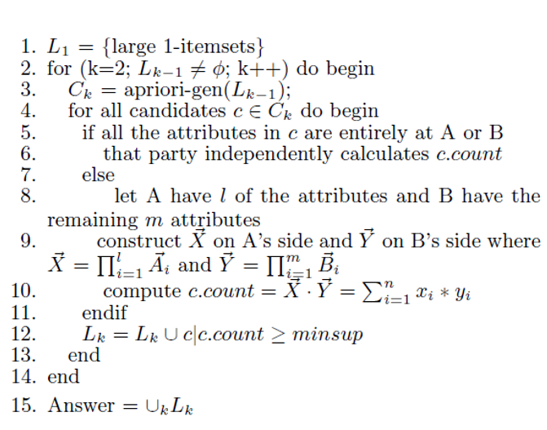

Figure 1 – Pseudocode for the distributed Apriori Algorithm [1]

**Vaidya-Clifton Algorithm**

The first of the two algorithms examined in this paper is the Vaidya-Clifton algorithm presented in [1]. This dot product algorithm attempts to mask the true values of the transactions by placing them in algebraic equations padded with random values. According to [1], The knowledge disclosed by these equations only allows computation of private values if one side learns a substantial number of the private values from an outside Source (though we note that this has been disproven by later works [2]).

The algorithm consists of 2 steps. In step 1, Alice generates $\frac{n}{2}$ random numbers $R_{1},…R_{\frac{n}{2}}$. Alice uses $\vec{X}$, these random numbers and a matrix A of coefficients $a_{i,j}$ to compute a vector ${\vec{X}}^{'}$ consisting of the following n values:

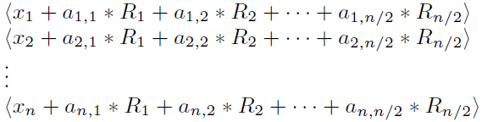

The matrix A is known to both Alice and Bob and is generated randomly such that $a_{i,j}$ form coefficients for a set of n linear equations, out of which any $\frac{n}{2}$ are independent.

Alice sends all n values of ${\vec{X}}^{'}$ to Bob, who computes $S={\vec{X}}^{'}⋅\vec{Y}$ by multiplying each value received with the corresponding y value and summing the results.

In step 2, Bob sends S and the following $\frac{n}{2}$ values to Alice:

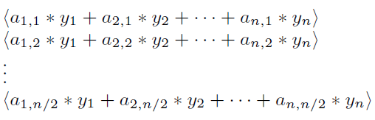

S can be written as follows:

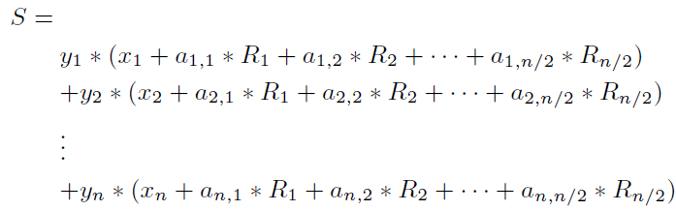

Simplifying the equation further, and grouping the $x_{i}⋅y_{i}$ terms, we get:

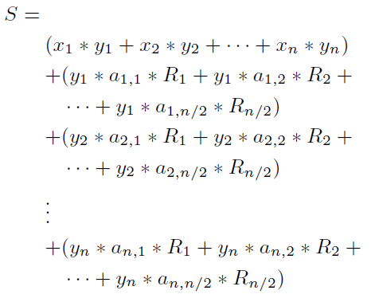

The first line of the R.H.S can be written as $\sum_{i=1}^{n}{x_{i}⋅y_{i}}$– the desired result. In the remaining portion, we group the multiplicative components vertically and rearrange the equation to factor out all the $R_{i}$ values, giving:

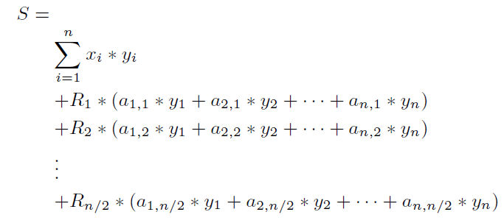

Since Alice already knows the values of $R_{i}$ and the other $\frac{n}{2}$ values sent by Bob are the same as the coefficients on the R.H.S of the above equation, Alice can compute the desired dot product by multiplying the $\frac{n}{2}$ values received from Bob with the corresponding $R_{i}$ and subtracting the sum from S.

**Goethals et al Homomorphic encryption Algorithm**

The second of the two algorithms examined in this paper is the Homomorphic Encryption based algorithm proposed by Goethals et al. [2] [3]. Homomorphic encryption is a form of encryption that allows computation on ciphertexts, generating an encrypted result which, when decrypted, matches the result of the operations as if they had been performed on the plaintext, for example:

$$Dec\left(Enc\left(X\right)⋅Enc\left(Y\right)\right)=X⋅Y$$

The key idea behind the protocol is to use a homomorphic encryption system in order to calculate the dot product. If Alice encrypts her vector and sends Bob its encrypted form, using the additive/multiplication homomorphic properties bob can compute the dot product. The algorithm’s pseudocode can be seen in figure 2. Note that $+_{h} and×_{h}$ are the addition and multiplication of the ciphertexts according to the homomorphic property.

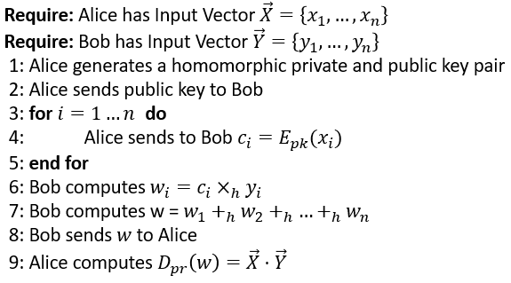

Figure 2 – The Goethals et al Homomorphic Algorithm [3]

**Extension to the multi-party case**

To conclude this chapter, an alternative solution to the scalar dot product protocols presented above that was not examined in this paper should be mentioned – Set Intersection. This solution involves encoding the vectors as sets (with position numbers as elements). An example for this process is given in figure 3:

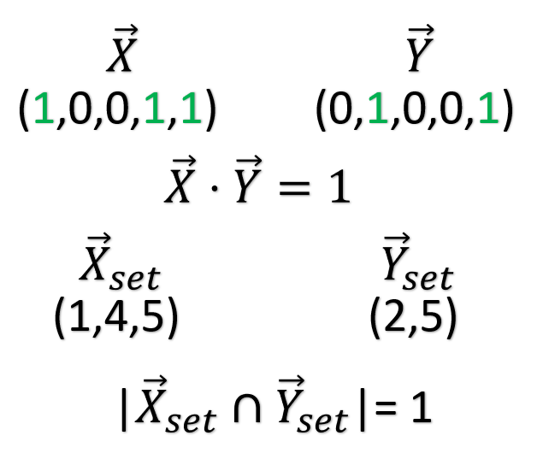

Figure 3 – Dot Product vs Set Intersection

The size of the set intersection of these vectors is equivalent to the result of the dot product but allows us to expand the algorithms shown above to more than two parties.

# Software Implementation

Alice and Bob are the main Classes of the software implementation and both of them implement the Akka actor interface. In order to facilitate communication between them, a variety of Message Classes were defined as well.

The main functions for each actor are as follows:

**Alice**

* **Generate_f1_alice**: initialization of Apriori algorithm - finding all frequent-1 Itemsets in the DB
* **Generate_candidates:** generates the set of candidates k-itemsets, from $F_{k-1}$, the set of frequent (k-1)-itemsets found in the previous step
* **Candidate_pruning:** prune the given candidates based on the following logic: a necessary condition of candidate to be frequent is that each of its (k-1)-itemset is frequent (The Apriori condition).
* **count_freqs:** for each itemset candidate - split it into frequencies that can and cannot be computed locally.
* **count_freq:** count the frequency of the itemset given as input via one of three methods:
  + if the itemset contains only local vectors - compute it locally.
  + if the itemset contains only remote vectors - send a request to Bob for remote computation.
  + if the itemset contains both local as well as remote vectors - invoke the selected privacy preserving communication algorithm.
* **update_freq:** add the given itemset to $F_{k}$ if its frequency is larger than the minimum support. once finished checking all candidates, proceed to next step of algorithm - generating $C_{k+1}$.
* **generate_A_matrix:** Generate a matrix of values that form coefficients of linear independent equations by:
  + generating a matrix with random numbers - rand_a .
  + For every row i, replace the diagonal element with the sum of the absolute values of elements of the corresponding row in rand_a (the remaining values remain unchanged).
  + such a matrix is diagonally dominant => is nonsingular => Linearly independent rows
* **comm_clifton & calc_freq_vc:**  used to send the X’ vector to bob and perform the dot product calculation upon receiving S,Y’.
* **comm_homomorphic & decrypt_homomorphic:** used to send the encrypted X vector to bob and to decrypt the dot product received from him.

**Bob**

* **generate_f1_Bob:** initialization of Apriori algorithm - finding all frequent-1 Itemsets in the DB. Sends the results to Alice.
* **count_freq:** used to calculate the frequency for local itemsets.
* **count_freq_vc & count_freq_homomorphic:** used to calculate the local part of a shared itemset according to the relevant algorithm.

**General**

* **Paillier:** the implementation of the Paillier cryptosystem used in the homomorphic algorithm. Includes encrypt/dycript methods.

Note: For a full list of classes and a detailed description of each function please see the attached Javadoc.

# Data Set Description

To test the algorithms described in the previous chapters two databases were used:

1. a subset of the 1987 National Indonesia Contraceptive Prevalence Survey. The database contains the following values:

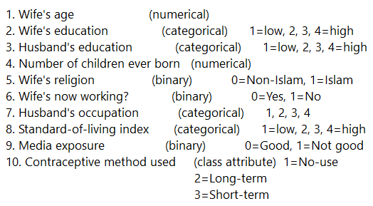

1. a subset of the Cleveland Heart Disease Database. The database contains the following values:

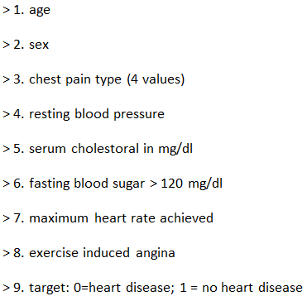

Since both databases are numeric, and the algorithms call for binary values in each column, the Databases were modified so that each column contains binary values. This was done by splitting some of the fields into several binary ranges (for example the age field was split into 10-year age ranges) while for others a binary column was generated for each option (for example the 1-4 education scale in the first database was split into 4 binary columns). An example of the process for the first database can be seen in figure 4 (the original field can be seen to the left, in red, while the generated binary fields are in green):

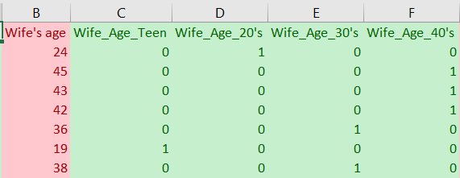

Figure 4 – Database Processing

# Test results

The algorithms were applied on each of the databases with 3 different levels of support: 50%, 30% and 20%. The results for each algorithm were compared with each other as well as a third party Apriori package[8] to insure correctness.

Following are some insights derived from the test results (The full results are attached in appendix 1):

**Indonesia Contraceptive Prevalence Survey**

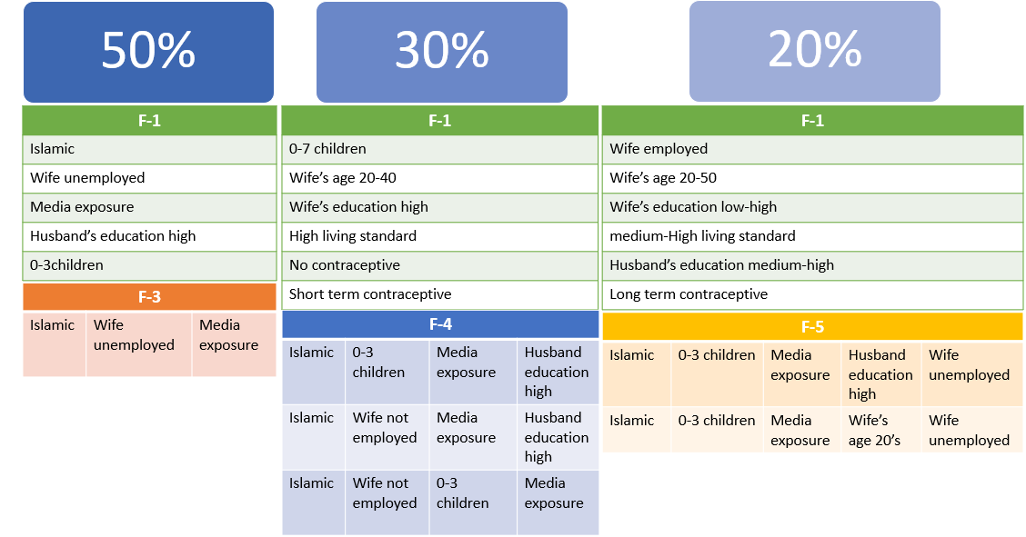

Figure 5 – Indonesia Contraceptive Prevalence Survey Results

As can be seen in figure 5, the traits that are prevalent in most of the population sampled is Islam, Media exposure, 0-3 children and female unemployment (cultural characteristics) as well as high male education. Based on Indonesia’s education numbers in modern times[9] and considering that the survey data is from 1987, the prevalence of high male education could indicate that the survey was not conducted among a representative subsection of the population but rather a specific minority (such as university employees for example).

Moving to itemsets with more than 30% support, we find high female education as well as high living standards (again supporting the hypothesis in the previous paragraph) as well as no/short term contraceptive use.

Finally, with a minimum support of 20% we get a broader section of the population, with both a broader age range as well as more differing education levels.

**Cleveland Heart Disease Database**

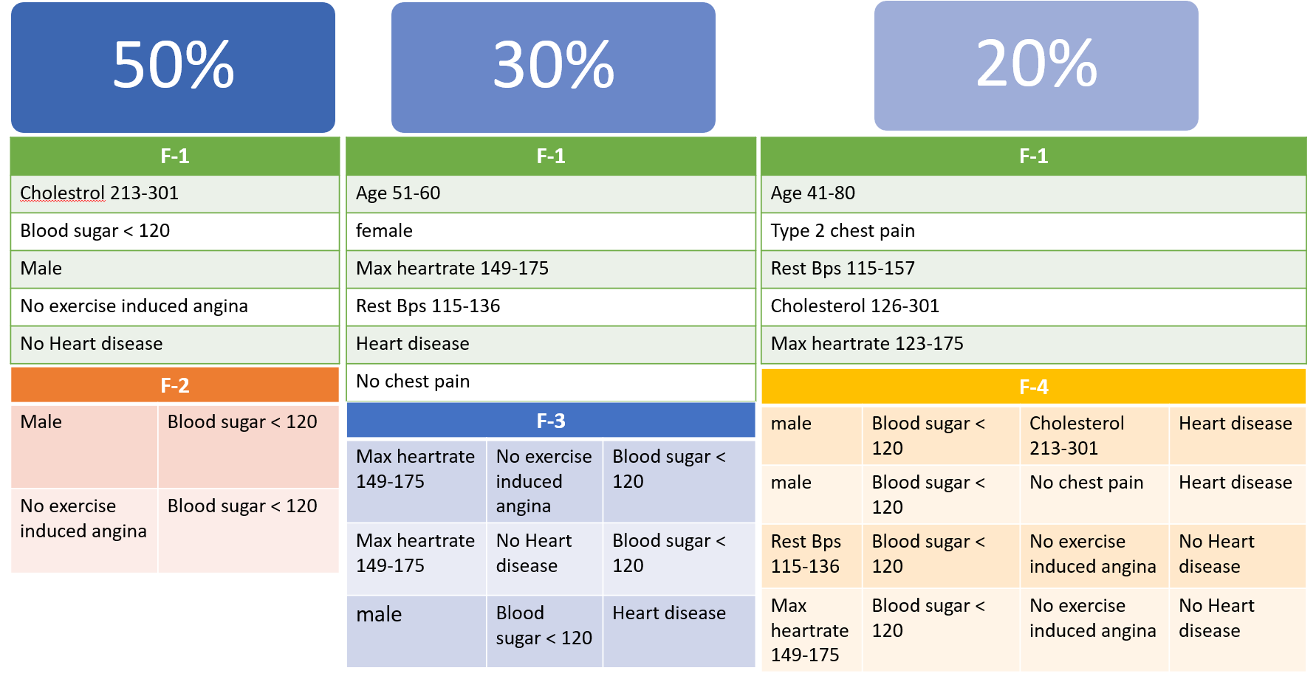

Figure 6 – Cleveland Heart Disease Database Results

As can be seen in figure 6, unsurprisingly most of the patients in the database are males (in accordance with their higher risk of heart disease) and the other traits conform with the average values measured in adults (except for the cholesterol values).

Moving to a minimum support of 30%, we have female patients as well as a few more statistics such as a maximum heart rate and resting blood pressure. For F-3 we have among others the itemset of [male, blood sugar<120, heart disease]. Since a majority of the database is comprised of males and these blood sugar levels are normal, this result isn’t helpful in narrowing down heart disease symptoms.

With a minimum support of 20% we have some additional traits as can be seen in figure 6. And once more most of the itemsets in F-4 are basically average values for various traits combined with no heart disease.

Of note are the first two itemsets in F-4 as can be seen in figure 6. From the first we can see the known link between high cholesterol and heart disease, while from the second we can see that in a not insignificant part of the population heart disease is not accompanied by chest pain. This result would have probably been more pronounced if the database had a higher percentage of female patients[10].

# Evaluation and Analysis of the Implemented Algorithms

Both the Vaydia-Clifton algorithm and the homomorphic encryption algorithm implemented in this paper are based upon the Apriori algorithm which suffers from several inefficiencies:

1. Candidate generation generates large numbers of subsets.
2. The algorithm scans the database many times, which reduces the overall performance.
3. both the time and space complexity of this algorithm are very high: $O(2^{N})$

where N is the total number of columns (items) present in the database.

With regards to the implemented communication algorithms, while both algorithms have an $O(n)$ communication overhead for each dot product calculation (n being the number of transactions, or rows in the database), the asymptotic constant for the homomorphic algorithm is much smaller, as only one value is sent back from Bob to Alice unlike in the Vaydia-Clifton algorithm. This communication advantage can be improved further via packing several bits into each cyphertext [2] [11].

With regards to security, as mentioned in previous chapters the Vaidya-Clifton algorithm has been demonstrated to be unsecure, while the security of the homomorphic algorithm is equivalent to that of a general RSA algorithm, and depends on the bit length of the keys.

# Appendix – Full Test Results

**Indonesia Contraceptive Prevalence Survey**

**Minsup = 50%**

**F-1:**

Set: [Islamic] support: 0.850645

Set: [Wife unemployed] support: 0.749491

Set: [media exposure] support: 0.926001

Set: [Husband's_Education_High] support: 0.610319

Set: [Children_0to3] support: 0.616429

**F-2:**

Set: [Islamic, Wife unemployed] support: 0.648337

Set: [Husband's_Education_High, media exposure] support: 0.592668

Set: [Children_0to3, media exposure] support: 0.583843

Set: [Islamic, media exposure] support: 0.782077

Set: [Wife unemployed, media exposure] support: 0.693822

Set: [Children_0to3, Islamic] support: 0.513238

**F-3:**

Set: [Islamic, Wife unemployed, media exposure] support: 0.595384

**Minsup = 30%**

**F-1:**

Set: [Islamic] support: 0.850645

Set: [Wife_Age_20's] support: 0.367957

Set: [Wife_Age_30's] support: 0.314324

Set: [Wife unemployed] support: 0.749491

Set: [Wife's_Education_High] support: 0.391718

Set: [Living_Standard_High] support: 0.464358

Set: [media exposure] support: 0.926001

Set: [No_Contraceptive] support: 0.427020

Set: [Husband's_Education_High] support: 0.610319

Set: [Short_Term_Contraceptive] support: 0.346911

Set: [Children_0to3] support: 0.616429

Set: [Children_4to7] support: 0.321113

**F-2:**

Set: [Wife_Age_20's, Children_0to3] support: 0.318398

Set: [Wife_Age_20's, Islamic] support: 0.339443

Set: [Wife's_Education_High, Husband's_Education_High] support: 0.369314

Set: [Husband's_Education_High, Children_0to3] support: 0.411405

Set: [Wife_Age_20's, media exposure] support: 0.350984

Set: [Husband's_Education_High, Islamic] support: 0.486083

Set: [Children_0to3, Islamic] support: 0.513238

Set: [Husband's_Education_High, Wife unemployed] support: 0.456212

Set: [Children_0to3, Wife unemployed] support: 0.447386

Set: [Wife's_Education_High, media exposure] support: 0.387644

Set: [Islamic, Wife unemployed] support: 0.648337

Set: [Husband's_Education_High, Living_Standard_High] support: 0.353021

Set: [Husband's_Education_High, media exposure] support: 0.592668

Set: [Children_0to3, media exposure] support: 0.583843

Set: [Islamic, Living_Standard_High] support: 0.359131

Set: [Islamic, media exposure] support: 0.782077

Set: [Wife unemployed, Living_Standard_High] support: 0.332654

Set: [Islamic, No_Contraceptive] support: 0.376103

Set: [Wife unemployed, media exposure] support: 0.693822

Set: [Islamic, Short_Term_Contraceptive] support: 0.300068

Set: [Wife unemployed, No_Contraceptive] support: 0.311609

Set: [Living_Standard_High, media exposure] support: 0.452138

Set: [media exposure, No_Contraceptive] support: 0.376782

Set: [media exposure, Short_Term_Contraceptive] support: 0.329939

**F-3:**

Set: [Islamic, Living_Standard_High, media exposure] support: 0.347590

Set: [Wife unemployed, Living_Standard_High, media exposure] support: 0.324508

Set: [Islamic, media exposure, No_Contraceptive] support: 0.328581

Set: [Wife_Age_20's, Children_0to3, media exposure] support: 0.304820

Set: [Husband's_Education_High, Children_0to3, Islamic] support: 0.323829

Set: [Wife_Age_20's, Islamic, media exposure] support: 0.322471

Set: [Wife's_Education_High, Husband's_Education_High, media exposure] support: 0.365241

Set: [Husband's_Education_High, Islamic, Wife unemployed] support: 0.370672

Set: [Children_0to3, Islamic, Wife unemployed] support: 0.379498

Set: [Husband's_Education_High, Children_0to3, media exposure] support: 0.401901

Set: [Husband's_Education_High, Islamic, media exposure] support: 0.471826

Set: [Children_0to3, Islamic, media exposure] support: 0.483367

Set: [Husband's_Education_High, Wife unemployed, media exposure] support: 0.443313

Set: [Children_0to3, Wife unemployed, media exposure] support: 0.424304

Set: [Islamic, Wife unemployed, media exposure] support: 0.595384

Set: [Husband's_Education_High, Living_Standard_High, media exposure] support: 0.346232

**F-4:**

Set: [Husband's_Education_High, Children_0to3, Islamic, media exposure] support: 0.315682

Set: [Husband's_Education_High, Islamic, Wife unemployed, media exposure] support: 0.359810

Set: [Children_0to3, Islamic, Wife unemployed, media exposure] support: 0.357094

**Minsup = 20%**

F-1:

Set: [Wife_Age_20's] support: 0.367957

Set: [Wife_Age_30's] support: 0.314324

Set: [Wife_Age_40's] support: 0.207739

Set: [Wife's_Education_Low] support: 0.226748

Set: [Wife's_Education_Medium] support: 0.278344

Set: [Wife's_Education_High] support: 0.391718

Set: [Husband's_Education_Medium] support: 0.238968

Set: [Husband's_Education_High] support: 0.610319

Set: [Children_0to3] support: 0.616429

Set: [Children_4to7] support: 0.321113

Set: [Islamic] support: 0.850645

Set: [Wife unemployed] support: 0.749491

Set: [Wife employed] support: 0.250509

Set: [Living_Standard_Medium] support: 0.292600

Set: [Living_Standard_High] support: 0.464358

Set: [media exposure] support: 0.926001

Set: [No_Contraceptive] support: 0.427020

Set: [Long_Term_Contraceptive] support: 0.226069

Set: [Short_Term_Contraceptive] support: 0.346911

**F-2:**

Set: [Wife_Age_20's, Husband's_Education_High] support: 0.228785

Set: [Wife_Age_20's, Children_0to3] support: 0.318398

Set: [Wife_Age_30's, Husband's_Education_High] support: 0.200950

Set: [Wife_Age_20's, Islamic] support: 0.339443

Set: [Wife_Age_30's, Islamic] support: 0.245078

Set: [Wife's_Education_High, Husband's_Education_High] support: 0.369314

Set: [Wife_Age_20's, Wife unemployed] support: 0.283096

Set: [Wife's_Education_High, Children_0to3] support: 0.270876

Set: [Wife_Age_30's, Wife unemployed] support: 0.219280

Set: [Wife's_Education_Low, Islamic] support: 0.211813

Set: [Wife's_Education_Medium, Islamic] support: 0.243041

Set: [Wife's_Education_High, Islamic] support: 0.294637

Set: [Husband's_Education_High, Children_0to3] support: 0.411405

Set: [Wife's_Education_Medium, Wife unemployed] support: 0.217923

Set: [Wife's_Education_High, Wife unemployed] support: 0.276307

Set: [Wife_Age_20's, media exposure] support: 0.350984

Set: [Husband's_Education_Medium, Islamic] support: 0.220638

Set: [Wife_Age_30's, media exposure] support: 0.286490

Set: [Husband's_Education_High, Islamic] support: 0.486083

Set: [Children_0to3, Islamic] support: 0.513238

Set: [Husband's_Education_High, Wife unemployed] support: 0.456212

Set: [Children_4to7, Islamic] support: 0.276307

Set: [Wife's_Education_Low, media exposure] support: 0.207739

Set: [Wife's_Education_High, Living_Standard_High] support: 0.262050

Set: [Children_0to3, Wife unemployed] support: 0.447386

Set: [Wife's_Education_Medium, media exposure] support: 0.266124

Set: [Children_4to7, Wife unemployed] support: 0.249830

Set: [Wife's_Education_High, media exposure] support: 0.387644

Set: [Husband's_Education_High, Living_Standard_High] support: 0.353021

Set: [Islamic, Wife unemployed] support: 0.648337

Set: [Husband's_Education_Medium, media exposure] support: 0.220638

Set: [Children_0to3, Living_Standard_High] support: 0.290563

Set: [Islamic, Wife employed] support: 0.202308

Set: [Husband's_Education_High, media exposure] support: 0.592668

Set: [Husband's_Education_High, No_Contraceptive] support: 0.229464

Set: [Children_0to3, media exposure] support: 0.583843

Set: [Children_0to3, No_Contraceptive] support: 0.286490

Set: [Children_4to7, media exposure] support: 0.292600

Set: [Islamic, Living_Standard_Medium] support: 0.262050

Set: [Husband's_Education_High, Short_Term_Contraceptive] support: 0.206382

Set: [Islamic, Living_Standard_High] support: 0.359131

Set: [Children_0to3, Short_Term_Contraceptive] support: 0.213170

Set: [Wife unemployed, Living_Standard_Medium] support: 0.226069

Set: [Islamic, media exposure] support: 0.782077

Set: [Wife unemployed, Living_Standard_High] support: 0.332654

Set: [Islamic, No_Contraceptive] support: 0.376103

Set: [Wife unemployed, media exposure] support: 0.693822

Set: [Islamic, Short_Term_Contraceptive] support: 0.300068

Set: [Wife unemployed, No_Contraceptive] support: 0.311609

Set: [Wife employed, media exposure] support: 0.232179

Set: [Wife unemployed, Short_Term_Contraceptive] support: 0.272234

Set: [Living_Standard_Medium, media exposure] support: 0.277665

Set: [Living_Standard_High, media exposure] support: 0.452138

Set: [media exposure, No_Contraceptive] support: 0.376782

Set: [media exposure, Long_Term_Contraceptive] support: 0.219280

Set: [media exposure, Short_Term_Contraceptive] support: 0.329939

**F-3:**

Set: [Wife_Age_20's, Husband's_Education_High, Children_0to3] support: 0.205024

Set: [Wife_Age_20's, Husband's_Education_High, Islamic] support: 0.203666

Set: [Wife_Age_20's, Children_0to3, Islamic] support: 0.289885

Set: [Wife's_Education_High, Husband's_Education_High, Children_0to3] support: 0.259335

Set: [Wife_Age_20's, Children_0to3, Wife unemployed] support: 0.238968

Set: [Wife's_Education_High, Husband's_Education_High, Islamic] support: 0.274949

Set: [Wife_Age_20's, Islamic, Wife unemployed] support: 0.262729

Set: [Wife's_Education_High, Children_0to3, Islamic] support: 0.200272

Set: [Wife's_Education_High, Husband's_Education_High, Wife unemployed] support: 0.260692

Set: [Wife_Age_20's, Husband's_Education_High, media exposure] support: 0.221317

Set: [Wife_Age_20's, Children_0to3, media exposure] support: 0.304820

Set: [Husband's_Education_High, Children_0to3, Islamic] support: 0.323829

Set: [Wife's_Education_High, Husband's_Education_High, Living_Standard_High] support: 0.253904

Set: [Wife's_Education_High, Islamic, Wife unemployed] support: 0.214528

Set: [Husband's_Education_High, Children_0to3, Wife unemployed] support: 0.295316

Set: [Wife_Age_20's, Islamic, media exposure] support: 0.322471

Set: [Wife_Age_30's, Islamic, media exposure] support: 0.221996

Set: [Wife's_Education_High, Husband's_Education_High, media exposure] support: 0.365241

Set: [Wife_Age_20's, Wife unemployed, media exposure] support: 0.270876

Set: [Wife's_Education_High, Children_0to3, media exposure] support: 0.268160

Set: [Wife_Age_30's, Wife unemployed, media exposure] support: 0.200272

Set: [Husband's_Education_High, Islamic, Wife unemployed] support: 0.370672

Set: [Husband's_Education_High, Children_0to3, Living_Standard_High] support: 0.233537

Set: [Children_0to3, Islamic, Wife unemployed] support: 0.379498

Set: [Wife's_Education_Medium, Islamic, media exposure] support: 0.232858

Set: [Children_4to7, Islamic, Wife unemployed] support: 0.217923

Set: [Wife's_Education_High, Islamic, media exposure] support: 0.291921

Set: [Husband's_Education_High, Children_0to3, media exposure] support: 0.401901

Set: [Wife's_Education_Medium, Wife unemployed, media exposure] support: 0.209097

Set: [Wife's_Education_High, Wife unemployed, media exposure] support: 0.273591

Set: [Husband's_Education_High, Islamic, Living_Standard_High] support: 0.261371

Set: [Husband's_Education_Medium, Islamic, media exposure] support: 0.204345

Set: [Children_0to3, Islamic, Living_Standard_High] support: 0.217244

Set: [Husband's_Education_High, Islamic, media exposure] support: 0.471826

Set: [Husband's_Education_High, Wife unemployed, Living_Standard_High] support: 0.251867

Set: [Children_0to3, Islamic, media exposure] support: 0.483367

Set: [Children_0to3, Islamic, No_Contraceptive] support: 0.246436

Set: [Husband's_Education_High, Wife unemployed, media exposure] support: 0.443313

Set: [Children_4to7, Islamic, media exposure] support: 0.249830

Set: [Wife's_Education_High, Living_Standard_High, media exposure] support: 0.260692

Set: [Children_0to3, Wife unemployed, media exposure] support: 0.424304

Set: [Children_4to7, Wife unemployed, media exposure] support: 0.227427

Set: [Islamic, Wife unemployed, Living_Standard_Medium] support: 0.205024

Set: [Islamic, Wife unemployed, Living_Standard_High] support: 0.263408

Set: [Husband's_Education_High, Living_Standard_High, media exposure] support: 0.346232

Set: [Islamic, Wife unemployed, media exposure] support: 0.595384

Set: [Islamic, Wife unemployed, No_Contraceptive] support: 0.276307

Set: [Children_0to3, Living_Standard_High, media exposure] support: 0.283096

Set: [Islamic, Wife unemployed, Short_Term_Contraceptive] support: 0.241005

Set: [Husband's_Education_High, media exposure, No_Contraceptive] support: 0.220638

Set: [Children_0to3, media exposure, No_Contraceptive] support: 0.266124

Set: [Islamic, Living_Standard_Medium, media exposure] support: 0.248473

Set: [Husband's_Education_High, media exposure, Short_Term_Contraceptive] support: 0.201629

Set: [Islamic, Living_Standard_High, media exposure] support: 0.347590

Set: [Children_0to3, media exposure, Short_Term_Contraceptive] support: 0.202987

Set: [Wife unemployed, Living_Standard_Medium, media exposure] support: 0.216565

Set: [Wife unemployed, Living_Standard_High, media exposure] support: 0.324508

Set: [Islamic, media exposure, No_Contraceptive] support: 0.328581

Set: [Islamic, media exposure, Short_Term_Contraceptive] support: 0.285132

Set: [Wife unemployed, media exposure, No_Contraceptive] support: 0.273591

Set: [Wife unemployed, media exposure, Short_Term_Contraceptive] support: 0.258656

**F-4:**

Set: [Wife_Age_20's, Islamic, Wife unemployed, media exposure] support: 0.250509

Set: [Wife's_Education_High, Husband's_Education_High, Wife unemployed, media exposure] support: 0.257977

Set: [Husband's_Education_High, Children_0to3, Islamic, media exposure] support: 0.315682

Set: [Wife's_Education_High, Husband's_Education_High, Living_Standard_High, media exposure] support: 0.252546

Set: [Wife's_Education_High, Islamic, Wife unemployed, media exposure] support: 0.212492

Set: [Husband's_Education_High, Children_0to3, Wife unemployed, media exposure] support: 0.289885

Set: [Husband's_Education_High, Islamic, Wife unemployed, media exposure] support: 0.359810

Set: [Husband's_Education_High, Children_0to3, Living_Standard_High, media exposure] support: 0.228785

Set: [Children_0to3, Islamic, Wife unemployed, media exposure] support: 0.357094

Set: [Husband's_Education_High, Islamic, Living_Standard_High, media exposure] support: 0.255261

Set: [Children_0to3, Islamic, Living_Standard_High, media exposure] support: 0.210455

Set: [Husband's_Education_High, Wife unemployed, Living_Standard_High, media exposure] support: 0.247115

Set: [Children_0to3, Islamic, media exposure, No_Contraceptive] support: 0.226748

Set: [Islamic, Wife unemployed, Living_Standard_High, media exposure] support: 0.255261

Set: [Islamic, Wife unemployed, media exposure, No_Contraceptive] support: 0.239647

Set: [Islamic, Wife unemployed, media exposure, Short_Term_Contraceptive] support: 0.228785

Set: [Wife_Age_20's, Children_0to3, Islamic, Wife unemployed] support: 0.218601

Set: [Wife's_Education_High, Husband's_Education_High, Islamic, Wife unemployed] support: 0.200950

Set: [Wife_Age_20's, Children_0to3, Islamic, media exposure] support: 0.276307

Set: [Wife's_Education_High, Husband's_Education_High, Children_0to3, media exposure] support: 0.256619

Set: [Wife_Age_20's, Children_0to3, Wife unemployed, media exposure] support: 0.230143

Set: [Husband's_Education_High, Children_0to3, Islamic, Wife unemployed] support: 0.236253

Set: [Wife's_Education_High, Husband's_Education_High, Islamic, media exposure] support: 0.272234

**F-5:**

Set: [Husband's_Education_High, Children_0to3, Islamic, Wife unemployed, media exposure] support: 0.230821

Set: [Wife_Age_20's, Children_0to3, Islamic, Wife unemployed, media exposure] support: 0.209776

**Cleveland Heart Disease Database Results**

**Minsup = 50%**

**F-1:**

Set: [chol_213-301] support: 0.584158

Set: [blood_sugar<120] support: 0.851485

Set: [male] support: 0.683168

Set: [no_exercise_induced_angina] support: 0.673267

Set: [no_heart_disease] support: 0.544554

**F-2:**

Set: [male, blood_sugar<120] support: 0.574257

Set: [blood_sugar<120, no_exercise_induced_angina] support: 0.577558

**Minsup = 30%**

**F-1:**

Set: [chol_213-301] support: 0.584158

Set: [blood_sugar<120] support: 0.851485

Set: [Age_51to60] support: 0.425743

Set: [male] support: 0.683168

Set: [max_heartrate_149-175] support: 0.458746

Set: [female] support: 0.316832

Set: [no_chest_pain] support: 0.471947

Set: [exercise_induced_angina] support: 0.326733

Set: [no_exercise_induced_angina] support: 0.673267

Set: [no_heart_disease] support: 0.544554

Set: [heart_disease] support: 0.455446

Set: [restBps_115-136] support: 0.465347

**F-2:**

Set: [Age_51to60, male] support: 0.310231

Set: [male, no_chest_pain] support: 0.343234

Set: [male, restBps_115-136] support: 0.333333

Set: [male, chol_213-301] support: 0.419142

Set: [Age_51to60, blood_sugar<120] support: 0.339934

Set: [male, blood_sugar<120] support: 0.574257

Set: [no_chest_pain, blood_sugar<120] support: 0.412541

Set: [male, no_exercise_induced_angina] support: 0.429043

Set: [restBps_115-136, blood_sugar<120] support: 0.396040

Set: [male, no_heart_disease] support: 0.306931

Set: [male, heart_disease] support: 0.376238

Set: [no_chest_pain, heart_disease] support: 0.343234

Set: [chol_213-301, blood_sugar<120] support: 0.495050

Set: [restBps_115-136, no_exercise_induced_angina] support: 0.323432

Set: [chol_213-301, no_exercise_induced_angina] support: 0.392739

Set: [blood_sugar<120, max_heartrate_149-175] support: 0.386139

Set: [chol_213-301, no_heart_disease] support: 0.303630

Set: [blood_sugar<120, no_exercise_induced_angina] support: 0.577558

Set: [blood_sugar<120, no_heart_disease] support: 0.468647

Set: [blood_sugar<120, heart_disease] support: 0.382838

Set: [max_heartrate_149-175, no_exercise_induced_angina] support: 0.376238

Set: [max_heartrate_149-175, no_heart_disease] support: 0.310231

Set: [no_exercise_induced_angina, no_heart_disease] support: 0.468647

**F-3:**

Set: [blood_sugar<120, max_heartrate_149-175, no_exercise_induced_angina] support: 0.326733

Set: [blood_sugar<120, no_exercise_induced_angina, no_heart_disease] support: 0.399340

Set: [male, chol_213-301, blood_sugar<120]

support: 0.353135

Set: [male, blood_sugar<120, no_exercise_induced_angina]

support: 0.356436

Set: [male, blood_sugar<120, heart_disease]

support: 0.323432

Set: [chol_213-301, blood_sugar<120, no_exercise_induced_angina]

support: 0.343234

Set: [male, no_chest_pain, blood_sugar<120]

support: 0.300330

**Minsup = 20%**

**F-1:**

Set: [Age_41to50] support: 0.250825

Set: [Age_51to60] support: 0.425743

Set: [Age_61to80] support: 0.260726

Set: [male] support: 0.683168

Set: [female] support: 0.316832

Set: [no_chest_pain] support: 0.471947

Set: [chest_pain_type_2] support: 0.287129

Set: [restBps_115-136] support: 0.465347

Set: [restBps_136-157] support: 0.287129

Set: [chol_126-213] support: 0.273927

Set: [chol_213-301] support: 0.584158

Set: [blood_sugar<120] support: 0.851485

Set: [max_heartrate_123-149] support: 0.290429

Set: [max_heartrate_149-175] support: 0.458746

Set: [exercise_induced_angina] support: 0.326733

Set: [no_exercise_induced_angina] support: 0.673267

Set: [no_heart_disease] support: 0.544554

Set: [heart_disease] support: 0.455446

**F-2:**

Set: [Age_51to60, male] support: 0.310231

Set: [Age_51to60, no_chest_pain] support: 0.214521

Set: [male, no_chest_pain] support: 0.343234

Set: [Age_51to60, restBps_115-136] support: 0.201320

Set: [male, restBps_115-136] support: 0.333333

Set: [Age_51to60, chol_213-301] support: 0.267327

Set: [male, chol_126-213] support: 0.201320

Set: [Age_41to50, blood_sugar<120] support: 0.231023

Set: [male, chol_213-301] support: 0.419142

Set: [Age_51to60, blood_sugar<120] support: 0.339934

Set: [Age_61to80, blood_sugar<120] support: 0.217822

Set: [no_chest_pain, chol_213-301] support: 0.264026

Set: [male, blood_sugar<120] support: 0.574257

Set: [Age_51to60, max_heartrate_149-175] support: 0.214521

Set: [female, blood_sugar<120] support: 0.277228

Set: [male, max_heartrate_123-149] support: 0.224422

Set: [no_chest_pain, blood_sugar<120] support: 0.412541

Set: [male, max_heartrate_149-175] support: 0.270627

Set: [Age_51to60, no_exercise_induced_angina] support: 0.257426

Set: [chest_pain_type_2, blood_sugar<120] support: 0.231023

Set: [restBps_115-136, chol_213-301] support: 0.273927

Set: [Age_51to60, no_heart_disease] support: 0.211221

Set: [male, exercise_induced_angina] support: 0.254125

Set: [Age_51to60, heart_disease] support: 0.214521

Set: [male, no_exercise_induced_angina] support: 0.429043

Set: [male, no_heart_disease] support: 0.306931

Set: [female, no_exercise_induced_angina] support: 0.244224

Set: [no_chest_pain, exercise_induced_angina] support: 0.264026

Set: [restBps_115-136, blood_sugar<120] support: 0.396040

Set: [male, heart_disease] support: 0.376238

Set: [female, no_heart_disease] support: 0.237624

Set: [no_chest_pain, no_exercise_induced_angina] support: 0.207921

Set: [restBps_136-157, blood_sugar<120] support: 0.244224

Set: [no_chest_pain, heart_disease] support: 0.343234

Set: [chest_pain_type_2, no_exercise_induced_angina] support: 0.250825

Set: [restBps_115-136, max_heartrate_149-175] support: 0.214521

Set: [chol_126-213, blood_sugar<120] support: 0.231023

Set: [chest_pain_type_2, no_heart_disease] support: 0.227723

Set: [chol_213-301, blood_sugar<120] support: 0.495050

Set: [restBps_115-136, no_exercise_induced_angina] support: 0.323432

Set: [restBps_115-136, no_heart_disease] support: 0.267327

Set: [chol_213-301, max_heartrate_149-175] support: 0.267327

Set: [blood_sugar<120, max_heartrate_123-149] support: 0.240924

Set: [chol_213-301, no_exercise_induced_angina] support: 0.392739

Set: [blood_sugar<120, max_heartrate_149-175] support: 0.386139

Set: [chol_213-301, no_heart_disease] support: 0.303630

Set: [chol_213-301, heart_disease] support: 0.280528

Set: [blood_sugar<120, exercise_induced_angina] support: 0.273927

Set: [blood_sugar<120, no_exercise_induced_angina] support: 0.577558

Set: [blood_sugar<120, no_heart_disease] support: 0.468647

Set: [blood_sugar<120, heart_disease] support: 0.382838

Set: [max_heartrate_149-175, no_exercise_induced_angina] support: 0.376238

Set: [max_heartrate_149-175, no_heart_disease] support: 0.310231

Set: [exercise_induced_angina, heart_disease] support: 0.250825

Set: [no_exercise_induced_angina, no_heart_disease] support: 0.468647

Set: [no_exercise_induced_angina, heart_disease] support: 0.204620

**F-3:**

Set: [Age_51to60, male, chol_213-301] support: 0.204620

Set: [Age_51to60, male, blood_sugar<120] support: 0.247525

Set: [male, no_chest_pain, blood_sugar<120] support: 0.300330

Set: [male, restBps_115-136, chol_213-301] support: 0.211221

Set: [male, no_chest_pain, exercise_induced_angina] support: 0.204620

Set: [male, restBps_115-136, blood_sugar<120] support: 0.277228

Set: [Age_51to60, chol_213-301, blood_sugar<120] support: 0.221122

Set: [male, no_chest_pain, heart_disease] support: 0.273927

Set: [male, chol_213-301, blood_sugar<120] support: 0.353135

Set: [male, restBps_115-136, no_exercise_induced_angina] support: 0.217822

Set: [no_chest_pain, chol_213-301, blood_sugar<120] support: 0.224422

Set: [male, chol_213-301, no_exercise_induced_angina] support: 0.267327

Set: [male, blood_sugar<120, max_heartrate_149-175] support: 0.217822

Set: [Age_51to60, blood_sugar<120, no_exercise_induced_angina] support: 0.201320

Set: [restBps_115-136, chol_213-301, blood_sugar<120] support: 0.231023

Set: [male, chol_213-301, heart_disease] support: 0.237624

Set: [male, blood_sugar<120, exercise_induced_angina] support: 0.217822

Set: [male, blood_sugar<120, no_exercise_induced_angina] support: 0.356436

Set: [male, blood_sugar<120, no_heart_disease] support: 0.250825

Set: [female, blood_sugar<120, no_exercise_induced_angina] support: 0.221122

Set: [no_chest_pain, blood_sugar<120, exercise_induced_angina] support: 0.224422

Set: [male, blood_sugar<120, heart_disease] support: 0.323432

Set: [female, blood_sugar<120, no_heart_disease] support: 0.217822

Set: [male, max_heartrate_149-175, no_exercise_induced_angina] support: 0.224422

Set: [no_chest_pain, blood_sugar<120, heart_disease] support: 0.287129

Set: [chest_pain_type_2, blood_sugar<120, no_exercise_induced_angina] support: 0.204620

Set: [male, exercise_induced_angina, heart_disease] support: 0.204620

Set: [male, no_exercise_induced_angina, no_heart_disease] support: 0.257426

Set: [restBps_115-136, blood_sugar<120, no_exercise_induced_angina] support: 0.287129

Set: [female, no_exercise_induced_angina, no_heart_disease] support: 0.211221

Set: [restBps_115-136, blood_sugar<120, no_heart_disease] support: 0.234323

Set: [chol_213-301, blood_sugar<120, max_heartrate_149-175] support: 0.231023

Set: [no_chest_pain, exercise_induced_angina, heart_disease] support: 0.231023

Set: [chest_pain_type_2, no_exercise_induced_angina, no_heart_disease] support: 0.204620

Set: [chol_213-301, blood_sugar<120, no_exercise_induced_angina] support: 0.343234

Set: [chol_213-301, blood_sugar<120, no_heart_disease] support: 0.264026

Set: [chol_213-301, blood_sugar<120, heart_disease] support: 0.231023

Set: [restBps_115-136, no_exercise_induced_angina, no_heart_disease] support: 0.244224

Set: [chol_213-301, max_heartrate_149-175, no_exercise_induced_angina] support: 0.214521

Set: [blood_sugar<120, max_heartrate_149-175, no_exercise_induced_angina] support: 0.326733

Set: [chol_213-301, no_exercise_induced_angina, no_heart_disease] support: 0.254125

Set: [blood_sugar<120, max_heartrate_149-175, no_heart_disease] support: 0.267327

Set: [blood_sugar<120, exercise_induced_angina, heart_disease] support: 0.204620

Set: [blood_sugar<120, no_exercise_induced_angina, no_heart_disease] support: 0.399340

Set: [max_heartrate_149-175, no_exercise_induced_angina, no_heart_disease] support: 0.273927

**F-4:**

Set: [male, chol_213-301, blood_sugar<120, no_exercise_induced_angina] support: 0.227723

Set: [male, chol_213-301, blood_sugar<120, heart_disease] support: 0.201320

Set: [male, blood_sugar<120, no_exercise_induced_angina, no_heart_disease] support: 0.204620

Set: [restBps_115-136, blood_sugar<120, no_exercise_induced_angina, no_heart_disease] support: 0.214521

Set: [chol_213-301, blood_sugar<120, no_exercise_induced_angina, no_heart_disease] support: 0.221122

Set: [male, no_chest_pain, blood_sugar<120, heart_disease] support: 0.234323

Set: [blood_sugar<120, max_heartrate_149-175, no_exercise_induced_angina, no_heart_disease] support: 0.234323

# References

|  |  |
| --- | --- |
| [1] | J. Vaidya and C. Clifton, "Privacy Preserving Association Rule Mining in Vertically Partitioned Data," in *KDD*, 2002. |
| [2] | B. Goethals, S. Laur, H. Lipmaa and T. Mielikäinen, "On Private Scalar Product Computation for Privacy-Preserving Data Mining," in *ICISC*, 2004. |
| [3] | M. Kantarcioglu, "A Survey of Privacy-Preserving Methods Across Horizontally Partitioned Data," in *Privacy-Preserving Data Mining: Models and Algorithms*, Boston, MA: Springer, 2008, pp. 313-335. |
| [4] | P. Paillier, "Public-Key Cryptosystems Based on Composite Degree Residuosity Classes," in *Advances in Cryptology — EUROCRYPT ’99. Lecture Notes in Computer Science*, Berlin, Heidelberg. |
| [5] | C. C. Aggarwal and P. S. Yu, Privacy-Preserving Data Mining: Models and Algorithms, Boston, MA: Springer, 2008. |
| [6] | J. Vaidya, "Vertically Partitioned Data," in *Encyclopedia of Database Systems*, Boston, MA: Springer, 2009, pp. 3263-3265. |
| [7] | R. Agrawal, T. Imielinski and A. Swami, "Mining association rules between sets of items in large databases," in *ACM SIGMOD Intl. Conf. on Management of Data,*, 1993. |
| [8] | J. R. Haritsa, "Mining Association Rules under Privacy Constraints," in *Privacy-Preserving Data Mining: Models and Algorithms*, Boston, MA: Springer, 2008, pp. 239-266. |
| [9] | R. Agrawal and R. Srikant , "Fast algorithms for mining association rules," in *Proceedings of the 20th International Conference on Very Large Data Bases*, Santiago, Chile, 1994. |
| [10] | J. Vaidya, "A Survey of Privacy-Preserving Methods Across Vertically Partitioned Data," in *Privacy-Preserving Data Mining: Models and Algorithms*, Boston, MA: Springer, 2008, pp. 336-358. |
| [11] | H. Lipmaa, "An Oblivious Transfer Protocol with Log-Squared Total Communication," in *ISC*, Berlin, Heidelberg, 2005. |

1. <https://www.businessinsider.com/microsoft-contractors-listened-to-recordings-with-minimal-security-2020-1>
2. <https://www.usatoday.com/story/tech/2020/01/03/google-records-everything-voice-search-iphone-android-desktop/2800403001/>
3. <https://www.calcalist.co.il/internet/articles/0,7340,L-3793692,00.html>
4. <https://akka.io/>
5. <https://www.csee.umbc.edu/~kunliu1/research/Paillier.html>
6. <http://www2.cs.uregina.ca/~dbd/cs831/notes/itemsets/itemset_prog1.html>
7. <http://opencsv.sourceforge.net/>
8. <http://www2.cs.uregina.ca/~dbd/cs831/notes/itemsets/itemset_prog1.html>
9. <https://en.wikipedia.org/wiki/Indonesia>
10. <https://www.heart.org/en/health-topics/heart-attack/warning-signs-of-a-heart-attack/heart-attack-symptoms-in-women>