Programming Project 2 – Reliable Data Transmission (RDT)

Introduction

In this project you will code part of a simulation of reliable data transmission over an unreliable underlying system. You will complete the RDTLayer class that allows the transfer of string data through an unreliable channel in a simulated send-receive environment.

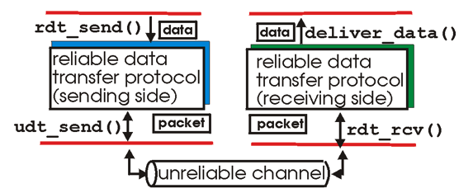

The provided code includes the **UnreliableChannel** class, the **Segment** class (for data and acknowledgment packets), and the main function. Your task is to finish the implementation of the **RDTLayer** class. When you review the rdt_main.py file, you'll notice that the **RDTLayer** class is used for both the client and server. Sending data happens in the processSend() method, and receiving data happens in the processReceiveAndSendRespond() method. Each method must determine if the instance is a client or server and act accordingly, meaning the **RDTLayer** will handle sending and receiving data and acknowledgment segments.

Your code should be able to simulate many of the features discussed in your textbook for RDT and TCP. Note that we will not be using actual TCP headers or bytes. This is more high-level than that, but the principles are the same.

RDTLayer

The RDTLayer class needs to provide reliable transport no matter how bad the unreliable channel is at delivering packets. And it is bad! The UnreliableChannel class may do any of the following:

* Deliver packets out-of-order (data or ack packets)
* Delay packets by several iterations (data or ack packets)
* Drop packets (data or ack packets)
* Experience errors in transmission (failed checksum - data packets only)
* Various combinations of the above

*\*\*The words ‘segment’ and ‘packet’ are frequently used interchangeably with TCP communications.*

The RDTLayer class must handle all of these and deliver the data correctly and as efficiently as possible. In this project, you must finish the implementation of the RDTLayer class. To help build your RDTLayer implementation, the UnreliableChannel class takes flags that can turn on/off the different types of unreliability. It is recommended that you use those flags, starting with completely reliable channels, get that working, and go from there, enabling each of the unreliable features in turn.

Note that the Segment class already has methods for calculating and checking the checksum. It also has methods for saving a ‘timestamp’ (iteration count). We will be using iteration count instead of time, because the simulation executes much too quickly to use actual time.

Your final RDTLayer implementation must:

* Run successfully with the original provided UnreliableChannel and Segment classes
* Deliver all of the data with no errors
* Succeed even with all of the unreliable features enabled
* Send multiple segments at a time (pipeline) (This project program is operating in discrete time slices/iterations rather than continuous time. If you are sending the maximum amount of data you can at each iteration (based on the state of the available flow control window) instead of strictly a single segment at each iteration, you are likely meeting the pipeline requirement.)
* Utilize a flow-control ‘window’
* Utilize Go-Back-N or selective retransmit
* Include segment ‘timeouts’ (use iteration count, not actual time)
* Abide by the payload size constant provided in the RDTLayer class
* Abide by the flow-control window size constant provided in the RDTLayer class
* Efficiently run with the fewest packets sent/received. Who can transmit all of the data with the fewest iterations?

Example screenshots:

Output with smaller texts:

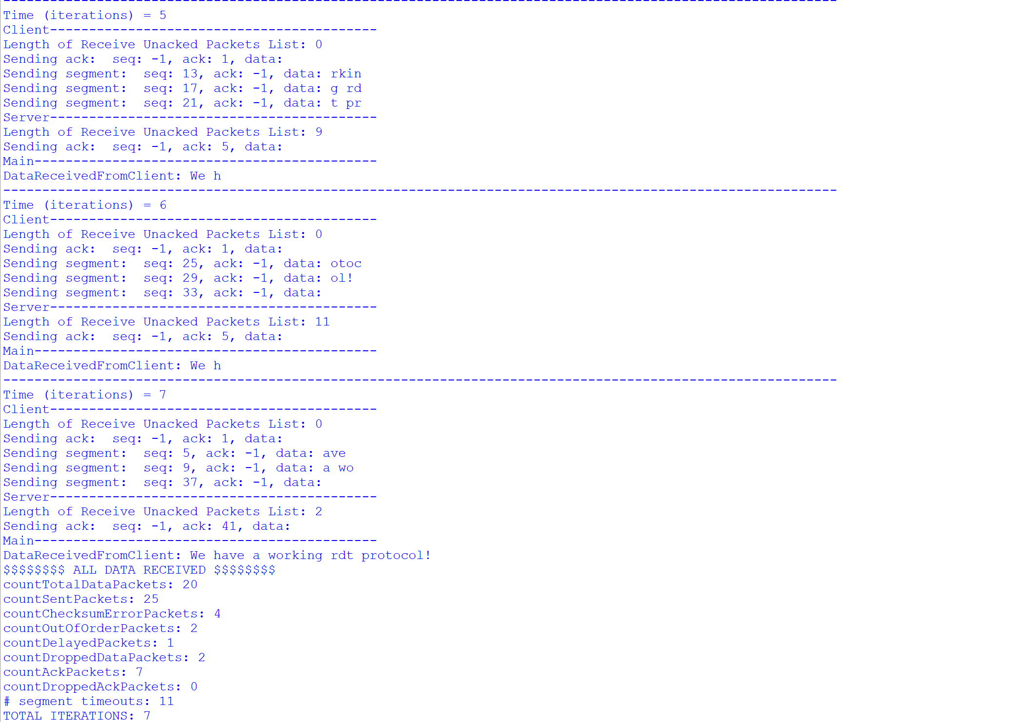

Output with larger texts:

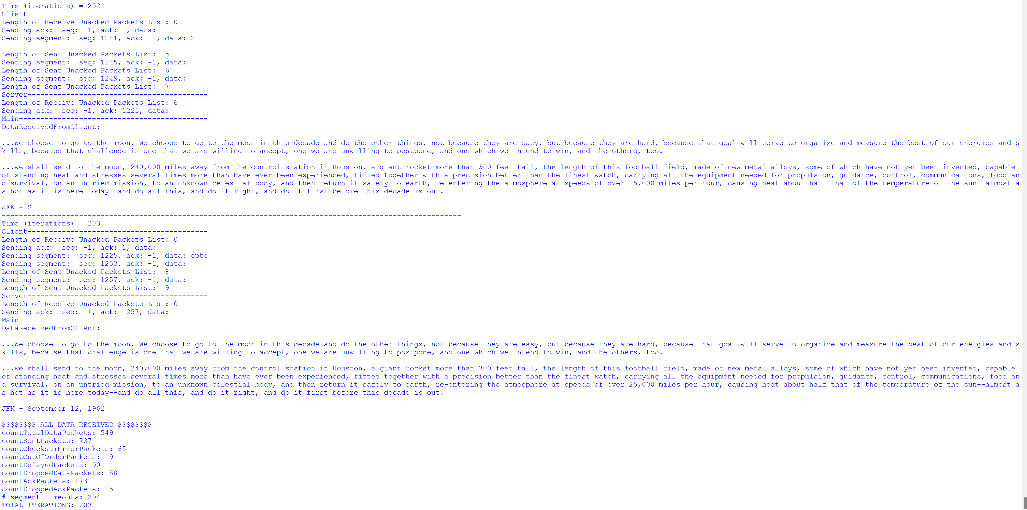

What to turn in

1. Include a copy of all your code.
2. Include the answers and screenshots for the following questions:

* Where did the bulk of logic occur? (3 pts)
* How were the timeouts resolved?  What happened if timeouts have been resolved? (3+ 2 pts)
* How was the packet dropping handled? (2 pts)
* How was the retransmission policy implemented (5 pts)? Please provide a screenshot of the output to show the policy clearly.

1. In rdt_main.py, you will see two different length texts to send through the RDTLayer. Start with the smaller one, then try the larger one.
2. Take screenshots of your running code for both the larger and smaller texts and include it in your submission doc.
3. Add any comments/questions to your submission doc.