**Rotterdam Project**

Environmental Consultants helping farmers reduce pollution

List of Resources

* Ammonium test kit
* Phosphate test kit
* Ladel
* Beaker
* Dissolved o2 probe
* EC , TDS , pH probe
* Deionised water

Location 1

Coordinates – (51.9249651 , 4.6898213)

What 3 words – Rebelled Rots Roved

Weather – 12 degrees 12mph – windy and warm

TOD - 9:50

Ammonium nitrate mg/l : 0.04 0.16 0.21

Phosphate : 0.00 0.00 0.00

Dissolved O2 : 14 , 14 , 14 , 14.1

EC micro siemens : 610 , 609 , 609 , 607

TDS ppm: 304 , 304 , 303 , 302

pH: 7.88 , 7.87 , 7.82 , 7.79

Soil :

EC: 44 , 44 , 45 , 46

TDS: 22 , 23 , 23 , 23

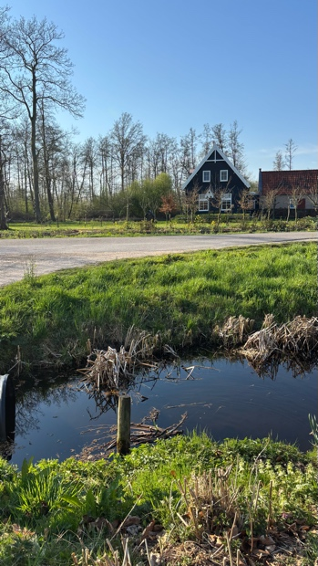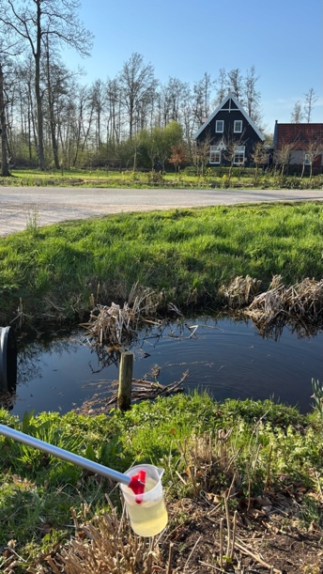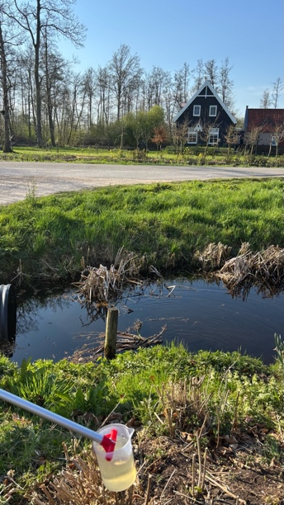pH: 7.98 , 7.87 , 7.81 , 7.84

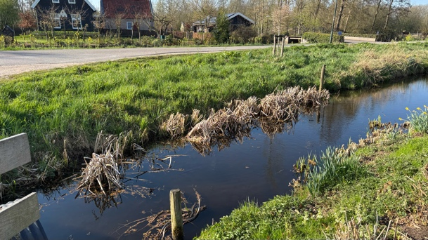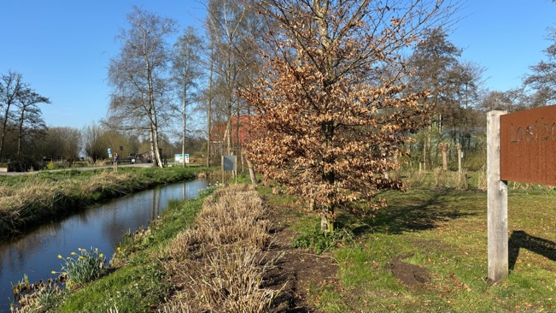

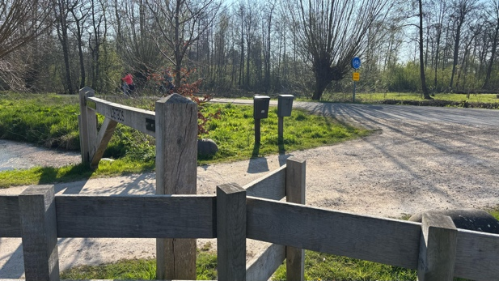

Location 2

Coordinates – ( 51.93258 N , 4.69048 E )

What 3 words – Shepards Strengths Sing

Weather – 14 mph 14 degrees gusty and warm

TOD – 11:10

Ammonium nitrate mg/l : 1.46 0.59 0.69

Phosphate : 0.00 0.00 0.10

Dissolved O2 : -0.18 , -0.17 , -0.18

EC micro siemens : 524 , 525 , 524

TDS ppm: 261 , 261 , 261

pH: 6.92 , 6.96 , 6.97 , 7.00

Soil :

EC: 24 , 25 , 25 , 25

TDS: 12 , 12 , 13 , 13

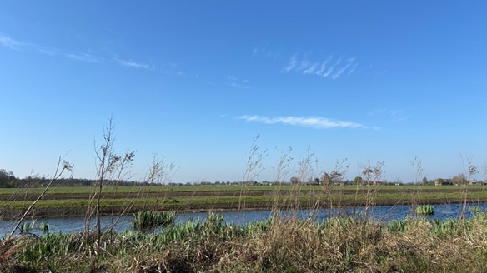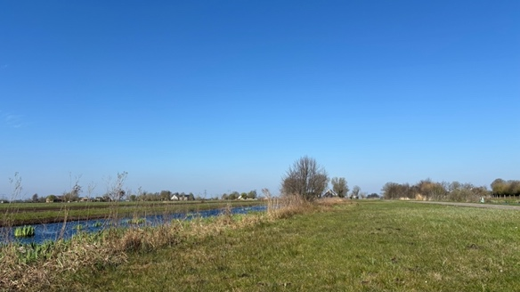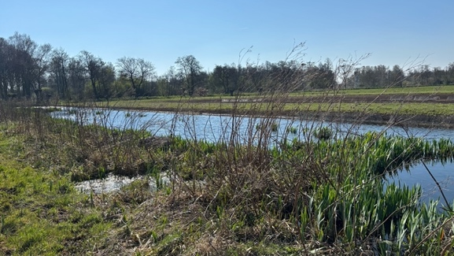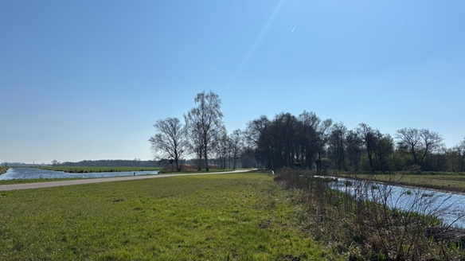pH: 7.14 , 7.13 , 7.08 , 7.03

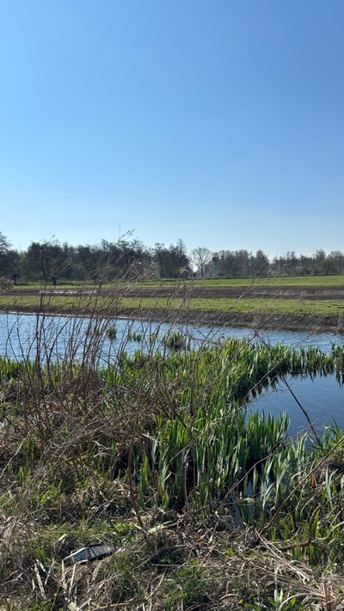

Location 3

Coordinates – (51.93269° N, 4.69060° E)

What 3 words – inapt evolves televised

Weather – windy sunny 16 degrees 14mph ESE winds

TOD – 12:05

Ammonium nitrate mg/l : 0.01 , 0.00 , 0.01

Phosphate : 0.00 0.00 0.00

Dissolved O2 : 15.59 , 15.86 , 15.88 , 18.88

EC micro siemens : 615 , 616 , 617 , 617

TDS ppm: 308 , 309 , 309 , 308

pH: 6.56 , 6.85 , 6.92 , 7.02

Soil :

EC: 22 , 23 , 23 , 23

TDS: 14 , 14 , 15 , 15

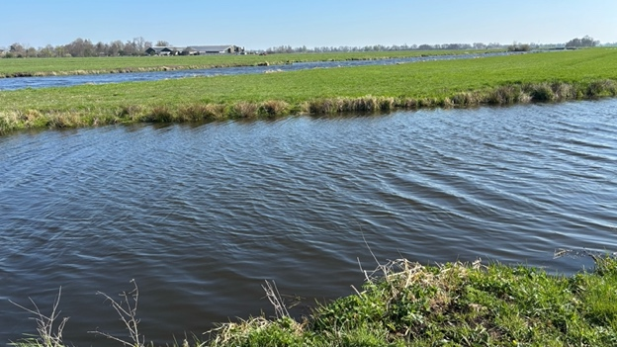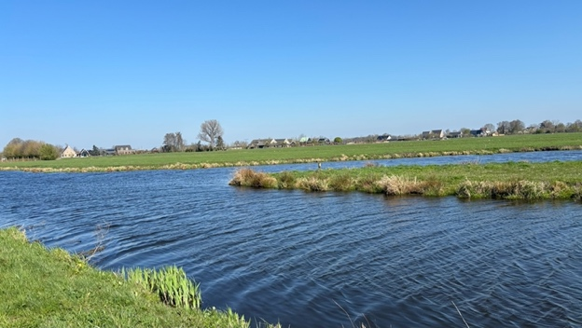pH: 7.89 , 7.89, 7.87 , 7.85

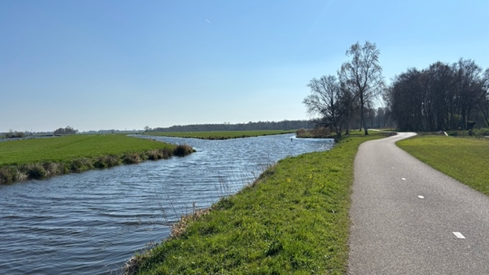

Location 4

Coordinates – (51.92660 N , 4.68902 E)

What 3 words – Jelly Philsopher Fluids

Weather – sunny less wind 18 degrees

TOD – 14:00

Ammonium nitrate mg/l : 0.79 , 1.24 , 1.35

Phosphate : 0.13 0.00 0.03

Dissolved O2 : -0.21 , -0.13 , -0.13 , -0.14

EC micro siemens : 543 , 543 , 543 , 543

TDS ppm: 272 , 272 , 272 , 272

pH: 7 , 7 , 7.03 , 7.05

Soil :

EC: 83 , 83 , 83 , 83

TDS: 37 , 37 , 37 , 37

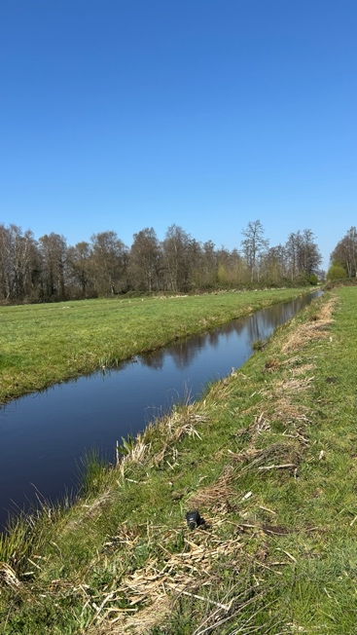pH: 6.5 , 6.51 , 6.4 , 6.45

