**Capstone Project Concept Note and Implementation Plan**

**Project Title: *Predictive Flood Modeling for Resilient Communities in Sierra Leone.***

**Team Members**

1. Steven Daniel

**Concept Note**

**1. Project Overview**

The capstone project focuses on developing a flood prediction model for Sierra Leone, a country frequently grappling with flood disasters during the rainy seasons. Leveraging crucial environmental data such as rainfall patterns, humidity, and temperature, clouds, dew point etc, the project aims to deliver accurate and timely predictions. The primary objective is to facilitate swift measures for mitigating the impact on communities and critical infrastructure.

The project directly aligns with 3 SDGs; SDG 11 – Sustainable Cities and Communities, SDG 13 – Climate Action, and SDG 9 – Industry, Innovation, and Infrastructure. Additionally, it is indirectly related to SDG 1 – No poverty.

***SDG 11 – Sustainable Cities and Communities:*** By providing timely flood predictions, the project contributes to creating more resilient and sustainable cities and communities. Swift measures based on accurate predictions can minimize the impact of floods on urban areas, protecting both lives and infrastructure.

***SDG 13 – Climate Action:*** The project aligns directly with climate action by addressing the impact of flooding, a consequence intensified by climate change. Mitigating the effects of floods through accurate predictions supports the broader goal of climate resilience.

***SDG 9 – Industry, Innovation, and Infrastructure:*** The development of a flood prediction model represents a technological innovation that contributes to the advancement of infrastructure resilience. By integrating data-driven insights, the project aligns with the goal of fostering sustainable and resilient infrastructure development.

***SDG 1 – No Poverty:*** While not directly related to SDG 1, the project indirectly addresses poverty reduction by mitigating the impact of natural disasters. Protecting communities from floods helps safeguard livelihoods, prevent economic loss, and contributes to overall poverty reduction.

The problem at hand is the recurrent occurrence of floods in Sierra Leone, leading to significant human and economic losses [1][2]. The potential impact of the solution lies in:

* ***Reducing Deaths and Affected Population:*** Timely and accurate flood predictions enable authorities to evacuate vulnerable areas, reducing the number of casualties and people affected.
* ***Economic Impact Reduction:*** By providing actionable insights, the model helps mitigate the economic impact on GDP caused by flood disasters, contributing to the overall economic stability of the region.
* ***Climate Change Resilience:*** The project addresses the broader challenge of climate change by developing a tool that aids in adapting to and mitigating the consequences of changing environmental patterns.
* ***Infrastructure and Community Resilience:*** Implementing effective flood mitigation measures enhances the resilience of critical infrastructure and communities, aligning with the broader goals of sustainable development.

**2. Objectives**

The primary aim is to build a predictive model that delivers precise and timely flood predictions, facilitating prompt actions to mitigate the impact on both communities and infrastructure. In pursuit of this primary goal, the following specific objectives will guide the execution of the project:Top of Form

1. *Aggregate and preprocess data to establish a robust foundation for the flood prediction model by compiling a comprehensive dataset, ensuring inclusivity of relevant environmental variables.*
2. *Utilize machine learning algorithms such as Logistic Regression, K-Nearest Neighbors (KNN), Support Vector Machine (SVM), and Decision Tree for flood predictions to apply advanced analytical techniques to interpret complex relationships within the dataset, enhancing prediction accuracy and reliability.*
3. *Evaluate and select appropriate technologies and tools for data analytics, and machine learning to ensure the adoption of cutting-edge methodologies, enhancing the precision and scalability of the flood prediction model.*
4. *Validate the machine learning model using historical data and optimize parameters for improved performance. This is to enhance the model's reliability by rigorously validating its predictive capabilities and fine-tuning parameters for optimal results.*
5. *Create an intuitive interface for end-users to access and interpret flood predictions. This will facilitate the practical application of predictions by providing a user-friendly interface for decision-makers and communities.*

**Project's Contribution to Problem Under Review:**

1. ***Prediction Accuracy:*** By deploying advanced machine learning algorithms, the project aims to significantly improve the accuracy of flood predictions, enabling timely and precise response measures.
2. ***Community Resilience:*** The user-friendly interface empower communities to take informed actions, enhancing their resilience to flood disasters.
3. ***Resource Optimization:*** The project contributes to optimizing resource allocation by providing accurate predictions, allowing authorities to focus efforts on high-risk areas.
4. ***Long-Term Adaptability:*** Continuous monitoring and updating ensure the model remain effective in the face of changing environmental dynamics, addressing the long-term sustainability of flood prediction efforts.

**3. Background**

Sierra Leone, a small country on the west coast of Africa with a population of 7,548,702 [3], grapples with recurring challenges, especially during the rainy seasons, where devastating floods wreak havoc on vulnerable communities and critical infrastructure. The susceptibility to flooding is heightened by a convergence of geographical, climatic, and environmental factors, underscoring the urgency to develop effective predictive models.

The historical backdrop is marked by severe flooding incidents, notably the catastrophic mudslide and flooding on August 14, 2017, claiming over 400 lives [1], left hundreds injured, with an additional 600 people missing and leaving over 3,000 people homeless, destroyed hundreds of properties and displaced hundreds of families at Sugar Loaf mountain running through the Lumley community in the outskirts of Freetown, Sierra Leone’s capital [4] leaving hundreds injured, and displacing thousands, with lingering effects on housing and livelihoods.

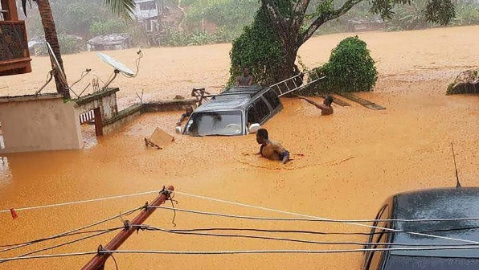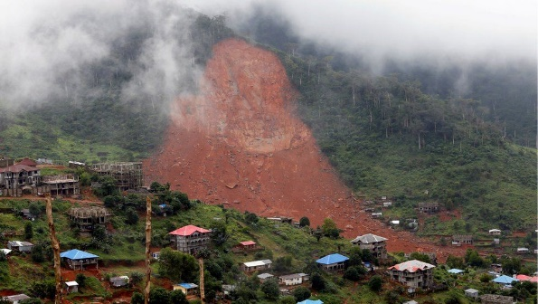***Figure 1: Sierra Leone’s 2017 devastating mudslide***

*Source:* [*https://www.bbc.com/news/world-africa-40973539*](https://www.bbc.com/news/world-africa-40973539)

***Figure 2: Funeral rites of Sierra Leone’s 2017 devastating mudslide victims***

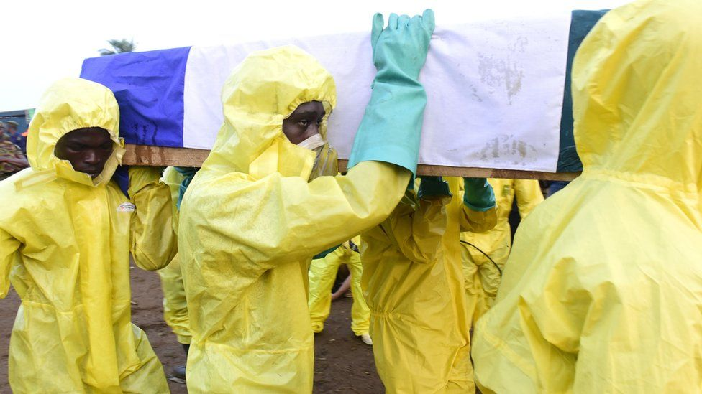

*Source:* [*https://www.bbc.com/news/world-africa-40973539*](https://www.bbc.com/news/world-africa-40973539)

Another significant event occurred from May to August 2019, with persistent torrential rains causing floods, landslides, and extensive destruction, impacting livelihoods of approximately 896 households (5,381 people) according to the results of the rapid needs assessment (RNA) conducted by the Office of National Security (ONS) in collaboration with other humanitarian actors in disaster management [2].

***Figure 3: Image of 2019 flooding in Sierra Leone***

*Source:* [5]

While existing mechanisms for flood prediction exist, they often lack the precision and timeliness needed for proactive measures. Traditional methods relying on historical data and manual observations struggle to keep pace with the dynamic nature of weather patterns and environmental conditions.

In response, the project advocates for a transformative approach: leveraging machine learning for flood prediction. Conventional methods stumble in handling the complexity of environmental factors, whereas machine learning excels in processing large datasets, identifying complex patterns, and making accurate predictions. Technology allows for a clear understanding of flood dynamics, incorporating real-time data to enhance predictive model effectiveness.

While environmental monitoring initiatives have laid essential groundwork, integrating advanced machine learning algorithms signifies a crucial leap forward. By harnessing data analytics and predictive modeling, the project aims to boost precision and lead time for flood predictions, empowering authorities, and communities with insights for proactive interventions.

The choice of a machine learning approach is justified by its capacity to analyze historical data and adapt to evolving patterns in real-time. Leveraging environmental data such as rainfall patterns, river flow, and topography, machine learning algorithms discern subtle relationships, generating accurate and timely predictions. This shift from reactive to proactive flood management aligns with global best practices, emphasizing the necessity of innovative approaches in addressing the complex challenge of flood prediction and mitigation.

**4. Methodology**

The methodology for developing the flood prediction model involves the application of machine learning techniques to analyze and predict flood occurrences. This project will follow the SDG AI Lab’s Data Science Project Framework [6] with slight variation.

The key steps and methodologies include:

1. ***Business Understanding:***

Gaining a clear understanding of the business problem or opportunity that the project aims to address. This phase is crucial as it articulates the business objectives or problems that this project aims to solve.

1. ***Data Collection:***

This will involve acquiring a comprehensive dataset containing information on rainfall patterns, river flow, topography, and historical flood records. This involves sourcing data from relevant data sources, and relevant datasets from Kaggle. Due to unavailability of data from meteorological agencies, satellite imagery, environmental monitoring stations in Sierra Leone, I will use data from Kaggle that is related to other countries to build the mode.

1. ***Data Preprocessing:***

Cleaning and preparing the collected data for analysis. This includes handling missing values, normalizing data, and addressing outliers to ensure the dataset's quality and reliability.

1. ***Feature Selection:***

Identifying the most relevant features that significantly contribute to flood prediction. This involves a thorough analysis of the dataset to select key variables such as rainfall intensity, river flow rates, and geographical factors.

1. ***Algorithm Selection:***

Choosing appropriate machine learning algorithms based on the nature of the problem. For this flood prediction model, logistic regression, k-nearest neighbors (KNN), support vector machine (SVM), and decision tree algorithms are selected for their effectiveness in classification tasks and their suitability for handling various data types.

1. ***Model Training:***

Training the selected machine learning models using historical data. This involves feeding the algorithm with labeled data, allowing it to learn and identify patterns associated with past flood occurrences.

1. ***Model Evaluation:***

Assessing the performance of the trained models using evaluation metrics such as accuracy, precision, recall, and F1 score. This step ensures that the models can effectively generalize to new, unseen data.

1. ***Real-time Data Integration:***

Ensuring the model's adaptability by incorporating real-time data through API call, enabling it to dynamically adjust predictions based on evolving weather conditions and environmental changes.

1. ***Model Deployment:***

Implementing the trained and optimized model in a deployable form for practical use. This includes integrating the model into a user-friendly interface for authorities and communities to access timely flood predictions.

The implementation of random forest classifier, logistic regression, KNN, SVM, and decision tree algorithms, coupled with real-time data adaptability, forms a robust methodology for developing a reliable and effective flood prediction model.

**5.** **Architecture Design Diagram**

***Figure 4: SDG AI Lab Standard Framework for a Data Science Project (Architecture Diagram)***

*Source:* [6]

**Components of the Architecture Diagram**

1. ***Data Collection:***

* Responsible for gathering data from various sources such as meteorological agencies, satellite imagery, and environmental monitoring stations.
* Integrates with external datasets, including those from platforms like Kaggle.

1. ***Data Exploration and Preparation:***

* Cleans and prepares the collected data, handling missing values, normalizing data, and addressing outliers.
* Ensures the quality and reliability of the dataset for further analysis.

1. ***Model Selection and Feature Engineering:***

* Identifies and selects relevant features that significantly contribute to flood prediction.
* Analyzes the dataset to determine key variables such as rainfall intensity and geographical factors.

1. ***Build/Train Model:***

* Incorporates logistic regression, k-nearest neighbors (KNN), support vector machine (SVM), and decision tree algorithms for flood prediction.
* Trains the selected models using historical data to learn and identify patterns associated with past flood occurrences.

1. ***Model Evaluation:***

* Assesses the performance of the trained models using evaluation metrics such as accuracy, precision, recall, and F1 score.
* Ensures the models can effectively generalize to new, unseen data.

1. ***Model Deployment:***

* Implements the trained and optimized model in a deployable form for practical use.
* Integrates the model into a user-friendly interface for authorities and communities to access timely flood predictions.

**6. Data Sources**

For this project, the primary data source is historical weather data for Sierra Leone spanning the past forty years. The dataset, obtained from OpenWeather (<https://openweathermap.org/>), comprises information on various weather parameters, including temperature, rainfall, humidity, wind speed, and more, measured hourly since January 1, 1979. This dataset is crucial for building a predictive flood model, as it aligns with the geographical and climatic conditions of Sierra Leone. The preprocessing steps involve addressing missing values and optimizing the dataset for machine learning model training, ensuring accuracy in flood predictions. The rich coverage of weather parameters in this dataset serves as a valuable resource, enabling insights into the distinct wet and dry seasons, anomalous years with exceptionally high rainfall, and overall trends in annual rainfall. The relevance of this data is underscored by its capacity to contribute to the development of a reliable flood prediction model, enhancing the region's resilience to extreme weather events.

Top of Form

*Source of data:* [*https://history.openweathermap.org/storage/52b96426702dd7eed9a4507cd5c11615.csv*](https://history.openweathermap.org/storage/52b96426702dd7eed9a4507cd5c11615.csv)

Top of Form

**7. Literature Review**

The literature review presents three significant flood prediction models, each contributing valuable insights to the field. First, the exploration of various machine learning (ML) algorithms highlights their importance in addressing challenges faced by traditional models, providing a foundation for your project [8]. Second, the hybrid modeling approach incorporating Long Short-Term Memory (LSTM) for urban flood forecasting showcases the effectiveness of combining rainfall-runoff models with deep learning techniques, inspiring your project's application of similar hybrid models to Sierra Leone's environmental conditions [9]. Third, the optimized Artificial Neural Network (ANN), particularly the Multi-Layer Perceptron (MLP), for river water level forecasting serves as a reference for your project's focus on tailoring ANN architectures to specific time horizons, enhancing accuracy in predicting floods in Sierra Leone [10]. In essence, this project builds upon and extends these models, adapting ML techniques to Sierra Leone's context, employing hybrid modeling, and optimizing ANN architectures for precise and timely flood predictions.

**Implementation Plan**

**1. Technology Stack**

1. ***Programming Languages:***

* ***Python***: For its extensive support in machine learning libraries and data processing and for front-end development.

1. ***Libraries*:**

* ***Pandas***: For data manipulation and preprocessing.
* ***NumPy***: For numerical operations and array processing.
* ***Scikit-learn:*** For machine learning algorithms and model evaluation.
* ***TensorFlow***: For implementing and training machine learning models.
* ***Matplotlib and Seaborn***: For data visualization.

1. ***Frameworks*:**

* ***Flask:*** For building the web application and API to deploy the model.

1. ***Integrated Development Environment***

* ***Jupyter Notebooks:*** For interactive development and testing of machine learning models.
* ***Visual Studio Code:*** For developing web frontend web pages and building flask API application to get data from API and return prediction.

1. ***Database:***

* ***SQLite***: For storing and managing structured data.

1. ***Containerization:***

* ***Docker:*** For containerizing the application, ensuring consistent deployment across different environments.

1. ***Cloud Platform:***

* ***Digital Ocean:*** For scalable and cloud-based storage, computation, and deployment.

1. ***Web Development:***

* ***HTML, CSS, JavaScript:*** For frontend development.
* ***Bootstrap or other frontend frameworks***: For responsive and user-friendly web interfaces.

1. ***Version Control:***

* ***Git:*** For version control and collaboration.

**2. Timeline**

|  |  |  |  |  |
| --- | --- | --- | --- | --- |
| **ID** | **TASK NAME** | **EXPECTED START DATE** | **EXPECTED END DATE** | **ACTUAL END DATE** |
| D1 | Capstone project workshop | Nov 7, 2023 | Nov 7, 2023 | Nov 7, 2023 |
| D2 | Idea proposal submission | Nov 15, 2023 | Nov 15, 2023 | Nov 15, 2023 |
| D3 | Pair coding (EDA) | Nov 14, 2023 | Nov 14, 2023 | Nov 14, 2023 |
| D4 | Literature review, Data review and technology review submission | Nov 19, 2023 | Nov 26, 2023 | Nov 26, 2023 |
| D5 | In-class check (Lit, tech, data reviews) | Nov 20, 2023 | Nov 20, 2023 | Nov 20, 2023 |
| D6 | Pair coding (Deep learning) | Nov 21, 2023 | Nov 21, 2023 | Nov 21, 2023 |
| D7 | Concept note and implementation plan submission | Nov 24, 2023 | Nov 26, 2023 | Nov 26, 2023 |
| **D8** | **Data Collection and Preprocessing** | | | |
| T1 | Acquire flood data from Kaggle's "Kerala Flood: Monthly Rainfall Index and Flood Probability" dataset. | Nov 9, 2023 | Nov 11, 2023 | Nov 14, 2023 |
| T2 | Perform data cleaning to address missing values and ensure consistency in format. | Nov 10, 2023 | Nov 14, 2023 | Nov 20, 2023 |
| T3 | Conduct exploratory data analysis to gain insights into the dataset. | Nov 14, 2023 | Nov 16, 2023 | Nov 21, 2023 |
| **D9** | **Model Development** | | | |
| T1 | Choose machine learning algorithms for flood prediction (Logistic Regression, K-Nearest Neighbors, SVM, Decision Tree) | Nov 15, 2023 | Nov 16, 2023 | Nov 16, 2023 |
| T2 | Implement selected algorithms and fine-tune parameters. | Nov 16, 2023 | Nov 19, 2023 | Nov 26, 2023 |
| T3 | Validate the model using historical data and adjust as needed. | Nov 20, 2023 | Nov 22, 2023 | Nov 27, 2023 |
| **D10** | **Training and Evaluation** | | | |
| T1 | Split the dataset into training and testing sets. | Nov 22, 2023 | Nov 24, 2023 | Nov 28, 2023 |
| T2 | Train the model with the training set. | Nov 22, 2023 | Nov 24, 2023 | Nov 28, 2023 |
| T3 | Evaluate model using the testing set and refine as necessary. | Nov 22, 2023 | Nov 24, 2023 | Nov 28, 2023 |
| T4 | Model refinement and testing | Nov 25, 2023 | Nov 28, 2023 | Dec 02, 2023 |
| T5 | Pair coding (Model test and evaluation | Nov 28, 2023 | Nov 28, 2023 | Nov 28, 2023 |
| T6 | Data preparation/Feature Engineering and model exploration submission | Nov 29, 2023 | Nov 29, 2023 | Nov 29, 2023 |
| T7 | In-class check (Data preparation) | Nov 30, 2023 | Nov 30, 2023 | Nov 30, 2023 |
| T8 | Model refinement and tests submission | Dec 3, 2023 | Dec 3, 2023 | Dec 3, 2023 |
| T8 | Code, draft presentation submission | Dec 5, 2023 | Dec 5, 2023 | Dec 5, 2023 |
| T9 | In-class check (code, draft presentation) | Dec 6, 2023 | Dec 6, 2023 | Dec 6, 2023 |
| **D11** | **Deployment** | | | |
| T1 | Choose a suitable platform or framework for model deployment. | Nov 24, 2023 | Nov 24, 2023 | Nov 24, 2023 |
| T2 | Develop a user interface for accessing flood predictions. (HTML, CSS, Python) and develop API to get data for making real-time prediction. | Nov 24, 2023 | Nov 30, 2023 | Dec 8, 2023 |
| T3 | Deploy the model on the chosen platform | Dec 9, 2023 | Dec 9, 2023 | Dec 9, 2023 |
| T4 | Test the deployed model with real-time or simulated data. | Dec 9, 2023 | Dec 10, 2023 | Dec 10, 2023 |
| **D12** | **Deployment submission** | | | |
| T1 | Deployment submission | Dec 11, 2023 | Dec 11, 2023 | Dec 11, 2023 |
| T2 | Final draft presentation submission | Dec 13, 2023 | Dec 13, 2023 | Dec 13, 2023 |
| D13 | **Presentation** | | | |
| T1 | Presentation day rehearsal (Q & A) | Dec 15, 2023 | Dec 15, 2023 | Dec 15, 2023 |
| **D14** | **Presentation day/ Graduation Day** | **Dec 17, 2023** | **Dec 17, 2023** | **Dec 17, 2023** |

**3. Milestones**

1. Successful acquisition and preprocessing of data from Kaggle.
2. Selection and implementation of machine learning algorithms (Logistic Regression, K-Nearest Neighbors, SVM, Decision Tree).
3. Successful development of the model.
4. Splitting of the dataset into training and testing sets.
5. Completion of training model with the training set.
6. Successful evaluation of model using the test set.
7. Selection of a suitable platform or framework for model deployment.
8. Successful development of a user interface for accessing flood predictions.
9. Successful development of API application for accessing real-time weather forecasts used for making prediction.
10. Deployment of the model on the chosen platform and successful testing with real-time or simulated data.

**4. Challenges and Mitigations**

1. ***Data Quality:***

* ***Challenge:*** Inconsistencies or inaccuracies in the collected data may impact the reliability of the flood prediction model.
* ***Mitigation*:** Implement thorough data validation and cleaning processes during the preprocessing stage. Utilize statistical methods and visualization techniques to identify and rectify outliers or missing values. Collaborate with domain experts to ensure data accuracy and relevance.

1. ***Model Performance:***

* ***Challenge*:** The selected machine learning algorithms may not perform optimally, leading to inaccurate predictions.
* ***Mitigation*:** Conduct extensive testing and evaluation of multiple algorithms to identify the most suitable ones for the specific context of the model. Implement ensemble methods or fine-tuning techniques to enhance model performance.

1. ***Technical Constraints:***

* ***Challenge*:** Technical limitations, such as hardware constraints or platform compatibility issues, may hinder the deployment and scalability of the flood prediction model.
* ***Mitigation*:** Perform a comprehensive analysis of the technical requirements for model deployment. Choose a scalable and compatible platform and ensure that the chosen technology stack aligns with the project's objectives. Monitor system performance regularly and address any technical constraints promptly to maintain the model's effectiveness.

**5. Ethical Considerations**

1. ***Data Privacy:***

* ***Consideration*:** Respect for individuals' privacy and the confidentiality of personal data collected for the project.
* ***Mitigation*:** Implement robust data anonymization techniques to remove personally identifiable information from the dataset. Adhere to relevant data protection regulations and obtain necessary permissions for data collection.

1. ***Bias in Data and Models:***

* ***Consideration*:** Unintentional bias in the data or models that may disproportionately impact certain demographic groups.
* ***Mitigation*:** Conduct a thorough bias analysis of both training and evaluation datasets. Address bias through data preprocessing techniques, such as choosing machine learning algorithms that are less prone to bias. Regularly monitor and audit the model for fairness throughout its lifecycle.

1. ***Community Impact:***

* ***Consideration*:** Potential impact, positive or negative, on the communities in Sierra Leone based on flood predictions.
* ***Mitigation*:** Engage with local communities, authorities, and stakeholders to ensure that the deployment of the flood prediction model aligns with their needs and priorities. Communicate the model's predictions transparently and responsibly, emphasizing its role as a tool for preparedness rather than creating panic. Establish feedback mechanisms for continuous improvement based on community insights.

1. ***Transparency and Accountability:***

* ***Consideration*:** Ensuring transparency in the decision-making process of the machine learning model and being accountable for its predictions.
* ***Mitigation*:** Provide clear documentation on the model's architecture, training data, and evaluation metrics. Foster open communication with stakeholders about the model's limitations and uncertainties. Establish mechanisms for handling and learning from model errors and iterate on the model based on feedback and evolving conditions.

**6. References**

[1] “Reflections on Sierra Leone’s mudslide disaster - BBC News.” Accessed: Nov. 20, 2023. [Online]. Available: https://www.bbc.com/news/world-africa-40973539

[2] “Sierra Leone: Floods - Emergency Plan of Action (EPoA) DREF n° MDRSL008 Final Report - Sierra Leone | ReliefWeb.” Accessed: Nov. 26, 2023. [Online]. Available: https://reliefweb.int/report/sierra-leone/sierra-leone-floods-emergency-plan-action-epoa-dref-n-mdrsl008-final-report

[3] “Stats SL - Statistics Sierra Leone Hands Over Final Census Results To President Bio.” Accessed: Nov. 26, 2023. [Online]. Available: https://www.statistics.sl/index.php/statistics-sierra-leone-hands-over-final-census-results-to-president-bio.html

[4] “Sierra Leone: Post-Mudslides and Floods Needs Assessment and Recovery Framework | GFDRR.” Accessed: Nov. 26, 2023. [Online]. Available: https://www.gfdrr.org/en/sierra-leone-post-mudslides-and-floods-needs-assessment-and-recovery-framework

[5] “MDRSL008-Sierra Leone Floods-DREF Final Report.”

[6] “SDG AI Lab Data Science Project Framework (Capstone Project).pptx.” Accessed: Nov. 26, 2023. [Online]. Available: https://undp.sharepoint.com/:p:/r/sites/FrontierTechLeadersCommunity/_layouts/15/Doc.aspx?sourcedoc=%7B870D3A35-8B5A-4F52-8726-F9D6CBE9714C%7D&file=SDG%20AI%20Lab%20Data%20Science%20Project%20Framework%20(Capstone%20Project).pptx&action=edit&mobileredirect=true

[7] “Monthly Rainfall Index and Flood Probability.” Accessed: Nov. 21, 2023. [Online]. Available: https://www.kaggle.com/datasets/mukulthakur177/kerela-flood/data

[8] A. Mosavi, P. Ozturk, and K.-W. Chau, “Flood Prediction Using Machine Learning Models: Literature Review.”

[9] H. Moon, S. Yoon, and Y. Moon, “Urban flood forecasting using a hybrid modeling approach based on a deep learning technique,” *Journal of Hydroinformatics*, vol. 25, no. 2, pp. 593–610, Mar. 2023, doi: 10.2166/hydro.2023.203.

[10] A. Paul and P. Das, “Flood Prediction Model using Artificial Neural Network,” *International Journal of Computer Applications Technology and Research*, vol. 3, no. 7, pp. 473–478, 2014, [Online]. Available: www.ijcat.com