**Capstone Project Concept Note and Implementation Plan**

**Group Members:  
Finhas Demissie  
Selam Habtewolde  
Bealu Girma**

**Concept Note**

**1. Project Overview**

**This capstone project aims to develop a machine learning-based model for predicting landslide susceptibility in Ethiopia, aligning with Sustainable Development Goals (SDGs) 11 (Sustainable Cities and Communities) and 13 (Climate Action). The project addresses the critical issue of landslide risk, which threatens lives, infrastructure, and development in the region. By identifying high-risk areas, the solution has the potential to save lives, protect assets, and support sustainable urban planning and disaster preparedness.**

**2. Objectives**

**The primary objectives of this project are:**

**· Develop a predictive model that accurately identifies landslide-prone areas in Ethiopia.**

**· Integrate environmental and geological data such as elevation, rainfall, and land cover to enhance model accuracy.**

**· Facilitate early warning systems by providing timely and reliable risk assessments to decision-makers and local communities.**

**· Contribute to policy-making by offering data-driven insights that can inform urban planning, infrastructure development, and disaster management strategies.**

**3. Background**

**Ethiopia is highly susceptible to landslides due to its diverse topography and seasonal rainfall patterns. Current mitigation strategies are often reactive rather than proactive, leading to significant loss of life and property. Existing solutions include basic risk maps and early warning systems, but they lack precision and scalability. A machine learning approach is necessary to improve prediction accuracy and to handle large, complex datasets that traditional methods struggle to process.**

**4. Methodology**

**The project will employ supervised learning techniques, using algorithms such as Random Forest, Gradient Boosting, and Neural Networks to model landslide susceptibility. The model will be trained on a dataset that includes geospatial features like elevation, slope, rainfall, and land cover. Cross-validation and hyperparameter tuning will be utilized to optimize model performance. The final model will be evaluated using metrics such as accuracy, precision, recall, and F1-score to ensure robustness.**

**5. Architecture Design Diagram**

**The architecture of the project consists of the following key components:**

**· Data Collection: Gathering geospatial and environmental data from reliable sources.**

**· Data Preprocessing: Cleaning, normalizing, and transforming raw data into a suitable format for modeling.**

**· Model Training: Applying machine learning algorithms to the preprocessed data to build the predictive model.**

**· Model Evaluation: Assessing the model’s performance using statistical metrics and refining it as needed.**

**· Deployment: Implementing the model in a user-friendly interface for stakeholders to access and utilize.  
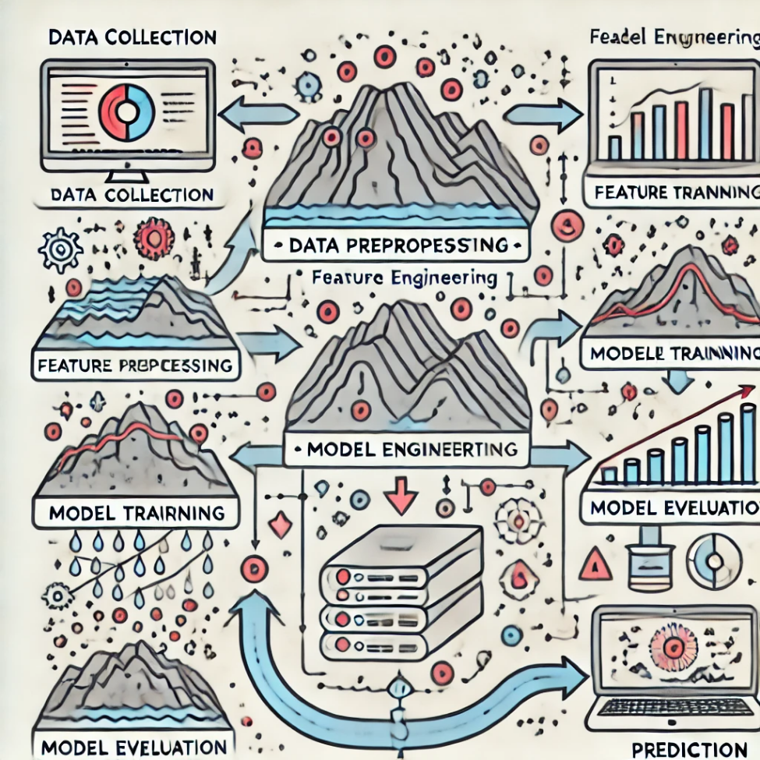**

***Each component's roles:***

**· Data Collection ensures the acquisition of accurate and relevant datasets.**

**· Data Preprocessing enhances the quality and suitability of data for analysis.**

**· Model Training focuses on creating a predictive model with high accuracy.**

**· Model Evaluation ensures the model’s reliability and effectiveness.**

**· Deployment provides an accessible platform for the model’s practical application.**

**6. Data Sources**

**The data for this project will be sourced from reputable institutions, including satellite imagery, topographical maps, and climate datasets. The data will include features like elevation, slope, rainfall, and land cover, which are critical in determining landslide susceptibility. Preprocessing steps will involve data cleaning, normalization, and feature engineering to ensure high-quality inputs for the model.**

**7. Literature Review**

**Existing research supports the use of machine learning in landslide prediction, particularly in regions with complex topographies like Ethiopia. Studies have demonstrated that integrating environmental factors such as elevation, slope, and rainfall into predictive models significantly enhances accuracy. This project builds on prior work by employing advanced algorithms and a comprehensive dataset, aiming to improve prediction precision and applicability in the Ethiopian context.**

**Implementation Plan**

**1. Technology Stack**

• List the technologies and tools you plan to use for the implementation of your project.

**Programming languages**

* **Python:** For developing the machine learning model, data preprocessing, and analysis.
* **JavaScript:** For front-end development of the website.

**Libraries**

* **Scikit-learn:** For implementing machine learning algorithms.
* **Pandas and NumPy:** For data manipulation and numerical operations.
* **Matplotlib and Seaborn:** For data visualization.

o **Frameworks**

* **Django:** For developing the web server and deploying the model.
* **React.js :** For building dynamic user interfaces on the website.

o **Any other software or hardware components.**

* **Jupyter Notebook:** For prototyping and experimenting with the machine learning model.
* **Git:** For version control and collaboration.

**2. Timeline** 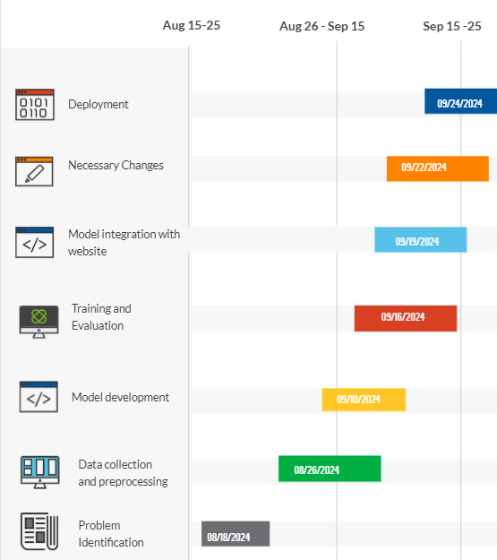

**3. Milestones**

• Identify key milestones in your project's development.

* **Dataset Acquisition**: Securing a reliable and high-quality dataset is crucial for the success of our landslide prediction model. We focused on obtaining a dataset that provides comprehensive and accurate data, ensuring that our model has a strong foundation to learn from.
* **Data Cleaning and Preprocessing:** Although time-consuming, the process of cleaning and preprocessing the data was essential. We meticulously balanced the dataset and ensured its quality, resulting in a refined dataset that is well-prepared for effective model training.

**4. Challenges and Mitigations**

• Anticipate potential challenges that may arise during the project and propose strategies for mitigating them.

* **Model Performance**: A significant challenge in my landslide prediction project was dealing with poor model performance. Despite multiple iterations, the initial results were unsatisfactory, largely due to issues with data quality. This necessitated repeated cycles of data preprocessing, including rebalancing the dataset, handling missing values, and refining feature selection. Each iteration was time-intensive, but it was crucial for improving the model's accuracy and reliability.

**5. Ethical Considerations**

• Discuss any ethical considerations associated with your project, especially concerning data privacy, bias, and the potential impact on the target community.

* **Data Privacy:** Protecting sensitive data, ensuring anonymization, and secure storage to maintain individuals' privacy.
* **Bias**: Addressing potential biases in the dataset to ensure fair and accurate predictions across different regions.
* **Impact on the Community:** Ensuring accurate predictions to aid in disaster preparedness while clearly communicating the model’s limitations to avoid unnecessary panic or false security.Team