# **Literature Review**

1. **Introduction:**
   * Landslide susceptibility mapping is critical for disaster preparedness, especially in mountainous regions like the Himalayas. The application of machine learning techniques and GIS-based approaches has significantly advanced the accuracy and utility of these maps. Reviewing existing literature helps identify effective methodologies and critical factors influencing landslide susceptibility, setting a foundation for your research.
2. **Organization:**
   * This literature review is organized thematically, focusing on machine learning techniques and GIS-based approaches used for landslide susceptibility mapping.
3. **Summary and Synthesis:**
   * **Machine Learning Techniques in the Himalayas:**
     + Pham et al. (2018) conducted a study on landslide susceptibility mapping in the Himalayas using various machine learning techniques, including Random Forest and Support Vector Machines. Their research demonstrated that machine learning models significantly improve prediction accuracy over traditional methods, particularly in complex terrains like the Himalayas. This study highlights the importance of selecting appropriate features and the potential of machine learning in high-risk regions.
   * **GIS-Based Mapping Using Logistic Regression and Random Forest:**
     + Chen et al. (2017) applied GIS-based logistic regression and Random Forest models to map landslide susceptibility in a region of China. The study found that the Random Forest model outperformed logistic regression in terms of prediction accuracy, demonstrating the value of ensemble learning techniques. The integration of GIS with machine learning models allowed for the efficient handling of spatial data, making it easier to identify high-risk areas for landslides.
4. **Conclusion:**
   * The reviewed literature emphasizes the effectiveness of machine learning techniques, particularly Random Forest, in improving landslide susceptibility mapping. The integration of GIS in these models further enhances their practical application in regions like the Himalayas. Your project will build on these findings by developing a machine learning model tailored to the environmental conditions of Ethiopia, aiming to contribute valuable tools for disaster risk management in the region.

**References:**

1. Pham, B. T., Prakash, I., Bui, D. T., Tien Bui, D., & Revhaug, I. (2018). Landslide susceptibility assessment using machine learning techniques: A case study of the Himalayas. Landslides, 15(3), 789-804. <https://doi.org/10.1007/s10346-017-0910-1>
2. Chen, W., Li, X., Wang, Y., & Liu, S. (2017). GIS-based landslide susceptibility mapping using logistic regression and random forest models: A case study in the Three Gorges area, China. Geomorphology, 291, 30-50. <https://doi.org/10.1016/j.geomorph.2017.03.001>

# **Data Research:**

**1**. **Introduction**:

A landslide dataset typically contains information about the location, frequency, and characteristics of landslides, often including factors like slope, soil type, rainfall, and land use. Such datasets are crucial for understanding the patterns and triggers of landslides, aiding in risk assessment and mitigation efforts. They support research in geospatial analysis, machine learning, and environmental science, enabling the development of predictive models and early warning systems. Accurate and comprehensive landslide data is essential for protecting lives and infrastructure, particularly in regions prone to these natural hazards.

**• What is the importance of the research questions you aim to address?**

* What factors contribute to the occurrence of landslides?
* How can landslides be prevented before they occur?
* What are the potential risks associated with landslides?
* How can early warning systems be enhanced using landslide data?
* What are the best practices for assessing landslide hazard zones?
* How do different types of soil and rock influence landslide susceptibility?
* What impact do human activities, such as construction and deforestation, have on landslide risks?
* How can communities effectively prepare for and respond to landslide events?
* What technological advancements are improving landslide monitoring and prevention?

**• Why is a thorough exploration of data necessary?**

A thorough exploration of data is necessary because it helps uncover underlying patterns, relationships, and anomalies that may not be immediately apparent. This process, often called exploratory data analysis (EDA), allows you to understand the data's structure, distribution, and quality. By thoroughly exploring data, you can identify missing values, outliers, and inconsistencies, which could impact the accuracy of your analysis or models. It also aids in selecting appropriate statistical techniques or machine learning algorithms, ensuring more reliable and valid results. Ultimately, thorough data exploration is key to making informed decisions and developing robust models.

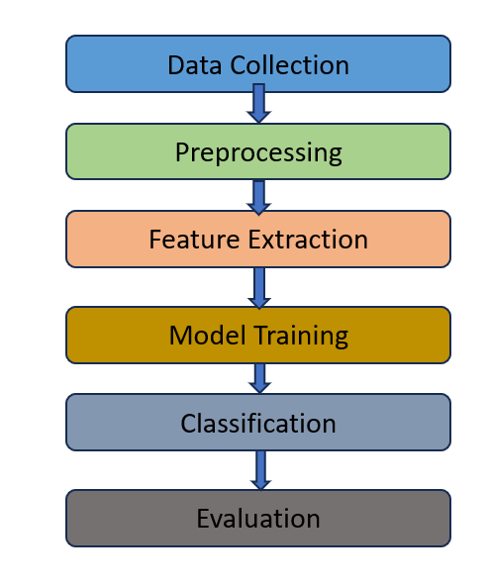**2. Organization:** The workflow for the project will be as follow

## **3. Data Description:**

The dataset we will be using for our project is designed for landslide prediction in Muzaffarabad, Pakistan, a region highly susceptible to landslides due to its mountainous terrain and climatic conditions. This dataset includes various environmental and geographical parameters such as slope, soil type, rainfall, land use, and elevation, which are crucial for assessing landslide risk. It is a csv dataset that consists 1212 records and 13 features.

**• Why you chose which data and how it relates to your project**

This data is chosen because it provides critical insights into the conditions that trigger landslides, allowing for the development of predictive models. By analyzing these factors, the project can accurately assess landslide risk, ultimately contributing to more effective disaster prevention and mitigation strategies. The chosen data is, therefore, highly pertinent to achieving our project goals.

## **4. Data Analysis and Insights:**

* Our dataset has 13 features and 1212 records.
* The 13 features are shown on the right figure, and all are non-null values
* It is a numerical dataset
* Datatype of integer
* Target variable is the column landslide, having two categorical values 0 and 1

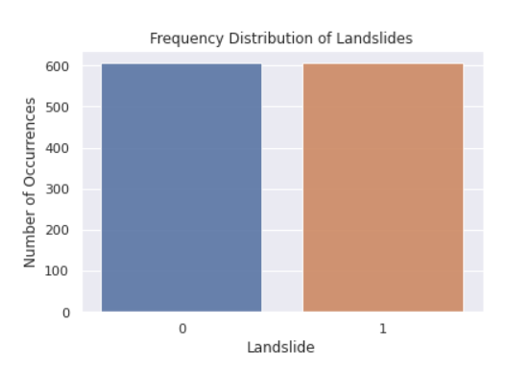

Here is the target variable distribution:

0 = landslide non-occurrence

1 = landslide occurrence

**Mutual information**: a key concept in machine learning that measures the dependency between two variables. It indicates how much knowledge of one variable reduces uncertainty about another. In feature selection, mutual information helps identify the most relevant features by quantifying the amount of information each feature provides about the target variable. A higher mutual information score suggests a stronger relationship between the feature and the target, making it valuable for improving model accuracy. This concept is widely used in tasks like classification and clustering to enhance model performance by focusing on the most informative data.

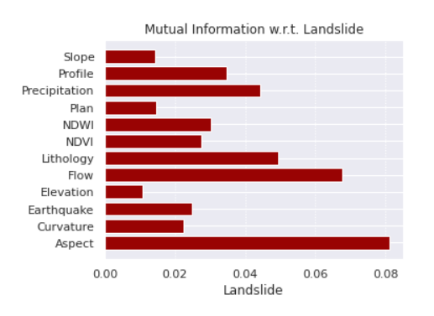

**5. Conclusion:**

**Key Findings:**

The analysis highlighted significant correlations between factors like slope, rainfall, soil type, and landslide occurrences in Muzaffarabad, with slope and rainfall being particularly influential. High-risk areas were also identified.

This research is essential for developing accurate landslide prediction models, which are crucial for disaster risk management. The findings will help create effective early warning systems and prioritize mitigation efforts, ultimately protecting lives and infrastructure in landslide-prone areas.

## **6. Proper Citations:**

https://www.kaggle.com/datasets/adizafar/landslide-prediction-for-muzaffarabadpakistan/data

# **Technology Review: Machine Learning for Landslide Prediction**

1. **Introduction**

Landslides are among the most destructive natural disasters, leading to significant loss of life,

infrastructure, and environmental degradation. With climate change exacerbating the frequency and

intensity of such events, there is a growing need for advanced predictive models to mitigate their

impact. This technology review focuses on the application of machine learning (ML) techniques for

predicting landslides by analyzing environmental and geological data. The importance of this

technology review lies in its potential to enhance disaster preparedness and resilience, aligning with

Sustainable Development Goals (SDGs) 9, 11, and 13, which emphasize the importance of innovation,

sustainable communities, and climate action.

The relevance of this technology to the project is significant. Predictive modeling using machine learning

can provide early warnings, enabling timely evacuations and reducing the vulnerability of communities

in landslide-prone areas. This review will explore the various ML algorithms and tools that are pivotal

in achieving accurate and reliable landslide predictions.

## **2. Technology Overview**

Machine learning is a subset of artificial intelligence (AI) that involves training algorithms to recognize

patterns in data and make predictions or decisions based on that data. In the context of landslide

prediction, ML models analyze various environmental and geological parameters such as slope gradient,

rainfall, soil type, and historical landslide occurrences to identify areas at risk.

Purpose:

The primary purpose of using machine learning in landslide prediction is to create a model that can

accurately predict the likelihood of a landslide occurring in a given area. This predictive capability is

essential for disaster management agencies to take proactive measures, such as issuing early warnings

and planning evacuations, thereby minimizing the impact of landslides on vulnerable communities.

Key Features:

Key features of machine learning in this domain include:

● Data-Driven Predictions : ML models rely on large datasets to make accurate predictions.

These datasets typically include environmental, geological, and historical landslide data.

● Algorithmic Flexibility : A variety of algorithms, such as Random Forest, Support Vector

Machine (SVM), and Logistic Regression, can be used, each with its strengths and

weaknesses.

● Scalability : ML models can be scaled to cover large geographic areas, making them

suitable for national or regional disaster management efforts.

● Real-Time Processing : Advanced ML models can process incoming data in real-time,

providing up-to-date predictions as new information becomes available.

Common Usage in Relevant Fields

In relevant fields such as geology, environmental science, and disaster management, ML is

commonly used for:

● Landslide Susceptibility Mapping : ML models are employed to create maps that highlight

areas at high risk of landslides.

● Risk Assessment : ML helps in assessing the risk levels associated with different geographic

regions based on environmental and geological factors.

● Early Warning Systems : Integrating ML models with real-time data feeds can create

systems that issue early warnings to populations at risk.

## **3. Relevance to Your Project**

The relevance of machine learning to this project lies in its ability to address specific challenges

associated with landslide prediction. Traditional methods of landslide prediction often rely on empirical

models or expert judgment, which can be less accurate and harder to scale. Machine learning, on the

other hand, offers a data-driven approach that can adapt to new information and provide more accurate

predictions.

In particular, ML can help improve the process of identifying areas at risk by:

● Enhancing Predictive Accuracy : By analyzing vast amounts of data, ML models can

identify subtle patterns and correlations that might be missed by traditional methods.

● Enabling Proactive Measures : Accurate predictions allow for proactive measures, such as

infrastructure reinforcement and community evacuation plans, to be implemented before a

disaster strikes.

● Supporting Sustainable Urban Planning : ML models can be used to guide urban planning

decisions, ensuring that new developments are constructed in safer areas.

## **4. Comparison and Evaluation**

In this project, various machine learning algorithms can be compared to determine the most suitable one

for landslide prediction:

Random Forest

- Strengths : High accuracy, handles large datasets well, and is less prone to overfitting.

- Weaknesses : Computationally expensive and can be slower in processing.

- Suitability : Ideal for initial modeling efforts where accuracy is prioritized.

Support Vector Machine (SVM)

- Strengths : Effective in high-dimensional spaces and robust to overfitting, especially in classification

tasks.

- Weaknesses : Requires careful parameter tuning and is less effective with large datasets.

- Suitability : Suitable for regions where the data is well-separated or where precise classification is

needed.

Logistic Regression

- Strengths : Simple, interpretable, and computationally efficient.

- Weaknesses : Assumes linear relationships between features, which may not capture complex patterns.

- Suitability : Best for baseline models or when interpretability is crucial.

Cost, Ease of Use, Scalability, and Performance

- Cost : All three algorithms are accessible through open-source libraries like Scikit-Learn, minimizing

cost.

- Ease of Use : Logistic Regression is the easiest to implement, while Random Forest and SVM require

more expertise.

- Scalability : Random Forest and Logistic Regression scale better with large datasets, while SVM may

struggle.

- Performance : Random Forest generally offers the best performance in terms of accuracy, though SVM

can excel in specific scenarios.

## **5. Use Cases and Examples**

Several real-world projects have successfully applied ML techniques for landslide prediction:

Case Study 1: Landslide Susceptibility Mapping in the Himalayas

This study utilized Random Forest and SVM to create landslide susceptibility maps, which were used by

local authorities to enhance disaster preparedness and reduce the impact of landslides in vulnerable

areas.

Case Study 2: GIS-Based Landslide Susceptibility Mapping

In this project, Logistic Regression was employed alongside Geographic Information Systems (GIS) to

identify landslide-prone areas in a region. The model's predictions were instrumental in guiding land use

planning and infrastructure development.

Example: Danish Case Study on Landslide Susceptibility

The GEUS project in Denmark used Random Forest, SVM, and Logistic Regression to map landslide

susceptibility in the Vejle Fjord area. The models provided valuable insights into areas at risk,

supporting future infrastructure planning and risk mitigation efforts.

## **6. Identify Gaps and Research Opportunities**

While machine learning offers significant advantages for landslide prediction, several gaps and limitations

remain:

- Data Quality and Availability : The accuracy of ML models depends heavily on the quality and

availability of data. In many regions, comprehensive datasets may be lacking.

- Algorithm Limitations : Each algorithm has its limitations, such as SVM's computational intensity or

Logistic Regression's assumption of linearity. Customization and hybrid approaches may be needed to

address these issues.

- Model Interpretability : Complex models like Random Forest can be challenging to interpret, making

it difficult to understand the underlying factors driving predictions. Research into explainable AI could

help address this issue.

## **7. Conclusion**

In conclusion, machine learning holds great promise for enhancing landslide prediction and mitigation

efforts. By leveraging data-driven models, disaster management agencies can take proactive measures to

protect vulnerable communities, aligning with SDGs 9, 11, and 13. The technology's flexibility,

scalability, and predictive accuracy make it an invaluable tool for future urban planning and climate

action initiatives. However, addressing the identified gaps, such as data quality and model

interpretability, will be crucial for maximizing the effectiveness of ML in this domain.

Team Members:  
  
Finhas Demissie   
Selam Habtewolde  
Bealu Girma