**Capstone Project Concept Note and Implementation Plan**

**Project Title: Web-Based Platform for Creating Awareness About Wildlife (SDG 15: Life on Land)**

**Group 11 Team Members**

**EDLAWIT BELAY TEKA**

**Feven Muluken Eijgu**

**Mercy Abebaw**

**Tolcha Adere Ayale**

**Wagari Endalew**

**Concept Note**

**1. Project Overview**

Our capstone project is a web-based platform dedicated to raising awareness about wildlife conservation, aiming to educate the public and encourage community engagement in protecting endangered species and natural habitats. By leveraging accessible digital tools, we aim to bridge the gap between scientific information and everyday understanding, making conservation knowledge available to all.

This initiative directly aligns with the **United Nations Sustainable Development Goal (SDG) 15: Life on Land**, which focuses on sustainably managing forests, combating desertification, halting biodiversity loss, and protecting terrestrial ecosystems. It also touches on **SDG 13: Climate Action**, as preserving wildlife plays a critical role in maintaining ecosystem balance and climate resilience.

**Problem Statement and Potential Impact**

Many people lack awareness about the urgent threats facing wildlife, such as habitat destruction, poaching, and climate change. This knowledge gap leads to reduced public support for conservation efforts and limits participation in sustainable practices.

Our platform will serve as an educational hub that:

* Provides engaging content about endangered species, conservation efforts, and environmental challenges.
* Encourages user participation through quizzes, pledges, and community forums.
* Promotes local and global conservation events and initiatives.

By raising awareness and inspiring action, our project has the potential to foster a more environmentally conscious society, support conservation organizations, and contribute to the long-term preservation of biodiversity.

1. **Objectives**

Our main aim is to create awareness about wildlife conservation through a web-based platform. To achieve this, our project has the following specific objectives:

**Raise Awareness About Wildlife Conservation**

* Share facts, stories, and visuals to educate users on endangered species and biodiversity threats.
* Highlight the importance of wildlife to ecosystems and human well-being.

**Encourage Sustainable Actions**

* Provide practical tips and everyday actions that users can take to help protect wildlife and habitats.
* Promote eco-friendly behavior and lifestyle changes.

**Develop a User-Friendly Web Platform**

* Design a clean, responsive website accessible across devices.
* Ensure content is easy to understand for users of all ages and backgrounds.

**Build a Community Around Conservation**

* Create space for users to share local conservation efforts and success stories.
* Encourage collaboration and connection among users passionate about wildlife.

**3. Background**

**Wildlife conservation** has become an urgent global issue due to the rapid decline in biodiversity caused by habitat destruction, illegal poaching, pollution, and climate change. Despite the growing severity of the problem, public awareness remains limited. Many people are unaware of how their daily actions can contribute to the endangerment or protection of species. This lack of awareness is one of the key barriers to achieving large-scale, community-driven conservation efforts.

Several organizations and initiatives—such as the **World Wildlife Fund (WWF)**, **National Geographic**, and government-led conservation programs—work tirelessly to protect wildlife. These efforts often involve awareness campaigns, protected areas, and species monitoring. While these are impactful, many of them rely on traditional media or localized outreach, which may not fully engage today’s tech-savvy and digitally connected populations, especially the younger generation.

A **web-based platform** offers a modern, scalable solution to this problem by making conservation content more accessible and engaging for users around the world. It removes geographical barriers and allows for real-time updates, interactive content, and global participation. Through storytelling, gamification, and community features, it can turn awareness into action more effectively than passive reading or watching.

Integrating **machine learning (ML)** into this platform brings additional value. ML can personalize content based on user interests, recommend relevant articles or activities, and even analyze user engagement to improve educational outcomes. For example, ML algorithms can track which topics gain the most attention and adapt the platform to highlight pressing issues accordingly. This intelligent, data-driven approach ensures that conservation messaging is both relevant and impactful for each individual user.

1. **Methodology**

To enhance user engagement and make our wildlife conservation platform more intelligent and impactful, we plan to incorporate basic machine learning techniques.

* **User Behavior Analysis & Content Recommendation:** We will use **classification algorithms** like **Logistic Regression** or **Decision Trees** to categorize user interests based on their interactions (e.g., pages visited, )
* **Image Recognition for Wildlife Species :** We plan to integrate a simple **image classification model** using **Convolutional Neural Networks (CNNs)** to allow users to upload pictures of animals and receive information about the species. Pre-trained models like **MobileNet**, **ResNet**, or **TensorFlow Lite models** will be used for fast, accurate predictions on web or mobile platforms.
* **Frameworks and Tools: Python** with libraries such as **scikit-learn**, **TensorFlow** will be used for machine learning tasks. For web integration, **Flask** can serve as backends to connect the ML models to the front end. **Google Colab** or **Jupyter Notebooks** will be used for initial development and testing.

1. **Architecture Design Diagram** 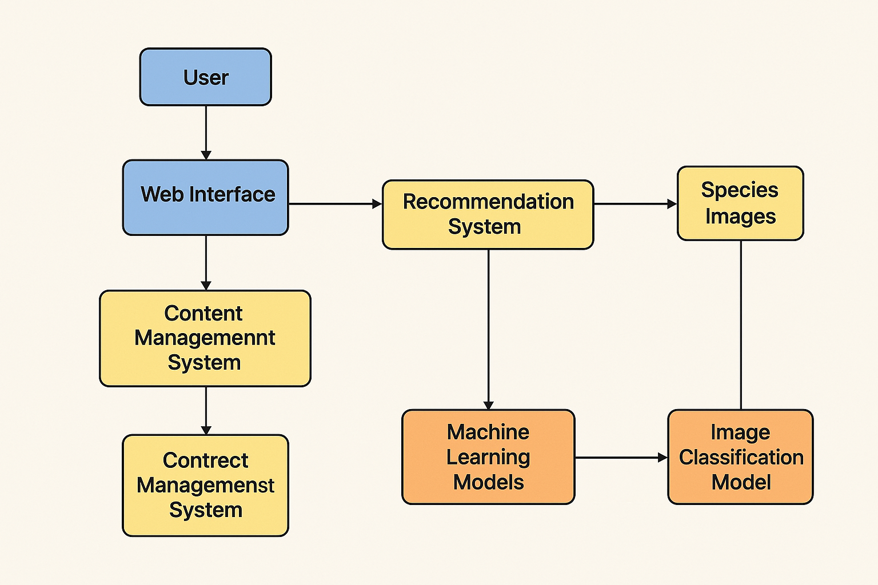

### ****User Role**:** The end-user accessing the platform via a web browser or mobile device.

### **Functionality:** Interacts with the site by reading content, uploading images, or participating in community discussions.

* **. Web Interface (Frontend) Role:** The visual and interactive layer of the platform.
* **Functionality:** Displays articles, videos, images, and interactive features like quizzes and forms. Built with HTML/CSS/JavaScript and possibly React or Vue.js for dynamic behavior.
* **Application Server (Backend)Role:** Handles all business logic and acts as a bridge between frontend and backend services.
* **Functionality:** Processes user requests, connects to databases, handles user authentication, routes data to/from ML models. Frameworks like **Flask** or **Django** are ideal.
* **. Database Role:** Stores platform data.
* **Functionality:** Manages structured data such as user profiles, conservation content, comments, and image metadata. Common choices: **MySQL**, **PostgreSQL**, or **MongoDB**.

### ****Machine Learning Engine Role:**** Adds intelligence to the system.

**Functionality: Content Recommendation System**: Suggests personalized articles or actions based on user behavior.

**Image Recognition**: Identifies species from uploaded images using a pre-trained CNN model.

**Sentiment Analysis**: Evaluates tone of comments/posts to gauge community sentiment.

Built with **TensorFlow**, **scikit-learn**, or **PyTorch**.

* **Cloud Storage / Media Server Role:** Stores large files and media.

**Functionality:** Handles user-uploaded images, videos, and multimedia conservation content. Services like **Amazon S3**, **Google Cloud Storage**, or similar can be used.

* **Admin Dashboard Role:** Platform control center for moderators and admins.

**Functionality:** Allows content management, user activity tracking, report generation, and system monitoring.

1. **Data Sources**

For our wildlife conservation awareness platform, we plan to use a combination of **open-source datasets** . Key sources include wildlife image datasets such as the **iNaturalist** and **WWF Species Data**, which contain labeled images and information on thousands of animal species. These datasets are crucial for training our **image recognition model** to identify species from user-uploaded photos. Additionally, we will use **text-based data** from conservation articles, blogs, and social media posts to support our **content recommendation and sentiment analysis** features. All data will undergo preprocessing, including image resizing and normalization for model training, text cleaning (removal of stop words, punctuation, etc.), and labeling for classification tasks. This data is directly relevant as it provides the content and intelligence behind our educational tools, making conservation learning interactive and personalized.

**7. Literature Review**

Recent literature emphasizes the effectiveness of **digital platforms and machine learning** in enhancing environmental awareness and conservation efforts. Studies have shown that **interactive web tools** significantly improve user engagement and knowledge retention in environmental education (e.g., Kumar et al., 2020).

Additionally, research by Norouzzadeh et al. (2018) demonstrated that **deep learning models**, particularly CNNs, can accurately classify wildlife species from camera trap images, supporting the feasibility of image recognition in conservation. Similarly, content-based **recommendation systems** have been used successfully in educational platforms to personalize learning experiences and boost user interaction.

Our project builds upon these findings by integrating these proven techniques—interactive content delivery, image classification, and content recommendation—into a single platform tailored to wildlife conservation awareness. By combining these elements, we aim to create a more impactful, scalable, and user-centered solution that goes beyond traditional awareness campaigns.

**Implementation Plan**

**1. Technology Stack**

### ****Programming Languages****

* **Python** – For backend development and machine learning models.
* **JavaScript** – For frontend interactivity and dynamic elements.
* **HTML/CSS** – For designing and styling the user interface.

### ****Libraries****

* **scikit-learn** – For building simple ML models like classification and recommendation systems.
* **TensorFlow**  – For training and deploying deep learning models (e.g., CNNs for image recognition).
* **Pandas / NumPy** – For data manipulation and preprocessing.
* **OpenCV** – For image handling and preprocessing tasks.
* **NLTK / TextBlob** – For basic NLP and sentiment analysis.

### ****Optional Hardware / External Tools****

* **User Devices (PCs / Smartphones)** – As the main interface for accessing the platform.
* **Camera / Smartphone Camera** – For capturing wildlife images to upload and analyze.

### ****Platforms & Tools****

**Google Colab / Jupyter Notebook** – For building and testing ML models in a cloud environment.

**GitHub** – For version control and collaborative development.

### ****Frameworks****

**Flask** or **Django** – For backend web development and connecting ML models to the web app.

**2. Timeline**

* **Phase Task**
* **Week 1** Collect wildlife datasets

Clean and preprocess data(text+image)

Research ML models and tools

* **Week 2** Develop image classification model

Begin frontend and backend setup

* **Week 3** Train and evaluate ML models

Integrate models with backend

Design user interface

* **Week 4** Final testing and presentation

1. **Milestones**

* Data Acquisition Completed: All required datasets (wildlife images, articles, and user-generated data) have been collected.

**4. Challenges and Mitigations**

1. **Data Quality**

Challenge: Incomplete, noisy, or imbalanced data (e.g., rare species underrepresented).

Mitigation:

Use **data augmentation** techniques (rotate, flip, crop images).

Clean and validate data before training.

Use **reputable sources** (iNaturalist, WWF).

Apply **transfer learning** to compensate for limited datasets.

1. **Model Performance**

Challenge: Low accuracy or poor generalization.

Mitigation:

Try different algorithms and perform **hyperparameter tuning**.

Use **cross-validation** to evaluate model stability.

Monitor performance using metrics like accuracy, precision, recall.

Apply **early stopping** and **regularization** to avoid overfitting.

1. **Technical Constraints**

Challenge: Limited hardware/resources and integration complexity.

Mitigation:

Use cloud platforms like **Google Colab** for training.

Choose **lightweight models** (e.g., MobileNet for image tasks).

Use **Flask APIs** to connect ML models with the web platform.

Keep code modular to simplify debugging and scaling..

**5. Ethical Considerations**

Ethical considerations play a vital role in the development and deployment of our wildlife conservation awareness platform. One of the primary concerns is **data privacy**, especially as users may upload images, comments, or location data. To address this, we will limit the collection of personal information, implement data anonymization techniques, and ensure secure data storage practices. A clear and transparent privacy policy will inform users about how their data is used, with their consent being a prerequisite for any data collection. By prioritizing data protection, we aim to build user trust and ensure compliance with ethical standards.

Another key consideration is **algorithmic bias and the potential impact on the community**. Machine learning models can inadvertently favor common species while misclassifying or ignoring rare or region-specific wildlife due to unbalanced datasets. To mitigate this, we will source data from diverse, reputable sources and conduct regular performance audits. Moreover, we understand that the platform’s content can influence public perception, so we will present only accurate, verified information from trusted conservation organizations. AI-generated insights will be clearly labeled, with users encouraged to provide feedback or corrections. This ethical framework ensures our project promotes awareness responsibly and supports positive, informed community engagement.

**6. References**

 Wearn, O. R., & Glover-Kapfer, P. (2019). Camera-trapping for conservation: A guide to best practices. WWF Conservation Technology Series. <https://www.wwf.org.uk/sites/default/files/2019-07/Camera-Trapping-for-Conservation.pdf>

GBIF – Global Biodiversity Information Facility. (n.d.). Free and open access to biodiversity data. <https://www.gbif.org/>