**Capstone Project Concept Note and Implementation Plan**

# Project Title: ****Spectrum-EDU (****AI BASED E-LEARNING PLARFORM)

**Team Members**

1. Eyerusalem Kidane
2. Feven A. Haile
3. Fikir Fikre
4. Mahlet Seyoum
5. Melat Ermiyas

**Concept Note**

**1. Project Overview**

* **Spectrum-EDU** is an e-learning platform comprising mainly 5 traits Personalization, Gamification, Accessibility, Multilingual support(Amharic and English), Cultural Adaptation to help children that face challenges in accessing education due to geographical barriers, socio-economic limitations, disabilities, or conflict-affected environments. Our platform aligns with **SDG 4 (Quality Education)** and **SDG 10 (Reduced Inequalities)** by providing **inclusive, personalized, and accessible learning** for children facing barriers to traditional schooling due to disabilities, late enrollment, or geographic and socio-economic challenges.
* Many children face barriers to education due to geography, poverty, disabilities, or conflict, and current e-learning platforms often lack the personalization and adaptability needed to support them. Our AI-driven platform aims to overcome these challenges by offering personalized, engaging, and accessible learning through adaptive lessons, gamification, and multimodal content tailored to each child’s needs.

**2. Objectives**

1. Develop an AI-powered e-learning platform that personalizes lessons based on each child's progress and learning style.
2. Integrate gamification elements to boost motivation and engagement.
3. Offer multimodal content (text, voice, video, interactive exercises) to support diverse accessibility needs.

The project aims to make quality education more inclusive and engaging for children facing barriers like distance, disability, or socio-economic limitations. By adapting content to individual needs and using interactive, accessible formats, the platform empowers self-paced learning and helps bridge educational gaps.

**3. Background**

* Ongoing conflict in Ethiopia particularly the Tigray war has damaged over 8,000 schools and left 3.1 to 3.6 million children out of school, undermining basic access to education. At the same time, national Grade 12 pass rates have plunged to just 3.3 percent in 2022 and 3.2 percent in 2023, with 1,328 schools recording zero passing students. Existing e‑learning offerings are largely English‑only, non‑personalized, and neglect both Amharic content and learners with disabilities.
* As a solution **Spectrum-EDU an** AI/ML‑powered adaptive learning, gamification, accessibility features, and multilingual support are therefore essential to bridge these gaps at scale.

**4. Methodology**

* We’ll combine classical supervised methods, ensemble learners, collaborative filtering and NLP pipelines to model each student’s knowledge and engagement in real time. **Scikit‑Learn** will power core tasks like classification (e.g. **support‑vector machines**, **random forests**) and **clustering** (e.g. k‑means) of performance data, while **XGBoost’s gradient‑boosted trees** will drive fast, accurate predictions of learning outcomes and difficulty scaling. The **Surprise library** will handle recommendation logic—using both **neighborhood‑based** and **matrix‑factorization** approaches—to suggest the next best exercise or resource. Meanwhile, **SpaCy** and **NLTK** will form our text‑processing backbone, tokenizing and parsing student responses, extracting key entities, and generating concise lesson summaries.
* On the implementation side, our stack centers on a few key packages and architectures. **Scikit‑Learn** provides the full suite of model selection, preprocessing, and evaluation utilities needed to iterate on classification, regression, and clustering pipelines. **XGBoost** ensures scalable, high‑performance gradient boosting across large interaction logs. Surprise delivers off‑the‑shelf collaborative‑filtering algorithms (SVD, KNN, Slope One) for real‑time recommendation. **SpaCy** and **NLTK** supply industrial‑grade tokenizers, lemmatizers, taggers, and parsing models for natural‑language understanding. Finally, **Pandas** will manage feature engineering and data cleaning, and **Flask** will expose our models as RESTful endpoints—enabling low‑latency, lightweight integration with the front‑end.

**5.Architecture Design Diagram**

**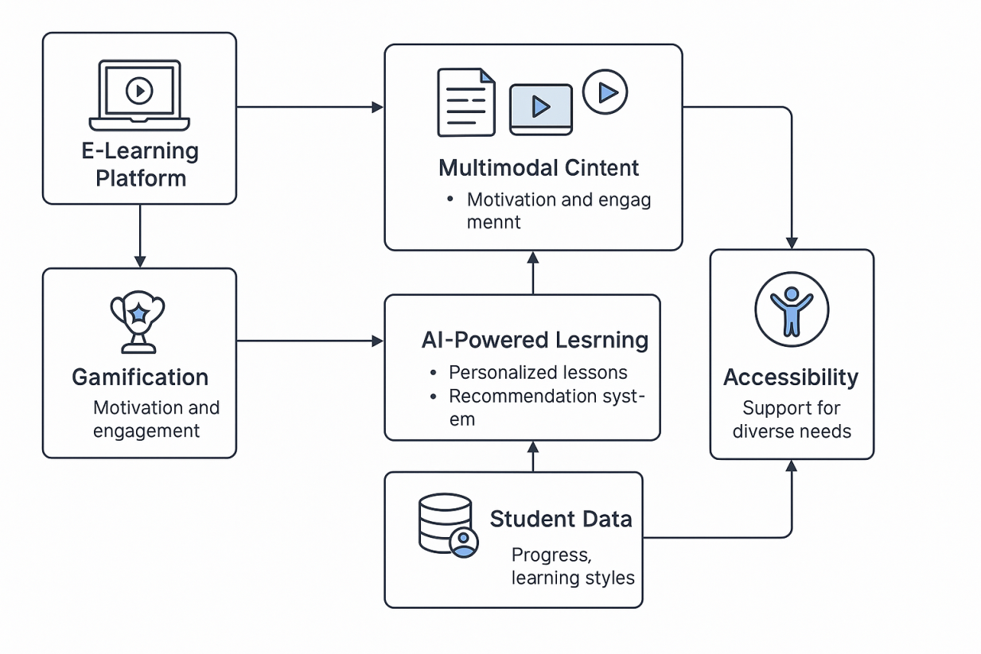**

• **E-Learning Platform**: The core interface where students access their lessons. This web-based platform integrates content delivery, progress tracking, and user interaction in real time.

• **Multimodal Content**: Hosts a mix of text, voice, video, and interactive exercises, ensuring learning materials are accessible and engaging for students with diverse learning styles and abilities.

• **Gamification**: Embeds points, badges, leaderboards, and interactive challenges to boost student motivation and long-term engagement.

• **AI-Powered Learning**: Uses supervised learning models (SVM, Random Forests) for performance analysis, XGBoost for predictive scaling, and collaborative filtering (Surprise) for personalized recommendations — adjusting content to each learner’s pace and style.

• **Student Data**: Stores and tracks learner profiles, progress, and behavior patterns — serving as input for personalization algorithms and helping adapt difficulty and content recommendations.

• **Accessibility**: Focuses on providing assistive technologies such as text-to-speech, alternative text content, adjustable reading speeds, and Amharic-English multilingual options for students with disabilities or language barriers.

**6. Data Sources**

* Detail the data sources you intend to use for your project.
* Include information about the type of data, its relevance to the problem, and any preprocessing steps required. **(You can use previous data review research but this should be 1 paragraph)**
* The data sources for the Spectrum-EDU project are drawn from diverse and relevant educational datasets that reflect real-world challenges faced by marginalized learners. These include the **Student Performance Prediction Dataset**, which contains academic records like grades, attendance, parental background, and study habits; the **Students’ Adaptability Level in Online Education Dataset**, which captures psychological and technological readiness for remote learning; and **xAPI-Edu-Data**, which tracks behavioral interaction logs such as time spent on activities, content views, forum participation, and task completion rates. These datasets are chosen for their ability to represent the complex interplay of academic performance, adaptability, and engagement — all of which are central to personalizing and enhancing e-learning experiences for underserved students.
* The datasets used contain a mix of **numerical, categorical, and behavioral data** including grades, attendance records, device access, motivation levels, adaptability scores, and interaction logs. This variety ensures the platform’s AI models can account for both cognitive and contextual differences among students. Preprocessing steps involve **data cleaning** (handling missing values and outliers), **feature scaling** (standardizing numerical data for models like SVM), **encoding categorical features** (such as parental education levels and adaptability categories), and **behavioral sequence extraction** (from logs for engagement analysis). This preparation ensures the data is both structured and ready for machine learning, enabling effective training of predictive models that tailor lessons and engagement strategies to individual learners’ needs.

**7. Literature Review**

* Studies such as Jannathul Firthous et al. and Thongprasit & Wannapiroon emphasize the value of using data-driven algorithms, real-time feedback, and adaptive learning paths to personalize content based on each student’s progress and needs. Gamification research, including the Polymath case study and broader investigations into game-based learning, highlights how points, rewards, and interactive challenges increase student motivation and sustained engagement. Lastly, accessibility-focused research, including E-Learning and Disability in Higher Education and Developing Inclusive E-Learning Systems, underscores the importance of designing inclusive platforms that offer flexible, assistive technologies like text-to-speech, screen readers, and language adaptability. Together, this body of work directly informs the methodological choices of Spectrum-EDU, which leverages AI models, multimodal content, and gamified environments to create an accessible and adaptive educational experience for underserved children.
* The existing research identifies clear patterns: adaptive AI systems enhance personalized learning, gamification boosts motivation and engagement, and accessible design ensures inclusivity for students with disabilities or diverse linguistic backgrounds. For example, studies confirm that personalized content and real-time recommendations improve learning outcomes, while game mechanics foster deeper engagement. Accessibility research shows current e-learning tools still fall short in fully meeting the needs of disabled and marginalized students, highlighting a gap. Spectrum-EDU builds on these findings by combining all three strands — personalization, gamification, and accessibility — into one cohesive AI-powered platform. The project not only applies predictive algorithms for adaptive learning paths but also embeds culturally relevant multilingual support (Amharic and English) and real-time emotional and performance monitoring to offer targeted interventions. This comprehensive approach extends prior work by addressing both academic and non-academic barriers that students face, particularly in conflict-affected and under-resourced settings.

**Implementation Plan**

1. **Technology Stack**

The following technologies and tools have been selected for the design, development, and deployment of Spectrum-EDU, focusing on accessibility, personalization, scalability, and multilingual support.

**Programming Languages**

* **Python** – for machine learning models, backend development
* **JavaScript (React)** – for frontend development
* **HTML/CSS** – for structure and responsive design

**Libraries and Packages**

* **Scikit-learn** – classical ML algorithms (SVM, KNN, clustering)
* **XGBoost** – gradient boosting for performance prediction
* **Surprise** – collaborative filtering for personalized recommendations
* **Pandas, NumPy** – data preprocessing and manipulation
* **SpaCy, NLTK** – for NLP tasks (text analysis, tokenization, summarization)
* **SHAP** – explainable AI to interpret model predictions

**Frameworks**

* **Flask** – lightweight backend framework to serve ML models via REST APIs
* **React** – for building dynamic, responsive web interfaces
* **TensorFlow Lite** (planned) – for deploying ML models on low-resource devices (future enhancement)

**Other Tools & Components**

* **PostgreSQL** – database for user data and progress tracking
* **Firebase** – authentication and real-time notification (gamification)
* **Google Text-to-Speech API** – accessibility support
* **Figma** – UI/UX prototyping and design
* **Git & GitHub** – version control and collaboration
* **VS Code / Jupyter Notebooks** – development environments
* **Heroku or AWS** – for cloud hosting and deployment

**2. Timeline**

| **Week** | **Tasks** | **Deliverables / Goals** |
| --- | --- | --- |
| 1 | Finalize requirements, project planning, initial UI design | Project blueprint and wireframes |
| 2 | Dataset exploration, preprocessing setup | Cleaned, ready-to-use datasets |
| 3 | Feature engineering, NLP preprocessing | Processed features, tokenized datasets |
| 4 | Build baseline ML models (SVM, Random Forest, KMeans) | Initial model benchmarks |
| 5 | Integrate XGBoost and recommendation algorithms (Surprise) | Personalized recommendation pipeline |
| 6 | Frontend setup with React + mock content | Functional frontend skeleton |
| 7 | Backend Flask API development + React-Flask integration | Working ML endpoints |
| 8 | Gamification engine, TTS accessibility integration | Badges, points, text-to-speech working |
| 9 | Testing, performance evaluation, feedback loop implementation | QA reports, accuracy benchmarks |
| 10 | Final polishing, deployment to Heroku/AWS, documentation | Live MVP + Final Report |

**Task Distribution Matrix**

|  |  |  |  |  |  |
| --- | --- | --- | --- | --- | --- |
| **Task / Member** | **Eyerusalem** | **Feven** | **Fikir** | **Mahlet** | **Melat** |
| UI/UX Design (Figma, Frontend) | * ✅ |  | ✅ |  | ✅ |
| Data Preprocessing & Feature Eng. | ✅ | ✅ |  |  | ✅ |
| Machine Learning Model Development |  | ✅ |  | ✅ | ✅ |
| NLP & Language Adaptation (Amharic) | ✅ | ✅ |  | ✅ |  |
| Gamification & Accessibility Tools |  | ✅ | ✅ |  |  |
| Backend Integration (Flask APIs) | ✅ |  | ✅ | ✅ |  |
| Testing & Evaluation | ✅ | ✅ | ✅ | ✅ | ✅ |
| Documentation & Deployment | ✅ | ✅ | ✅ | ✅ | ✅ |

**3. Milestones**

|  |  |
| --- | --- |
| |  |  | | --- | --- | | Milestone | Description | | M1: Dataset Prepared | Data cleaned, preprocessed, and split into training/testing sets | | M2: First Working Model | SVM/XGBoost model trained with at least 70% accuracy on validation set | | M3: Recommendation Engine Functional | Surprise library integrated and delivering personalized lessons | | M4: Frontend-Backend Integration Complete | React interface communicates successfully with Flask APIs | | M5: Accessibility Features Functional | Text-to-speech and multilingual toggling (Amharic-English) implemented | | M6: Gamification System | Users earn points, badges, and can view progress | | M7: Final Testing & Optimization | QA complete, model explain ability added via SHAP, usability tested | | M8: Deployment & Presentation Ready | Platform deployed, fully functional MVP delivered | |  |

**4. Challenges and Mitigations**

**Data Quality and Availability**  
One major challenge anticipated is obtaining clean, representative, and contextually relevant data especially datasets that include Ethiopian learners, or those learning in Amharic. Many public datasets are biased towards Western learners and may not capture the socio-cultural nuances of our target population.

**Mitigation:** We will address this by augmenting existing datasets with synthetic data generation techniques where applicable and seeking partnerships with local NGOs or education ministries for access to more localized data.

**Model Performance and Interpretability**  
AI models, particularly deep learning models, can sometimes be “black boxes,” making it difficult to explain their decisions. This could limit trust and transparency in educational contexts.

**Mitigation:** We will employ explainable AI techniques (e.g., SHAP values, decision trees for model comparison) to interpret key predictions and provide insights into why certain recommendations are made.

**Technical Constraints and Deployment**  
Infrastructure limitations such as unreliable internet access and low-end user devices in rural or conflict-affected areas could restrict usage.

**Mitigation:** Spectrum-EDU will be designed as a lightweight web application with offline capabilities (using service workers) and mobile-first responsiveness. We will minimize bandwidth requirements by compressing video/audio and caching content locally.

**Language Processing in Low-Resource Languages**  
Amharic poses challenges in NLP due to limited annotated corpora and pre-trained models.

**Mitigation:** We will fine-tune existing open-source Amharic models (such as AmharicBERT or AfriBERTa) and contribute to the open data movement by publishing cleaned datasets.

**User Engagement and Retention**  
Sustained engagement may wane if the platform feels repetitive or lacks real-world relevance.

**Mitigation:** Through iterative testing and user feedback loops, we’ll dynamically adjust content and gamification elements to maintain novelty and relevance. Adaptive difficulty scaling will also ensure consistent challenge levels.

**5. Ethical Considerations**

**Data Privacy and Security**  
We recognize the sensitive nature of educational data especially data on children. To protect user privacy, we will implement strong encryption standards, anonymize datasets used for training, and store all data in compliance with international standards such as GDPR.  
No personally identifiable information will be used in training without informed consent, and usage will follow strict access controls.

**Bias and Fairness**  
Algorithmic bias is a concern, especially when models are trained on non-representative datasets. This could unfairly disadvantage certain learner groups.  
We will regularly audit model outputs for signs of bias and ensure balanced data collection from multiple regions, languages, and socio-economic backgrounds to avoid skewed results.

**Inclusivity and Accessibility**  
Accessibility must not be an afterthought. We will proactively design with inclusivity in mind using Universal Design for Learning (UDL) principles. Text-to-speech, adjustable UI elements, and support for visual/auditory impairments will be integral not optional.

**Psychological and Social Impact**  
The gamification and personalization strategies must not create over-competition or discourage slower learners. We will ensure that the platform fosters a growth mind set, celebrates incremental progress, and avoids ranking systems that may demotivate students.

**6.References**

[1]. Firthous, I. A. J., et al. (2024). AI‑Enhanced E‑Learning Platform. International Research Journal of Modernization in Engineering Technology and Science, 6(11).

[https://www.irjmets.com/uploadedfiles/paper//issue\_11\_november\_2024/64173/final/fin\_irjmets1733038023.pdf](https://www.irjmets.com/uploadedfiles/paper/issue_11_november_2024/64173/final/fin_irjmets1733038023.pdf)

[2].Thongprasit, J., & Wannapiroon, P. (2022). Framework of Artificial Intelligence Learning Platform for Education. International Education Studies, 15(1), 76–86.

<https://doi.org/10.5539/ies.v15n1p76>

[3]. 1.Polymath Aims to Make Learning Math as Enjoyable as Roblox (TechCrunch Article)

<https://techcrunch.com/2025/02/17/polymath-aims-to-make-learning-math-as-enjoyable-as-roblox-with-its-educational-sandbox-game/>

[4]. Strmečki, D., Bernik, A., & Radošević, D. (2015). Gamification in E‑Learning: Introducing Gamified Design Elements into E‑Learning Systems. Journal of Computer Science, 11(12), 1108–1117.

<https://doi.org/10.3844/jcssp.2015.1108.1117>

[5]. Seale, J. (2014). E-Learning and Disability in Higher Education: Accessibility Research and Practice (2nd ed.). Routledge.

<https://www.taylorfrancis.com/books/mono/10.4324/9780203095942/learning-disability-higher-education-jane-seale>

[6]. Savidis, A., Grammenos, D., & Stephanidis, C. (2006). Developing inclusive e-learning systems. *Universal Access in the Information Society*, 5(1), 51–72.

<https://doi.org/10.1007/s10209-006-0024-1> ​[SpringerLink](https://link.springer.com/article/10.1007/s10209-006-0024-1?utm_source=chatgpt.com" \t "_blank)

[7]. Adaptive Learning Using Artificial Intelligence in e-Learning: ALiterature Review

[8]. Enhancing e-learning through AI: advanced techniques for optimizing student performance

[9]. Agent-Based Recommendation in E-Learning Environment Using Knowledge Discovery and Machine Learning Approaches