

**TITLE:** AirSense - AI-Powered Air Quality Monitoring & Forecasting

**Concept Note and Implementation Plan Submission**

**Team Members**

1. Dawit Getachew

2. Gelasa Jarso

3. Helen Zelalem

4. Mukitar Seid

5. Tekleeyesus Munye

**PART I: Concept Note**

**1. Project Overview**

**a) Project Overview & SDG Relevance:**  
AirSense is a smart system that uses artificial intelligence to monitor and forecast air pollution levels. By providing real-time updates and future predictions, it helps people and city officials make informed decisions to protect public health. This project aligns with SDG 3 (Good Health and Well-being) by aiming to reduce the health impacts of polluted air, and SDG 11 (Sustainable Cities and Communities) by supporting cleaner, safer urban living.

**b) Problem & Impact:**  
Urban areas often suffer from poor air quality, which leads to serious health problems and environmental challenges. Many cities lack reliable tools for monitoring and predicting pollution. AirSense addresses this gap by using real and historical data to predict air quality and send early alerts. This can help reduce health risks, raise awareness, and guide better planning for sustainable, healthier cities.

**2. Objectives**

**Project Objectives**

* Monitor real-time air quality in urban areas.
* Predict future pollution levels using AI and historical data.
* Provide early health alerts and useful insights to the public and decision-makers.

The goal is to reduce health risks from air pollution by keeping communities informed and prepared. AirSense will help cities respond faster, plan better, and move toward healthier, cleaner environments.

**3. Background**

* Air pollution is a growing threat in many cities, causing serious health issues like asthma, heart disease, and respiratory infections. Traditional monitoring systems often lack real-time updates and do not predict future pollution levels. Some existing tools only display current data without offering alerts or forecasts.
* AirSense uses machine learning to fill this gap by analyzing patterns in historical and real-time data to predict upcoming air quality issues. This approach allows for early warnings and smarter planning, making it more effective than static monitoring systems.

**4. Methodology**

* AirSense uses supervised machine learning to predict air quality levels. We plan to use algorithms like Random Forest, XGBoost, and LSTM (Long Short-Term Memory) for time series forecasting. The project will be implemented using Python, with tools like scikit-learn, TensorFlow/Keras, and Pandas for data processing and model training. These techniques help identify pollution patterns and provide accurate, timely forecasts.

1. **Architecture Design Diagram**

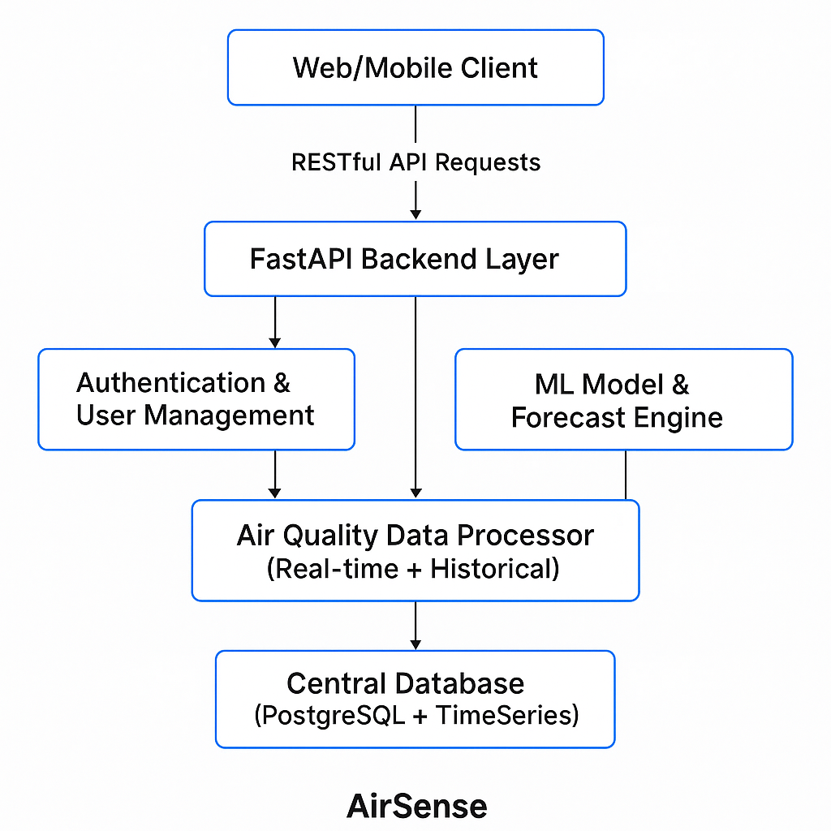

**Component Descriptions**

**1. Web/Mobile Client**

Role: Frontend interface used by users (urban residents, policymakers, health workers).

Functionality: Displays air quality data, visualizations, health alerts, forecasts. Users can interact with dashboards, subscribe to alerts, and view historical trends.

**2. FastAPI Backend Layer**

Role: Main server handling business logic and requests from the frontend.

Functionality: Acts as a bridge between users and all services like ML predictions, data storage, and user management.

**3. Authentication & User Management**

Role: Secure access to the platform.

Functionality: Handles user sign-up/login, authentication tokens, user roles (admin, user), and access control.

**4. ML Model & Forecast Engine**

Role: Core engine for air quality prediction.

Functionality: Uses trained machine learning models on historical + real-time data to forecast AQI (Air Quality Index) and pollutant levels. Models like Random Forest, XGBoost, or LSTM could be applied here.

**5. Notification Service**

Role: Sends health alerts and forecast updates to users.

Functionality: Pushes notifications via email, SMS, or in-app messages about dangerous pollution levels or daily air forecasts.

**6. Air Quality Data Processor**

Role: Ingests and cleans air quality data.

Functionality: Pulls data from external APIs (e.g., Beijing Multi-Site Dataset), real-time sensors, and formats it for use by ML models and visualizations.

**7. Central Database (PostgreSQL + TimeSeries Extension)**

Role: Stores persistent system data.

Functionality:

Stores user data, settings

Historical and real-time AQI data

Model outputs, logs, and alert history

**6. Data Sources**

For the AirSense project, we will utilize the **Beijing Multi-Site Air-Quality Data Set** from Kaggle, which includes real-time and historical air quality data collected from multiple monitoring sites across Beijing. The dataset contains critical features such as PM2.5, PM10, NO2, CO, O3, temperature, humidity, wind speed, and wind direction, all of which are highly relevant for predicting air pollution levels and issuing health alerts. This multidimensional data enables the development of accurate forecasting models by capturing the temporal and spatial variability of air pollutants. Preprocessing steps will include handling missing values, normalizing numerical features, encoding categorical variables like wind direction, and converting timestamps into time-series-friendly formats to prepare the data for machine learning models.

**7. Literature Review**

Recent literature demonstrates the effectiveness of machine learning models, particularly deep learning approaches like LSTM (Long Short-Term Memory) networks, in accurately forecasting air quality based on time-series data. Studies such as “Deep Air Learning: Interpolation, Prediction, and Feature Analysis of Fine-grained Air Quality” and other research using the Beijing dataset have shown that incorporating meteorological factors alongside pollutant data significantly enhances prediction accuracy. Moreover, ensemble methods like Random Forests and XGBoost have been proven effective for modeling non-linear relationships between environmental variables. Building upon these insights, AirSense will integrate LSTM for time-series forecasting and ensemble models for feature analysis to deliver more reliable, interpretable, and real-time air quality predictions tailored for urban environments, extending existing work by incorporating user-focused health alerts and sustainability insights.

**PART II: Implementation Plan**

**1. Technology Stack**

Sure, here's a well-organized Technology Stack for your AirSense project:

**A. Programming Languages**

Python – Core language for backend development, data processing, and machine learning.

JavaScript – For frontend development if building a web dashboard.

Dart – If using Flutter for a cross-platform mobile app.

**B. Backend Framework**

FastAPI – Lightweight and high-performance Python framework for building RESTful APIs.

**C. Frontend Frameworks (Optional Based on Platform)**

React.js – For building a responsive web dashboard.

Flutter – For cross-platform mobile applications (iOS and Android).

**D. Machine Learning & Data Processing Libraries**

Pandas / NumPy – Data manipulation and analysis.

Scikit-learn – Classical machine learning models (Random Forest, etc.).

XGBoost / LightGBM – Advanced boosting models for AQI prediction.

TensorFlow / PyTorch – If using deep learning models like LSTM for time-series forecasting.

Matplotlib / Seaborn / Plotly – Data visualization and charting.

Airflow / Prefect – For orchestrating ML workflows (optional).

**E. Database**

PostgreSQL – Relational database for structured data.

TimescaleDB (PostgreSQL extension) – For efficient time-series data storage and querying.

**F. Cloud Services & Deployment**

AWS / Azure / GCP – For hosting, ML model deployment, and scalable backend services.

EC2 / App Engine – For running backend APIs

S3 / Cloud Storage – For storing large data files and backups

Lambda / Cloud Functions – Serverless data processors (optional)

Docker – For containerization and deployment.

GitHub Actions / Jenkins – CI/CD pipelines.

**G. Notification & Messaging**

Twilio / Firebase Cloud Messaging – For SMS and push notifications.

SendGrid / Mailgun – For email alerts.

**H. APIs & External Data Sources**

OpenAQ / WAQI / Beijing Multi-Site Dataset – For real-time air quality data feeds.

**I. Monitoring & Analytics**

Grafana – For real-time dashboards and monitoring.

Prometheus – For backend monitoring and alerts.

**J. Version Control**

Git + GitHub – For version control and team collaboration.

1. **Timeline**

| **Week** | **Milestone** |
| --- | --- |
| Week 1 | Data Collection, Cleaning & Preprocessing, EDA |
| Week 2 | Model Development, Training, and Evaluation |
| Week 3 | System Integration, UI Development, Deployment, Testing, Documentation |
|  |  |

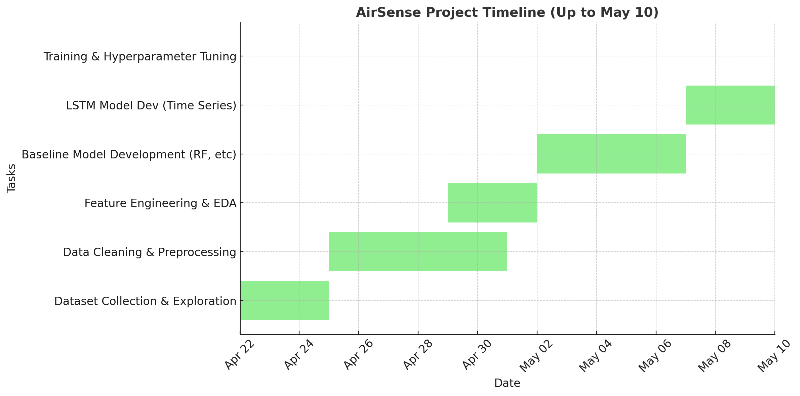

| **Task** | **Dawit Getachew** | **Gelasa Jarso** | **Helen Zelalem** | **Mukitar Seid** | **Tekleeyesus Munye** |
| --- | --- | --- | --- | --- | --- |
| Dataset Collection & Exploration | ✅ | ✅ | ❌ | ❌ | ❌ |
| Data Cleaning & Preprocessing | ✅ | ✅ | ✅ | ❌ | ❌ |
| Feature Engineering & EDA | ❌ | ✅ | ✅ | ✅ | ❌ |
| Baseline Model Development (RF, etc) | ❌ | ✅ | ❌ | ✅ | ✅ |
| LSTM Model Dev (Time Series) | ❌ | ❌ | ✅ | ✅ | ✅ |
| Training & Hyperparameter Tuning | ❌ | ✅ | ✅ | ✅ | ❌ |
| Evaluation & Visualization | ✅ | ❌ | ✅ | ❌ | ✅ |
| Backend Development (FastAPI) | ✅ | ❌ | ❌ | ✅ | ✅ |
| Frontend Interface (Streamlit/Web) | ❌ | ✅ | ✅ | ❌ | ✅ |
| Testing & Debugging | ✅ | ✅ | ✅ | ✅ | ✅ |
| Feedback Collection & Iteration | ✅ | ✅ | ✅ | ✅ | ✅ |
| Documentation & Final Report | ✅ | ✅ | ✅ | ✅ | ✅ |

**3. Milestones**

Here are some key milestones forAirSense project:

1. Project Planning and Requirement Analysis

2. Data Acquisition and Preprocessing

3. Model Development

4. Air Quality Prediction System

5. Health Alerts System

6. User Interface (UI) Development

7. Testing and Validation

8. Deployment and Monitoring

9. Post-Deployment Optimization

10. Project Evaluation and Reporting

**4. Challenges and Mitigations**

Here’s a breakdown of Challenges and Mitigations for AirSense project, focusing on core aspects like data quality, model performance, and technical constraints.

A. Data Quality Issues

Challenges:

Inconsistent or missing data from public air quality APIs or sensors.

Noisy or inaccurate sensor readings.

Lack of labeled data for training robust ML models.

Mitigation Strategies:

Implement data cleaning and preprocessing pipelines using Pandas and NumPy to handle missing/null values.

Use data imputation techniques (mean, interpolation, KNN) for missing data.

Integrate multiple data sources (e.g., OpenAQ, local government sensors) to ensure redundancy and consistency.

Maintain a data quality score and set validation checks before model training.

B. Model Performance Challenges

Challenges:

Underfitting/overfitting due to limited or imbalanced data.

Difficulty capturing complex temporal patterns in AQI data.

Model drift over time due to changing environmental conditions.

Mitigation Strategies:

Use advanced models like XGBoost, Random Forest for structured data, and LSTM/RNN for time-series patterns.

Perform cross-validation and hyperparameter tuning (e.g., GridSearchCV).

Monitor model performance continuously and implement scheduled retraining with fresh data.

Use ensemble models to improve accuracy and robustness.

C. Technical Constraints

Challenges:

Limited computing power for real-time predictions or large model training.

Deployment issues on mobile or low-bandwidth environments.

Managing concurrent users or high data traffic.

Mitigation Strategies:

Use cloud platforms (AWS/GCP/Azure) to scale backend and model serving with autoscaling instances.

Apply model optimization techniques (quantization, pruning) for mobile deployment.

Cache predictions for frequently accessed regions using Redis or similar in-memory stores.

Use load balancers and asynchronous APIs to handle user traffic efficiently.

D. Security and Privacy

Challenges:

Ensuring secure user authentication and access control.

Protecting personal user data and sensor locations.

Mitigation Strategies:

Implement OAuth2 or JWT-based authentication.

Use HTTPS and data encryption for all API traffic.

Store sensitive data securely using environment variables and database encryption.

E. Integration & Maintenance

Challenges:

Integration with third-party APIs and keeping them updated.

Maintaining and scaling the system over time.

Mitigation Strategies:

Use modular architecture and write unit/integration tests.

Create API wrappers for third-party services to handle changes centrally.

Maintain comprehensive documentation and use tools like Docker for reproducibility.

**5. Ethical Considerations**

Ethical responsibility is a key aspect of building a system like AirSense, especially since it deals with environmental data, public health, and potentially sensitive user information.

Here’s a thoughtful and comprehensive section on Ethical Considerations for your AirSense project:

A. Data Privacy and Security

Considerations:

AirSense may collect sensitive data such as user locations (for region-specific air quality alerts), preferences, or contact information (for notifications).

If sensors are installed, they might be placed in areas where user movement or personal habits could be inferred.

Ethical Practices:

Anonymize all user and location data before storage or analysis.

Implement strict access controls and end-to-end encryption for all data transmissions.

Clearly present a privacy policy that explains how user data is collected, used, and stored.

Allow users to opt-in/opt-out of data collection and notifications.

B. Algorithmic Bias and Fairness

Considerations:

ML models trained on biased or incomplete data may produce inaccurate predictions for certain regions, particularly underrepresented communities.

Disparities in sensor coverage can lead to inequities in forecasting and alerts.

Ethical Practices:

Use diverse datasets that represent different geographical, environmental, and socioeconomic conditions.

Regularly audit model outputs to detect and correct systematic bias.

Ensure transparency in how predictions are made, especially if alerts affect behavior (e.g., outdoor activity decisions).

C. Accessibility and Inclusion

Considerations:

The system should serve all communities, including those with limited internet access or technological literacy.

If the app is not inclusive, it may disproportionately benefit urban, tech-savvy populations while leaving vulnerable groups behind.

Ethical Practices:

Provide a lightweight version of the platform for low-bandwidth users.

Ensure the app supports multiple languages, including local dialects if possible.

Design with inclusive UX principles, making it usable by the elderly, children, and people with disabilities.

D. Impact on Public Perception and Behavior

Considerations:

Inaccurate or poorly communicated predictions could cause panic or false reassurance.

Overreliance on automated forecasts might lead to passive behavior in users rather than proactive health measures.

Ethical Practices:

Accompany predictions with explanations, confidence levels, and recommended actions.

Include disclaimers that clarify model limitations and advise consulting public health authorities for critical decisions.

Work with local governments and health experts to align forecasts with trusted public messaging.

E. Environmental and Social Responsibility

Considerations:

Deploying sensors and infrastructure should not harm the environment or displace existing ecosystems.

Ethical Practices:

Use sustainable and minimally invasive sensor technology.

Involve the local community in deployment and education to promote ownership and trust.

**6. References**

**1.OpenAQ Platform** – Real-time and historical air quality data API  
OpenAQ. (n.d.). Retrieved from: [https://openaq.org](https://openaq.org" \t "_new)

**2.Beijing Multi-Site Air-Quality Data Set** – Kaggle  
Zhang, J. (n.d.). Beijing Multi-Site Air-Quality Data. Retrieved from: https://www.kaggle.com/datasets/utkarshxy/beijing-air-quality-dataset

**3.Scikit-learn: Machine Learning in Python**  
Pedregosa, F., et al. (2011). Scikit-learn: Machine Learning in Python. Journal of Machine Learning Research, 12, 2825–2830. Retrieved from: [https://scikit-learn.org](https://scikit-learn.org" \t "_new)

**4.FastAPI Framework** – FastAPI Documentation  
FastAPI. (n.d.). FastAPI – Fast (high-performance), web framework for building APIs with Python. Retrieved from: https://fastapi.tiangolo.com

**5.XGBoost: A Scalable Tree Boosting System**  
Chen, T., & Guestrin, C. (2016). XGBoost: A scalable tree boosting system. In Proceedings of the 22nd ACM SIGKDD International Conference on Knowledge Discovery and Data Mining (pp. 785–794).

**6.TimescaleDB** – Time-Series Database Built on PostgreSQL  
Timescale. (n.d.). Retrieved from: [https://www.timescale.com](https://www.timescale.com" \t "_new)

**7.Twilio** – Cloud Communications Platform  
Twilio. (n.d.). Retrieved from: [https://www.twilio.com](https://www.twilio.com" \t "_new)

**8.TensorFlow: Large-Scale Machine Learning on Heterogeneous Systems**  
Abadi, M., et al. (2016). TensorFlow: Large-scale machine learning on heterogeneous systems. Retrieved from: [https://www.tensorflow.org](https://www.tensorflow.org" \t "_new)

**9.World Health Organization (WHO)** – Air Quality Guidelines  
World Health Organization. (2021). WHO global air quality guidelines. Retrieved from: [https://www.who.int/publications/i/item/9789240034228](https://www.who.int/publications/i/item/9789240034228" \t "_new)