**Capstone Project Concept Note And Implementation Plan**

PROJECT TITLE:  
 **AI-POWERED MICRO-SCHOLARSHIP PLATFORM FOR LOW-INCOME STUDENTS**

**TEAM MEMBERS:**

1. Gbanyan Sumo—gbanyansumo25@gmail.com
2. Havious Wah – haviouswah22@gmail.com
3. Archie Quewon – archiequewon921@gmail.com
4. Titus S. Foko – titusfoko94@gmail.com
5. Michael T. Butler – [mb3746576@gmail.com](mailto:mb3746576@gmail.com)
6. Jay Sackie Menniboe — jmennibo@gmail.com

**1. PROJECT OVERVIEW**

This project aims to design and implement a web and mobile platform that connects donors with financially disadvantaged students. The system leverages artificial intelligence (AI) algorithms to verify student eligibility, recommend donor-student matches, and predict the potential academic and socioeconomic impact of micro-scholarships.

Micro-scholarships will cover tuition, books, and learning materials, while the platform tracks and reports student progress in real time to ensure transparency and accountability.

The project directly addresses:

**SDG 1**: **No Poverty** – Breaking poverty cycles through educational opportunities.

**SDG 4**: **Quality Education** – Expanding inclusive and equitable access to education.

**2. OBJECTIVES**

* Build a secure, user-friendly digital platform for students and donors.
* Use machine learning models to verify student eligibility and reduce fraudulent applications.
* Implement recommendation algorithms to connect donors with students whose needs and goals align.
* Develop predictive models to forecast the impact of scholarships on student performance and future earnings.
* Ensure accountability by tracking student progress and sending updates to donors.

**3. BACKGROUND**

* Financial hardship remains a major barrier for disadvantaged students. Many drop out despite strong academic potential due to lack of tuition, books, or digital resources. Traditional scholarship processes are bureaucratic, limited, and slow.
* Existing Initiatives:
* UNESCO’s Education for All Fund showed how small, targeted funding improves attendance and retention.
* ScholarMatch by Dave Eggers demonstrated how donor-student matching increases efficiency in scholarship distribution.
* Why Machine Learning?  
   Machine learning allows automated eligibility checks, efficient donor-student matching, and outcome predictions. Unlike static aid programs, AI enables continuous improvement as more data is collected.

**METHODOLOGY**

**3.1 Introduction**

This chapter presents the methodological framework adopted for the design and implementation of an *AI-Powered Micro-Scholarship Platform for Low-Income Students*. The methodology is grounded in machine learning techniques, optimization strategies, and responsible AI principles. The aim is to establish a robust, fair, and transparent system capable of predicting scholarship eligibility, matching students with appropriate opportunities, and ensuring equitable distribution of micro-scholarships.

The methodology is structured into six key components: (1) problem framing and data design, (2) modeling plan, (3) fairness, privacy, and transparency, (4) training, evaluation, and monitoring, (5) MLOps and engineering stack, and (6) implementation roadmap.

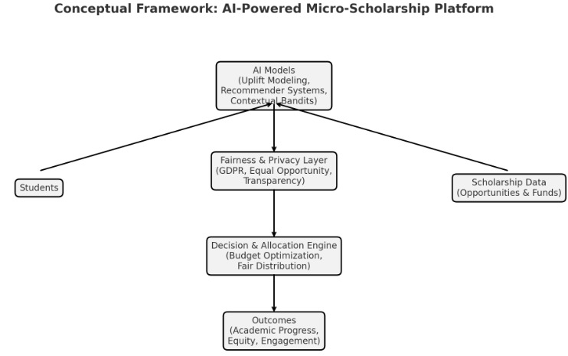**ARCHITECTURE DESIGN DIAGRAM (CONCEPTUAL)**

**DATA SOURCES**

Your system needs **multi-dimensional data** to fairly prioritize students. Possible sources:

1. **School Records**
   * **Academic performance**: GPA, test scores, class rankings
   * **Attendance data**: absenteeism, punctuality
   * **Teacher recommendations**
2. **Household & Socioeconomic Data**
   * Household income (from surveys or census)
   * Household size & dependents
   * Parent/guardian education & occupation
   * Access to electricity/internet
3. **Geospatial Data**
   * Distance to school (Google Maps API / local survey)
   * Rural vs. urban classification
4. **Health & Special Needs**
   * Disability status (official documents or self-report)
   * Orphan/vulnerable child status (validated by NGOs or community leaders)
5. **External Data Sources**
   * National Education Ministry databases
   * NGOs/INGOs operating in education (UNICEF, Save the Children)
   * Community-based organizations for verification
6. **User-Submitted Data**
   * Students/parents filling mobile forms (via app or SMS USSD system)
   * Peer/teacher verification

**LITERATURE REVIEW**

Past studies show that even small scholarships can make a big difference for low-income students, helping them stay in school and do better. UNESCO found that small, targeted support works well, and ScholarMatch showed how connecting the right donors with the right students creates real impact. Our platform builds on these ideas by using AI to check student needs, predict outcomes, and track progress—so donors can feel confident and students have a better chance to succeed.

**Full Technology Stack Overview**

The AI-powered micro-scholarship platform is designed to connect donors with low-income

students using machine learning, ethical data practices, and transparent dashboards. To

achieve this, the platform must be:

• **Scalable**: Capable of growing from pilot to national deployment

• **Ethical**: Built with fairness-aware models and privacy safeguards

• **Transparent**: Offering real-time impact tracking for donors

• **Accessible**: Optimized for low-bandwidth environments and mobile-first users

The chosen technology stack reflects these goals. It combines lightweight backend

frameworks, dynamic frontend libraries, robust databases, and explainable ML models, all

proven in real-world deployments across education, philanthropy, and development sectors.

**Libraries & Toolkits**

A **library** is a collection of pre-written code that developers can use to optimize tasks. It

provides a set of functions, classes, or methods that can be called upon to perform specific

operations. Libraries are designed to be reusable and modular, allowing developers to

integrate them into their projects to avoid rewriting common functionalities.

For example, the Python Standard Library includes modules for handling various tasks such

as file I/O, string manipulation, and data serialization. Developers can import these modules

and use their functions directly in their code.

|  |  |  |
| --- | --- | --- |
| Category | Tools Used | Functionality |
| Machine Learning Models | Scikit-Learn, XGBoost, LightGBM | Dropout Prediction, Donor matching |
| Data Processing | Pandas NumPy | Cleaning, transformation, feature engineering |
| Fairness & Ethics | Fairlearn, AIF360 | Bias detection, fairness-aware modeling |
| Explainability | SHAP, LIME | Model transparency for donor trust |
| Visualization | Chart.js | Impact dashboards and progress tracking |
| Authentication | PyJWT | Secure user sessions and API access |
| Testing | Pytest, Postman | Unit tests, API Validation |

**Comparative Analysis/ Technology Stack Comparison**

**Backend Frameworks**

In the era of web development, the backend serves as the engine that powers the functionality

and logic behind every successful web application. Choosing the right backend frameworks is

crucial for building robust, scalable, and efficient web solutions that meet the demands of

modern users.

|  |  |  |  |
| --- | --- | --- | --- |
| Framework | Flask (Chosen) | Django | Node.js (Express) |
| Language | Python | Python | JavaScript |
| Architecture | Microframework | Full-stack | Microframework |
| Flexibility | High | Moderate | High |
| ML Integration | Seamless | Require setup | External bridge |
| Resource Use | Lightweight | Heavier | Lightweight |
| Best For | Custom APIs, ML pipelines | Admin-heavy apps | Real-time apps |

**2. Timeline (Indicative – can be turned into a Gantt chart)**

* **Week 1–2:** Data collection & preprocessing.
* **Week 3–4:** Develop verification engine.
* **Week 5–6:** Build recommendation engine.
* **Week 7–8:** Train and evaluate predictive models.
* **Week 9:** Platform integration (web + mobile).
* **Week 10:** Deployment & testing.

**3. Milestones**

* Completion of **data pipeline**
* Prototype of **verification engine**
* Drafted **Architecture design diagram.**

**4. Challenges and Mitigations**

* **Data Quality Issues:** Use preprocessing, validation, and anonymization.
* **Model Bias:** Monitor and retrain models with diverse datasets.
* **Scalability:** Use cloud infrastructure for flexible scaling.
* **Trust and Adoption:** Build donor/student confidence via transparency dashboards.

**5. Ethical Considerations**

* This project sits at the center of educational equity and advanced technology, making its ethical design and implementation paramount. While the primary goal, removing financial barriers to education is laudable, the methods introduce significant ethical challenges that must be proactively addressed.
* 1. Data Privacy and Security: this is the most immediate concern, as the platform's functionality likely relies on collecting vast amounts of sensitive student data.
* 2. Algorithmic Bias and Fairness: AI models are not objective; they learn from data and reflect the biases embedded within it. Deploying them in a scholarship context could systematically disadvantage certain groups.
* 3. Potential Impact on the Target Community: the platform's design could have profound second- and third-order effects on the behaviors and well-being of the students it intends to help.

**REFERENCES:**

**6. References**

* UNESCO (Education for All Fund)
* ScholarMatch (Dave Eggers initiative)
* Agarwal, A., Beygelzimer, A., Dudík, M., Langford, J., & Wallach, H. (2018). A reductions approach to fair classification. *International Conference on Machine Learning*, 60–69.
* European Data Protection Board. (2020). *Guidelines 4/2019 on Article 25 Data Protection by Design and by Default.*