Capstone Project Concept Note and Implementation Plan
Project Title: Forecasting Disease Outbreaks Using Integrated Mobility and Health Data
Team Members
- Han D D Htet
- Kyaw Zin Htet
- Aung Ko Min
- Naing Lin
1. Project Overview
The COVID-19 pandemic highlighted a critical global challenge: the rapid spread of airborne diseases and the need for effective preparedness strategies. This project aims to address this problem by creating an early warning system capable of forecasting spikes in disease cases. The project is directly relevant to Sustainable Development Goal 3 (Good Health and Well-Being) by developing tools to enhance national and global health preparedness. Our solution will leverage machine learning to analyze the complex interactions between public health statistics, population mobility, and government policy data to provide a reliable forecast of potential outbreaks. The potential impact is to provide public health agencies with a vital tool to improve readiness and make data-driven decisions for future public health challenges.
2. Objectives
The specific objectives of this project are:
- To identify and integrate three distinct time-series datasets: Epidemiological data from Our World in Data (OWID), population mobility data from Google Community Mobility Reports, and government policy data from the Oxford COVID-19 Government Response Tracker (OxCGRT).
- To implement and train a Random Forest model to serve as a powerful performance baseline.
- To develop, train, and evaluate a comprehensive suite of advanced deep learning models, including Gated Recurrent Unit (GRU), Long Short-Term Memory (LSTM), Temporal Convolutional Network (TCN), Transformer, and Hybrid models.
- To perform a robust comparative study of all implemented models to identify which architecture provides the best forecasting performance for this critical public health task.
3. Background
The existing literature firmly establishes the link between human mobility and the spread of infectious diseases. Foundational studies by researchers such as Kraemer et al. (2020) and Pepe et al. (2021) used mobile phone and community mobility data to show a strong association between reduced human movement and a slowdown in the spread of COVID-19. Building on this, recent research has demonstrated the effectiveness of a machine learning approach. For example, Jiao et al. (2025) successfully used deep learning models like LSTMs with mobility data to forecast COVID-19 trends. This approach is necessary because deep learning models can capture the complex, non-linear relationships between human behavior and future case numbers, outperforming simpler models.
4. Methodology
This project will employ a comparative study of several machine learning and deep learning techniques to determine the most effective model for disease outbreak forecasting. The methodologies to be implemented include:
- Random Forest: An ensemble model used to establish a powerful, non-sequential baseline performance.
- Gated Recurrent Unit (GRU): A modern recurrent neural network (RNN) that uses gates to manage a memory state and learn temporal patterns.
- Long Short-Term Memory (LSTM): A classic and powerful RNN highly effective at learning very long-term dependencies in sequence data.
- Temporal Convolutional Network (TCN): A model that adapts convolutional neural networks to sequence data, using dilated convolutions to identify patterns over long periods.
- Transformer: A state-of-the-art model that relies on a self-attention mechanism to weigh the importance of all time steps at once, allowing it to capture complex global relationships.
- Hybrid Models (e.g., LSTM-Transformer): A modern approach that combines the strengths of different architectures to potentially achieve the best performance.
5. Architecture Design Diagram
The project will follow a sequential data processing and modeling architecture, as illustrated below.

Forecasting Output

Model Training & Evaluation

Feature Engineering

Data Ingestion & Preprocessing

Data Sources
- Data Sources: Three raw datasets: The OWID COVID-19 dataset (epidemiological data), Google Community Mobility Reports (population mobility data), and the OxCGRT dataset (government policy data).
- Data Ingestion & Preprocessing: This component, built using the Pandas library, is responsible for loading the raw CSV files, cleaning the data, handling missing values, and merging the three sources into a single, comprehensive time-series dataset aligned by date and country.
- Feature Engineering: This stage involves creating predictor variables for the models. This includes generating "lag" features (e.g., using mobility data from 1-3 weeks prior to predict current cases ) and selecting relevant metrics like positive_rate and the StringencyIndex.
- Model Training & Evaluation: The core of the project where each of the selected models (Random Forest, LSTM, GRU, TCN, Transformer, Hybrid) is trained on the historical data and evaluated to measure its predictive accuracy.
- Forecasting Output: The final component delivers the predictions from the best-performing model, providing an early warning of potential future spikes in disease cases.
6. Data Sources
This project is founded on a multi-dimensional dataset created by integrating three robust, publicly available sources. The primary dataset is the Our World in Data (OWID) COVID-19 Dataset, which provides the epidemiological target variables we aim to predict, such as positive_rate and new_cases. This is supplemented by our core behavioral predictor, the Google Community Mobility Reports, which tracks daily population movement trends across categories like workplaces and transit stations. Finally, to provide essential context, we will use the Oxford COVID-19 Government Response Tracker (OxCGRT), which quantifies policy interventions through metrics like the StringencyIndex. By combining health data (the target), mobility data (the behavior), and policy data (the context), we can build a model that understands the complex dynamics of an outbreak.
7. Literature Review
A review of existing literature confirms that the link between human mobility and disease spread is well-established, validating the core hypothesis of this project. Foundational papers have provided data-driven evidence that changes in mobility directly impact COVID-19 transmission rates. More recent research has successfully leveraged this relationship for prediction, with studies demonstrating that deep learning models like LSTMs can effectively forecast future cases using mobility as a key input feature. Our project builds directly on this work by moving beyond the application of a single model to conduct a comprehensive, comparative study. We will implement and evaluate a full suite of technologies—from a Random Forest baseline to state-of-the-art Transformer and Hybrid models—on the same integrated dataset to provide a clear evaluation of which model offers the best performance for this public health task.
Implementation Plan
1. Technology Stack
- Programming Language: Python
- Libraries: Pandas (for data loading, cleaning, and merging), Scikit-learn (for Random Forest baseline).
- Frameworks: TensorFlow or PyTorch will be used to build, train, and evaluate the GRU, LSTM, TCN, Transformer, and Hybrid deep learning models.
2. Timeline and Task Distribution
- Project Timeline (Gantt Chart)
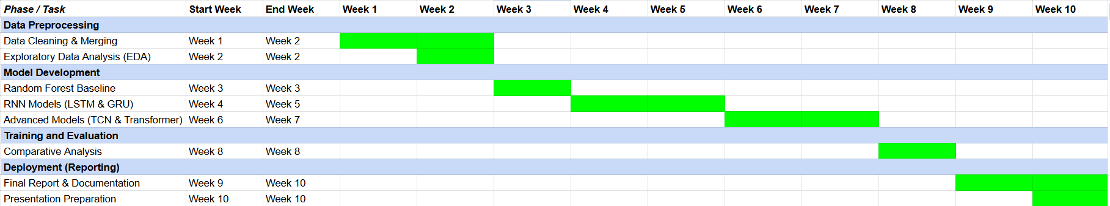

- Task Distribution Matrix
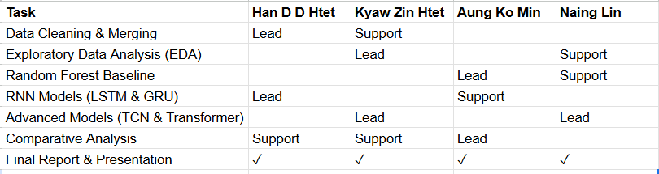

Legend:
- Lead: Has primary responsibility for completing the task.
- Support: Actively assists the lead and contributes to the task.
- ✓: All members have equal responsibility
3. Milestones
- Week 2: A final, cleaned, and merged dataset is created and ready for modeling.
- Week 4: The Random Forest baseline model is successfully trained and evaluated, establishing a performance benchmark.
- Week 6: LSTM and GRU models are implemented, and their initial performance metrics are recorded.
- Week 8: TCN, Transformer, and Hybrid models are implemented, trained, and evaluated.
- Week 10: The comparative analysis is complete, the best-performing model is identified, and the final project report is drafted.
4. Challenges and Mitigations
- Challenge: Data Quality
  - Potential issues include missing data points or misalignments between the three datasets.
  - Mitigation: We will use the Pandas library for systematic data cleaning and interpolation for missing time-series values. A thorough exploratory data analysis (EDA) will be conducted to identify and address inconsistencies before modeling.
- Challenge: Model Performance
  - Advanced models like the Transformer can be prone to overfitting on smaller datasets.
  - Mitigation: We will implement regularization techniques such as dropout and early stopping during training. We will start with smaller model architectures and use careful hyperparameter tuning to find the optimal balance between complexity and generalization.
- Challenge: Technical Constraints
  - Training multiple deep learning models is computationally expensive and can be time-consuming.
  - Mitigation: We will leverage cloud-based platforms like Google Colab for access to free GPU resources, which can significantly speed up training. Model development and testing will be done on smaller data subsets to allow for faster iteration.
5. Ethical Considerations
This project is designed with key ethical principles in mind.
- Data Privacy: All datasets used are public and aggregated. The Google Mobility data is anonymized, and the OWID and OxCGRT datasets contain no personally identifiable information, ensuring individual privacy is protected.
- Bias: We acknowledge that mobility data may underrepresent certain demographics (e.g., populations without smartphones). This is a limitation, and the model's predictions will be framed with this potential bias in mind.
- Impact: The output of our model is intended as a decision-support tool for public health experts, not as a definitive public forecast. We recognize that an inaccurate forecast could have negative societal consequences, and therefore the model's limitations and confidence intervals will be clearly communicated.
6. References
- Ayyoubzadeh, S. M., et al. (2020). Predicting COVID-19 incidence through Google Trends and mobility data. Health Information Science and Systems.
- Bai, S., et al. (2018). An Empirical Evaluation of Generic Convolutional and Recurrent Networks for Sequence Modeling. arXiv:1803.01271.
- Chollet, F. (2017). Deep Learning with Python. Manning Publications.
- Jiao, S., et al. (2025). Spatio-temporal epidemic forecasting using mobility data and deep learning. Scientific Reports.
- Vaswani, A., et al. (2017). Attention Is All You Need. Advances in Neural Information Processing Systems (NeurIPS).

