Assignment 3: Capstone Project Concept Note and Implementation Plan
Project Title: Road Traffic Accident Prediction
Team Members
- Thu Thu Win
- Ye Htet Naing
- Unt Ko
- Sai Shang Hlang
- Chaw Nu Htun

Concept Note
1. Project Overview
This capstone project focuses on developing a machine learning-based road accident prediction system that analyzes environmental, road geometry, traffic, and weather data to identify high-risk areas and times for road accidents. The project directly supports Sustainable Development Goal (SDG) 3: Good Health and Well-being and SDG 11: Sustainable Cities and Communities by promoting safer transportation systems and reducing road traffic injuries.
The problem addressed is the increasing rate of road accidents due to human error, poor road conditions, and environmental factors. Current systems are often reactive rather than predictive, leading to delayed responses and loss of life. This project leverages data-driven models—such as Random Forest, XGBoost, and SVM—to forecast accident likelihoods, enabling authorities to take proactive measures such as deploying traffic controls, improving infrastructure, or raising public awareness. By transforming raw data into actionable insights, the project aims to enhance road safety management, minimize accident-related casualties, and contribute to the creation of smarter and safer cities.
2. Objectives
- To develop a predictive model by testing and comparing machine learning algorithms like Random Forest, XGBoost, and SVM to find the most accurate one for predicting the accident risk. This directly addresses the current lack of proactive , data-driven methods.
- To identify the main factors that contribute to road accidents based on the data and the results of our best model. This provides actionable insights for targeted interventions, moving beyond reactive approaches.
- To establish a reliable foundation for a road accident risk prediction system that can be expanded upon in the future. This contributes to reduced accident rates by creating a scalable tool for proactive resource allocation and safety measures.
3. Background
A recent comprehensive review [1] of 191 studies from 2019-2024 maps the state-of-the-art in machine learning for traffic accident analysis, revealing that advanced models like Random Forest, CNNs, and LSTMs significantly outperform traditional methods in predicting accident risk, frequency, and severity. This enhanced accuracy is most pronounced when models integrate diverse data sources, such as traffic flow, weather, and social media. Despite this progress, the field faces persistent challenges, including data imbalance, limited model interpretability, and a strong regional bias in datasets, all of which must be addressed to improve global road safety and reduce the 1.19 million annual traffic fatalities.

4. Methodology
For this project, we will use a supervised machine learning methodology, specifically focusing on a regression task to predict the continuous value of road traffic accident risk.
The core of our implementation will rely on two powerful ensemble models.
- Random Forest (RF): This algorithm builds multiple decision trees during training and outputs the mean prediction of the individual trees. It's robust, handles non-linear relationships well, and is less prone to overfitting.
- XGBoost (Extreme Gradient Boosting): This is a high-performance gradient boosting framework. It builds models in a sequential, stage-wise fashion, with each new model correcting the errors of the previous ones. It is crucial for this project due to its industry-leading accuracy and efficiency.
We will compare these models using standard regression metrics, such as Root Mean Squared Error (RMSE) and Mean Absolute Error (MAE), to select the best-performing model for deployment.
5. Architecture Design Diagram
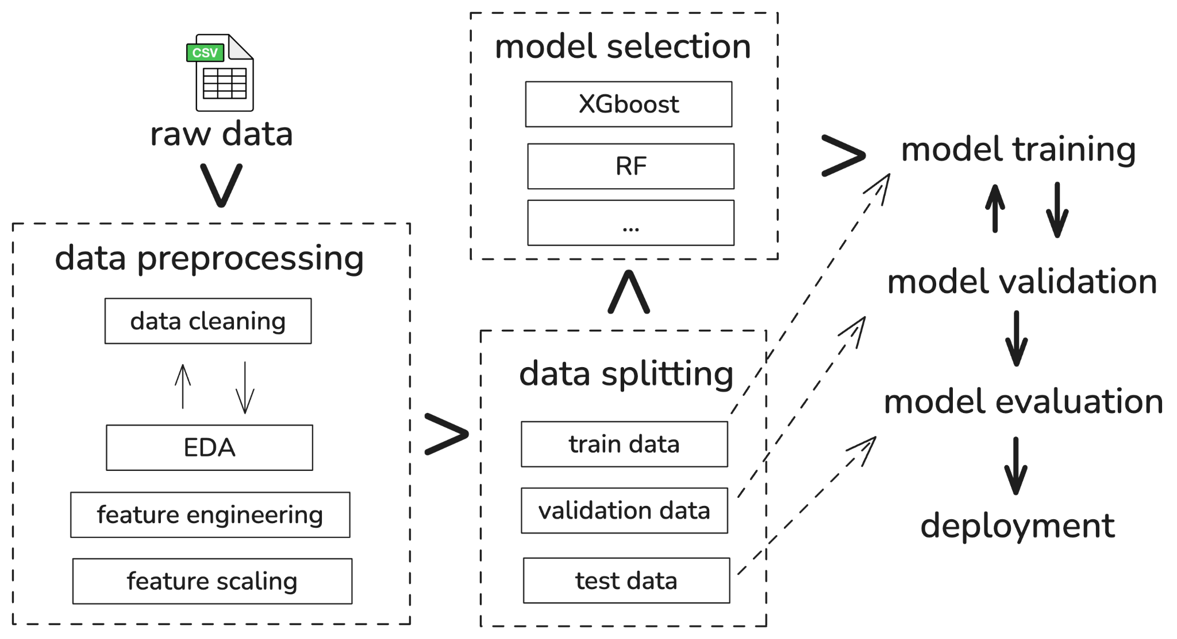

Components
Raw data: The initial, unprocessed data source (CSV file)
Data Preprocessing: A set of steps to clean and prepare the data for modeling.
- Data Cleaning: Handles missing values, removes duplicates, and corrects errors.
- EDA (Exploratory Data Analysis): The process of visualizing and analyzing the data to understand its patterns, relationships, and characteristics.
- Feature Engineering: Creating new, relevant features from the existing data to improve model performance.
- Feature Scaling: Standardizing or normalizing the range of data features (e.g., to a 0-1 range) to ensure the model algorithms perform correctly.
Data Splitting: Dividing the dataset to ensure the model can be evaluated fairly.
- Train Data: The largest portion, used to teach the model.
- Validation Data: Used to tune the model's parameters (hyperparameters) and prevent overfitting during the training process.
- Test Data: Held aside until the very end. It provides an unbiased, final evaluation of the best model's performance on unseen data.
Model Selection: The process of choosing which algorithms (e.g., XGBoost, Random Forest) to test for prediction of road traffic accident risk.
Model Training & Validation: An iterative loop where the selected models are fit to the train data, and their performance is immediately checked against the validation data. This helps find the best-performing model and settings.
Model Evaluation: The final, chosen model is tested against the test data to produce the final performance metrics (RMSE).
Deployment: The final step, where the fully trained and evaluated model is saved and packaged to be used by the production system.

6. Data Sources
The dataset for this project is based on the Simulated Roads Accident dataset, which includes both numerical and categorical data describing road, weather, and environmental conditions relevant to accident prediction. The data was generated through a deep learning model trained using domain-informed simulation logic, enabling realistic representation of variables such as road curvature, surface type, lighting conditions, and weather patterns. This dataset is highly relevant as it allows investigation into how these factors contribute to accident risk. Preprocessing steps include handling missing or inconsistent values, encoding categorical variables, normalizing numerical features, and splitting the dataset into training and testing sets to build and evaluate machine learning models effectively[2].
7. Literature Review
Existing research demonstrates the growing effectiveness of machine learning (ML) in predicting and analyzing road accidents by uncovering complex relationships between environmental, road, and traffic factors. Behboudi et al. (2024) provided a comprehensive review showing that ML models like Random Forest, XGBoost, and SVM outperform traditional statistical methods in accident prediction accuracy. Assi highlighted the benefits of hybrid models combining Principal Component Analysis (PCA) with ML techniques to improve crash severity classification. Similarly, Vanitha and Swedha confirmed the strong predictive capability of traditional ML algorithms in identifying accident-prone areas, while Ahmed et al. emphasized the importance of explainable ML models for interpreting key risk factors. Building on these studies, this project integrates data-driven predictive modeling with environmental and road condition variables to develop a more holistic and interpretable system for real-time road accident risk prediction, advancing previous work by focusing on practical deployment, explainability, and proactive safety planning aligned with sustainable urban mobility goals.

Implementation Plan
1. Technology Stack
Our technology stack includes
- Programming Languages: Python
- Libraries:Numpy, Pandas, Scikit-learn, Matplotlib, Seaborn
- Algorithms and Models: Random Forest, XGBoost, SVR( Support Vector Regression)
- Software and Hardware: Google Colab, Juypter Notebook
2. Timeline
- Data collection and preprocessing (50%)
- Model development (25%)
- Training, and evaluation (25%)
- Deployment: December

3. Milestones
We've identified four critical milestones that will guide our progress.
- 1. Finished data preprocessing
- 2. Finished model development
- 3. Finished training
- 4. Deployed
4. Challenges and Mitigations
Despite the high accuracy of modern machine learning models, their adoption in real-world traffic safety is hindered by significant challenges. A primary issue is model interpretability; the "black box" nature of complex algorithms like XGBoost reduces trust among policymakers, making them hesitant to rely on models they cannot understand. Another major gap is cross-regional generalization, as models trained on data from one specific region often fail when applied elsewhere due to differing local contexts. To mitigate these critical issues, future research recommends focusing on two key areas: developing hybrid models that integrate explainable AI (XAI) frameworks to improve transparency and build trust, and exploring transfer learning techniques to enhance a model's adaptability and performance across diverse geographical regions.
5. Ethical Considerations
- Data Privacy: The use of detailed datasets, which may include precise locations and times of accidents, raises significant privacy concerns. There is a risk that individuals involved in accidents could be re-identified if the data is not properly handled and anonymized.
- Algorithm Bias: The machine learning model is at risk of perpetuating biases present in the historical accident data. For example, if certain neighborhoods have higher reported accident rates due to socioeconomic factors or over-policing, the model may unfairly label those areas as high-risk, potentially leading to discriminatory outcomes in resource allocation.
- Impact on the target community: The predictions generated by the model could have significant real-world consequences. If used to direct increased police patrols, it could lead to heightened surveillance in specific communities. Conversely, if used to justify infrastructure investment, it could divert resources away from other areas in need, creating inequitable safety outcomes.

6. References
- Hamdan, Noura, and Tibor Sipos. 2025. “Advancements in Machine Learning for Traffic Accident Severity Prediction: A Comprehensive Review”. Periodica Polytechnica Transportation Engineering 53 (3):347-55. https://doi.org/10.3311/PPtr.40369.
- Synthetic Dataset: Road Accident Risk Factor - Ian Too, Kaggle https://www.kaggle.com/datasets/ianktoo/simulated-roads-accident-data/
- N. Behboudi, S. Moosavi, and R. Ramnath, “Recent Advances in Traffic Accident Analysis and Prediction: A Comprehensive Review of Machine Learning Techniques,” Jun. 2024. Available: https://arxiv.org/pdf/2406.13968
- K. Assi, “Traffic Crash Severity Prediction—A Synergy by Hybrid Principal Component Analysis and Machine Learning Models,” in International Journal of Environmental Research and Public Health (IJERPH),
Available:https://www.researchgate.net/publication/344839529_Traffic_Crash_Severity_Prediction-A_Synergy_by_Hybrid_Principal_Component_Analysis_and_Machine_Learning_Models
- R. Vanitha and M. Swedha, “Prediction of Road Accidents Using Machine Learning Algorithms,” in Middle East Journal of Applied Science & Technology (MEJAST), May 2023, pp. 64–75. Available:https://www.researchgate.net/publication/370961834_Prediction_of_Road_Accidents_Using_Machine_Learning_Algorithms
- S. Ahmed, A. Hossain, S. K. Ray, M. M. I. Bhuiyan, and S. R. Sabuj, “A study on road accident prediction and contributing factors using explainable machine learning models: analysis and performance : ,” in Transportation Research Interdisciplinary Perspectives, May 2023.
Available:https://www.researchgate.net/publication/370288284_A_study_on_road_accident_prediction_and_contributing_factors_using_explainable_machine_learning_models_analysis_and_performance

