Capstone Project Concept Note and Implementation Plan

Project Title: UrbanOS: The Digital Twin for the Net-Zero Metropolis

Team Members
- Shin Thant Phyo
- Htet Paing Lin
- Htoo Thet Naung
- Thet Hmue Khin
- Naw May Thu Han
- Shwe Yamin

Concept Note

1. Project Overview

UrbanOS is an intelligent digital twin platform designed to simulate, optimize, and decarbonize urban operations through a dual-layer AI system. It addresses two interlinked urban challenges: inefficient municipal services (traffic congestion, waste collection inefficiency) and the hidden carbon footprint of AI-driven smart city infrastructure.

By integrating machine learning, optimization algorithms, and carbon-aware computing, UrbanOS aims to help cities operate more sustainably. The system visualizes real-time optimization through a web-based dashboard, empowering decision-makers to achieve resource efficiency and carbon neutrality in city operations.

Relevance to SDGs:
- SDG 11 – Sustainable Cities and Communities: Enables smart traffic and waste management.
- SDG 12 – Responsible Consumption and Production: Reduces waste and resource inefficiencies.
- SDG 13 – Climate Action: Implements a Green AI Scheduler to cut computational carbon emissions.

2. Objectives
- Develop a digital twin that integrates live urban data for real-time decision-making.
- Use LSTM-based models to forecast traffic congestion and support efficient route planning.
- Optimize waste collection routes with machine learning algorithms to minimize fuel and time.
- Implement a Green AI Scheduler to dynamically shift computational workloads to low-carbon energy periods.
- Demonstrate the potential of carbon-aware AI for net-zero urban intelligence systems.

3. Background

Rapid urbanization and the climate crisis have accelerated the demand for data-driven smart cities. While digital twins and AI systems promise operational efficiency, their energy-intensive computation introduces new sustainability challenges.Existing smart city systems focus mainly on optimizing physical processes, such as traffic and waste management, but rarely address the energy impact of the AI models themselves. UrbanOS bridges this gap by combining “Green by AI” (AI for sustainability) and “Green in AI” (sustainable AI operation) approaches.

4. Methodology

UrbanOS employs a hybrid AI architecture:
- Deep Learning (LSTM): For real-time and historical traffic forecasting.
- Optimization Algorithms (Google OR-Tools): For waste collection route optimization.
- Green AI Scheduler (ML-based Controller): Shifts non-urgent computational workloads to periods of low grid carbon intensity, minimizing digital emissions.

All modules are integrated through an IoT-enabled digital twin that visualizes system states, predictions, and scheduling recommendations via an interactive dashboard.
5. Architecture Design Diagram
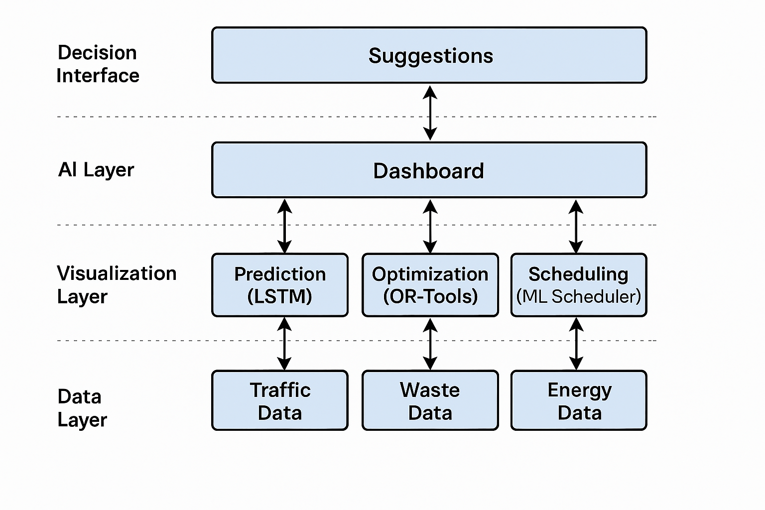

6. Data Sources
- Traffic Flow Data: Time-series data from municipal open data (e.g., NYC Open Data) for LSTM training.
- Waste Collection Data: IoT sensor datasets (Dublin, Limerick, Kaggle) with GPS and bin fill levels.
- Grid Carbon Intensity Data: Time-series gCO₂/kWh values from ElectricityMap or National Grid APIs.

These datasets are chosen for their variability and richness, enabling robust model training and validation. Preprocessing includes normalization, feature extraction, and temporal alignment.

7. Literature Review

The literature establishes three foundational pillars for UrbanOS:
- Urban Digital Twins (UDTs): Real-time city models combining IoT, GIS/BIM, and ML analytics.
- AI-Driven Optimization: Proven use of LSTM and OR-Tools for traffic and waste management.
- Green AI: Carbon-aware scheduling to reduce AI system emissions.

UrbanOS extends existing research by integrating these domains into a single net-zero framework that balances physical and digital sustainability.

Implementation Plan

1. Technology Stack
- List the technologies and tools you plan to use for the implementation of your project.
  - Programming Languages: Python, JavaScript
  - Libraries/Frameworks: TensorFlow/Keras (LSTM), scikit-learn, Google OR-Tools, Flask/Django (backend), React.js (frontend)
  - Visualization Tools: Plotly, Leaflet.js, Streamlit
  - Data Management: PostgreSQL, Pandas, APIs (ElectricityMap, Open Data Portals)
  - Hosting/Infrastructure: Google Cloud Platform (GCP) or AWS for scalable deployment or Streamlit

2. Timeline
Phase | Activities | Duration
Week 1–2 | Literature review and data collection | 2 weeks
Week 3–4 | Data preprocessing and exploratory analysis | 2 weeks
Week 5–6 | LSTM model development for traffic forecasting | 2 weeks
Week 7–8 | Waste optimization and Green AI Scheduler design | 2 weeks
Week 9–10 | Integration and dashboard development | 2 weeks
Week 11 | Testing and model evaluation | 1 week
Week 12 | Final report and deployment | 1 week

If paired work is required, tasks can be distributed as:
- Data & ML Models: Shin Thant Phyo, Thet Hmue Khin, Htoo Thet Naung
- Visualization & Backend: Htet Paing Linn, Naw May Thu Han, Shwe Yamin

3. Milestones
- Data acquisition and cleaning completed
- LSTM model achieves target accuracy on validation data
- Waste optimization routes validated with simulation
- Successful integration of Green AI Scheduler
- Deployment of live UrbanOS dashboard

4. Challenges and Mitigations
  Challenge
  Data inconsistency or missing values
  Model overfitting
  Limited computation resources
  Scheduler timing inaccuracies
  Mitigation
  Apply interpolation and normalization techniques
  Use dropout, cross-validation, and regularization
  Use cloud-based GPU instances and efficient model pruning
  Employ real-time API updates and periodic retraining

5. Ethical Considerations
- Data Privacy: Use anonymized and open datasets to prevent identity exposure.
- Bias Mitigation: Ensure fairness in AI models, particularly across geographic and demographic datasets.
- Environmental Impact: The Green AI Scheduler directly minimizes model-related carbon emissions, aligning the project with ethical sustainability goals.

6. References
- MIT News. Generative AI’s Environmental Impact.
- MDPI. A Review of Urban Digital Twins Integration and Challenges.
- ElectricityMap.org. Carbon Intensity Data API.
- Smart Dublin. Smart Waste Management Datasets.
- National Grid ESO. UK Carbon Intensity API.
- MDPI. Green Artificial Intelligence for Smart Cities.

