UrbanOS: The Digital Twin for the Net-Zero Metropolis

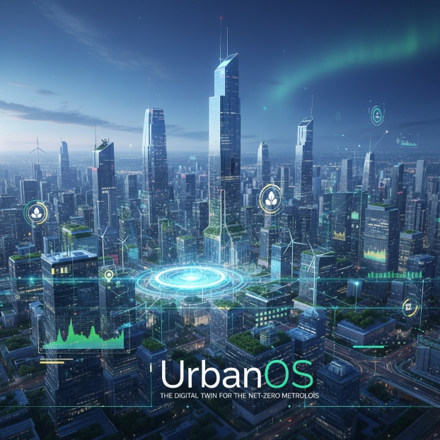

Group – 9
FTL Machine Learning Bootcamp

Team Members: Shin Thant Phyo
Htet Paing Linn
Htoo Thet Naung
Thet Hmue Khin
Naw May Thu Han
Shwe Yamin
Project Title: UrbanOS: The Digital Twin for the Net-Zero Metropolis
1. Project Idea:
UrbanOS is an intelligent digital twin platform that simulates and optimizes city operations through a dual-layer AI framework. It targets two core urban challenges: (1) inefficient services like traffic and waste management, and (2) the hidden carbon footprint of digital control systems. The platform provides a web-based interface to visualize real-time optimizations, demonstrating how smart cities can reduce resource consumption while maintaining minimal environmental impact.
2. Relevance to Sustainable Development Goals (SDGs):
- SDG 11 – Sustainable Cities and Communities: Improves traffic and waste collection efficiency.
- SDG 12 – Responsible Consumption and Production: Reduces operational waste and energy use.
- SDG 13 – Climate Action: Introduces a Green AI Scheduler to minimize the carbon footprint of computation.
3. Literature Examples:
- Google Environmental Insights Explorer (EIE): Provides emissions and mobility data analytics to help cities design low-carbon strategies, inspiring UrbanOS’s traffic optimization and visualization features.
- ElectricityMap by Tomorrow.io: Tracks real-time electricity grid carbon intensity, influencing the design of the UrbanOS Green AI Scheduler that defers computation to periods of low-carbon energy availability.

4. Describe Your Data:
- Traffic Flow Data: time-series sensor data for LSTM traffic prediction.
- Waste Collection Data: Smart Waste datasets (Dublin / Kaggle), GPS and bin fill levels for route optimization using Google OR-Tools.
- Grid Carbon Intensity Data: time-series gCO₂/kWh values for the Green AI Scheduler.
5. Approach (Machine Learning or Deep Learning):
A hybrid AI approach will be used:
- Deep Learning: LSTM models for traffic congestion forecasting using real-time and historical data.
- Machine Learning: Optimization algorithms for waste collection and service scheduling.
- Green AI Scheduler: A machine learning–based controller to shift non-urgent computational workloads to periods and locations with lower grid carbon intensity, minimizing overall digital emissions.

