## Overview

The deployment phase of this machine learning project focuses on making the model available for real-world use through a web application built using Streamlit. This involves serializing the trained model, serving it through the Streamlit application, integrating APIs for interaction, ensuring security, and monitoring performance.

## Model Serialization

### Process

The trained model is serialized to facilitate its deployment. Serialization involves saving the model in a format that can be easily loaded for inference.

### Format

* Format Used: The model is serialized using the YOLO .pt format.
* Considerations: The .pt format is chosen for its compatibility with PyTorch, allowing for efficient storage and loading of the model for predictions. The model includes all necessary weights and configurations.

## Model Serving

### Deployment Platform

The serialized model is served using a Streamlit web application, which provides an interactive interface for users to interact with the model.

### Choices

* Platform: The application is developed using Streamlit, which is chosen for its simplicity in creating interactive web applications with Python.
* Local Hosting: Initially, the application is hosted locally for testing and development purposes. For production, it can be deployed on cloud platforms like Heroku, AWS, or Streamlit Sharing for wider accessibility.

### Serving Framework

* Framework Used: Streamlit is used to build and serve the web application. The PyTorch model is loaded within the Streamlit app to handle inference requests.

## API Integration

### Integration Details

The machine learning model is integrated into the Streamlit application, providing an easy-to-use interface for making predictions.

### Application Interface

* User Input: Users can upload images or input video streams for disease detection.
* Model Interaction: The Streamlit app loads the serialized .pt model and uses it to make predictions on the provided inputs.

Input and Response Formats

* Input Format: The application accepts image files and video streams.
* Response Format: The application displays the prediction results directly on the web interface, including disease identification and confidence scores.

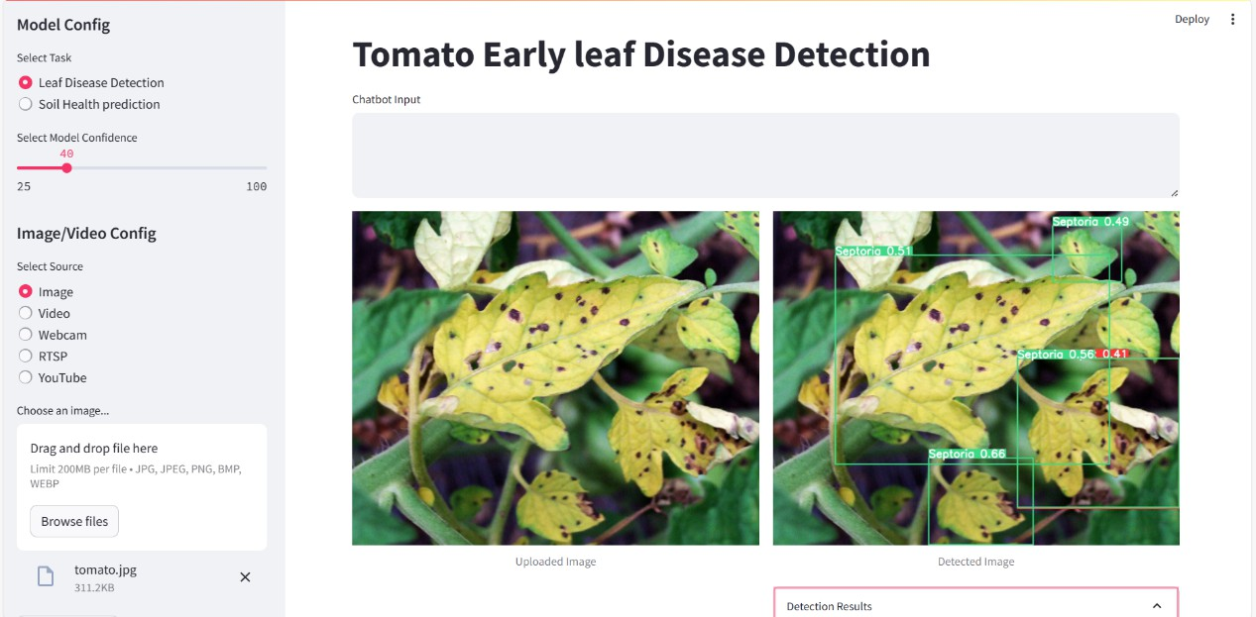

## Security Considerations

### Measures Implemented

While deploying the Streamlit application, several security measures are considered:

* Access Control: For a publicly accessible application, user authentication mechanisms such as OAuth can be integrated.
* Data Privacy: Ensure that any user data (images or videos) are handled securely and not stored without consent.
* Network Security: Use HTTPS to encrypt data in transit between the user and the application.

## Monitoring and Logging

### Performance Monitoring

Monitoring the deployed model’s performance ensures it operates correctly and efficiently.

**Metrics Tracked**

* Application Uptime: Monitor the availability of the Streamlit application.
* Prediction Latency: Track the time taken to return a prediction after user input.
* User Interactions: Log the number and type of user interactions for usage analytics.

**Logging and Alerts**

* Logging: Use Python's logging library to log key events and errors within the application.
* Alerts: Set up alerts to notify the development team of any critical issues, such as application downtime or errors, using monitoring tools like Prometheus or built-in features in cloud platforms.