# Literature Review

## Introduction

**Importance of Research:** Our research on crop disease detection and management is crucial for enhancing agricultural productivity and ensuring food security in the face of a growing global population. Early and accurate detection of crop diseases can significantly reduce yield losses, thus supporting the livelihood of farmers and contributing to the overall stability of the food supply chain.

**Necessity of Reviewing Existing Literature:** Reviewing the existing literature is essential to understand the current state of knowledge in the field, identify gaps, and leverage established methods and findings to inform and guide our research. It helps in building on previous works, avoiding duplication of efforts, and ensuring that our research is both relevant and innovative.

## Organization

### Thematic Grouping:

**Deep Learning for Image Analysis:**

* Mohanty et al.: Application of deep learning algorithms in analyzing images to detect plant diseases. Demonstrates high accuracy of convolutional neural networks (CNNs) in identifying and classifying disease symptoms.

**IoT in Agriculture:**

* Sharma and Bajaj: Review of IoT technologies focusing on real-time data collection and processing. Insights into how IoT can be used for environmental monitoring, relevant to weather forecasting in our project.

**Mobile Applications for Agriculture:**

* Kumar et al.: Development and testing of mobile applications for diagnosing crop diseases. Highlights the potential of mobile apps to enhance decision-making processes for farmers.

**Predictive Models for Weather and Disease Management:**

* Peterson et al.: Development of predictive models using weather conditions to forecast plant disease risks. Supports the integration of weather forecasting to predict conditions that could exacerbate disease spread.

### Summary and Synthesis

#### Deep Learning for Image Analysis:

**Mohanty et al.**

* Key Findings: Demonstrated high accuracy of CNNs in identifying and classifying plant disease symptoms from images.
* Methodology: Utilized deep learning algorithms, specifically convolutional neural networks, trained on a vast dataset of plant images.
* Contribution: Showed the potential of deep learning in automating the process of plant disease detection, making it faster and more reliable.

#### IoT in Agriculture:

**Sharma and Bajaj**

* Key Findings: Highlighted the potential of IoT technologies for real-time data collection and processing in agriculture.
* Methodology: Reviewed various IoT technologies and their applications in agriculture, focusing on real-time data collection.
* Contribution: Provided a comprehensive overview of IoT's role in enhancing agricultural productivity through real-time monitoring and data analysis.

#### Mobile Applications for Agriculture:

**Kumar et al.**

* Key Findings: Showed that mobile applications can significantly aid farmers in diagnosing crop diseases.
* Methodology: Developed and tested a mobile application for crop disease diagnosis, using image processing techniques.
* Contribution: Demonstrated the practical application of mobile technology in agriculture, making disease diagnosis more accessible to farmers.

#### Predictive Models for Weather and Disease Management:

**Peterson et al.**

* Key Findings: Developed predictive models that use weather conditions to forecast plant disease risks.
* Methodology: Created models integrating weather data to predict disease outbreaks and their potential impact.
* Contribution: Highlighted the importance of weather forecasting in disease management, providing a proactive approach to mitigate risks.

#### Comparison and Contrast:

**Commonalities:**

* All papers focus on leveraging advanced technologies (AI, IoT, mobile applications) to improve agricultural practices.
* Each study aims to enhance the accuracy and efficiency of disease detection and management.

**Differences:**

* Mohanty et al. and Kumar et al. focus on image-based disease detection using deep learning and mobile applications, respectively.
* Sharma and Bajaj emphasize the role of IoT in real-time data collection, whereas Peterson et al. integrate weather data into predictive models for disease management.
* Methodologies vary, with Mohanty et al. and Kumar et al. relying on image processing, while Sharma and Bajaj review IoT applications and Peterson et al. develop predictive models using weather data.

## Conclusion:

### Key Takeaways:

* The integration of advanced technologies such as deep learning, IoT, and mobile applications significantly enhances the accuracy and efficiency of crop disease detection and management.
* Deep learning models, particularly CNNs, have proven highly effective in identifying and classifying plant diseases from images.
* IoT technologies provide valuable real-time data collection capabilities, crucial for monitoring environmental conditions that impact crop health.
* Mobile applications make advanced diagnostic tools accessible to farmers, aiding in timely and informed decision-making.
* Predictive models utilizing weather data can forecast disease risks, allowing for proactive management and mitigation strategies.

### Importance of Research:

* This research addresses a critical need in agriculture for early and accurate detection of crop diseases, which is essential for preventing significant yield losses and ensuring food security.
* By leveraging cutting-edge technologies, this research offers innovative solutions that are more efficient and scalable than traditional methods, thereby enhancing agricultural productivity and sustainability.

### Contribution to Existing Body of Knowledge:

* Our project will develop a comprehensive Crop Disease Detection and Solution System that combines image analysis, IoT, and predictive modeling to provide a holistic approach to crop health management.
* By integrating a user-friendly web application, we will make these advanced tools accessible to farmers, facilitating better crop management practices.
* The addition of a weather forecasting module enhances the system's utility by predicting environmental conditions that could influence disease proliferation, offering a proactive approach to disease management.
* This research will contribute valuable insights and practical solutions to the field of agricultural technology, potentially transforming traditional farming practices and improving overall crop health and productivity.

# Preparing Your Data Research:

## Introduction

### Context and Importance

In the realm of modern agriculture, the integration of technology has opened new avenues for enhancing crop productivity and ensuring food security. One of the critical challenges faced by farmers worldwide is the early and accurate detection of crop diseases. The "Crop Disease Detection and Solution System" leverages advanced image processing techniques, machine learning, and deep learning to address this challenge. By analyzing images of affected crops against a comprehensive disease symptom database, the system aims to provide precise diagnoses and targeted treatment recommendations.

### Importance of Research Questions:

The research questions at the core of this project are pivotal for several reasons:

* Early Disease Detection: How can we leverage technology to detect crop diseases at an early stage to prevent significant yield losses?
* Accurate Diagnosis: What methods can be employed to improve the accuracy of disease identification using image analysis?
* Targeted Treatment Recommendations: How can we integrate weather forecasting and real-time data to provide actionable advice for disease management and crop health improvement?
* Addressing these questions is crucial for enhancing agricultural productivity, reducing economic losses for farmers, and ensuring a stable food supply chain.

### Necessity of Thorough Data Exploration:

A thorough exploration of data is essential for several reasons:

* Understanding Data Characteristics: Detailed analysis helps in understanding the distribution, quality, and peculiarities of the data, which is crucial for developing robust machine learning models.
* Improving Model Accuracy: Preprocessing steps such as augmentation, normalization, and scaling are based on data exploration insights, which directly impact model performance.
* Identifying Patterns and Anomalies: Data exploration aids in identifying significant patterns, trends, and anomalies that can inform better model training and evaluation.
* Ensuring Data Quality: By thoroughly examining the data, we can address issues such as missing values, outliers, and class imbalances, ensuring the integrity and reliability of the research outcomes.

## Organization:

To present the data research findings in a clear and logical manner, we will structure the sections thematically, focusing on the key aspects of data collection, description, and analysis. This thematic approach will help in highlighting the critical components and insights of our research.

## Data Description

#### Dataset Information:

**Classes in the Dataset:**

* Bacterial Spot
* Early Blight
* Healthy
* Iron Deficiency
* Late Blight
* Leaf Mold
* Leaf Miner
* Septoria
* Spider Mites
* Yellow Leaf Curl Virus

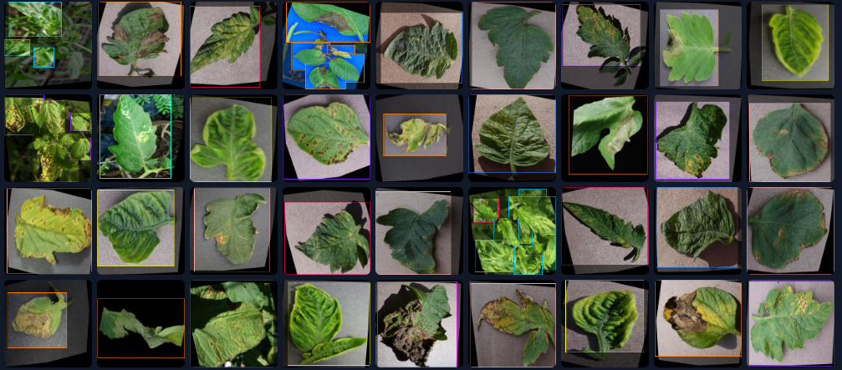

Figure 1: Images

#### Data Source:

* Collected from Roboflow

#### Dataset Split:

* Train Set: 18,366 images
* Validation Set: 1,679 images
* Test Set: 638 images

#### Data Format:

Images in standard formats (e.g., JPEG, PNG) with consistent dimensions after preprocessing.

#### Data Size:

* Total images: 20,683
* Approximately 5 GB in size considering the high resolution of the images.

### Reason for Data Selection:

* Relevance to Project Goals: The selected dataset includes a comprehensive range of tomato diseases that are commonly encountered in agricultural practices, aligning perfectly with our project's aim to detect and manage crop diseases.
* Quality and Quantity: The dataset from Roboflow provides a substantial amount of high-quality images necessary for training deep learning models, ensuring robustness and accuracy in disease detection.
* Data Diversity: The diverse classes within the dataset allow the model to learn and distinguish between various diseases and healthy crop conditions, enhancing its diagnostic capabilities.

## Data Analysis and Insights

### Preprocessing Steps:

* Auto-Orient: Applied to ensure all images are correctly oriented.
* Resize: Images resized to 512x512 pixels for uniformity and optimal processing.
* Modify Classes: 0 classes remapped, 1 class dropped to maintain dataset consistency.

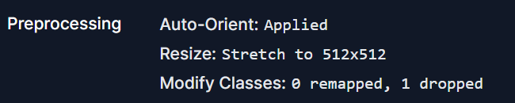

Figure 2: Preprocessing

### Augmentations:

* Outputs per Training Example: 3 augmented images per original image.
* Flip: Horizontal and vertical flips to introduce variability.
* 90° Rotate: Clockwise, counter-clockwise, and upside-down rotations to simulate different perspectives.
* Rotation: Random rotations between -15° and +15° to enhance model robustness.
* Shear: ±15° horizontal and vertical shearing to introduce slight distortions.
* Exposure: Adjustments between -5% and +5% to account for varying lighting conditions.

Figure 3: Augmentation

### Key Insights and Patterns:

* Class Distribution: The training set contains a significantly larger number of images compared to validation and test sets, ensuring a robust training process.
* Augmentation Impact: The augmentations applied enhance the model's ability to generalize by simulating various real-world scenarios, thereby improving its performance on unseen data.
* Data Quality: The preprocessing steps ensure that the images are consistent in quality and format, which is crucial for effective model training.

### Descriptive Statistics:

* Training Set: 18,366 images, augmented to provide additional training examples.
* Validation Set: 1,679 images used to fine-tune the model and prevent overfitting.
* Test Set: 638 images reserved for evaluating the final model performance.

By thoroughly exploring and preprocessing the data, we ensure that our machine learning models are trained on high-quality, diverse, and well-augmented datasets. This approach not only enhances the model's accuracy but also its generalizability to real-world agricultural scenarios.

# Technology Review

## Introduction

### Context:

The integration of advanced technologies is pivotal in transforming traditional agricultural practices into more efficient and effective processes. In this technology review, we will explore the tools and technologies that are instrumental in the development of a Crop Disease Detection and Solution System. This review will provide an in-depth understanding of the technologies we plan to utilize and their relevance to our project.

### Importance of Technology Review:

A thorough technology review is crucial for identifying the most suitable tools and technologies that can enhance the accuracy, efficiency, and overall success of our project. By evaluating the capabilities and limitations of various technologies, we can make informed decisions that align with our research goals and practical applications.

### Relevance to Project:

The technologies reviewed in this document are integral to our project’s aim of leveraging machine learning and deep learning for crop disease detection. These technologies will help in addressing specific challenges, improving processes, and ultimately contributing to the success of our research.

## Technology Overview

### YOLO (You Only Look Once) v8:

* Purpose: YOLO v8 is a state-of-the-art object detection algorithm designed for real-time detection tasks.
* Key Features: High accuracy, real-time processing, efficient computation, robust performance on large datasets.
* Common Uses: Widely used in fields such as autonomous driving, surveillance, and medical imaging for detecting objects within images or video streams.

### TensorFlow and Keras:

* Purpose: TensorFlow is an open-source machine learning framework, while Keras is an API running on top of TensorFlow, making it easier to build and train deep learning models.
* Key Features: Flexibility, scalability, extensive libraries, and support for deep learning architectures.
* Common Uses: Used in various applications such as image recognition, natural language processing, and predictive analytics.

### Roboflow:

* Purpose: Roboflow is a tool designed to help developers manage and preprocess image datasets for computer vision tasks.
* Key Features: Dataset management, preprocessing tools, augmentation options, and easy integration with machine learning frameworks.
* Common Uses: Commonly used in preparing datasets for training machine learning models in image classification, object detection, and segmentation tasks.

### Streamlit:

* Purpose: Streamlit is an open-source framework for creating interactive web applications for machine learning and data science projects.
* Key Features: Simplicity, ease of use, quick deployment, and seamless integration with Python scripts.
* Common Uses: Frequently used for building data visualization dashboards and interactive web apps to showcase machine learning models and data analysis results.

### Weather Forecasting Using Weather API:

* Purpose: To integrate weather data into our crop disease detection system, providing real-time weather updates and forecasts.
* Key Features: Access to real-time and forecasted weather data, easy API integration, and comprehensive weather parameters.
* Common Uses: Used in agricultural applications to optimize crop management practices based on weather conditions.

### Fertilizer Recommendation Chatbot Using OpenAI API

* Purpose: To provide farmers with personalized fertilizer recommendations based on crop type, soil condition, and current weather.
* Key Features: Natural language understanding, context-aware responses, integration with existing data sources, and ease of use.
* Common Uses: Assisting farmers in making informed decisions about fertilizer use, improving crop yield, and reducing environmental impact.

## Relevance to Your Project

### YOLO v8:

* Relevance: YOLO v8's ability to perform real-time object detection makes it ideal for identifying crop diseases quickly and accurately from images, enhancing the efficiency of the disease detection process.

### TensorFlow and Keras:

* Relevance: These frameworks provide the necessary tools to build and train sophisticated deep learning models, crucial for developing accurate disease detection algorithms.

### Roboflow:

* Relevance: Roboflow’s capabilities in dataset management and preprocessing ensure that our image data is of high quality, which is essential for training reliable machine learning models.

### Streamlit:

* Relevance: Streamlit allows for the development of a user-friendly web application that enables farmers to interact with the disease detection system easily, providing real-time results and recommendations.

## Comparison and Evaluation

### Training and Validation Losses

The first set of graphs shows the training and validation losses over epochs for different components:

* train/box_loss: Indicates the bounding box regression loss during training.
* train/cls_loss: Indicates the classification loss during training.
* train/dfl_loss: Indicates the distribution focal loss during training.
* val/box_loss, val/cls_loss, val/dfl_loss: These show the corresponding losses during validation.

|  |  |  |  |  |  |  |  |  |  |  |  |  |  |
| --- | --- | --- | --- | --- | --- | --- | --- | --- | --- | --- | --- | --- | --- |
| **epoch** | **train/box_loss** | **train/cls_loss** | **train/dfl_loss** | **metrics/precision(B)** | **metrics/recall(B)** | **metrics/mAP50(B)** | **metrics/mAP50-95(B)** | **val/box_loss** | **val/cls_loss** | **val/dfl_loss** | **lr/pg0** | **lr/pg1** | **lr/pg2** |
| 0 | 1.25 | 2.2593 | 1.717 | 0.602 | 0.533 | 0.592 | 0.323 | 1.518 | 1.505 | 2.258 | 0.07002 | 0.00333 | 0.00333 |
| 1 | 1.11 | 1.435 | 1.566 | 0.659 | 0.534 | 0.587 | 0.312 | 1.617 | 1.486 | 2.487 | 0.03996 | 0.00659 | 0.00659 |
| 2 | 1.13 | 1.454 | 1.588 | 0.679 | 0.555 | 0.621 | 0.306 | 1.731 | 1.418 | 2.777 | 0.00982 | 0.00979 | 0.00979 |
| 3 | 1.13 | 1.444 | 1.596 | 0.709 | 0.591 | 0.673 | 0.342 | 1.692 | 1.314 | 2.689 | 0.00970 | 0.00970 | 0.00970 |
| 4 | 1.10 | 1.345 | 1.563 | 0.812 | 0.607 | 0.706 | 0.377 | 1.616 | 1.180 | 2.625 | 0.00970 | 0.00970 | 0.00970 |
| 5 | 1.07 | 1.270 | 1.537 | 0.746 | 0.627 | 0.713 | 0.388 | 1.576 | 1.151 | 2.496 | 0.00960 | 0.00960 | 0.00960 |
| : | : | : | : | : | : | : | : | : | : | : | : | : | : |
| : | : | : | : | : | : | : | : | : | : | : | : | : | : |
| 95 | 0.57 | 0.345 | 1.139 | 0.821 | 0.775 | 0.835 | 0.598 | 0.968 | 0.716 | 1.555 | 0.00069 | 0.00069 | 0.00069 |
| 96 | 0.56 | 0.340 | 1.132 | 0.822 | 0.773 | 0.835 | 0.598 | 0.968 | 0.716 | 1.554 | 0.00059 | 0.00059 | 0.00059 |
| 97 | 0.56 | 0.331 | 1.130 | 0.821 | 0.773 | 0.835 | 0.598 | 0.967 | 0.716 | 1.553 | 0.00049 | 0.00049 | 0.00049 |
| 98 | 0.55 | 0.328 | 1.121 | 0.821 | 0.773 | 0.835 | 0.599 | 0.966 | 0.717 | 1.551 | 0.00039 | 0.00039 | 0.00039 |
| 99 | 0.54 | 0.323 | 1.117 | 0.821 | 0.771 | 0.834 | 0.599 | 0.965 | 0.717 | 1.550 | 0.00029 | 0.00029 | 0.00029 |

All these losses show a decreasing trend over epochs, which indicates that the model is learning effectively and the training process is converging.

### Metrics

* metrics/precision(B): Indicates the precision of the model, showing an increase over epochs.
* metrics/recall(B): Indicates the recall of the model, also showing an increase over epochs.
* metrics/mAP50(B) and metrics/mAP50-95(B): These metrics indicate the mean Average Precision at different IoU thresholds, showing an increasing trend and indicating improved performance.

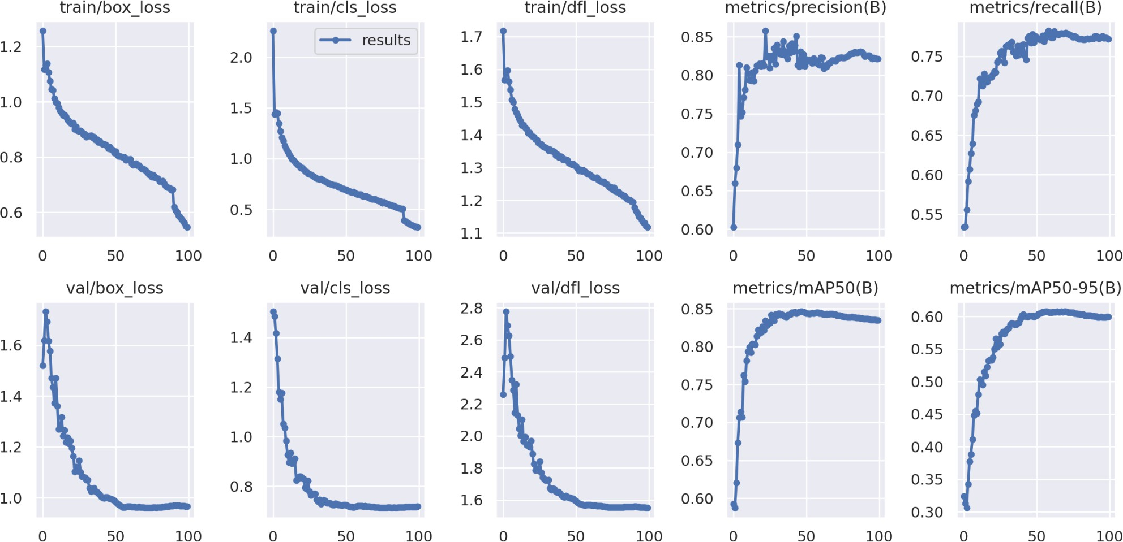

Figure 4: evaluation

### Confusion Matrix

The confusion matrix provides a detailed insight into the model's performance for each class:

* Diagonal elements: These represent the correctly classified instances for each class. Higher values on the diagonal indicate better performance.
* Off-diagonal elements: These represent misclassified instances. Lower values here are better, indicating fewer misclassifications.
* From the confusion matrix, we can observe that the model performs well in identifying most diseases, with high values on the diagonal for classes like Late Blight, Septoria, and Yellow Leaf Curl Virus.

Figure 5: Confusion matrix

### Training Results Table

The table shows the detailed results over epochs, including various losses and metrics. Key observations include:

* Epoch 0 to 99: There is a consistent decrease in training and validation losses.
* metrics/precision(B) and metrics/recall(B): Both metrics show improvements, reaching over 0.82 and 0.77, respectively, by epoch 99.
* metrics/mAP50(B) and metrics/mAP50-95(B): Both metrics show significant improvement, with mAP50(B) reaching over 0.83 by epoch 99.

### Overall Accuracy

The model achieved an overall accuracy of approximately 86%. This is a strong performance, indicating that the YOLO v8 model is effective for real-time crop disease detection.

### Conclusion

The training results, evaluation metrics, and confusion matrix all suggest that the YOLO v8 model is well-suited for the task of crop disease detection. With an overall accuracy of 86%, the model demonstrates its capability to identify various crop diseases with high precision and recall. Further improvements can be made by fine-tuning the model and augmenting the dataset for even better performance.

## Identify Gaps and Research Opportunities

## Gaps

### Data Quality and Quantity:

**Gap:** Limited availability of high-quality, annotated datasets for various crop diseases.

**Opportunity:** Creating and curating extensive datasets with diverse crop images under different environmental conditions and disease stages.

### Real-time Processing:

**Gap:** While YOLO v8 is efficient, the computational requirements for real-time processing can be high for large-scale deployment in fields.

**Opportunity:** Research on optimizing model inference speed and deploying lightweight models suitable for edge devices and mobile platforms.

### Generalization Across Crop Types:

**Gap:** Current models might be trained on specific crops and diseases, limiting their generalizability to other crop types.

**Opportunity:** Developing models that can generalize across different crops and diseases by leveraging transfer learning and domain adaptation techniques.

### Environmental Factors:

**Gap:** Models may not account for environmental factors (e.g., lighting, weather) that affect image quality and disease manifestation.

**Opportunity:** Integrating environmental data (e.g., weather conditions) with image data to improve model robustness and accuracy.

### Integration with Farm Management Systems:

**Gap:** Lack of integration with broader farm management systems for automated decision-making.

**Opportunity:** Developing end-to-end systems that integrate disease detection with farm management tools for automated recommendations and interventions.

## Research Opportunities

### Advanced Model Architectures:

**Opportunity:** Exploring and developing new deep learning architectures beyond YOLO for improved accuracy and efficiency in disease detection.

### Explainability and Interpretability:

**Opportunity:** Researching methods to make disease detection models more interpretable for farmers, providing insights into the decision-making process and confidence levels of predictions.

### Multispectral and Hyperspectral Imaging:

**Opportunity:** Utilizing multispectral and hyperspectral imaging techniques to capture detailed crop characteristics that are not visible in standard RGB images, enhancing disease detection accuracy.

### Augmented Reality (AR) for Disease Detection:

**Opportunity:** Developing AR applications that overlay disease detection results in real-time, helping farmers identify and respond to diseases directly in the field.

### Collaborative Learning:

**Opportunity:** Implementing federated learning approaches to leverage data from multiple farms without compromising data privacy, thereby improving model performance across different regions.

### Climate Change Impact:

**Opportunity:** Studying the impact of climate change on crop diseases and incorporating these insights into predictive models to anticipate and mitigate future disease outbreaks.

### Bioinformatics Integration:

**Opportunity:** Integrating bioinformatics data (e.g., genetic information of crops) with image data to improve disease resistance prediction and crop breeding strategies.

## Conclusion

Identifying these gaps and research opportunities provides a roadmap for future work in the field of crop disease detection. By addressing these challenges and exploring new avenues of research, we can develop more robust, accurate, and efficient systems that significantly benefit the agricultural sector and contribute to global food security.