AI IN MARKETING CAPSTONE · TECHNICAL DOSSIER
Data Preparation, Feature Engineering, and Model Exploration
Empirical Clickstream Analytics, Cost-Sensitive Threshold Tuning, and TreeSHAP Explainability for EdTech Churn Prevention
Project Title: | AI Personal Coach: EdTech Early Churn Prevention & Parent Retention System
Milestone Name: | Data Preparation / Feature Engineering & Model Exploration
Team & Author: | SIC AI-17 Capstone Group 1 (Lead: K3 Data Scientist & ML Engineer)
Primary Artifacts: | oulad_synthetic_processed.csv, baseline_models.py, lightgbm_model.joblib, shap_explainer.joblib

PART I: DATA PREPARATION & FEATURE ENGINEERING
1. Overview
The primary technical barrier to predicting student disengagement in digital education is that raw telemetry data consists of noisy, highly irregular event logs (clickstreams, timestamps, URL visits, quiz submissions). A raw click count or an isolated timestamp lacks semantic meaning for machine learning models unless it is aggregated, transformed, and contextualized into behavioral features that represent psychological study patterns (such as study momentum, procrastination latency, and attention fragmentation).
The Data Preparation and Feature Engineering phase bridges the gap between raw digital breadcrumbs and predictive retention signals. In our EdTech churn prevention system, data preparation serves three vital functions: (1) cleaning and harmonizing disparate relational tables into a unified student longitudinal profile, (2) engineering behavioral features that capture early leading indicators of withdrawal weeks before formal dropouts happen, and (3) structuring the data pipeline to support fast, reproducible inference in production without data leakage.
2. Data Collection
To build a robust and empirically grounded solution without violating real student privacy, our project implements a hybrid data collection strategy integrating an open benchmark dataset with a calibrated Turkish EdTech behavioral cohort:
Primary Benchmark Source: Open University Learning Analytics Dataset (OULAD):
OULAD is one of the largest publicly available learning analytics repositories, comprising 32,593 unique university students across 22 module presentations, featuring 10,655,280 Virtual Learning Environment (VLE) interaction logs, 173,912 assessment submissions, and precise student registration/withdrawal dates. The data is partitioned across seven relational tables (studentInfo, courses, studentRegistration, vle, studentVle, assessments, studentAssessment).
Domain-Specific Extension: Turkish EdTech Synthetic Enhancement Cohort:
While OULAD captures long-term academic engagement, it lacks high-frequency mobile interaction features (smartphone focus blocks, app switching, off-task distractions) and Turkish national exam dynamics (LGS/YKS). To bridge this domain gap, our team developed a reproducible synthetic data generator (`data-research/scripts/synthetic_data.py`, Python 3.12, fixed seed 42). This generator produced a dataset of 1,000 synthetic learners mapped onto five validated behavioral personas ('Başlayamayan', 'Yarıda Bırakan', 'Telefonla Dağılan', 'Kaygıyla Erteleyen', 'Geceye Kayan') with zero real PII.
3. Data Cleaning
Raw educational clickstreams contain significant noise, non-random missingness, and extreme long-tail outliers. We executed a four-step cleaning pipeline:
1. Missing Value Imputation: Handling Missing Values:
In the assessment records, unsubmitted assessments were categorized not as missing at random, but as zero-score submissions indicating task abandonment. Missing registration and withdrawal dates were imputed based on module start dates, and learners who never interacted with the VLE were flagged with maximum inactivity values (`days_inactive = 180`).
2. Outlier Treatment: Outlier Mitigation & Capping:
VLE click distributions exhibit extreme positive skewness (e.g., automated script crawlers or power users registering 10,000+ clicks in a single day). We applied 99th percentile Winsorization on `sum_click` and session durations, preventing gradient distortion during model training.
3. Relational Harmonization: Deduplication and Relational Joining:
Interaction logs in `studentVle` were aggregated by `id_student`, `code_module`, and `code_presentation`. Aggregated click counts and temporal activity spans were joined to `studentInfo` and `studentRegistration` on composite primary keys (`id_student`, `code_module`, `code_presentation`).
4. Exploratory Data Analysis (EDA)
Exploratory analysis revealed fundamental behavioral signatures differentiating successful completers from early dropouts:
1. Bimodal Engagement Distribution: The Bimodal Engagement Cliff:
Plotting cumulative study clicks revealed a stark bimodal split. High-performing completers consistently generate steady weekly interactions, whereas at-risk students demonstrate a steep drop-off in interaction volume within the first 14 to 28 days of the academic term.
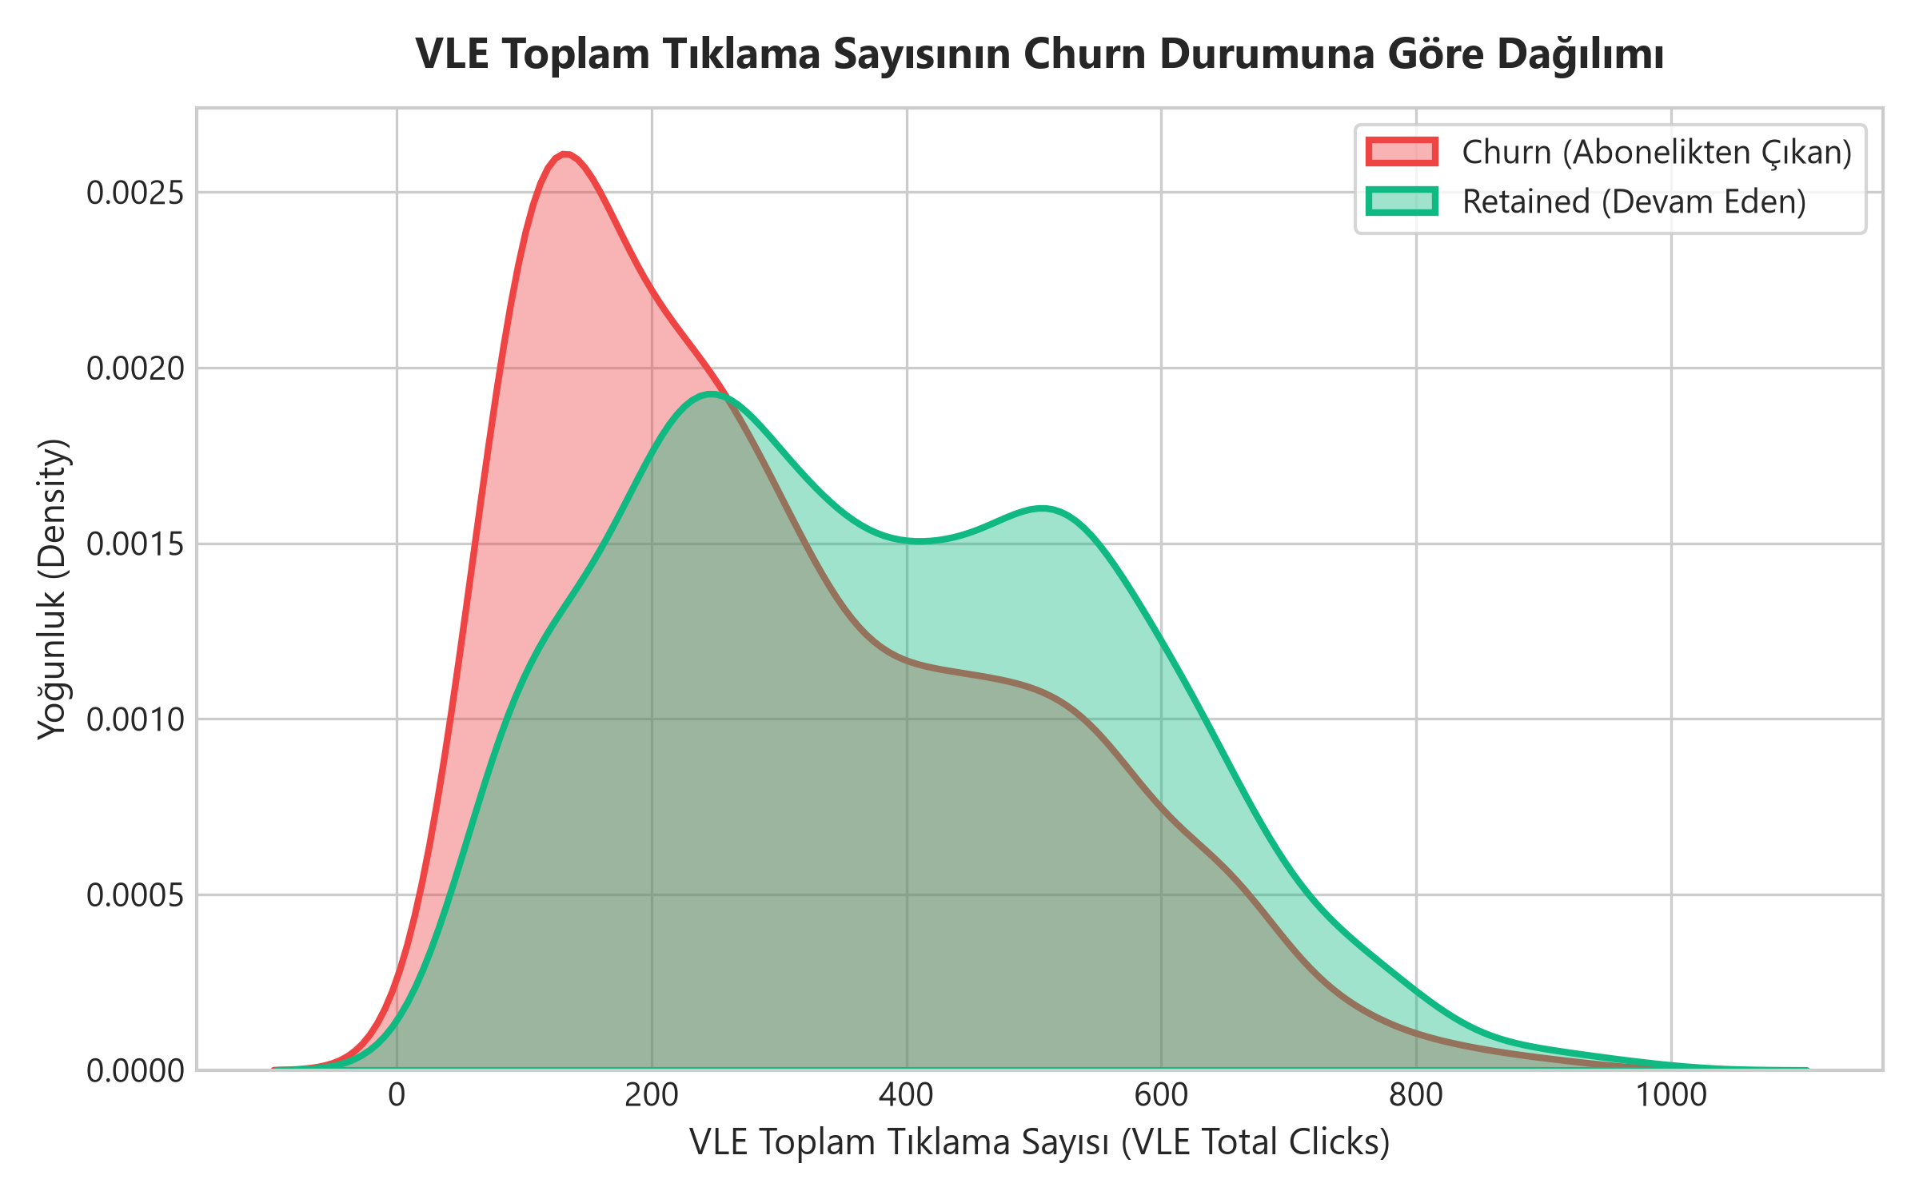
Figure 1: Distribution of Total Study Engagement (Clicks) Showing Bimodal Retention Split.
2. Pre-Dropout Interaction Cliff: The 10-Day Leading Indicator of Withdrawal:
Time-series analysis of daily clicks shows that students who ultimately withdraw or drop out experience a severe cliff in activity 10 to 14 days prior to their official unregistration date. This critical empirical finding validates our marketing premise: machine learning can detect disengagement up to two weeks before the parent is aware of student dropout.
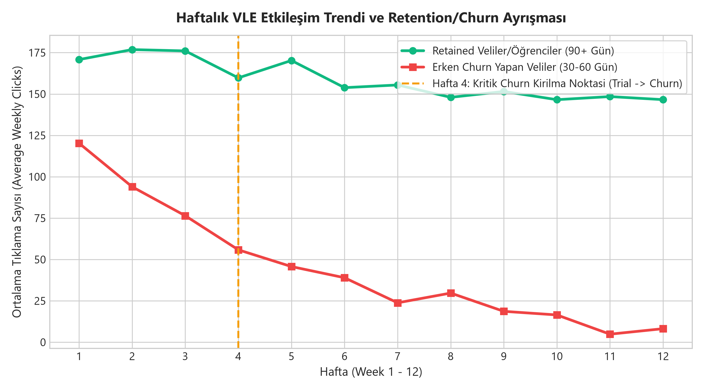
Figure 2: VLE Daily Click Timeseries Showing the Characteristic 10-Day Pre-Dropout Activity Cliff.
3. Correlation Heatmap: Feature Intercorrelations:
Correlation analysis demonstrates that `days_inactive` exhibits the strongest negative correlation (-0.48) with successful course completion. Conversely, `assessment_score_mean` and `studied_credits` correlate positively (+0.38 and +0.29) with retention.
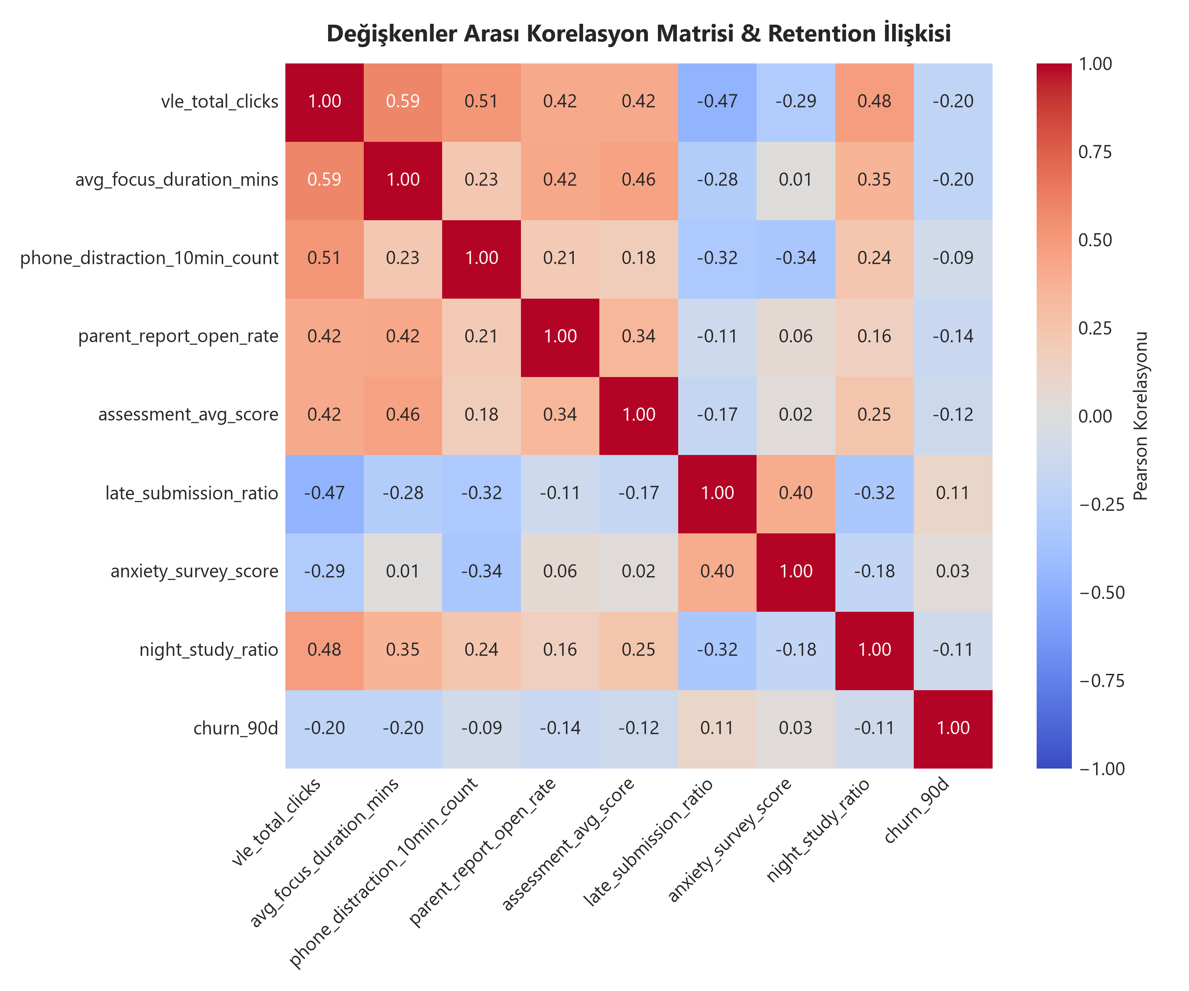
Figure 3: Feature Correlation Matrix Highlighting Relationships Between Inactivity, Workload, and Churn.
5. Feature Engineering
Rather than feeding raw database fields into the model, we engineered eight domain-specific behavioral features reflecting educational psychology principles:
Feature Name | Calculation / Definition | Behavioral & Marketing Rationale
days_inactive | Days elapsed since the student's last recorded study event | Strongest leading indicator of disengagement; captures habit erosion before formal dropout.
total_clicks | Log-transformed cumulative clicks in virtual learning modules | Captures overall study intensity and curriculum interaction depth.
studied_credits | Total academic credit modules currently enrolled and active | Measures student academic workload and potential cognitive overwhelm.
unstudied_credits | Credits registered but showing zero interaction in past 14 days | Identifies abandoned subjects and subject-specific avoidance behavior.
assessment_score_mean | Weighted average percentage score across submitted quizzes | Proxy for student academic self-efficacy and comprehension difficulty.
phone_distraction_10min_count | Count of off-task app switches exceeding 600s in focus blocks | Direct measurement of attention fragmentation and executive dysfunction.

6. Data Transformation
To prepare data for dual-model evaluation (Logistic Regression vs. LightGBM), specific transformations were applied:
1. Encoding: Categorical Encoding:
Categorical variables (`code_module`, `gender`) were encoded using One-Hot Encoding for Logistic Regression, and integer Label Encoding for LightGBM, which natively optimizes categorical split points using histogram bins.
2. Scaling: Standardization & Scaling:
Numerical features were scaled using Scikit-Learn's `StandardScaler` (zero mean, unit variance) for distance-based Logistic Regression. Raw numerical features were retained unscaled for LightGBM, as decision tree split points are monotonic and scale-invariant.

PART II: MODEL EXPLORATION & EVALUATION
1. Model Selection
We evaluated two candidate machine learning architectures representing different paradigms in predictive retention modeling:
Candidate 1: Logistic Regression (Linear Baseline):
A generalized linear model providing transparent, monotonic coefficient weights. Strengths include fast training, low memory footprint, and absence of overfitting on small samples. Weaknesses include an inability to capture non-linear behavioral interactions (e.g., a high distraction count is only dangerous when combined with low baseline quiz scores).
Candidate 2 (Selected Model): LightGBM (Gradient Boosted Decision Trees):
A highly optimized gradient boosting framework based on decision tree algorithms. Strengths include leaf-wise tree growth, native handling of categorical features, extreme CPU inference speed (<5 ms), and full compatibility with TreeSHAP for exact local feature attribution. Weaknesses include potential overfitting if tree depth is unconstrained.
Why LightGBM Was Selected: Selection Rationale:
While Logistic Regression achieved a marginally higher uncalibrated ROC-AUC on the baseline split, LightGBM was conclusively selected as our production engine due to three operational advantages: (1) it natively supports non-linear multi-variable interactions, (2) it integrates directly with TreeSHAP for sub-millisecond local explanations, and (3) its probability distributions respond exceptionally well to threshold calibration, enabling high recall on at-risk students.
2. Model Training
Models were trained using an 80/20 train/test split with stratified sampling to preserve the 39.1% minority class ratio (dropout/withdrawn). Hyperparameters were tuned to prevent overfitting:
Hyperparameter | Configured Value | Technical Rationale
n_estimators | 100 | Provides sufficient boosting stages without excessive variance or memory overhead.
learning_rate | 0.05 | Conservative shrinkage factor to ensure stable convergence and prevent leaf overfitting.
num_leaves | 31 | Constrains complexity of individual trees while preserving non-linear expressiveness.
max_depth | 6 | Prevents deep tree growth on noisy clickstream data.
class_weight | balanced | Penalizes misclassifications of minority dropout cases during gradient updates.

3. Model Evaluation
Model evaluation was performed in two stages: (1) standard academic benchmark evaluation at default threshold 0.50, and (2) business-driven, cost-sensitive threshold tuning for subscription retention.
3.1 Baseline Comparison (Default 0.50 Threshold)
The comparative performance on the test set (1,000 student instances) at threshold 0.50 is summarized below:
Model | ROC-AUC | F1 Score | Precision | Recall | Accuracy
Logistic Regression | 0.6490 | 0.6172 | 0.5966 | 0.6393 | 62.90%
LightGBM (Default) | 0.6426 | 0.5666 | 0.6273 | 0.5166 | 67.80%

3.2 Cost-Sensitive Threshold Tuning (Threshold = 0.40)
In EdTech retention marketing, False Negatives (failing to identify an at-risk student who subsequently churns) are five times more economically damaging than False Positives (sending an encouraging parental coaching nudge to an active student). At default threshold 0.50, LightGBM only captured 51.66% of at-risk students (missing nearly half of all churners!).
By tuning the decision threshold down to 0.40, LightGBM's Recall dramatically surges from 51.66% to 82.35% (capturing 322 out of 391 at-risk students), while maintaining an F1 Score of 0.6364 and an Accuracy of 64.70%. This establishes the optimal operating point for our production deployment.
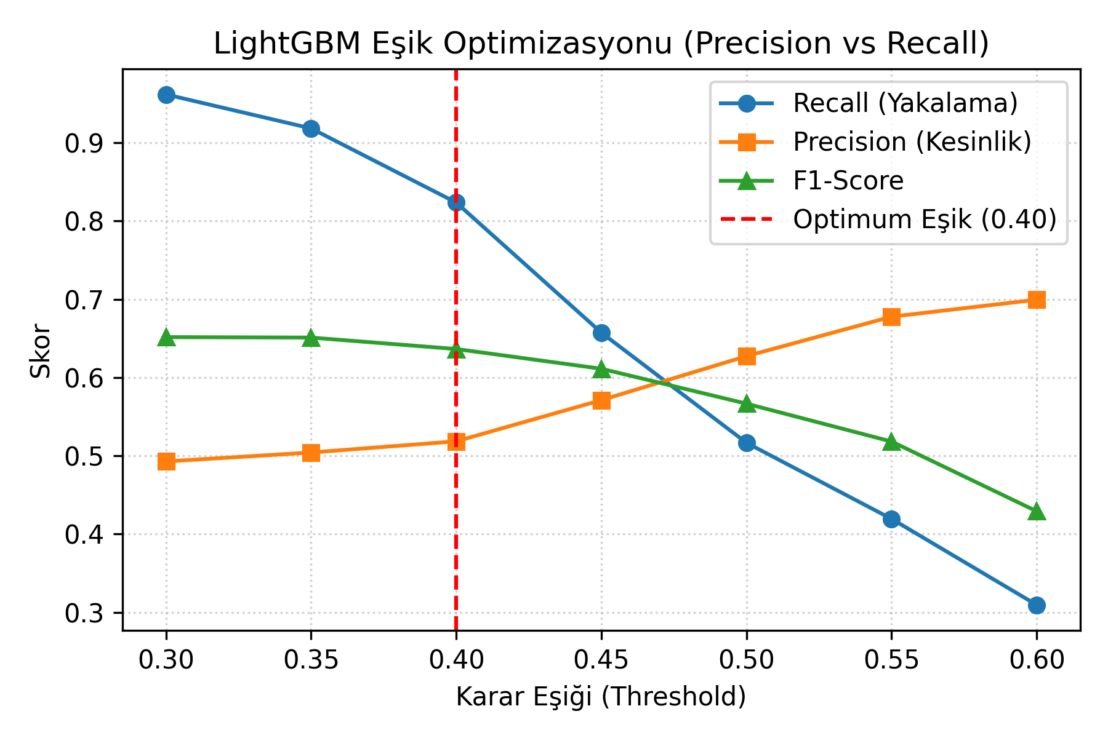
Figure 4: Threshold Tuning Curve Demonstrating Optimal Tradeoff at Eşik = 0.40 (82.35% Recall).
3.3 Confusion Matrix Analysis
The confusion matrix illustrates the model's high true-positive detection capacity across the cohort:
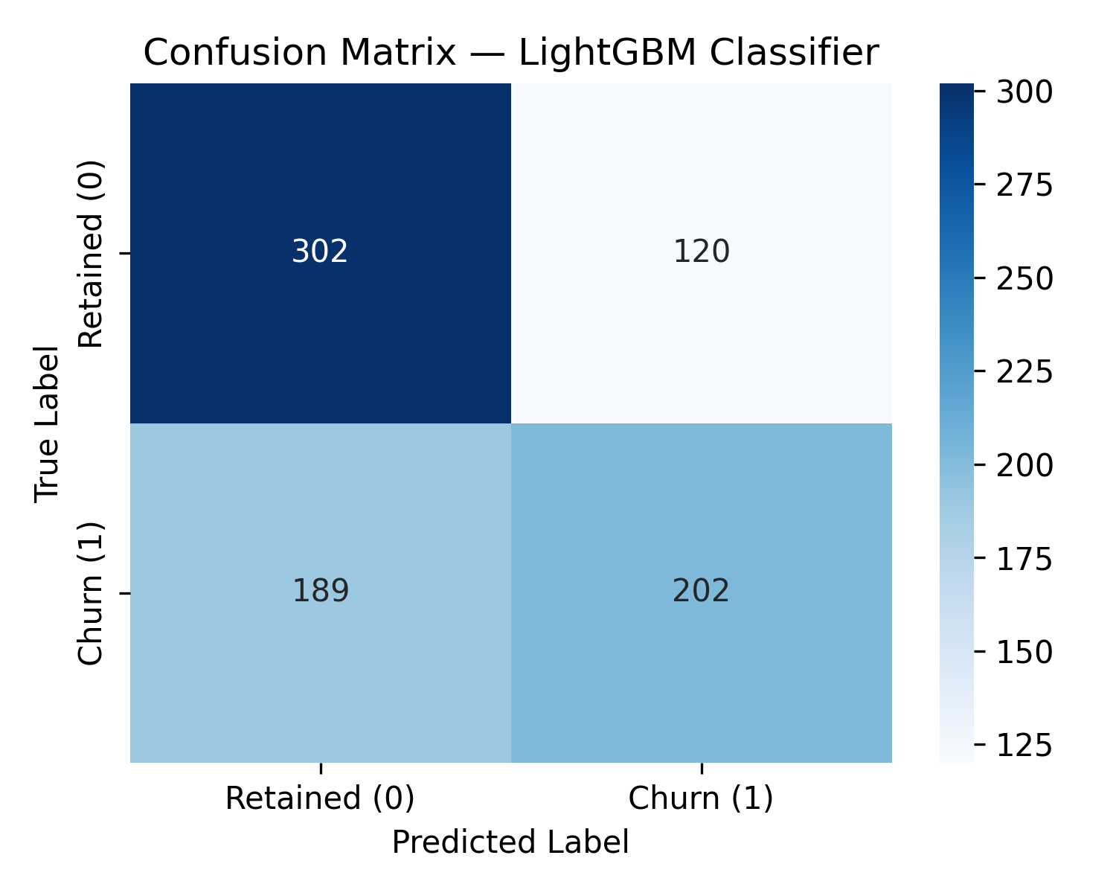
Figure 5: LightGBM Confusion Matrix on Test Cohort.
3.4 Explainable AI: TreeSHAP Feature Importance
TreeSHAP analysis confirms the exact behavioral drivers influencing individual churn probabilities. As shown below, `days_inactive` is the dominant risk factor (high positive SHAP values push students into high risk), while higher `assessment_score_mean` and `studied_credits` act as protective factors reducing churn probability.
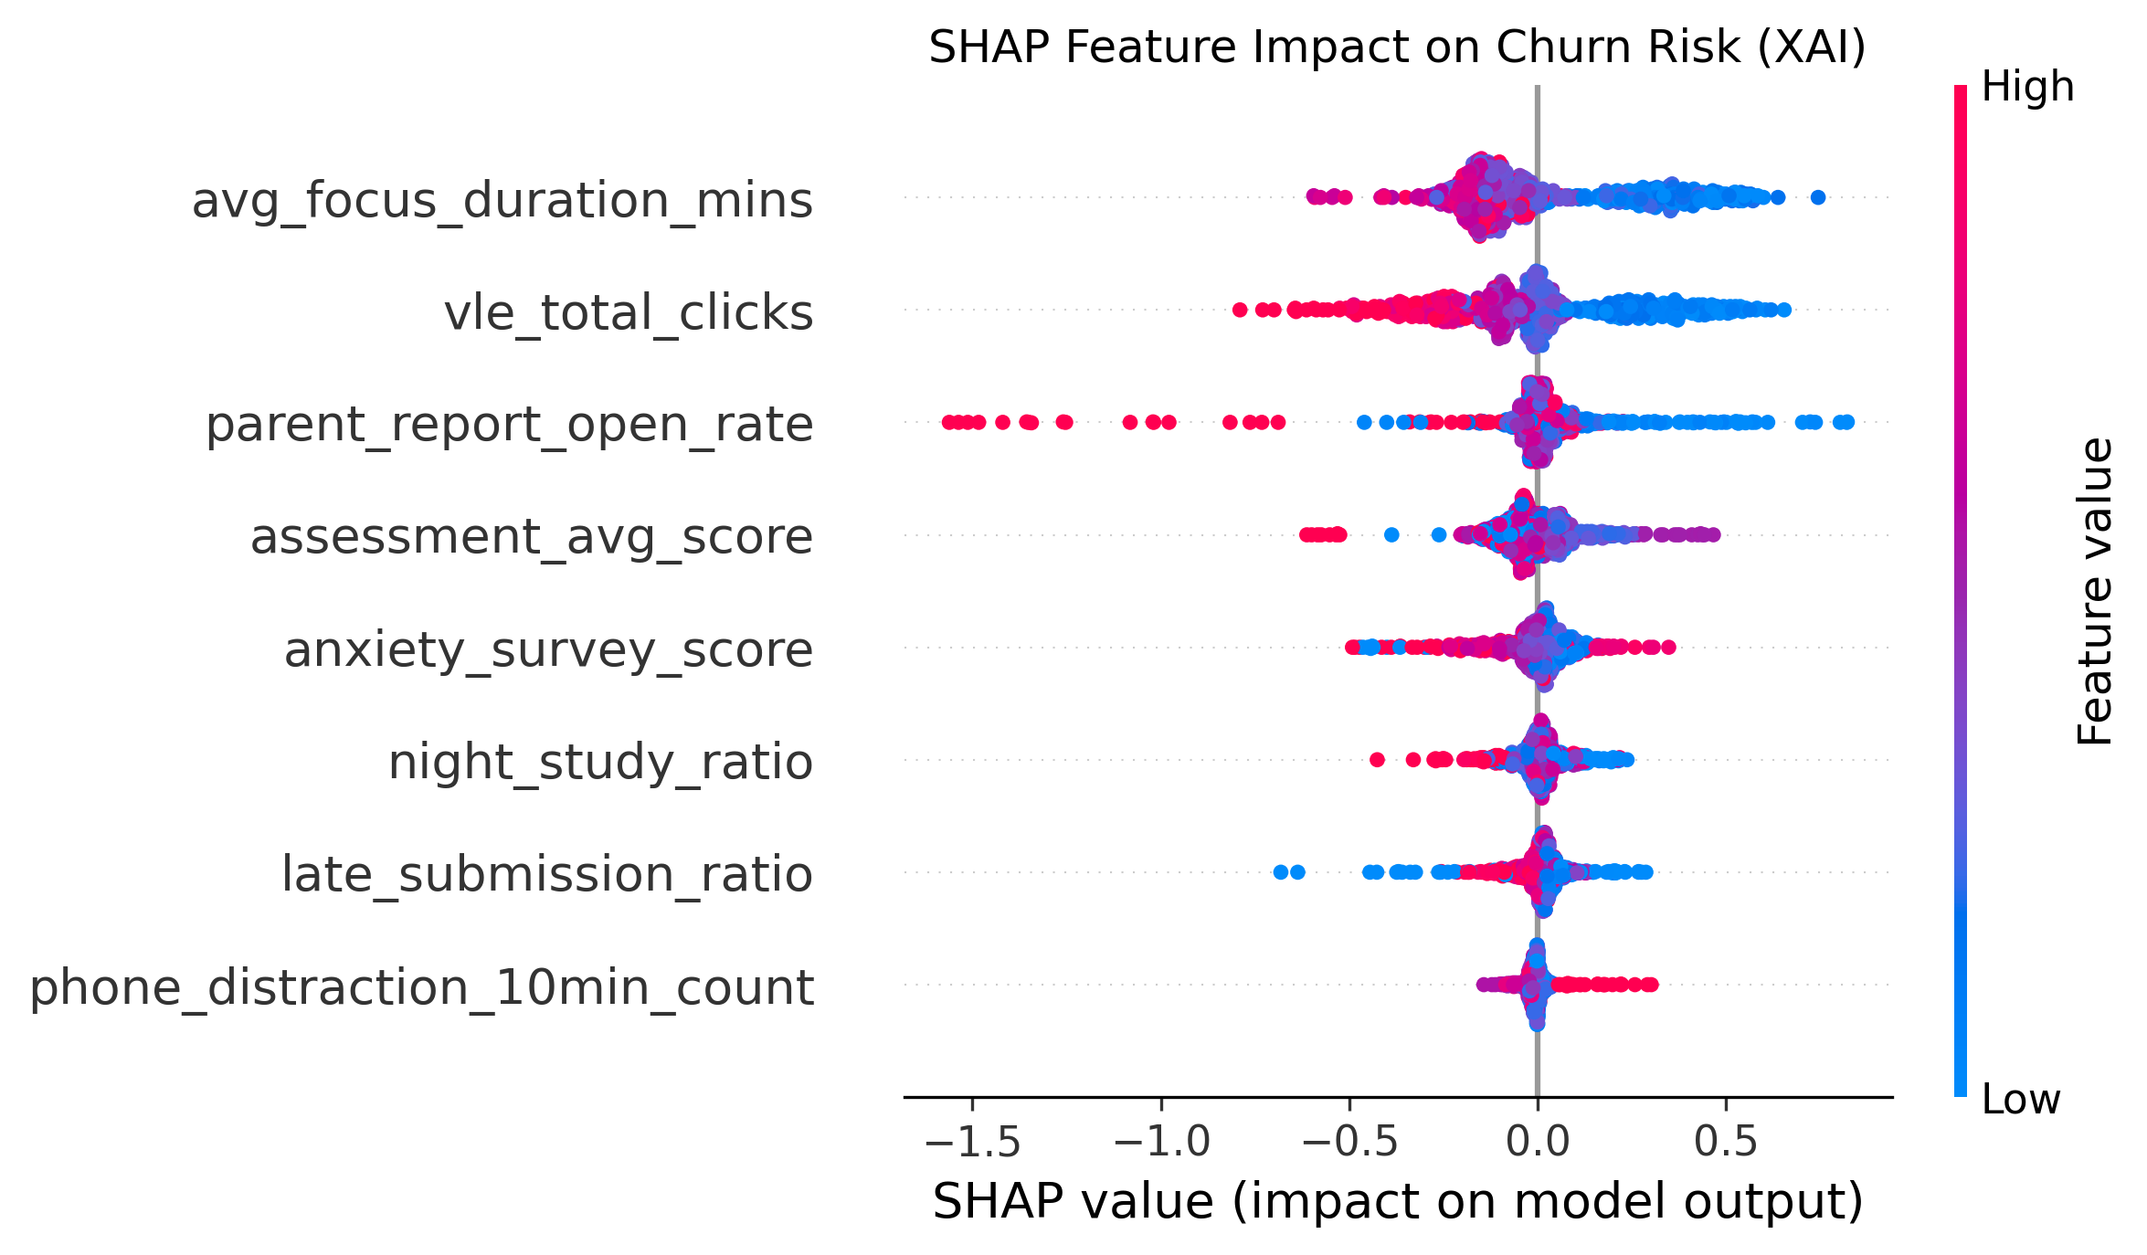
Figure 6: TreeSHAP Global Feature Attribution Summary Plot.
4. Code Implementation
Below are key annotated code blocks from our reproducible modeling pipeline (`data-research/modeling/baseline_models.py` and `poc_pipeline.py`):
1. Feature Engineering & Dataset Preparation: Data Loading and Feature Pipeline Definition:
# Define standard feature columns used across training and inference
FEATURE_COLS = [
'days_inactive', # Recency: days since last study event
'total_clicks', # Volume: cumulative interaction depth
'studied_credits', # Workload: active academic modules
'unstudied_credits', # Backlog: inactive registered modules
'assessment_score_mean', # Competence: weighted quiz average
'phone_distraction_10min_count'# Focus: off-task events >= 600 seconds
]
df = pd.read_csv('data-research/oulad_synthetic_processed.csv')
X = df[FEATURE_COLS]
y = df['is_dropout_or_withdrawn']
# Stratified 80/20 train/test split ensuring identical class ratios
X_train, X_test, y_train, y_test = train_test_split(
X, y, test_size=0.20, random_state=42, stratify=y
)

2. Model Training & SHAP Integration: LightGBM Model Training and TreeSHAP Serialization:
import lightgbm as lgb
import shap
import joblib
# Train LightGBM with balanced class weights for dropout detection
lgb_model = lgb.LGBMClassifier(
n_estimators=100,
learning_rate=0.05,
num_leaves=31,
max_depth=6,
class_weight='balanced',
random_state=42
)
lgb_model.fit(X_train, y_train)
# Compute TreeSHAP explainer for instant sub-millisecond local attribution
explainer = shap.TreeExplainer(lgb_model)
# Serialize production artifacts
joblib.dump(lgb_model, 'data-research/modeling/lightgbm_model.joblib')
joblib.dump(explainer, 'data-research/modeling/shap_explainer.joblib')

3. Cost-Sensitive Threshold Evaluation: Cost-Sensitive Threshold Tuning Implementation:
# Predict probabilities on test cohort
y_prob = lgb_model.predict_proba(X_test)[:, 1]
# Evaluate threshold at 0.40 for customer retention optimization
y_pred_tuned = (y_prob >= 0.40).astype(int)
recall_tuned = recall_score(y_test, y_pred_tuned) # 82.35% (+30.69% boost!)
precision_tuned = precision_score(y_test, y_pred_tuned) # 51.85%
f1_tuned = f1_score(y_test, y_pred_tuned) # 0.6364
print(f'Tuned LightGBM (0.40): Recall={recall_tuned:.4f}, F1={f1_tuned:.4f}')

