Data Preparation, Feature Engineering and Model Exploration
Reproducible temporal customer modeling for future-purchase inactivity
Course: Samsung Innovation Campus — AI in Marketing Capstone
Team: Group 7
Project: GrowthPilot AI
Prepared by: Şahin Başcı
Date: 9 September 2026
Status: Final local academic package

AI AUTHORSHIP DISCLOSURE — This document was drafted with OpenAI Codex/ChatGPT assistance and checked against repository evidence. Reported project metrics come from executed, versioned artifacts; external claims are cited. Human review remains required.

Part I — Data preparation and feature engineering

1. Overview and collection
The pipeline downloads UCI Online Retail II from its stable repository URL, verifies SHA-256 572e36277c2390fbfde10664750731e0a86f55e33470d91919085f0408e67bfb, profiles both worksheets and writes deterministic reports. Raw and customer-level prepared files are local/ignored; aggregate evidence and scripts are versioned.

2. Cleaning and validation
Step | Rows / rule | Rationale
Raw input | 1,067,371 | Preserved external-source evidence
Exact duplicate removal | 34,335 removed | Avoid repeated identical transaction lines
Identity/date usability | 235,151 excluded | Customer snapshots require stable ID and time
Normalized retained rows | 797,885 | Canonical names/types after deterministic rules
Eligible purchase event | Positive quantity and price; non-cancellation; pre-cutoff | Separate purchases from returns/cancellations

Evidence class: project-generated from artifacts/reports/data_preparation.json.
Missing customer identifiers are not imputed because arbitrary identity assignment would create false histories. Missing descriptions do not block customer-level behavior features. Nonpositive quantity/price and cancellation invoices are excluded from eligible purchase events but remain part of source-quality evidence. Monetary outliers are not winsorized before aggregation; log1p and standardized transformations reduce scale dominance inside fitted pipelines.

3. Temporal snapshots and leakage prevention
Split | Cutoff(s) | Rows | Inactivity rate
Training | 2010-06-01 monthly through 2010-12-01 | 20,677 | 0.483823
Validation | 2011-03-01 | 3,349 | 0.577187
Calibration | 2011-06-01 | 2,659 | 0.499436
Final test | 2011-09-01 | 2,772 | Sealed until final evaluation

All features use events strictly before the cutoff; each 90-day label window is fully observed.

4. EDA
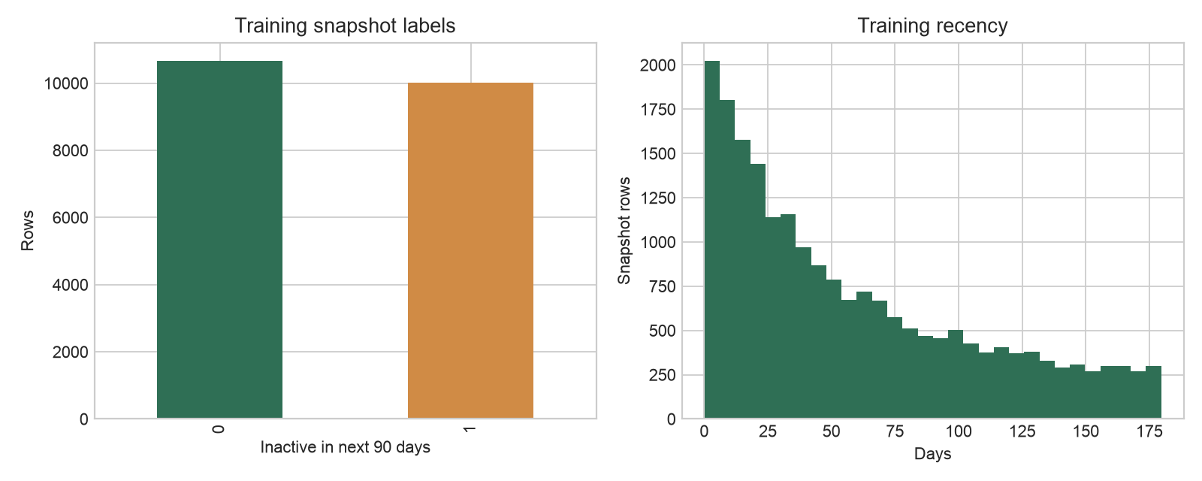
Figure 1. Label prevalence and recency across training snapshots.
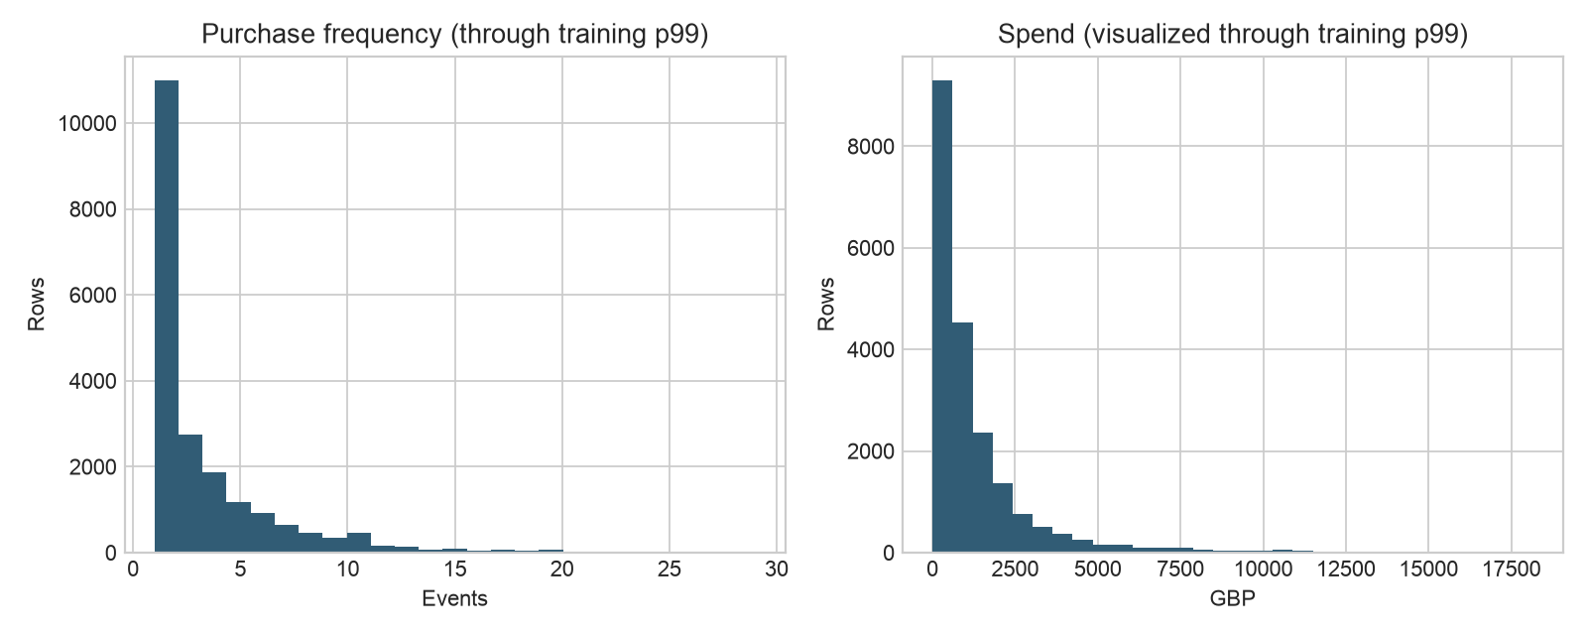
Figure 2. Frequency and spend distributions support transformed modeling.
Training contains 20,677 customer snapshots with 48.3823% inactivity labels. Validation has 3,349 rows with 57.7187% inactivity. The prevalence shift is one reason accuracy is unsuitable as the primary measure. Skew and repeat observations also motivate time-based evaluation and customer-behavior aggregates rather than random line-level splitting.

5. Feature design
Feature family | Examples | Rationale
Recency/tenure | recency_days, tenure_days | How recently and how long the relationship has existed
Frequency/cadence | invoice_count, active_days, mean/median/max gap | Repeat behavior and purchase periodicity
Monetary | gross/net spend, average order value, return value | Commercial magnitude and reversal behavior
Product breadth | distinct products, quantity, basket breadth | Depth and diversity of engagement
Windowed behavior | 30/60/90-day counts/spend; trend deltas | Recent acceleration or decline before cutoff
Context | country and snapshot month | Market/time context, encoded inside the pipeline

6. Scaling, normalization and encoding
The scikit-learn ColumnTransformer fits preprocessing only on training data. Numeric columns use median imputation, log1p where defined and StandardScaler for logistic regression. Categorical values use most-frequent imputation and one-hot encoding with unknown-category tolerance. Tree candidates use compatible encoded input without assuming that scaling improves trees.
numeric = Pipeline([
('impute', SimpleImputer(strategy='median')),
('scale', StandardScaler()),
])
categorical = Pipeline([
('impute', SimpleImputer(strategy='most_frequent')),
('onehot', OneHotEncoder(handle_unknown='ignore')),
])
model = Pipeline([('preprocess', ColumnTransformer(...)),
('classifier', LogisticRegression(C=0.01, max_iter=2000))])

Part II — Model exploration

1. Candidate selection rationale
The recency heuristic is a business baseline; the dummy prior detects whether a model adds ranking information. Logistic regression is transparent, fast and regularizable. Random forest captures nonlinear interactions with modest preprocessing. LightGBM is an efficient boosted-tree challenger. The concept deck anticipated LightGBM, but the experiment did not privilege it: validation PR-AUC selected logistic regression.
Candidate | Strength | Weakness
Recency heuristic | Simple, explainable business reference | Ignores frequency, value and cadence
Dummy prior | Calibration/prevalence sanity check | No individualized ranking
Logistic regression | Transparent, efficient, stable regularization | Linear log-odds boundary; encoded interactions limited
Random forest | Nonlinear interactions and robustness | Larger model; probability calibration may degrade
LightGBM | Strong nonlinear tabular learner | More tuning/interpretation complexity and overfit risk

2. Training, hyperparameters and validation
Candidate preprocessing and models are fit on seven pre-test training cutoffs. Model family is selected by the single 2011-03-01 validation snapshot. A later 2011-06-01 calibration snapshot is reserved for sigmoid probability calibration and the operational threshold; the final 2011-09-01 cutoff is never used during exploration.
Model | Key parameters | Validation PR-AUC | ROC-AUC | Brier | Top-10% lift
Recency | clip(recency/180) | 0.715529 | 0.689417 | 0.248166 | 1.292940
Dummy | prior | 0.577187 | 0.500000 | 0.244072 | 0.961948
Logistic | C=1.0 | 0.805322 | 0.782819 | 0.213300 | 1.510154
Random forest | 300 trees; leaf=10 | 0.803517 | 0.782053 | 0.195463 | 1.520498
LightGBM | 300 trees; lr=.05; leaves=31 | 0.805223 | 0.776941 | 0.200875 | 1.546357

Selection metric: validation PR-AUC. Initial winner: logistic regression.

3. Evaluation interpretation
Logistic PR-AUC 0.805322 narrowly exceeds LightGBM 0.805223 and random forest 0.803517 in initial exploration. Tree candidates have better uncalibrated Brier values, which motivates a separate calibration step rather than changing the selection metric after seeing results. The recency baseline is meaningfully weaker but nontrivial, confirming that simple recency carries signal.

4. Reproducibility
make data-download
make data-profile
make data-prepare
make features-build
make train
# Outputs include split hashes, MLflow run IDs, parameters and validation metrics.
Every split has a SHA-256 checksum and versioned target/feature/split identifiers. MLflow records model runs. The final test flag in model_exploration.json is false, demonstrating that exploration completed before final-test access.

5. Conclusion
The preparation pipeline is leakage-aware, deterministic and suitable for the chosen historical study. Initial exploration selected logistic regression for refinement. This conclusion is limited to the stated validation cutoff and metric; it does not claim universal superiority or production readiness.

References
Chen, D. (2012). Online Retail II [Dataset]. UCI Machine Learning Repository. https://doi.org/10.24432/C5CG6D
scikit-learn developers. Model evaluation, preprocessing and probability calibration documentation. https://scikit-learn.org/stable/
Ke, G., et al. (2017). LightGBM: A highly efficient gradient boosting decision tree. Advances in Neural Information Processing Systems, 30.
Project evidence: artifacts/reports/dataset_profile.json, artifacts/reports/data_preparation.json, artifacts/eda, artifacts/ml/model_exploration.json and the corresponding scripts/tests.

