Concept Note and Implementation Plan

Project Information
Project Title: Modelling and Improving Brand Visibility in AI Assistant Recommendations
Team Members: Kübra Gezici / Furkan Karlı / Murat Mert Küçük / Zeynep Sude inal
Repository: edasaruhan/SIC_AI_17_Capstone_Group_8

Concept Note

1. Project Overview
Product discovery is moving from search engines to conversational AI assistants. A search engine returned ten ranked links and left selection to the user; an assistant returns two or three brand names and the decision is effectively made. There is no second page, no listing below the fold, and no paid placement inside the organic answer. A brand that is not named is not ranked lower — it is absent from the consideration set entirely.
Marketing context.
Dimension | This project
Target customer (system user) | Digital marketing and GEO agencies serving SME and mid-market clients; secondarily PR and corporate communication agencies
End beneficiary | Small, local and challenger brands without the equity of global incumbents
Product / service | A visibility diagnostic tool delivered as a web interface and an agency-ready report
Channel analysed | Conversational AI assistants, with and without web retrieval
Customer journey stage | Awareness and consideration — specifically shortlist formation
Business process | Content and earned-media planning; marketing budget allocation
Customer and business impact. Agencies currently face a question they cannot answer: a client asks why they never appear in ChatGPT or Gemini recommendations, and the agency has no diagnostic instrument. Existing tools count mentions retrospectively but cannot explain them. The consequence is that content budget is spent on intuition.
Our system changes the decision rather than the dashboard. A brand invisible because the model does not recognise it needs sustained brand investment measured in quarters. A brand invisible because the content written about it is weak can be fixed in weeks at a fraction of the cost. These are opposite budget decisions, and no current tool separates them. For an agency the measurable value is a new billable deliverable and a defensible allocation recommendation; for the brand it is avoided waste and faster recovery of a discovery channel it is currently losing.

2. Objectives and Marketing KPIs
Objectives. (1) Measure brand visibility in AI assistant recommendations for Turkish queries, where no measurement currently exists. (2) Build a model that predicts which brand will be recommended from the content the assistant retrieves. (3) Separate the contribution of brand recognition from the contribution of content. (4) Convert that separation into prioritised, verifiable content actions.
Marketing KPIs the project influences.
KPI | Definition | Baseline | Target / success criterion
AI Share of Voice (ASoV) | % of category responses mentioning the brand | Unknown for Turkish — established by this project | Baseline table published for 30 brands across 3 sectors
Top-1 recommendation rate | % of responses where the brand is the primary pick | Measured in Layer A | Model predicts it above naive baseline
Content-attributable visibility share | Portion of visibility explained by content rather than recognition | No existing measurement | Reported per sector with 95% confidence interval
Prescription actionability | Agency judgement of whether recommended actions are executable | None | ≥ 2 of 3 agencies rate the report actionable in validation
Technical success criteria (proxies for the above).
Criterion | Baseline | Target
Top-1 accuracy | Naive rule: pick brand of first-ranked source | Beat by ≥ 10 percentage points
PR-AUC (row level) | Class prevalence ≈ 0.125 | ≥ 0.60
Prior-only model (M0) | Brand recognition alone | Full model beats it materially, with clustered bootstrap CIs excluding overlap
Calibration | — | Brier score reported; probabilities calibrated before client-facing use
The project is judged successful if the Turkish baseline is published, the model beats both naive and prior-only baselines with reported confidence intervals, and the attribution is produced with an interpretable prescription that agencies confirm they could act on.

3. Background and Marketing Context
Why this matters now. Assistant-mediated discovery has become a primary research channel, and organic traffic to brand properties is declining as a result. Teams that invested heavily in SEO have no equivalent instrument for the new channel and, in many cases, do not know whether their content is cited, summarised or ignored.
Who is affected. Most acutely, small and local brands. Research shows US-centric models favour globally known brands over local equivalents, and that when products are otherwise indistinguishable the known brand is recommended almost always. The disadvantage is structural, not a result of product quality.
Current practice and its limits. A commercial category has formed rapidly — Profound, AthenaHQ, Peec AI, Otterly, Scrunch, Adobe LLM Optimizer, plus extensions from Semrush and Ahrefs. Their architecture is a scheduled prompt runner plus mention counting, reported as ASoV over time. Three limitations follow: they count rather than predict; they do not separate recognition from content; and they are English-centric and priced for enterprise buyers, leaving Turkish queries and SME-focused agencies unserved. In Turkey, several agencies now market GEO services, but as service providers using these same foreign tools — no local measurement capability exists.
Why AI is the right approach. The problem is intrinsically an AI problem in two senses. The channel being measured is an AI system, so the only way to observe it is to query it systematically and treat its outputs as data. And the signal that determines recommendation lives in subtle properties of natural language — specificity versus vagueness, hedging, authority markers, evidential quality — which cannot be captured by keyword counting. This requires NLP: a supervised model over retrieved text, combined with interpretable feature-based modelling to make the output actionable.

4. Proposed AI Methodology
Task formulation. Given a query and the set of candidate brands with the web content supporting each, predict which brand the assistant recommends. Trained as binary classification over (response, candidate brand) pairs and evaluated listwise, since the real decision is a selection among candidates.
Model family. Models are built cumulatively, because the marketing insight lies in the differences between them, not in any single score.
Model | Input | Algorithm | Purpose
Naive baselines | — | Rules (first-ranked source’s brand; most frequent brand) | Floor that must be beaten
M0 | Brand prior only | Logistic regression | Isolates recognition effect
M1 | + position, source type | Logistic regression | Structural effects
M2 | + engineered language features | LightGBM + SHAP | Production model — produces prescriptions
M3 | Retrieved snippet text | Cross-encoder (BERTurk for Turkish, XLM-R multilingual) | Highest expected accuracy; enables ablation
M3b | Sentence embeddings + M2 features | LightGBM | Fallback and control
Key methodological device — masking ablation. M3 is trained twice on identical data: once with brand names visible in the snippets, once replaced by a [BRAND] token. The performance gap isolates how much of the decision is name recognition versus content. Combined with including or excluding the brand-prior feature, this yields a three-condition attribution table. This is the mechanism that produces our differentiating KPI and it is why a text-based model is required — masking is a text-level intervention that a feature-only model cannot perform.
Why this approach fits. Interpretability is a functional requirement, not a preference: the deliverable is “change this, expect roughly this much,” so SHAP-compatible gradient boosting is the production choice. The transformer earns its place through the ablation rather than accuracy alone. Data scale (thousands of grouped examples) dictates base-size models; larger models would overfit. Cost is negligible — approximately $8–40 for the entire data generation — so model choice is driven by quality and provider diversity rather than budget. We explicitly reject prompting an LLM to judge visibility directly: it is circular, unreproducible, and cannot explain why.
Evaluation. Technical: PR-AUC as primary (class prevalence ≈ 12.5% makes accuracy misleading), ROC-AUC secondary, response-level top-1 accuracy and NDCG@3 as business-facing metrics. Confidence intervals via clustered bootstrap at query level, because 20–30 repetitions per cell break independence. Calibration assessed with Brier score. Generalisation tested by leaving out one sector, one model and one language in turn. Marketing: agency validation, in which the report is produced for a real brand and reviewed for actionability; and consistency of prescriptions with the controlled Layer B interventional evidence.

5. Architecture / Workflow Design Diagram
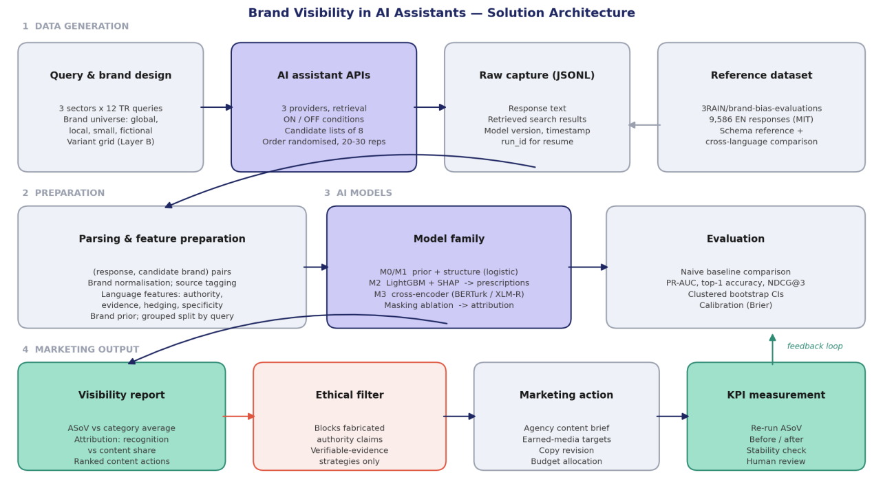
Solution architecture
Component roles.
- Query and brand design — defines what is measured: Turkish queries across three sectors, a brand universe spanning global, local, small and validated fictional brands, and the controlled variant grid for the interventional layer.
- AI assistant APIs — the measurement instrument. Three providers, retrieval on/off conditions, candidate lists of eight brands per call, randomised ordering, 20–30 repetitions.
- Raw capture — every call stored as JSONL with response text, retrieved search results, model version and timestamp; run_id allows resuming after interruption. Raw data is never modified.
- Reference dataset — the open English dataset provides the schema, validates our method, and supplies the cross-language comparison.
- Parsing and feature preparation — converts responses into (response, candidate brand) pairs, normalises brand names, tags source domains, extracts language features, computes the brand prior from the retrieval-off condition, and freezes the query-level grouped split.
- Model family and evaluation — as described in Section 4.
- Visibility report — the marketing output: ASoV against category average, the recognition-versus-content attribution, and ranked actions with estimated gains.
- Ethical filter — blocks fabricated-authority recommendations before they reach the user.
- Marketing action — the report becomes an agency content brief, earned-media target list and budget allocation.
- KPI measurement and human review — visibility is re-measured after action, forming the feedback loop; an agency strategist reviews all recommendations before execution.

6. Data Sources
The project uses one open reference dataset, one dataset we generate, and one secondary benchmark. The reference dataset is 3RAIN/brand-bias-evaluations (HuggingFace, MIT licence): 9,586 assistant responses across four models and four domains, with 10 queries per domain, roughly 30 repetitions per cell, and two conditions — with and without web retrieval. Each record contains the response text, the queries the model issued, the full organic search results retrieved, and structured labels extracted by a judge model, including top_recommendation, brand_mentions with position, and confidence_in_extraction; the format is nested JSON, flattened to Parquet. Its decisive property is that it pairs what the model saw with what it recommended, which is what makes supervised learning of the decision possible, while the retrieval-off condition provides a direct empirical measure of each brand’s prior recognition. We generate a parallel Turkish dataset on the same schema: Layer A (observational — 3 sectors × 12 queries × 2 conditions × 3 models × 20–30 repetitions, approximately 4,300 calls yielding around 34,000 labelled rows through the candidate-list design) and Layer B (interventional — 30 brands × 8 controlled description variants × 2 models × 10 repetitions, approximately 4,800 calls). E-GEO (arXiv:2511.20867) serves as a secondary English e-commerce benchmark for generalisation testing. Major preprocessing steps are: use only the all subset of the reference data to avoid double counting; parse nested JSON fields; normalise brand names with a curated alias dictionary; tag result domains as affiliate, editorial or official through a rule-based list built by two independent annotators with agreement reported; extract language features from versioned lexicons; compute brand priors from the retrieval-off condition; exclude low-confidence extraction rows from primary training; and freeze a query-level grouped split, since repeated sampling makes rows non-independent and random splitting would leak. Responsible use: no personal, customer or user data is collected or processed at any stage — inputs are synthetic personas and public brand information, and outputs are model-generated text — so no consent or anonymisation obligations arise; collected responses remain subject to the providers’ terms of use, which is documented in the published data card.

7. Literature and Industry Review
Academic work converges on four propositions. LLM recommendations exhibit systematic bias toward incumbent and globally known brands, exceeding the popularity bias of classical recommender systems and disadvantaging local brands specifically (Lichtenberg et al., 2024; Kamruzzaman et al., 2024). This dominance is nonetheless conditional: Chu & Hou (2026) show that when products are specified identically the known brand wins essentially always, but the advantage collapses once any differentiating quality signal appears, with product parameters explaining the large majority of ranking variance and brand identity only a marginal share — meaning the real barrier for challengers is absence of differentiating information rather than brand equity itself. Content is therefore a genuine lever: Aggarwal et al. (2024) formalise Generative Engine Optimization and report roughly 40% visibility gains from content rewriting alone, Filandrianos et al. (2025) show that credibility-oriented language (authority, social proof) shifts recommendations substantially while overt promotional language does not, and Pfrommer et al. (2024) demonstrate that list position independently affects rankings — a methodological constraint that makes order randomisation mandatory. Industry practice has moved faster than academia: platforms including Profound and Adobe’s LLM Optimizer have standardised ASoV as the operational metric, Adobe reports multi-fold citation increases and a 41% rise in LLM referral traffic after applying GEO discipline internally, and agency case studies report citation rates rising from single digits to the mid-twenties within a quarter — though these are vendor-published, self-reported, and lack control conditions or independent verification. The gap this capstone addresses is therefore fourfold: the entire literature is English with Turkish unmeasured; every study is descriptive, producing rates rather than a reusable predictive model; no work separates recognition-driven from content-driven visibility, which is precisely the distinction that determines budget allocation; and the industry evidence has no open reproducible baseline against which its claims can be assessed.

Implementation Plan

1. Technology Stack
Language and environment. Python 3.11; uv for dependency management; configuration in YAML with pydantic-settings; secrets in .env, never committed; fixed random seeds throughout.
Data collection. httpx with asyncio for concurrent requests; tenacity for retry with exponential backoff; provider SDKs (anthropic, openai, google-generativeai); pydantic for response schema validation; JSONL via jsonlines for raw capture; rich and loguru for progress and logging. Model providers: three distinct providers selected for diversity, using budget and mid-tier models (Gemini Flash-Lite tier, Claude Haiku, GPT budget tier) with batch API where latency permits.
Data processing and storage. pandas for the main pipeline, duckdb for SQL over JSONL and Parquet, pyarrow/Parquet as the derived format, datasets for loading the reference dataset. Versioning through data/raw, data/interim, data/processed plus a committed splits.json.
Text processing and features. regex and unicodedata for Turkish normalisation (particularly İ/ı handling); rapidfuzz for brand-name matching; tldextract for domain parsing; textstat for readability; zeyrek for Turkish morphological analysis where lexicon matching requires it. Language lexicons stored as versioned YAML under lexicons/.
Modelling. scikit-learn and lightgbm for M0–M2; torch, transformers and accelerate for M3, with dbmdz/bert-base-turkish-cased (BERTurk), xlm-roberta-base and microsoft/deberta-v3-base; sentence-transformers for M3b; optuna for hyperparameter search; mlflow (local) for experiment tracking; shap and captum for explainability; scipy and statsmodels for statistics. Training on Google Colab or Kaggle free-tier GPU with checkpointing.
Interface and delivery. streamlit for the report interface; plotly and matplotlib for visualisation; deployment to Streamlit Community Cloud or HuggingFace Spaces.
Quality and collaboration. Git and GitHub with short-lived task branches and pull requests; ruff, black, pre-commit; pytest for parsing, normalisation and split-integrity tests; make targets for setup, format, check; GitHub Actions running make check on every pull request.

2. Timeline and Task Distribution
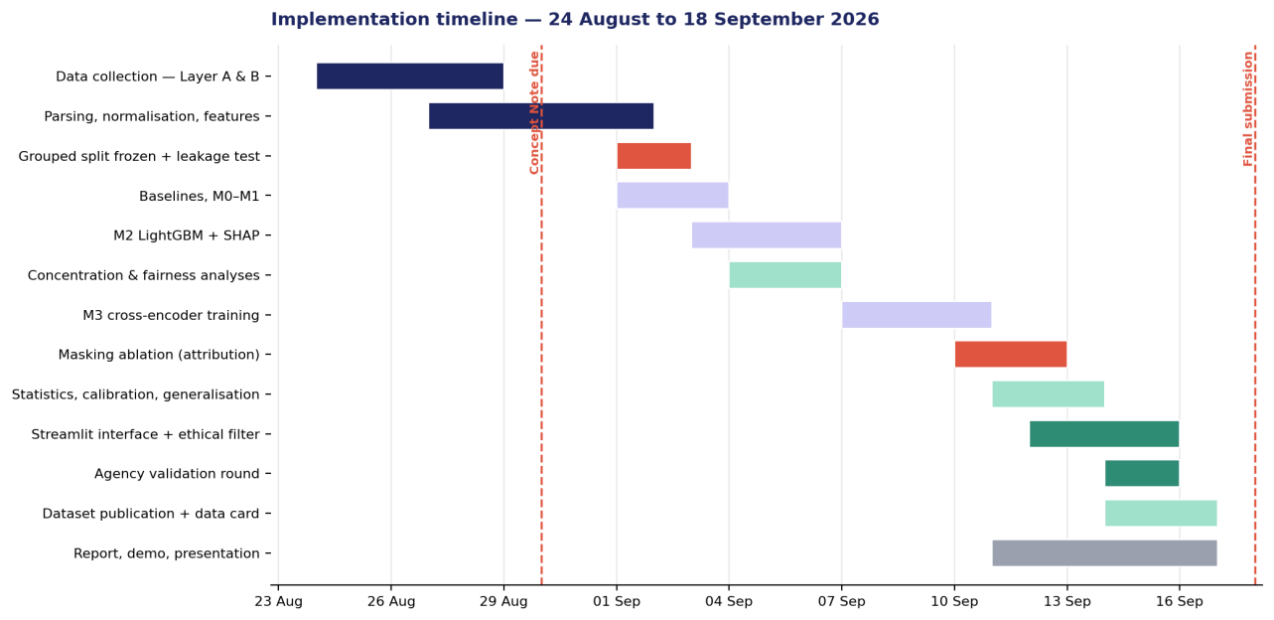
Implementation timeline
Task distribution matrix. Responsibilities continue the Sprint 0 allocation. R = responsible, S = supporting.
Work package | Kübra | Furkan | Murat | Zeynep
Collection infrastructure, API orchestration | S | R | S
Query pool, brand universe, variant grid | S |  | S | R
Layer A and Layer B execution and monitoring |  | R | S
Parsing, brand normalisation, grouped split |  | S | R
Affiliate domain tagging (two annotators) |  |  | R | R
Language feature engineering and lexicons | R |  | S
Baselines, M0–M2, SHAP | R |  | S
M3 cross-encoder, M3b, masking ablation | R | S
Statistics, calibration, generalisation tests | R |  | S
Concentration and fairness analyses | S |  | R
Streamlit interface and ethical filter | S | R |  | S
Agency validation round |  |  |  | R
Dataset publication and data card |  | S | R
Technical report, demo, presentation | S | S | S | R
Sprint 2 carries the highest load; collection runs in parallel with annotation and feature work. Working rhythm: 30-minute planning on Monday, 30-minute review on Friday, one summary note per sprint committed to the repository.

3. Milestones and Deliverables
# | Milestone | Target date | Evidence of completion
M1 | Turkish data collection complete | 29 Aug | Raw JSONL in place; parse-success and cost report; collection log
M2 | Data ready for modelling | 3 Sep | pairs.parquet, frozen splits.json, leakage test passing, data card draft
M3 | Baseline established | 4 Sep | Naive and M0 scores recorded; comparison table committed
M4 | Interpretable model working | 7 Sep | M2 trained, SHAP figures produced, first prescriptions generated
M5 | Turkish visibility baseline published | 7 Sep | ASoV table for 30 brands across 3 sectors; concentration and fairness analyses
M6 | Attribution validated | 13 Sep | Three-condition ablation table with clustered bootstrap confidence intervals
M7 | Working prototype | 16 Sep | Streamlit app producing a full report from brand + sector input; ethical filter unit-tested
M8 | User test completed | 16 Sep | Reports produced for ≥ 2 agencies; written feedback recorded
M9 | Dataset published | 17 Sep | Turkish dataset and data card publicly available with licence
M10 | Final evaluation and submission | 18 Sep | Technical report, demo, presentation; pipeline reproducible from clean clone

4. Challenges and Mitigation Strategies
Challenge | Consequence if unmanaged | Mitigation | Fallback
Data leakage from random splitting | Inflated scores; invalid claims to clients | Query-level grouped split frozen at M2, protected by automated test | — (non-negotiable)
Collection slips past 29 Aug | All downstream modelling delayed with no slack | Daily monitoring; resume via run_id; hard checkpoint at 28 Aug | Halve Layer B variants; drop third model
API rate limits or cost overrun | Incomplete dataset | Candidate-list design (8× efficiency); batch API; daily spend cap; pilot-measured limits | Reduce to two providers; reduce repetitions to 20
Small and imbalanced dataset | Transformer overfits | Base-size models only; three seeds; grouped CV; PR-AUC not accuracy | M3b embedding hybrid; report M2 as production model
Deep learning fails to beat gradient boosting | “Why deep learning?” challenge | Reported honestly — at our data scale this is a legitimate finding | M2 ships as production model; M3 retained solely for the ablation
Model memorises brand names | Content effect unmeasurable | The masking ablation measures this directly and reports it | Report as a finding rather than a failure
Turkish parsing failures | Silent data loss | Strict output templates; parse tests; per-model success rates reported | Replace underperforming model after pilot
Judge-model label noise | Unreliable ground truth | Exclude low-confidence rows; 100-row manual verification with agreement reported | Restrict analysis to high-confidence subset
Provider model updates mid-project | Learned relationships go stale | All collection within a two-week window; version and timestamp on every row | Stability re-run quantifies drift and is reported as a finding
Agency validation does not materialise | No marketing-side evidence | 15 organisations contacted to secure 3 sessions; scheduled early | Internal expert review against a written rubric
Difficulty proving true marketing impact | Claims exceed evidence | Layer B provides controlled interventional evidence for a feature subset; elsewhere estimates are labelled as estimates | Frame outputs as expected values with confidence, never guarantees

5. Ethical and Responsible AI Considerations
Privacy and personal data. The project collects no personal, customer or user data at any stage. Inputs are synthetic personas and publicly available brand information; outputs are model-generated text. No consent, anonymisation or data-subject obligations arise. Provider terms of use governing collected responses are documented in the published data card. Interview notes from agency conversations are stored without personally identifying detail and are not committed to the repository.
Manipulation risk — the central ethical issue. The literature demonstrates that fabricated authority claims — invented clinical citations, non-existent expert endorsements — are among the most effective levers for increasing visibility. A system that optimised visibility naively would surface fabrication as its top recommendation, making the tool an instrument for deceiving consumers. Our mitigation is structural rather than advisory: the recommendation layer is constrained at code level to verifiable-evidence and source-diversity strategies, a blocked-template list is maintained, and an output filter is applied and unit-tested. This constraint is a deliberate product decision, and we accept that it caps measurable performance.
Fairness and bias. The project’s subject matter is algorithmic bias. We report a model-by-model fairness comparison showing how each assistant treats local and small brands relative to global incumbents, and a concentration measure quantifying how winner-takes-all each category is. We also acknowledge bias in our own instrument: our brand universe, sector selection and Turkish lexicons embed choices that shape results, so all are published for scrutiny.
Transparency and explainability. Every prediction is accompanied by an attribution, never a bare score. The method, dataset, lexicons and code are published openly — a deliberate contrast with commercial tools whose methodology is proprietary and unverifiable.
Avoiding misleading outputs. Three safeguards: probabilities are calibrated before being shown, so a stated figure means what it claims; estimated gains are labelled as expected values under current model behaviour, not guarantees; and the surrogate-model limitation is stated in the interface itself, not only in documentation.
Human oversight. The intended user is an agency strategist, not an automated pipeline. Output is a prioritised recommendation set with confidence indicators, requiring human judgement to convert into a content plan. No output is published or executed automatically.
AI assistance disclosure. Generative AI tools were used during the preparation of this document for drafting, structuring, literature synthesis and figure generation, and during the project for code assistance. All content has been reviewed, verified and edited by the team; the research design, methodological decisions and conclusions are our own, and all cited sources have been checked against their originals.

6. References
Adobe (2026). How to improve brand visibility in AI search engines. Adobe Business Blog. https://business.adobe.com/blog/improve-brand-visibility-in-ai-search-engines
Aggarwal, P., Murahari, V., Rajpurohit, T., Kalyan, A., Narasimhan, K. & Deshpande, A. (2024). GEO: Generative Engine Optimization. Proceedings of KDD 2024, pp. 50–61.
Bagga, P. S., Wu, Y., Aggarwal, P. & Deshpande, A. (2025). E-GEO: A Testbed for Generative Engine Optimization in E-Commerce. arXiv:2511.20867.
Chu, X. & Hou, Y. (2026). Incumbent Advantage: Brand Bias and Cognitive Manipulation Dynamics in LLM Recommendation Systems. arXiv:2606.17443.
Filandrianos, G., Dimitriou, A., Lymperaiou, M., Thomas, K. & Stamou, G. (2025). Bias Beware: The Impact of Cognitive Biases on LLM-Driven Product Recommendations. Proceedings of EMNLP 2025.
Kamruzzaman, M., Nguyen, H. M. & Kim, G. L. (2024). “Global is good, local is bad?”: Understanding Brand Bias in LLMs. Proceedings of EMNLP 2024, pp. 12704–12721.
Ke, G., Meng, Q., Finley, T., Wang, T., Chen, W., Ma, W., Ye, Q. & Liu, T.-Y. (2017). LightGBM: A Highly Efficient Gradient Boosting Decision Tree. NeurIPS 30.
Kumar, A. & Lakkaraju, H. (2024). Manipulating Large Language Models to Increase Product Visibility. arXiv:2404.07981.
Lichtenberg, J. M., Buchholz, A. & Schwöbel, P. (2024). Large Language Models as Recommender Systems: A Study of Popularity Bias. arXiv:2406.01285.
Lundberg, S. M. & Lee, S.-I. (2017). A Unified Approach to Interpreting Model Predictions. NeurIPS 30.
Pfrommer, S., Bai, Y., Gautam, T. & Sojoudi, S. (2024). Ranking Manipulation for Conversational Search Engines. Proceedings of EMNLP 2024, pp. 9520–9534.
Schweter, S. (2020). BERTurk — BERT models for Turkish. Zenodo. Model: dbmdz/bert-base-turkish-cased
Sundararajan, M., Taly, A. & Yan, Q. (2017). Axiomatic Attribution for Deep Networks. Proceedings of ICML 2017.
Three Rivers AI Nexus (2026). What Brands Does Your AI Prefer? Dataset: 3RAIN/brand-bias-evaluations, HuggingFace, MIT License.
Documentation: HuggingFace datasets, transformers; LightGBM; SHAP; Streamlit; Anthropic, OpenAI and Google Gemini API references (accessed August 2026).

