UNHOOK / CAPSTONE PROJECT

Model Refinement
and Test Submission
Final Technical Report • Step 9 of 9
An AI-driven progressive bandwidth throttling and adaptive human-in-the-loop intervention concept

PROJECT | DOCUMENT CONTROL
Project | UNHOOK | Android digital wellbeing capstone
Report date | 7 November 2026
Scope | Model Refinement; Test Submission; Conclusion; References
Evidence base | Recorded UNHOOK Steps 1–8 results and frozen model artifacts
Model status | Offline prototype evaluated; no integrated Android/VPN deployment

Executive summary
A structured machine-learning pipeline was refined to predict y_next_day_behavior_change_proxy, an experimental label denoting an unusually large next-day smartphone-use deviation. The available data contained 4,054 participant-day observations from 284 users with 30 numerical candidate features. The final train-only fitted model is a class-weighted Logistic Regression with median imputation, a constant-feature filter, ANOVA top-10 feature selection, standardization, C = 2.0, and a frozen decision threshold of 0.55.
Independent held-out test (611 rows; 43 users): Macro F1 0.6210; positive-class F1 0.4089; precision 0.3274; recall 0.5446; TN 397, FP 113, FN 46, TP 55. The stated target of Macro F1 > 0.85 was not met.
A matching portable Python/Kotlin numeric scorer and input/output contracts were verified offline. Android data collection, on-device feature extraction, JITAI decision logic, and VPN throttling remain future integration and validation work. No measured performance in this report constitutes addiction diagnosis or clinically validated real-time risk prediction.

Study at a glance
DATA SPLIT | RECORDS | USERS | POSITIVE PROXY | PREVALENCE
Train | 2,784 | 198 | 415 | 14.91%
Validation | 659 | 43 | 121 | 18.36%
Held-out test | 611 | 43 | 101 | 16.53%
Total | 4,054 | 284 | 637 | 15.71%

All splits were participant-disjoint. No participant/date identifier or next-day outcome-audit field was used as a predictor. All data-dependent transformation steps were fitted only on the training partition relevant to each experiment.

Model Refinement

1. Overview
The refinement phase followed a documented progression from dataset audit to baseline validation, participant-group cross-validation, feature selection, nested model search, and final model locking. Its goal was to improve generalization and to examine the trade-off between missed positive proxy events and unnecessary alerts, while preventing participant overlap and withholding the final test set from model selection.
The supervised target is y_next_day_behavior_change_proxy: from features available for day t, predict a rule-defined marked change in unlocking or nighttime non-study use on day t+1. This is an operational research proxy, not a WHO addiction diagnosis, a verified psychological outcome, a sleep measure, or a real-time JITAI alert target. Reported probabilities are uncalibrated model scores for this proxy.

2. Model Evaluation
Step 3 provided an initial evaluation at the fixed 0.50 threshold using 2,784 training rows and a separate 659-row participant-disjoint validation set. Class weights (or an appropriate XGBoost positive weight) addressed imbalance; SMOTE was not applied. XGBoost led initial validation Macro F1, while Logistic Regression achieved better positive-class F1 and recall.
INITIAL MODEL / VALIDATION | MACRO F1 | POSITIVE F1 | PRECISION (+) | RECALL (+) | AP
Majority baseline | 0.4495 | 0.0000 | 0.0000 | 0.0000 | 0.1836
Logistic Regression | 0.6050 | 0.4246 | 0.3207 | 0.6281 | 0.3730
Random Forest | 0.4444 | 0.0000 | 0.0000 | 0.0000 | 0.3604
XGBoost | 0.6116 | 0.3959 | 0.3372 | 0.4793 | 0.3376

The XGBoost validation confusion matrix was TN 424, FP 114, FN 63, TP 58. Logistic Regression achieved TP 76 but produced 161 false positives. Random Forest showed severe generalization problems: training Macro F1 approximately 0.9986 versus validation 0.4444, with no positive predictions at the fixed threshold. Accuracy alone was therefore not used to select the final model.

3. Refinement Techniques
- Model comparisons: majority-class baseline, Logistic Regression, Random Forest, and XGBoost; later tuning focused on Logistic Regression and XGBoost.
- Train-fold-only preprocessing: median SimpleImputer, VarianceThreshold, ANOVA SelectKBest where applicable, and StandardScaler for Logistic Regression.
- Class imbalance handling: class_weight="balanced" or training-fold-derived XGBoost scale_pos_weight. No synthetic oversampling / SMOTE was used in the executed experiments.
- Feature reduction: constant and highly correlated features examined; all-feature, correlation-pruned, and ANOVA 10/15/20 variants compared.
- Threshold sensitivity: positive decisions evaluated with multiple thresholds, reducing false alarms at the cost of more missed events in some configurations.

4. Hyperparameter Tuning
Step 6 used nested participant-group cross-validation: five outer folds to estimate selected-procedure performance and three inner folds to choose candidate models, feature-set variants, and thresholds. The search included 24 model/feature/hyperparameter configurations with 10 thresholds (0.30 to 0.75 in 0.05 increments). The objective was pooled inner out-of-fold Macro F1; positive F1 and lower false-positive rate were used for tie-breaking.
SEARCH DIMENSION | CONFIGURATIONS
Algorithm | Logistic Regression; XGBoost
Feature selection | ANOVA top 10; ANOVA top 15; all nonconstant features
Logistic Regression | C = 0.2 or 2.0; class_weight = none or balanced
XGBoost | max_depth = 2 or 3; scale_pos_weight = 1 or fold-derived class ratio
Decision threshold | 0.30, 0.35, 0.40, …, 0.75

Across outer folds, mean Macro F1 was 0.5867 (SD 0.0233); mean positive F1 0.3019, precision 0.2936, and recall 0.3206. Pooled outer out-of-fold counts were TP 134, FP 319, FN 281, TN 2050. All five outer selections favored Logistic Regression, but hyperparameters and selected features differed across folds.
FINAL LOCKED MODEL | SETTING
Pipeline | SimpleImputer → VarianceThreshold → ANOVA top-10 → StandardScaler → Logistic Regression
Parameters | C = 2.0; class_weight = balanced
Threshold | 0.55
Training data | All 2,784 train rows, 198 users; no validation/test fitting
Final train-only 3-fold CV | Macro F1 = 0.5986; positive F1 = 0.3474 (not held-out test)

A higher decision threshold reduced the number of false positives in Step 6 pooled outer predictions relative to an earlier exploratory Step 5 candidate (319 versus 667), but it also reduced captured positives (134 versus 233). These are different selection procedures, not a controlled causal estimate of improvement. The held-out test was not used to set this threshold.

5. Cross-Validation
Step 4 established five-fold GroupKFold on the 2,784-row training set, grouped by participant_id to ensure no participant appeared on both sides of a fold. With unchanged Step 3 model parameters and threshold 0.50, fold-specific medians, class weights and scaling were estimated solely on the respective fold-training subset. Validation and test sets were not consulted during Steps 4–6.
MODEL | 5-FOLD MEAN MACRO F1 | SD | MEAN POSITIVE F1
Majority baseline | 0.4597 | 0.0071 | 0.0000
Logistic Regression | 0.5576 | 0.0198 | 0.3298
Random Forest | 0.4906 | 0.0188 | 0.0651
XGBoost | 0.5588 | 0.0197 | 0.2835

These averages differ from Step 3 validation results because the participant cohorts differ. Later Step 6 nested evaluation avoids using an outer fold to select its own model and threshold; the nested mean (0.5867) is therefore the more appropriate internal estimate of the tuned selection process. GroupKFold addresses between-user leakage but does not establish chronological future robustness.

6. Feature Selection
Step 5 audited all 30 numerical inputs. has_screen_events was constant across training rows. The pairs screen_unlock_events / unlocks_per_background_hour and screen_on_events / screen_off_events had very high Pearson correlations (approximately 0.9984 and 0.9807, respectively). These findings motivated controlled comparisons rather than untested permanent deletion.
ALGORITHM | FEATURE VARIANT | MEAN MACRO F1 | POSITIVE F1
Logistic Regression | All 30 | 0.5576 | 0.3298
Logistic Regression | ANOVA top 15 | 0.5705 | 0.3440
Logistic Regression | ANOVA top 10 | 0.5748 | 0.3524
XGBoost | All 30 | 0.5588 | 0.2835
XGBoost | ANOVA top 15 | 0.5588 | 0.2930
XGBoost | ANOVA top 10 | 0.5519 | 0.2897

The exploratory best Logistic Regression feature set reduced the effective input dimension from 30 to 10, with a mean Macro F1 improvement from 0.5576 to 0.5748 (1.72 percentage points). In every fold, features were selected using only that fold’s training subset. This result motivated, but did not alone determine, the final locked model. The final ten feature names are recorded in Appendix A.

Test Submission

1. Overview
After model selection and threshold freezing, Step 7 applied the same train-fitted joblib pipeline to the 659-row external validation split and the 611-row independent held-out test split. Step 8 then prepared reusable prediction interfaces and an offline Kotlin numeric port; no fit or tuning operation was conducted with test labels. The test exercise evaluates generalization of the next-day proxy prediction to unseen participants, not deployment performance on Android.
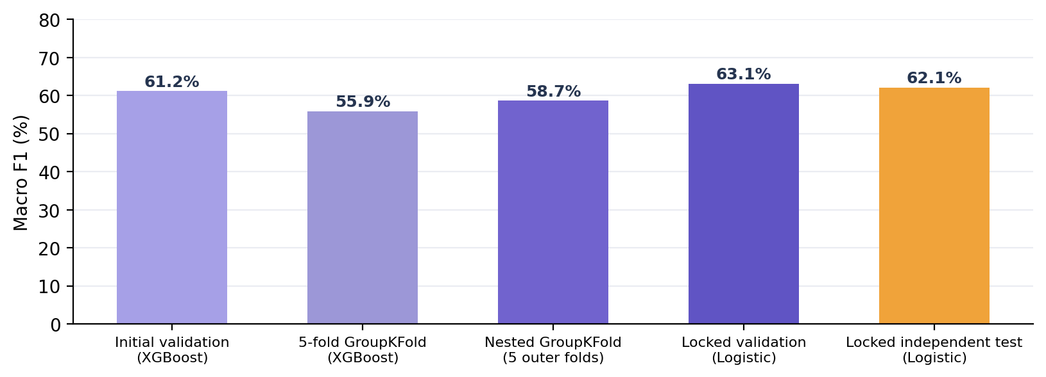
Figure 1. Different evaluation phases and cohorts; bars should not be read as a single continuously improving learning curve.

2. Data Preparation for Testing
Participant-level separation yielded 198 training users, 43 validation users, and 43 held-out test users with zero identity overlap. Step 2 checked matching input schemas, no duplicated participant-day records, and no infinite numerical inputs. Across splits, 189 missing numeric cells occurred in night_unlock_ratio, night_nonstudy_app_ratio, and prior20_night_ratio_delta. The saved pipeline learned medians exclusively from training data; external validation and test rows were transformed with those frozen values.
The test feature order was fixed using feature_columns.txt (30 columns). participant_id and local_date remained outside the predictor matrix. The next-day label audit fields were excluded, and no test-set resampling, SMOTE, feature reselection, refitting, or threshold adjustment occurred. The independent test was evaluated after the training-only model selection and lock.

3. Model Application
The locked model was loaded from unhook_step6_train_only_locked_pipeline.joblib. Its full preprocessing steps and decision threshold were applied without modification. The following illustrates the application logic in the existing Step 7 Python runner:
import joblib
import pandas as pd

model = joblib.load('unhook_step6_train_only_locked_pipeline.joblib')
feature_columns = open('feature_columns.txt').read().splitlines()
X_test = pd.read_csv('test_features.csv')[feature_columns]
proxy_probability = model.predict_proba(X_test)[:, 1]
proxy_flag = (proxy_probability >= 0.55).astype(int)
# Test labels are used only for evaluation, never refitting.

The output is a score and binary indicator for the experimental next-day behavior-change proxy. It is neither a clinical addiction probability nor permission to apply an automatic network restriction.

4. Test Metrics
Independent test metrics were computed from 611 participant-days belonging to 43 users, including 101 positive proxy labels (16.53% prevalence). Validation metrics are shown for context; they represent a separate cohort and should not be interpreted as an in-sample training score.
METRIC | TRAIN-ONLY NESTED CV | VALIDATION | HELD-OUT TEST
Macro F1 | 0.5867 ± 0.0233 | 0.6314 | 0.6210
Positive-class F1 | 0.3019 | 0.4351 | 0.4089
Precision (+) | 0.2936 | 0.3583 | 0.3274
Recall (+) | 0.3206 | 0.5537 | 0.5446
Accuracy | — | 0.7360 | 0.7398
Average precision | — | 0.3890 | 0.3053
ROC-AUC | — | 0.7277 | 0.6928
Brier score | — | 0.2253 | 0.2300

Training-only nested CV values are five-fold means under the model-selection procedure; the 3-fold full-train selection score for the final locked configuration was Macro F1 = 0.5986. The validation and held-out test values come from that final locked model. Because these estimates use different protocols and cohorts, cross-column differences are descriptive, not proof of an intervention effect.
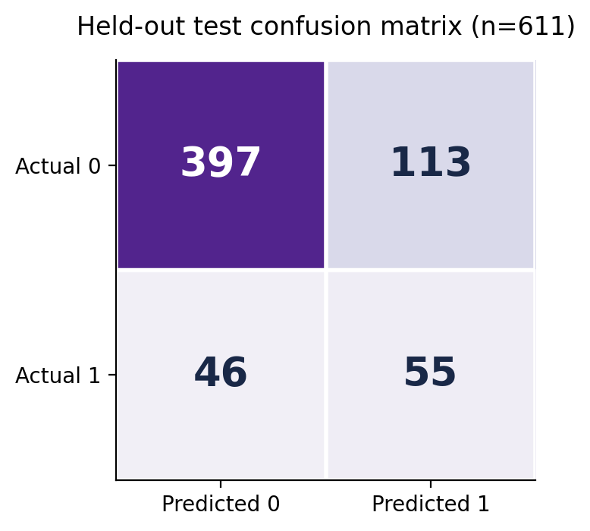
Figure 2. Independent test counts for the final locked threshold 0.55: TN 397, FP 113, FN 46, TP 55.
On the held-out test, precision for the positive proxy was 32.7%, recall 54.5%, and positive-class F1 40.9%. The participant-cluster bootstrap (3,000 resamples) produced a descriptive 95% interval of 0.569–0.672 for Macro F1 and 0.312–0.495 for positive F1. These intervals do not verify future temporal robustness or diagnosis accuracy.

5. Model Deployment
Step 8 delivered an offline inference prototype, not an Android application. The original 30-input scikit-learn pipeline remained immutable and hash-verified. A mathematically equivalent 10-feature linear scoring definition was exported for portable pure-Python and Kotlin use. A request/response contract and error-handling rules were documented. The Kotlin implementation was compiled and tested in a JVM environment, but not deployed as an Android APK or used with real device events.
COMPONENT | CURRENT STATUS
Frozen Python model | Delivered; joblib pipeline and SHA-256 verified
Portable Python scorer | Delivered; 659/659 validation predictions matched locked model
Kotlin numeric core | Delivered; 12/12 synthetic JVM parity tests passed
Android UsageStats pipeline | Proposed only; permission/feature acquisition not implemented
In-app interventions / JITAI | Proposed only; not connected to model prediction
VpnService bandwidth throttling | Not implemented or tested on-device

The planned architecture is: explicit permissions → local usage-event collection → validated feature extractor → portable next-day proxy scorer → separately designed and prospectively validated intervention logic → user feedback interface → independent VPN traffic-control module. Android per-app VPN routing is not itself a traffic-rate limiting algorithm. Automatic interventions must remain disabled until false-positive burden, privacy protections, and operational behavior are tested.

6. Code Implementation
The delivered implementation includes a strict 30-feature Python pipeline wrapper, JSON/CSV command-line scoring, a lightweight 10-feature portable scorer, a Kotlin numeric class, input schemas, synthetic fixtures, and regression tests. The portable logistic calculation uses training-only medians, scaler parameters, model coefficients, and the unchanged threshold:
z = intercept + sum(
coefficient[i] * ((value[i] or train_median[i]) - mean[i]) / scale[i]
for i in range(10)
)
p = 1 / (1 + exp(-z))
predicted_next_day_proxy = int(p >= 0.55)
# Deliberate safety contract:
automatic_intervention_authorized = False

SOFTWARE CHECK | DOCUMENTED RESULT
Frozen model hash | Matched original Step 7 model
Portable Python parity | 659/659; maximum |Δp| = 2.22e-16
Decision parity | All 659 validation proxy flags identical
Kotlin JVM tests | 12 / 12 synthetic test cases passed
Python unit tests | 5 / 5 passed

These tests validate numerical reproducibility and input/output consistency only. They do not measure battery usage, traffic handling, operating-system background limits, behavioral effectiveness, or real-time on-device inference latency. Full source and README instructions are included in the Step 8 handoff archive.

Conclusion
The UNHOOK model refinement workflow is fully documented through dataset audit, split-safe preprocessing, baseline evaluation, five-fold GroupKFold, feature selection, nested 5×3 GroupKFold tuning, locked model testing, and offline code packaging. The selected Logistic Regression model used ANOVA top-10 features, C = 2.0, balanced class weights, and threshold 0.55. On 611 independent held-out test observations, Macro F1 was 0.6210 and positive-class F1 was 0.4089, with 113 false positives and 46 false negatives. The project’s proposed Macro F1 > 0.85 target was not reached.
Methodological strengths are participant-disjoint evaluation, fold-internal preprocessing, explicit test-set preservation, recorded hyperparameter selection, reproducibility artifacts, and transparent reporting of error costs. Limitations include a rule-derived next-day proxy rather than independently validated addiction labels, old observational logs, non-chronological evaluation, limited sample size, score calibration uncertainty, false-alarm burden, and incomplete mapping from daily features to live Android events.
Before any real-world deployment, future work should collect prospective consent-based Android usage streams, verify genuine sessions and usable nighttime signals, define independently supported behavioral outcome labels, evaluate time-ordered and out-of-domain performance, improve model calibration, and run a small participant-consented pilot. The Android app, safety controls, and actual local VPN throttling must be implemented and validated separately. Current output should remain research-only and must not trigger autonomous network throttling.

References
[1] UNHOOK Project Team (2026). Model Refinement_Template.docx (instructor-provided structure).
[2] UNHOOK Project Team (2026). UNHOOK_ÖDEV2(1).pdf: Capstone Project Concept Note and Implementation Plan.
[3] UNHOOK Project Team (2026). Steps 1–5: Dataset Audit; Data Preparation; Initial Model Evaluation; GroupKFold Cross-Validation; Feature Selection (internal reports and code archives).
[4] UNHOOK Project Team (2026). Step 6: Model Refinement and Hyperparameter Tuning (locked_configuration.json; nested_cv_summary.json; model artifact).
[5] UNHOOK Project Team (2026). Step 7: Held-out Test and Final Model Evaluation (step7_metrics.json; test_cluster_bootstrap.json; predictions).
[6] UNHOOK Project Team (2026). Step 8: Model Deployment and Code Implementation (portable_linear_model.json; parity_summary.json; Python and Kotlin source).
[7] scikit-learn developers. scikit-learn documentation: Pipeline, GroupKFold, model selection, precision/recall/F1, and model persistence. https://scikit-learn.org/stable/
[8] Android Developers. UsageStatsManager API. https://developer.android.com/reference/android/app/usage/UsageStatsManager
[9] Android Developers. VPN / per-app VPN and VpnService.Builder. https://developer.android.com/develop/connectivity/vpn

Appendix A — Selected features and model limitations
The following ten variables were selected when the final pipeline was fitted on the full training split. Selection order is preserved as recorded by the locked configuration. Many are daily aggregates or rolling 20-day historical summaries, not directly available as instantaneous real-time signals.
SELECTED FEATURE (1–5) | SELECTED FEATURE (6–10)
1. night_unlock_events_00_06 | 6. has_notification_events
2. night_unlock_ratio | 7. prior20_median_night_unlock_ratio
3. night_nonstudy_app_events | 8. prior20_unlock_delta
4. night_nonstudy_app_ratio | 9. prior20_unlock_ratio
5. notification_posted_nonstudy | 10. prior20_app_delta

The label reflects future deviation in user behavior, not a medical diagnosis. No true sleep onset/offset, problem gambling diagnosis, or intervention response is provided as a validated target by these artifacts. Feature attribution and correlations should not be treated as causal explanations of harm.

Appendix B — Reproducibility and artifact index
ARTIFACT | ROLE / EVIDENCE
UNHOOK_ADIM6_Model_Refinement_Teslim_Paketi.zip | Nested CV experiments; training-only model selection; final locked configuration and model
UNHOOK_ADIM7_Bagimsiz_Test_Teslim_Paketi.zip | Frozen model evaluation; validation/test predictions; confusion matrix and uncertainty
UNHOOK_ADIM8_Model_Deployment_ve_Kod_Teslim_Paketi.zip | Portable JSON model, Python/Kotlin scorers, interface specifications, parity tests
UNHOOK_ADIM2_Model_Hazirlik_Paketi.zip | Participant-disjoint train/validation/test inputs; raw train file for fold-safe CV

