Literature, Data and Technology Review
SIC AI 20 Capstone · Group 13 · Project: Game Risk Card · Yusuf Topçu (individual project)

Part A – Literature Review

Introduction
Mobile games are among the most used apps, and some of them are designed to maximise time on screen rather than fun. The WHO now recognises gaming disorder (ICD-11). Our research question is: can we detect screen-time dark patterns in a game automatically from its user reviews, and explain the result in a transparent way? A literature review is needed to (1) define which patterns to look for, (2) learn how common and harmful they are, and (3) see which machine learning methods already work on app reviews.

Organization
We group the papers by theme: (A) dark patterns in general user interfaces, (B) dark patterns and harm in games, (C) machine learning on app reviews, and (D) text classification methods.

Summary and Synthesis
Theme A – Dark patterns in interfaces.
- Gray et al. (2018) collected practitioner examples and proposed five strategies (nagging, obstruction, sneaking, interface interference, forced action). Contribution: a widely used vocabulary for dark patterns.
- Mathur et al. (2019) crawled 11K shopping websites with automated tools and found dark patterns on about 11% of them. Contribution: shows that dark patterns can be measured at scale with automation.
- Di Geronimo et al. (2020) inspected 240 popular mobile apps: 95% had at least one dark pattern, and most users did not notice them. Contribution: mobile-specific evidence and a strong argument for automatic warnings.
Theme B – Games.
- Zagal, Björk & Lewis (2013) defined dark patterns in game design and grouped them into temporal, monetary and social-capital patterns (e.g. “playing by appointment”, “grinding”). darkpattern.games builds on this taxonomy and adds psychological patterns; our 14 target traps come from its temporal, social and psychological groups.
- King et al. (2019) analysed game patents and showed that some monetised games use data and design to exploit players (e.g. dynamic offers). Contribution: links design choices to consumer harm.
- Zendle & Cairns (2018) surveyed about 7,400 gamers and found a link between loot box spending and problem gambling. Contribution: evidence that random rewards (loot boxes) are among the most harmful patterns – which supports giving them the highest weight in our card.
Theme C – Machine learning on app reviews.
- Guzman & Maalej (2014) extracted app features from reviews and measured the sentiment about each feature. Contribution: reviews contain detailed, feature-level information.
- Maalej & Nabil (2015) classified reviews into bug reports, feature requests and praise with simple text features and classic classifiers (e.g. Naive Bayes). Contribution: classic ML works well on short review texts.
Theme D – Text classification methods.
- Salton & Buckley (1988) introduced the TF-IDF family of term weights; Joachims (1998) showed that linear models on such features are strong for text categorisation. These are the basis of our feature pipeline.
Comparison: Themes A and B describe and count dark patterns but rely on manual inspection of apps. Theme C shows that reviews can be mined automatically, but these studies do not target dark patterns. No work we found predicts game dark patterns from reviews and turns the result into a consumer-facing, explainable label.

Conclusion
- Dark patterns are common in mobile apps and games, and some (loot boxes) are linked to real harm.
- Existing studies are manual and do not scale to thousands of games.
- Review mining with classic ML is proven to work.
Our contribution: we combine these lines of work – a player-voted taxonomy (darkpattern.games) as labels, Google Play reviews as input – to predict screen-time traps for any game, including games with no votes, and show the evidence on a transparent risk card.

Citations
Gray, C. M., Kou, Y., Battles, B., Hoggatt, J., & Toombs, A. L. (2018). The dark (patterns) side of UX design. In Proceedings of the 2018 CHI Conference on Human Factors in Computing Systems (CHI ’18). ACM.
Mathur, A., Acar, G., Friedman, M. J., Lucherini, E., Mayer, J., Chetty, M., & Narayanan, A. (2019). Dark patterns at scale: Findings from a crawl of 11K shopping websites. Proceedings of the ACM on Human-Computer Interaction, 3(CSCW).
Di Geronimo, L., Braz, L., Fregnan, E., Palomba, F., & Bacchelli, A. (2020). UI dark patterns and where to find them: A study on mobile applications and user perception. In Proceedings of the 2020 CHI Conference on Human Factors in Computing Systems (CHI ’20). ACM.
Zagal, J. P., Björk, S., & Lewis, C. (2013). Dark patterns in the design of games. In Proceedings of the 8th International Conference on the Foundations of Digital Games (FDG 2013).
King, D. L., Delfabbro, P. H., Gainsbury, S. M., Dreier, M., Greer, N., & Billieux, J. (2019). Unfair play? Video games as exploitative monetized services: An examination of game patents from a consumer protection perspective. Computers in Human Behavior, 101, 131–143.
Zendle, D., & Cairns, P. (2018). Video game loot boxes are linked to problem gambling: Results of a large-scale survey. PLoS ONE, 13(11), e0206767.
World Health Organization (2019). International Classification of Diseases, 11th Revision (ICD-11): 6C51 Gaming disorder.
Guzman, E., & Maalej, W. (2014). How do users like this feature? A fine grained sentiment analysis of app reviews. In 2014 IEEE 22nd International Requirements Engineering Conference (RE).
Maalej, W., & Nabil, H. (2015). Bug report, feature request, or simply praise? On automatically classifying app reviews. In 2015 IEEE 23rd International Requirements Engineering Conference (RE).
Salton, G., & Buckley, C. (1988). Term-weighting approaches in automatic text retrieval. Information Processing & Management, 24(5), 513–523.
Joachims, T. (1998). Text categorization with support vector machines: Learning with many relevant features. In Machine Learning: ECML-98. Springer.

Part B – Data Research

Introduction
A model can only be as good as its labels and inputs. Before modelling we needed to know: how many games have enough player votes, how balanced the labels are, and whether reviews actually talk about the traps. A careful data exploration also prevents data leakage (using information that already contains the answer).

Organization
We describe the two sources (labels and inputs), then the cleaning funnel, then the main insights.

Data Description
 | darkpattern.games (labels) | Google Play (inputs)
What | Player votes per game and pattern: “X present / Y absent” | User reviews, description, store info
Format | HTML pages (parsed with BeautifulSoup) → CSV | JSON (google-play-scraper) → JSONL
Size | ~31,000 games listed; 2,099 with votes | 200 English reviews per game; 98,968 reviews for 497 games
Access | Written permission; ≥5 s between requests; non-commercial; no republishing of raw data | Public store pages; 2 s between requests; user names not stored
Why | Only public source with per-pattern player votes | Reviews describe real play experience

We focus on 14 patterns that increase screen time: temporal (Playing by Appointment, Daily Rewards, Grinding, Advertisements, Infinite Treadmill, Can’t Pause or Save, Wait To Play), social (Fear of Missing Out, Social Obligation/Guilds, Competition) and psychological (Variable Rewards, Invested/Endowed Value, Badges/Endowed Progress, Complete the Collection).

Data Analysis and Insights
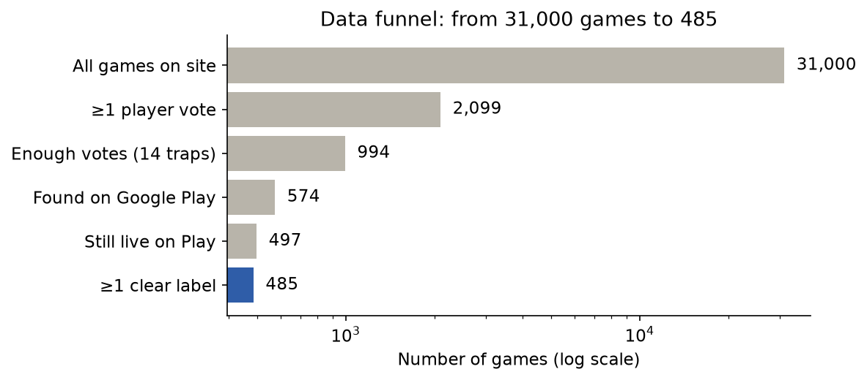
Figure 1 – Data funnel
- Most games have no votes. A random sample of 500 games showed 92% with zero votes. The site lists games by rating, so voted games are at the top; a binary search found the border (2,099 voted games). This cut scraping time from about 42 hours to about 3 hours.
- Few voters per game. In about half of the voted games the most-voted pattern has only one vote. We therefore require at least 2 votes per label.
- Final dataset: 485 games with at least one clear label and ~200 reviews each (96,645 reviews).
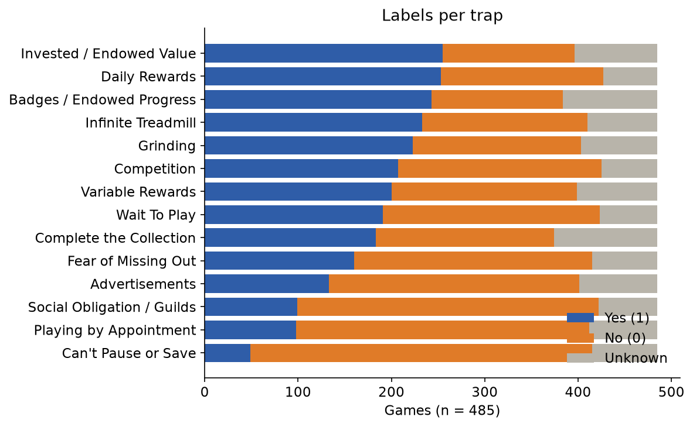
Figure 2 – Labels per trap (yes / no / unknown)
- Label balance differs by trap: most traps are close to 50/50, but Can’t Pause or Save has only 49 “yes” labels.
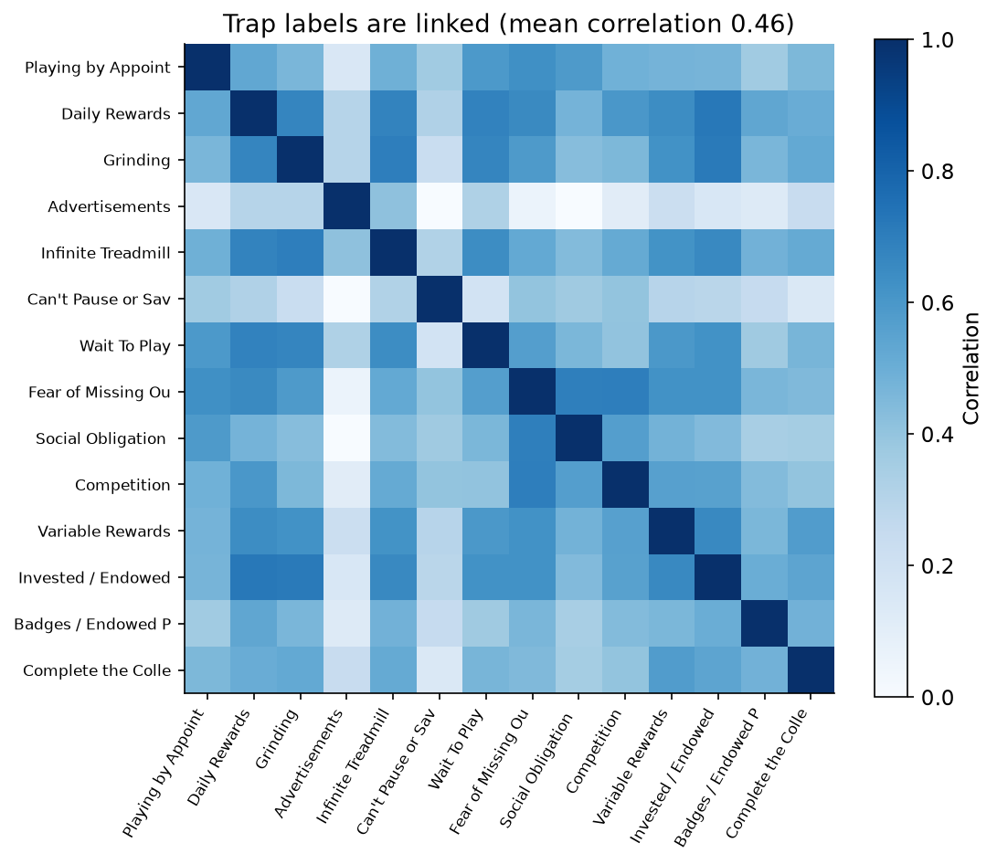
Figure 3 – Correlation between trap labels
- Labels are linked (mean correlation 0.46): dark games tend to use many traps together. Advertisements is the most independent trap (0.18).
- Reviews carry signal. Share of reviews that mention a keyword, in games with vs. without the trap:
Trap | Keywords | Trap present | Trap absent
Advertisements | ad, ads, advert | 38.3% | 10.2%
Social Obligation / Guilds | guild, clan, alliance | 4.5% | 0.4%
Variable Rewards | gacha, loot box, summon | 5.7% | 1.2%
Daily Rewards | daily, login | 4.1% | 1.2%
Wait To Play | wait, timer, energy | 9.9% | 4.4%

- Review profile: average review length 406 characters; stars: 1★ 21%, 2★ 13%, 3★ 15%, 4★ 18%, 5★ 33%; dates from 2015 to 2026 (28% from 2026).

Conclusion
Only about 1.6% of the site’s games are usable, but 485 well-labelled games with ~97K reviews are enough for classic ML. Reviews clearly mention many traps, the labels are linked to each other, and one trap (Can’t Pause or Save) is rare. These findings shaped our design: a strict label rule, per-trap models, and a check whether models learn the specific trap or only “dark game in general”.

Citations
DarkPattern.games – Healthy Gaming Database. https://www.darkpattern.games (player votes used with written permission of the site owner; non-commercial use).
Google Play Store, app pages and user reviews. https://play.google.com
google-play-scraper (Python package). https://pypi.org/project/google-play-scraper/

Part C – Technology Review

Introduction
The project needs tools for polite web scraping, data handling, text features, classification, evaluation and visualisation. Choosing simple, transparent and well-documented tools matters because the dataset is small and the output must be explainable to non-experts.

Technology Overview
Tool | Purpose | Key features we use
Python 3.12 | Main language | Large data science ecosystem
requests + BeautifulSoup | Scrape darkpattern.games | HTTP with retry; CSS selectors (div.face_score, a.hoverline)
google-play-scraper | Google Play data | app() for store info, reviews() for English reviews
pandas | Tables, joins, summaries | merge, groupby, read/write CSV/JSONL
scikit-learn | Features + models + evaluation | TfidfVectorizer, LogisticRegression, StratifiedKFold, roc_auc_score
matplotlib | Charts | ROC, calibration, bar charts
HTML + JavaScript | Card page | Offline, searchable page; no server needed

Relevance to Our Project
- Polite scraping (requests + 5 s delay) respects the data owner’s conditions.
- scikit-learn pipelines keep TF-IDF and the model together, so text statistics are learned only from training folds (no leakage).
- Logistic regression weights can be read directly, which supports the transparent card.

Comparison and Evaluation
Model option | Strengths | Weaknesses | Fit for us
Naive Bayes | Very fast; good baseline for text | Strong independence assumption; weaker probabilities | Possible baseline
Logistic regression (chosen) | Fast, strong on sparse text, readable weights | Linear; word order mostly lost | Best balance
Linear SVM | Strong text classifier | No direct probabilities; less readable | Similar accuracy, less explainable
Transformer (e.g. BERT) | Understands context and negation | Needs GPU and more labels; hard to explain; may overfit 485 games | Future work

All chosen tools are free and open source, run on a laptop, and train all 14 models in minutes.

Use Cases and Examples
- Classic text classifiers (Naive Bayes, logistic regression) were used to classify app reviews into bug reports and feature requests (Maalej & Nabil, 2015).
- Automated crawling tools were used to measure dark patterns on 11K websites (Mathur et al., 2019).
- scikit-learn is a standard tool for text classification in research and industry (Pedregosa et al., 2011).

Identify Gaps and Research Opportunities
- Bag-of-words loses context: “there are no ads” contains “ads”. We keep word pairs and do not remove stop words such as “no/not”; our keyword rules also skip negated mentions.
- English-only and US store: reviews in other languages are ignored.
- Scraping libraries can break when page layouts change; we documented the HTML structure and added retries.

Conclusion
A simple stack – Python, scikit-learn, pandas, BeautifulSoup and google-play-scraper – is enough for this project. It is free, fast, and, most importantly, explainable: we can show which words drive each prediction, which matches our goal of a transparent risk card.

Citations
Pedregosa, F., et al. (2011). Scikit-learn: Machine learning in Python. Journal of Machine Learning Research, 12, 2825–2830.
Salton, G., & Buckley, C. (1988). Term-weighting approaches in automatic text retrieval. Information Processing & Management, 24(5), 513–523.
Joachims, T. (1998). Text categorization with support vector machines: Learning with many relevant features. In Machine Learning: ECML-98. Springer.
Devlin, J., Chang, M.-W., Lee, K., & Toutanova, K. (2019). BERT: Pre-training of deep bidirectional transformers for language understanding. In Proceedings of NAACL-HLT 2019.
Maalej, W., & Nabil, H. (2015). Bug report, feature request, or simply praise? On automatically classifying app reviews. In 2015 IEEE 23rd International Requirements Engineering Conference (RE).
Mathur, A., Acar, G., Friedman, M. J., Lucherini, E., Mayer, J., Chetty, M., & Narayanan, A. (2019). Dark patterns at scale: Findings from a crawl of 11K shopping websites. Proceedings of the ACM on Human-Computer Interaction, 3(CSCW).
Richardson, L. Beautiful Soup (Python package). https://www.crummy.com/software/BeautifulSoup/
google-play-scraper (Python package). https://pypi.org/project/google-play-scraper/
The pandas development team. pandas (Python package). https://pandas.pydata.org
Hunter, J. D. (2007). Matplotlib: A 2D graphics environment. Computing in Science & Engineering, 9(3), 90–95.

